­­

Preparation questions:

|  |  |  |
| --- | --- | --- |
|  |  | Floating point |
|  |  | Integer |
|  |  | Integer |
|  |  | Complex |
|  |  | Complex |

1. TypeError: 'str' object does not support item assignment
2. grain
3. we access the string at the mentioned index from its end
4. IndexError: list assignment index out of range
5. 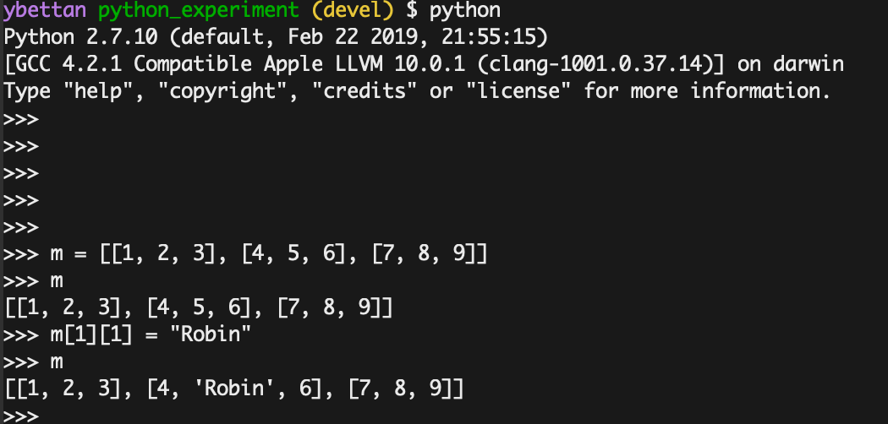

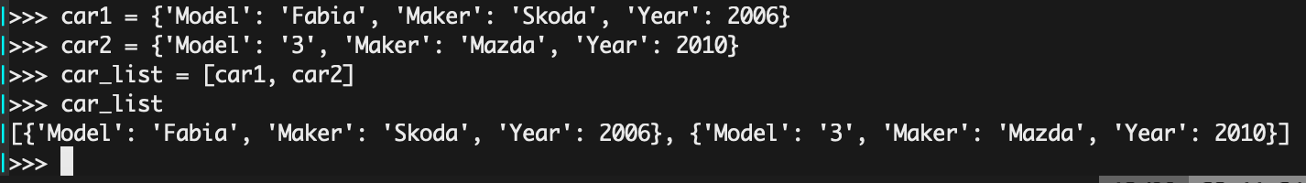

1. TypeError: 'tuple' object does not support item assignment

mmm…

Maybe x is not so small

Changing x to 100 will result in printing:

x is large!

1. Done
2. All values are not greater than 4.

Done.

1. Same as section b
2. In python 2 range(start, end) returns the list [start, …, end-1]

In python 3 range(start, end) returns a sequence (lazy evaluated) from start to end-1

1 is odd

2 is even

…

7 is odd

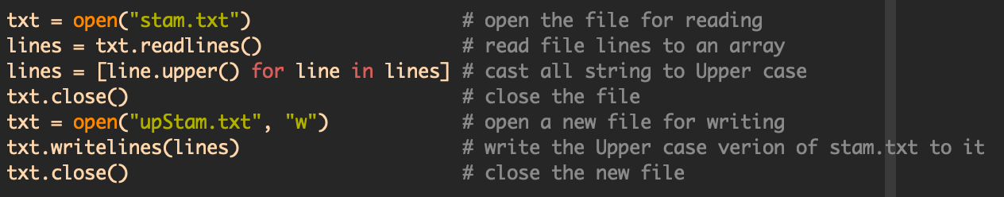The upStam.txt file contain the upper-case version of the stam.txt file

|  |  |
| --- | --- |
| an | This is **an** isl**an**d |
| \ban | This is **an** island |
| \Ban | This is an isl**an**d |