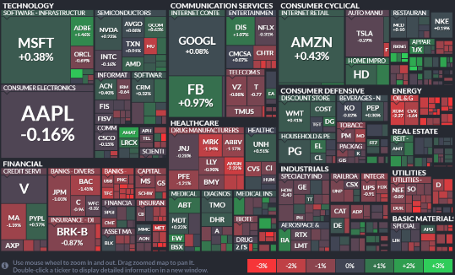**Group2**

**Kevin Sheekey**

**Kyle Pavelka**

**Matt brown**

**Meriane Franco**

**Ravi Patel**

**Project Proposal**

Data: Stock data for the SPX 500 from the last 6 months.

Dashboard:

* Stock Momentum
* Chart to Compare performance
* Plotly (dropdown, restyle)
* Filter/slider for the dates
* Testing different pattern or metrics for predicting stock performance.

Bonus:

* Custom chart – i.e., Tree Map picture

**Draft Project Plan**

|  |  |  |  |  |  |  |  |  |
| --- | --- | --- | --- | --- | --- | --- | --- | --- |
| Activity | Team player | Day1 – 5/22 | Day2 – 5/25 | Day3 – 5/27 | Day4 – 6/1 | Day5 – 6/3 | Day6 – 6/5 | Day7 – 6/8 |
| Project Manager | Meriane |  |  |  |  |  |  | Presentation |
| Grab data | Kyle |  |  |  |  |  |  |
| Github set up | Kyle | Done |  |  |  |  |  |
| Division of charts | All |  |  |  |  |  |  |
| Drop down | Matt/Ravi |  |  |  |  |  |  |
| Voice of Customer | Kyle |  |  |  |  |  |  |
| Check if all requirements are done | All |  |  |  |  | X |  |
| Dashboard Design Idea | Kyle |  |  |  |  |  |  |
| Tree Map Design Idea | Ravi |  |  |  |  |  |  |
| Index Set up (Html) – 4 boxes | Team – Meriane/Kevin |  |  |  |  |  |  |
| Style | Kevin/Meriane |  |  |  |  |  |  |
| Project Plan Update | Meriane |  |  |  |  |  |  |
| Custom chart* Bonus | Matt |  |  |  |  |  |  |

References:

<https://finviz.com/map.ashx?t=sec&st=>

[Amazon Candlestick Patterns (AMZN) - Investing.com](https://www.investing.com/equities/amazon-com-inc-candlestick)

<https://www.anychart.com/products/anystock/overview/>

[Quandl Documentation](https://docs.quandl.com/)