Table of Contents

1. Introduction ------------------------------------------------------------------------------------
2. Overview-----------------------------------------------------------------------------------------
3. Team Member Work Allocation-------------------------------------------------------------
4. Epic & Stories -----------------------------------------------------------------------------------
5. Use Cases ----------------------------------------------------------------------------------------
   * 1. Admin Management System-------------------------------------------------------------
     2. Booking Management System -----------------------------------------------------------
     3. Customer Management System---------------------------------------------------------
6. Class Diagram ----------------------------------------------------------------------------------
7. Software Requirements-----------------------------------------------------------------------
8. Conclusion----------------------------------------------------------------------------------------

1) Introduction

This project presents a review on the software program "Online Bus Ticket Reservation System" as should be used in a bus transportation system, a facility which is used to reserve seats, cancellation of reservation and different types of route enquiries used on securing quick reservations. OBTRS is built for managing and computerizing the traditional database, ticket booking and tracking bus and travel made. It maintains all customer details, bus details, reservation details.

1. Overview

OBTRS have the following micro services:

* User or Customer Management
* Booking Management
* Admin Management

The model followed was an agile model. Agile SDLC model is a combination of iterative and incremental process models with focus on process adaptability and customer satisfaction by rapid delivery of working software product. Agile Methods break the product into small incremental builds. These builds are provided in iterations.

The project had eight sprints to undergo. Every sprint had incremental learning. The first sprint had design and BDD/TDD implementations to display followed by core java and collection implementation in the second sprint. The database was static made through collections to enhance and have a practical knowledge on the collections framework. The third sprint had JDBC implementation in the middle layer. The UI was not yet done so we had a presentation layer in core java itself to test our functionalities.

1. Team Member Work Allocation
2. Yash Bhatia- Admin Management
3. Amaan Ahmad- Bus Booking Management
4. Shivani Sharma- Customer Management
5. Shivam Singh- Customer Management

4) Epic & Stories

|  |  |  |  |  |
| --- | --- | --- | --- | --- |
| Epic | Stories | As a/an | I want to | So that .. |
| Bus Booking  Management System | Sign Up to the application | Customer | Enter the details to sign up | A new user’s data is added to the database |
| Login/Logout session | Customer | Enter the details to Login | To gain access of the application and logout |
| User Profile Page | Customer | Display user’s home page | Users can check their travel history |
| Password Encryption | Customer | Encrypt the entered user password | Provides Security feature to the user |
| Change Password | Customer | Change user’s account password. | User can fulfil password related constraints during sign up |
| Forget Password | Customer | Recover user’s password | An email is sent to user containing the password |
| User Profile and Privacy settings | Customer | Add User’s additional details | A user may add additional Information |
| Logged In user profile page content | Customer | To book bus | User can book bus and can see details of the bus. |
| Search Bus | Customer | Search for bus | User can search for the bus according to the requirements |
| Sorting Bus Details | Customer | To sort the bus details | Customer can choose the bus as per requirement |
| Modify Search | Customer | To modify the search details | Customer can choose the bus as per requirement |
| Add Route/Bus | Admin | To add a new bus or route | Customer has various options |
| Generate Reports | Admin | To Generate bus reports | Admin can see booking details |
| Update Bus Details | Admin | To Update bus details | Admin can change the arrival and departure time, route, etc., |
| Bus Booking | Booking Management | To confirm the booking | To accept further booking details once the seat and bus is selected |
| Generate Ticket | Booking Management | To Generate e-ticket | Customer can print or send the e-ticket to his/her e-mail |
| Cancel Booking | Customer, Admin, Booking Management | To cancel the bus booking | Booking can be cancelled(if required) |
| Refund Money | Booking Management | To Refund money | Money can be refunded to the customer in case of booking cancellation |
| Display Fare | Booking Management | To display the bus fare | The Customer can view the total bus fare after entering the number of passengers |
| Seat Availability | Booking Management | To update seat availability | Seat availability can be updated in case of any booking or cancellation |
| Give Feedback | Customer | Provide valuable feedback | Services can be upgraded as per the feedback |
| Bus Rating | Customer | Rate the application | Rating can be provided for the application |

1. Use Cases
   1. Admin Management

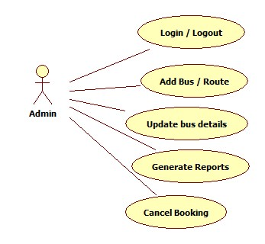

Online Bus Ticket Reservation System (OBTRS) aims to make a user friendly reservation management system where operations can be performed with a single click. The Admin functionalities include Login/Logout from the system, adding a new bus or route, updating bus details, generating reports and also cancelling the booking.

* 1. Bus Booking Management

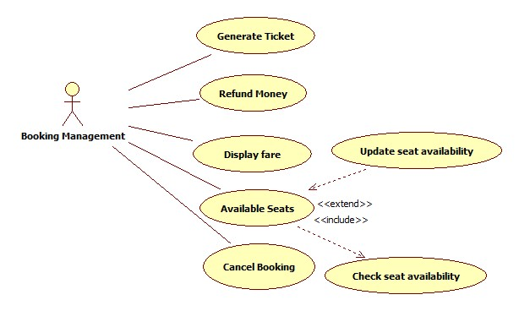

The booking management is capable of generating tickets, refunding money in case of cancellations, displaying fares, cancelling bookings and also updating seat availability as per the bookings and cancellations.

* 1. Customer Management

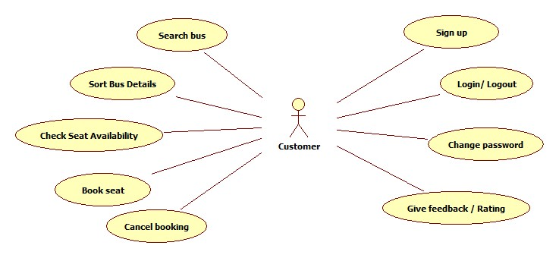

The Customer through OBTRS can perform the following functionalities, namely, searching and sorting buses, booking bus seat(s), cancel booking, changing user password along with login/logout from the system and also providing feedback for the bus service and rate the OBTRS application.

1. Class Diagram

1. System Requirements

Below is a list of the minimum Hardware and Software requirements to access Great Outdoors website.

**Operating System:**

* Windows 7 and above.
* Mac OSX 10.8, 10.9, 10.10 or 10.11
* Android 3 and onwards.

**Hardware:**

* Processor (CPU) with 2 gigahertz (GHz) frequency or above
* A minimum of 4 GB of RAM
* Monitor Resolution 1024 X 768 or higher (For better view)
* A minimum of 5 GB of available space on the hard disk
* Internet Connection Broadband (high-speed) Internet connection with a speed of 2 Mbps or higher
* Keyboard and a Mouse or some other compatible pointing device

**Browsers:**

* Chrome* 58+
* Microsoft Edge* 20+
* Mozilla Firefox 40+
* Internet Explorer 11+ (Windows only)
* Safari 6+ (MacOS only)
* Android* 3+

*\**Google Chrome version 42+ and Microsoft Edge do not support NPAPI-type plug-ins, including Java plug-ins and many media browser plug-in.

*Users using unsupported browsers may experience issues submitting forms, placing orders, purchasing, updating details and transaction management threads.*

**Browser Configuration:**

Your browser must be configured as follows:

* JavaScript must be enabled
* CORS must be configured properly
* Cookies must be enabled.
* Pop-up windows must be enabled.

**Software:**

* Java — to view and interact with all available blackboard applications.
* Eclipse — Eclipse workbench was used to run JDK (write, compile and run the code).
* Visual Studio Code — for writing codes for frontend using angular, VS Code was used as a workbench.
* Apache Tomcat — it was used as a server for hosting the website.