Boardgame- test

3 server we have to create.

Runner server is integrating with the GitHub as a runner server. All the other tool we have to install / configure here.

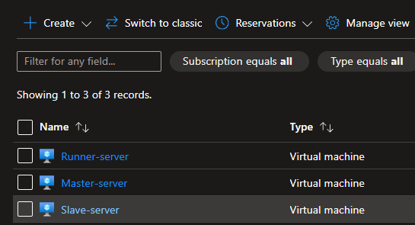

We have to open the some Ports for incoming and outgoing traffic.

Kubernetes are running on the slave server.

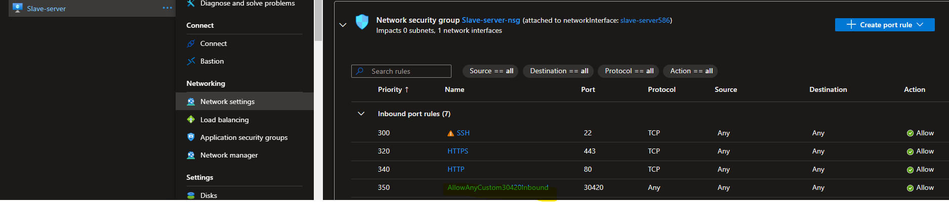

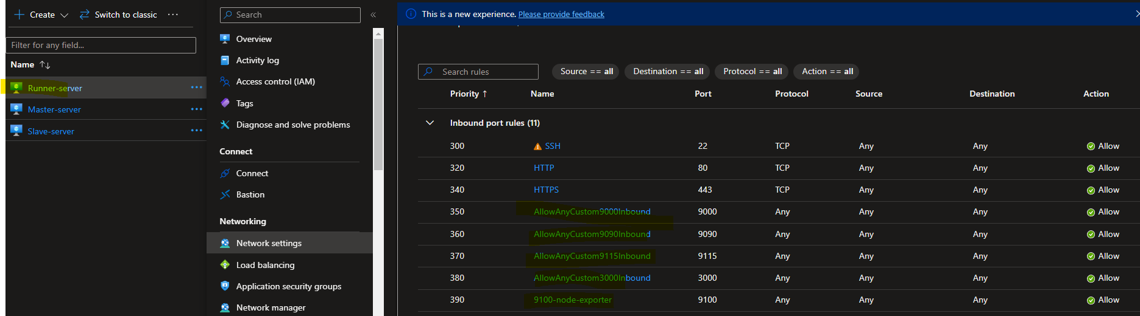

Master node we have to run the script and got the access token.

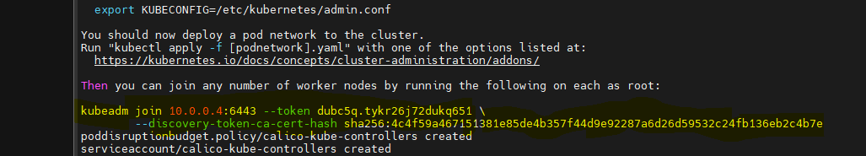

Copy the token (yellow part) and past to the worker node. With root directory.

Sudo su

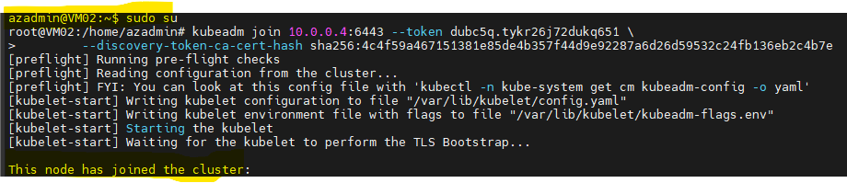

Once the node has joined.

kubectl get nodes (type the command and check the answer).

Note – control-plane (master server/node), <none> is worker node.

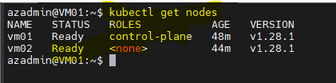

Installed maven (on runner server)

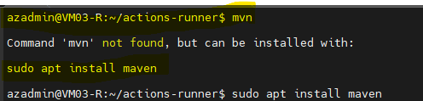

Sudo apt install maven -y

Configure the below snap as per the requirement.

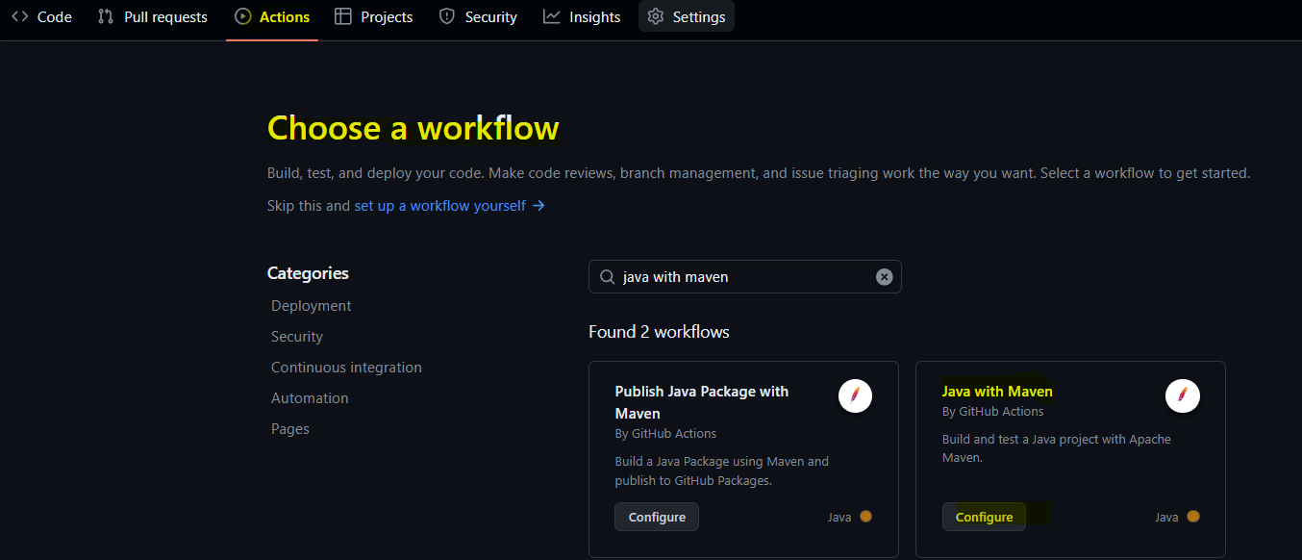

Note expoter – used for the system level monitoring

Blackbox monitoring – used for the website monitoring

Monitoring tools

<https://prometheus.io/download/>

wget (url as copy as address)

tar -xvf

mv (rename the file)

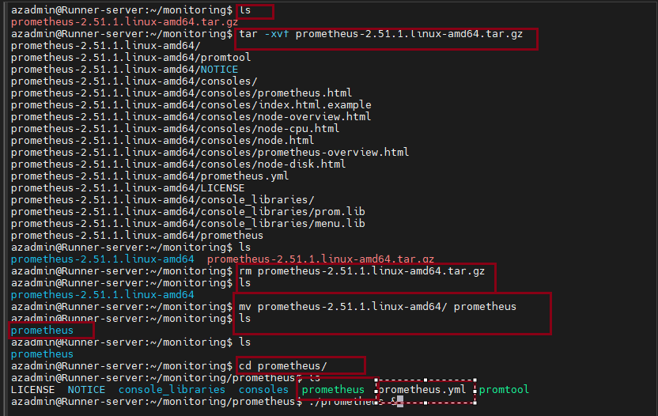

Same process for black box download.

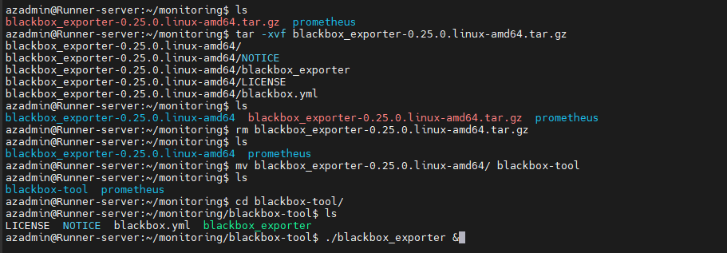

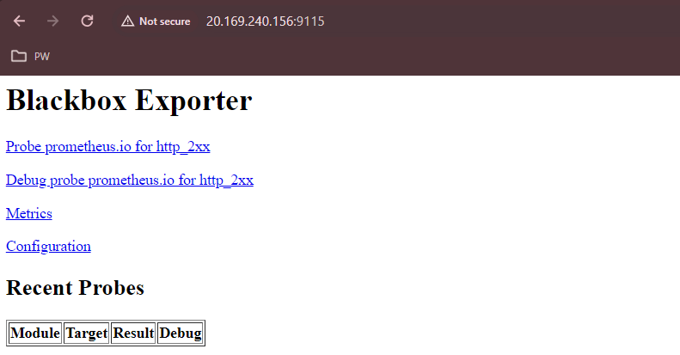

We have to configure

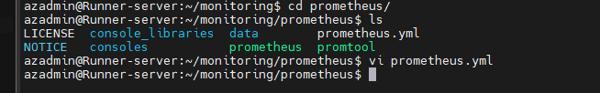

<https://github.com/prometheus/blackbox_exporter/blob/master/README.md>

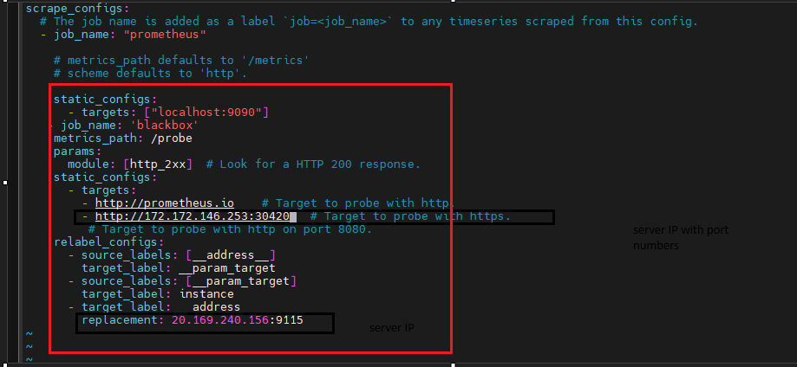

We have to restart the Prometheus

First, we have to kill it.

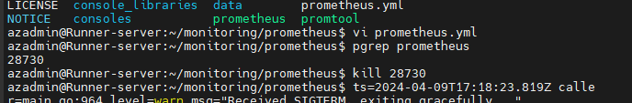

Blackbox running

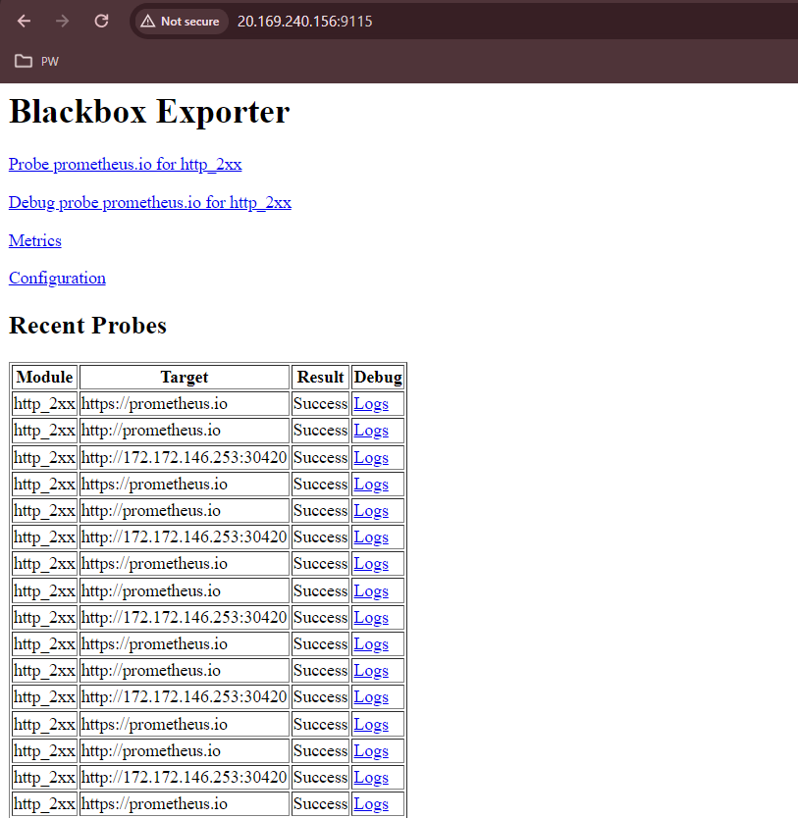

Prometheus running too

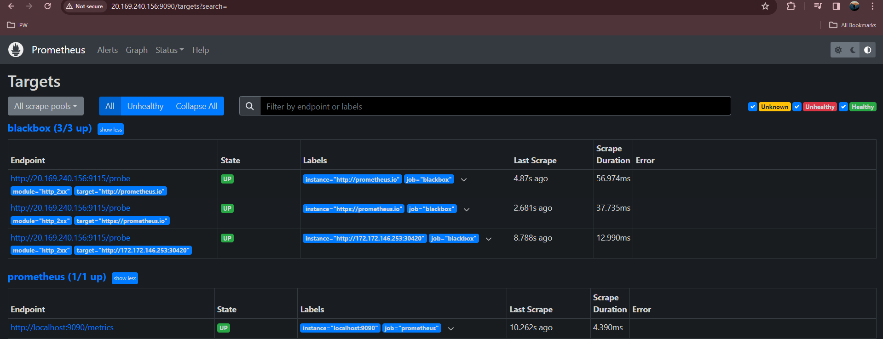

Grafana

Note – get this result proper visualize format we can use Grafana.

<https://grafana.com/grafana/download>

copy the command to the runner server

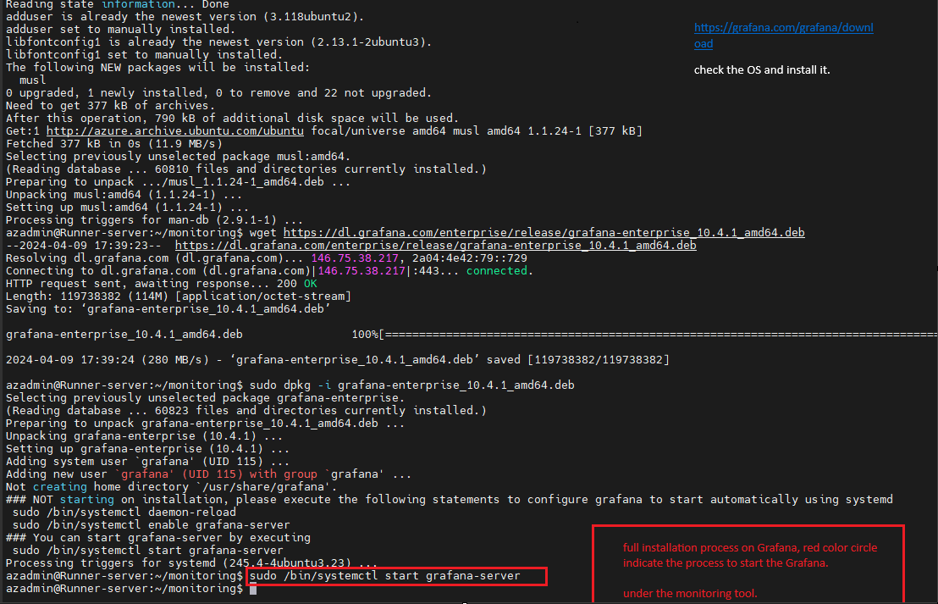

Check the runner IP with port 3000

We have to follow the below steps

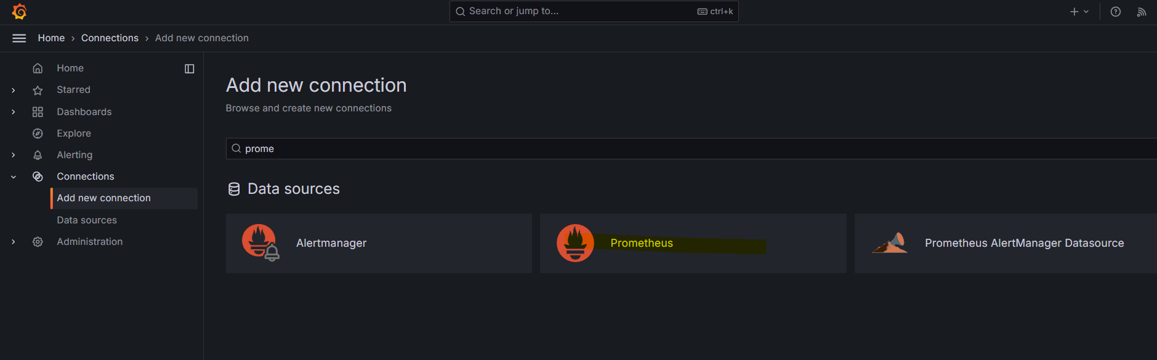

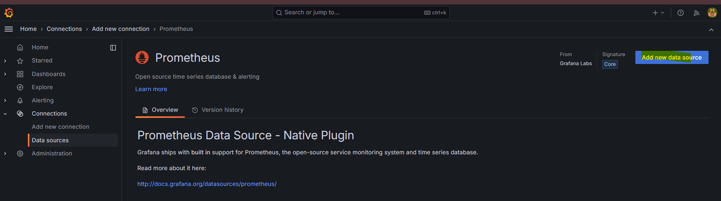

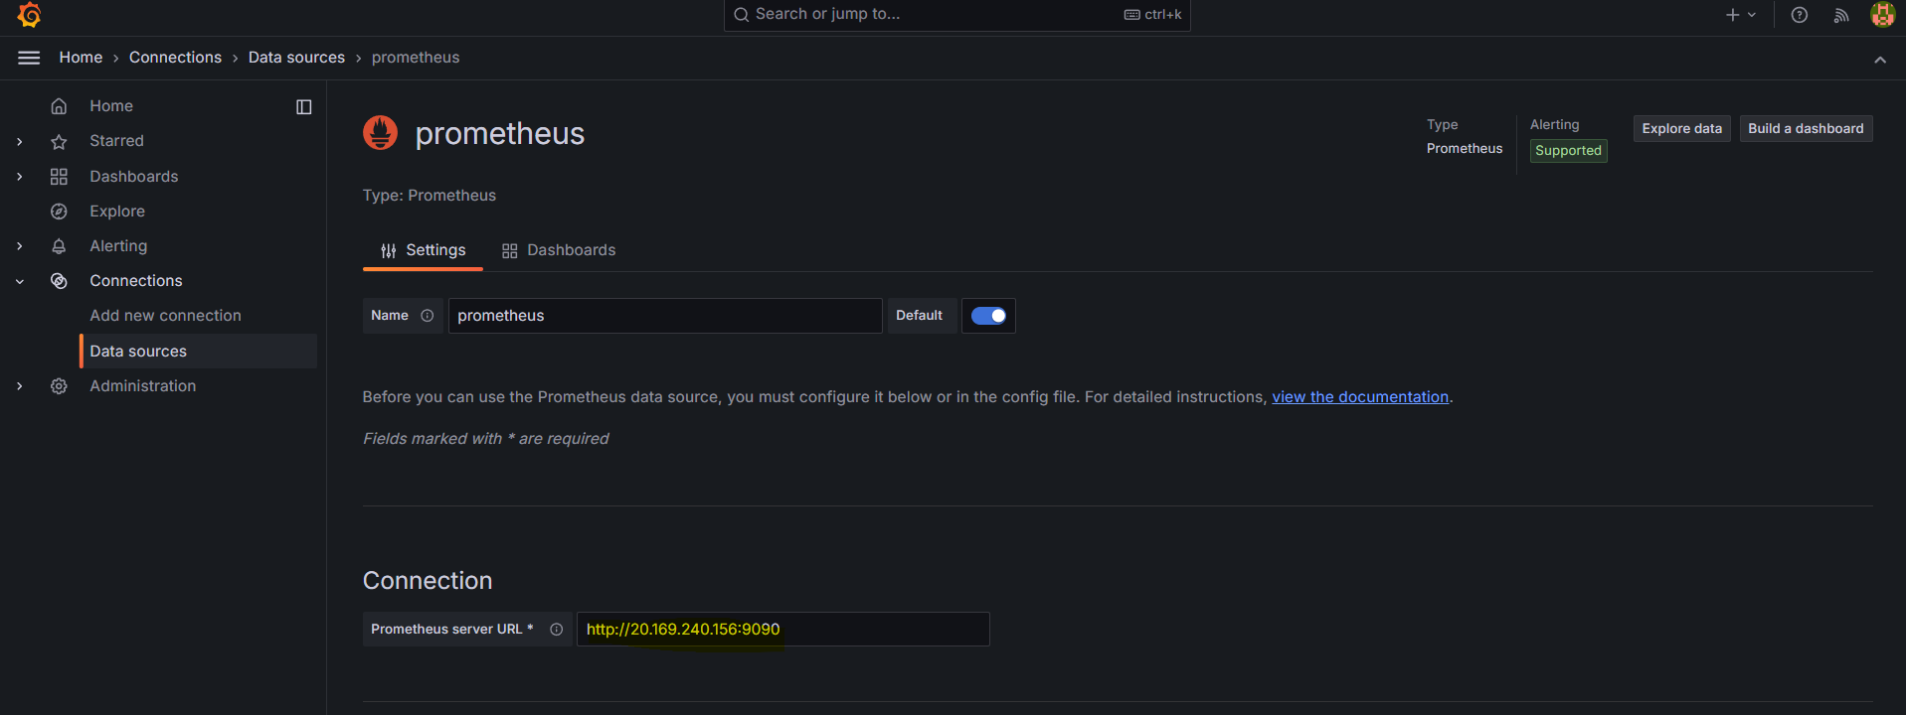

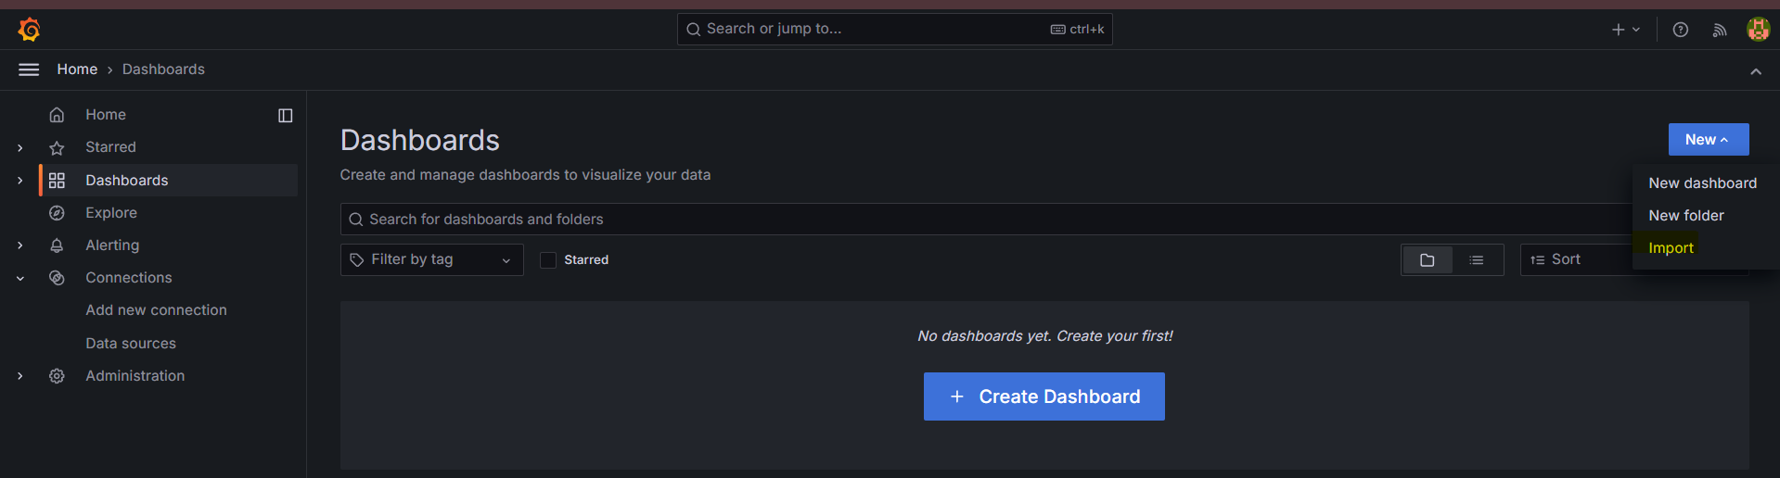

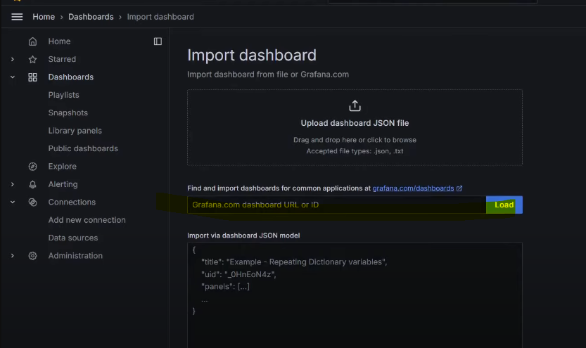

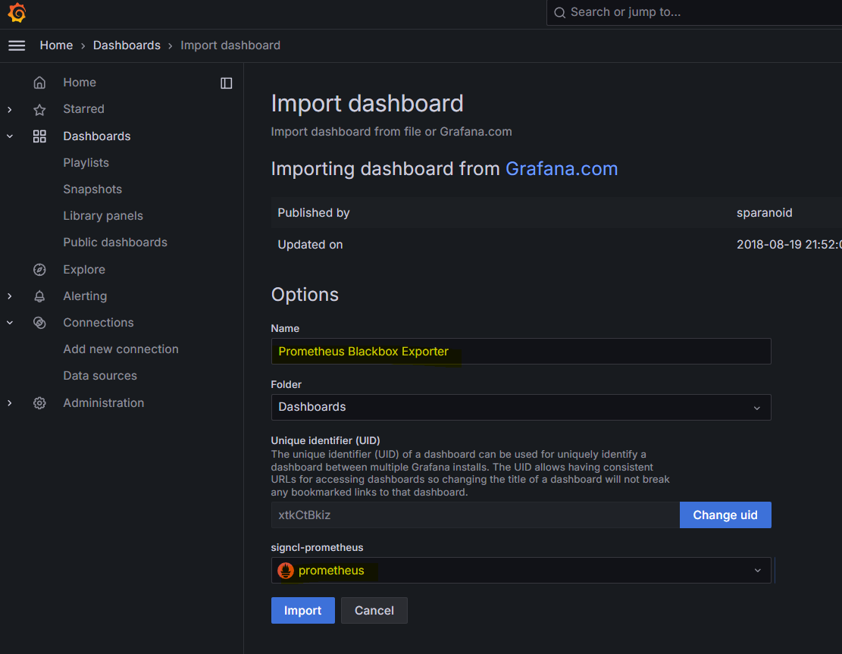

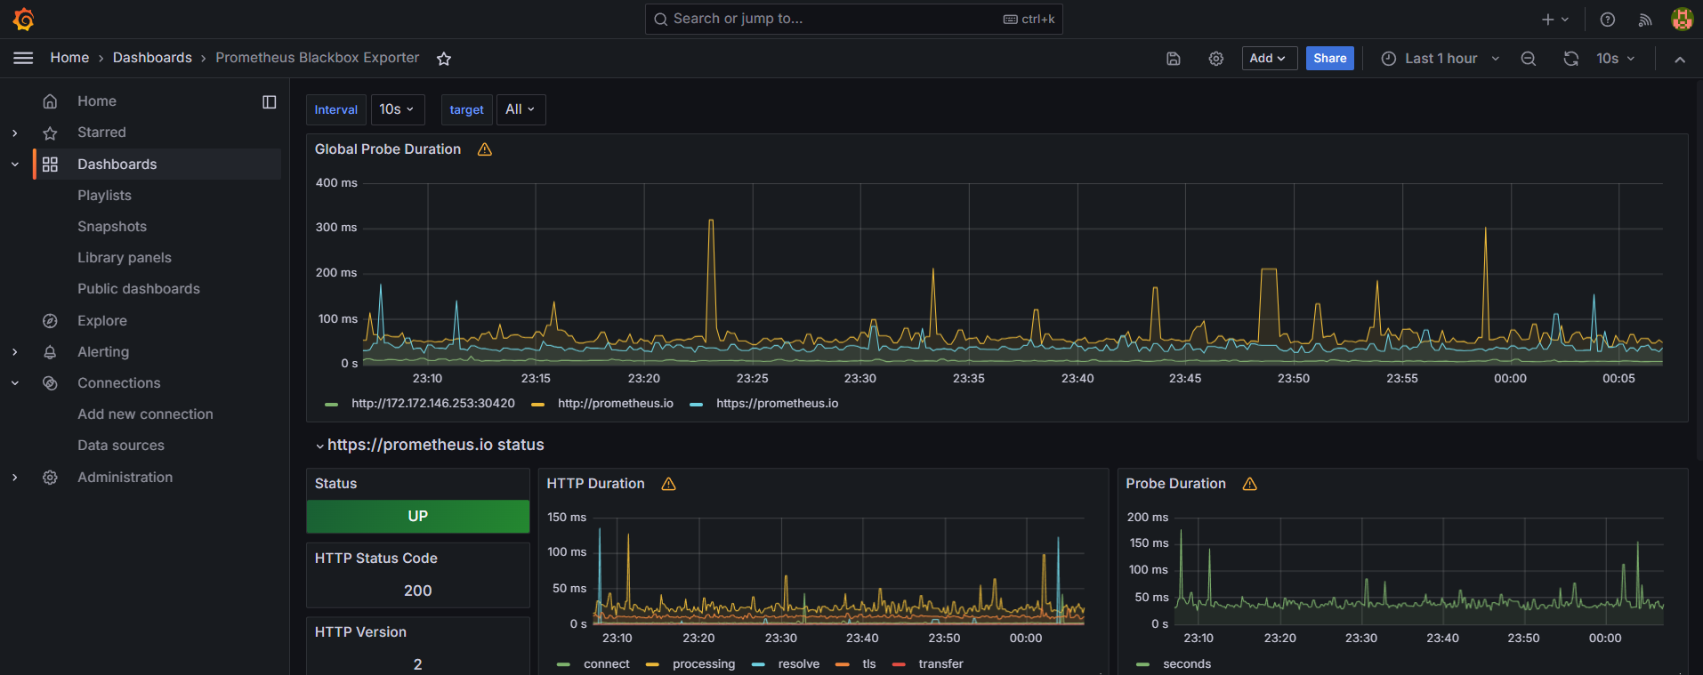

Node exporter

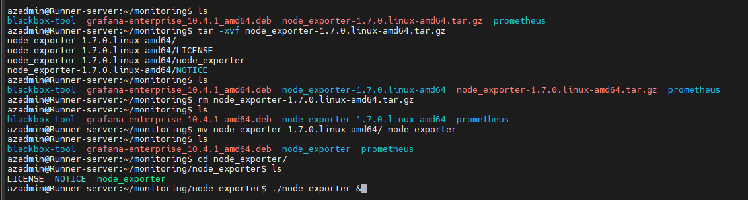

Runner server IP with port number 9100

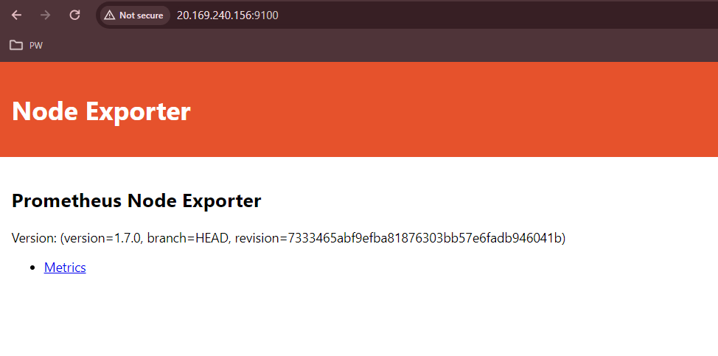

After write the yml code in the Prometheus.yml

# write the command inside the prometheus.yml file

- job_name: ‘node_exporter # your tool name

static_configs:

- targets: ['localhost:9100']



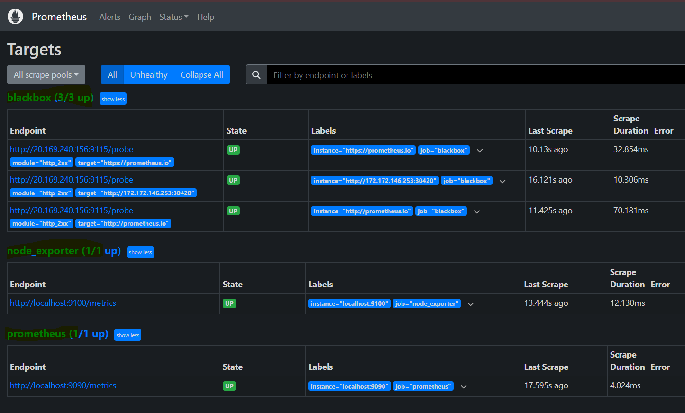

Goto the Grafana

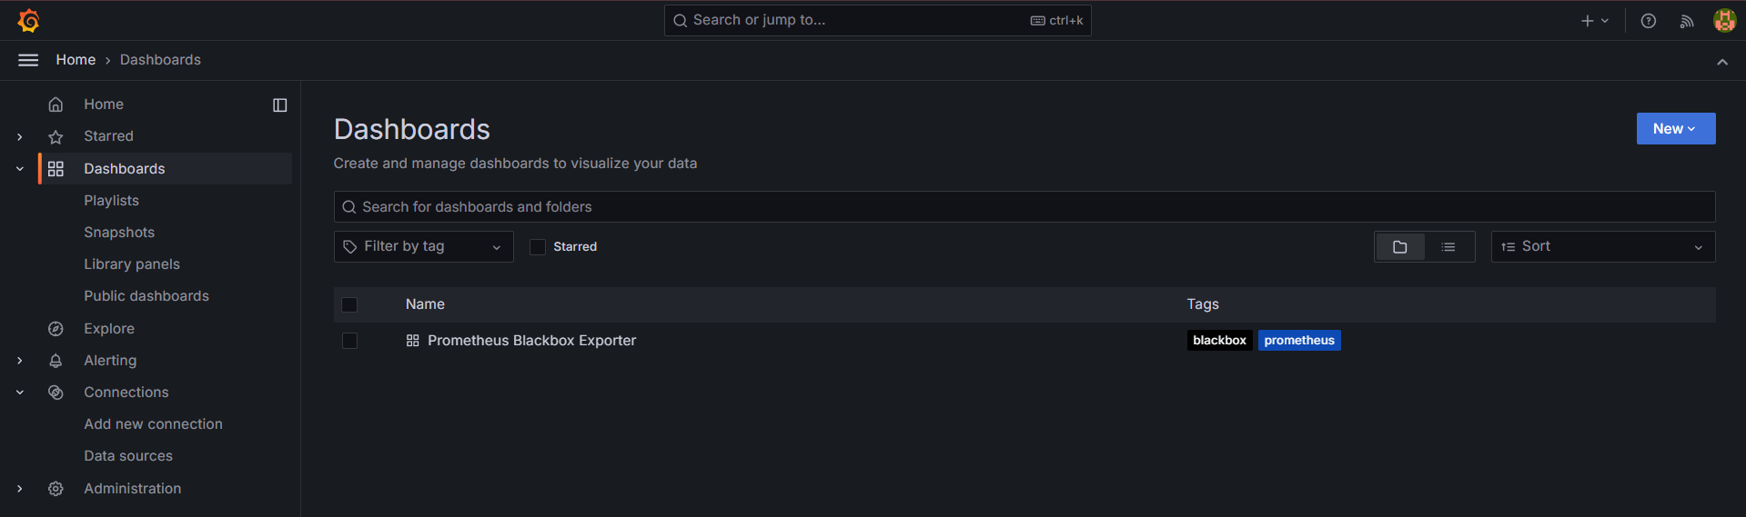

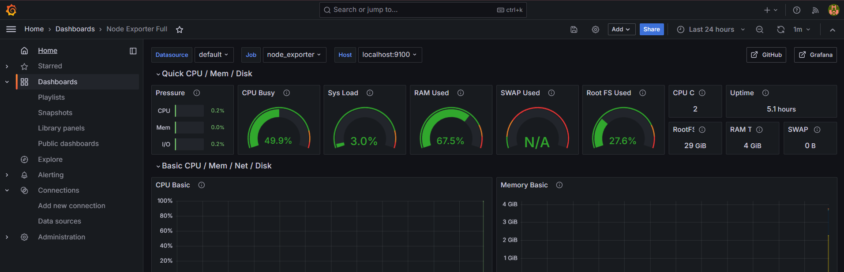

What are we downloading the under the particular server.

Master server

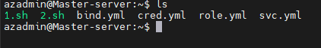

Slave server

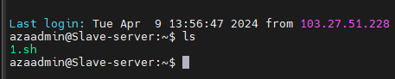

Runner

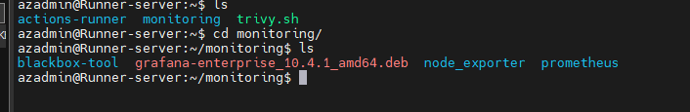

Projected output

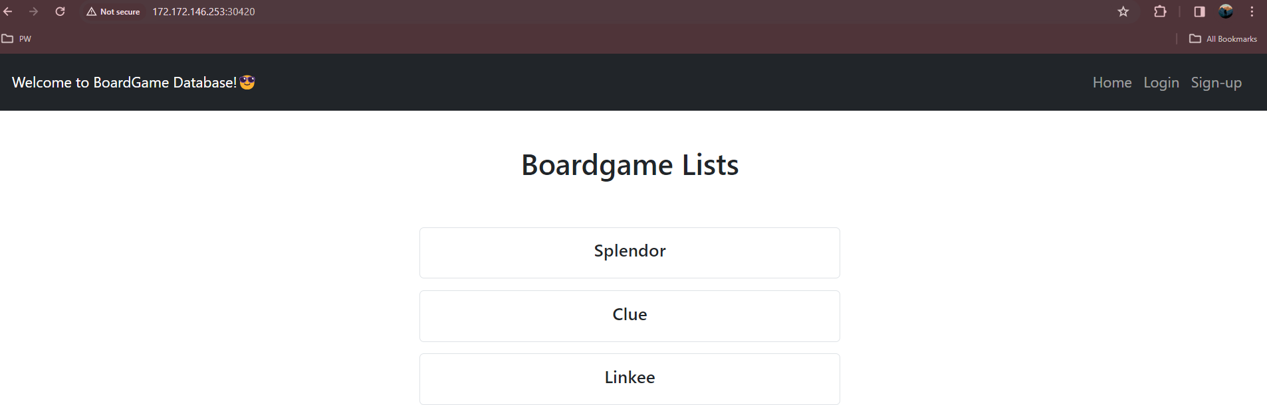

SonarQube check

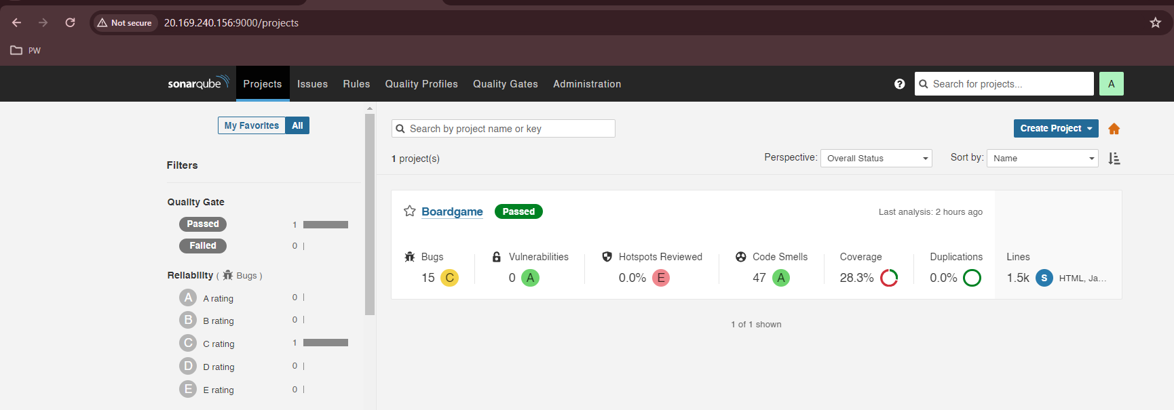

Error, we faced when setup the pipeline.

