**Netflix**

Create one server and install the Jenkins in this server.

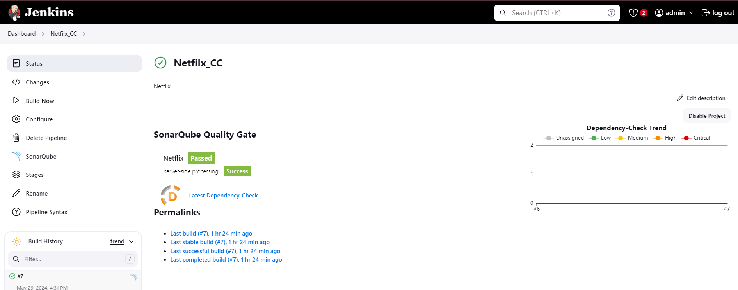

install the SonarQube on the same server.

And do the basic configuration to setup the sonarqube.

Setup the webhook on the sonarqube server to check the logs.

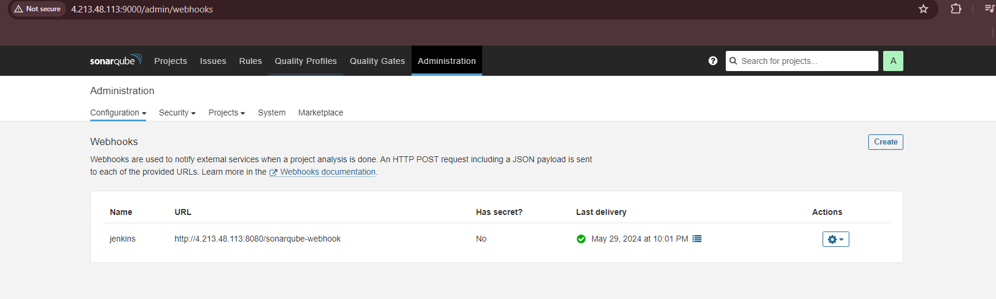

Below image indicate the code quality check along with other vulnaribilties.

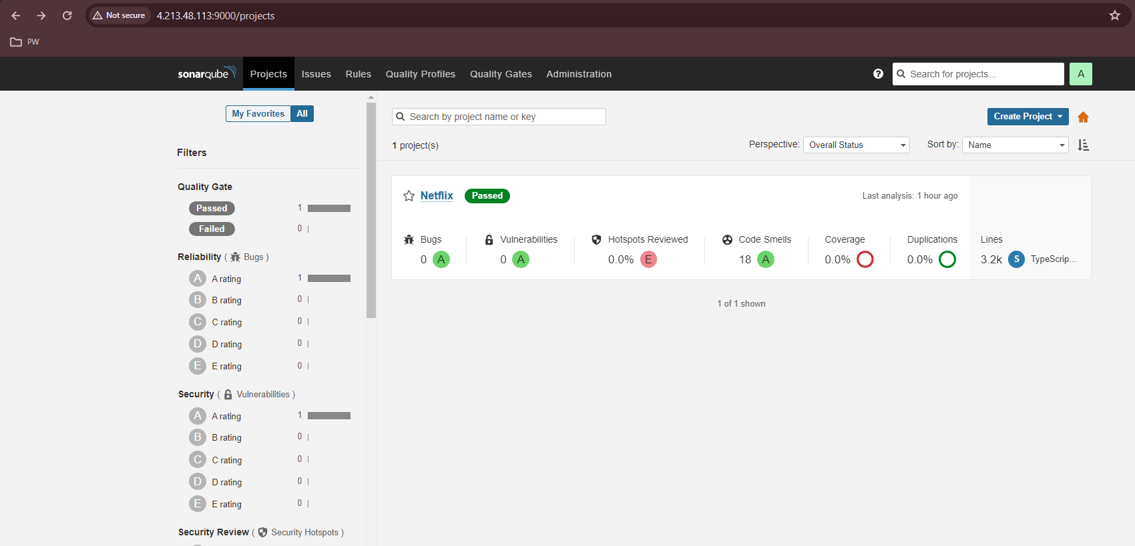

We have to mapped the dockerhub credential with Jenkins to replicate the application image.

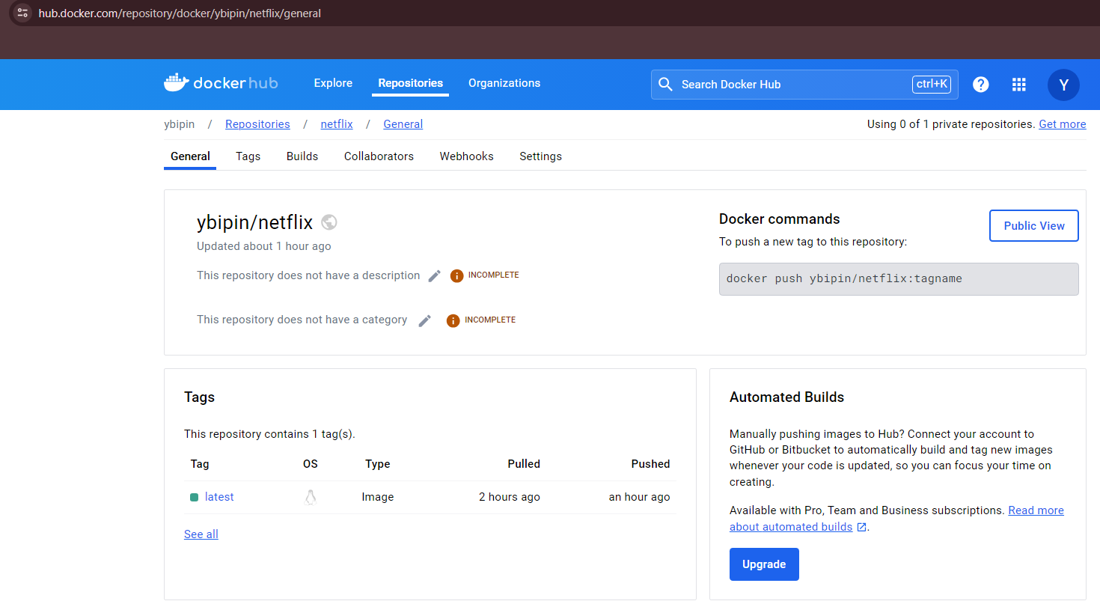

We have added all the steps.

Pipeline output, all the process we have follow as pr the application requirement.

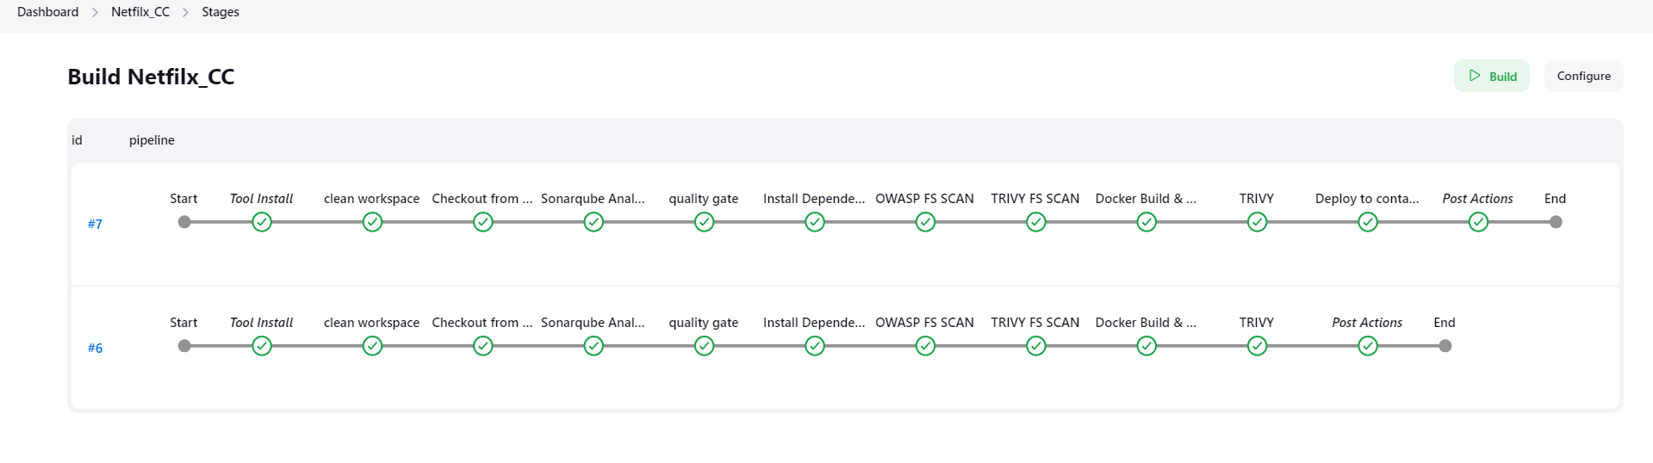

For monitoring purpose, we are using the below 2 tools.

1. Prometheus --> Collect the metric logs for mapped tools, and resources.
2. Grafana -- > present the data in visualize format, easy for understand the presented information.

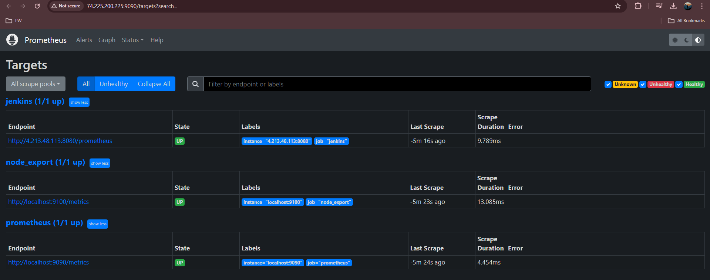

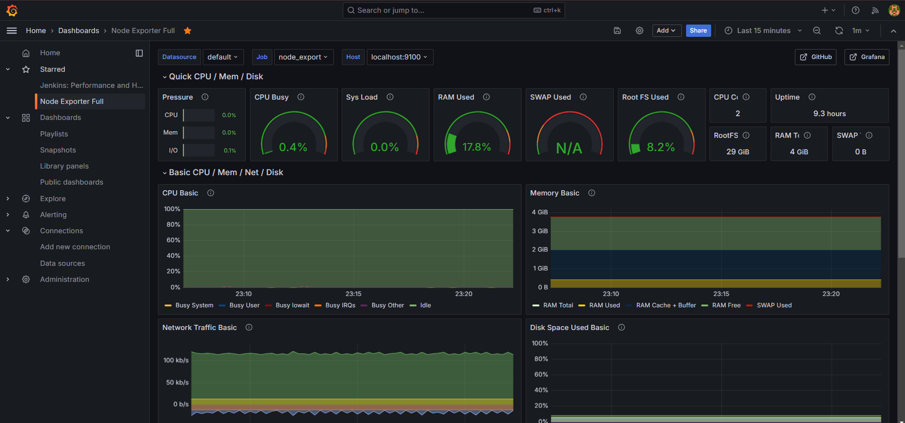

Below image indicate the Jenkins server mapped with the Prometheus.

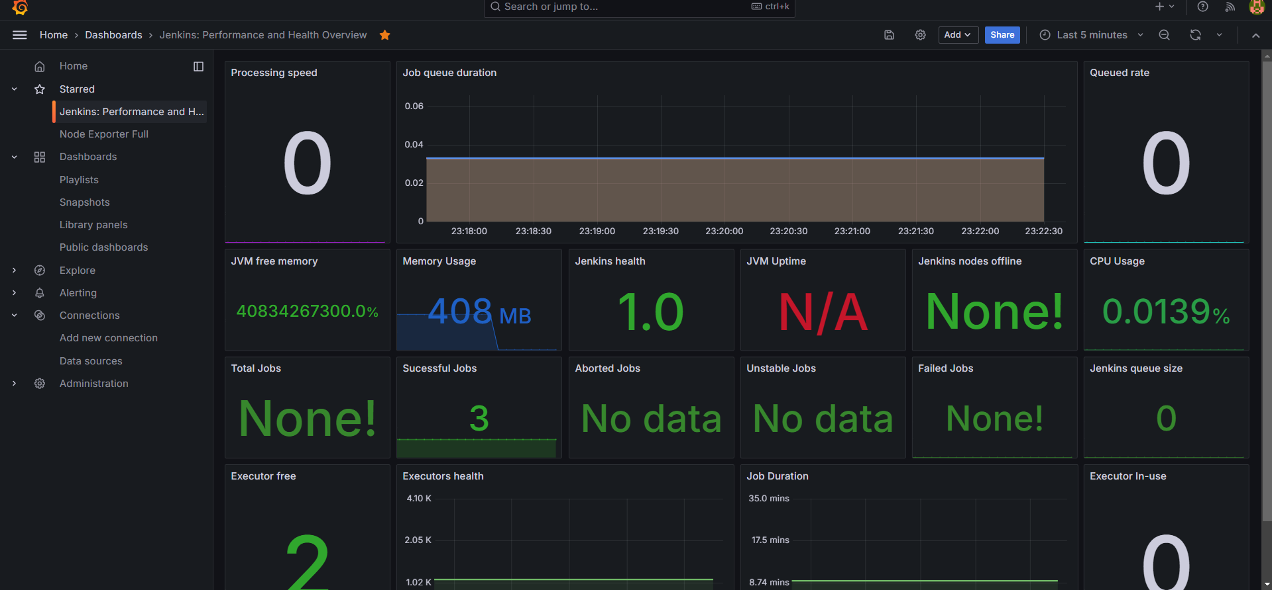

output

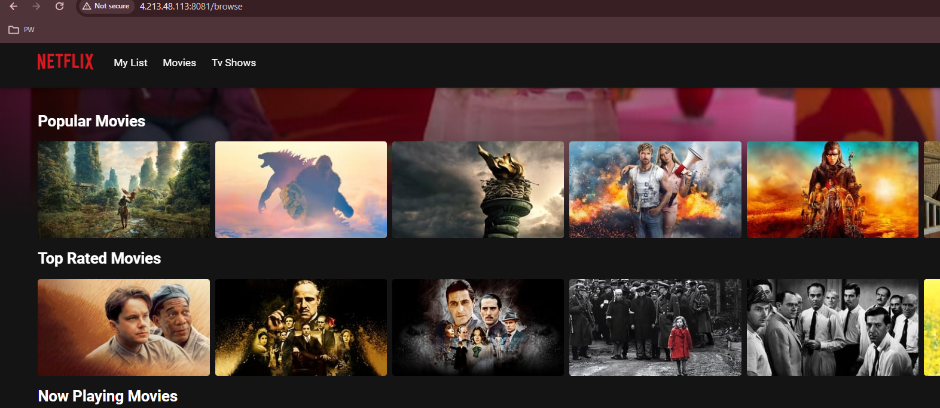

Here are link as well as document we have follow for creating this project.

<https://mrcloudbook.com/netflix-clone-ci-cd-with-monitoring-email-devsecops/>

YouTube video.

<https://www.youtube.com/watch?v=pbGA-B_SCVk&t=5454s&ab_channel=Mr.CloudBook>