**INTRODUCTION**

**What is cloud computing?**

**Cloud computing** is the use of [computing](http://en.wikipedia.org/wiki/Computing) resources (hardware and software) that are delivered as a service over a network (typically the [Internet](http://en.wikipedia.org/wiki/Internet)). The name comes from the common use of a cloud-shaped symbol as an abstraction for the complex infrastructure it contains in system diagrams. Cloud computing entrusts remote services with a user's data, software and computation. Cloud computing consists of hardware and software resources made available on the Internet as managed third-party services. These services typically provide access to advanced software applications and high-end networks of server computers.

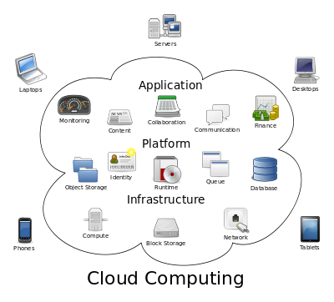

Structure of cloud computing

**How Cloud Computing Works?**

The goal of cloud computing is to apply traditional [supercomputing](http://www.webopedia.com/TERM/S/supercomputer.html), or [high-performance computing](http://www.webopedia.com/TERM/H/High_Performance_Computing.html) power, normally used by military and research facilities, to perform tens of trillions of computations per second, in consumer-oriented applications such as financial portfolios, to deliver personalized information, to provide data storage or to power large, immersive computer games.

The cloud computing uses [networks](http://www.webopedia.com/TERM/N/network.html) of large groups of [servers](http://www.webopedia.com/TERM/S/server.html) typically running low-cost consumer PC technology with specialized connections to spread data-processing chores across them. This shared [IT](http://www.webopedia.com/TERM/I/IT.html) infrastructure contains large pools of systems that are linked together. Often, [virtualization](http://www.webopedia.com/TERM/V/virtualization.html) techniques are used to maximize the power of cloud computing.

**Characteristics and Services Models:**

The salient characteristics of cloud computing based on the definitions provided by the National Institute of Standards and Terminology (NIST) are outlined below:

* **On-demand self-service**: A consumer can unilaterally provision computing capabilities, such as server time and network storage, as needed automatically without requiring human interaction with each service’s provider.
* **Broad network access**: Capabilities are available over the network and accessed through standard mechanisms that promote use by heterogeneous thin or thick client platforms (e.g., mobile phones, laptops, and PDAs).
* **Resource pooling**: The provider’s computing resources are pooled to serve multiple consumers using a multi-tenant model, with different physical and virtual resources dynamically assigned and reassigned according to consumer demand. There is a sense of location-independence in that the customer generally has no control or knowledge over the exact location of the provided resources but may be able to specify location at a higher level of abstraction (e.g., country, state, or data center). Examples of resources include storage, processing, memory, network bandwidth, and virtual machines.
* **Rapid elasticity**: Capabilities can be rapidly and elastically provisioned, in some cases automatically, to quickly scale out and rapidly released to quickly scale in. To the consumer, the capabilities available for provisioning often appear to be unlimited and can be purchased in any quantity at any time.
* **Measured service**: Cloud systems automatically control and optimize resource use by leveraging a metering capability at some level of abstraction appropriate to the type of service (e.g., storage, processing, bandwidth, and active user accounts). Resource usage can be managed, controlled, and reported providing transparency for both the provider and consumer of the utilized service.

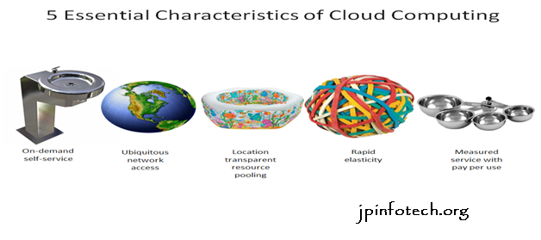

Characteristics of cloud computing

**Services Models:**

  Cloud Computing comprises three different service models, namely Infrastructure-as-a-Service (IaaS), Platform-as-a-Service (PaaS), and Software-as-a-Service (SaaS). The three service models or layer are completed by an end user layer that encapsulates the end user perspective on cloud services. The model is shown in figure below. If a cloud user accesses services on the infrastructure layer, for instance, she can run her own applications on the resources of a cloud infrastructure and remain responsible for the support, maintenance, and security of these applications herself. If she accesses a service on the application layer, these tasks are normally taken care of by the cloud service provider.

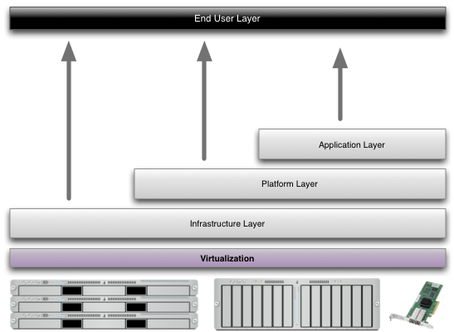

Structure of service models

**Benefits of cloud computing:**

1. **Achieve economies of scale** – increase volume output or productivity with fewer people. Your cost per unit, project or product plummets.
2. **Reduce spending on technology infrastructure.** Maintain easy access to your information with minimal upfront spending. Pay as you go (weekly, quarterly or yearly), based on demand.
3. **Globalize your workforce on the cheap.** People worldwide can access the cloud, provided they have an Internet connection.
4. **Streamline processes.** Get more work done in less time with less people.
5. **Reduce capital costs.** There’s no need to spend big money on hardware, software or licensing fees.
6. **Improve accessibility.** You have access anytime, anywhere, making your life so much easier!
7. **Monitor projects more effectively.** Stay within budget and ahead of completion cycle times.
8. **Less personnel training is needed.** It takes fewer people to do more work on a cloud, with a minimal learning curve on hardware and software issues.
9. **Minimize licensing new software.** Stretch and grow without the need to buy expensive software licenses or programs.
10. **Improve flexibility.** You can change direction without serious “people” or “financial” issues at stake.

**Advantages:**

1. **Price:** Pay for only the resources used.
2. **Security**: Cloud instances are isolated in the network from other instances for improved security.
3. **Performance:** Instances can be added instantly for improved performance. Clients have access to the total resources of the Cloud’s core hardware.
4. **Scalability:** Auto-deploy cloud instances when needed.
5. **Uptime:** Uses multiple servers for maximum redundancies. In case of server failure, instances can be automatically created on another server.
6. **Control:** Able to login from any location. Server snapshot and a software library lets you deploy custom instances.
7. **Traffic:** Deals with spike in traffic with quick deployment of additional instances to handle the load.