桂林电子科技大学2020-2021学年第2学期

Linux应用实践实验报告

实验名称：实验七、综合实例

一、实验目的
  - 掌握Linux系统下进行综合应用开发的基本方法；
  - 掌握Linux系统下进行综合应用开发的合适工具选型和应用；
  - 掌握在Linux应用开发中获取资料和在线帮助的方法。
二、实验内容：
实验要求以自由组合方式，每两个同学为一小组，每小组单独完成本次实验所有内容。具体实验内容如下：
- 实现一个网络文件传输工具，可以使用文件和目录的传输；
- 增加共享目录，可以增加和删除共享的目录和文件，供网络查看；
- 可以查看对方共享目录和文件，并选择下载；
- 可以向对方传送文件和目录，并且该文件和目录会自动被对方共享。

Client
#include <stdio.h>
#include <string.h>
#include <stdlib.h>
#include <string.h>
#include <unistd.h>
#include <fcntl.h>
#include <sys/types.h>
#include <sys/socket.h>
#include <netinet/in.h>
#include <arpa/inet.h>

#define MAXLINE 1024

void usage(char *command)
{
printf("usage :%s ipaddr portnum filename\n", command);
exit(0);
}
int main(int argc,char **argv)
{
struct sockaddr_in serv_addr;
char buf[MAXLINE];
int sock_id;
int read_len;
int send_len;
FILE *fp;
int i_ret;

if (argc != 4) {
usage(argv[0]);
}

/* open the file to be transported commented by guoqingbo*/
if ((fp = fopen(argv[3],"r")) == NULL) {
perror("Open file failed\n");
exit(0);
}

/* create the socket commented by guoqingbo*/
if ((sock_id = socket(AF_INET,SOCK_STREAM,0)) < 0) {
perror("Create socket failed\n");
exit(0);
}

memset(&serv_addr, 0, sizeof(serv_addr));
serv_addr.sin_family = AF_INET;
serv_addr.sin_port = htons(atoi(argv[2]));
inet_pton(AF_INET, argv[1], &serv_addr.sin_addr);

/* connect the server commented by guoqingbo*/
i_ret = connect(sock_id, (struct sockaddr *)&serv_addr, sizeof(struct sockaddr));
if (-1 == i_ret) {
printf("Connect socket failed\n");
return -1;
}

/* transported the file commented by guoqingbo*/
bzero(buf, MAXLINE);
while ((read_len = fread(buf, sizeof(char), MAXLINE, fp)) >0 ) {
send_len = send(sock_id, buf, read_len, 0);
if ( send_len < 0 ) {
perror("Send file failed\n");
exit(0);
}
bzero(buf, MAXLINE);
}

fclose(fp);
close(sock_id);
printf("Send Finish\n");
return 0;
}

server

#include <stdio.h>
#include <string.h>
#include <stdlib.h>
#include <string.h>
#include <unistd.h>
#include <sys/types.h>
#include <sys/socket.h>
#include <netinet/in.h>
#include <arpa/inet.h>

#define MAXLINE 1024

void usage(char *command)
{
printf("usage :%s portnum filename\n", command);
exit(0);
}
int main(int argc,char **argv)
{
struct sockaddr_in serv_addr;
struct sockaddr_in clie_addr;
char buf[MAXLINE];
int sock_id;
int link_id;
int recv_len;
int write_leng;
int clie_addr_len;
FILE *fp;

if (argc != 3) {
usage(argv[0]);
}
if ((fp = fopen(argv[2], "w")) == NULL) {
perror("Open file failed\n");
exit(0);
}
if ((sock_id = socket(AF_INET, SOCK_STREAM, 0)) < 0) {
perror("Create socket failed\n");
exit(0);
}
/*fill the server sockaddr_in struct commented by guoqingbo*/
memset(&serv_addr, 0, sizeof(serv_addr));
serv_addr.sin_family = AF_INET;
serv_addr.sin_port = htons(atoi(argv[1]));
serv_addr.sin_addr.s_addr = htonl(INADDR_ANY);

if (bind(sock_id, (struct sockaddr *)&serv_addr, sizeof(serv_addr)) < 0 ) {
perror("Bind socket failed\n");
exit(0);
}

if (-1 == listen(sock_id, 10)) {
perror("Listen socket failed\n");
exit(0);
}
/* server part commented by guoqingbo*/
while (1) {
clie_addr_len = sizeof(clie_addr);
link_id = accept(sock_id, (struct sockaddr *)&clie_addr, &clie_addr_len);
if (-1 == link_id) {
perror("Accept socket failed\n");
exit(0);
}
bzero(buf, MAXLINE);
while (recv_len = recv(link_id, buf, MAXLINE, 0)) {
/* receiver data part commented by guoqingbo*/
if(recv_len < 0) {
printf("Recieve Data From Server Failed!\n");
break;
}
printf("#");
write_leng = fwrite(buf, sizeof(char), recv_len, fp);
if (write_leng < recv_len) {
printf("Write file failed\n");
break;
}
bzero(buf,MAXLINE);
}
printf("\nFinish Recieve\n");
fclose(fp);
close(link_id);
}
close(sock_id);
return 0;
}

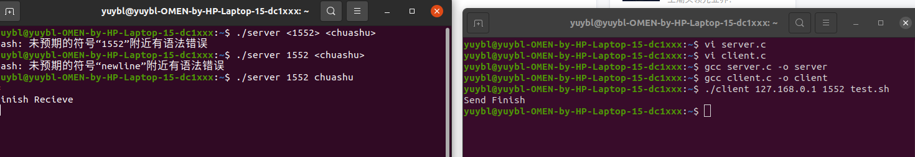
四、实验结果分析
实现通过发送的形式来共享文件，可发送文件/文件目录等，选择文件，传输文件等。
问题：不能自由的拖拽式共享，暂未解决
问题2：通信为循环是通信，不能同时选择发送和接收，即未引入多线程模式，暂未解决
传输依赖于c的socket.

