Finite Automate Execution Environment
Test application – Balls
Low Level Design.
Rev. 0.04 at 29-Dec-2009

Document History
Date | Author | Rev | Description
08-Nov-2008 | Yuri Borisov | 0.01 | First draft
18-Nov-2008 | Yuri Borisov | 0.02 | Aligned with new FAP library version FAPWS FAPWS_REL_21SEP06
20-Dec-2009 | Yuri Borisov | 0.03 | Added design of redrawing the balls
29-Dec-2009 | Yuri Borisov | 0.04 | Extended collisions model  Added design of manual movement of the balls

Table of content
Table of content 2
1. References 3
2. Definitions, Acronyms, and Abbreviations 3
3. References 3
4. Introduction 3
5. General 3
5.1. Common 3
5.1.1. FAPBL_LLD_GEN_001 Math model of ball movement by forces of gravitation effect 3
5.1.2. FAPBL_LLD_GEN_001 The mathematical model of balls collision 3
5.1.2.1. Central elastic event (центральное упругое столкновение) 4
5.1.3. FAPBL_LLD_GEN_002 How to implement update of ball 5
5.1.4. FAPBL_LLD_GEN_003 How to get the information about type of object? 5
5.2. How to implement redrawing of balls 5
5.2.1. FAPBL_LLD_DRW_004 General points of redrawing 5
5.3. How to implement the manual moving of the ball 6
5.3.1. FAPBL_LLD_MMV_001 General points of manual moving 6
5.3.2. FAPBL_LLD_MMV_002 Mathematical model of general moving 6
6. Traceability matrix 7
6.1. SRS to requirements 7

References

Definitions, Acronyms, and Abbreviations
FAP | Finite automata programming environment
State Confirmation | To set the current state value from the new value
State Updating | To perform transition for the state, calculate the new state value.

References

PH_COLL | /home/yborisov/projects/fap/work/fapg/fap-balls/doc/stas1.docx – Essey

Introduction
Задача- найти реализацию устройства оценивания обстановки на базе автоматного проектирования. Для этого реализуем обстановку, например, в виде механических объектов в замкнутой прямоугольной области 2-х мерного пространства. На первое время перемещение объектов будем производить «вручную»

General

Common

FAPBL_LLD_GEN_001 Math model of ball movement by forces of gravitation effect
Lets consider that there are N balls in the environment. So the ball k is influenced by other N-1 ball. The force acting to ball k is as

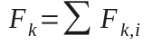, (3)
where
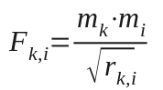 – force to ball k from the ball i, (4)
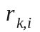 - The range between the balls
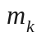 - The mass of the ball k

FAPBL_LLD_GEN_001 The mathematical model of balls collision
Let’s consider the two balls collision only. The more complex case- more then two balls collisions can simplify believing that it is sequence of two balls collisions.

Central elastic event (центральное упругое столкновение)
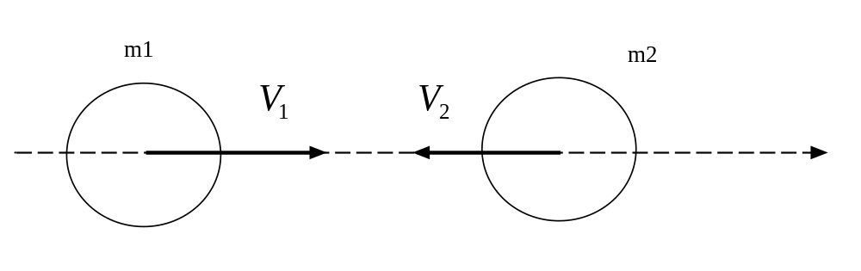
Figure 1 Central elastic event

Two laws describes the model of event: law of conservation of energy, and law of conservation of impuls.
According with law of conservation of impuls:

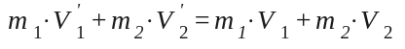 , (1)
Where
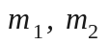- masses of 1st and 2nd balls accordingly
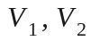 - velocities of 1st and 2nd balls before the event
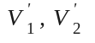- velocities of 1st and 2nd balls after the event

The equation (1) can be transformed as following:

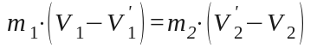 (6)

According with law of conservation of energy:

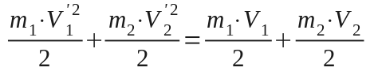 , (2) , or simplified

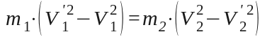 (5)

Dividing (5) by (6) will result in equation as:

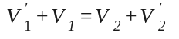, or

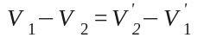 (7)

Equation (7) shows that the difference between velocities stays the same after event but the sign of difference changes. It means that the balls “exchange” by velocities
Let’s consider the two balls collision only. The more complex case- more then two balls collisions can simplify believing that it is sequence of two balls collisions.
Consider the balls rapprochement with the angle 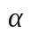.

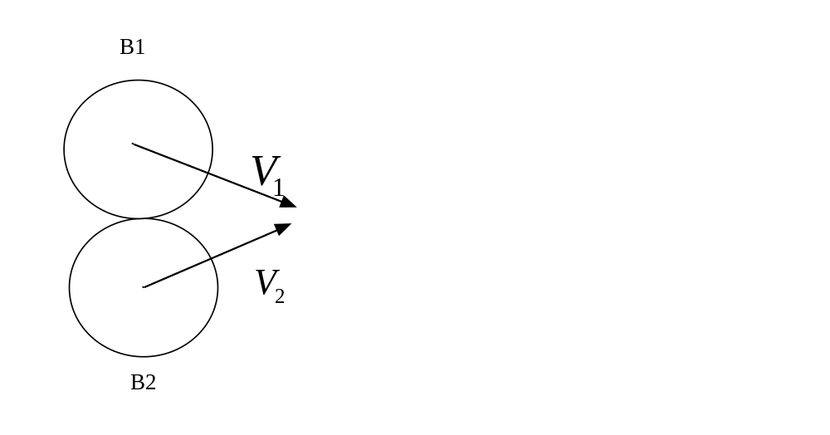
Figure 1 Balls collisions diagram

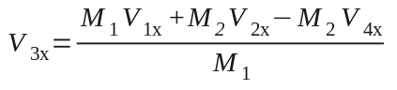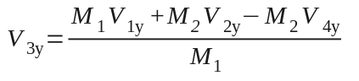
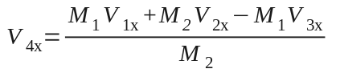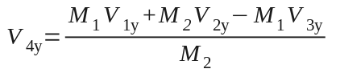

FAPBL_LLD_GEN_002 How to implement update of ball
According with the current design (release FAPWS FAPWS_REL_21SEP06) a ball update partially is being made by Environment. This part of update is the update of the ball’s velocity. The idea of this solution I believe was that only environment knows all the interactions between the physical instances within itself. So Environment should be an object but Ball should be a subject of the play. It means that the ball “can not decide” what to do within the environment and thus is some passive element in the movement. Is this approach correct?

FAPBL_LLD_GEN_003 How to get the information about type of object?
In the current design (release FAPWS FAPWS_REL_21SEP06) the method “GetNextCompByType” of object is used by Environment to pick up all the balls inside it. But this method was removed from FAP library. So using this method within Test Application “Ball” is not compatible with the newest version of library. Do we need this method?

See FAP_LLD_PB_001 in FAP LLD.

How to implement redrawing of balls

FAPBL_LLD_DRW_004 General points of redrawing
The typical interaction the FAP object with the graphical environment subsystem is as following:
FAP object signals to environment about invalidation of graphical representation
- environment performs invalidation
- environment generates request for redraw basing on set of invalidation
- environment requests FAP object to redraw the graphical representation

How to implement the manual moving of the ball

FAPBL_LLD_MMV_001 General points of manual moving
Currently the policy of moving is that moving is just something isolated of balls model. For instance if moved ball meets collision with another ball, the moving just gets denied. It was more convenient if we use the same model. For instance if we consider manual moving as movement under some external force. In this case the collision result in interaction of all balls under collision. And the result movement would depend also on what is the value of external force.

FAPBL_LLD_MMV_002 Mathematical model of general moving
So lets say that if the ball is manually moved then some external force. Lets use the model of elastic. In this case the force will be proportional to to stretching of elastic.

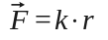, (M1)
where
r [m]– the length of “elastic” (distance between the moved ball and new coordinate set manually
k – [n/m] stiffness coefficient

Scaling

FAPBL_LLD_SCL_001 General
Scaling is very important part of the model of balls. The reason is that the time and dimensions are discrete. That means that there should be some limitation of representation of “physical” values. For example if we fix the dimension of area and set up the discrete of time, then we will not be able to simulate any values of velocity. That is because the accuracy will be not enough to simulate the movement correctly.

Suggestions for FAP improvement

Traceability matrix

SRS to requirements

LLD | SRS or primary CR

