SARscope: an interactive workbench for positional structure–activity relationships and evidence stress testing
Yassir Boulaamane
Laboratory of Innovative Technologies, National School of Applied Sciences of Tangier, Abdelmalek Essaadi University, Tetouan 93000, Morocco
Correspondence: yassirxmail@gmail.com
Molecular Informatics · software and methods draft. Author declarations require confirmation before submission.

Abstract
Medicinal chemists interpret structural changes through their measured effects on potency, and those effects depend on attachment position, the remaining structure and experimental context. We present SARscope, an interactive workbench that couples these controls to inspection of the underlying measurements. Three published assay datasets—BRAF, dopamine D2 receptor and estrogen receptor alpha—were reconstructed from frozen ChEMBL release 37 records. Positional comparisons required an identical mapped isomeric core, unchanged substituents elsewhere and a shared assay and endpoint. The selected series contained 16, 23 and 53 compounds, yielding 263 positional comparisons. BRAF hydroxyl addition and DRD2 chlorine removal showed opposite effects at different positions, and a complete four-compound cycle placed both DRD2 positions in one chemical background. All 17 repeated-comparison transformations retained the sign of their median effect after compound omissions, but only 15 retained the configured directional criterion, and none of 191 transformation-level permutation tests met the adjusted 0.05 cutoff. SARscope therefore links positional comparisons to source measurements and exposes their dependence on retained compounds, chemical contexts and practical thresholds, identifying missing-cycle measurements and conflicting pairs for follow-up without predicting potency or assigning calibrated confidence. The cases verify the implementation and illustrate local structure–activity relationships; they do not establish prospective transferability, binding mechanisms or improved chemist performance.

Graphical Abstract
Image file: figures/graphical-abstract.svg (vector; PDF and 300 dpi PNG alongside).
A single hydroxyl addition to one BRAF series splits in two: adding it at the para position of the pendant phenyl costs 1.63 log units of potency, while the same addition at the meta position gains 1.57. Bars show how far each median moves when individual compounds are omitted. SARscope links such positional comparisons back to the measurements that support them.
Keywords: structure–activity relationships · matched molecular pairs · activity cliffs · chemoinformatics · assay comparability

1. Introduction
Lead optimization depends on deciding which changes to a chemical series are worth pursuing. Medicinal chemists make these decisions by comparing close analogues, considering whether a measured difference is consistent with other members of the series and whether the compounds were tested under comparable conditions. Matched molecular pair analysis provides a formal representation of this reasoning: a defined structural replacement is associated with the change in a measured property while the shared structure is retained [1]. Efficient fragmentation algorithms have made these comparisons practical for large collections [2], and platforms such as mmpdb organize transformations together with the chemical environments in which they occur [3]. Matched molecular series extend this view beyond individual pairs and can support hypothesis generation or prediction when the transfer of activity trends is evaluated explicitly [4].
Public bioactivity resources offer an opportunity to examine such relationships outside a single project. ChEMBL supplies structures, standardized activity measurements, assay descriptions, target assignments and source-document links [5]. Its curation procedures already address unit consistency, activity validity, target mapping and potential duplication [6]. Recent work has further enriched bioassay descriptions and experimental-method annotations through manual and AI-assisted curation [7]. The remaining task for an analysis tool is therefore not to recreate assay-linked data, but to make the comparisons supported by those data easier to inspect. In particular, a target-level collection is not automatically a coherent chemical series or a single experimental setting.
The experimental context matters because reported potency is not a property of the molecular structure alone. Investigations of public binding data have documented uncertainty, undifferentiated stereoisomers and repeated citations of individual measurements [8]. Mixing heterogeneous IC50 measurements can introduce additional variability [9]. Paired differences may be less sensitive to systematic assay shifts than absolute activities, but their agreement still depends on curation and the comparison being made [10]. An assay identifier is thus a useful control, not proof of identical conditions or independent replication. Repeated records also need to remain distinguishable from distinct chemical comparisons, and missing protein-variant annotations cannot be treated as confirmation of a wild-type construct.
Chemical context introduces a separate difficulty. The same replacement may have different effects at different attachment positions, or when another substituent changes. Four-compound substitution cycles provide a way to inspect whether two measured changes are additive in a defined chemical background. Their interpretation requires attention to assay uncertainty; a nonzero contrast does not by itself establish a binding interaction or a change in mechanism [11]. Activity cliffs draw attention to another form of local behavior, in which similar compounds differ substantially in potency [12]. Benchmarking has shown why model evaluation around such compounds cannot be replaced by a global prediction score [13, 14]. Yet a cliff label remains conditional on the chosen structural representation and numerical cutoffs. The compounds and measurements behind the label still need to be examined.
Established software already addresses much of this analysis. DataWarrior combines chemical visualization with SAR tables and activity-cliff inspection [15]. SAR maps organize R-group combinations for medicinal-chemistry interpretation, including the identification of missing analogues and screening measurements [16]. Activity Landscape Plotter provides web-based examination of activity landscapes [17]. More recently, SPARFlow integrated chemical curation, similarity networks, R-group decomposition, activity cliffs and modelability assessment within KNIME [18]. OOMMPPAA links matched transformations to structural information for compound-design questions [19]. Nonadditivity analysis examines complete substitution cycles and their statistical behavior [20], with subsequent work investigating their chemical drivers and modeling implications [21].
R-group decomposition, cliff visualization and missing-analogue identification are therefore established capabilities, not novelty claims for SARscope. The present evaluation focuses on the connection between a positional SAR statement, its assay-linked source measurements and the evidence-omission tests applied to it. Comparisons with existing software need to address that workflow, rather than the number of analysis functions available.
For the end user, the practical question is often narrower: does a particular substitution conclusion survive removal of the evidence on which it relies? A chemist may want to know whether one compound determines the median, whether an effect changes between assays, or whether a missing fourth analogue prevents a comparison of two chemical backgrounds. These questions are not answered by adding another descriptor or model. They require a traceable connection between the proposed SAR statement, its eligible molecular comparisons and the records retained in the analysis. Machine-readable evidence and executable procedures also make those statements easier to revisit, consistent with the goals of FAIR data stewardship and reusable scientific software [22, 23].
SARscope was developed as an interactive workbench for these tasks. It links mapped substitution positions to the compounds, potency differences and assay records behind them, then lets the user challenge a selected effect through evidence omissions and alternative practical thresholds. Context-specific views and complete cycles help identify where a pooled conclusion becomes misleading. Evidence-gap suggestions identify measurements that could clarify the comparison; they are not potency forecasts. Here we evaluate the implementation in three published chemical series from different target families, examine its agreement with explicit numerical references and established pair analysis, and assess the limits of descriptive support labels. The study is a retrospective evaluation of an interpretation workflow, not an independent validation of SAR transferability or a demonstration of improved experimental outcomes.
The numerical analysis is separated from the browser interface. Molecular frameworks [24] and mapped R-groups are calculated using RDKit [25]; record handling and numerical summaries use pandas and NumPy, with SciPy and scikit-learn used where required by the broader analysis. The Streamlit interface exposes curation, chemical-series preparation, activity-cliff analysis and modeling as separate, user-initiated stages. The SAR workspace therefore does not train models or run docking merely because a series is opened.

1.1. Software design
The core map connects a structural position to its substitution distributions and controlled pair evidence. The stress-test panel operates on a user-selected transformation and the curated measurements already retained in memory (Figure 1). It does not fetch additional records or fit a predictive model. Content-based signatures prevent an evidence card from remaining current when the selected transformation, records or test settings change. A comparison limit and bounded omission/cycle searches are reported explicitly rather than silently treated as complete analyses.
The implementation preserves each compound's mapped isomeric core. The browser lets the user select a core state, with the largest state offered first by compound count, not potency. Command-line maps default to that largest state and record exclusions. Oppositely assigned and unassigned core states are separate; CIP labels alone are not used to establish identity because substituent changes can alter their priorities. Legacy tables lacking per-compound core metadata are identified as unaudited, rather than used to claim a stereo control.

2. Results and Discussion

Assay and stereochemical restrictions defined the comparison sets
The three assay cohorts contained 187 raw activity records and 172 standardized compounds after curation. The largest scaffold groups contained 16 BRAF, 26 DRD2 and 53 ER-alpha compounds. The stereochemical audit identified three core states within the DRD2 group: 23 compounds with one assigned configuration, two with the opposite configuration and one with unassigned core stereochemistry. The 23-compound state, corresponding to the reported (S,S) cyclopropyl configuration, was retained. The other two series each contained one mapped core state.
Series | Curated assay compounds | Selected compounds | Positional comparisons | Distinct transformations
BRAF | 44 | 16 | 29 | 15
DRD2 | 30 | 23 | 36 | 21
ER-alpha | 98 | 53 | 198 | 155

The selected series covered 36.4%, 76.7% and 54.1% of their respective curated assay cohorts. Together they contained 92 compounds and 263 positional comparisons. Restricting the DRD2 core removed ten comparisons from the original scaffold-based set. This is a substantive control: a shared scaffold and assay do not establish that an observed difference is attributable to the displayed substituent alone.

BRAF hydroxyl effects depended on attachment position
On the pendant phenyl ring of the BRAF series, adding hydroxyl at the para position gave a median ΔpIC50 of −1.63 across two matched comparisons. Adding the same group at the meta position gave +1.57 across two comparisons. Thus the observed effects differed in direction despite involving the same nominal chemical change. Their magnitudes correspond to approximately a 43-fold loss and a 37-fold gain in potency, respectively, when calculated from the median logarithmic effects.
Replacing meta methoxy with hydroxyl gave a median increase of 1.43 units across three disjoint pairs in three remaining-substituent contexts, corresponding to about a 27-fold potency increase. The positional map is shown in Figure 2 and individual changes with their spread in Figure 3. Removing individual compounds left the median for this transformation between +1.31 and +1.86.
These observations support a local distinction between the tested phenyl positions. They do not identify the origin of the difference. In particular, the data do not distinguish direct protein contacts from changes in solvation, conformation or other properties, and they do not establish a general advantage for hydroxyl substitution outside this series.

DRD2 chlorine substitution showed opposite positional effects
Within the stereochemically restricted DRD2 series, chlorine removal from the para position of the N-aryl ring increased pIC50 by a median of 0.68 units across four disjoint pairs. Removal from the ortho position decreased pIC50 by 0.87 units across three disjoint pairs. The signs persisted after individual-compound omissions. The compound-omission median ranges were +0.53 to +0.82 for para removal and −1.37 to −0.68 for ortho removal (Figure 3).
A complete four-compound cycle placed both positions in the same chemical background (Figure 4). The unsubstituted analogue, CHEMBL341497, had an IC50 of 37 nM. Para chlorine alone, CHEMBL419610, gave 246 nM, whereas ortho chlorine alone, CHEMBL126633, gave 5 nM. The doubly substituted compound, CHEMBL302075, had two retained values of 65 and 93 nM; their median pIC50 corresponds to 77.75 nM after back-conversion.
Para chlorination reduced potency in both ortho backgrounds, while ortho chlorination increased potency in both para backgrounds. The difference between the conditional effects was −0.369 pIC50 units. This is a modest departure from additivity, not evidence of a cooperative binding mechanism. Experimental replicate assignments and assay uncertainty were insufficient to distinguish such an effect from measurement variation. The cycle nevertheless provides a clearer account of the positional SAR than a pooled statement about chlorine.

ER-alpha transformations were dominated by sparse or mixed evidence
The ER-alpha series yielded the most transformations, but only seven of its 155 transformations met the moderate- or strong-support criteria. Eighty-three were mixed or subthreshold and 65 had limited support at the default threshold. At mapped R3, replacing bromine with vinyl or allyl gave median changes of −0.68 and −0.69 pIC50 units across four and three disjoint pairs, respectively. Their directions persisted after compound omission (Figure 3).
These effects describe the ER-alpha counter-assay. They provide no estimate of ER-beta selectivity or receptor agonism. The contrast between the large number of displayed transformations and the small number with repeated comparison support illustrates why transformation coverage should not be equated with confidence in a medicinal-chemistry recommendation.

Repeated observations did not establish statistical confidence
Seventeen transformations met the default repeated-comparison criteria across the three series, and every one retained the sign of its median after each valid compound omission. The number meeting those criteria fell from 25 at a 0.25-unit threshold to 17 at 0.5, 11 at 0.75 and seven at 1.0. The threshold therefore materially affected how much of the dataset appeared to support a directional interpretation.
The permutation diagnostic provided a different perspective. At the default threshold, shuffled assignments produced means of 4.36, 2.89 and 5.90 qualifying transformations in BRAF, DRD2 and ER-alpha, compared with observed counts of five, five and seven. The probabilities of a shuffled count at least as large as the observed count were 0.453, 0.136 and 0.389. None of the 191 transformation P values remained below 0.05 after multiple-comparison adjustment.
The observed directions and the omission checks remain useful descriptions of these measurements. They are not independent corroboration of a generalizable substituent effect. In these examples, pair count, consistency and effect size were insufficient to make the software's descriptive support grades calibrated statistical evidence.

Stress tests separated sign retention from a persistent conclusion
The current workbench reproduced all 263 scoped pair identities and potency differences against both the saved scientific results and the exhaustive reference. In the DRD2 case it retained the same 23-compound core state and excluded the same three opposite or unassigned-state compounds. This establishes consistency between the tested implementation and the case-study calculation, not external validation of the source measurements.
The 17 repeated-comparison transformations were then examined with the full directional criterion, rather than median sign alone. Fifteen retained that criterion in every tested nonempty evidence subset. The other two retained their sign but became smaller than the 0.5-unit practical threshold after specific compound omissions.
Series | Evaluated transformations | Median sign retained after compound omissions | Full directional criterion retained in tested nonempty subsets
BRAF | 5 | 5 | 4
DRD2 | 5 | 5 | 5
ER-alpha | 7 | 7 | 6
Total | 17 | 17 | 15

For BRAF, fluorine removal at R1 had a baseline median of −0.684 units. Omitting CHEMBL5077573 or CHEMBL5083036 changed the median to −0.256: the direction was unchanged, but the configured evidence no longer supported a directional statement above the practical threshold. In ER-alpha, the R3 bromovinyl-to-cyano comparison changed from +0.603 to +0.152 after omitting CHEMBL186513 or CHEMBL188900. Chemical-context omissions exposed the same dependencies.
Each case contained one source assay and one publication. Omitting either left no eligible evidence for all 17 transformations. These examples therefore cannot validate persistence across assays or publications, even though the software supports those checks. No omission or cycle-search bound was reached in this audit. Complete-cycle views and bounded missing-cell suggestions were produced from the observed analogue patterns, but the proposed measurements were not performed. Their experimental value remains to be evaluated.
The full software test run completed 420 tests with three skips and two network tests deselected. The browser tests included selection of core states, a real BRAF four-compound cycle display, stale-result invalidation and hashed evidence exports. These tests are evidence of implementation behavior, not independent medicinal-chemistry review or a usability comparison.

Activity-cliff calls were sensitive to the chosen definition
Three BRAF positional comparisons exceeded a 100-fold potency difference. Only one also exceeded the reference fingerprint-similarity threshold. It linked CHEMBL5092007 and CHEMBL5076831, with reported IC50 values of 97 and 9,710 nM, Tanimoto similarity 0.918 and a potency difference of 2.00045 pIC50 units. No mapped DRD2 or ER-alpha pair satisfied the reference criterion.
The BRAF call disappeared when the similarity cutoff was increased to 0.95 or the potency-gap cutoff to 2.5 units. Its gap was only slightly above the chosen 2.0-unit boundary. Two other BRAF comparisons had larger potency gaps but similarities of 0.800 and 0.826, so they were excluded by the fingerprint cutoff. The practical implication is that a cliff flag should direct attention to a pair, not determine whether its measured difference deserves inspection.

Comparison with mmpdb identified a coverage limitation
On the complete curated assay cohorts, SARscope's single-cut MMP routine returned 760 distinct within-cohort compound pairs. All were present among the 816 pairs found by mmpdb. The 56 additional mmpdb pairs involved hydrogen substitution: two in BRAF and 54 in ER-alpha. The current single-cut MMP routine therefore does not have equivalent coverage for implicit-hydrogen changes. The separate R-group analysis does represent hydrogen alternatives, as the examples above show.
This result supports consistency within the overlapping pair set and identifies a concrete limitation. It does not demonstrate greater analytical coverage, faster interpretation or improved prediction compared with mmpdb or DataWarrior.
The BRAF and DRD2 examples show why a substituent effect must be attached to a defined position. Hydroxyl addition and chlorine removal each changed direction between tested positions. These distinctions were evident in assay-matched comparisons without proposing a binding mechanism. The four-compound DRD2 cycle made the chemical context explicit and showed how the direction of each chlorination could be examined in both backgrounds.
The stereochemical audit was equally consequential. A scaffold grouping that looked chemically coherent contained opposite and unassigned core configurations. Removing those comparisons changed the DRD2 median effects and the number of eligible pairs. This is a limitation of relying on scaffold membership and a representative core drawing without inspecting per-compound stereochemistry. The present analysis applied an additional mapped-core restriction; that restriction must be made explicit whenever these results are reproduced or used to assess the software.
The robustness checks also place useful limits on interpretation. A sign that survives omission of individual compounds is less dependent on one example, but it is not evidence that the effect transfers to a new chemical background. The label permutations showed that the configured support criteria can also be met by shuffled potency assignments. Descriptive grades should therefore be read as summaries of what is present in the dataset, not as probabilities that a design change will succeed. Assay precision and independent chemical examples remain necessary when a decision depends on a small effect.
Activity cliffs pose a related problem. Their identification depends on a structural representation and numerical cutoffs. In the BRAF example, the reference call was near the potency boundary, while larger measured differences were excluded by the similarity criterion. These findings favor showing similarity, potency difference and the underlying compounds together. They also support assessing prediction error locally rather than relying only on a global model score, as emphasized by activity-cliff benchmarking studies [13, 14]. The present study did not perform an independent cliff-specific prediction trial.
SARscope's practical contribution is the ability to move from a structural annotation to its supporting measurements within the same analysis. The chemist can compare positions, inspect contradictory examples, change the experimental subset and retain the evidence with the exported result. Established tools already implement the underlying scaffold, R-group and matched-pair concepts. The available comparison therefore supports a complementary interpretation workflow, not superiority of the pairing algorithms. The additional stress-test audit also distinguishes an effect retaining its sign from one retaining the configured practical interpretation. In two examples, that distinction exposed dependence on specific compounds that a sign-only stability check would miss.
The follow-up suggestions are intended to make an evidence gap actionable. Completing a cycle or retesting a conflicting pair is a way to challenge a local interpretation, not a guarantee that the suggested compound will improve potency. Because the present cases contain one assay and publication each, the analysis cannot establish that the conclusions survive new experimental protocols or independent source documents. A frozen temporal or publication-disjoint evaluation, with simple and context-aware matched-pair baselines, is needed before the workbench can be presented as improving SAR transferability or design decisions.
Several limitations remain. The series were selected retrospectively and cover only three target families. The largest-scaffold restriction omitted substantial fractions of the assay cohorts. Compounds and transformations share chemical backgrounds, and the source records do not establish independent experimental replication. The permutation diagnostic assumes exchangeability and does not account for all structure-dependent sources of variability. Complete cycles were defined on one R-group mapping rather than an exhaustive nonadditivity search. The source papers were not independently annotated to provide an external SAR reference, and no blinded medicinal-chemist or usability comparison has yet been completed. The supporting QSAR results are retrospective and do not address prospective or cross-target prediction.

3. Conclusions
Assay-matched, stereochemically consistent comparisons revealed clear positional differences in three published chemical series. Their interpretation changed when stereochemistry, effect-size thresholds and the limits of descriptive support were examined. SARscope provides an interactive way to inspect those relationships and the measurements behind them. Its present role is to support local SAR reasoning and the choice of follow-up experiments, rather than to replace experimental validation or establish universal substituent rules.

4. Computational Methods

Data selection and experimental scope
Activity records were taken from frozen ChEMBL release 37 datasets for BRAF (CHEMBL5145), DRD2 (CHEMBL217) and estrogen receptor alpha (CHEMBL206). One published assay was selected for each target: CHEMBL5046398, CHEMBL671074 and CHEMBL829540, respectively [26–28]. Selection was retrospective and based on the availability of populated chemical series, not on predictive-model performance. These examples are illustrative rather than a representative sample of medicinal chemistry projects.
The BRAF data describe an enzyme inhibition assay in a study of imidazothiazole pan-RAF inhibitors [26]. The DRD2 data describe radioligand competition by trans-phenylcyclopropylmethyl arylpiperazines [27]. The estrogen data are the ER-alpha counter-assay from a study of ER-beta-selective ligands [28]. They are not ER-beta measurements, and selectivity cannot be inferred from this assay alone.
We retained exact IC50 values in nM and removed records flagged for validity concerns or potential duplication. Structures were standardized, and records for the same standardized structure were combined using the median on the logarithmic potency scale. Potency was expressed as pIC50 = −log10(IC50 in mol/L). No conversion from IC50 to Ki was made. Records lacking a structured protein variant annotation were retained as unannotated, not assumed to be wild type. Assay descriptions and original activity identifiers were retained for inspection.

Structural controls and positional comparisons
The largest Murcko scaffold group was selected within each assay, with lexical tie-breaking and no use of potency in the selection. RDKit R-group decomposition identified the variable positions [25]. An additional audit compared the stereochemically annotated mapped core returned for every compound. Where more than one core state was present, the largest state was retained before positional effects were calculated. Unassigned and oppositely assigned core stereochemistry were not pooled. The original scaffold grouping alone did not enforce that restriction. The current workbench now applies the same core-state control, and its selected cohorts were checked against the saved case-study analysis.
A pair was admitted when the two compounds had the same selected core and identical substituents at every mapped position except one. Effects were calculated as ΔpIC50 = pIC50(to) − pIC50(from), so a positive value indicates increased potency. Fragment order was fixed before examining the activities. Repeated measurements of a compound were combined within its assay. Copies of the same identified record/value were deduplicated, but equal rounded values from distinct record IDs were not assumed to be duplicates. Each molecular pair contributed once to a transformation summary. We report pair counts and the number of disjoint pairs, meaning pairs that do not share a compound. These are distinct chemical comparisons, not independent biological replicates.
Attachment labels refer to the specific decomposition. For the BRAF pendant phenyl ring, R3 and R4 correspond to para and meta substitution relative to its attachment to the heterocyclic core. On the DRD2 N-aryl ring, R2 and R4 correspond to para and ortho substitution relative to the piperazine attachment. These relationships were checked on the molecular graphs; the numerical R-labels are not conventional atom numbering.

Effect summaries and robustness checks
The default practical effect-size threshold was 0.5 pIC50 units, equivalent to approximately a 3.2-fold concentration difference. It was not treated as an estimate of assay precision. A directional summary required an absolute median effect at least this large, at least 80% agreement in sign and no pair effects exceeding the threshold in opposite directions. Two disjoint pairs were required for the software's moderate-support label; three disjoint pairs across at least two remaining-substituent contexts were required for its strong-support label. These labels describe data support and consistency, not statistical confidence.
We repeated the summaries at thresholds of 0.25, 0.75 and 1.0 units. For individual-compound sensitivity, all pairs involving an omitted compound were removed before recalculating the median. The resulting range was used to assess dependence on a single compound; it is not a confidence interval.
An exploratory null diagnostic shuffled the compound pIC50 values 5,000 times within each selected series while leaving the pair network unchanged. A shuffled compound received the same value in all pairs containing it, preserving the dependence caused by compound reuse. Two-sided permutation P values for median effects were adjusted across all 191 transformations using the Benjamini–Hochberg procedure [29]. The number of transformations meeting the descriptive support criteria was also compared with the shuffled counts. This retrospective diagnostic assumes exchangeable potency labels; it does not model assay error or provide guaranteed false-discovery control for dependent chemical comparisons.

Complete substitution cycles and activity cliffs
For two variable positions, complete four-compound substitution cycles were identified when every combination was represented by one compound with the same selected core and unchanged substituents elsewhere. Ambiguous cells were excluded. Differences between conditional substituent effects were expressed as ΔΔpIC50 [11]. These IC50 contrasts were not converted into binding free energies.
Activity-cliff calls were examined for the already mapped pairs using Morgan fingerprints of radius 2, 2,048 bits and chirality disabled, using a circular fingerprint representation [30]. The reference criterion required Tanimoto similarity above 0.90 and an absolute potency difference above 2.0 pIC50 units. The effect of changing either cutoff was inspected. This was not an exhaustive activity-cliff survey of the complete target datasets.

Software comparison and supporting modeling results
Single-cut pair coverage was compared with mmpdb 3.1.4 on identical curated assay cohorts [3]. The comparison used the same cut pattern and a ten-heavy-atom limit for variable fragments. Compound-pair membership, rather than fragment-label spelling, was compared. Timing was not used as an outcome because the mmpdb run included process startup and file operations whereas SARscope was called within an existing process.
An earlier random-forest regression benchmark on the full three-target datasets was retained as supporting analysis. It used one scaffold-held-out split per target and a training-set median baseline. Bootstrap intervals were calculated from the saved predictions by resampling test scaffold groups. Those results describe the particular retrospective splits, not prospective performance or independent validation of the SAR examples. Details are provided in the Supporting Information.

Evidence stress tests and follow-up measurements
A stress test retains the selected position, directed fragments, endpoint and variant-annotation stratum. One compound omission removes every comparison incident to that compound. A chemical-context omission removes a combination of the unchanged R-groups. Assay and publication omissions remove the relevant raw records and recompute surviving shared-assay medians; there is no fallback to pooled compound potency. Omissions leaving no eligible pairs are recorded as unevaluable and are not counted as evidence that the effect persists.
The panel repeats the descriptive directional criterion over user-selected effect thresholds and reports individual assay/context strata. Default bounds are 100 omissions per axis, 5,000 cycle-candidate visits and 12 measurement suggestions. The omission bound is adjustable in the interface. Any truncated omission/cycle search or source map is labeled partial; displayed suggestions are a bounded set, not an exhaustive synthesis plan.
For complete four-compound cycles, each analogue cell must contain one compound and all four must share an assay, endpoint and recorded variant context. Three measured corners can instead identify an existing analogue needing a measurement in that assay or a missing structural combination. A proposed structure is assembled only when the source core and mapped fragments exactly reconstruct its isomeric SMILES; otherwise only the substitution pattern is shown. The procedure does not enumerate unspecified stereochemistry, predict potency or assess synthetic feasibility. Opposing assay effects for the same molecular pair can prompt a recommendation to remeasure both compounds together in a defined protocol.
The current workbench was evaluated from the hash-checked frozen assay snapshots, not from live downloads. Its scoped pair identities and deltas were compared with the saved scientific case-study results and a separate exhaustive enumeration of all two-compound combinations. The enumeration shares RDKit's decomposition and therefore verifies implementation, not independent chemical truth. The stress-test audit examined all 17 transformations satisfying the default repeated-comparison criteria. Tests also covered copied records, mismatched assay/variant contexts, ambiguous cycle cells, bounded computation and invalidation of stale browser results.
AI-assisted drafting and programming tools were used in software and manuscript preparation. These tools were not expert reviewers or sources of experimental validation. The author is responsible for reviewing the code, calculations, references and final interpretation.

Acknowledgements
Any acknowledgements require author confirmation and permission from the people named. AI assistance is disclosed in the Computational Methods section; no AI system is credited with authorship.

Conflict of Interest
Author confirmation required before submission.

Author Contributions
The final author list and contributions require author confirmation before submission.

Funding
Author confirmation required before submission.

Data Availability Statement
The source code [31] and browser application [32] are available at the cited locations. The manuscript package contains frozen assay snapshots, original activity identifiers, analysis scripts, machine-readable results and input/source/output hashes, together with the current workbench audit and the comparator outputs.
SARscope is distributed under the MIT licence and runs on Python-compatible platforms; numerical reproduction was checked on Linux x86_64 with Python 3.13, and cross-platform numerical equivalence was not evaluated.
A public, versioned archive and DOI for the tested revision are not yet assigned. The full benchmark snapshots and saved predictions exist only in a prepared local reproducibility archive and must be publicly deposited if the supporting modelling results are retained at submission. Redistributed ChEMBL records remain under CC BY-SA 3.0, separate from the MIT code licence.

Figure Legends
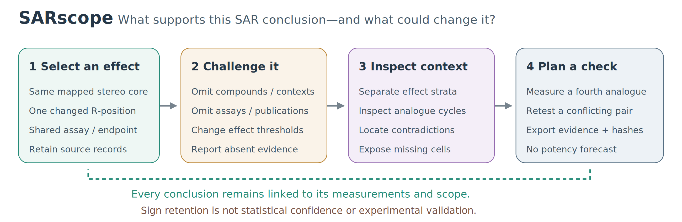
Figure 1. Workflow for challenging an observed positional SAR conclusion. The chemist selects a transformation, inspects the controlled assay evidence, tests sensitivity to retained records and thresholds, and examines contexts or missing-cycle measurements. The exported evidence card preserves the observations, decisions and limitations. Follow-up suggestions are unmeasured hypotheses, not predicted potency gains.

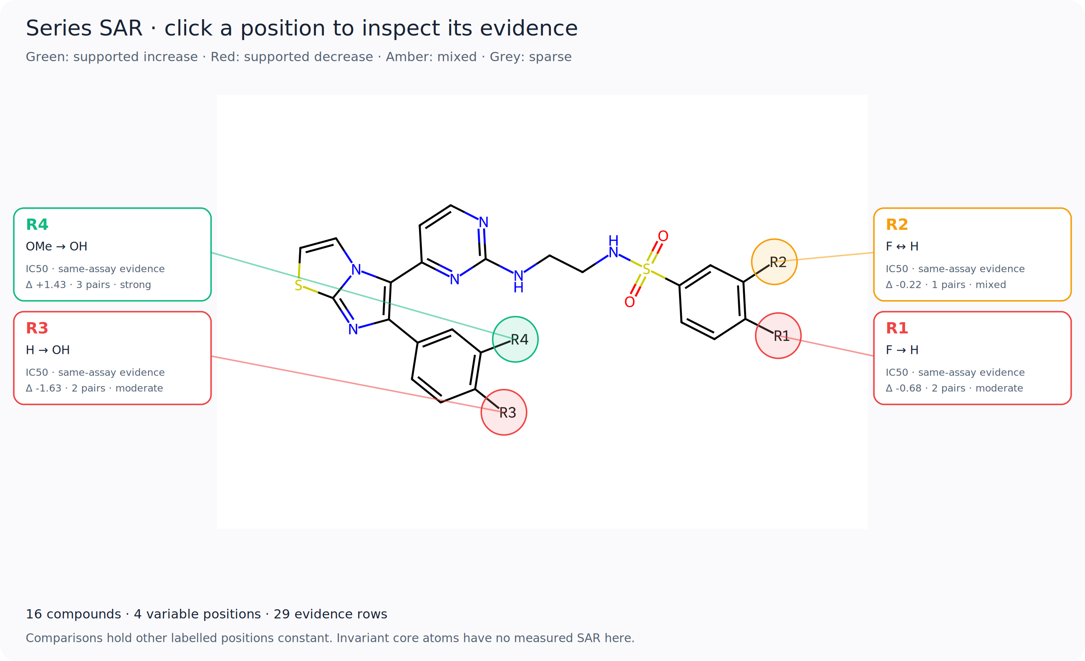
Figure 2. Interactive positional SAR map for the BRAF series. The shared structure, variable positions and example transformations are shown together. Labels describe the measured comparisons and the software's support criteria, not statistical significance or a binding mechanism. Selecting a position in the application opens its supporting compounds and assay records.

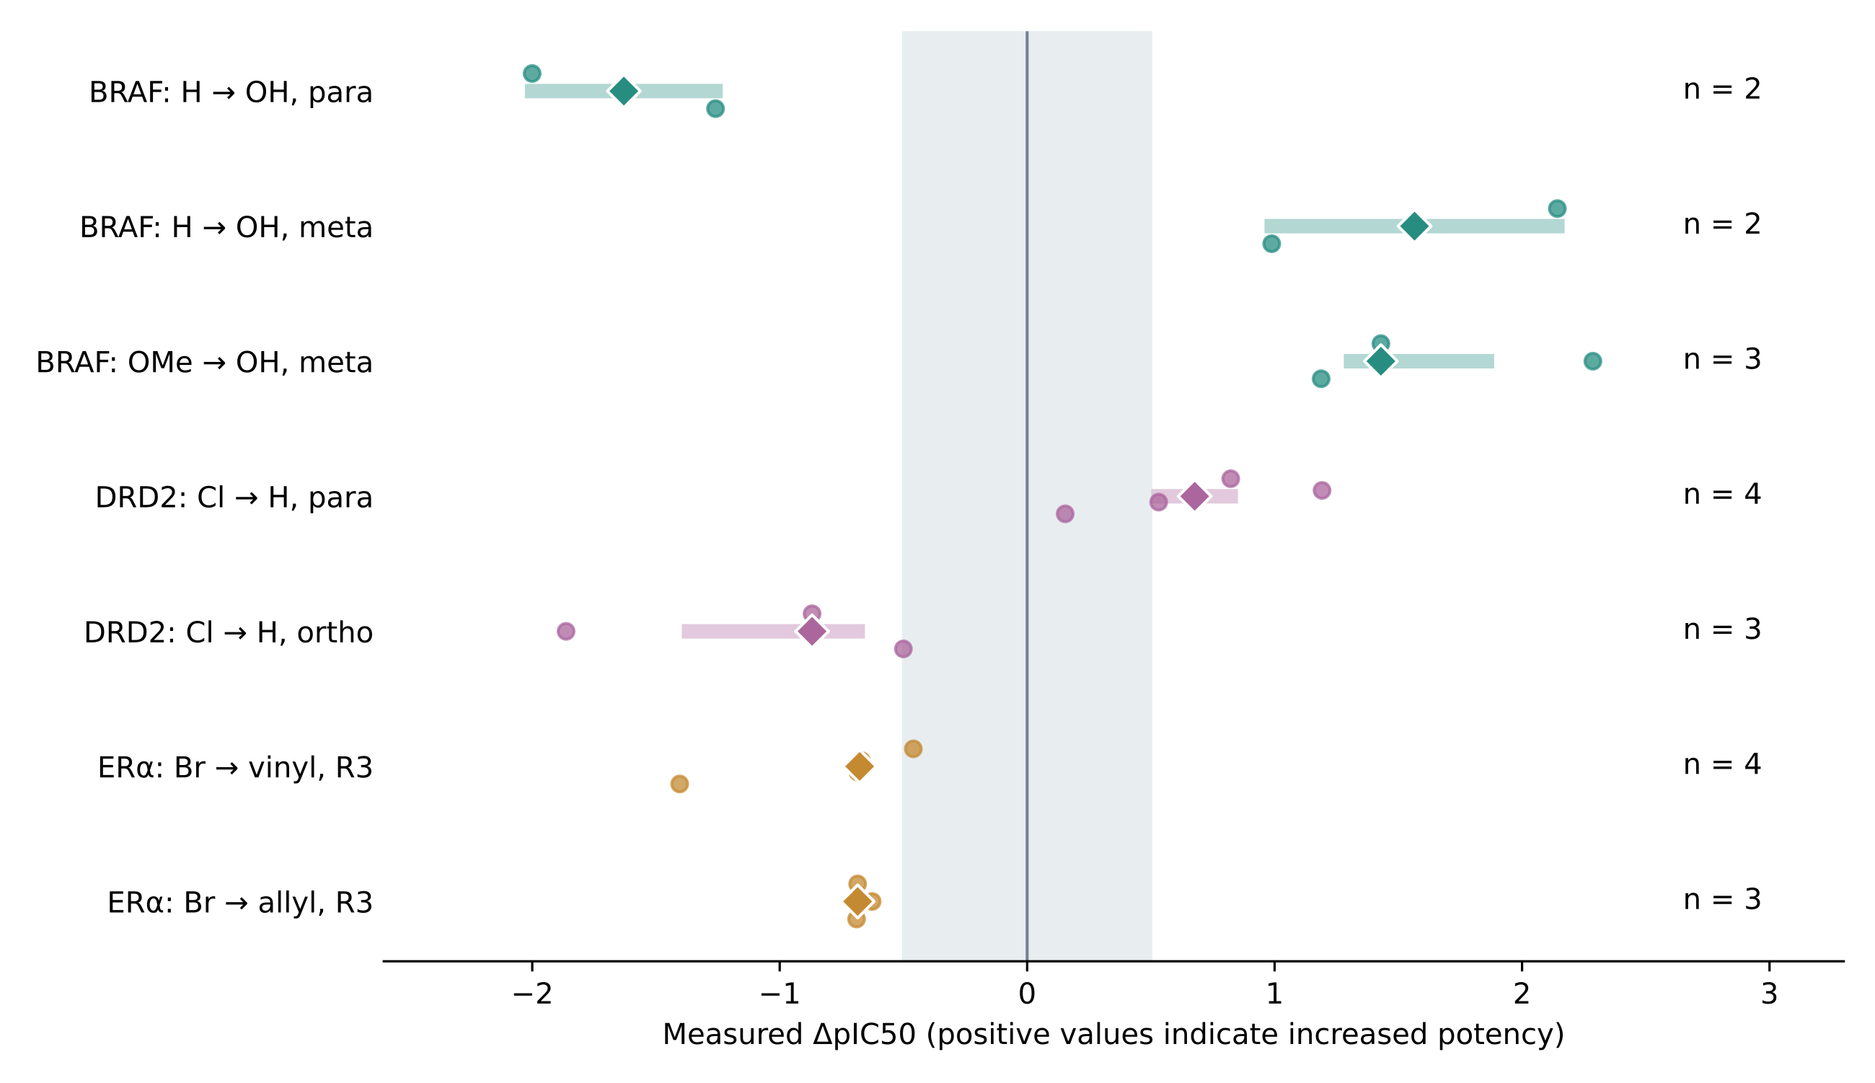
Figure 3. Individual pair effects for selected BRAF, DRD2 and ER-alpha transformations. Circles show measured pair differences; diamonds show their medians. Thick pale segments show the range of medians after omitting individual compounds and all their incident pairs, not confidence intervals. The grey band marks changes smaller than 0.5 pIC50 units. The number of pairs is shown for each transformation. All displayed DRD2 pairs have the same selected stereochemical core. The displayed examples were chosen to illustrate positional contrasts and repeated comparisons, not as an exhaustive ranking of transformations.

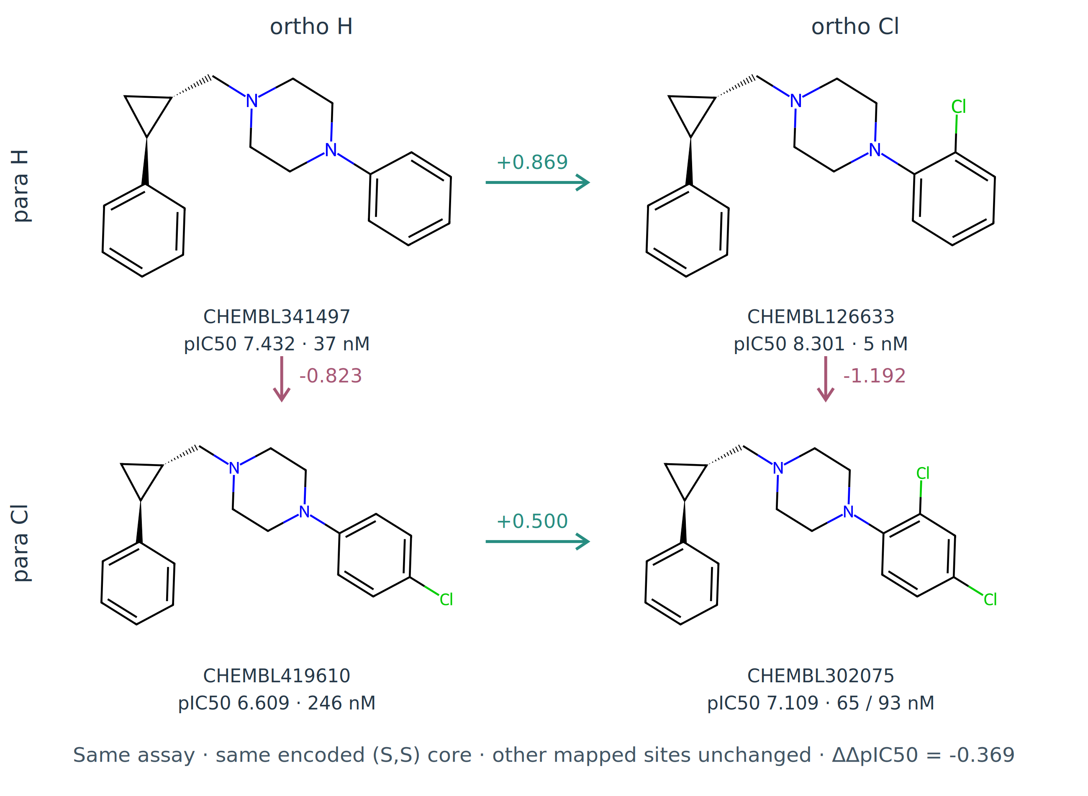
Figure 4. Complete DRD2 para/ortho chlorination cycle within the selected (S,S) core. Other mapped positions are unchanged and all measurements come from CHEMBL671074. Structures and original IC50 values are shown; the doubly chlorinated compound has retained values of 65 and 93 nM. Arrows show differences calculated from median pIC50. The −0.369-unit contrast describes a modest departure from additivity, not a binding free energy or evidence of biological cooperativity.

References
[1] E. Griffen, A. G. Leach, G. R. Robb, D. J. Warner, *J. Med. Chem.* 2011, *54*, 7739–7750. [2] J. Hussain, C. Rea, *J. Chem. Inf. Model.* 2010, *50*, 339–348. [3] A. Dalke, J. Hert, C. Kramer, *J. Chem. Inf. Model.* 2018, *58*, 902–910. [4] N. M. O’Boyle, J. Boström, R. A. Sayle, A. Gill, *J. Med. Chem.* 2014, *57*, 2704–2713. [5] B. Zdrazil, E. Felix, F. Hunter, E. J. Manners, J. Blackshaw, S. Corbett, M. de Veij, H. Ioannidis, D. M. Lopez, J. F. Mosquera, M. P. Magarinos, N. Bosc, R. Arcila, T. Kizilören, A. Gaulton, A. P. Bento, M. F. Adasme, P. Monecke, G. A. Landrum, A. R. Leach, *Nucleic Acids Res.* 2024, *52*, D1180–D1192. [6] G. Papadatos, A. Gaulton, A. Hersey, J. P. Overington, *J. Comput.-Aided Mol. Des.* 2015, *29*, 885–896. [7] I. Smit, M. F. Adasme, E. Manners, S. Corbett, N. Bosc, H.-M.-A. Do, A. R. Leach, N. M. O’Boyle, B. Zdrazil, *J. Cheminform.* 2026, *18*. [8] C. Kramer, T. Kalliokoski, P. Gedeck, A. Vulpetti, *J. Med. Chem.* 2012, *55*, 5165–5173. [9] T. Kalliokoski, C. Kramer, A. Vulpetti, P. Gedeck, *PLoS One* 2013, *8*, e61007. [10] J. Nelen, H. Pérez-Sánchez, H. De Winter, D. Van Rompaey, *J. Cheminform.* 2025, *17*. [11] C. Kramer, J. E. Fuchs, K. R. Liedl, *J. Chem. Inf. Model.* 2015, *55*, 483–494. [12] G. M. Maggiora, *J. Chem. Inf. Model.* 2006, *46*, 1535–1535. [13] D. van Tilborg, A. Alenicheva, F. Grisoni, *J. Chem. Inf. Model.* 2022, *62*, 5938–5951. [14] D. van Tilborg, A. Alenicheva, F. Grisoni, *J. Chem. Inf. Model.* 2023, *63*, 2266–2266. [15] T. Sander, J. Freyss, M. von Korff, C. Rufener, *J. Chem. Inf. Model.* 2015, *55*, 460–473. [16] D. K. Agrafiotis, M. Shemanarev, P. J. Connolly, M. Farnum, V. S. Lobanov, *J. Med. Chem.* 2007, *50*, 5926–5937. [17] M. González-Medina, O. Méndez-Lucio, J. L. Medina-Franco, *J. Chem. Inf. Model.* 2017, *57*, 397–402. [18] E. E. Abreu-Martínez, K. Martinez-Mayorga, G. Merino, *J. Cheminform.* 2026, *18*. [19] A. R. Bradley, I. D. Wall, D. V. S. Green, C. M. Deane, B. D. Marsden, *J. Chem. Inf. Model.* 2014, *54*, 2636–2646. [20] C. Kramer, *J. Chem. Inf. Model.* 2019, *59*, 4034–4042. [21] L. Guasch, N. Maeder, J. G. Cumming, C. Kramer, *J. Comput.-Aided Mol. Des.* 2024, *38*. [22] M. D. Wilkinson, M. Dumontier, I. J. Aalbersberg, G. Appleton, M. Axton, A. Baak, N. Blomberg, J.-W. Boiten, L. B. da Silva Santos, P. E. Bourne, J. Bouwman, A. J. Brookes, T. Clark, M. Crosas, I. Dillo, O. Dumon, S. Edmunds, C. T. Evelo, R. Finkers, A. Gonzalez-Beltran, A. J. G. Gray, P. Groth, C. Goble, J. S. Grethe, J. Heringa, P. A. C. ’t Hoen, R. Hooft, T. Kuhn, R. Kok, J. Kok, S. J. Lusher, M. E. Martone, A. Mons, A. L. Packer, B. Persson, P. Rocca-Serra, M. Roos, R. van Schaik, S.-A. Sansone, E. Schultes, T. Sengstag, T. Slater, G. Strawn, M. A. Swertz, M. Thompson, J. van der Lei, E. van Mulligen, J. Velterop, A. Waagmeester, P. Wittenburg, K. Wolstencroft, J. Zhao, B. Mons, *Sci. Data* 2016, *3*. [23] C. T. Hoyt, B. Zdrazil, R. Guha, N. Jeliazkova, K. Martinez-Mayorga, E. Nittinger, *J. Cheminform.* 2023, *15*. [24] G. W. Bemis, M. A. Murcko, *J. Med. Chem.* 1996, *39*, 2887–2893. [25] RDKit: open-source cheminformatics, https://www.rdkit.org/, accessed 13 October 2026. [26] M. S. Abdel-Maksoud, M. I. El-Gamal, B. S. Lee, M. M. Gamal El-Din, H. R. Jeon, D. Kwon, U. M. Ammar, K. I. Mersal, E. M. H. Ali, K.-T. Lee, K. H. Yoo, D. K. Han, J. K. Lee, G. Kim, H. S. Choi, Y. J. Kwon, K. H. Lee, C. H. Oh, *J. Med. Chem.* 2021, *64*, 6877–6901. [27] X. Zhang, K. Hodgetts, S. Rachwal, H. Zhao, J. W. F. Wasley, K. Craven, R. Brodbeck, A. Kieltyka, D. Hoffman, M. D. Bacolod, B. Girard, J. Tran, A. Thurkauf, *J. Med. Chem.* 2000, *43*, 3923–3932. [28] M. S. Malamas, E. S. Manas, R. E. McDevitt, I. Gunawan, Z. B. Xu, M. D. Collini, C. P. Miller, T. Dinh, R. A. Henderson, J. C. Keith, H. A. Harris, *J. Med. Chem.* 2004, *47*, 5021–5040. [29] Y. Benjamini, Y. Hochberg, *J. R. Stat. Soc. B* 1995, *57*, 289–300. [30] D. Rogers, M. Hahn, *J. Chem. Inf. Model.* 2010, *50*, 742–754. [31] Y. Boulaamane, SARscope: source-code repository, https://github.com/yboulaamane/sarscope, accessed 13 October 2026. [32] Y. Boulaamane, SARscope: browser application, https://sarscope.streamlit.app/, accessed 13 October 2026.

