SARscope: interactive, assay-aware structure–activity interpretation with activity-cliff diagnostics
Working software-article draft. Not for submission yet. Independent literature annotations, expert review and the user-level comparator study remain pending. Author list/affiliations/declarations require confirmation. Local artifacts are not a publicly archived release. Paper text/protocol/graphics: CC BY 4.0; ChEMBL-derived evidence: CC BY-SA 3.0; software: MIT.
Draft corresponding author: Yassir Boulaamane, yassirxmail@gmail.com, from project metadata. This does not establish final authorship, affiliation or contributions.

Abstract

Background
Public bioactivity records are useful for examining medicinal-chemistry series, but interpretation requires maintaining experimental context, identifying comparable structural changes and distinguishing observed effects from unsupported generalizations. SARscope provides a staged browser and command-line workflow that links curated measurements to interactive position-level SAR, activity-cliff inspection and optional retrospective QSAR.

Implementation and results
The software combines established RDKit structure analysis with measurement provenance, matched single-position comparisons and explicit descriptive support grades. Three frozen published-data examples cover BRAF, DRD2 and estrogen receptor alpha. Their largest scaffold series contain 16, 26 and 53 molecules, yielding 29, 46 and 198 position-pair records respectively. Exhaustive reference enumeration reproduced all pair identities and numerical differences. A single-cut comparison on identical curated inputs found all SARscope compound pairs within mmpdb's output, while mmpdb identified 56 additional pairs involving hydrogen substitutions. Supporting retrospective scaffold-held-out QSAR results vary substantially by target. Expert agreement and user-level comparative benefit have not yet been measured.

Scientific Contribution
SARscope links interactive position-level SAR statements to exact source measurements and distinguishes matched-assay effects from pooled evidence. Its staged workflow combines interpretable support counts, conflicting examples and activity-cliff diagnostics without equating them with causal mechanisms. The current contribution is an auditable interpretation workflow built on established cheminformatics methods, not a new fingerprint, pairing algorithm or experimentally validated optimization strategy.

Conclusions
The implementation and examples establish feasibility and numerical consistency. Independent review and comparative evaluation are required to establish the workflow's incremental practical value and support publication claims.
Keywords: structure–activity relationships; activity cliffs; medicinal chemistry; ChEMBL; assay provenance; interactive cheminformatics; QSAR.

Introduction
Bioactivity databases such as ChEMBL collect structures and measurements with assay and publication context [1]. A target-level potency table is not, by itself, a coherent SAR series: measurements can differ in endpoint, assay format, protein construct, reporting precision and source provenance. Structural similarity can help identify local changes, but a large potency difference requires inspection of the measurements and chemical context before a medicinal chemist can act on it.
Established tools already address important parts of this problem. DataWarrior provides R-group decomposition, chemical-space visualization, activity-cliff analysis and separation by experimental categories [2,3]. mmpdb offers matched molecular-pair analysis, transformation environments and property-change statistics [4,5]. RDKit supplies core molecular representations and decomposition methods [6]. SARscope therefore does not claim these capabilities are novel.
The intended contribution is a browser-accessible, staged interpretation workflow: a user selects the target and experimental subset, explicitly curates it, chooses an analysis, and follows an annotated structural change back to exact source records. Directional statements remain separate from mechanistic explanations and prospective predictions. The contribution must ultimately be judged by traceability, interpretation quality, reproducibility and user task performance relative to existing tools, rather than by feature count.

Implementation

Architecture and staged interaction
SARscope is an MIT-licensed Python package with a Streamlit interface and a CLI. The analysis layer is independent of the browser. Structure standardization uses Sorbent/RDKit; tabular operations use pandas; numerical/statistical analyses use NumPy/SciPy; optional QSAR uses scikit-learn. An embedded SVG component supports clickable and keyboard-accessible attachment positions without a remote graphics dependency. The browser does not run every analysis upon loading: curation, chemical space, scaffolds/SAR, activity cliffs, modeling and explanation are explicit user actions.
Figure 1 depicts the scope and evidence boundaries. Selecting a position displays fragment changes, supporting compounds, measured concentrations, effect sizes and source assay records. Exports contain structures, retained measurements, pair-level evidence, transformation summaries, an annotated SVG and analysis scope. The map is an evidence-navigation interface, not an automatic biological conclusion generator.

Curation and provenance
The default quantitative workflow retains exact molar measurements for the selected endpoint/assay type, excludes source validity flags and likely duplicates, standardizes structures and aggregates repeated measurements by standardized structure. Every filter has an explicit count and recorded setting. Raw records and retained measurement IDs are preserved. Quantitative conversion to -log10(molar) is a unit conversion, not a conversion of IC50 to Ki or of qualitative screening activity to potency. PubChem qualitative calls use a separate classification workflow.
Structured variant annotations are normalized without inferring mutations from free-text descriptions. Missing annotations remain unreported, not confirmed wild type. Raw assay descriptions are retained for review, since discrepancies between structured fields and prose can remain. A shared assay identifier is a compatibility safeguard, not proof that all measurements are experimentally interchangeable.

Position-level SAR
Within a chosen Murcko scaffold series, symmetry-aware RDKit R-group decomposition defines a labeled core and variable positions. A comparison is admitted at a position only when both compounds agree at every other mapped variable position. For shared assay, endpoint and normalized variant context, per-compound measurement medians determine the signed potency difference. If no compatible context exists, pooled molecule values are labeled as unmatched and are not promoted to supported assay-matched evidence.
Transformation summaries preserve endpoint and variant strata. Each molecular pair contributes one median effect across its compatible assay measurements; repeated assays do not multiply pair support. The summary displays the number of molecular pairs, distinct other-position contexts, assays, and a conservative deterministic count of disjoint pairs sharing no compounds. Disjoint pairs are not called independent biological experiments. Attachment labels refer to the RDKit decomposition, not medicinal-chemistry atom numbering.
Descriptive grades use explicit heuristics. At the fixed 0.5-log-unit threshold, subthreshold changes, less than 80% sign agreement or opposing assay effects are mixed. A coherent assay-matched transformation with at least two disjoint pairs is moderate; at least three disjoint pairs across at least two other-site contexts is strong. Remaining effects are limited. A reached pair cap prevents promotion to moderate/strong. Grades are not calibrated confidence levels or probabilities; the effect threshold and support rules require independent review. Fixed positions, linker changes, coupled multisite changes and some symmetry ambiguities remain outside this map's representational scope.

Activity cliffs and optional modeling
Activity-cliff exploration exposes multiple pairs under user-selected fingerprint similarity and potency-gap thresholds. Cliffs motivate inspection of measurements and local transformations; they do not identify the cause of the activity change. Optional classification/regression supports explicit random, scaffold, temporal and source-based validation settings, descriptor/fingerprint representations, baselines, held-out diagnostics and applicability-domain summaries. Regression retains the continuous endpoint. A favorable random split cannot establish prospective performance, and an applicability-domain flag is not assurance of prediction accuracy. The main article focuses on SAR interpretation rather than asserting predictive superiority of these standard models.

Evaluation methods

Frozen published-data examples
Three literature assays were chosen from the already frozen ChEMBL 37 family panel for populated, chemically related series [7–9]. This was retrospective selection, not preregistration. Cases are BRAF/CHEMBL5046398, DRD2/CHEMBL671074 and ER-alpha/CHEMBL829540. The ER-alpha case is a counter-assay from a paper on ER-beta selectivity; its measurements must not be relabeled ER-beta. Within each assay, series selection uses the largest post-curation Murcko group, with lexical tie-breaking and no potency-based selection.
The small source cohorts, complete assay IDs, publication references, original records and hashes are included in the repository. Curation retains literature source records, binding IC50 in nM and unannotated structured variants. These examples overlap the benchmark source pool and are not independent QSAR tests. An exhaustive reference separately enumerates all compound combinations within the same RDKit-derived series, checking exactly one differing position and recalculating deltas from assay medians. This is numerical verification using shared chemistry infrastructure, not independent biological SAR validation.

Comparator and review design
An actual mmpdb 3.1.4 comparison uses identical curated inputs, one cut, a common cut SMARTS and 10-heavy-atom variable-fragment limit. It compares unordered compound-pair membership, with complete command logs and discrepancies exported. The algorithms differ in implicit-hydrogen handling and context enumeration, so pair-count differences alone cannot be labeled errors. Process timings include startup/I/O for mmpdb but only in-process execution for SARscope and are therefore not used to claim a speed advantage.
A 41-task grade-stratified expert review pack has been generated, but no reviews have been performed. Reviewers receive directed transformations and raw evidence without the tool's grade or summary. The protocol requires at least two independent reviewers, explicit unresolved cases, source citations and adjudication records. Separately, original-paper SAR expectations must be annotated before assessing trend recovery. A counterbalanced DataWarrior/RDKit/SARscope user-task comparison is specified but not run. Full procedures and empty templates are supplied in evaluation-protocol.md; they are not presented as completed experiments.

Supporting QSAR uncertainty audit
The existing panel uses one 200-tree random-forest regressor with ECFP4 features, fold-local filtering, three-fold scaffold-group training CV and a 20% outer scaffold holdout, seed 42. A training-set median is the baseline. The previous run is described in docs/benchmark-chembl37.md. The new audit resamples the saved test scaffold clusters 1,000 times, treating acyclic molecules as separate groups, and obtains percentile intervals for RMSE and paired baseline improvement. No model is retrained. These intervals condition on the existing split and fitted model; they are not prospective or repeated-training uncertainty estimates.

Results

Case coverage and numerical consistency
Case | Raw records | Retained measurements | Curated molecules | Scaffolds | Selected series | Position pairs | Transformations
BRAF | 46 | 44 | 44 | 8 | 16 | 29 | 15
DRD2 | 34 | 31 | 30 | 5 | 26 | 46 | 21
ER-alpha | 107 | 100 | 98 | 11 | 53 | 198 | 155

Selected-series coverage was 36.4%, 86.7% and 54.1% of curated molecules respectively. No selected-series compound failed decomposition and no pair cap was reached. Reference enumeration agreed with all 273 position-pair records to an absolute tolerance of 1e-10 log units. Cases retain all scaffold counts so coverage omissions remain visible. Local case-analysis times were a few seconds per case in one run (recorded in the CSV); these do not measure Streamlit cold starts. A fresh isolated Linux/Python 3.13 environment reproduced all 26 CSV outputs exactly apart from elapsed times. A transitive, wheel-hashed analysis runtime lock is supplied; other platforms and external release-archive reproduction have not been evaluated.
BRAF produced one strong, four moderate, nine mixed and one limited transformation. An illustrative methoxy-to-hydroxyl change at mapped R4 had median delta +1.43 across three disjoint pairs and three other-site contexts. This describes about 27-fold lower IC50 within those comparisons, not a general design rule or a claim of reproducing the authors' interpretation. The annotated map is Figure 2.
DRD2 produced two strong, three moderate, thirteen mixed and three limited transformations. Removing chlorine at mapped R2 had median delta +0.82, whereas removing it at mapped R4 had delta -0.73. Thus a generic “chlorine is beneficial” statement would conceal position dependence in this selected series. These observed D2 IC50 effects do not establish D2/D4 selectivity or antipsychotic efficacy.
ER-alpha produced two strong, five moderate, eighty-three mixed and sixty-five limited transformations. Most transformations were mixed or sparsely supported, illustrating why a map should not turn every numerical delta into a confident recommendation. No independent medicinal-chemist judgment is yet available for any of these statements or grades.

mmpdb comparison and a concrete limitation
Case | SARscope unique MMP pairs | mmpdb unique MMP pairs | Shared | mmpdb-only
BRAF | 114 | 116 | 114 | 2
DRD2 | 205 | 205 | 205 | 0
ER-alpha | 441 | 495 | 441 | 54

Every unique SARscope pair was found by mmpdb in this experiment. Inspection of all 56 mmpdb-only pairs found an explicit-H variable fragment in each. The current SARscope single-cut MMP workflow therefore misses these implicit-H substitution pairs, although its scaffold R-group map does represent H alternatives. Multiple context rows per pair explain differences in raw row counts. This is a useful negative comparison: the potential publication value lies in evidence navigation, not stronger pair enumeration. DataWarrior and human workflow comparisons remain pending.

Supporting retrospective QSAR result
Target | Test compounds | R² | RMSE | Conditional 95% RMSE interval | Spearman | Median-baseline RMSE
BRAF | 584 | 0.762 | 0.646 | 0.578–0.720 | 0.859 | 1.342
DRD2 | 99 | 0.310 | 0.902 | 0.756–1.041 | 0.574 | 1.087
ER-alpha | 651 | 0.696 | 0.828 | 0.744–0.925 | 0.836 | 1.503

The weakest case is DRD2, which must not be hidden by a panel average. Paired bootstrap intervals for baseline-minus-model RMSE were positive for these saved predictions; this supports improvement over a constant baseline on the particular held-out splits, not external reliability. Figure 3 displays per-target RMSE. Assay/document dependencies can remain across scaffold splits. The panel contains only three selected targets and cannot establish general cross-family utility.

Discussion and limitations
The principal intended use is to help computational and medicinal chemists inspect a series with explicit provenance and controlled local comparisons. The interactive map makes positional context, effect sizes and supporting records available together. Mixed and limited evidence should guide review rather than be hidden by a single summary or model score.
However, established comparators already provide SAR and activity-cliff analysis. The current numerical examples do not establish that SARscope materially improves interpretation or user efficiency. The evidence-grade heuristics have no independent calibration or expert agreement study. These are decisive evaluation gaps, not minor reporting omissions. Case selection is retrospective and limited to the largest Murcko series; substructure/symmetry choices and chemical standardization can affect which transformations are represented. Binding IC50 is assay-dependent and is not affinity, selectivity or cellular efficacy. Structured annotations can be incomplete, and source text requires review without silently changing labels.
The optional docking workflow is deliberately excluded from the central contribution. Rigid-receptor docking scores are hypotheses; unstable rankings cannot explain an activity cliff. The previous exploratory BRAF pair reversed ranking with Vina seed changes. It should not be used to claim a fluorine-dependent mechanism or improved experimental potency prediction. No docking protocol or experimental mechanistic validation was newly conducted for this paper package.
The lowest-cost next falsification test is independent chemist review of the prepared transformations: unsupported moderate/strong directional claims or systematic missed/conflicting trends would challenge the current grading and interpretation approach. A workflow-comparison pilot then tests whether the interface yields an advantage beyond existing tools. These evaluations should precede expanding the manuscript's scope or adding more modeling features.

Conclusions
SARscope implements a staged, auditable SAR workflow with interactive structural annotations, assay-context comparisons and activity-cliff exploration. Frozen examples establish numerical consistency and expose a concrete MMP coverage limitation. The software is a plausible publication candidate, but independent SAR review, completed workflow comparisons and publicly archived reproducibility assets are required before claiming a demonstrated advance.

Availability and requirements
Project: SARscope. Home page/source: https://github.com/yboulaamane/sarscope. Browser application: https://sarscope.streamlit.app/. Language: Python; supported minimum Python 3.12, with this evaluation observed on Python 3.13.13/Linux WSL2. Other requirements: RDKit, Sorbent, NumPy, pandas, SciPy, scikit-learn, matplotlib; Streamlit for the browser. See package metadata for optional dependencies. Core software license: MIT, with no additional restriction on nonacademic use. ChEMBL data have a separate CC BY-SA 3.0 license. Current development version: 0.1.0.dev0. A release DOI has not been assigned.

Declarations — author confirmation required

Availability of data and materials
Small frozen case snapshots, protocols, exports and tests are in paper/. Full ChEMBL 37 benchmark snapshots and saved predictions are currently local ignored artifacts and can be included by the archive builder. Until a versioned archive is publicly deposited, the complete QSAR result is not independently reproducible from the Git repository alone. The manuscript must be updated with actual anonymous-access URLs/DOIs before submission. Source-data attribution and transformations are documented in DATA-LICENSE.md.

Competing interests
Not yet supplied by the author(s); requires confirmation before submission.

Funding
Not yet supplied by the author(s); requires confirmation before submission.

Authors' contributions
Final roles and author list must be confirmed by the human author(s).

Acknowledgements and AI assistance
Codex was used to assist software implementation, evaluation-code preparation and drafting this working manuscript. Human authors must verify the code, numerical results, citations, interpretations and final text and approve the exact disclosure before submission. No AI system is listed as an author. Additional acknowledgements require permission from those named.

Figures and supplementary files
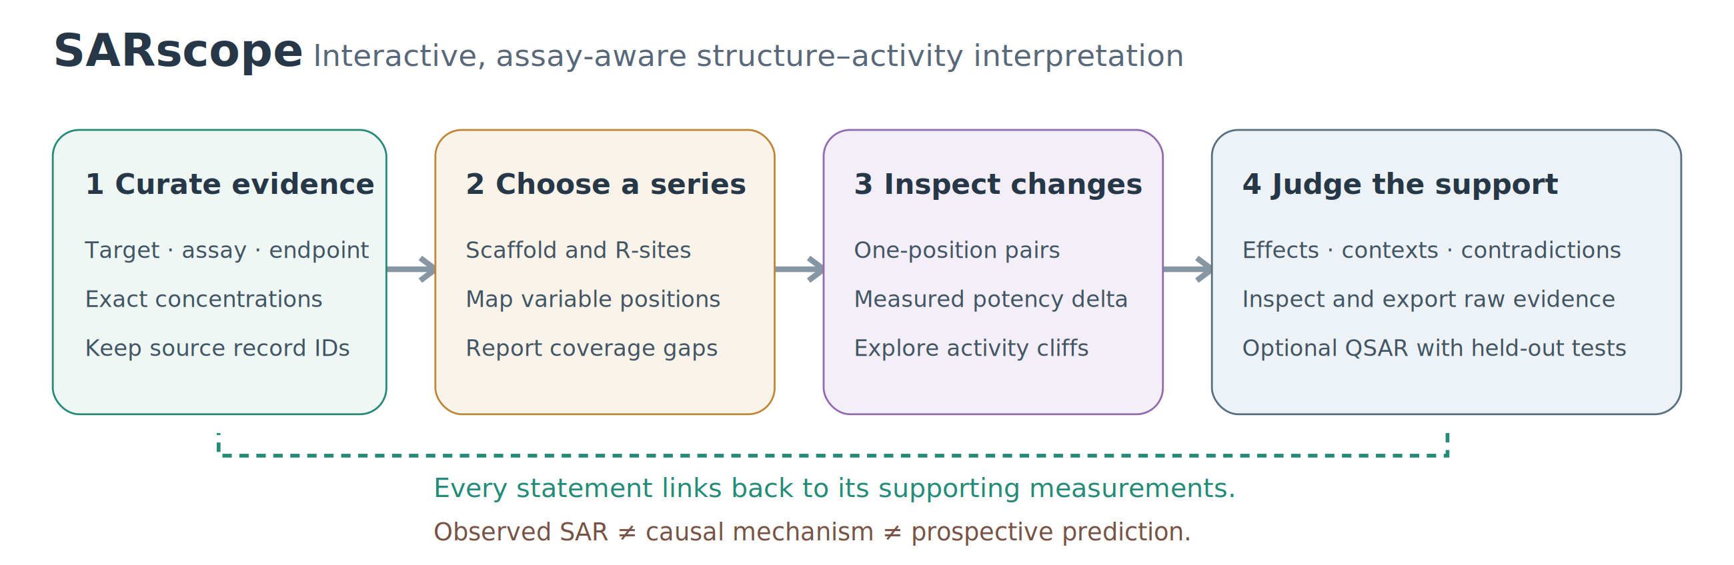
Figure 1. Original workflow schematic; no mechanistic claim.

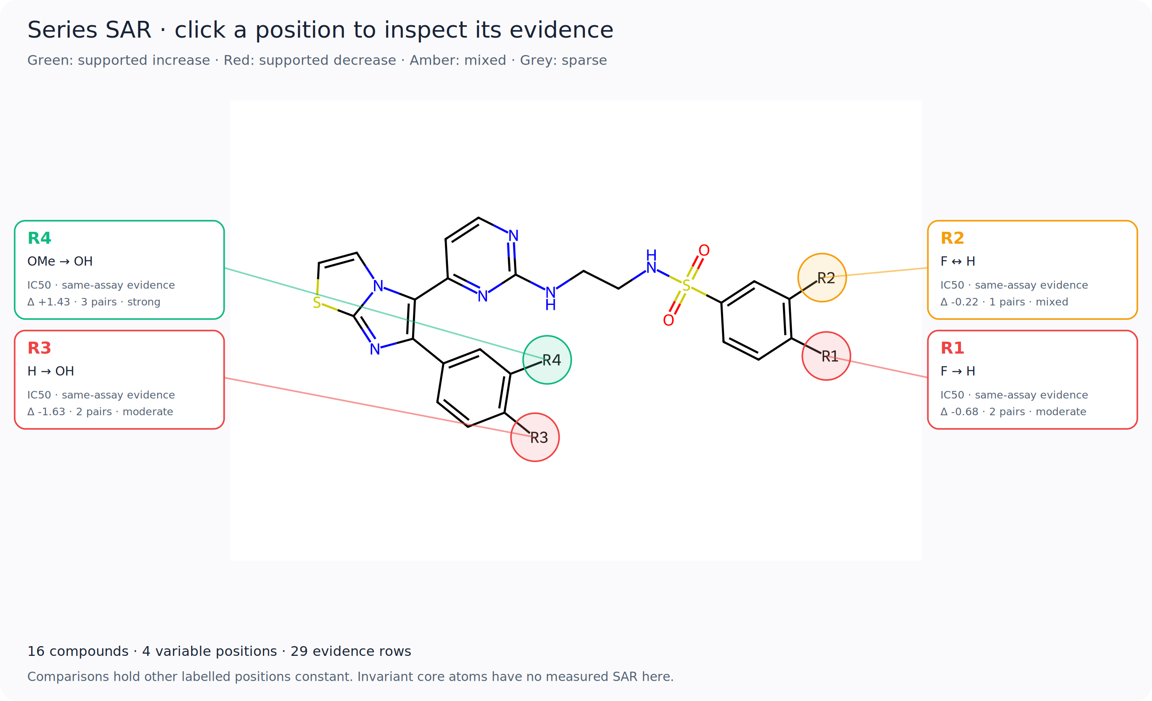
Figure 2. BRAF selected-series map. Labels show observed potency differences/support heuristics, not causal or universal effects. Full supporting pairs, structures and measurement IDs are exported alongside it.

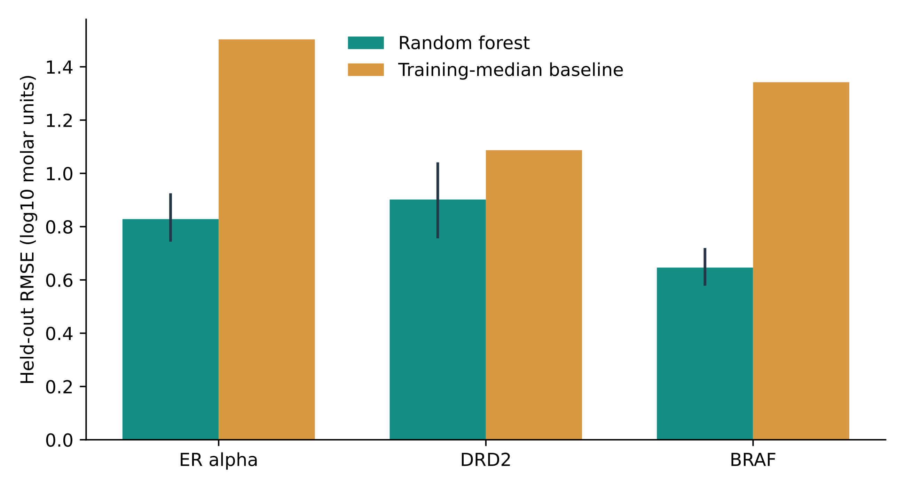
Figure 3. Existing scaffold-held-out RMSE versus training-median baseline. Vertical RF intervals are conditional scaffold-cluster bootstrap percentiles; no prospective or repeated-training claim is implied.
Additional files: source case cohorts/manifest; case CSVs/scope; mmpdb commands, inputs/pair membership/logs; bootstrap metrics; unreviewed review tasks/template; evaluation and release protocols. Full benchmark assets must accompany public deposition if the QSAR section is retained.

References
1. Zdrazil B et al. The ChEMBL Database in 2023: a drug discovery platform spanning multiple bioactivity data types and time periods. Nucleic Acids Res. 2024;52:D1180–D1192. https://doi.org/10.1093/nar/gkad1004.
2. Sander T, Freyss J, von Korff M, Rufener C. DataWarrior: an open-source program for chemistry aware data visualization and analysis. J Chem Inf Model. 2015;55:460–473. https://doi.org/10.1021/ci500588j.
3. DataWarrior chemistry documentation. https://openmolecules.org/help/chemistry.html. Accessed 12 October 2026.
4. Dalke A, Hert J, Kramer C. mmpdb: An Open-Source Matched Molecular Pair Platform for Large Multiproperty Data Sets. J Chem Inf Model. 2018;58:902–910. https://doi.org/10.1021/acs.jcim.8b00173.
5. mmpdb source and documentation. https://github.com/rdkit/mmpdb. Accessed 12 October 2026.
6. RDKit: Open-source cheminformatics. https://www.rdkit.org/. Accessed 12 October 2026. Exact evaluation version is recorded in the outputs.
7. Abdel-Maksoud MS et al. Discovery of New Imidazo[2,1-b]thiazole Derivatives as Potent Pan-RAF Inhibitors with Promising In Vitro and In Vivo Anti-melanoma Activity. J Med Chem. 2021;64:6877–6901. https://doi.org/10.1021/acs.jmedchem.1c00230.
8. Zhang X et al. trans-1-[(2-Phenylcyclopropyl)methyl]-4-arylpiperazines: mixed dopamine D(2)/D(4) receptor antagonists as potential antipsychotic agents. J Med Chem. 2000;43:3923–3932. https://doi.org/10.1021/jm990562x.
9. Malamas MS et al. Design and synthesis of aryl diphenolic azoles as potent and selective estrogen receptor-beta ligands. J Med Chem. 2004. https://doi.org/10.1021/jm049719y.

