SARscope: interactive analysis of position-dependent structure–activity relationships
Yassir Boulaamane
Correspondence: yassirxmail@gmail.com
Manuscript draft. Affiliation and author declarations require confirmation.

Abstract

Background
Comparisons between close analogues help medicinal chemists choose modifications during lead optimization. Their interpretation depends on the attachment position, the remaining structure and the experimental conditions. We developed SARscope to examine these factors together and make the measurements behind a structure–activity relationship (SAR) accessible through an interactive interface.

Methods
Three published IC50 datasets were reconstructed from a frozen ChEMBL release: BRAF inhibitors, dopamine D2 receptor ligands and an estrogen receptor alpha counter-assay. Comparisons were restricted to one assay, an identical stereochemically annotated core and a change at one mapped position. We examined individual pair effects, sensitivity to the effect-size threshold and omission of individual compounds. Potency-label permutations assessed whether descriptive support criteria alone distinguished the observed data from shuffled assignments.

Results
The selected series contained 16, 23 and 53 compounds and yielded 263 positional comparisons. Hydroxyl addition to the BRAF series was unfavorable at the para position but favorable at the meta position. Chlorine removal from the DRD2 N-aryl ring was favorable at the para position and unfavorable at the ortho position. Seventeen transformations met the configured repeated-comparison criteria and retained their direction after individual-compound omissions. However, their number was not unusual under the permutation diagnostic, and none of the 191 transformation-level tests remained below 0.05 after adjustment for multiple comparisons. These results distinguish observed local SAR from statistically established, transferable design rules.

Conclusions
SARscope links substituent effects to attachment position, stereochemistry and assay evidence. The examples demonstrate the value of inspecting local comparisons rather than interpreting a fragment or an activity-cliff flag in isolation. The current evidence supports exploratory SAR analysis, not prospective potency prediction or mechanistic conclusions.
Keywords: structure–activity relationships; medicinal chemistry; matched molecular pairs; activity cliffs; stereochemistry; ChEMBL.

Introduction
Medicinal chemists use comparisons between related compounds to decide which chemical changes to retain during lead optimization. A well-controlled comparison changes one part of the molecule while keeping the remainder of the structure and the assay conditions constant. Matched molecular pair analysis formalizes this reasoning and allows recurring transformations to be examined across larger collections [1]. Public resources such as ChEMBL make these comparisons possible well beyond a single project [2].
The main difficulty is not calculating a potency difference. It is deciding what that difference means. A substituent can be favorable at one attachment position and unfavorable at another. Its effect may also depend on groups elsewhere in the molecule. Measurements from different assays, endpoints or stereoisomers can obscure these distinctions. Nonadditivity studies have shown why substituent contributions and experimental uncertainty must be considered together [3]. A short statement such as “chlorine improves potency” can therefore be less informative than the individual comparisons from which it was derived.
DataWarrior already provides chemical-space visualization, R-group analysis and activity-cliff inspection, while mmpdb offers extensive transformation analysis [1,4]. SARscope builds on these established ideas. Its purpose is to place the shared structure, changed position, potency measurements and source assay in one interactive view. A chemist can select a position, inspect the compounds behind an apparent trend and distinguish repeated observations from isolated examples. Scaffold analysis, activity-cliff inspection and modeling remain separate choices rather than steps run automatically on every dataset.
Here we examine whether this approach produces interpretable local SAR in three published chemical series. The analysis focuses on positional effects, the comparability of the underlying compounds and the stability of descriptive summaries. We also assess the limits of threshold-based support labels and activity-cliff calls. The study does not introduce a new pairing algorithm or claim superiority in prospective compound design.

Materials and methods

Data selection and experimental scope
Activity records were taken from frozen ChEMBL release 37 datasets for BRAF (CHEMBL5145), DRD2 (CHEMBL217) and estrogen receptor alpha (CHEMBL206). One published assay was selected for each target: CHEMBL5046398, CHEMBL671074 and CHEMBL829540, respectively [5–7]. Selection was retrospective and based on the availability of populated chemical series, not on predictive-model performance. These examples are illustrative rather than a representative sample of medicinal chemistry projects.
The BRAF data describe an enzyme inhibition assay in a study of imidazothiazole pan-RAF inhibitors [5]. The DRD2 data describe radioligand competition by trans-phenylcyclopropylmethyl arylpiperazines [6]. The estrogen data are the ER-alpha counter-assay from a study of ER-beta-selective ligands [7]. They are not ER-beta measurements, and selectivity cannot be inferred from this assay alone.
We retained exact IC50 values in nM and removed records flagged for validity concerns or potential duplication. Structures were standardized, and records for the same standardized structure were combined using the median on the logarithmic potency scale. Potency was expressed as pIC50 = −log10(IC50 in mol/L). No conversion from IC50 to Ki was made. Records lacking a structured protein variant annotation were retained as unannotated, not assumed to be wild type. Assay descriptions and original activity identifiers were retained for inspection.

Structural controls and positional comparisons
The largest Murcko scaffold group was selected within each assay, with lexical tie-breaking and no use of potency in the selection. RDKit R-group decomposition identified the variable positions [9]. An additional audit compared the stereochemically annotated mapped core returned for every compound. Where more than one core state was present, the largest state was retained before positional effects were calculated. Unassigned and oppositely assigned core stereochemistry were not pooled. This audit was part of the present case-study analysis; the original scaffold grouping alone did not enforce that restriction.
A pair was admitted when the two compounds had the same selected core and identical substituents at every mapped position except one. Effects were calculated as ΔpIC50 = pIC50(to) − pIC50(from), so a positive value indicates increased potency. Fragment order was fixed before examining the activities. Repeated measurements of a compound were combined within its assay, and each molecular pair contributed once to a transformation summary. We report pair counts and the number of disjoint pairs, meaning pairs that do not share a compound. These are distinct chemical comparisons, not independent biological replicates.
Attachment labels refer to the specific decomposition. For the BRAF pendant phenyl ring, R3 and R4 correspond to para and meta substitution relative to its attachment to the heterocyclic core. On the DRD2 N-aryl ring, R2 and R4 correspond to para and ortho substitution relative to the piperazine attachment. These relationships were checked on the molecular graphs; the numerical R-labels are not conventional atom numbering.

Effect summaries and robustness checks
The default practical effect-size threshold was 0.5 pIC50 units, equivalent to approximately a 3.2-fold concentration difference. It was not treated as an estimate of assay precision. A directional summary required an absolute median effect at least this large, at least 80% agreement in sign and no pair effects exceeding the threshold in opposite directions. Two disjoint pairs were required for the software's moderate-support label; three disjoint pairs across at least two remaining-substituent contexts were required for its strong-support label. These labels describe data support and consistency, not statistical confidence.
We repeated the summaries at thresholds of 0.25, 0.75 and 1.0 units. For individual-compound sensitivity, all pairs involving an omitted compound were removed before recalculating the median. The resulting range was used to assess dependence on a single compound; it is not a confidence interval.
An exploratory null diagnostic shuffled the compound pIC50 values 5,000 times within each selected series while leaving the pair network unchanged. A shuffled compound received the same value in all pairs containing it, preserving the dependence caused by compound reuse. Two-sided permutation P values for median effects were adjusted across all 191 transformations using the Benjamini–Hochberg procedure [10]. The number of transformations meeting the descriptive support criteria was also compared with the shuffled counts. This retrospective diagnostic assumes exchangeable potency labels; it does not model assay error or provide guaranteed false-discovery control for dependent chemical comparisons.

Complete substitution cycles and activity cliffs
For two variable positions, complete four-compound substitution cycles were identified when every combination was represented by one compound with the same selected core and unchanged substituents elsewhere. Ambiguous cells were excluded. Differences between conditional substituent effects were expressed as ΔΔpIC50 [3]. These IC50 contrasts were not converted into binding free energies.
Activity-cliff calls were examined for the already mapped pairs using Morgan fingerprints of radius 2, 2,048 bits and chirality disabled. The reference criterion required Tanimoto similarity above 0.90 and an absolute potency difference above 2.0 pIC50 units. The effect of changing either cutoff was inspected. This was not an exhaustive activity-cliff survey of the complete target datasets.

Software comparison and supporting modeling results
Single-cut pair coverage was compared with mmpdb 3.1.4 on identical curated assay cohorts [1]. The comparison used the same cut pattern and a ten-heavy-atom limit for variable fragments. Compound-pair membership, rather than fragment-label spelling, was compared. Timing was not used as an outcome because the mmpdb run included process startup and file operations whereas SARscope was called within an existing process.
An earlier random-forest regression benchmark on the full three-target datasets was retained as supporting analysis. It used one scaffold-held-out split per target and a training-set median baseline. Bootstrap intervals were calculated from the saved predictions by resampling test scaffold groups. Those results describe the particular retrospective splits, not prospective performance or independent validation of the SAR examples. Details are provided in the Supplementary Information.

Results

Assay and stereochemical restrictions defined the comparison sets
The three assay cohorts contained 187 raw activity records and 172 standardized compounds after curation. The largest scaffold groups contained 16 BRAF, 26 DRD2 and 53 ER-alpha compounds. The stereochemical audit identified three core states within the DRD2 group: 23 compounds with one assigned configuration, two with the opposite configuration and one with unassigned core stereochemistry. The 23-compound state, corresponding to the reported (S,S) cyclopropyl configuration, was retained. The other two series each contained one mapped core state.
Series | Curated assay compounds | Selected compounds | Positional comparisons | Distinct transformations
BRAF | 44 | 16 | 29 | 15
DRD2 | 30 | 23 | 36 | 21
ER-alpha | 98 | 53 | 198 | 155

The selected series covered 36.4%, 76.7% and 54.1% of their respective curated assay cohorts. Together they contained 92 compounds and 263 positional comparisons. Restricting the DRD2 core removed ten comparisons from the original scaffold-based set. This is a substantive control: a shared scaffold and assay do not establish that an observed difference is attributable to the displayed substituent alone.

BRAF hydroxyl effects depended on attachment position
On the pendant phenyl ring of the BRAF series, adding hydroxyl at the para position gave a median ΔpIC50 of −1.63 across two matched comparisons. Adding the same group at the meta position gave +1.57 across two comparisons. Thus the observed effects differed in direction despite involving the same nominal chemical change. Their magnitudes correspond to approximately a 43-fold loss and a 37-fold gain in potency, respectively, when calculated from the median logarithmic effects.
Replacing meta methoxy with hydroxyl gave a median increase of 1.43 units across three disjoint pairs in three remaining-substituent contexts, corresponding to about a 27-fold potency increase. The individual changes and their spread are shown in Figure 2, alongside the positional map in Figure 1. Removing individual compounds left the median for this transformation between +1.31 and +1.86.
These observations support a local distinction between the tested phenyl positions. They do not identify the origin of the difference. In particular, the data do not distinguish direct protein contacts from changes in solvation, conformation or other properties, and they do not establish a general advantage for hydroxyl substitution outside this series.

DRD2 chlorine substitution showed opposite positional effects
Within the stereochemically restricted DRD2 series, chlorine removal from the para position of the N-aryl ring increased pIC50 by a median of 0.68 units across four disjoint pairs. Removal from the ortho position decreased pIC50 by 0.87 units across three disjoint pairs. The signs persisted after individual-compound omissions. The compound-omission median ranges were +0.53 to +0.82 for para removal and −1.37 to −0.68 for ortho removal (Figure 2).
A complete four-compound cycle placed both positions in the same chemical background (Figure 3). The unsubstituted analogue, CHEMBL341497, had an IC50 of 37 nM. Para chlorine alone, CHEMBL419610, gave 246 nM, whereas ortho chlorine alone, CHEMBL126633, gave 5 nM. The doubly substituted compound, CHEMBL302075, had two retained values of 65 and 93 nM; their median pIC50 corresponds to 77.75 nM after back-conversion.
Para chlorination reduced potency in both ortho backgrounds, while ortho chlorination increased potency in both para backgrounds. The difference between the conditional effects was −0.369 pIC50 units. This is a modest departure from additivity, not evidence of a cooperative binding mechanism. Experimental replicate assignments and assay uncertainty were insufficient to distinguish such an effect from measurement variation. The cycle nevertheless provides a clearer account of the positional SAR than a pooled statement about chlorine.

ER-alpha transformations were dominated by sparse or mixed evidence
The ER-alpha series yielded the most transformations, but only seven of its 155 transformations met the moderate- or strong-support criteria. Eighty-three were mixed or subthreshold and 65 had limited support at the default threshold. At mapped R3, replacing bromine with vinyl or allyl gave median changes of −0.68 and −0.69 pIC50 units across four and three disjoint pairs, respectively. Their directions persisted after compound omission (Figure 2).
These effects describe the ER-alpha counter-assay. They provide no estimate of ER-beta selectivity or receptor agonism. The contrast between the large number of displayed transformations and the small number with repeated comparison support illustrates why transformation coverage should not be equated with confidence in a medicinal-chemistry recommendation.

Repeated observations did not establish statistical confidence
Seventeen transformations met the default repeated-comparison criteria across the three series, and every one retained the sign of its median after each valid compound omission. The number meeting those criteria fell from 25 at a 0.25-unit threshold to 17 at 0.5, 11 at 0.75 and seven at 1.0. The threshold therefore materially affected how much of the dataset appeared to support a directional interpretation.
The permutation diagnostic provided a different perspective. At the default threshold, shuffled assignments produced means of 4.36, 2.89 and 5.90 qualifying transformations in BRAF, DRD2 and ER-alpha, compared with observed counts of five, five and seven. The probabilities of a shuffled count at least as large as the observed count were 0.453, 0.136 and 0.389. None of the 191 transformation P values remained below 0.05 after multiple-comparison adjustment.
The observed directions and the omission checks remain useful descriptions of these measurements. They are not independent corroboration of a generalizable substituent effect. In these examples, pair count, consistency and effect size were insufficient to make the software's descriptive support grades calibrated statistical evidence.

Activity-cliff calls were sensitive to the chosen definition
Three BRAF positional comparisons exceeded a 100-fold potency difference. Only one also exceeded the reference fingerprint-similarity threshold. It linked CHEMBL5092007 and CHEMBL5076831, with reported IC50 values of 97 and 9,710 nM, Tanimoto similarity 0.918 and a potency difference of 2.00045 pIC50 units. No mapped DRD2 or ER-alpha pair satisfied the reference criterion.
The BRAF call disappeared when the similarity cutoff was increased to 0.95 or the potency-gap cutoff to 2.5 units. Its gap was only slightly above the chosen 2.0-unit boundary. Two other BRAF comparisons had larger potency gaps but similarities of 0.800 and 0.826, so they were excluded by the fingerprint cutoff. The practical implication is that a cliff flag should direct attention to a pair, not determine whether its measured difference deserves inspection.

Comparison with mmpdb identified a coverage limitation
On the complete curated assay cohorts, SARscope's single-cut MMP routine returned 760 distinct within-cohort compound pairs. All were present among the 816 pairs found by mmpdb. The 56 additional mmpdb pairs involved hydrogen substitution: two in BRAF and 54 in ER-alpha. The current single-cut MMP routine therefore does not have equivalent coverage for implicit-hydrogen changes. The separate R-group analysis does represent hydrogen alternatives, as the examples above show.
This result supports consistency within the overlapping pair set and identifies a concrete limitation. It does not demonstrate greater analytical coverage, faster interpretation or improved prediction compared with mmpdb or DataWarrior.

Discussion
The BRAF and DRD2 examples show why a substituent effect must be attached to a defined position. Hydroxyl addition and chlorine removal each changed direction between tested positions. These distinctions were evident in assay-matched comparisons without proposing a binding mechanism. The four-compound DRD2 cycle made the chemical context explicit and showed how the direction of each chlorination could be examined in both backgrounds.
The stereochemical audit was equally consequential. A scaffold grouping that looked chemically coherent contained opposite and unassigned core configurations. Removing those comparisons changed the DRD2 median effects and the number of eligible pairs. This is a limitation of relying on scaffold membership and a representative core drawing without inspecting per-compound stereochemistry. The present analysis applied an additional mapped-core restriction; that restriction must be made explicit whenever these results are reproduced or used to assess the software.
The robustness checks also place useful limits on interpretation. A sign that survives omission of individual compounds is less dependent on one example, but it is not evidence that the effect transfers to a new chemical background. The label permutations showed that the configured support criteria can also be met by shuffled potency assignments. Descriptive grades should therefore be read as summaries of what is present in the dataset, not as probabilities that a design change will succeed. Assay precision and independent chemical examples remain necessary when a decision depends on a small effect.
Activity cliffs pose a related problem. Their identification depends on a structural representation and numerical cutoffs. In the BRAF example, the reference call was near the potency boundary, while larger measured differences were excluded by the similarity criterion. These findings favor showing similarity, potency difference and the underlying compounds together. They also support assessing prediction error locally rather than relying only on a global model score, as emphasized by activity-cliff benchmarking studies [8]. The present study did not perform an independent cliff-specific prediction trial.
SARscope's practical contribution is the ability to move from a structural annotation to its supporting measurements within the same analysis. The chemist can compare positions, inspect contradictory examples, change the experimental subset and retain the evidence with the exported result. Established tools already implement the underlying scaffold, R-group and matched-pair concepts. The available comparison therefore supports a complementary interpretation workflow, not superiority of the pairing algorithms.
Several limitations remain. The series were selected retrospectively and cover only three target families. The largest-scaffold restriction omitted substantial fractions of the assay cohorts. Compounds and transformations share chemical backgrounds, and the source records do not establish independent experimental replication. The permutation diagnostic assumes exchangeability and does not account for all structure-dependent sources of variability. Complete cycles were defined on one R-group mapping rather than an exhaustive nonadditivity search. The source papers were not independently annotated to provide an external SAR reference, and no blinded medicinal-chemist or usability comparison has yet been completed. The supporting QSAR results are retrospective and do not address prospective or cross-target prediction.

Conclusions
Assay-matched, stereochemically consistent comparisons recovered clear positional differences in three published chemical series. Their interpretation changed when stereochemistry, effect-size thresholds and the limits of descriptive support were examined. SARscope provides an interactive way to inspect those relationships and the measurements behind them. Its present role is to support local SAR reasoning and the choice of follow-up experiments, rather than to replace experimental validation or establish universal substituent rules.

Scientific contribution
This study connects interactive positional SAR with explicit assay and stereochemical controls. It demonstrates, using published measurements, that consistent local effects and threshold-defined activity cliffs are not equivalent to calibrated evidence for a transferable design rule. The contribution is an evidence-linked interpretation workflow and its evaluated limits, not a new pairing or prediction algorithm.

Data and software availability
SARscope source code is available at https://github.com/yboulaamane/sarscope under the MIT license; the browser application is at https://sarscope.streamlit.app/. The frozen assay snapshots, original identifiers, analysis scripts and machine-readable results are supplied with this manuscript package. ChEMBL-derived data carry the CC BY-SA 3.0 license. The full benchmark snapshots and predictions are included in the locally prepared reproducibility archive, but a publicly deposited versioned archive and DOI are not yet available. Public deposition is required before submission. Detailed procedures and software versions are given in the Supplementary Information.

Declarations

Funding and competing interests
To be supplied and confirmed by the author before submission.

Author contributions
The final author list, affiliation and contributions require confirmation.

Assistance in manuscript and software preparation
AI-assisted drafting and programming tools were used during preparation. The final text, calculations, references and interpretations require author review and approval; no AI system is credited with authorship.

Figure legends
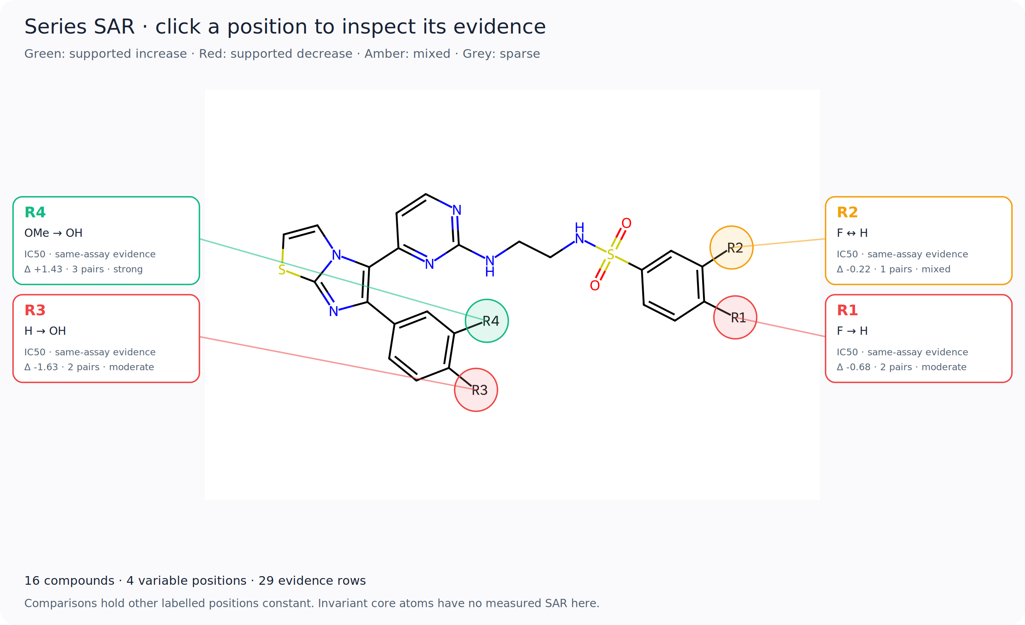
Figure 1. Interactive positional SAR map for the BRAF series. The shared structure, variable positions and example transformations are shown together. Labels describe the measured comparisons and the software's support criteria, not statistical significance or a binding mechanism. Selecting a position in the application opens its supporting compounds and assay records.

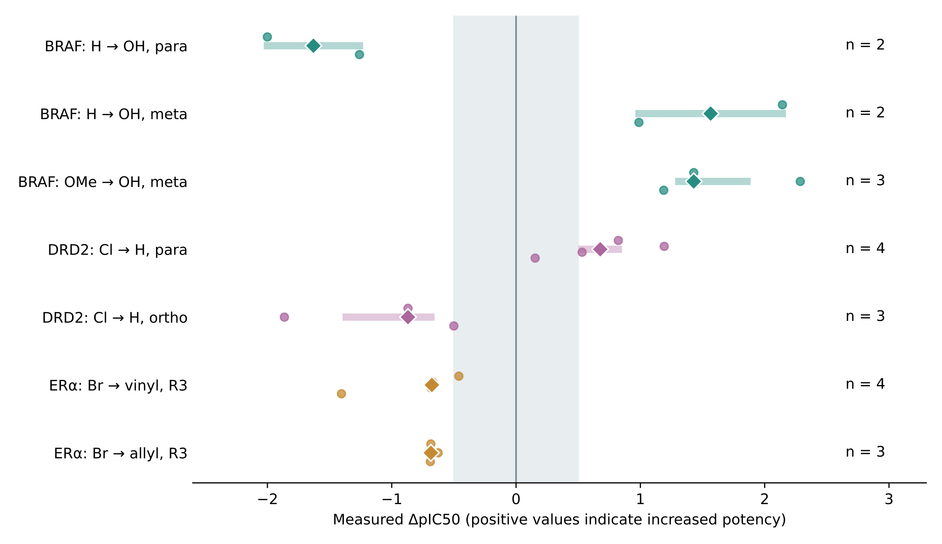
Figure 2. Individual pair effects for selected BRAF, DRD2 and ER-alpha transformations. Circles show measured pair differences; diamonds show their medians. Thick pale segments show the range of medians after omitting individual compounds and all their incident pairs, not confidence intervals. The grey band marks changes smaller than 0.5 pIC50 units. The number of pairs is shown for each transformation. All displayed DRD2 pairs have the same selected stereochemical core. The displayed examples were chosen to illustrate positional contrasts and repeated comparisons, not as an exhaustive ranking of transformations.

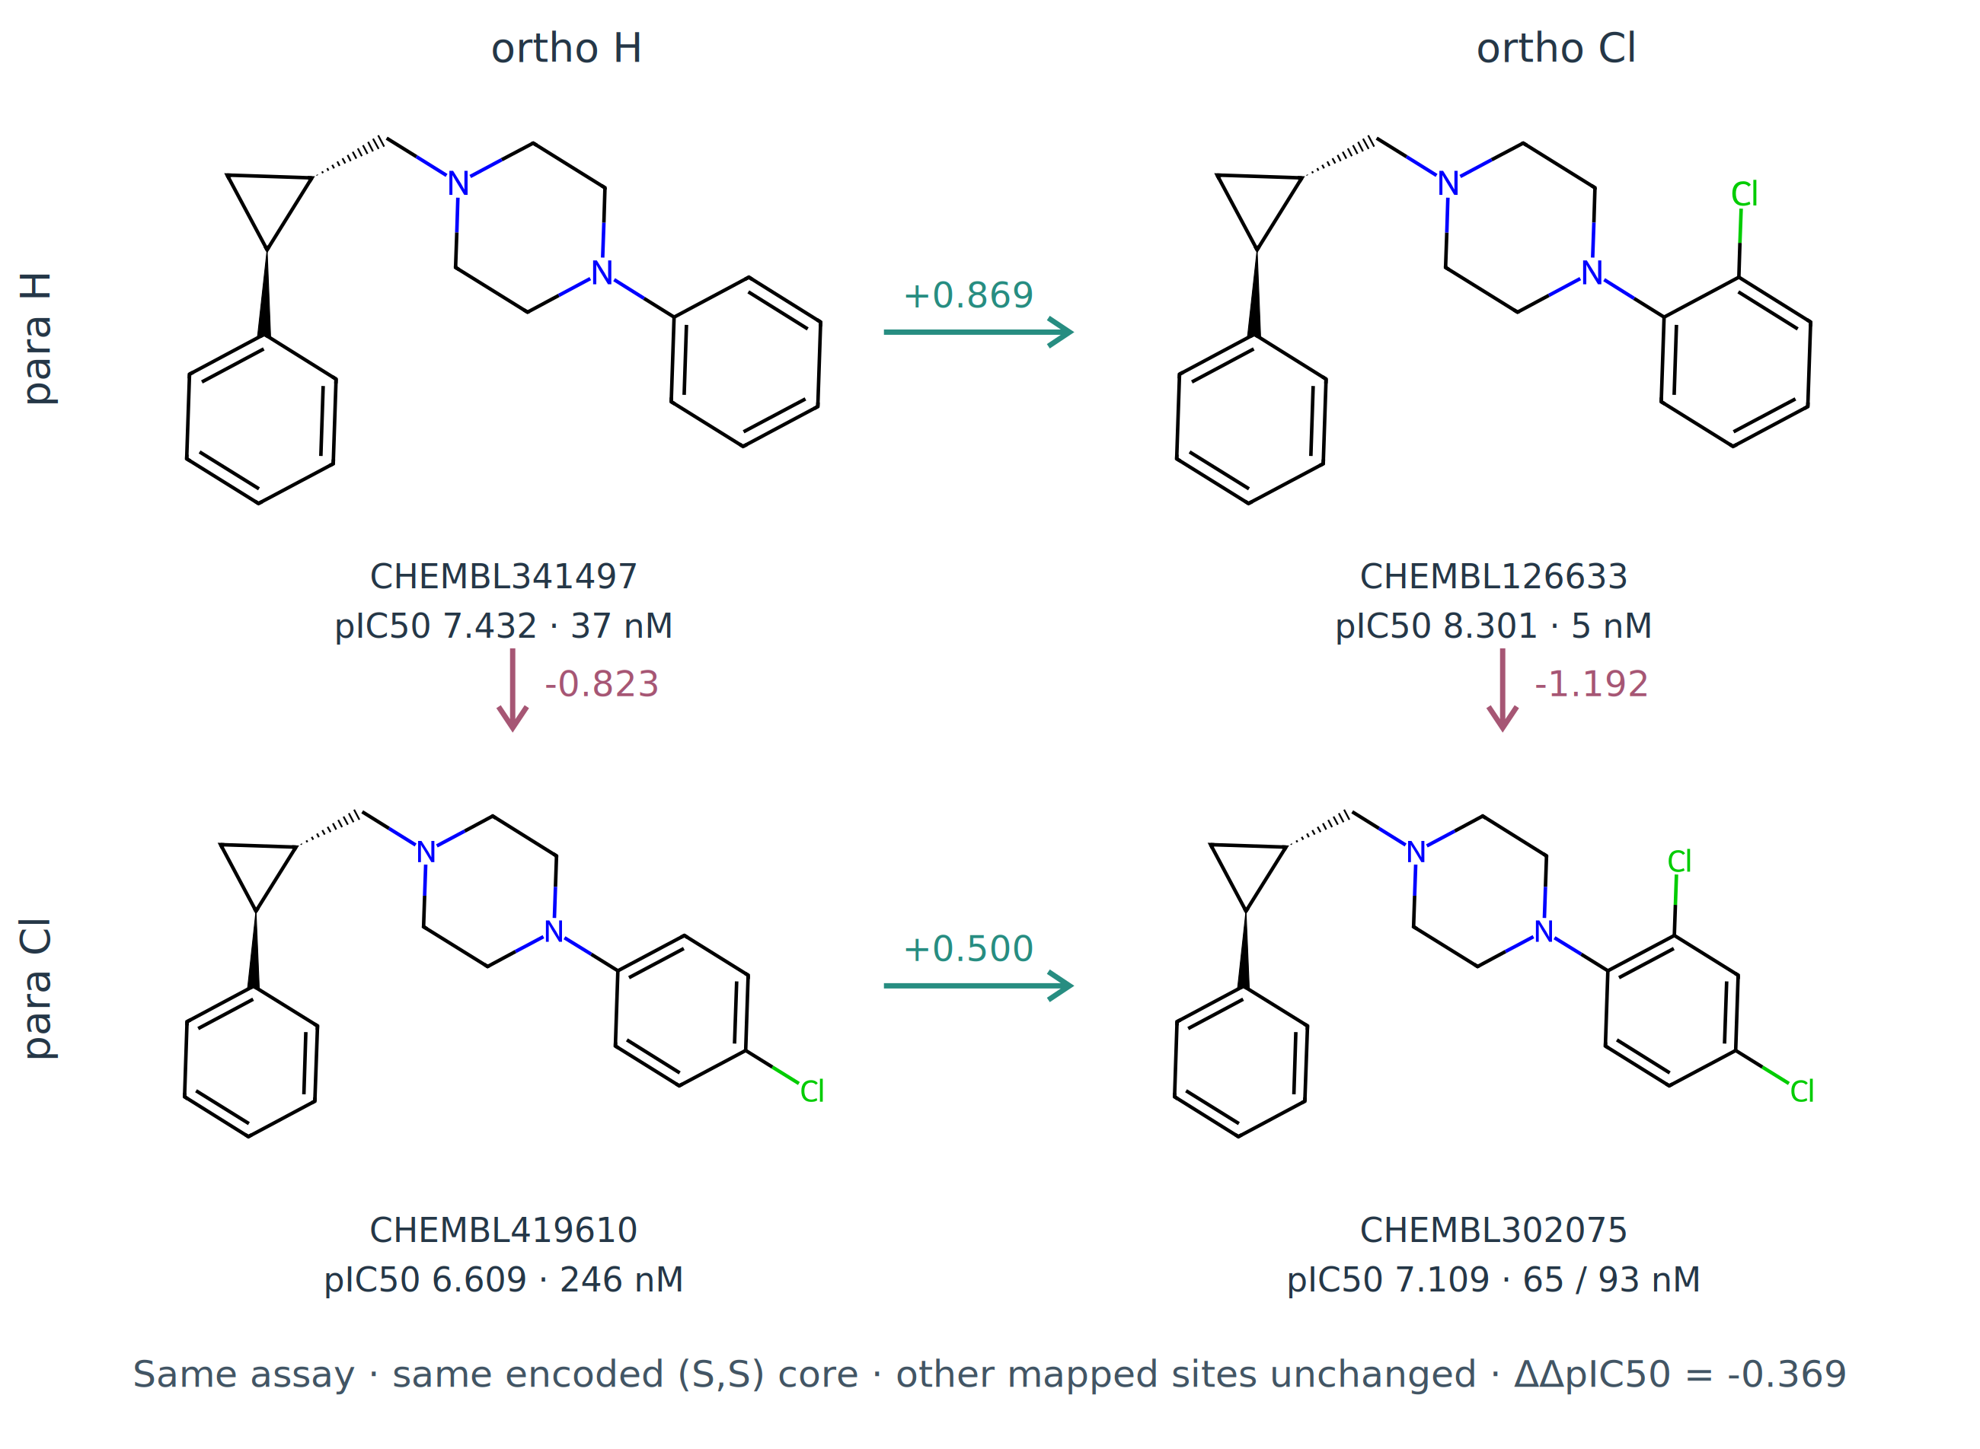
Figure 3. Complete DRD2 para/ortho chlorination cycle within the selected (S,S) core. Other mapped positions are unchanged and all measurements come from CHEMBL671074. Structures and original IC50 values are shown; the doubly chlorinated compound has retained values of 65 and 93 nM. Arrows show differences calculated from median pIC50. The −0.369-unit contrast describes a modest departure from additivity, not a binding free energy or evidence of biological cooperativity.

References
1. Dalke A, Hert J, Kramer C. mmpdb: An Open-Source Matched Molecular Pair Platform for Large Multiproperty Data Sets. J Chem Inf Model. 2018;58:902–910. https://doi.org/10.1021/acs.jcim.8b00173.
2. Zdrazil B et al. The ChEMBL Database in 2023: a drug discovery platform spanning multiple bioactivity data types and time periods. Nucleic Acids Res. 2024;52:D1180–D1192. https://doi.org/10.1093/nar/gkad1004.
3. Kramer C, Fuchs JE, Liedl KR. Strong Nonadditivity as a Key Structure–Activity Relationship Feature: Distinguishing Structural Changes from Assay Artifacts. J Chem Inf Model. 2015;55:483–494. https://doi.org/10.1021/acs.jcim.5b00018.
4. Sander T, Freyss J, von Korff M, Rufener C. DataWarrior: an open-source program for chemistry aware data visualization and analysis. J Chem Inf Model. 2015;55:460–473. https://doi.org/10.1021/ci500588j.
5. Abdel-Maksoud MS et al. Discovery of New Imidazo[2,1-b]thiazole Derivatives as Potent Pan-RAF Inhibitors with Promising In Vitro and In Vivo Anti-melanoma Activity. J Med Chem. 2021;64:6877–6901. https://doi.org/10.1021/acs.jmedchem.1c00230.
6. Zhang X et al. trans-1-[(2-Phenylcyclopropyl)methyl]-4-arylpiperazines: mixed dopamine D(2)/D(4) receptor antagonists as potential antipsychotic agents. J Med Chem. 2000;43:3923–3932. https://doi.org/10.1021/jm990562x.
7. Malamas MS et al. Design and synthesis of aryl diphenolic azoles as potent and selective estrogen receptor-beta ligands. J Med Chem. 2004;47:5021–5040. https://doi.org/10.1021/jm049719y.
8. van Tilborg D, Alenicheva A, Grisoni F. Exposing the Limitations of Molecular Machine Learning with Activity Cliffs. J Chem Inf Model. 2022;62:5938–5951. https://doi.org/10.1021/acs.jcim.2c01073. Correction: 2023;63:2266. https://doi.org/10.1021/acs.jcim.3c00423.
9. RDKit: Open-source cheminformatics. https://www.rdkit.org/. Accessed 13 October 2026.
10. Benjamini Y, Hochberg Y. Controlling the False Discovery Rate: A Practical and Powerful Approach to Multiple Testing. J R Stat Soc B. 1995;57:289–300. https://doi.org/10.1111/j.2517-6161.1995.tb02031.x.

