Supplementary Information: SARscope positional SAR study
Related manuscript: SARscope: interactive analysis of position-dependent structure–activity relationships.

S1. Source datasets and curation
The frozen ChEMBL 37 parent manifest has SHA-256 f48c8aec796c8986de3938febbc95b99149355660e1c31315f98852e3395a493. Assay snapshots and their individual hashes are in the case manifest. Complete assay cohorts were extracted before record filtering; successful transformations were not selected for inclusion in the snapshots.
Series | Target ID | Assay ID | Document ID | Raw records | Retained records | Curated compounds
BRAF | CHEMBL5145 | CHEMBL5046398 | CHEMBL5046217 | 46 | 44 | 44
DRD2 | CHEMBL217 | CHEMBL671074 | CHEMBL1133592 | 34 | 31 | 30
ER-alpha | CHEMBL206 | CHEMBL829540 | CHEMBL1138773 | 107 | 100 | 98

Settings: literature source ID 1; endpoint IC50; exact relation “=”; concentration unit nM; ChEMBL assay type B; no structured variant annotation; exclude potential duplicates and records carrying validity comments. Missing variant annotation is not interpreted as verified wild type. The ER-alpha assay is a counter-assay in a study of ER-beta ligands and was not relabeled ER-beta.
Structure standardization used Sorbent with canonical tautomerization enabled. Records were combined by standardized structure using median pIC50. This is a concentration-unit conversion and structure-level aggregation, not a biological conversion between IC50, Ki, Kd and EC50. Individual retained records remain available with source activity IDs and original concentration values.

S2. Stereochemical core audit
The largest Murcko series was selected by compound count, with lexical scaffold tie-breaking. The Murcko graph did not retain all information needed to separate core stereochemical states in the DRD2 series. Per-compound R-group decomposition cores were therefore recovered with RDKit and checked against the original R-position assignments. Every recovered substituent assignment matched the stored mapping before stereochemical restriction was applied.
The complete mapped, isomeric core string was used to define a core state. This avoids comparing R/S labels in isolation: a change in substituent priorities can alter a CIP label without altering the corresponding geometry. The largest core state was selected by count and lexical tie-breaking, without using potency.
The DRD2 group contained 23 compounds with one assigned core state, two with the opposite state and one with unassigned core stereochemistry. Excluded compounds were CHEMBL125455, CHEMBL126493 and CHEMBL2109988. All 23 selected complete structures carry the (S,S) cyclopropyl assignment according to their encoded structures. This refers to reported structural annotations, not independent experimental verification of stereochemical purity.
Series | Original scaffold group | Core states | Selected compounds | Selected measurements | Positional pairs
BRAF | 16 | 1 | 16 | 16 | 29
DRD2 | 26 | 3 | 23 | 24 | 36
ER-alpha | 53 | 1 | 53 | 55 | 198

The audit files list the core state and retention decision for every compound. This additional restriction was applied by the case-study analysis script. It was not automatically enforced by the original scaffold-group report in the application. Earlier manuscript tables containing 26 DRD2 series compounds and 46 positional pairs are superseded for the scientific analysis by 23 and 36. The earlier exports are preserved as the input record, not silently overwritten.

S3. Pair eligibility and effect summaries
The comparison requires the same selected isomeric core and the same fragment at every other mapped R-position. Potencies are recalculated from the selected assay records. Their medians must match the member table, and every signed pair delta is checked against the underlying compound values.
Transformation direction follows the lexical fragment ordering used by the software and is not chosen to maximize an observed gain. Summaries retain assay, endpoint and structured variant context. In these selected cases there is one assay and endpoint per series and no structured variant annotation. One molecular pair contributes one delta, even if the compound has multiple retained measurements.
The median and interquartile range describe observed pair effects. A conservative deterministic matching counts pairs that share no molecule IDs. Disjoint pairs are not experimental replicates, and overlapping chemical contexts can remain.
Descriptive support criteria reproduce the existing map implementation:
- Mixed: absolute median below the effect threshold, fewer than 80% of pair effects agreeing in sign, or effects beyond the threshold in opposite directions.
- Limited: a directional effect not meeting the disjoint-pair criteria below.
- Moderate: a directional, assay-matched effect with at least two disjoint pairs.
- Strong: a directional, assay-matched effect with at least three disjoint pairs and two remaining-substituent contexts.
The default threshold was 0.5 pIC50 units. It was fixed for the reference analysis, not estimated from assay noise or optimized against the outputs. The terms moderate and strong are interface labels, not significance levels or probabilities. No case reached the map's 20,000-row cap.

S4. Threshold and individual-compound sensitivity
The transformation family was kept fixed while effect thresholds were changed. The support criteria yielded the following numbers of moderate/strong labels:
Series | 0.25 units | 0.50 units | 0.75 units | 1.00 unit
BRAF | 7 | 5 | 4 | 4
DRD2 | 6 | 5 | 4 | 2
ER-alpha | 12 | 7 | 3 | 1
Total | 25 | 17 | 11 | 7

For each transformation, every constituent compound was omitted in turn. All pairs involving that compound were removed together. The median was recalculated only when at least one pair remained. The proportion of valid omissions retaining the original median's sign and the minimum/maximum resulting medians were recorded. For isolated one-pair transformations no valid omission remains; these fields are missing, not set to perfect stability.
All 17 reference moderate/strong transformations retained their median sign for every valid omission. This assessment measures influence within the observed network. It does not add independent evidence, estimate assay precision or demonstrate performance on future compounds.

S5. Label-permutation diagnostic
Five thousand potency-label permutations were generated for each selected series with NumPy random-generator seeds 20261013, 20261014 and 20261015 for BRAF, DRD2 and ER-alpha, respectively. Complete compound values were permuted, not individual pair deltas. Consequently the same shuffled value is used whenever a compound appears in more than one pair. Structures, pair membership and support counts remain fixed.
For each transformation, the two-sided permutation P value was calculated as (1 + number of shuffled absolute medians at least as large as the observed absolute median)/(5,001). A numerical tolerance of 1e-12 was used for comparison of floating-point values. Benjamini–Hochberg adjustment was applied to all 191 values together, not only the transformations selected for figures or support labels. Shared compounds and chemical backgrounds create dependent comparisons; the resulting adjusted values are reported as exploratory diagnostics without claiming guaranteed false-discovery control.
Series | Observed qualifying count | Shuffled mean count | Shuffled central 95% range | Probability of count at least observed
BRAF | 5 | 4.362 | 1–8 | 0.453
DRD2 | 5 | 2.887 | 0–6 | 0.136
ER-alpha | 7 | 5.898 | 2–11 | 0.389

No transformation had an adjusted P value below 0.05. This result limits claims based on support labels; it does not establish that the recorded pair differences are erroneous or that all transformations have no biological effect. The null removes the relationship between complete chemical structure and potency and assumes exchangeability of the measured values within a series. It is not a model of experimental noise or a substitute for new measurements.

S6. Four-compound cycles and mapped-pair cliff sensitivity
Complete cycles were constructed on two mapped positions while holding all other positions and the selected isomeric core constant. Every cell had to contain exactly one standardized compound. The enumeration yielded seven BRAF, six DRD2 and 25 ER-alpha cycles; these overlap and are not independent observations. This is not an exhaustive graph-based MMP nonadditivity search.
The reported DRD2 chlorine cycle contains CHEMBL341497 (H/H), CHEMBL419610 (para-Cl/ortho-H), CHEMBL126633 (para-H/ortho-Cl) and CHEMBL302075 (Cl/Cl). Its contrast is pIC50(Cl/Cl) − pIC50(Cl/H) − pIC50(H/Cl) + pIC50(H/H), equal to −0.3689947652 units. CHEMBL302075 has retained IC50 values of 65 and 93 nM; median aggregation on the logarithmic scale gives a back-converted equivalent concentration of 77.7496 nM. The published records do not identify independent replicate experiments for these entries. The contrast was not assigned a mechanistic or thermodynamic interpretation.
Morgan fingerprints used radius 2, 2,048 bits and chirality disabled. Similarity was calculated with Tanimoto, and the potency gap was the absolute pair ΔpIC50. At similarity above 0.90 and gap above 2.0, one of the 263 mapped pairs was called a cliff: CHEMBL5092007/CHEMBL5076831 in BRAF. The reported values are 97 and 9,710 nM; the gap is 2.00045 and similarity 0.918033. No call remains at similarity above 0.95 or gap above 2.5 units. The full cutoff grid and pair values are supplied. These counts concern mapped positional pairs only.

S7. mmpdb coverage comparison
Both methods received the same curated compounds from the complete assay cohorts, before the selected-core restriction used for the positional study. Counts therefore use 44 BRAF, 30 DRD2 and 98 ER-alpha compounds. The comparison used mmpdb 3.1.4, one cut, the RDKit default cut pattern, no extra salt removal, variable fragments of at most ten heavy atoms and at most half of the complete molecule. Commands, logs, fragment databases and pair membership are archived.
Series | SARscope unique pairs | mmpdb unique pairs | Shared | mmpdb-only
BRAF | 114 | 116 | 114 | 2
DRD2 | 205 | 205 | 205 | 0
ER-alpha | 441 | 495 | 441 | 54

All 56 mmpdb-only pairs contain an explicit hydrogen variable fragment in the mmpdb representation. This identifies a limitation of the current single-cut enumerator, not of the R-group map's representation of H alternatives. Timing values are retained in the original log but are not used as a speed comparison. No counterbalanced DataWarrior/RDKit/SARscope human-workflow study has been run.

S8. Supporting retrospective regression benchmark
The previously run frozen panel retained exact nM binding IC50 values lacking a structured variant annotation, excluded duplicate/validity flags and aggregated by standardized structure. It was not restricted to the three case-study assays. The label in the historical protocol should not be taken as confirmation of wild-type protein identity when annotations were absent.
Models used ECFP4 with fold-local feature filtering, a 200-tree random forest with maximum depth 15, three-fold scaffold-group training cross-validation, an outer 20% scaffold holdout and seed 42. Acyclic molecules were separate groups. The baseline predicted the training-set median. A thousand resamples of the saved held-out scaffold groups, seed 42, provided conditional RMSE intervals without retraining the models.
Target | Test compounds | R² | RMSE | Conditional 95% RMSE interval | Spearman | Baseline RMSE
BRAF | 584 | 0.762 | 0.646 | 0.578–0.720 | 0.859 | 1.342
DRD2 | 99 | 0.310 | 0.902 | 0.756–1.041 | 0.574 | 1.087
ER-alpha | 651 | 0.696 | 0.828 | 0.744–0.925 | 0.836 | 1.503

The intervals condition on one fitted model and split per target. Assay and document overlap may remain, and the selected panel is not external validation, cross-target transfer or a prospective trial. The case-study cohorts overlap this source pool and must not be described as independent QSAR test datasets.
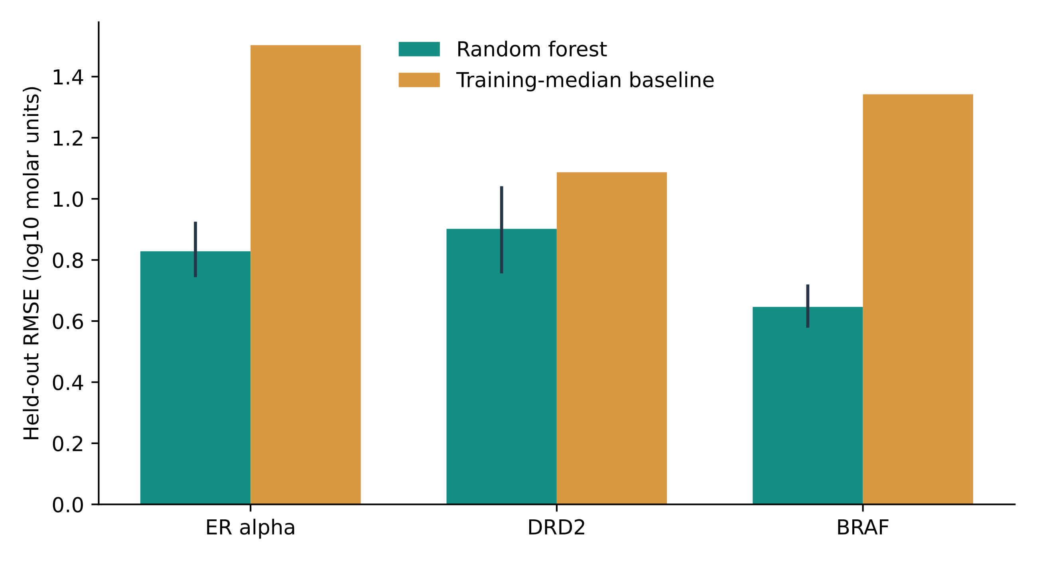
Figure S1. Previously saved scaffold-held-out regression errors and a training-median baseline. Intervals are conditional test-scaffold resampling intervals, not repeated-training uncertainty.

S9. Software, execution and availability
The analysis layer is implemented in Python; the browser interface uses Streamlit. Structure standardization uses Sorbent/RDKit, tabular operations pandas, numerical operations NumPy/SciPy and optional modeling scikit-learn. The analysis does not require the browser, a remote rendering service or docking. An SVG component supports position selection, while CSV exports retain measurements and source IDs.
The scientific robustness analysis is reproducible with the supplied analysis script, retained source tables and a new output directory. It performs no API queries, docking or model training. Seeds, settings, individual input SHA-256 hashes and package versions are recorded in its provenance file. The original case evaluation was also reproduced in a fresh isolated Linux/Python 3.13 environment; all 26 CSV outputs matched after timing fields were excluded. The supplied wheel-hashed runtime lock is platform-specific.
Observed analysis versions: RDKit 2026.3.6, NumPy 2.5.3, pandas 3.0.6, SciPy 1.18.1, scikit-learn 1.9.1 and Sorbent 0.1.0. The source revision base was 7a8e4c805d671d92bccf38673bd00bc2207ad7cd with manuscript/evaluation changes not yet committed at preparation. File hashes, rather than this base revision alone, define the accompanying working package.
Independent source-paper SAR annotation, expert review, human-workflow comparisons and external release-archive reproduction remain unperformed. A publicly accessible versioned code/data deposit must be provided before submission. Source code is MIT; ChEMBL-derived evidence is CC BY-SA 3.0.

