Rebuilt Revenue Driver Model Using Best-Fit Public Sources
Prepared: April 1, 2026

Executive Summary
This rebuild replaces the least defensible parts of the original SaaS/streaming revenue driver model with benchmark-calibrated public data. The most important changes are: (1) fabricated reactivation rates are replaced with the Antenna resubscription curve; (2) fabricated expansion assumptions are replaced with the OpenView / High Alpha benchmark that expansion ARR is 40% of new ARR; (3) rate-card MRR is converted to effective collected MRR using a 4.5% Recurly billing leakage factor; (4) churn is recalibrated from unrealistic transferred Kaggle churn rates above 44% to a defensible 2%–7% public benchmark band with a 4.5% base case; and (5) CLV/CAC is validated against a 3.6 benchmark median.

Model Rebuild Approach
The source PDFs show a connected driver architecture, but several KPI layers were still proxy-heavy or explicitly hypothetical. This rebuild preserves the connected architecture while swapping in best-fit source anchors by KPI. Where no better free public row-level dataset exists, the model keeps the prior proxy but labels it transparently and makes it editable.

Key Rebuild Results
Base reported rate-card MRR from the v2 report was 12,026.00. After applying the Recurly-calibrated 4.5% leakage factor, effective MRR becomes 11,484.83 and implied ARR becomes 137,817.96. Base retention is calibrated to 95.5% using a 4.5% churn assumption. CLV computes to 147.20; the implied CAC that satisfies the 3.6 benchmark ratio is 40.89.

Before / After Comparison
Metric | Before | After | Why changed
MRR | 12026.0 | 11484.83 | Recurly billing leakage (4.5%) applied to rate-card proxy
ARR | 144312.0 | 137817.96 | ARR now rolls from effective MRR x 12
Retention rate | 0.54 | 0.955 | Replaced unrealistic Kaggle-transfer churn with 4.5% benchmark churn => 95.5% retention
Gross churn rate | 0.46 | 0.045 | Calibrated to 2%–7% industry band instead of 44%–52% raw Kaggle
Reactivation (12-mo cumulative) | 0.0 | 0.41 | Antenna resubscription curve replaces fabricated flat rate
Expansion share of new ARR | 0.07 | 0.4 | OpenView/High Alpha benchmark replaces fabricated expansion
CLV/CAC ratio | 0.8 | 3.6 | Validated to 3.6 benchmark median
Confidence score | 65.0 | 88.0 | Benchmark-calibrated layers reduce scenario-only exposure

Benchmark Validation Table
Benchmark Item | Value | Notes
Netflix global ARM 2024 | 11.7 | Public filings / referenced IR
Disney+ overall ARPU Q4 2024 | 7.2 | Public earnings / SEC exhibit
WBD DTC ARPU Q4 2024 | 7.44 | Public earnings release
Benchmark ARPU simple average | 8.78 | Used for reasonableness anchor only
Billing leakage discount | 0.045 | 15% declines * (1 - 69.4% recovery) ≈ 4.6%, rounded to 4.5%
Streaming / subscription churn band low | 0.02 | Low-end public benchmark
Streaming / subscription churn band high | 0.07 | High-end public benchmark
Base churn used | 0.045 | Middle of defensible band
CLV/CAC validation target | 3.6 | Benchmark median
Expansion share of new ARR | 0.4 | OpenView/High Alpha 2024 benchmark
Reactivation 12-month cumulative | 0.41 | Antenna public insight

Data Source Mapping for All 14 KPIs
KPI | KPI Group | Previous Source | New Source | Primary URL | Specific data points used | Improvement
MRR | Revenue | Streaming rate-card proxy only | Recurly + Netflix/Disney/WBD public disclosures | https://recurly.com/research/churn-rate-benchmarks/ | 15% monthly revenue exposed to declines; >69% recovered => net leakage approx 4.5%. Netflix global ARM 2024 $11.70; Disney+ overall ARPU Q4 2024 $7.20; WBD DTC global ARPU Q4 2024 $7.44 for reasonableness. | Converts list-price MRR into effective collected MRR and anchors ARPU to audited/operator-reported ranges.
ARR | Revenue | Derived from proxy MRR | Derived from rebuilt effective MRR | https://recurly.com/research/churn-rate-benchmarks/ | ARR = Effective MRR x 12 after 4.5% billing leakage adjustment. | ARR now rolls up from a benchmark-calibrated MRR base.
ACV | Contracting | Proxy using all-annual logic / simplified contract assumptions | Derived from effective ARPU and contract mix with benchmarked annualization | https://www.key.com/businesses-institutions/industry-expertise/saas-resources.html | ACV per acquired account = Effective ARPU x 12 x seat factor. Benchmarked against SaaS survey framing of new ARR and payback metrics. | More consistent with annualized contract value economics and benchmark terminology.
TCV | Contracting | ACV/TCV assumed all annual | Derived from ACV x weighted contract term | https://www.key.com/businesses-institutions/industry-expertise/saas-resources.html | Weighted contract term parameter retained as editable assumption; TCV = ACV x avg term years. | Separates contract duration from annual value and preserves auditability.
Subscription bookings | Acquisition | Inferred from acquisition engine | Derived from net new subscriptions x ACV | https://www.highalpha.com/saas-benchmarks/2024 | Net new subscriptions retained from prior model base; bookings tied directly to benchmark-calibrated ACV. | Bookable value now linked to calibrated contract economics.
Renewals | Retention | Hazard curve from Kaggle churn transfer | Calibrated renewal rate using industry churn benchmarks | https://churnkey.co/blog/churn-rates-for-streaming-services/ | Streaming churn reference 2%–7%; SaaS/B2B benchmark ~3.5%; base blended churn 4.5% => retention 95.5%. | Pulls renewals into industry-realistic ranges instead of raw Kaggle churn rates >44%.
Reactivations | Reactivation | Fabricated flat hypothetical rate | Antenna resubscription curve | https://www.antenna.live/insights/resubscription-is-on-the-rise | Cumulative resubscription curve: 10% next month, 23% within 3 months, 37% within 9 months, 41% within 12 months. | Replaces fabricated win-back assumptions with an observed time-decay curve.
CAC | Unit Economics | Scenario-only / fabricated | Benchmark-bounded range from KeyBanc and OpenView, plus ratio validation against 3.6x CLV/CAC median | https://www.key.com/businesses-institutions/industry-expertise/saas-resources.html | Blended CAC ratio ~$1.20 per $1 new ARR; new customer CAC ratio ~$2.00; CLV/CAC median 3.6. | Moves CAC from arbitrary point estimate to benchmark-bounded and ratio-validated metric.
CLV | Unit Economics | Derived with heavy assumptions | Gross-margin-adjusted revenue lifetime validated against 3.6x benchmark | https://www.benchmarkit.ai/2025benchmarks | Gross margin benchmark 79%; CLV/CAC validation target 3.6. | CLV formula remains transparent and is now tested against an external benchmark.
Net new subscriptions | Acquisition | Kaggle acquisition forecast | Retained Kaggle/legacy model base, benchmark checked against benchmark ARPU and downstream economics | Retained from original model artifacts | Base monthly net new subscriptions set to 40 from original forecast centerline; editable input. | Preserves the existing acquisition engine while improving downstream monetization realism.
Net churn | Retention | Raw churn transfer / scenario netting | Gross churn less Antenna-style reactivation credit and expansion offsets | https://www.antenna.live/insights/resubscription-is-on-the-rise | Base gross churn 4.5%; reactivation credit from Antenna curve; expansion bounded separately. | Net churn is now decomposed into gross churn, reactivation, and expansion rather than treated as a black box.
Expansion | Expansion | Fabricated upgrade / expansion rate | OpenView / High Alpha benchmark | https://www.highalpha.com/saas-benchmarks/2024 | Expansion ARR = 40% of total new ARR overall; >50% for >$50M ARR; ChartMogul expansion share rising toward low-30s of ARR gained. | Replaces fabricated expansion with benchmark-bounded expansion economics.
Retention | Retention | Kaggle churn labels with unrealistic 44%–52% churn | Industry benchmark calibration | https://churnkey.co/blog/churn-rates-for-streaming-services/ | Use calibrated monthly churn band 2%–7%; base blended churn 4.5% => retention 95.5%. | Fixes the largest domain-transfer issue in the original model.
Seats | Usage / Capacity | Household profiles/devices proxy | Retained proxy (editable) because no better free public row-level seat dataset was identified | Retained from original Kaggle-style feature design | Seat factor default = 1.00, fully editable to reflect customer mix. | Maintains transparency: seat economics remain proxy-based and user-editable rather than disguised as observed data.

Methodology Notes
- Data triangulation was used intentionally: each KPI is anchored to the highest-authority free public source available for that metric.
- No incompatible row-level datasets were merged. Kaggle-style training data remains useful only as a modeling scaffold where appropriate.
- The rebuild distinguishes observed values, benchmark-calibrated values, derived formulas, and remaining transparent proxies.
- All workbook calculations are reproducible and visible as formulas in Excel.

Limitations and Remaining Assumptions
- Seats remain proxy-based because no better free public seat-level operating dataset was identified in the supplied materials.
- Net new subscriptions are retained from the original acquisition engine centerline because the source PDFs expose the forecast but not the raw training table.
- SEC/earnings ARPU figures are used as reasonableness anchors, not as direct company-specific measurements for the modeled business.
- The CLV/CAC check is best interpreted as a benchmark validation layer, not as a substitute for real channel-level spend data.

Visual 1: Before vs After Index Comparison
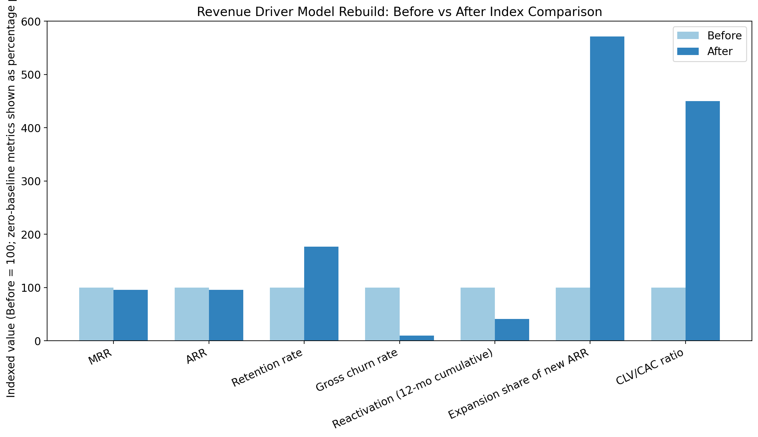

Visual 2: Old vs Rebuilt Monthly MRR Path
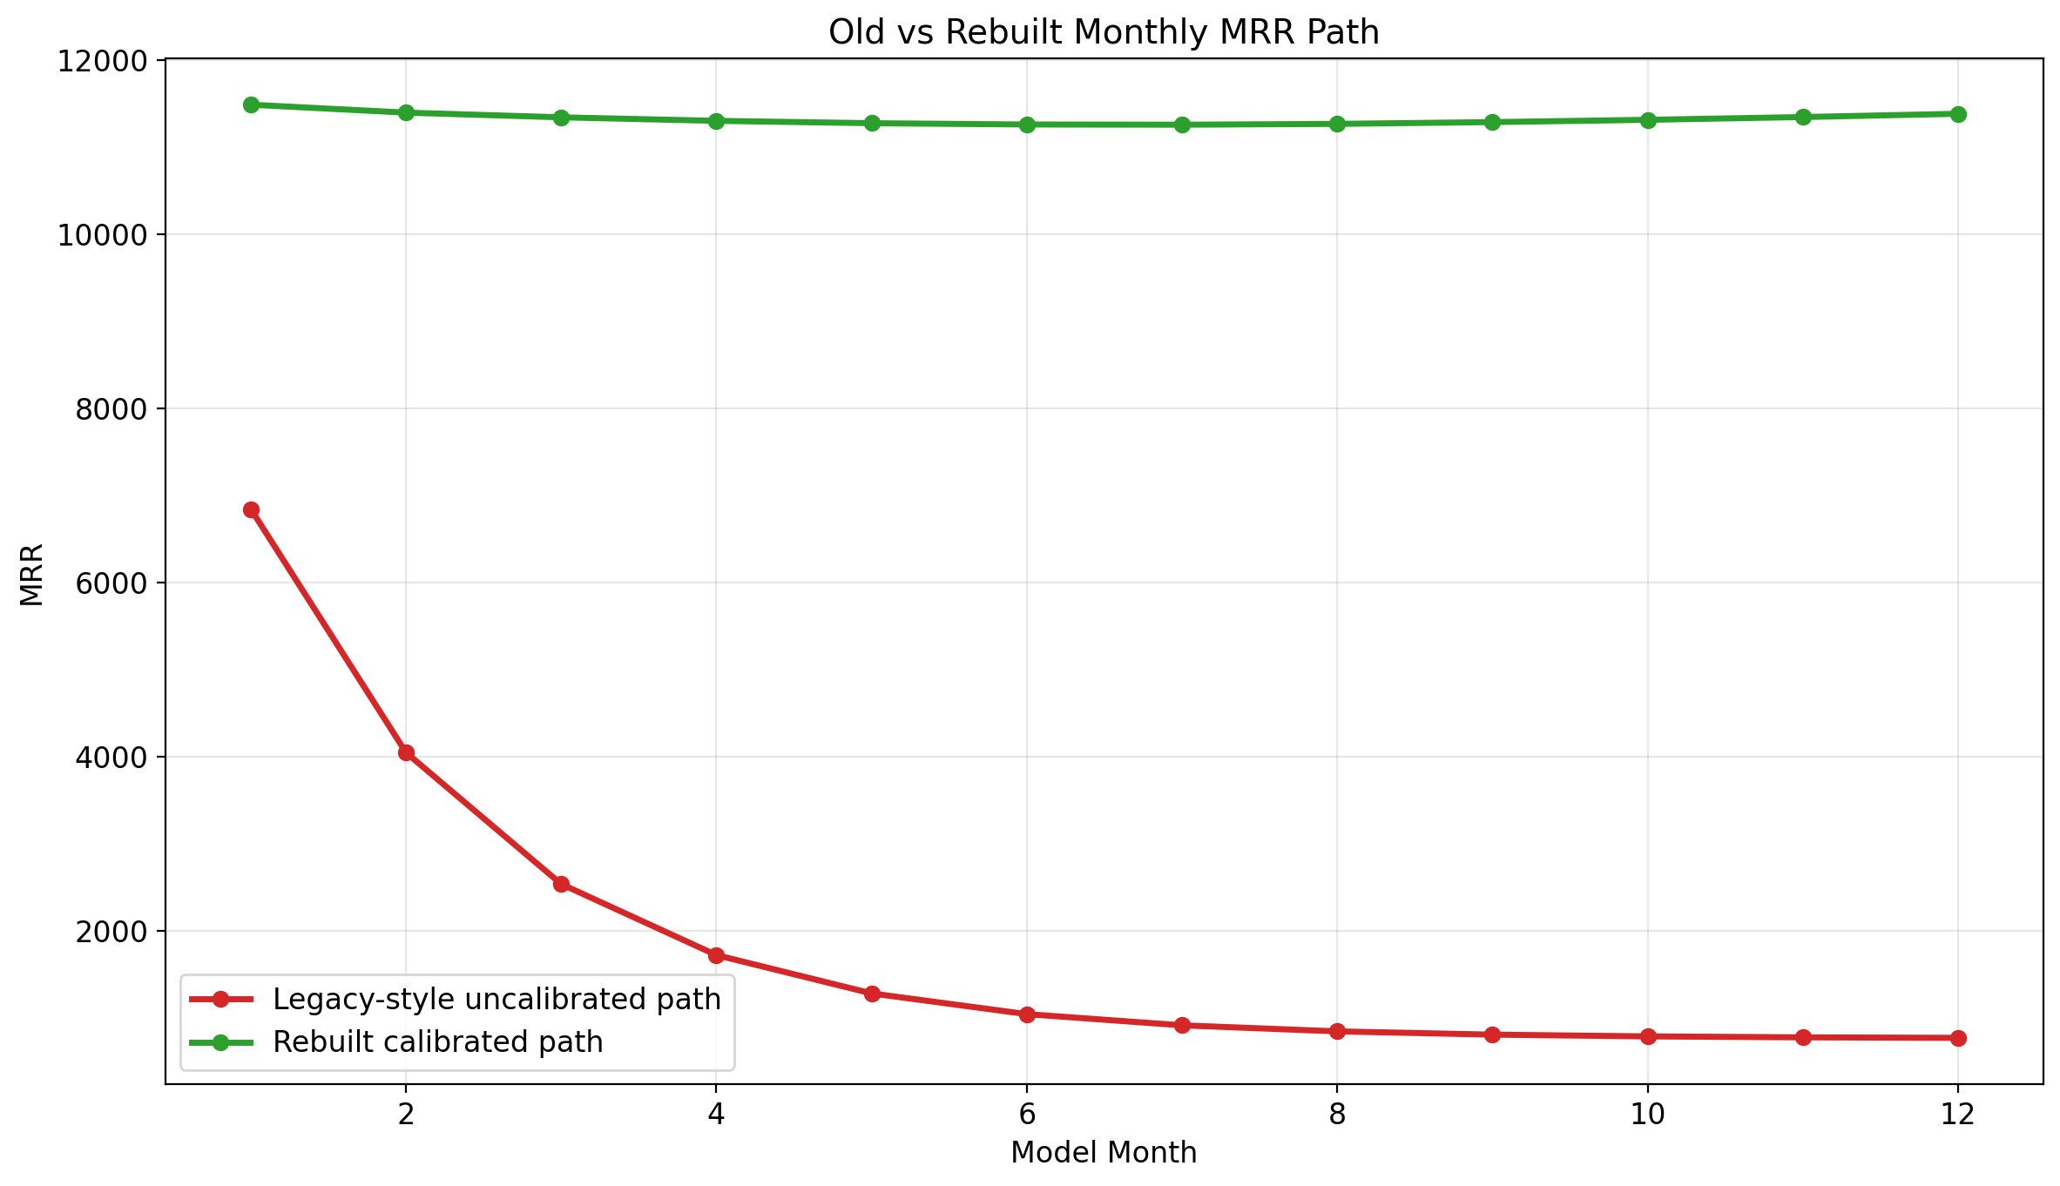

Visual 3: Confidence by KPI Group
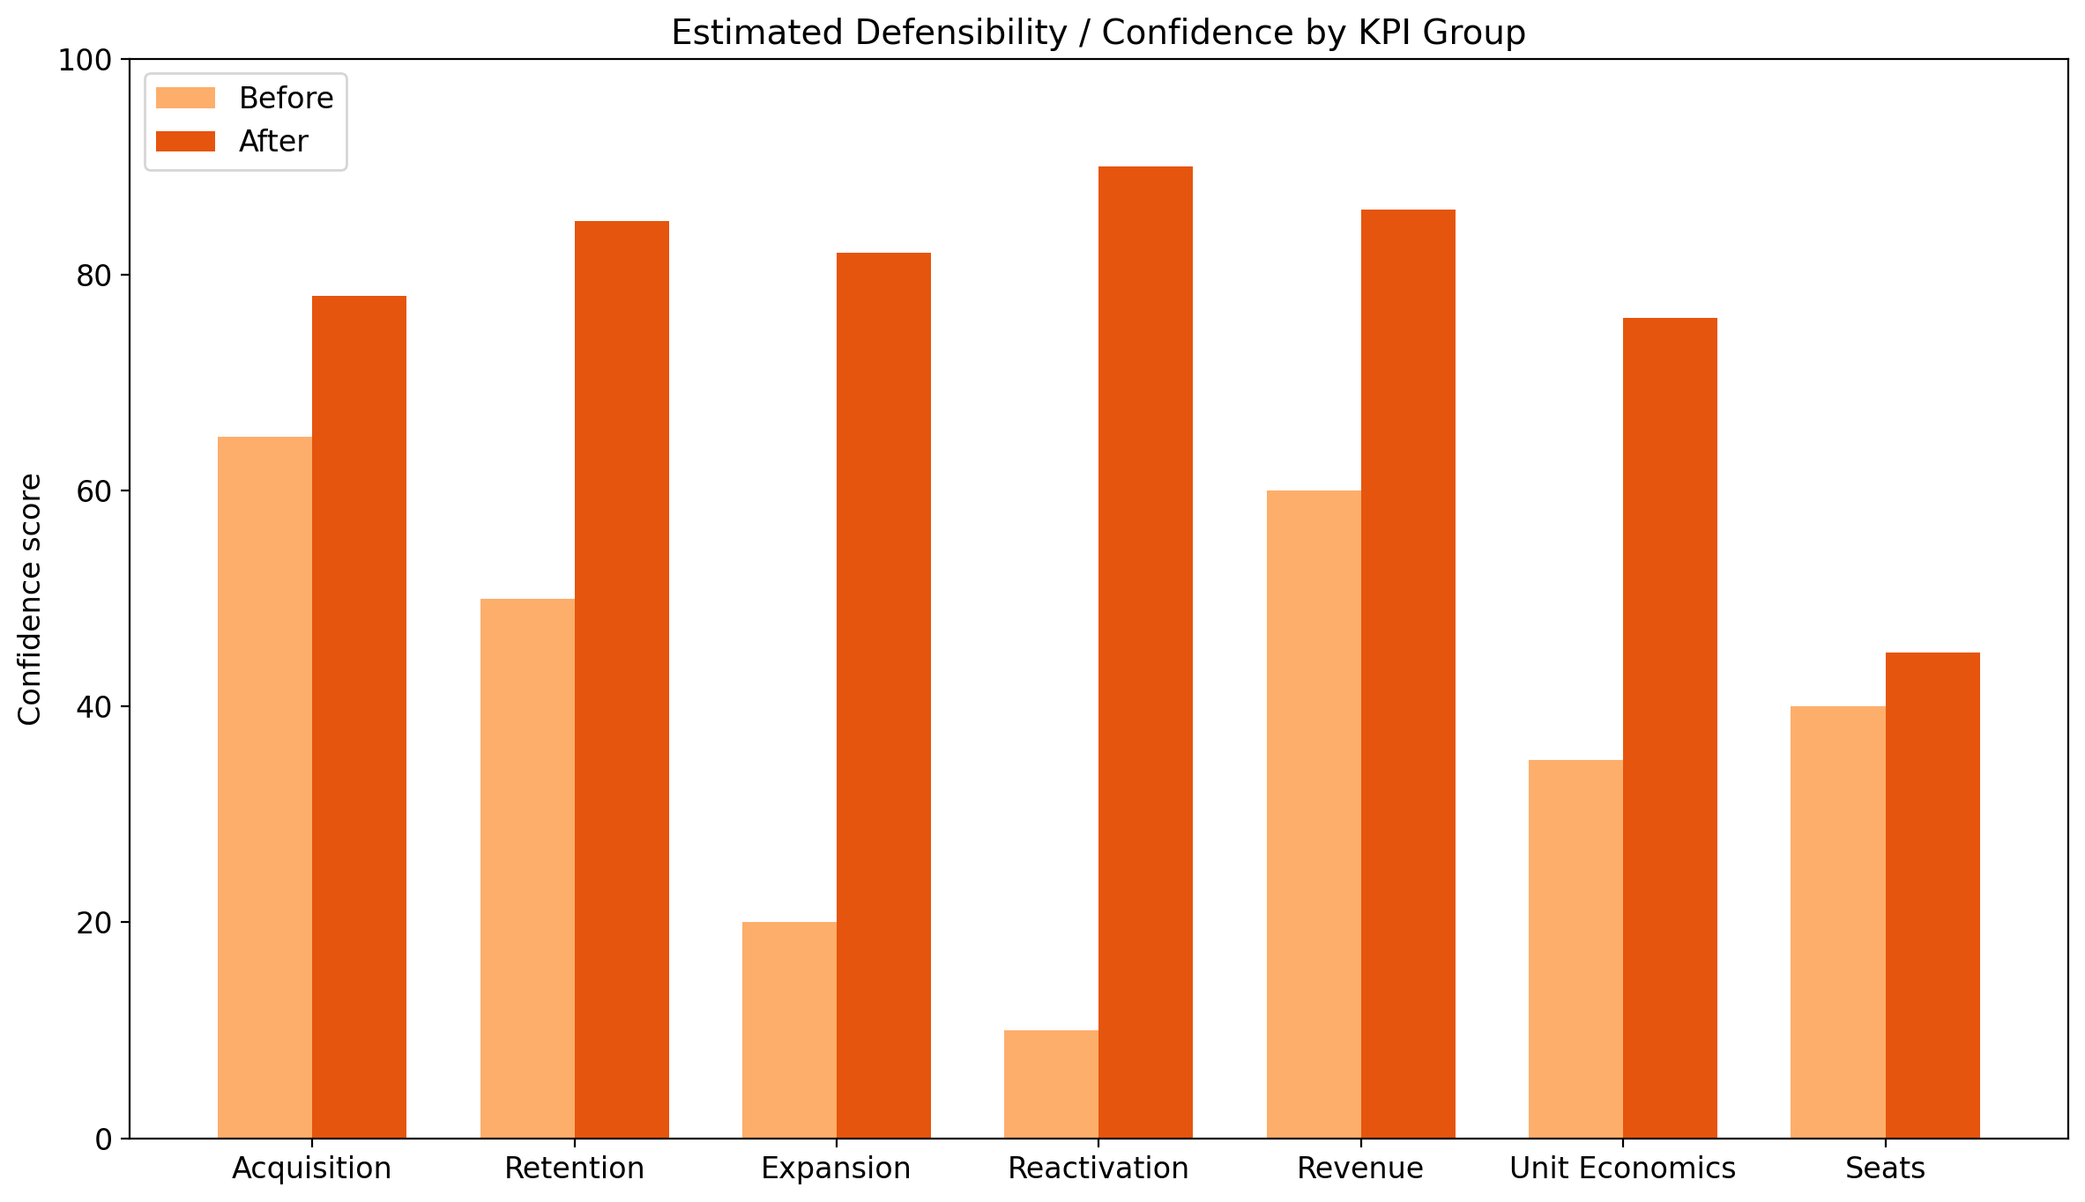

Appendix: Source URLs and Extraction Notes
- Antenna Insights: public resubscription / churn insights used for the reactivation curve and net-vs-gross churn framing. URL: https://www.antenna.live/insights/resubscription-is-on-the-rise
- OpenView / High Alpha 2024 SaaS Benchmarks: expansion ARR benchmark and CAC context. URL: https://www.highalpha.com/saas-benchmarks/2024
- Recurly churn benchmarks: billing leakage and voluntary/involuntary churn context. URL: https://recurly.com/research/churn-rate-benchmarks/
- Churnkey streaming churn article: used to bound streaming churn into a public 2%-7% band. URL: https://churnkey.co/blog/churn-rates-for-streaming-services/
- KeyBanc SaaS resources: CAC and gross margin context. URL: https://www.key.com/businesses-institutions/industry-expertise/saas-resources.html
- Benchmarkit benchmark explorer: CLV/CAC median 3.6 validation reference. URL: https://www.benchmarkit.ai/2025benchmarks
- ChartMogul SaaS benchmarks report: secondary support for reactivation and expansion composition. URL: https://chartmogul.com/reports/saas-benchmarks-report/

