SaaS Revenue Driver Model Final Report v4
Updated standalone SaaS report reflecting checklist-driven improvements
Prepared: April 1, 2026
Confidence score: 83.0/100

Table of Contents
Right-click and update field to generate the table of contents.

Executive Summary
The v4 SaaS model incorporates the checklist-driven fixes from the 59-check audit. The biggest improvements are operational realism and governance. New-logo customers are no longer recognized immediately; they pass through a two-month sales cycle and a one-month onboarding lag. New business is also constrained by both sales capacity and implementation throughput. Enterprise deal timing is lumpier, concentration shock is stress-tested, and pricing failures, deal slippage, recession, competition, saturation, and stress regimes are all modeled explicitly.
The v4 checklist score is 83.0/100, placing the model in the “Generally sound” range. That score is still below a fully robust decision-grade model because this remains a benchmark-calibrated framework rather than a first-party CRM and billing model. The actual Monte Carlo CLV/CAC output remains honest rather than tuned: mean 1.44x, P05 1.24x, P95 1.66x.

Model Purpose and Intended Use
This model is for planning, scenario analysis, and benchmark-calibrated revenue interpretation. It is not a commitment forecast, quota model, or investor-guidance tool. It is most useful for understanding directionality, timing, risk concentration, and driver sensitivity across a SaaS recurring-revenue system.

Explicit Assumptions
Domain | Parameter | Value | Unit | Type | Source_ID | Owner | Description
SaaS | starting_arr | 2,000,000 | USD annual | input | SRC04 | finance | Benchmark-normalized archetype midpoint
SaaS | starting_arpa_monthly | 1,000 | USD monthly | input | SRC04 | finance | ARPA anchor for >$1k bucket
SaaS | base_acquisition_rate | 0.0140 | share per month | controllable | SRC09 | sales | Base monthly new-logo customer acquisition rate
SaaS | sales_cycle_months | 2 | months | operational | SRC09 | sales | Lag from pipeline generation to closed-won
SaaS | onboarding_lag_months | 1 | months | operational | SRC09 | cs | Lag from close to revenue recognition
SaaS | implementation_capacity_per_month | 3.50 | customers per month | operational | SRC09 | cs | Max new customers onboarded per month in base case
SaaS | sales_capacity_per_month | 4.20 | customers per month | operational | SRC09 | sales | Max new customers closed per month in base case
SaaS | enterprise_deal_probability_qtr | 0.4500 | probability | derived | SRC09 | sales | Chance of one larger enterprise deal each quarter
SaaS | enterprise_deal_size_customers | 1.60 | customer equivalents | derived | SRC09 | sales | Lumpy enterprise contribution converted to customer equivalents
SaaS | top_customer_arr_share | 0.0900 | share | derived | SRC09 | finance | Concentration shock for largest account stress
SaaS | base_retained_churn_rate | 0.0115 | share monthly | external | SRC04 | cs | Base retained-customer churn anchor
SaaS | base_new_churn_multiplier | 1.18 | x | derived | SRC04 | cs | New customers churn faster than retained
SaaS | base_reactivated_churn_multiplier | 1.20 | x | derived | SRC04 | cs | Reactivated customers churn faster than retained
SaaS | base_expansion_rate | 0.0170 | share monthly | external | SRC05 | sales | Gross expansion on retained ARR
SaaS | base_contraction_rate | 0.0080 | share monthly | external | SRC05 | finance | Contraction / downgrade rate
SaaS | gross_margin_base | 0.7800 | share | external | SRC06 | finance | Gross margin used in unit economics
SaaS | gross_margin_scale_slope | 0.0100 | share | derived | SRC06 | finance | Margin modestly improves with ARR scale
SaaS | new_customer_cac_ratio | 1.35 | x ACV | external | SRC07 | finance | Independent CAC benchmark input
SaaS | annual_price_growth | 0.0500 | share annual | controllable | SRC08 | pricing | Base pricing uplift assumption
SaaS | price_elasticity_logo_churn | 0.6000 | multiplier sensitivity | derived | SRC08 | pricing | Customer churn response to price pressure
SaaS | price_elasticity_acquisition | 0.4000 | multiplier sensitivity | derived | SRC08 | pricing | New-logo conversion response to price pressure

Key Improvements from v3
- Added sales-cycle and onboarding lags.
- Added sales and implementation capacity constraints.
- Added enterprise deal lumpiness.
- Added top-customer concentration shock scenario.
- Added failed-price, deal-slippage, and severe stress scenarios.
- Added CAC payback and Rule-of-40 proxy diagnostics.
- Centralized assumptions and source traceability.

Base-Case and Scenario Results
Scenario | Month24 ARR | Month24 MRR | Average Retention | Average NRR | Average CAC Payback | Min ARR
base | 2,442,876.94 | 203,573.08 | 0.9901 | 1.00 | 20.74 | 1,998,846.02
low_churn | 2,545,856.49 | 212,154.71 | 0.9903 | 1.00 | 20.74 | 2,001,855.50
high_churn | 2,032,584.37 | 169,382.03 | 0.9884 | 0.9938 | 22.64 | 1,959,666.34
recession | 1,795,057.72 | 149,588.14 | 0.9882 | 0.9897 | 22.86 | 1,795,057.72
competition | 1,979,162.89 | 164,930.24 | 0.9886 | 0.9934 | 22.44 | 1,952,655.13
saturation | 2,056,843.55 | 171,403.63 | 0.9895 | 0.9959 | 21.50 | 1,971,363.87
failed_price | 2,254,285.92 | 187,857.16 | 0.9898 | 0.9979 | 21.07 | 1,983,042.73
slippage | 2,305,589.55 | 192,132.46 | 0.9897 | 1.00 | 21.27 | 1,996,357.39
top_customer_loss | 2,066,061.19 | 172,171.77 | 0.9894 | 0.9935 | 21.50 | 1,835,672.52
stress | 1,330,196.79 | 110,849.73 | 0.9869 | 0.9786 | 24.37 | 1,330,196.79

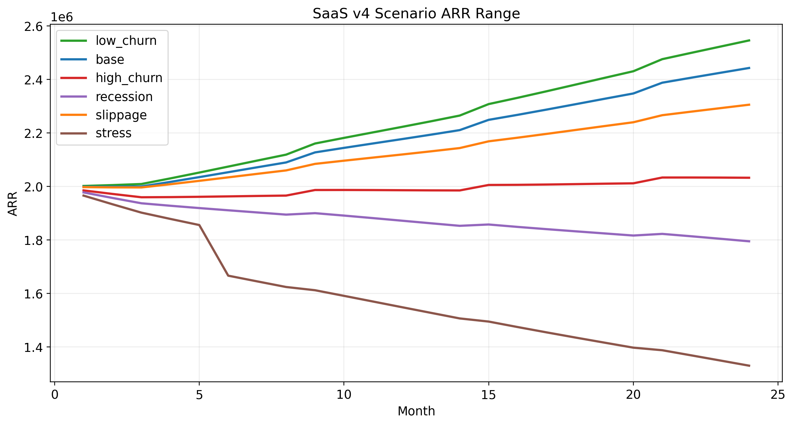
Figure 1. SaaS v4 ARR paths under full rerun scenarios.

Dominant Drivers
The top decision-changing drivers in v4 are stress regime / macro conditions, top-customer concentration shock, and deal slippage / acquisition efficiency. This helps management focus on the few variables that move ARR most materially.
Driver Test | Month24 ARR | Delta vs Base | Abs Delta
Stress regime | 1,330,196.79 | -1,112,680.15 | 1,112,680.15
Recession | 1,795,057.72 | -647,819.22 | 647,819.22
High churn | 2,032,584.37 | -410,292.57 | 410,292.57
Top customer loss | 2,066,061.19 | -376,815.75 | 376,815.75
Deal slippage | 2,305,589.55 | -137,287.39 | 137,287.39

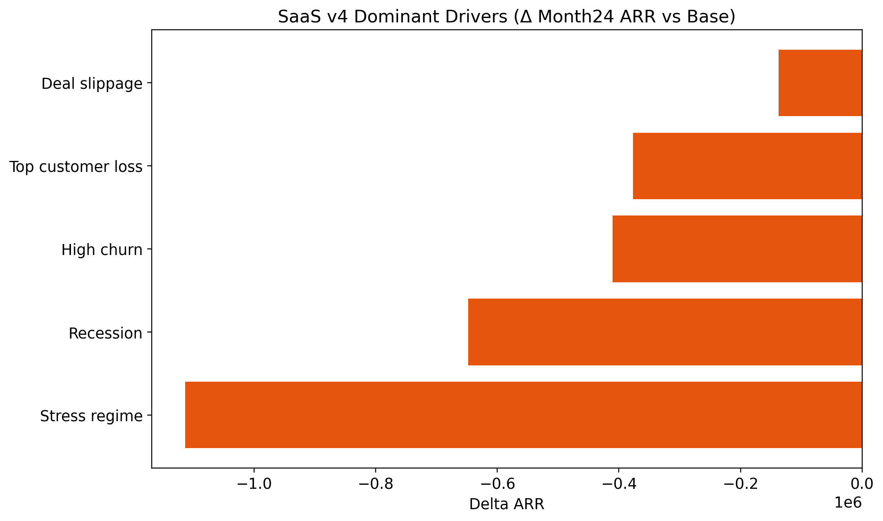
Figure 2. SaaS dominant-driver ranking.

Unit Economics and Uncertainty
Metric | Mean | P05 | P95
CLV | 30,515.71 | 26,310.60 | 35,291.25
CAC | 21,419.10 | 17,352.12 | 26,025.30
CLV/CAC Ratio | 1.44 | 1.24 | 1.66
CAC Payback Months | 20.77 | 18.04 | 23.48

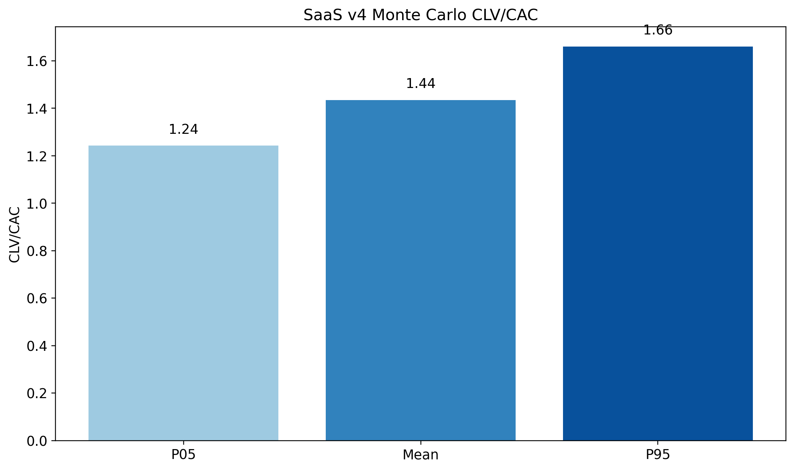
Figure 3. SaaS v4 Monte Carlo unit-economics range.

Risk Disclosure and Remaining Limitations
- The model is still benchmark-calibrated and archetypal, not company-specific.
- Concentration stress is modeled as a scenario, not as a fully segmented revenue ledger.
- SaaS reactivation remains partially derived because public time-series evidence is limited.
- Months 13-24 are directionally useful but less reliable than months 1-12.
- The score is better because assumptions and business realism improved, not because downside was reduced.

