Streaming Revenue Driver Model Final Report v4
Updated standalone Streaming report reflecting checklist-driven improvements
Prepared: April 1, 2026
Confidence score: 83.3/100

Table of Contents
Right-click and update field to generate the table of contents.

Executive Summary
The v4 Streaming model incorporates the checklist-driven fixes by improving assumption governance, uncertainty communication, scenario width, pricing-failure handling, campaign timing realism, and dominant-driver transparency. The model retains explicit subscriber accounting and adds a clearer separation between controllable actions, external conditions, and derived assumptions. It also expands downside coverage through failed-price and severe stress scenarios.
The v4 checklist score is 83.3/100, placing the model in the “Generally sound” range. The most important remaining limitation is that streaming gross-margin-based unit economics remain intentionally excluded rather than fabricated. This keeps the model more honest even if it leaves some economic questions unanswered.

Model Purpose and Intended Use
This model is for planning, scenario analysis, and recurring-revenue system interpretation. It is not a commitment forecast. It is most useful for evaluating how acquisition, churn, reactivation, pricing, leakage, and installed-base monetization interact.

Explicit Assumptions
Domain | Parameter | Value | Unit | Type | Source_ID | Owner | Description
Streaming | starting_rate_card_mrr | 12,026 | USD monthly | input | SRC01 | model | Observed anchor used to derive beginning subs
Streaming | weighted_arpu | 9.60 | USD monthly | input | SRC01 | model | Subscriber-weighted ARPU anchor
Streaming | billing_leakage_base | 0.0450 | share | external | SRC03 | finance | Base leakage from billing decline context
Streaming | billing_leakage_low | 0.0200 | share | external | SRC03 | finance | Low leakage scenario
Streaming | billing_leakage_high | 0.0800 | share | external | SRC03 | finance | High leakage scenario
Streaming | base_acquisition_rate | 0.0600 | share per month | controllable | SRC09 | growth | Base gross add rate before saturation
Streaming | market_capacity_multiplier | 2.10 | x starting subs | derived | SRC09 | strategy | Crude capacity guardrail
Streaming | annual_price_growth | 0.0500 | share annual | controllable | SRC08 | pricing | Base list-price growth assumption
Streaming | price_elasticity_churn | 0.8500 | multiplier sensitivity | derived | SRC08 | pricing | Churn response to price pressure
Streaming | campaign_pulse_amplitude | 0.1800 | share | controllable | SRC09 | growth | Acquisition pulse variability
Streaming | retention_intervention_lag_months | 1 | months | controllable | SRC09 | growth | Delay before interventions affect churn
Streaming | gross_expansion_rate_base | 0.0025 | share monthly | derived | SRC05 | strategy | Installed-base monetization beyond pure ARPU
Streaming | contraction_rate_base | 0.0015 | share monthly | derived | SRC08 | strategy | Promo/downgrade dilution

Key Improvements from v3
- Centralized assumptions and source traceability.
- Added campaign pulse / recognition lag for acquisition.
- Added failed-price and severe stress scenarios.
- Expanded dominant-driver analysis and downside range communication.
- Separated controllable, external, operational, and derived drivers.
- Strengthened intended-use and uncertainty interpretation guidance.

Base-Case and Scenario Results
Scenario | Month24 ARR | Month24 Total MRR | Average Net Churn | Average Dampening | Min ARR
base | 172,424.40 | 14,368.70 | 0.0236 | 0.3228 | 134,120.70
bull | 187,148.06 | 15,595.67 | 0.0231 | 0.3206 | 136,318.46
recession | 133,714.49 | 11,142.87 | 0.0270 | 0.3300 | 130,540.21
competition | 139,214.45 | 11,601.20 | 0.0269 | 0.3290 | 132,049.28
saturation | 131,180.61 | 10,931.72 | 0.0246 | 0.3332 | 130,594.96
failed_price | 157,513.87 | 13,126.16 | 0.0242 | 0.3248 | 133,723.41
stress | 98,922.08 | 8,243.51 | 0.0306 | 0.3389 | 98,922.08

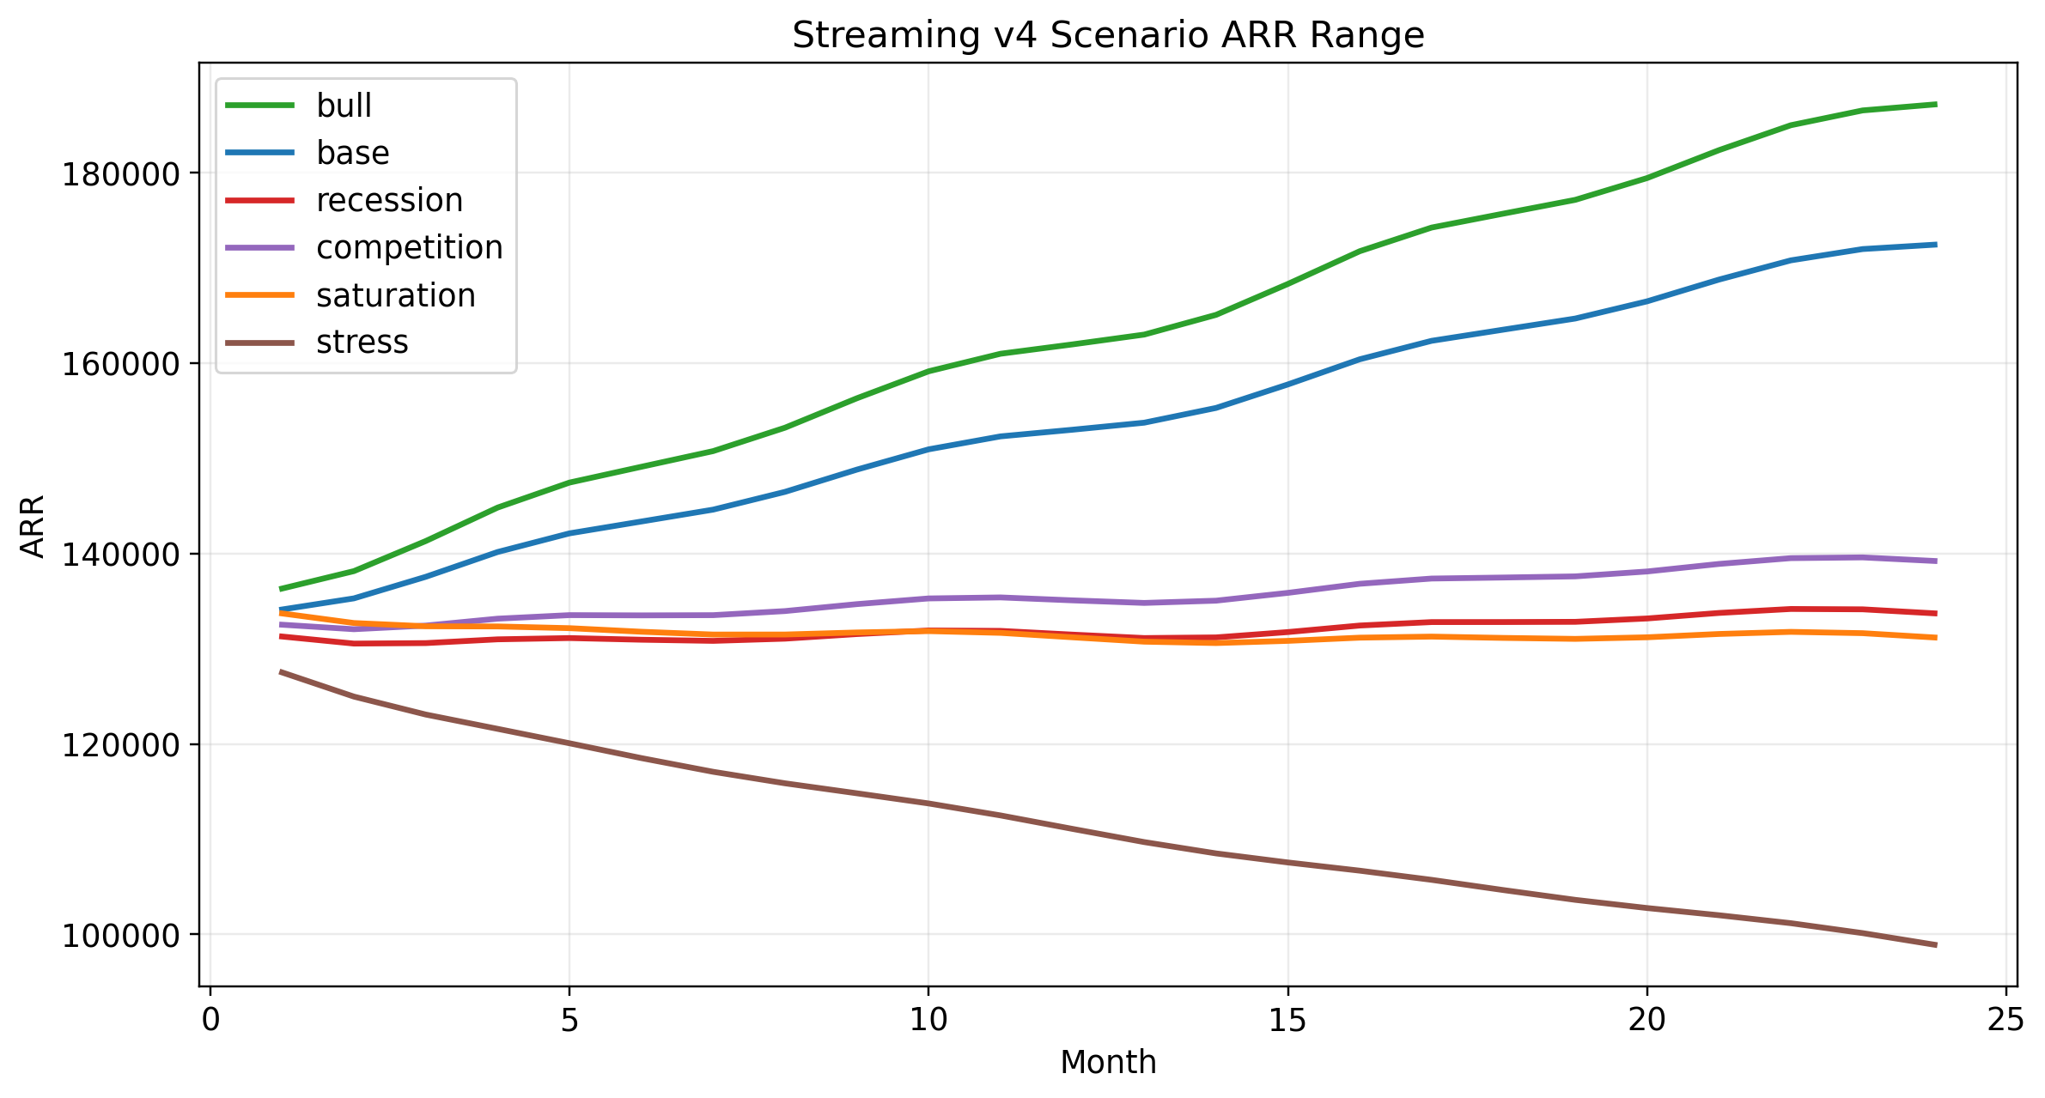
Figure 1. Streaming v4 ARR paths under full rerun scenarios.

Dominant Drivers
Driver Test | Month24 ARR | Delta vs Base | Abs Delta
Stress regime | 98,922.08 | -73,502.32 | 73,502.32
Competition shock | 139,214.45 | -33,209.95 | 33,209.95
Price growth -200bps | 157,513.87 | -14,910.53 | 14,910.53
Billing leakage +20% | 172,424.40 | 0 | 0
Acquisition rate -20% | 172,424.40 | 0 | 0

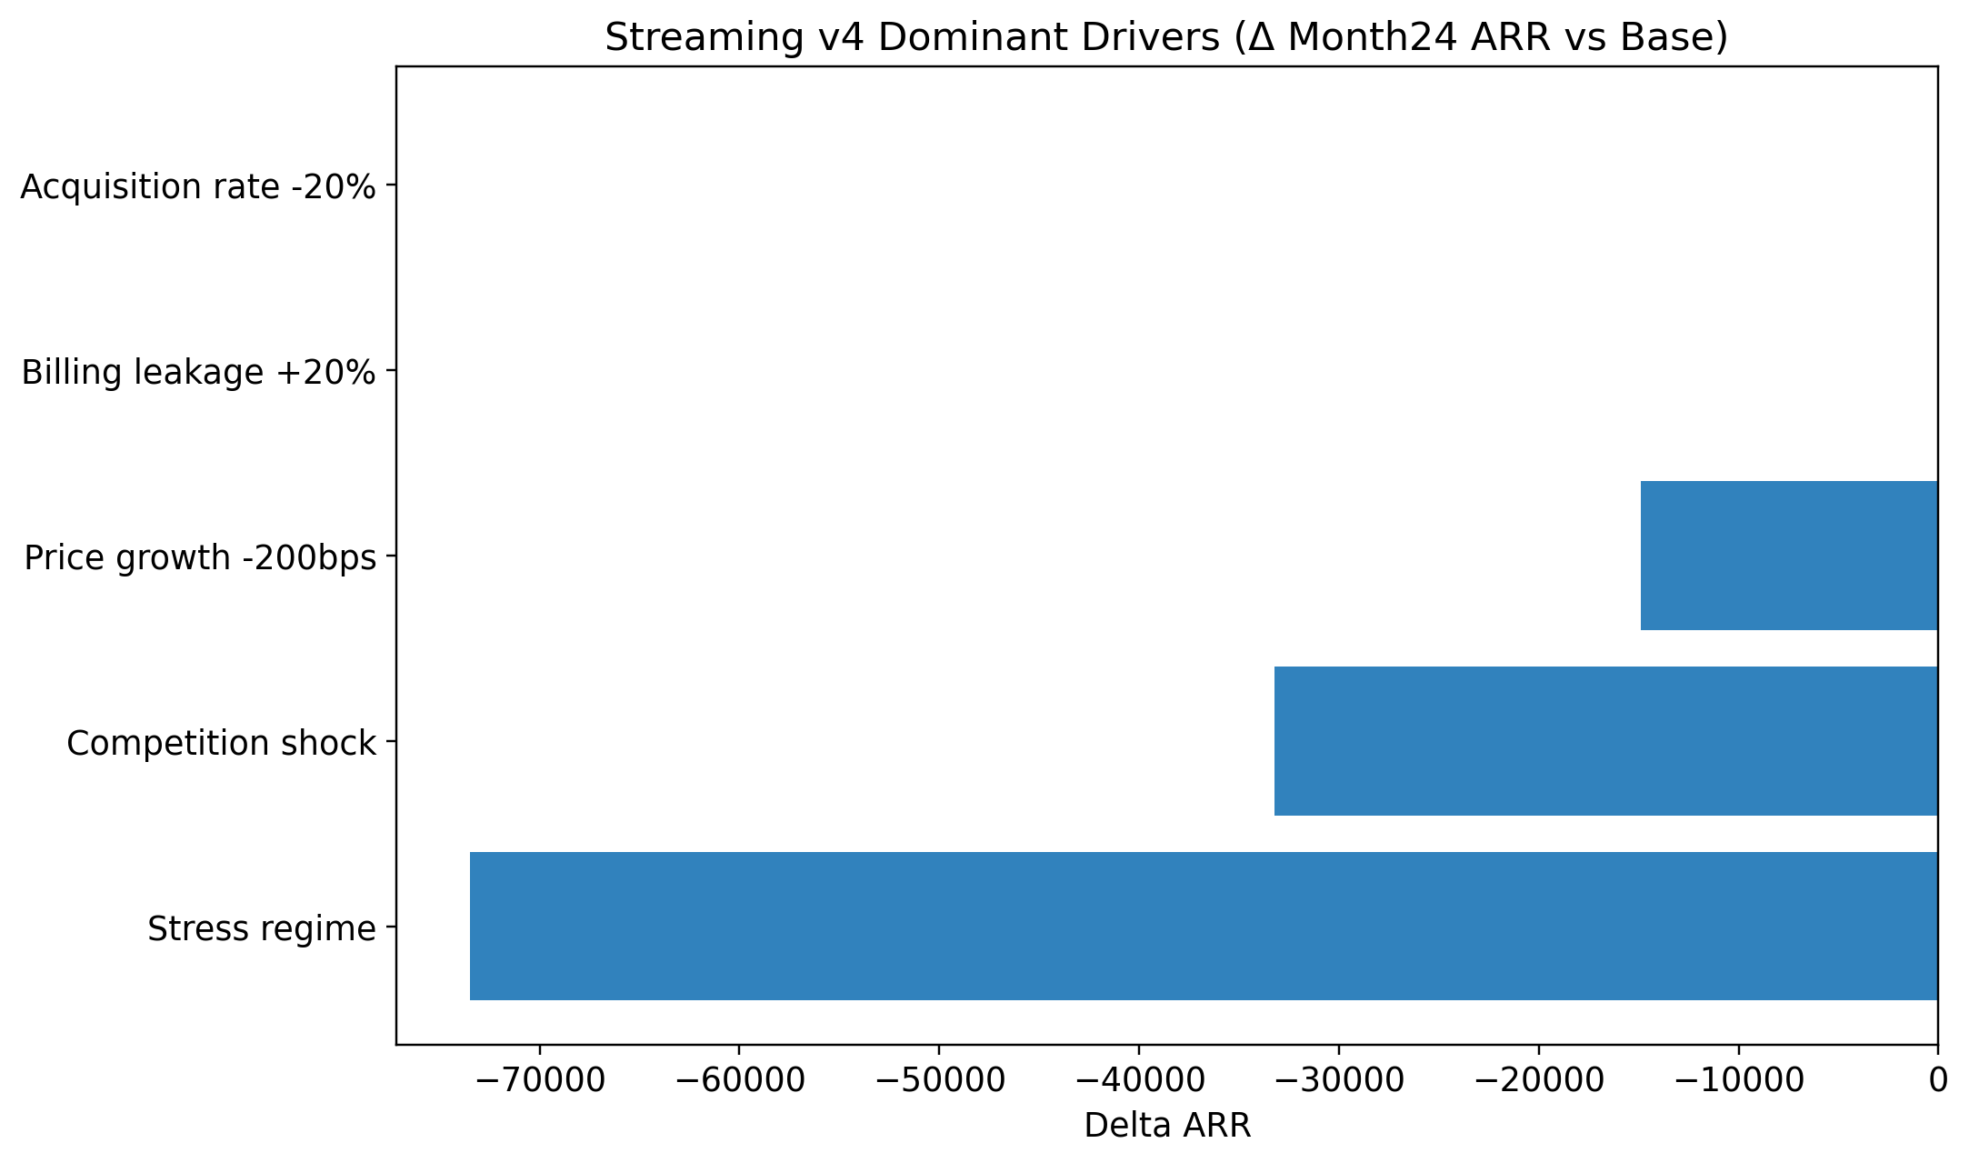
Figure 2. Streaming dominant-driver ranking.

Uncertainty and Interpretation
Headline outputs should always be interpreted together with scenario ranges. The stress, recession, competition, and failed-price scenarios are decision-relevant because they show how quickly ARR can compress when acquisition weakens, pricing underperforms, and churn pressure rises. The dashboard and workbook are designed to discourage deterministic use of the base case alone.

Risk Disclosure and Remaining Limitations
- Streaming CAC remains excluded because public-source support is still insufficient.
- Streaming margin is also excluded rather than guessed.
- Market capacity is still a planning guardrail, not a TAM study.
- Voluntary reactivation is sourced + interpolated; involuntary recovery remains derived from sourced aggregate evidence.
- Months 13-24 are directionally useful but less reliable than months 1-12.

