

Final Project: AI-Powered Visualizations

Estimated time: 60 minutes

Learning objectives
After completing the final project, you will be able to:
- Use generative AI tools to create a basic dashboard with given data
- Examine the effectiveness of different AI-driven insights in improving data storytelling
- Assess the quality and impact of dashboards and visualizations created using generative AI tools
- Design and compile a comprehensive data presentation using generative AI tools, showcasing dynamic dashboards and visualizations

Welcome to the project on AI-Powered Visualizations!

Introduction
Generative AI is helpful for Business Intelligence (BI) analysts as it can automate the creation of insightful and visually appealing data representations. It enables the swift generation of various visualizations, such as bar charts, line charts, and scatter plots, tailored to key metrics and trends. Analysts can use AI-powered tools to implement advanced techniques like heatmaps and geographical maps and customize visual elements for better readability. Additionally, generative AI helps develop interactive dashboards with features like filters and drill-down options, enhancing the user experience. This technology streamlines workflows, improves data visualization accuracy and clarity, and supports better decision-making and strategic planning. In this project, you will learn to use generative AI tools to create, analyze, and present data. You’ll develop dynamic dashboards and visualizations, demonstrating new skills in data handling, visualization, AI-driven insights, and data storytelling.
Note: The prompts used in the project are for reference only. You can consider drafting the prompts based on your organization's requirements.
Also, even if you use the same prompt given in the project for practice, you may receive different responses.

Exercise: AI-driven sales analysis
For this project, you'll work with OpenAI's AI-powered assistant, ChatGPT. A powerful language model designed to assist both consumers and businesses.
It understands and processes text, audio, video, and images. ChatGPT can help BI analysts streamline their workflows, automate repetitive tasks, and gain deeper insights through AI-driven analysis.
Scenario
Let's consider the following scenario for this exercise.
Alex has been a Business Intelligence (BI) Analyst at a retail company for seven years. Recently, the company launched a new initiative to improve sales performance and customer satisfaction. To support this initiative, Alex was assigned the task of analyzing sales data and creating insightful visualizations to guide strategic decisions.
To do so, Alex followed the steps below to utilize ChatGPT to accomplish his goals.
Step 1: Obtain initial data visualization
Step 2: Data aggregation and visualization for business insights
Step 3: Create basic visualizations
Step 4: Obtain advanced visualizations and customization
Step 5: Create interactive dashboards

Step 1: Obtain initial data visualization
In this step, you will provide the model with your dataset to analyze the data and recommend suitable visualizations based on the data types and key variables. Additionally, the model will help generate insights from these visualizations, such as identifying trends and patterns and summarizing the findings effectively.
For this lab, you will use the Superstore Sales Dataset, which is freely available onKaggle.com.
Note: You can download the dataset and upload it on ThoughtSpot, Looker Studio with LookML, Zoho Analytics, or any other platform supporting AI-driven analytics and visualizations to analyze the data and create insightful visualizations.
- You can access the ChatGPT platform using the link https://chatgpt.com/ or right-click on the link to open it in a new tab, and log in to ChatGPT. If you are a first-time user, set up OpenAI's ChatGPT account to sign up.
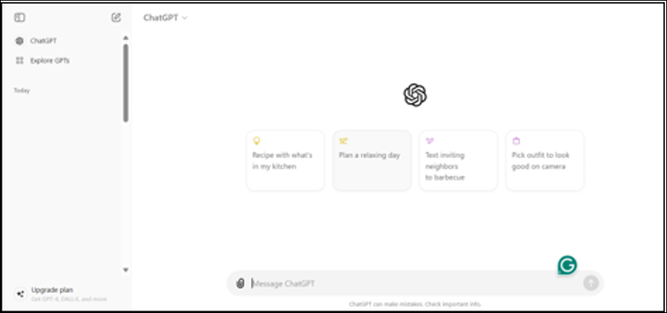
- Upload the Superstore Sales Dataset on ChatGPT and click enter on your keyboard or the top arrow sign on your screen to provide input.
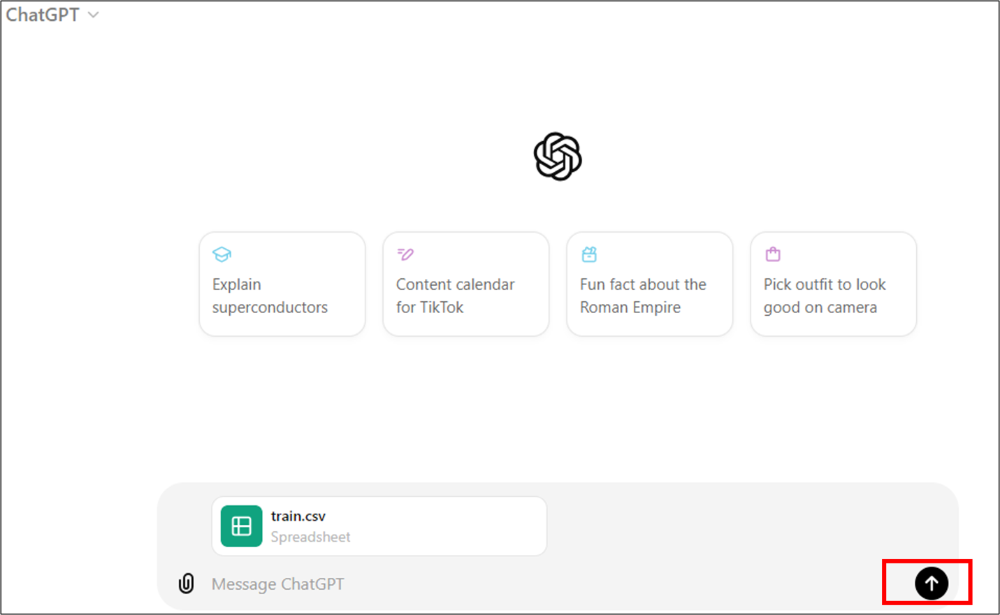
- Paste the following prompt in the input box to provide ChatGPT with the appropriate instructions to understand the types of data available and identify key variables that are crucial for analysis.
Review the dataset and identify the key variables for analysis. What types of data are most relevant to the business scenario?
Copy Prompt
- Select Enter on your keyboard or the top arrow sign on the screen to provide the input.
- 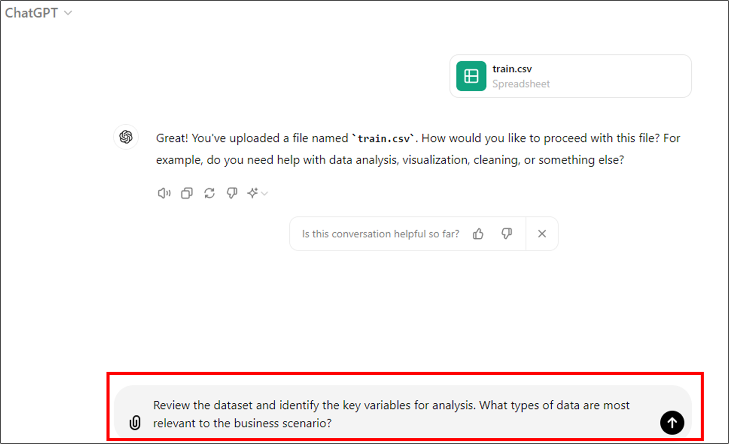
- A sample response received from ChatGPT is shown here.
- 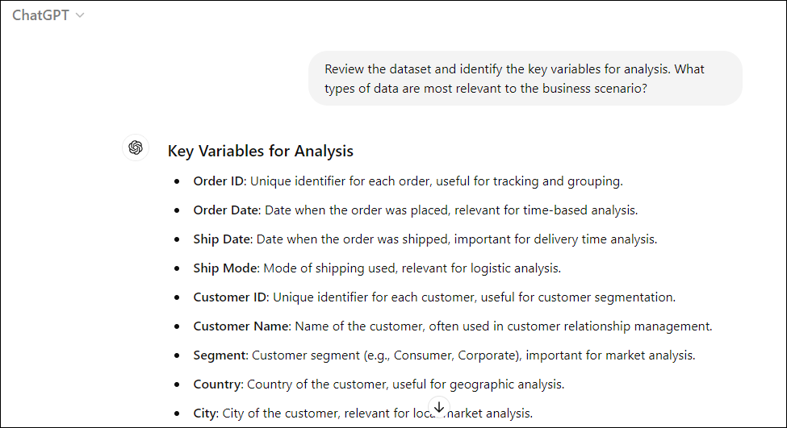
- 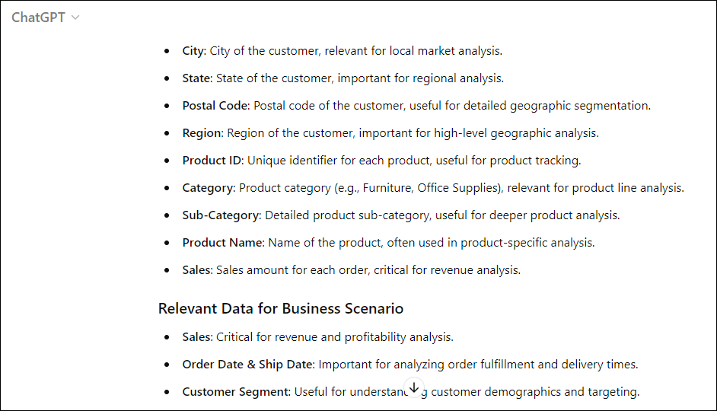
- 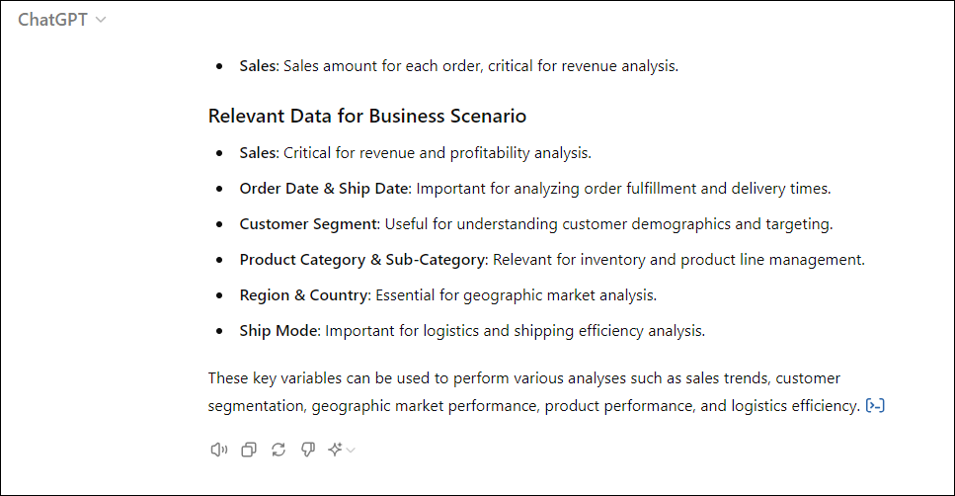
- Once you have obtained an overview of the dataset, ChatGPT will have enough background to develop basic visualizations and use them to gain initial insights into the dataset, such as identifying high-performing products or peak sales periods.
Consider the following prompts asking ChatGPT to create an initial visualization:
Create initial visualizations (e.g., bar chart, line chart, pie chart) to explore the dataset. What do these visualizations reveal about the data?
Copy Prompt
Select Enter on your keyboard or the top arrow sign on the screen to provide the input.
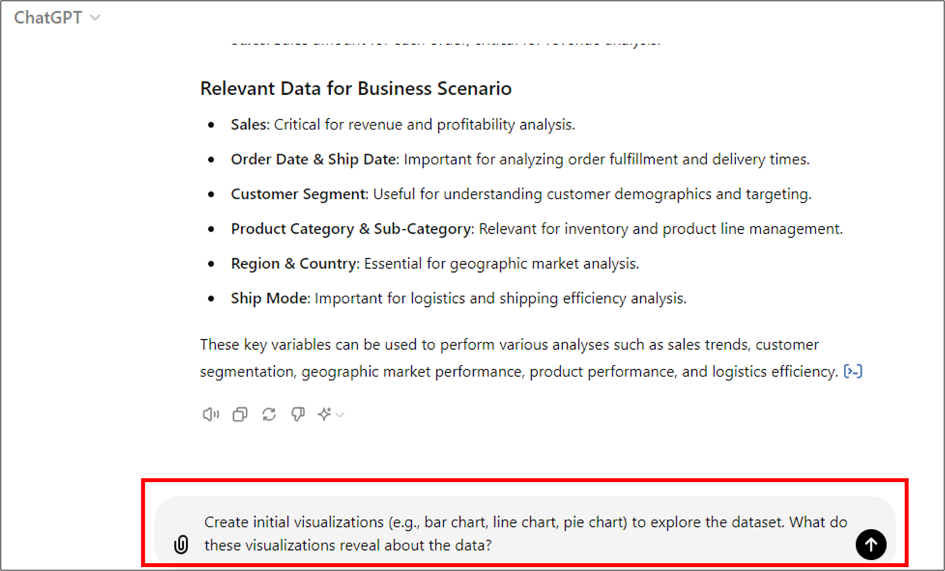
You will get the following response.
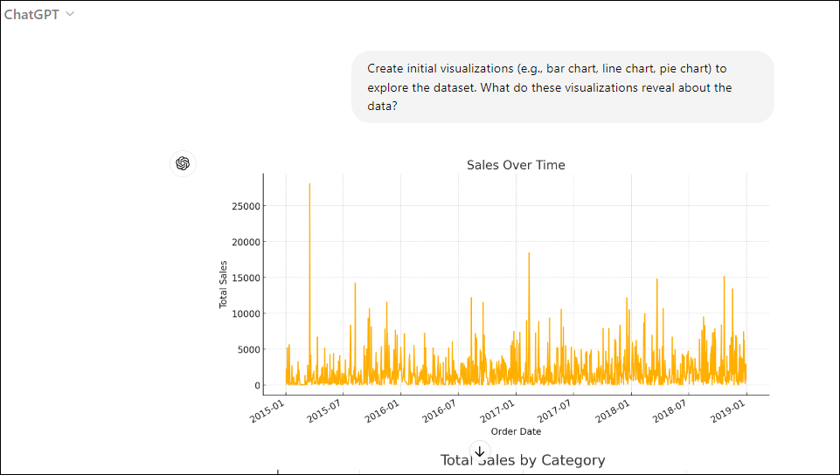
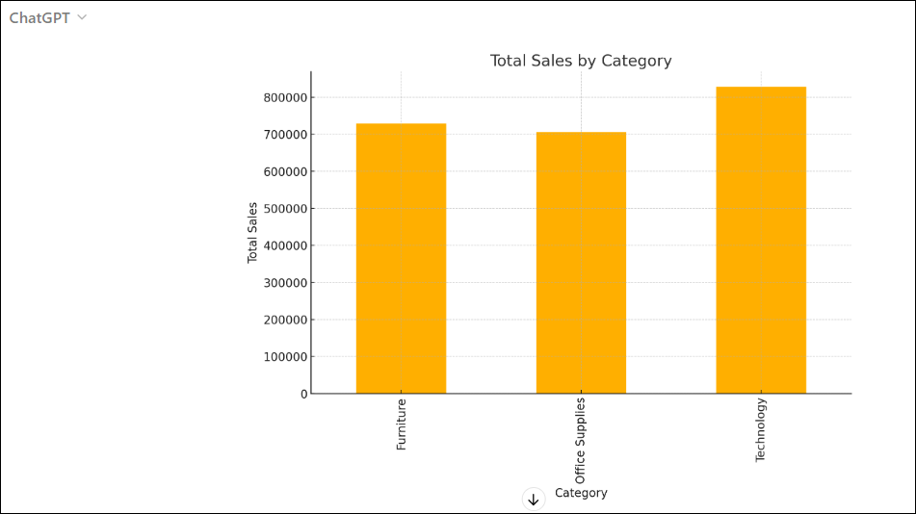
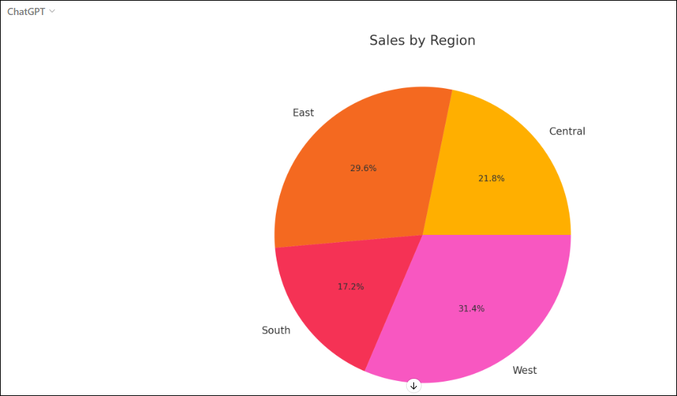
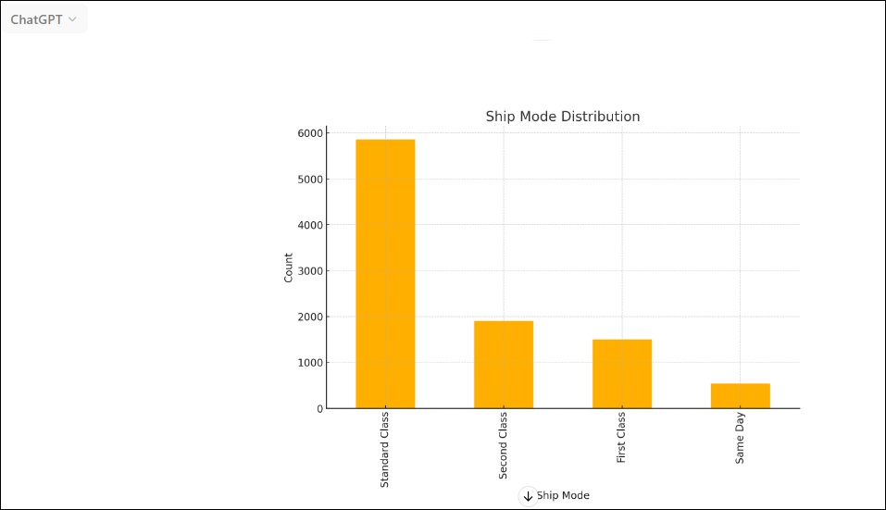
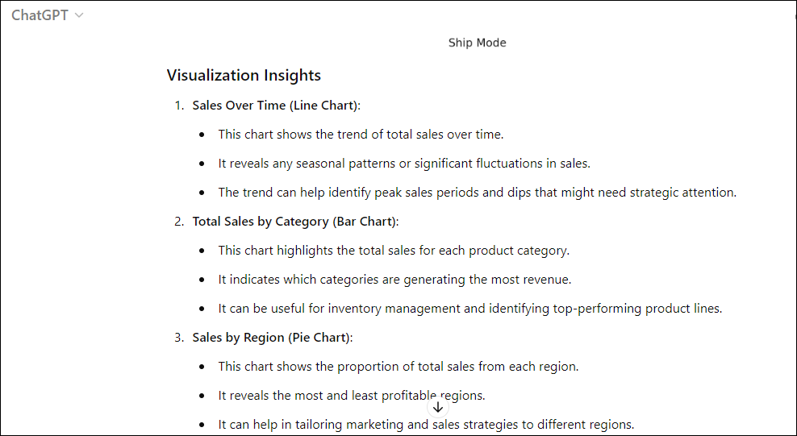
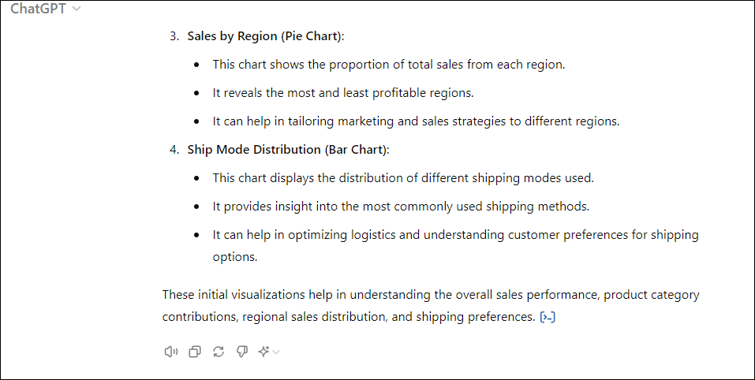
- After creating the initial visualizations, it's time to summarize the key insights to help guide further analysis.
Consider the following prompt asking ChatGPT to obtain a summary of insights.
Summarize the key insights from your visualizations. How can these insights guide further analysis?
Copy Prompt
Select Enter on your keyboard or the top arrow sign on the screen to provide the input.
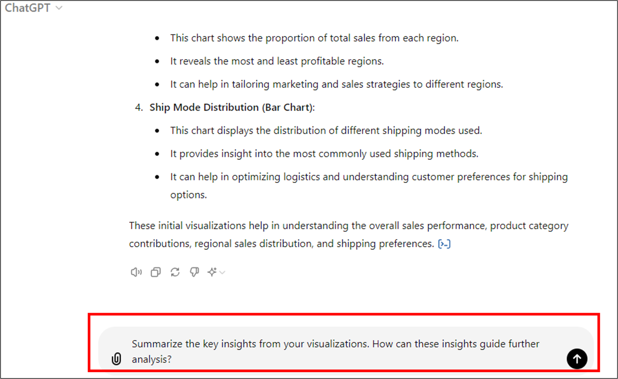
You will get the following response.
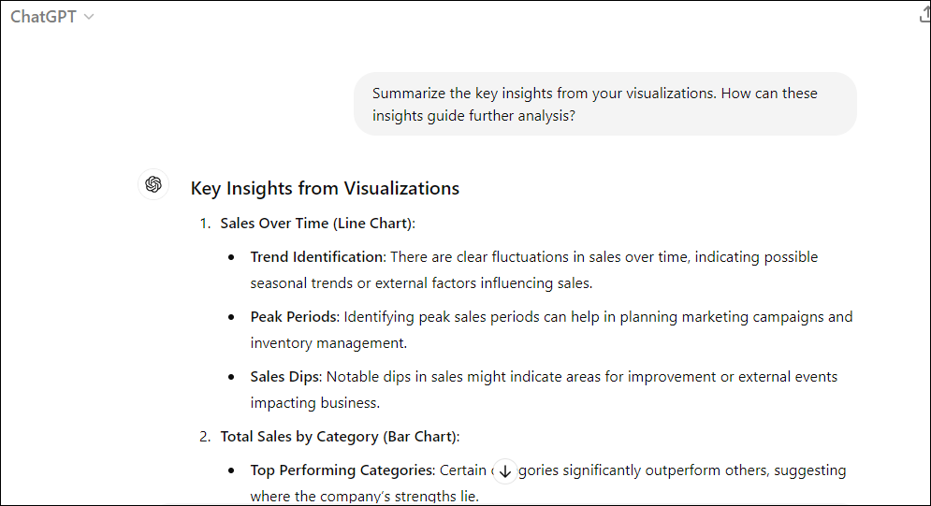
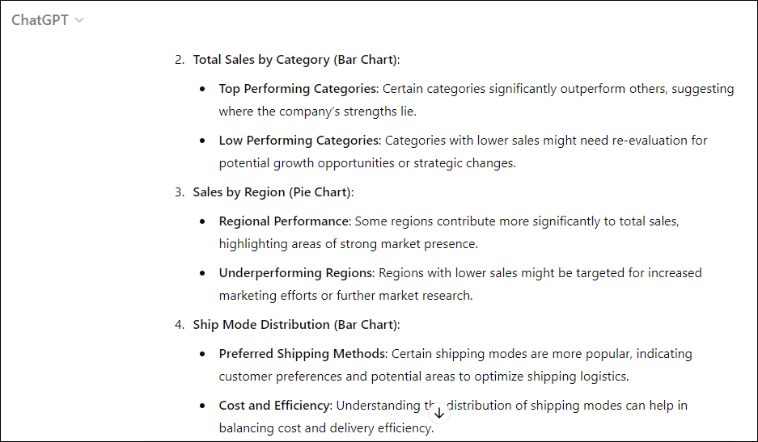
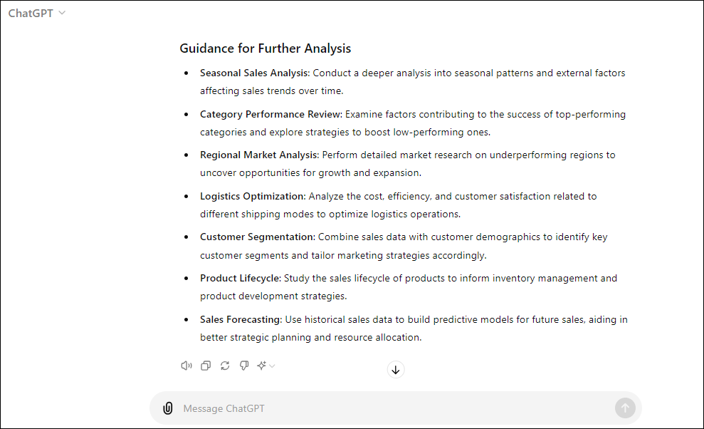

Step 2: Data aggregation and visualization for business insights
In this step, you will aggregate the data, generate detailed table reports, and create visualizations to analyze key metrics and trends within the dataset. These actions will enhance your understanding of overall business performance and help identify strategic opportunities.
- Use the following prompt to visualize the sales distribution by region, which will help you make strategic decisions regarding regional marketing efforts, resource allocation, and potential market expansion opportunities and click on Enter.
Visualize the proportion of total sales contributed by each region. This helps to understand the geographic distribution of sales.
Copy Prompt
- A sample response is shown here.
- 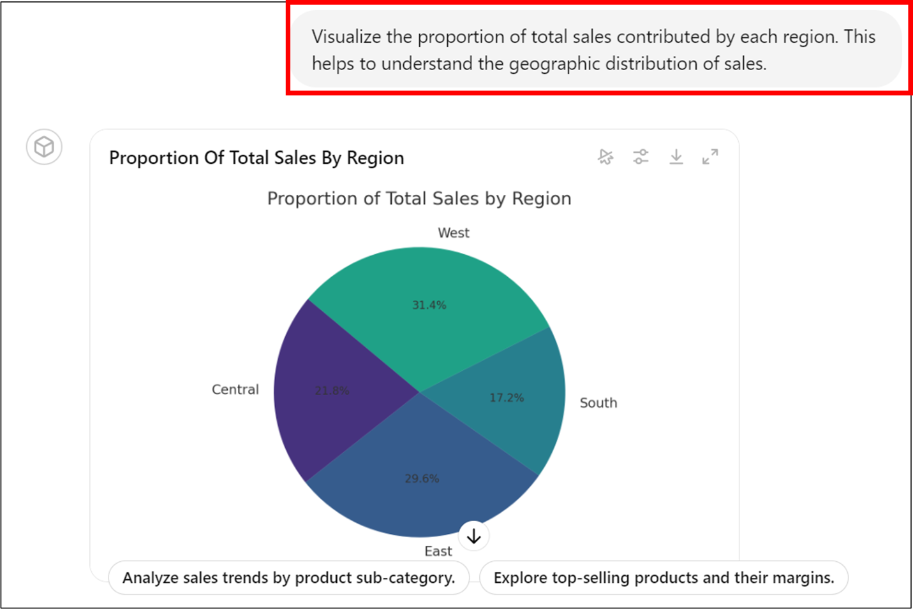
- 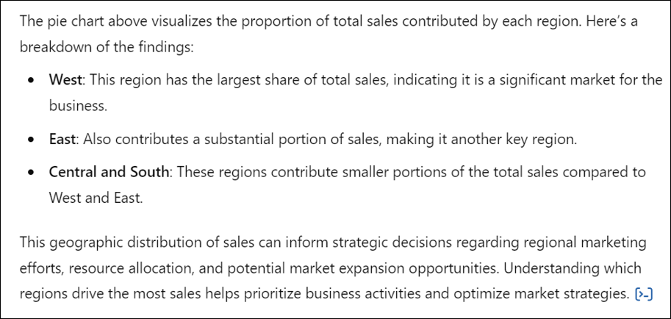
- Use the following prompt to visualize sales by customer segments to obtain detailed table reports, and click on Enter.
Compare total sales across different customer segments. This visualization highlights which segments are the most valuable to the business.
Copy Prompt
- You will get the following response.
- 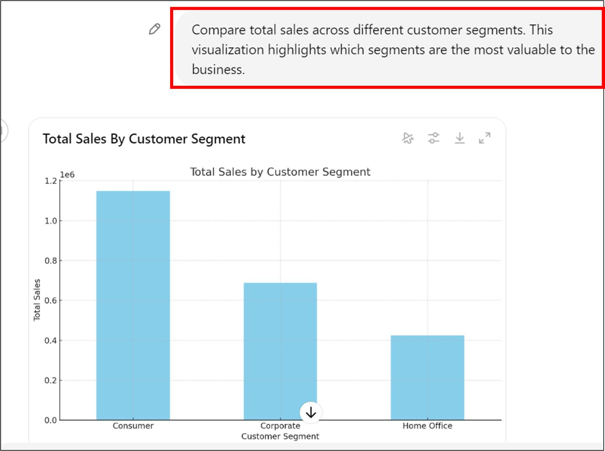
- 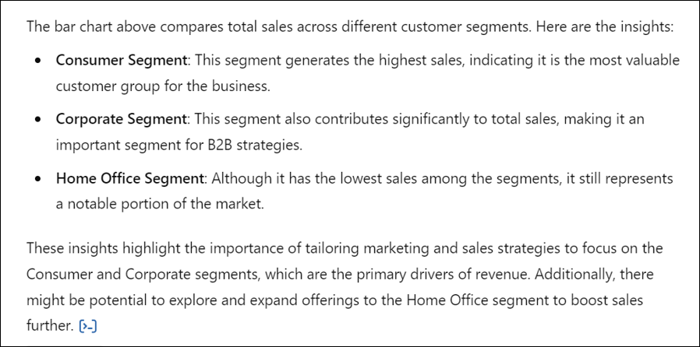
- Use the following prompt to identify the top-performing products in each category based on total sales, and click on Enter. This will help you make informed decisions regarding product focus, inventory planning, and marketing strategies, optimizing business performance.
Showcase the top 5 products by sales within the most successful product category. This helps identify the best-selling products and informs inventory and marketing strategies.
Copy Prompt
- You will get the following response.
- 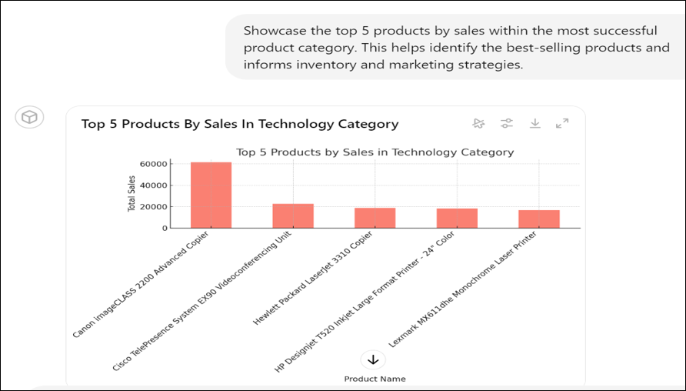
- 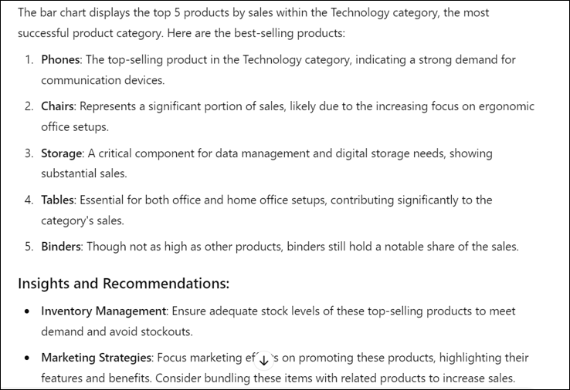
- 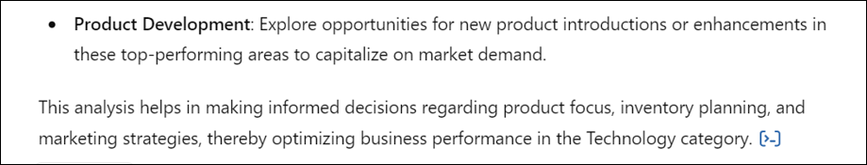

Try it yourself
Write clear and descriptive prompts to leverage the full potential of ChatGPT.
Follow these steps to generate outputs for creating visualizations and dashboards. Try out the prompts mentioned below.

Step 3: Create basic visualizations
Instructions:
1. Choose visualization types:
- Select the appropriate visualization types (e.g., bar charts, line charts, scatter plots) to represent key data points.
2. Implementation:
- Create these visualizations using the chosen AI-powered tool.
- Ensure each visualization includes clear labels, legends, and titles.
3. Evaluation:
- Assess the effectiveness of the visualizations in conveying the intended message.
Prompts:
- Choose and create basic visualizations to represent key metrics and trends in the dataset. Explain why you chose these particular visualization types.
- How do these visualizations help in understanding the data better? Are there any improvements you could make?

Step 4: Obtain advanced visualizations and customization
Instructions:
1. Advanced techniques:
- Implement advanced visualization techniques (e.g., heatmaps, bubble charts, geographical maps) to provide deeper insights.
2. Customization:
- Customize visualizations by adjusting elements like colors, labels, and themes for better readability and visual appeal.
3. Justification:
- Justify your choice of advanced techniques and customizations.
Prompts:
- Create advanced visualizations using the dataset. Why did you choose these specific advanced techniques?
- Customize the appearance of your visualizations. How do these customizations enhance the clarity and appeal of the data presentation?
- What additional insights do these advanced visualizations provide?

Step 5: Create interactive dashboards
Instructions:
1. Dashboard design:
- Integrate your visualizations into a cohesive, interactive dashboard.
- Include interactive elements like filters, drill-down options, and tooltips.
2. User experience:
- Ensure the dashboard is user-friendly and provides a logical flow for exploring the data.
3. Review and refine:
- Review the dashboard for coherence and clarity. Refine the design based on user feedback or self-assessment.
Prompts:
- Design an interactive dashboard incorporating all your visualizations. Describe the interactive features you’ve included and their purpose.
- How does the design of your dashboard enhance the user experience? What steps did you take to ensure it is easy to navigate and understand?
- What improvements could be made to the dashboard to better meet user needs?
Conclusion:
Congratulations on completing the project on AI-Powered Visualization!
In this lab, you explored a structured approach to apply generative AI tools in business intelligence and data analytics. You learned how to handle data, create insightful visualizations, and communicate findings effectively in real-world business intelligence scenarios.

