

Hands-on lab: Dashboards with AI

Estimated time: 30 minutes

Learning objectives
After completing this lab, you will be able to:
- Generate basic visualizations using an AI-powered tool's search-driven analytics.
- Create an interactive dashboard using an AI-powered tool.

Introduction
A Business Intelligence (BI) analyst is given a task to explore sales data and create interactive dashboards for the stakeholders.
In this lab, you'll create dynamic and interactive dashboards using ThoughtSpot, an AI-powered analytics and business intelligence tool. Participants will learn to utilize ThoughtSpot's search-driven analytics, AI-powered insights, and interactive features to analyze and visualize data effectively.
Data source
The data set used in this lab has been synthetically generated. Download thesales_data.csv data set. (To download the given data set in this lab, right-click on the given hyperlink and select Open link in new tab).
Software used for this lab
You'll be using an AI-based self-service analytics platform, "ThoughtSpot" to explore data and create interactive dashboards.
Before you begin
To access the ThoughtSpot platform, sign up for a free trial with the ThoughtSpot platform. ThoughtSpot offers a 14-day free trial.
To sign up for a free trial, go to https://www.thoughtspot.com. Click the Free Trial button in the top-right corner.
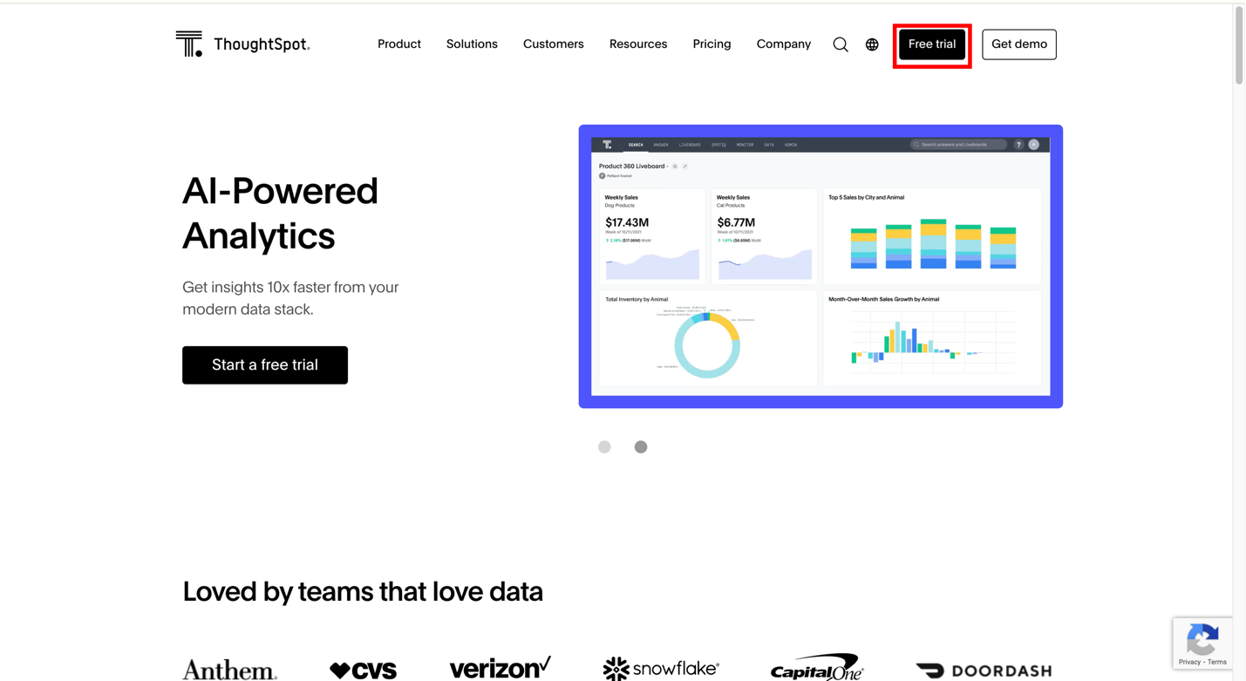
Sign up with your Gmail account. You'll receive an activation email. On clicking the Activate My Account button in the email, you'll be asked to set your password. After setting your password, you may proceed to use the platform.


Task 1: Connect to the data source
Keep the sales_data.csv data set handy.
This is the ThoughtSpot home page. To connect to the data source, select the Datatab.
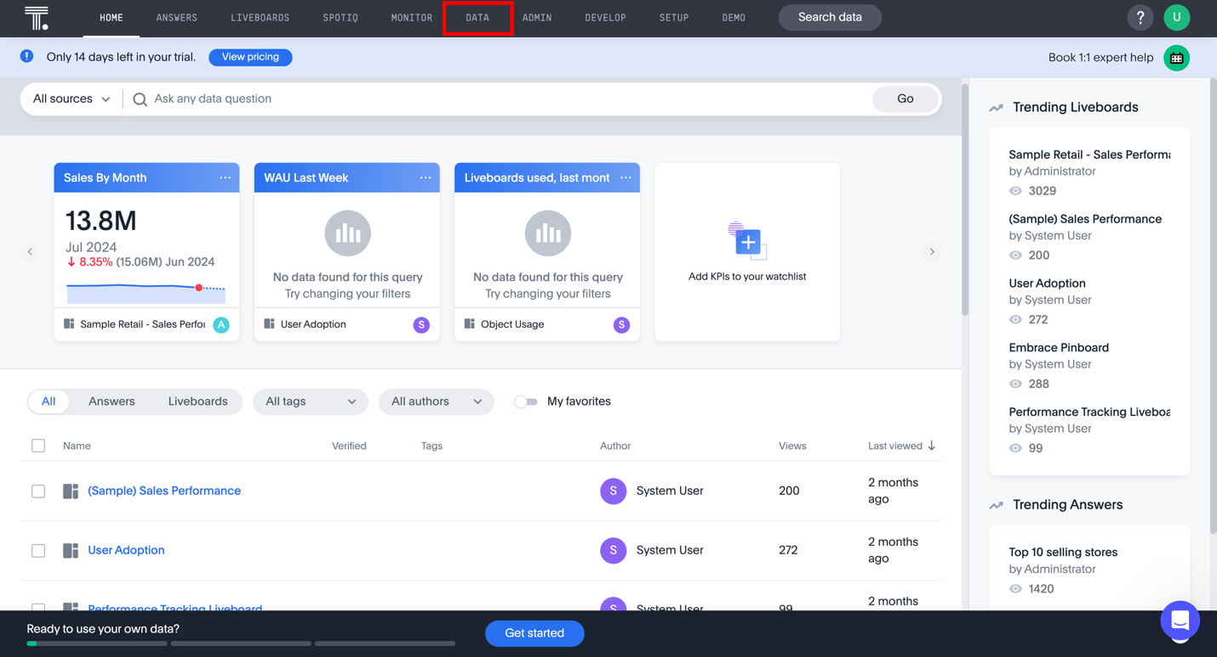
Click the + Create new button and select Connection from the drop-down list.
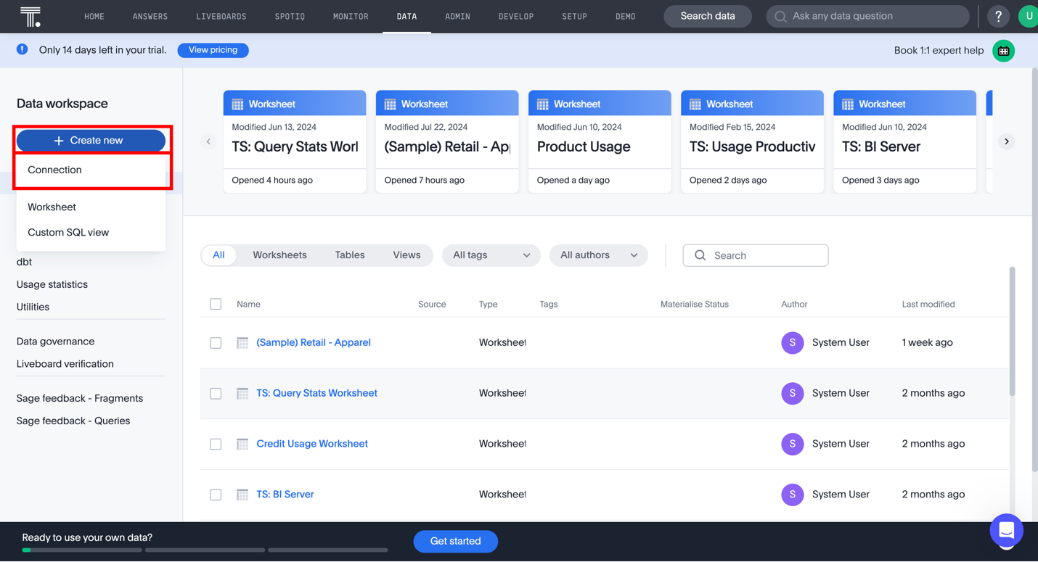
Name your connection and enter a description. Then click the Upload a CSV button.
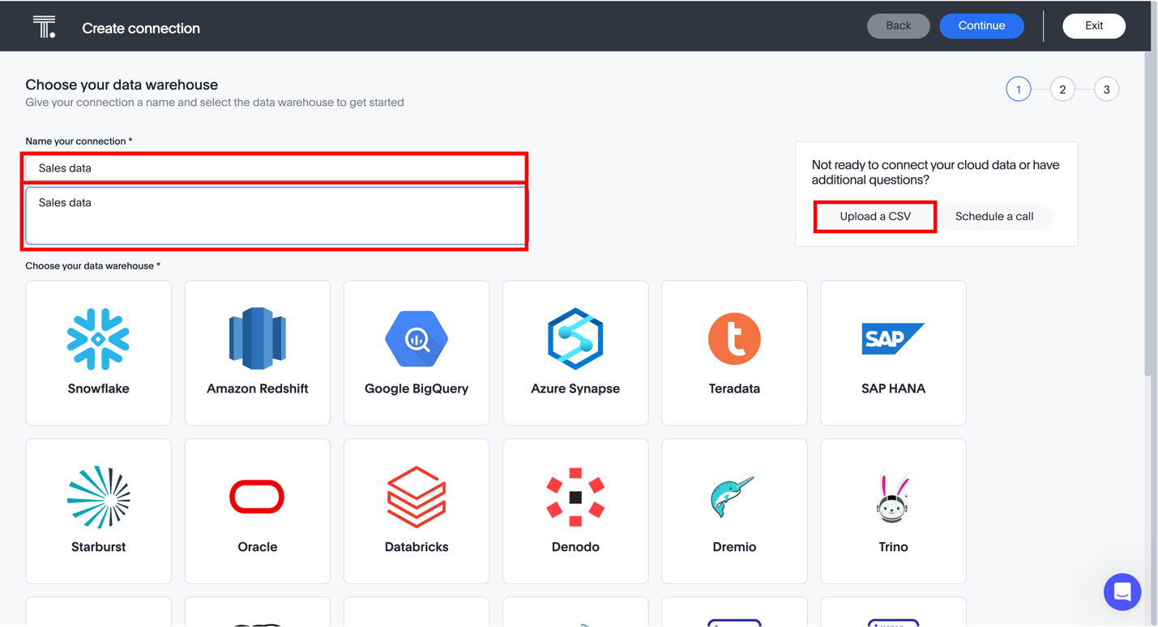
Upload the sales_data.csv file you downloaded earlier. Once done, click the Nextbutton.
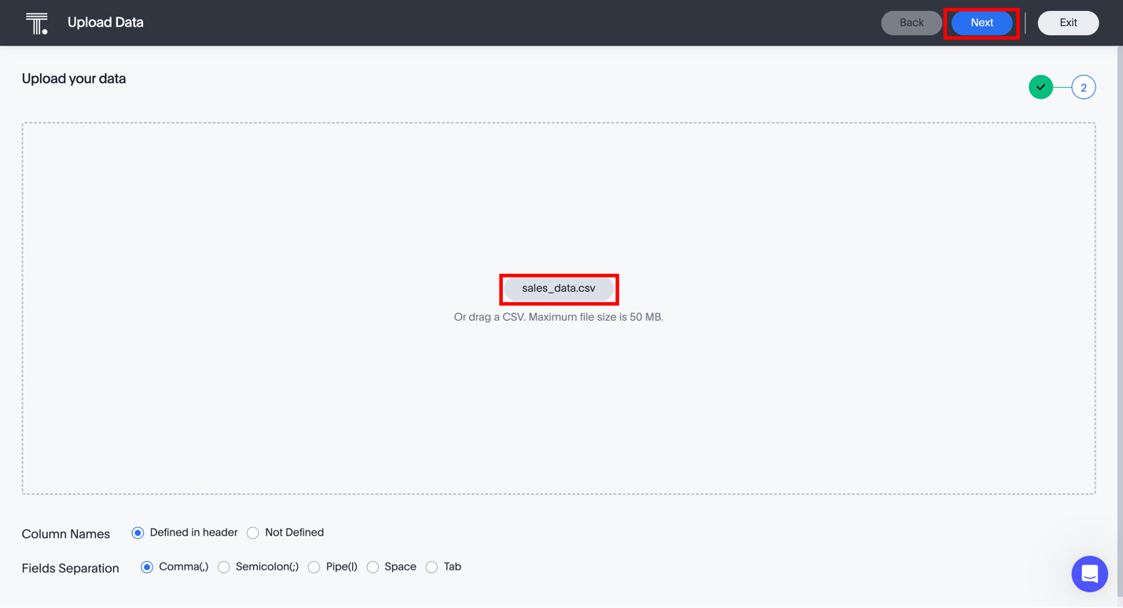
Ensure the data is correctly imported and available for analysis. Then click the Uploadbutton.
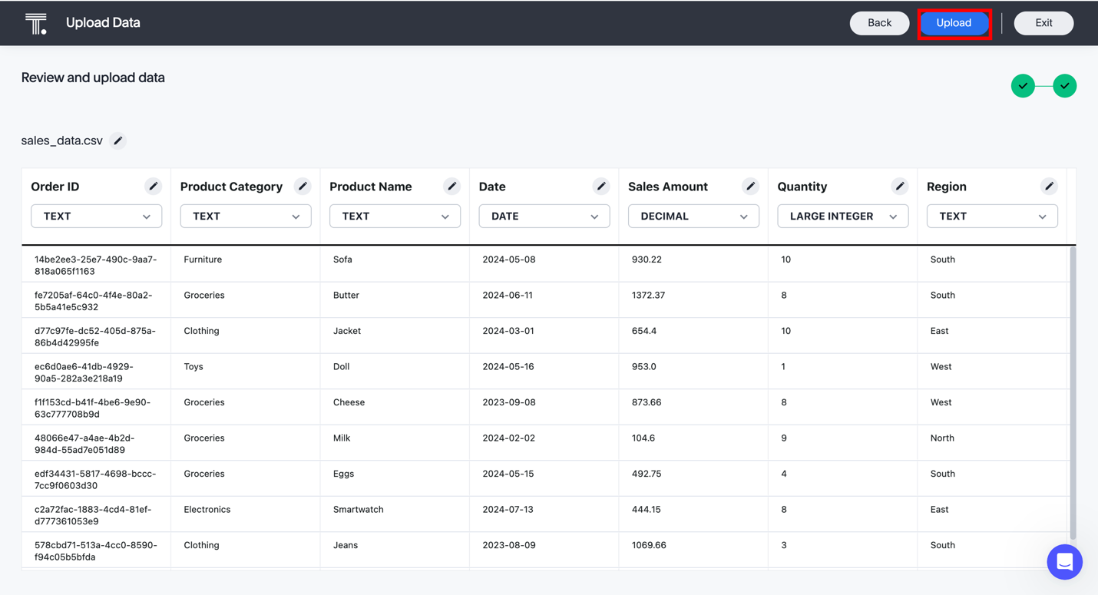
You will get a 'Success' message. You may click the Start search on your data button to explore the data and create basic visualizations.
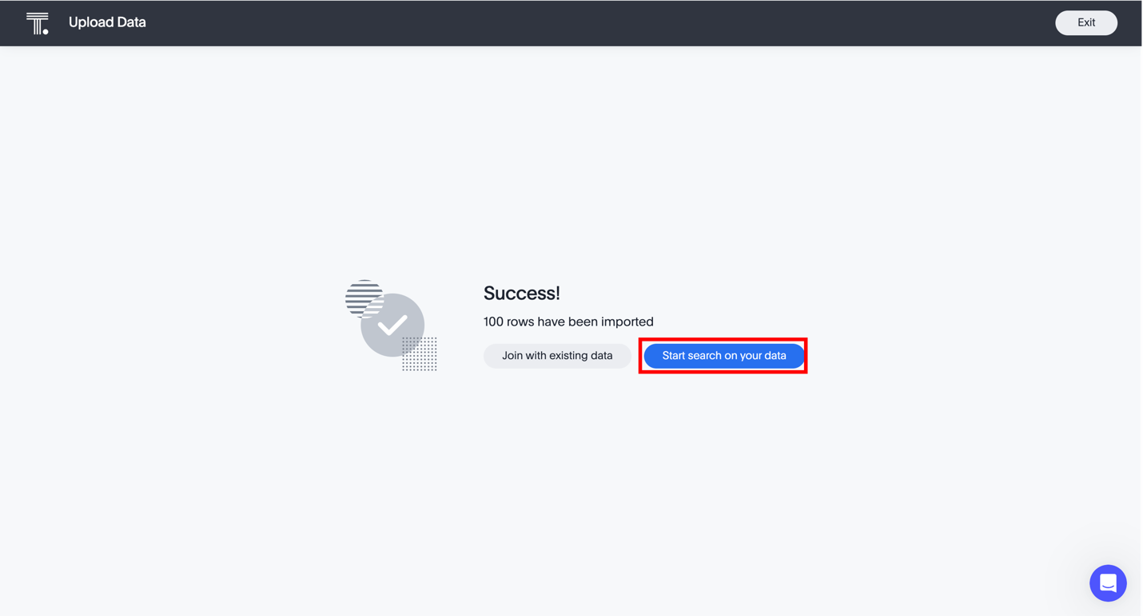

Task 2: Create basic visualizations
Now that you have uploaded the data, you can further explore the data and create basic visualizations.
Let us create a visualization to view the sales revenue for each product category.
Clicking the Start search on your data button will take you to the screen below. Another way to get to this screen is to click the Search Data button and select yourdata source from the drop-down list if it is not already selected.
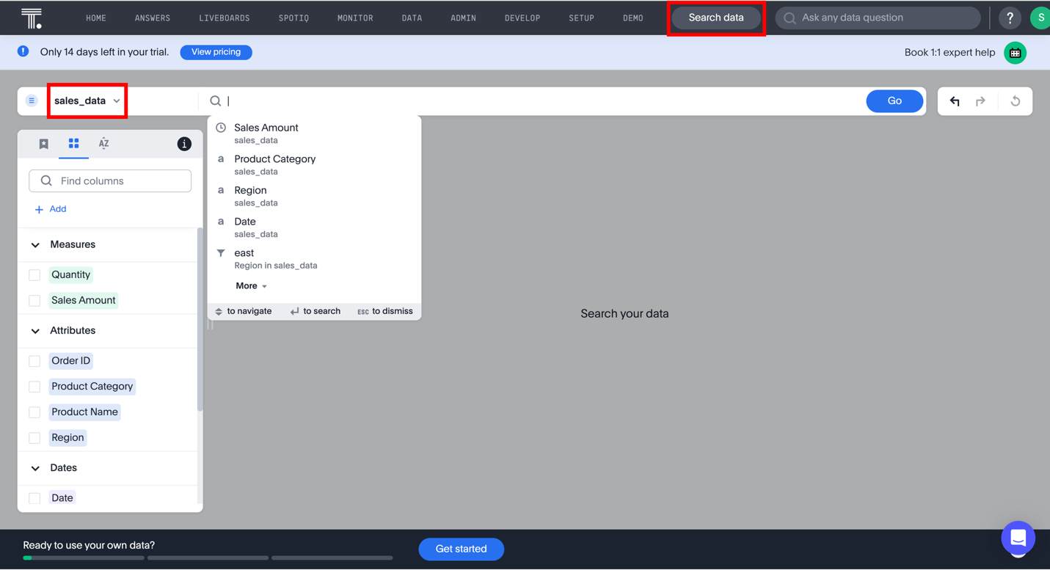
Click the columns you want to include in your visualization from Measures and Attributes. In this case, select the Sales Amount and Product Category. Then, click the Go button.
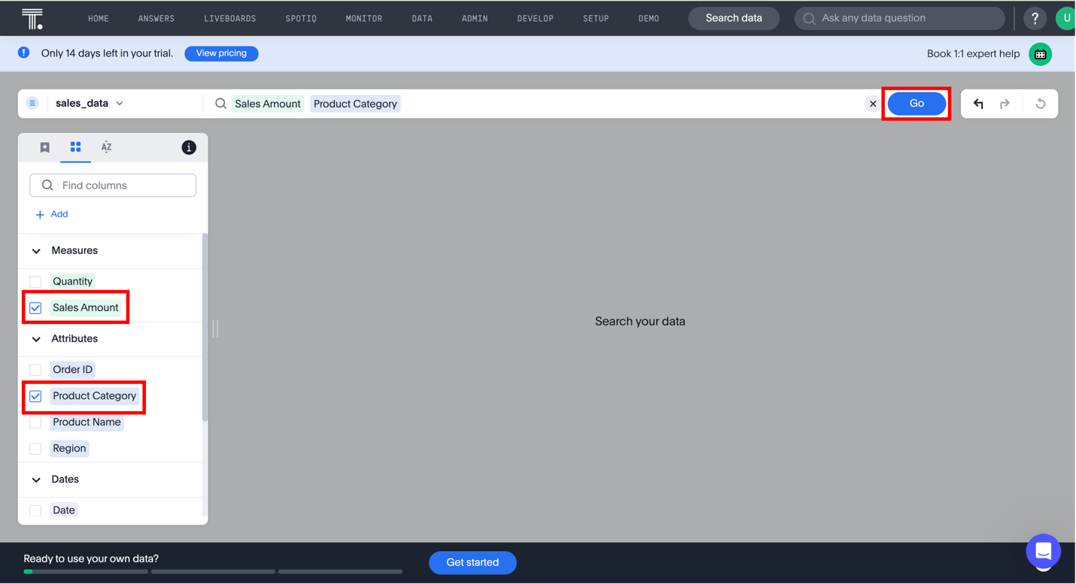
An appropriate visualization is displayed. You can choose another visualization type by clicking the Change visualization icon.
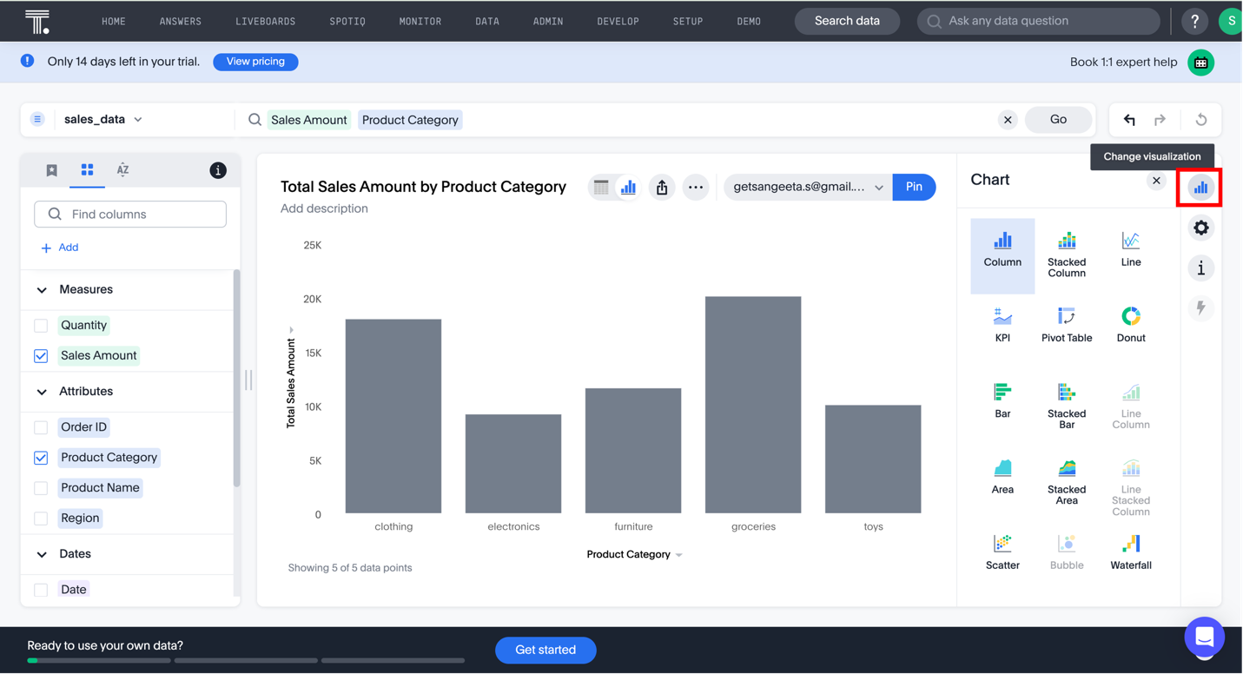
Customize the visualization using the available options in the Edit chart configurationicon.
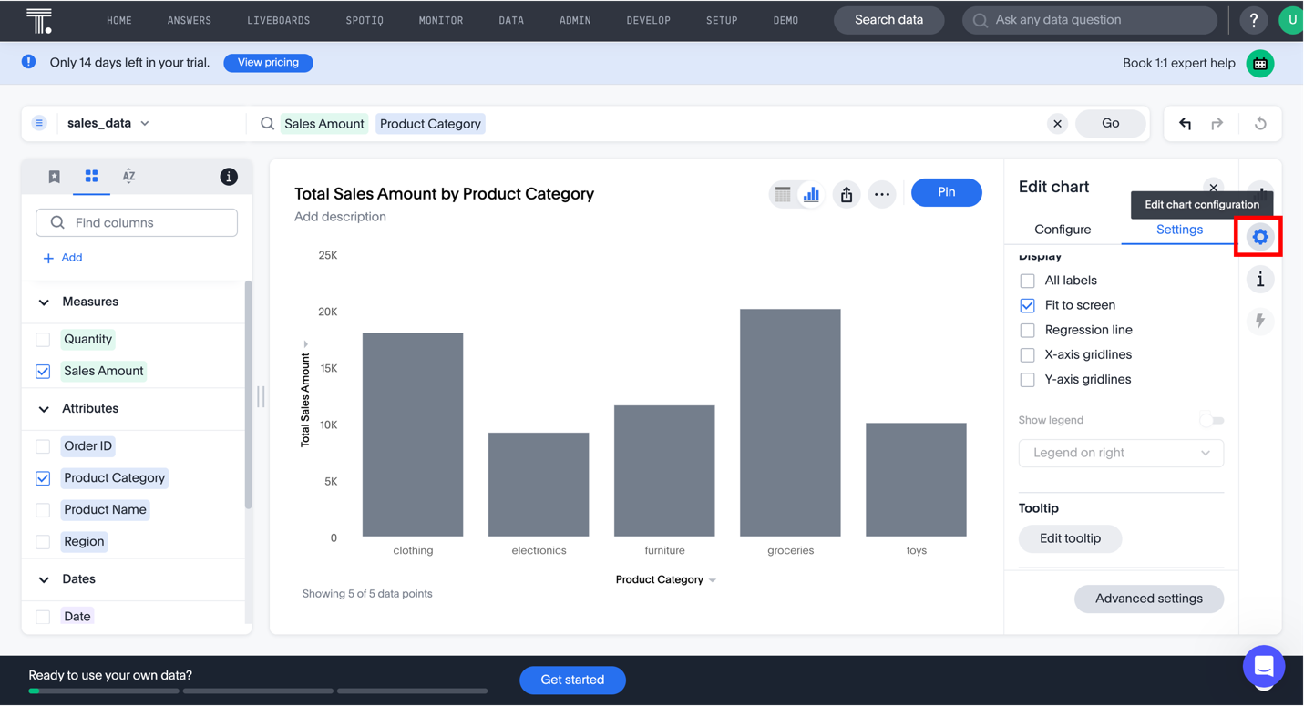

Task 3: Design interactive dashboards
Next, let's create an interactive dashboard using ThoughtSpot's pinboard feature.
Pin the visualization you have created to a new pinboard.
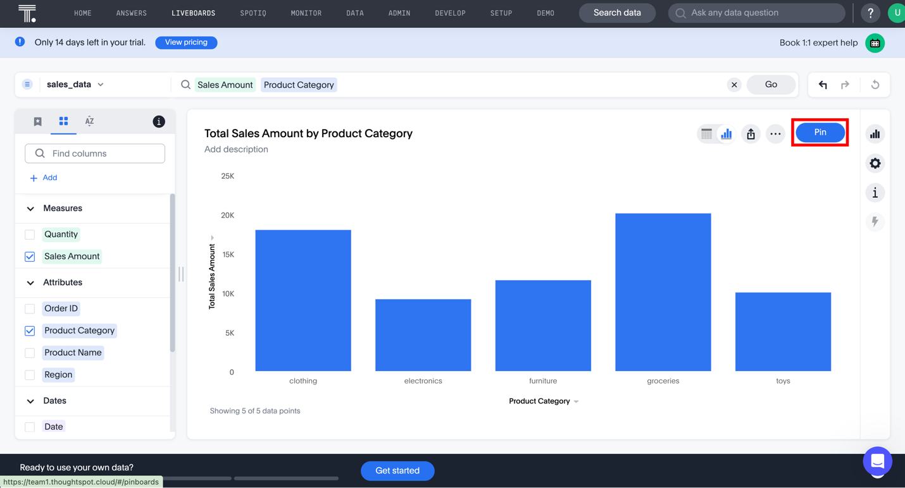
ThoughtSpot will create a liveboard and pin the visualization to the liveboard. Click the View Liveboard button.
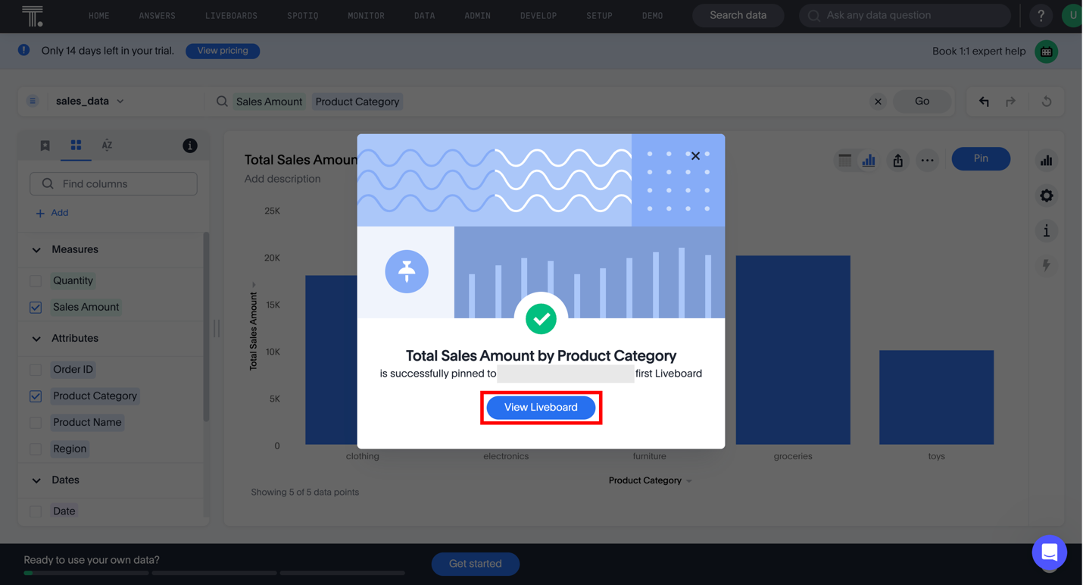
The Liveboard is displayed. Click the Edit icon to edit the Liveboard.
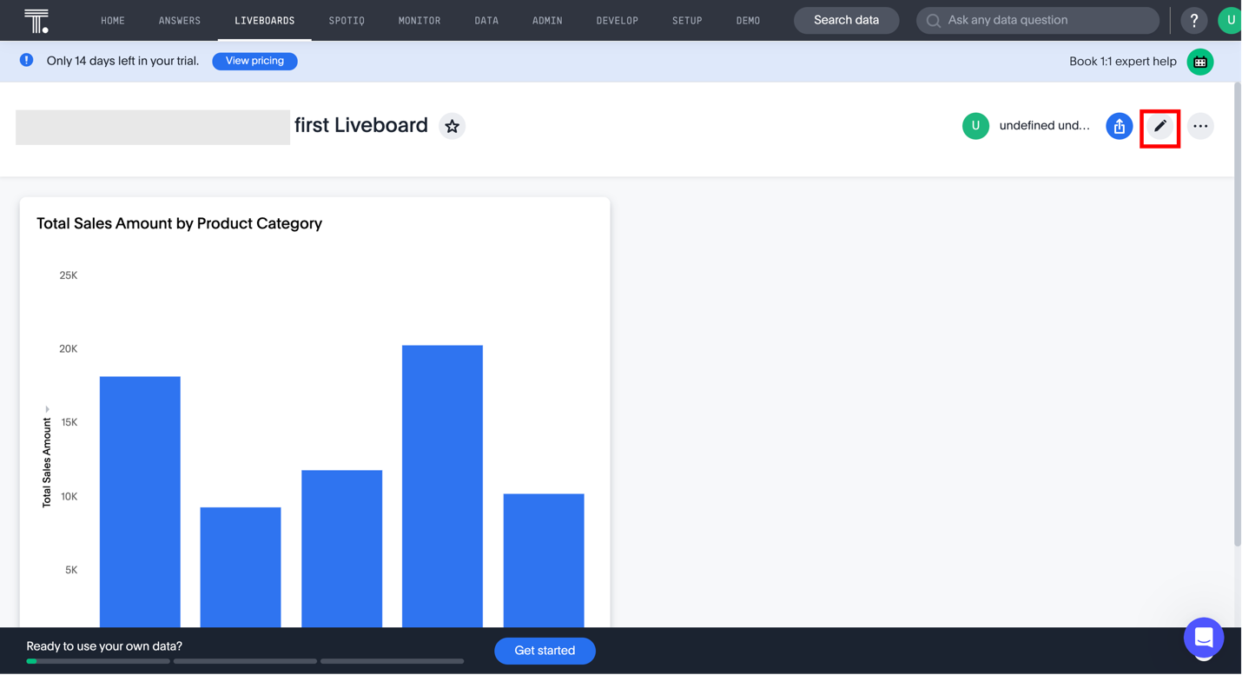
Edit the name of the liveboard. Change it to "Sales Data Visualization Dashboard" and click the Save button.
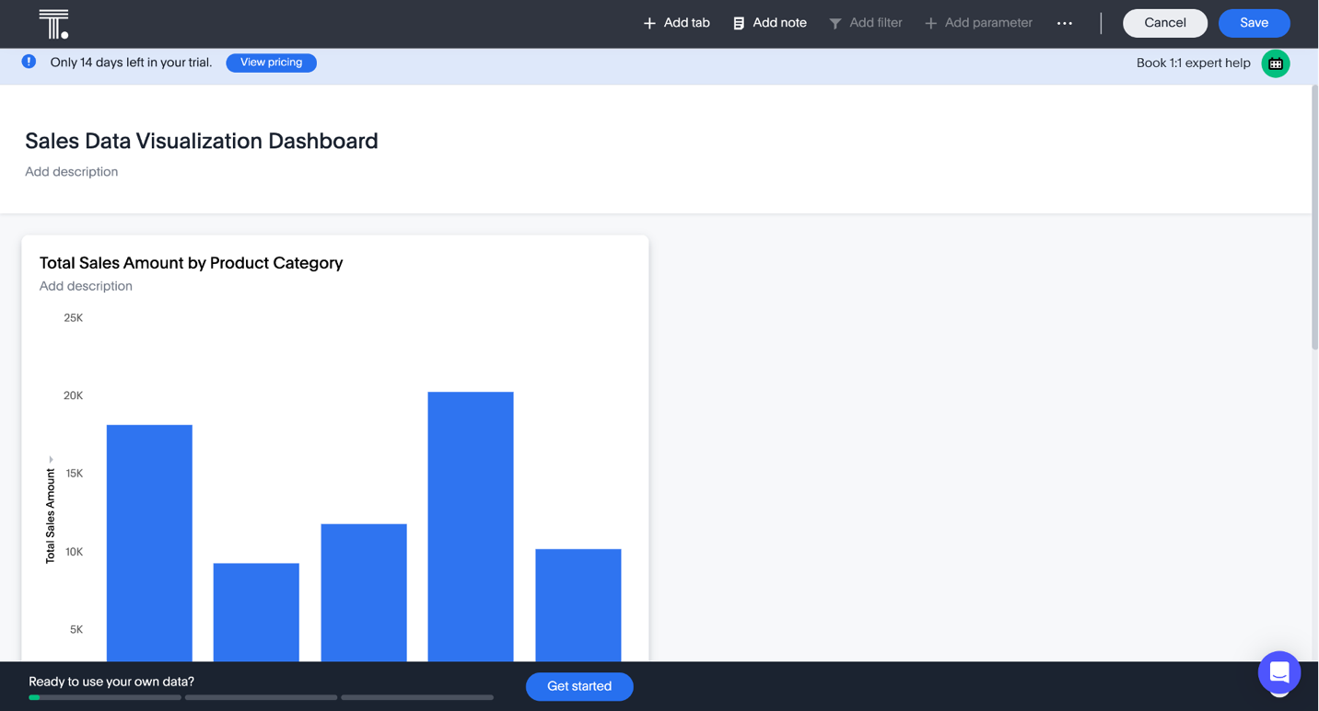
Let's create a couple of more visualizations and pin them to the dashboard. Go back to the Search Data screen and create a few visualizations.
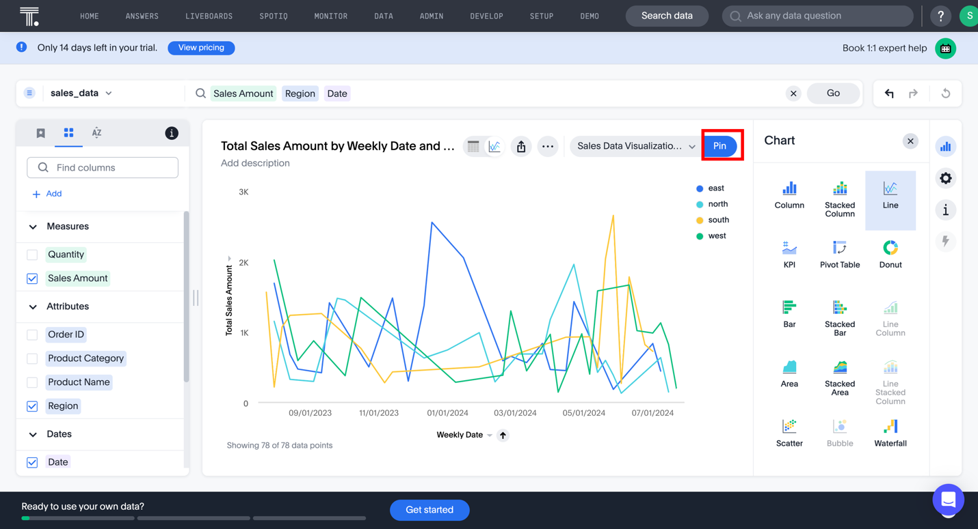
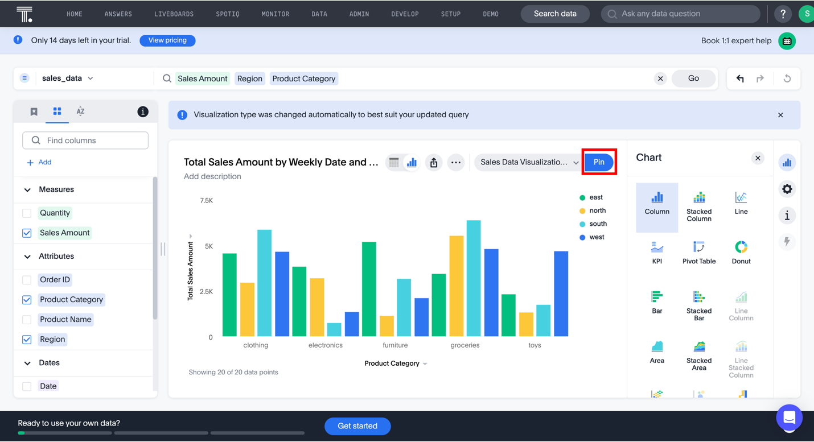
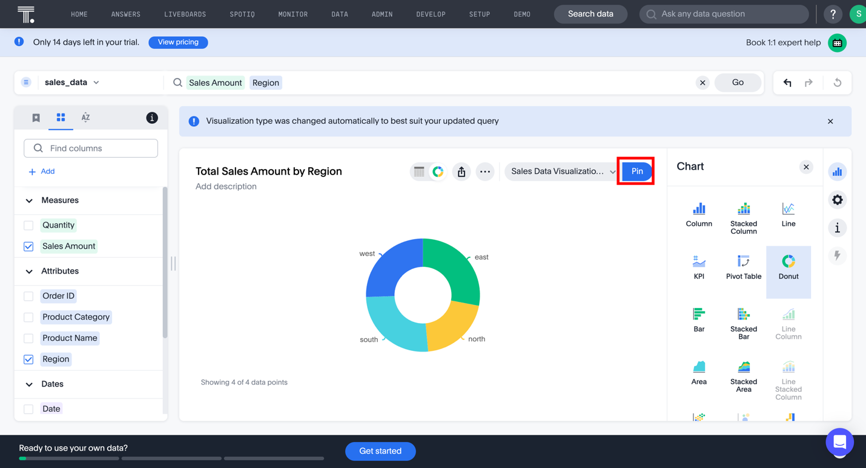
You can access your interactive dashboard or liveboard through the Liveboard tab. Click Explore on any of the pinned visualizations to explore it further.
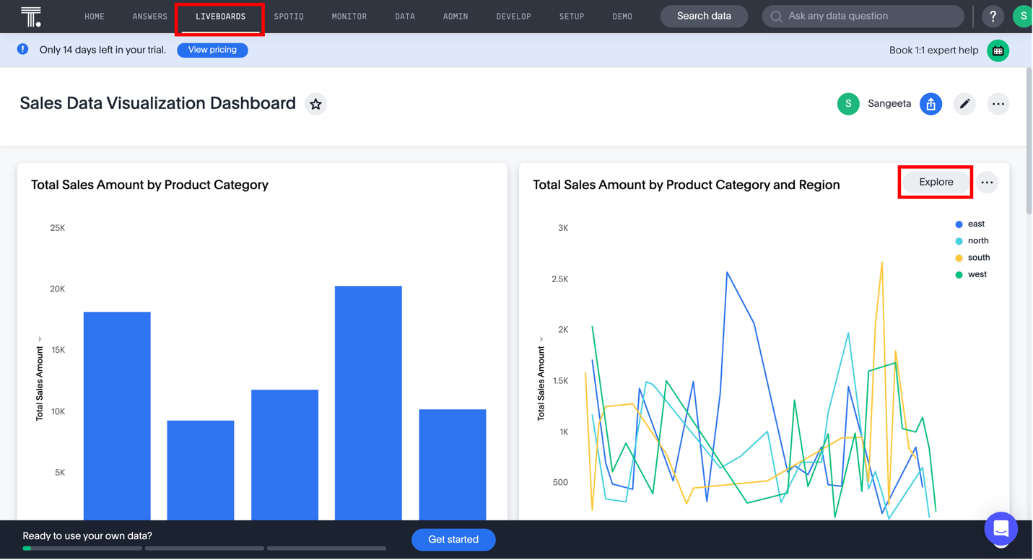
You can further explore the visualizations by using Filter, Add, Replace, and Compare functionalities.
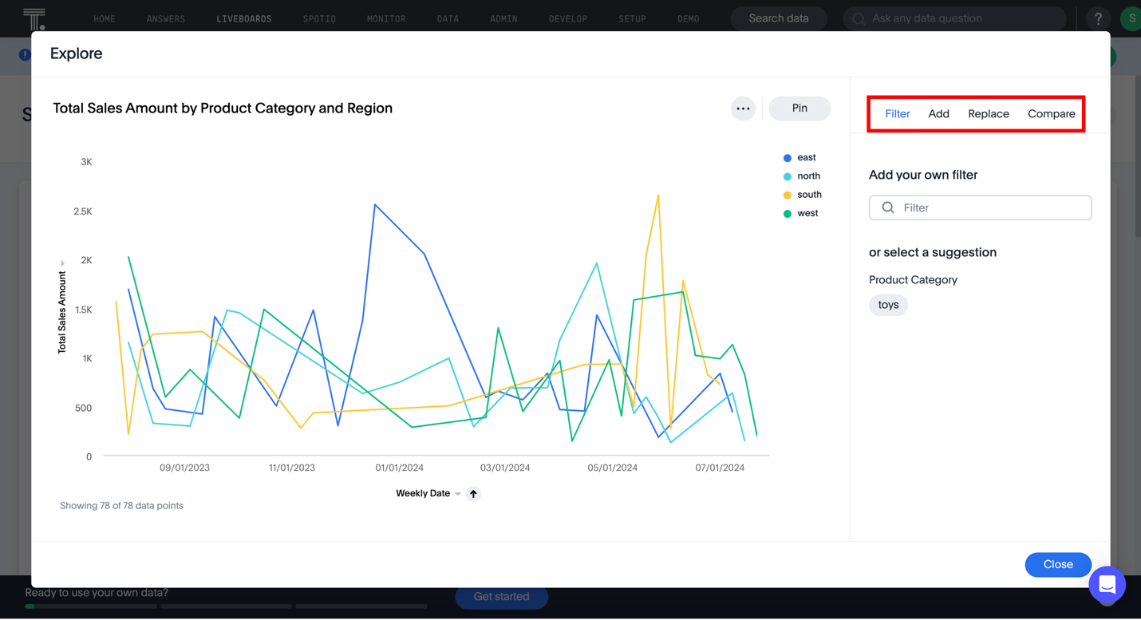
You can share the dashboards using ThoughtSpot's sharing features. Click the Shareicon.
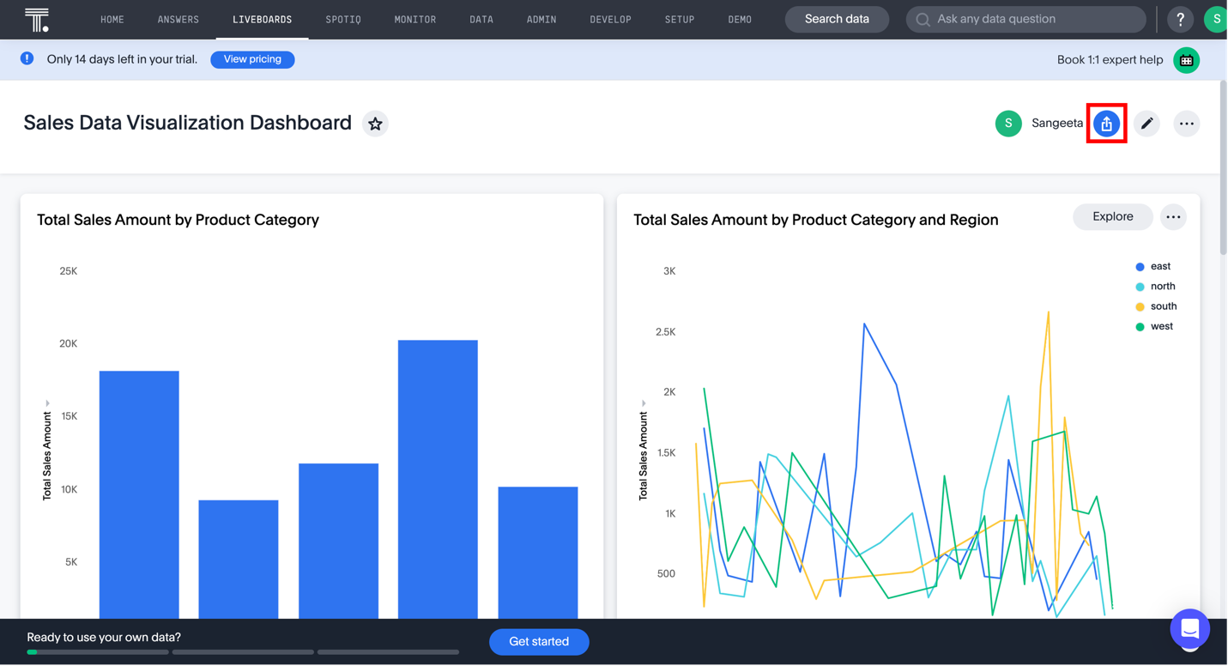
You may send an email or just share the link with stakeholders and collaborators.
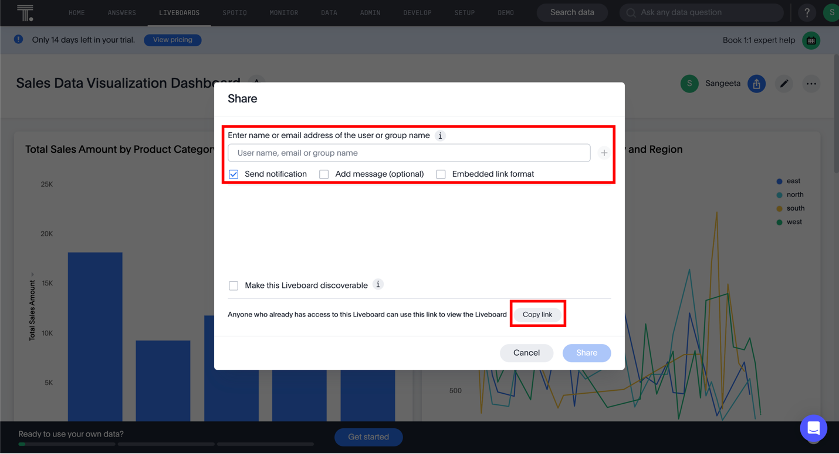

Try it yourself
Try to find answers to the following questions by creating visualizations and exploring the visualizations.
- Which region has the most sales?
- Which product category grosses the most sales in the north region?
- List the top five products by sales revenue.

Summary
Congratulations on completing the hands-on lab, Dashboards with AI.
In this lab, you explored how to generate basic visualizations and create interactive dashboards using the ThoughtSpot platform.

