

Hands-on lab: Generating SQL queries with AI

Estimated time: 30 minutes

Learning objectives
After completing this lab, you will be able to:
- Leverage generative AI models to create efficient queries for your data set.
- Improve the accuracy and performance of data retrieval and analysis tasks.

Welcome to the lab on Generating SQL queries with AI!

Introduction
BI analysts juggle with large volumes of data, writing intricate queries to access processed data from database tables according to specific requirements. These activities are time-consuming and require meticulous attention to detail for efficient data retrieval and analysis. However, consider a BI analyst who leverages generative AI tools and agents to streamline the creation of optimized queries. This allows them to focus on more strategic tasks, such as interpreting data insights and supporting decision-making processes.
Processed data stored in a database table can be accessed using queries tailored to your requirements. Since queries are a crucial part of a data professional's workflow, mastering the skill of writing efficient queries is essential.
In this lab, you will learn how to leverage generative AI platforms to create optimized queries for your data, provided you supply the model with sufficient context.
Note: The prompts given in this lab are for samples only. You can write prompts based on your requirements to generate responses. However, you may get a different response even if you use prompts from this lab.

Exercise 1: Leverage ChatGPT to create efficient queries for your data set
In this exercise, you'll leverage OpenAI's AI-powered assistant, ChatGPT. ChatGPT is a powerful language model designed to assist both consumers and businesses. It understands and processes text, audio, video, and images. ChatGPT helps professionals streamline their tasks, and BI analysts are no exception.
By using ChatGPT, BI analysts can simplify their workflow, create optimized queries, analyze data efficiently, and focus more on strategic decision making and insights.
In this lab, you will leverage ChatGPT to create efficient SQL queries tailored to your specific data analysis needs. You will start by providing a detailed description of your data set, including attributes such as age, gender, and chest pain type, to give ChatGPT the necessary context. Using this context, ChatGPT will then generate SQL queries for various data analysis tasks. For example, you can prompt ChatGPT to create queries for obtaining age distribution, performing gender analysis, determining the frequency of chest pain types, and investigating the distribution of heart disease within different age groups. This process will enable you to efficiently generate and execute SQL queries, enhancing your ability to analyze and interpret data as a BI analyst.

Step 1: Provide the required data set to ChatGPT
In this step, you will provide the model with a description of your data set to generate efficient and readily usable queries tailored to your requirements for fetching the data.
For this lab, you will use the Heart Disease data set from the UCI ML library, available publicly under the CCA 4.0 International license.
Note: You can download the data set and run the generated queries using any SQL querying system.
- You can access the ChatGPT platform using the link https://chatgpt.com/; right-click to open in a new tab, and log in to ChatGPT. If you are a first-time user, set up OpenAI's ChatGPT account to sign up.
- Paste the following text in the input box to provide ChatGPT with the appropriate context for the data.
In this lab, we will use the Heart Disease data set from the UCI Machine Learning Repository. This dataset includes various features such as age, gender, chest pain type, cholesterol levels, and more. The primary goal is to classify the presence of heart disease.
- age - age in years
- gender - gender (1 = male; 0 = female)
- cp - chest pain type
- --Value 1: typical angina

- --Value 2: atypical angina

- --Value 3: nonanginal pain

--Value 4: asymptomatic

- trestbps - resting blood pressure (in mm Hg on admission to the hospital)
- chol - serum cholesterol in mg/dl
- fbs - (fasting blood sugar > 120 mg/dl) (1 = true; 0 = false)
- restecg - resting electrocardiographic results
- --Value 0: normal

- --Value 1: having ST-T wave abnormality (T wave inversions and/or ST elevation or depression of > 0.05 mV)

--Value 2: showing probable or definite left ventricular hypertrophy by Estes’ criteria

- thalach - maximum heart rate achieved
- exang - exercise induced angina (1 = yes; 0 = no)
- oldpeak - ST depression induced by exercise relative to rest
- slope - the slope of the peak exercise ST segment
- --Value 1: upsloping

- --Value 2: flat

--Value 3: downsloping

- ca - number of major vessels (0-3) colored by fluoroscopy
- thal - 3 = normal; 6 = fixed defect; 7 = reversible defect
- num (the predicted attribute) - diagnosis of heart disease (angiographic disease status)
- --Value 0: < 50% diameter narrowing

--Value 1: > 50% diameter narrowing

In this lab, we will use the Heart Disease data set from the UCI Machine Learning Repository. This dataset includes various features such as age, gender, chest pain type, cholesterol levels, and more. The primary goal is to classify the presence of heart disease.
- age - age in years
- gender - gender (1 = male; 0 = female)
- cp - chest pain type
- --Value 1: typical angina
- --Value 2: atypical angina
- --Value 3: nonanginal pain
- --Value 4: asymptomatic

- trestbps - resting blood pressure (in mm Hg on admission to the hospital)
- chol - serum cholesterol in mg/dl
- fbs - (fasting blood sugar > 120 mg/dl) (1 = true; 0 = false)
- restecg - resting electrocardiographic results
--Value 0: normal
--Value 1: having ST-T wave abnormality (T wave inversions and/or ST elevation or depression of > 0.05 mV)
--Value 2: showing probable or definite left ventricular hypertrophy by Estes’ criteria

- thalach - maximum heart rate achieved
- exang - exercise induced angina (1 = yes; 0 = no)
- oldpeak - ST depression induced by exercise relative to rest
- slope - the slope of the peak exercise ST segment
--Value 1: upsloping
--Value 2: flat
--Value 3: downsloping

- ca - number of major vessels (0-3) colored by fluoroscopy
- thal - 3 = normal; 6 = fixed defect; 7 = reversible defect
- num (the predicted attribute) - diagnosis of heart disease (angiographic disease status)
--Value 0: < 50% diameter narrowing
--Value 1: > 50% diameter narrowing

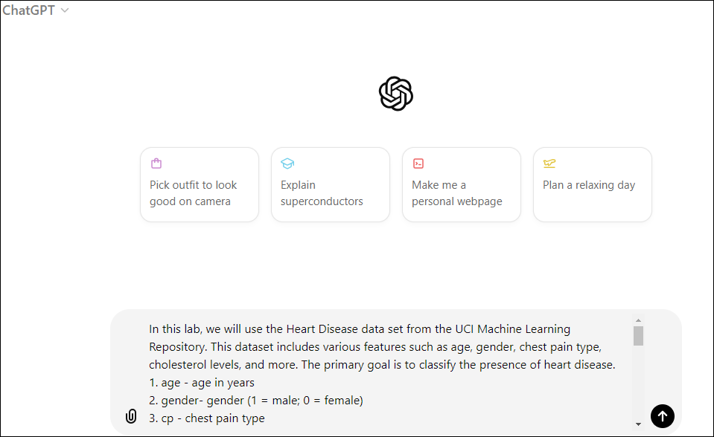
- Select Enter on your keyboard or the top arrow sign on the screen to provide the input.
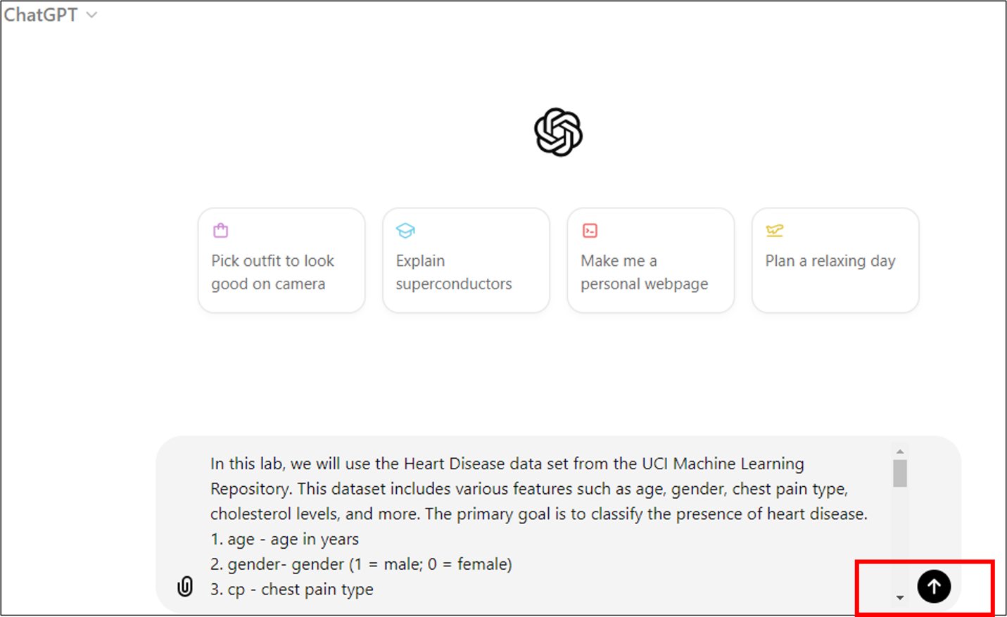

Step 2: Write prompts to create SQL queries
Once you have set the context, ChatGPT will have enough background to generate SQL queries for your prompts. Consider the following prompts, asking ChatGPT to generate SQL queries for different tasks:
- Obtain age distribution
Write an SQL query to find the minimum, maximum, and average age of patients in the data set.
Copy Prompt
- Select Enter on your keyboard or the top arrow sign on the screen to obtain the response.
- 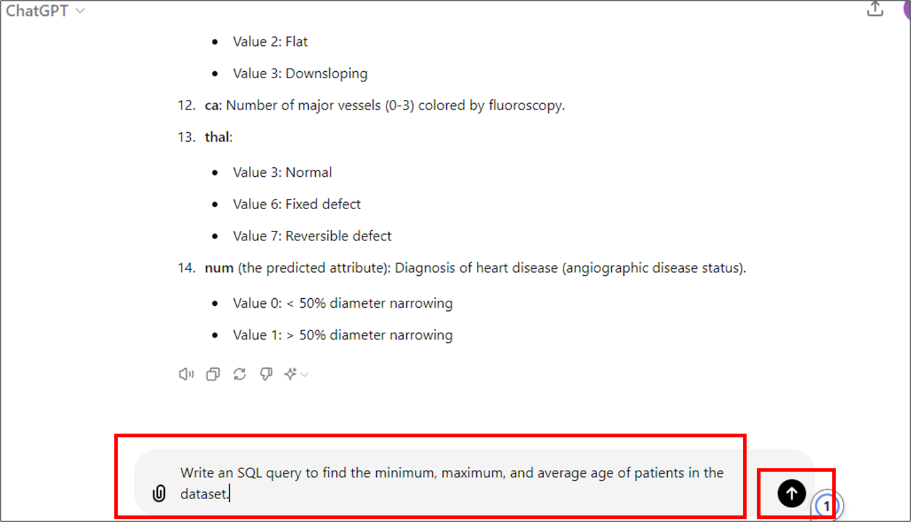
- You can see the following SQL query generated in response.
- 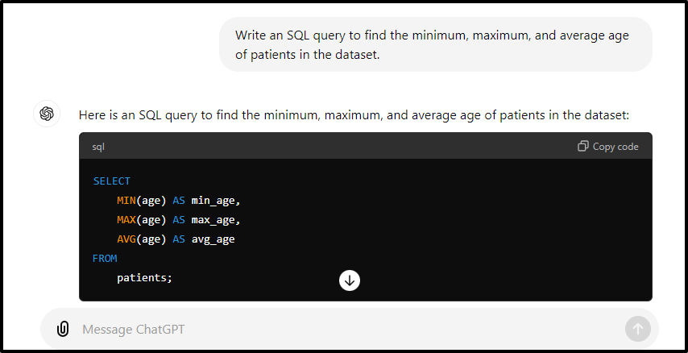
- Perform gender analysis
Write an SQL query to count the number of male and female patients in the data set.
Copy Prompt
- Select Enter on your keyboard or the top arrow sign on the screen to obtain the response.
- 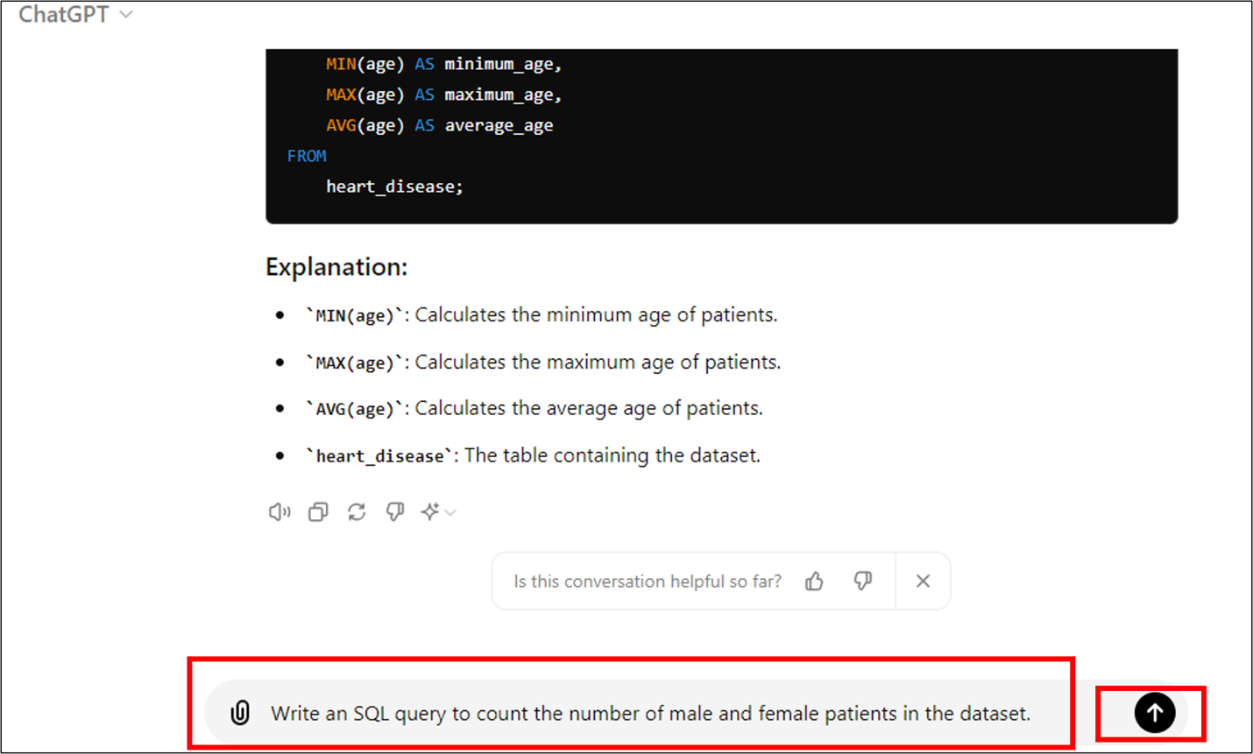
- You can see the following SQL query generated in response.
- 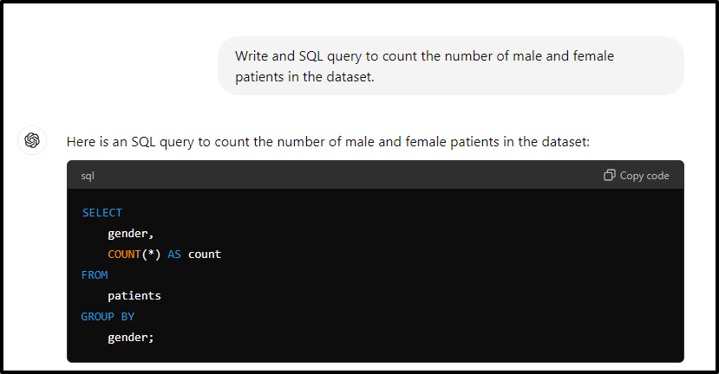
- Obtain the frequency of chest pain types
Write an SQL query to determine the frequency of each type of chest pain (typical angina, atypical angina, nonanginal pain, asymptomatic) among patients.
Copy Prompt
- Select Enter on your keyboard or the top arrow sign on the screen to obtain the response.
- 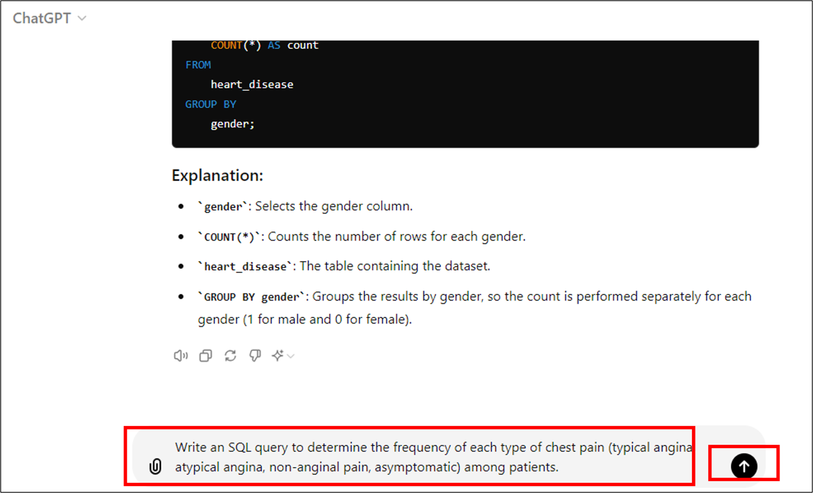
- You can see the following SQL query generated in response.
- 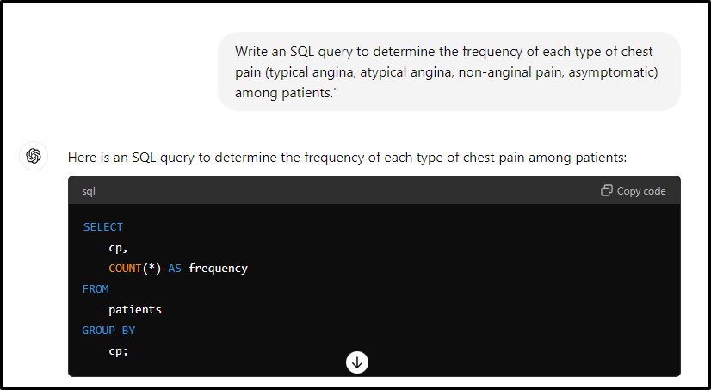
- To investigate target variables within different age groups
Write an SQL query to investigate the distribution of the target variable (presence or absence of heart disease) within different age groups (e.g., 20-30, 30-40, etc.).
Copy Prompt
- Select Enter on your keyboard or the top arrow sign on the screen to obtain the response.
- 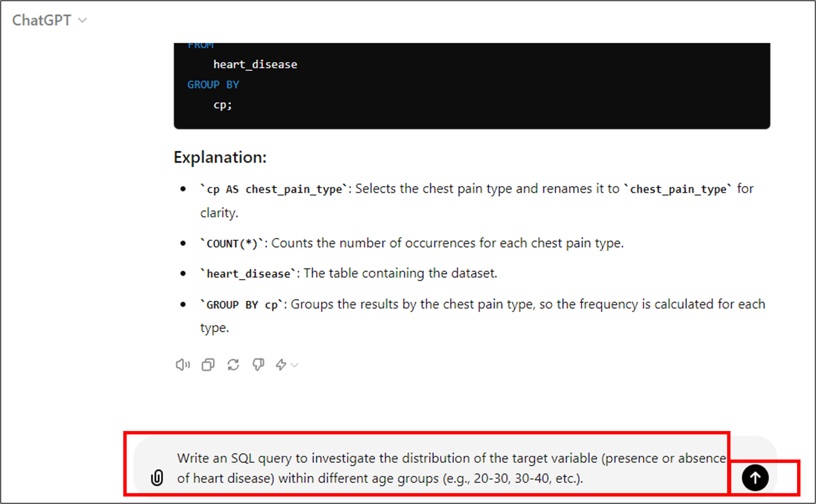
- You can see the following SQL query generated in response.
- 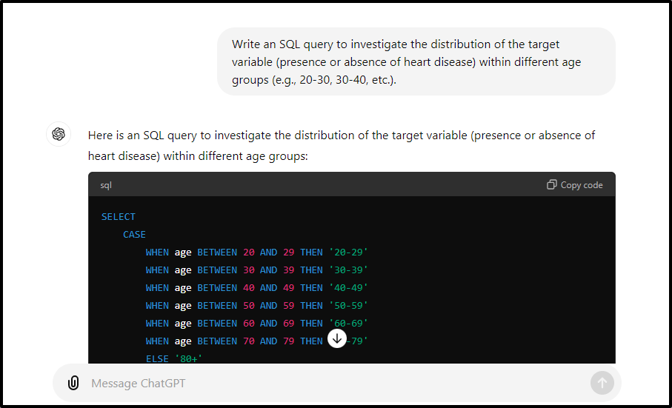
- 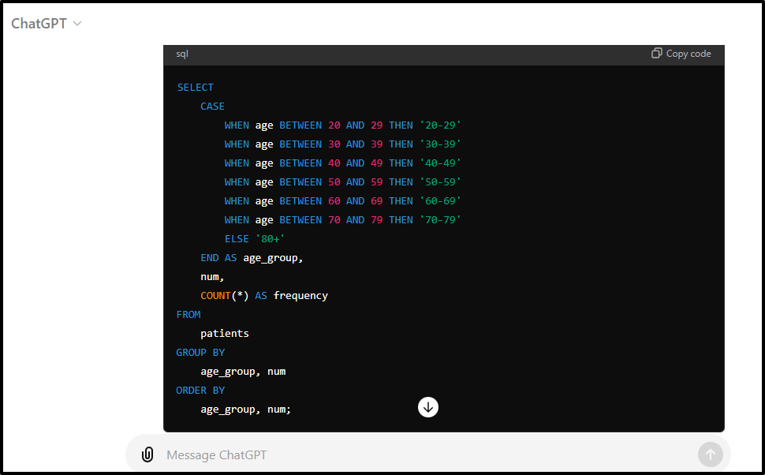

Try yourself
Write clear and descriptive prompts to leverage the full potential of ChatGPT.
Try to generate queries for the data set for the following prompts:
- Cholesterol range:
Find the range of cholesterol levels among patients (minimum, maximum).
- Age range and gender Analysis:
Determine the age range (youngest and oldest) for male and female patients separately.
- Maximum heart rate by age group:
Find the maximum heart rate achieved during exercise for different age groups (e.g., 30-40, 40-50, etc.).
- Percentage of patients with high blood sugar:
Calculate the percentage of patients with fasting blood sugar greater than 120 mg/dl.
- Ratio of patients with resting electrocardiographic abnormality:
Find the ratio of patients with abnormal resting electrocardiographic results to those with normal results.
- Number of patients with reversible thalassemia:
Count the number of patients with reversible thalassemia detected by thallium stress testing.
- Average age of patients with chest pain:
Calculate the average age of patients who experienced chest pain during diagnosis.
- Distribution of patients by the number of major vessels:
Investigate the distribution of patients based on the number.

Summary
Congratulations on completing the hands-on lab Generating SQL Queries with AI.
In this lab, you've leveraged ChatGPT, an AI chatbot, to create personalized SQL queries for efficiently extracting insights from large data sets. ChatGPT assists BI analysts in generating SQL queries for various business intelligence tasks, enhancing their ability to retrieve data quickly and accurately.

