

Hands-on lab: Text Generation and Summarization

Estimated time: 30 minutes

Learning objectives
After completing this lab, you will be able to:
- Leverage generative AI tools like ChatGPT for text generation
- Use generative AI tools for summarization

Introduction
Imagine a business intelligence (BI) analyst who creates reports, summaries, and presentations on a regular basis. BI analysts may not be proficient in writing. They may find writing summaries, building narratives, and customizing content for their audience extremely challenging. Other than these tasks, they also write emails. BI analysts can leverage generative AI tools like Open AI's ChatGPT, Google's Gemini, and Microsoft's Copilot, which help with tasks like summarizing, extracting important information, and writing.
In this lab, you'll work on tasks that demonstrate various uses of these tools in BI. We will be using ChatGPT for this exercise.
Note: The prompts given in this lab are for samples only. You can write prompts based on your requirements to generate responses. However, you may get a different response even if you use prompts from this lab.
Before you begin
You can access a ChatGPT platform, for example, OpenAI's ChatGPT interface or any platform integrating GPT-3. Open the link https://chatgpt.com/ in your browser window and log in to ChatGPT.
If you are a first-time user, set up OpenAI's ChatGPT account to sign up.
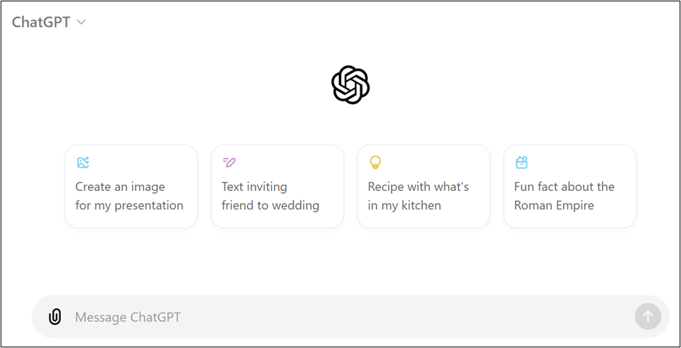
You can write the prompts in the Message ChaGPT field and click the arrow on the right to generate the output.
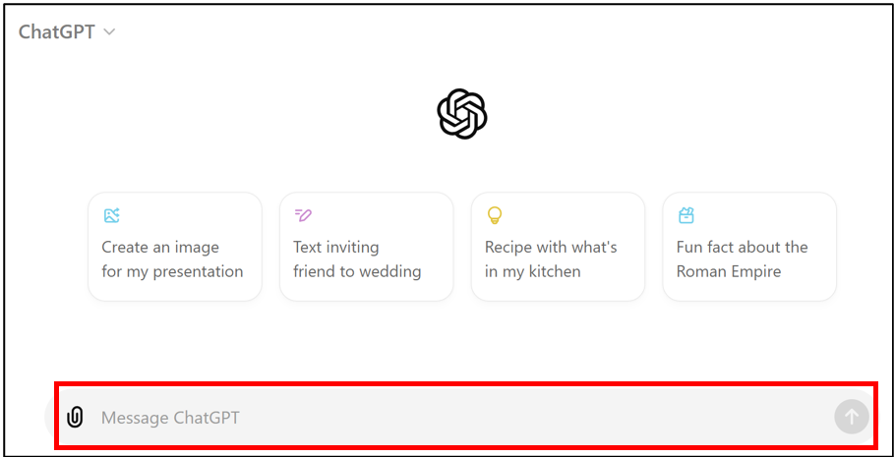

Task 1: Generating a data quality assessment report
You want to generate a data quality assessment report. Write the following prompt in the chat box.
"Prepare a report that assesses the quality of data in a customer database, highlighting any missing, inconsistent, or outdated information. Include recommendations for improving data quality."
Press Enter on your keyboard or click the arrow to the right of the chat box.
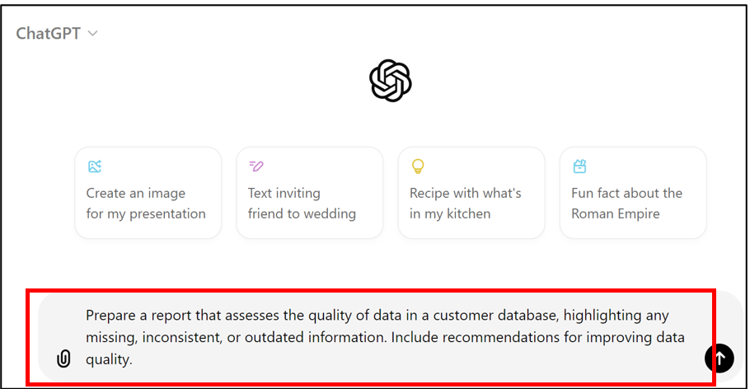
The generated sample response is shown below.
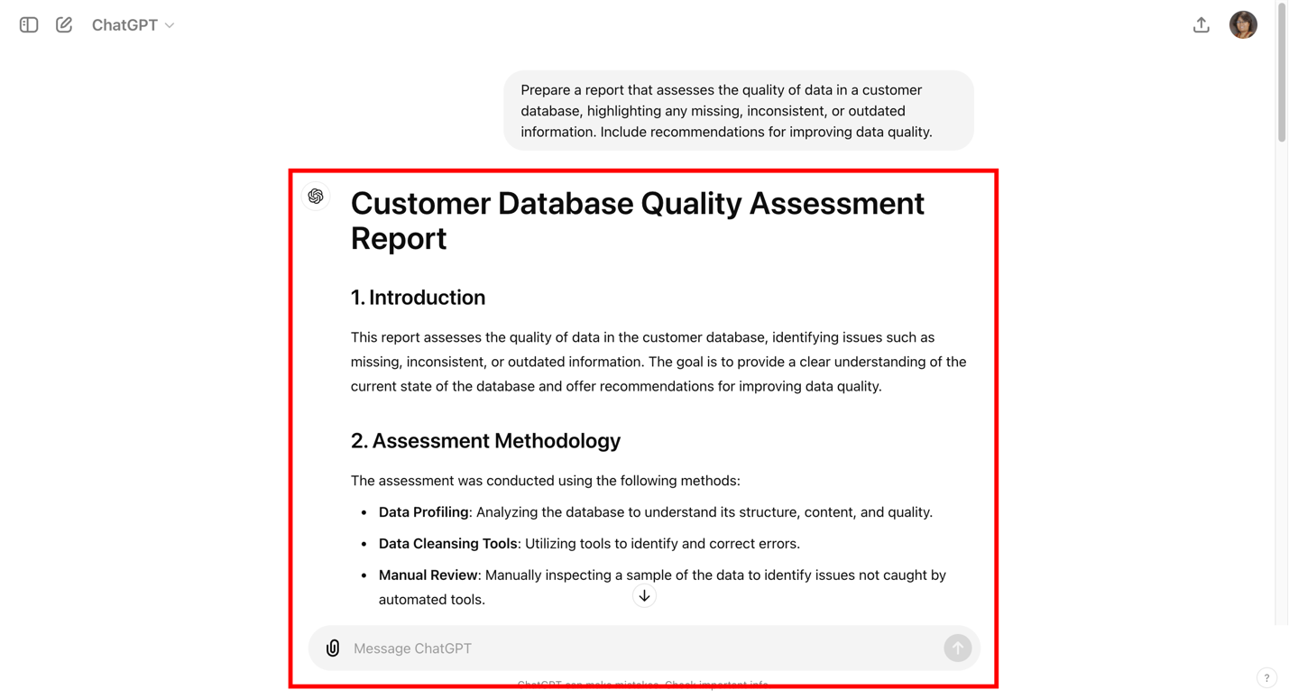
Here is the text response for the inserted prompt.
"Customer Database Quality Assessment Report
1. Introduction
This report assesses the quality of data in the customer database, identifying issues such as missing, inconsistent, or outdated information. The goal is to provide a clear understanding of the current state of the database and offer recommendations for improving data quality.
2. Assessment Methodology
The assessment was conducted using the following methods:
- Data Profiling: Analyzing the database to understand its structure, content, and quality.
- Data Cleansing Tools: Utilizing tools to identify and correct errors.
- Manual Review: Manually inspecting a sample of the data to identify issues not caught by automated tools.
3. Findings
3.1 Missing Data
Missing data can significantly impact the accuracy and usability of the database. The following table summarizes the missing data found in key fields:
Field Name</em | Percentage Missing
Customer ID | 0%
Name | 2%
Email Address | 5%
Phone Number | 8%
Address | 4%
Date of Birth | 10%
3.2 Inconsistent Data
Inconsistent data occurs when information is recorded in different formats or contradicts other entries. Common issues include:
- Name Formatting: Variations in capitalization (e.g., "John Doe" vs. "john doe").
- Date Formats: Dates recorded in different formats (e.g., MM/DD/YYYY vs. DD/MM/YYYY).
- Phone Number Formats: Inconsistent use of country codes and formatting (e.g., "(123) 456-7890" vs. "123-456-7890").
3.3 Outdated Data
Outdated data refers to information that is no longer accurate. This includes:
- Email Addresses: A significant number of email addresses that bounce back when contacted.
- Phone Numbers: Phone numbers that are no longer in service.
- Addresses: Customers who have moved without updating their address information.
4. Recommendations for Improving Data Quality
4.1 Implement Data Validation Rules
- Real-time Validation: Implement real-time validation rules to check for missing or incorrectly formatted data at the point of entry.
- Standardized Formats: Enforce standardized formats for key fields (e.g., email addresses, phone numbers, dates).
4.2 Regular Data Cleansing
- Automated Tools: Utilize automated data cleansing tools to regularly scan the database for errors and inconsistencies.
- Manual Review: Schedule periodic manual reviews of the data to identify and correct issues that automated tools may miss.
4.3 Update and Verify Contact Information
- Email Verification: Implement an email verification process to ensure email addresses are valid at the point of entry.
- Phone Verification: Use phone verification services to confirm phone numbers are accurate.
- Address Verification: Integrate address validation tools to ensure addresses are correct and up to date.
4.4 Establish Data Governance Policies
- Data Stewardship: Appoint data stewards responsible for maintaining data quality within the organization.
- Data Quality Metrics: Define and monitor key data quality metrics to track improvements over time.
- Training: Provide training for employees on the importance of data quality and best practices for data entry and maintenance.
4.5 Encourage Customer Updates
- Self-Service Portals: Provide customers with a self-service portal to update their information easily.
- Regular Communications: Send regular communications reminding customers to update their information.
5. Conclusion
Improving the quality of data in the customer database is crucial for enhancing business operations and customer relations. By implementing the recommended strategies, the organization can achieve a higher level of data accuracy, consistency, and timeliness, ultimately leading to better decision-making and customer satisfaction."
If you are not happy with the response, click Regenerate. You may ask for additional details to be added by writing prompts in the chat box.

Task 2: Writing an executive summary
You want to generate an executive summary for your report. Write the following prompt in the chat box.
"Write an executive summary for a report on the company's performance in the last quarter, focusing on revenue growth, cost reductions, and new product launches."
Press Enter on your keyboard or click the arrow to the right of the chat box.

The generated sample response is shown below.
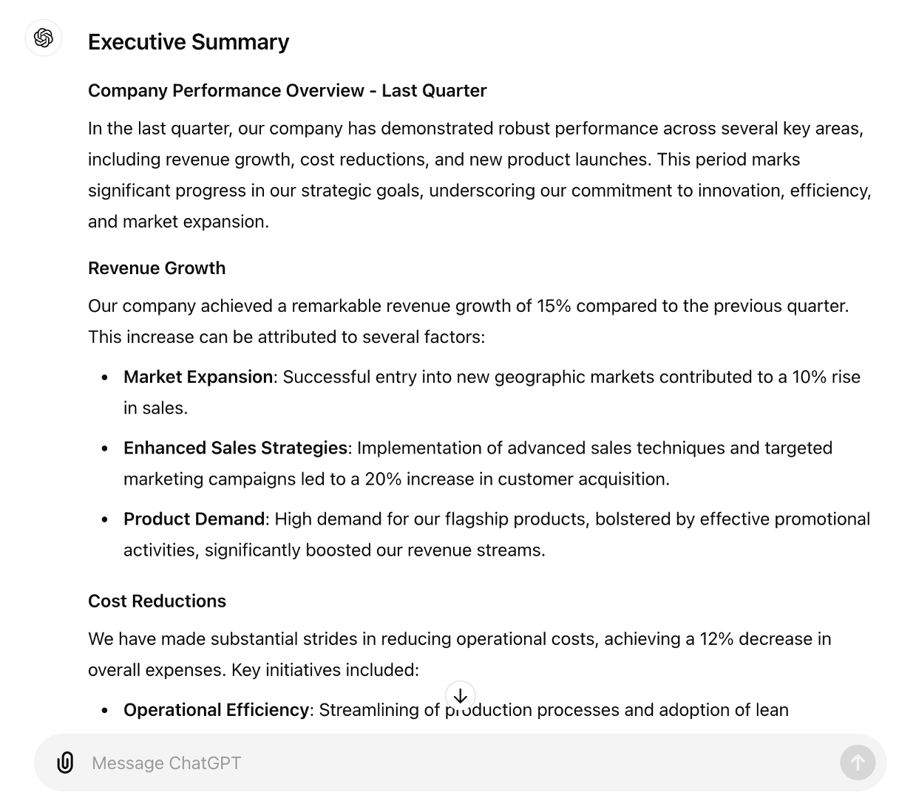
Here is the text response for the inserted prompt.
"Executive Summary
Company Performance Overview - Last Quarter
In the last quarter, our company has demonstrated robust performance across several key areas, including revenue growth, cost reductions, and new product launches. This period marks significant progress in our strategic goals, underscoring our commitment to innovation, efficiency, and market expansion.
Revenue Growth
Our company achieved a remarkable revenue growth of 15% compared to the previous quarter. This increase can be attributed to several factors:
- Market Expansion: Successful entry into new geographic markets contributed to a 10% rise in sales.
- Enhanced Sales Strategies: Implementation of advanced sales techniques and targeted marketing campaigns led to a 20% increase in customer acquisition.
- Product Demand: High demand for our flagship products, bolstered by effective promotional activities, significantly boosted our revenue streams.
Cost Reductions
We have made substantial strides in reducing operational costs, achieving a 12% decrease in overall expenses. Key initiatives included:
- Operational Efficiency: Streamlining of production processes and adoption of lean manufacturing techniques resulted in a 5% reduction in production costs.
- Supply Chain Optimization: Negotiation of better terms with suppliers and strategic inventory management contributed to a 4% decrease in supply chain costs.
- Energy Savings: Implementation of energy-efficient technologies and practices reduced energy consumption by 3%, translating into notable cost savings.
New Product Launches
Innovation remains a cornerstone of our growth strategy. This quarter, we successfully launched three new products, each receiving positive market reception:
- Product A: A cutting-edge technology solution that addresses key customer pain points, leading to a 25% increase in pre-orders.
- Product B: An eco-friendly product line that caters to the growing demand for sustainable solutions, capturing a new customer segment and contributing 8% to the overall revenue.
- Product C: A high-performance upgrade to an existing product, driving a 10% increase in sales from our loyal customer base.
Conclusion
The last quarter has been marked by significant achievements in revenue growth, cost reductions, and product innovation. These accomplishments not only reflect our strategic execution but also position us strongly for continued success in the upcoming quarters. We remain committed to leveraging our strengths, exploring new opportunities, and delivering value to our stakeholders.
Key Takeaways:
- 15% Revenue Growth: Driven by market expansion, enhanced sales strategies, and high product demand.
- 12% Cost Reduction: Achieved through operational efficiency, supply chain optimization, and energy savings.
- Successful New Product Launches: Introduction of innovative products that have been well-received in the market.
Moving forward, we will continue to build on these successes, ensuring sustained growth and profitability for our company."

Task 3: Writing a brief analysis of competitor performance
You want to write a brief analysis of competitor performance. Write the following prompt in the chat box.
"Write a brief analysis comparing your company's performance metrics, such as market share, revenue growth, and customer satisfaction, with those of a key competitor over the past year."
Press Enter on your keyboard or click the arrow to the right of the chat box.

The generated sample response is shown below.
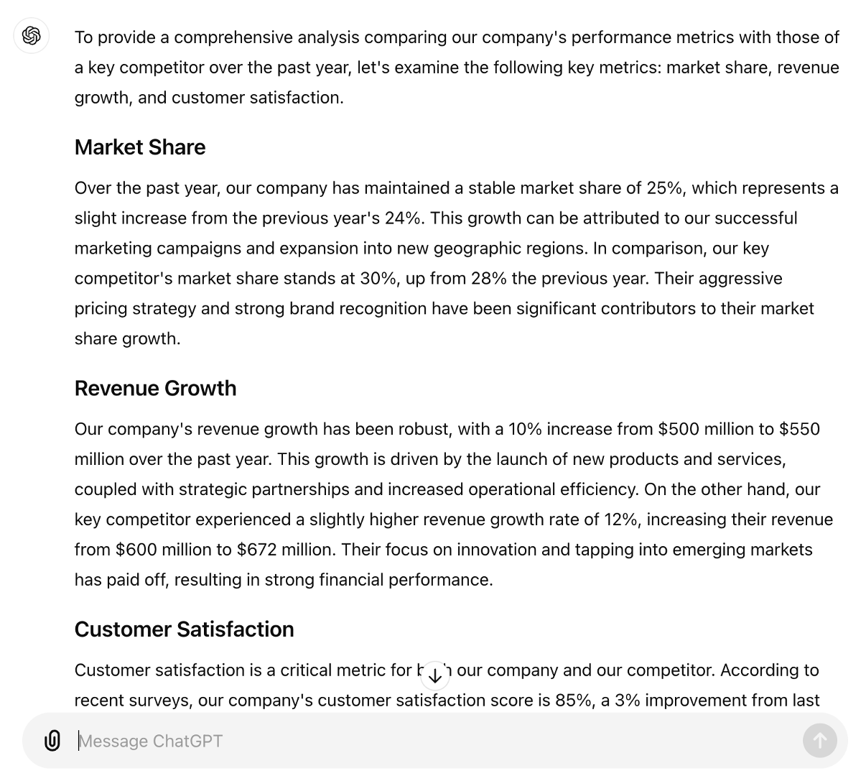
Here is the text response for the inserted prompt.
"To provide a comprehensive analysis comparing our company's performance metrics with those of a key competitor over the past year, let's examine the following key metrics: market share, revenue growth, and customer satisfaction.
Market Share
Over the past year, our company has maintained a stable market share of 25%, which represents a slight increase from the previous year's 24%. This growth can be attributed to our successful marketing campaigns and expansion into new geographic regions. In comparison, our key competitor's market share stands at 30%, up from 28% the previous year. Their aggressive pricing strategy and strong brand recognition have been significant contributors to their market share growth.
Revenue Growth
Our company's revenue growth has been robust, with a 10% increase from $500 million to $550 million over the past year. This growth is driven by the launch of new products and services, coupled with strategic partnerships and increased operational efficiency. On the other hand, our key competitor experienced a slightly higher revenue growth rate of 12%, increasing their revenue from $600 million to $672 million. Their focus on innovation and tapping into emerging markets has paid off, resulting in strong financial performance.
Customer Satisfaction
Customer satisfaction is a critical metric for both our company and our competitor. According to recent surveys, our company's customer satisfaction score is 85%, a 3% improvement from last year. This improvement is a result of our enhanced customer service initiatives, including faster response times and more personalized support. Conversely, our key competitor has a customer satisfaction score of 88%, up from 86% the previous year. Their investment in advanced customer service technologies and a focus on customer experience has resonated well with their customer base.
Summary
In summary, both our company and our key competitor have shown positive performance trends over the past year. While our company has seen significant improvements in market share and customer satisfaction, our competitor has slightly outpaced us in revenue growth and overall market share. Moving forward, our focus will be on leveraging our strengths in customer satisfaction and operational efficiency to drive further market share gains and revenue growth."

Task4: Creating an overview for a key performance indicator (KPI) dashboard
You want to write an overview for a KPI dashboard. Write the following prompt in the chat box.
"Develop an overview for a dashboard designed to monitor key performance indicators (KPIs) for a retail business, including inventory turnover, average transaction value, and customer satisfaction scores."
Press Enter on your keyboard or click the arrow to the right of the chat box.
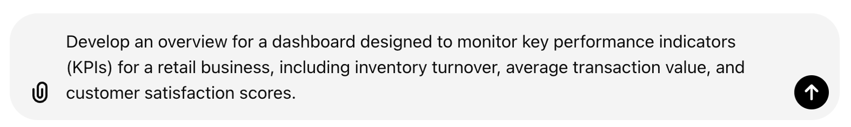
The generated sample response is shown below.
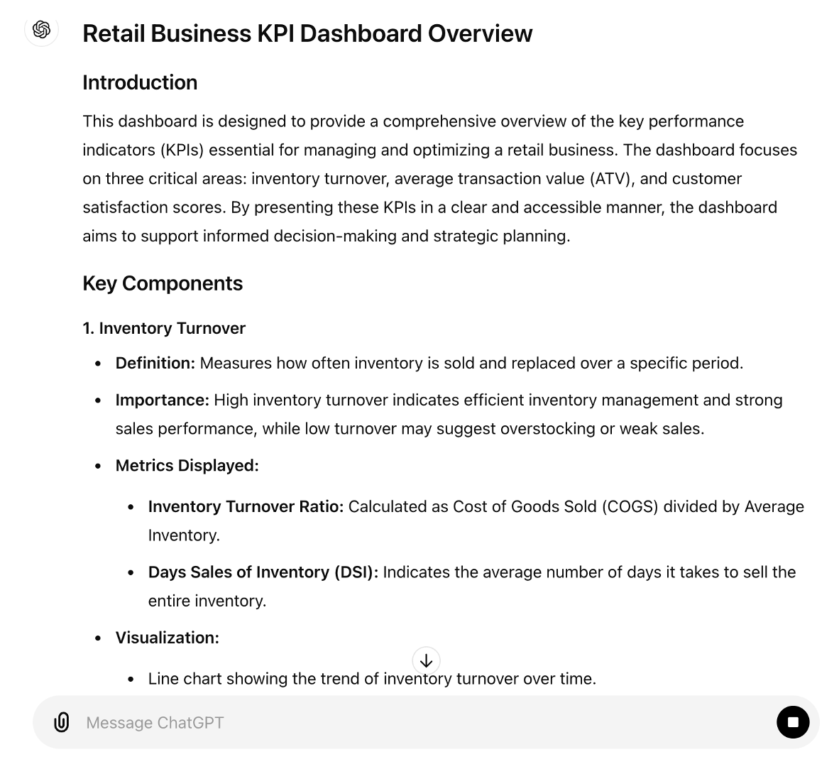
Here is the text response for the inserted prompt.
"Retail Business KPI Dashboard Overview
Introduction
This dashboard is designed to provide a comprehensive overview of the key performance indicators (KPIs) essential for managing and optimizing a retail business. The dashboard focuses on three critical areas: inventory turnover, average transaction value (ATV), and customer satisfaction scores. By presenting these KPIs in a clear and accessible manner, the dashboard aims to support informed decision-making and strategic planning.
Key Components
1. Inventory Turnover
- Definition: Measures how often inventory is sold and replaced over a specific period.
- Importance: High inventory turnover indicates efficient inventory management and strong sales performance, while low turnover may suggest overstocking or weak sales.
- Metrics Displayed:
  - Inventory Turnover Ratio: Calculated as Cost of Goods Sold (COGS) divided by Average Inventory.
  - Days Sales of Inventory (DSI): Indicates the average number of days it takes to sell the entire inventory.
- Visualization:
  - Line chart showing the trend of inventory turnover over time.
  - Bar chart comparing turnover rates across different product categories.
2. Average Transaction Value (ATV)
- Definition: Represents the average amount spent by customers per transaction.
- Importance: Higher ATV can indicate effective upselling and cross-selling strategies, as well as higher-priced product sales.
- Metrics Displayed:
  - Daily/Weekly/Monthly ATV: Average transaction value over selected time periods.
  - ATV by Product Category: Breakdown of ATV by different categories to identify high-performing segments.
- Visualization:
  - Line graph displaying ATV trends over time.
  - Pie chart showing the contribution of each product category to the overall ATV.
3. Customer Satisfaction Scores
- Definition: Reflects the overall satisfaction of customers with their shopping experience.
- Importance: High customer satisfaction is linked to customer loyalty, repeat business, and positive word-of-mouth.
- Metrics Displayed:
  - Net Promoter Score (NPS): Measures customer willingness to recommend the store to others.
  - Customer Satisfaction (CSAT) Score: Based on survey feedback.
  - Customer Feedback Trends: Analysis of customer reviews and feedback over time.
- Visualization:
  - Gauge chart displaying the current NPS and CSAT scores.
  - Sentiment analysis word cloud from customer reviews.
  - Trend line for NPS and CSAT over time.
Dashboard Features
- Interactive Filters: Allow users to filter data by time period, product category, store location, and more.
- Real-time Updates: Automatic updates to reflect the most current data available.
- Detailed Drill-Downs: Enable users to click on any KPI to see more detailed information and analysis.
- Benchmarking: Compare current performance against historical data and industry benchmarks.
- Alerts and Notifications: Automated alerts for significant changes in KPIs or threshold breaches.
Conclusion
The Retail Business KPI Dashboard is a powerful tool for tracking and analyzing critical performance indicators. By providing real-time insights into inventory turnover, average transaction value, and customer satisfaction scores, the dashboard helps retail managers make data-driven decisions to enhance operational efficiency, increase sales, and improve customer satisfaction."

Task 5: Generating a business strategy report headline
You want a headline for your business strategy report. Write the following prompt in the chat box.
"Create a headline for a business strategy report that outlines a new market entry plan, including market analysis, potential challenges, and strategic recommendations."
Press Enter on your keyboard or click the arrow to the right of the chat box.

The generated sample response is shown below.
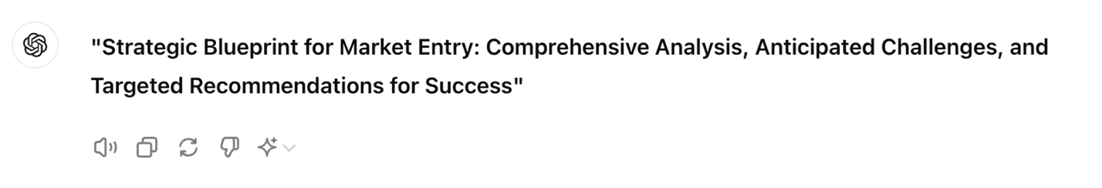
Here is the text response for the inserted prompt.
"Strategic Blueprint for Market Entry: Comprehensive Analysis, Anticipated Challenges, and Targeted Recommendations for Success"

Try it yourself
Try the following prompts yourself.
Prompt 1: Summarizing a business report
Summarize the following business report: "In Q2, the company saw a 15% increase in sales, driven primarily by the launch of a new product line. However, operational costs also rose due to increased marketing expenses."
Prompt 2: Extracting key points from meeting notes
List the key points from these meeting notes: "The project timeline has been adjusted to accommodate new client requirements. The team will prioritize feature A over feature B, and additional resources will be allocated to meet the new deadline."
Prompt 3: Creating an FAQ
Generate a list of frequently asked questions (FAQs) and answers about a new subscription service for a digital content platform.
Prompt 4: Writing a press release introduction
Write the introduction for a press release announcing the launch of a new educational app that offers interactive learning for children.
Summary
Congratulations on completing the hands-on lab, Text Generation and Summarization.
In this lab, you explored how to leverage generative AI tools like ChatGPT for text generation and summarizing.

