1 科学上网：
为固定科学上网config可以采用固定名称
ssh连接

#连接登录节点
Host 172.18.18.7
HostName 172.18.18.7
Port 22
User wangsenbao_it
IdentityFile C:\Users\Dlts\.ssh\172.18.18.7_0314162516_rsa.txt
ServerAliveInterval 60
ServerAliveCountMax 3
#容器计算节点/squeue
Host my_gpu
IdentityFile C:\Users\Dlts\.ssh\172.18.18.7_0314162516_rsa.txt
HostName gpu5
User wangsenbao_it
ProxyJump 172.18.18.7
ServerAliveInterval 60
ServerAliveCountMax 3
#主机
Host toy
IdentityFile C:\Users\Dlts\.ssh\172.18.18.7_0314162516_rsa.txt
HostName 173.0.179.2
User wangsenbao_it
ProxyJump my_gpu
ServerAliveInterval 60
ServerAliveCountMax 3

本地cmd：
ssh -NR 11806:127.0.0.1:7897 wangsenbao_it@toy -v

服务器：
export http_proxy=http://127.0.0.1:11806/
export https_proxy=http://127.0.0.1:11806/

显存占用：nvtop
sudo -E apt update
sudo -e apt install nvtop
新终端:nvtop
内存占用（新终端）：
Free -h

2 demo数据转换
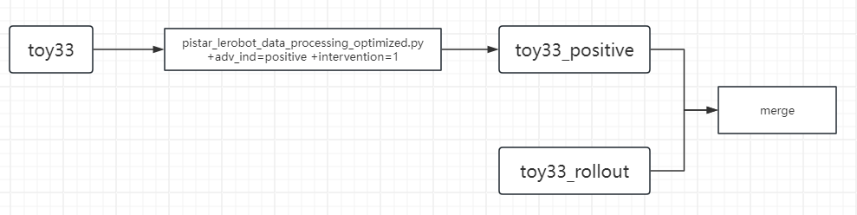
Cd /path/pistar

原数据转lerobot（加adv_ind和intervention，all_positive数据）:

sudo HF_LEROBOT_HOME=/public/home/wangsenbao_it/litianheng/lerobot_datasets \
PYTHONPATH=/public/home/wangsenbao_it/litianheng/pistar:/public/home/wangsenbao_it/litianheng/pistar/src:/public/home/wangsenbao_it/litianheng/pistar/packages/openpi-client/src \
/.venv/bin/python examples/libero/pistar_lerobot_data_processing.py \
--input-repo-id toy_33 \
--output-repo-id toy_33_pistar_all_positive \
--default-adv-ind positive \
--default-intervention 1

All positive与rollout合并:

sudo /.venv/bin/python scripts/merge_lerobot_datasets.py
--sources \
/root/.cache/huggingface/lerobot/toy_33_pistar_all_positive \
/public/home/wangsenbao_it/litianheng/lerobot_datasets/rollout/toy_task_rollout \
--output /public/home/wangsenbao_it/litianheng/lerobot_datasets/toy_33_pistar_all_positive \
--overwrite

3 归一化

sudo HF_LEROBOT_HOME=/public/home/wangsenbao_it/litianheng/lerobot_datasets \
HF_HOME=/public/home/wangsenbao_it/litianheng/.cache/huggingface \
HF_DATASETS_CACHE=/public/home/wangsenbao_it/litianheng/.cache/huggingface/datasets \
HF_HUB_CACHE=/public/home/wangsenbao_it/litianheng/.cache/huggingface/hub \
TMPDIR=/public/home/wangsenbao_it/litianheng/.cache/tmp \
PYTHONPATH=/public/home/wangsenbao_it/litianheng/pistar:/public/home/wangsenbao_it/litianheng/pistar/src:/public/home/wangsenbao_it/litianheng/pistar/packages/openpi-client/src \
XLA_PYTHON_CLIENT_PREALLOCATE=false \
XLA_PYTHON_CLIENT_MEM_FRACTION=0.9 \
/.venv/bin/python scripts/compute_norm_stats.py --config-name pi05_star_toy_task_merged

4 训练
sudo XLA_PYTHON_CLIENT_MEM_FRACTION=0.9 \
HF_LEROBOT_HOME=/public/home/wangsenbao_it/litianheng/lerobot_datasets \
HF_HOME=/public/home/wangsenbao_it/litianheng/.cache/huggingface \
HF_DATASETS_CACHE=/public/home/wangsenbao_it/litianheng/.cache/huggingface/datasets \
HF_HUB_CACHE=/public/home/wangsenbao_it/litianheng/.cache/huggingface/hub \
TMPDIR=/public/home/wangsenbao_it/litianheng/.cache/tmp \
PYTHONPATH=/public/home/wangsenbao_it/litianheng/pistar:/public/home/wangsenbao_it/litianheng/pistar/src:/public/home/wangsenbao_it/litianheng/pistar/packages/openpi-client/src \
XLA_PYTHON_CLIENT_PREALLOCATE=false \
/.venv/bin/python scripts/train.py pi05_star_toy_task_merged \
--exp-name=toy_task_merge_with_rollout \
--overwrite \
--no-wandb-enabled

挂起：
nohup sudo...--no-wandb-enabled > toy_task_merged.log 2>&1 &

追踪进度（新终端）：
tail -f toy_task_merged.log

