Yolanda Brown

Date: 2-3-2024

Assignment: Module 4.2 - MySQL Install

>>SQL installed

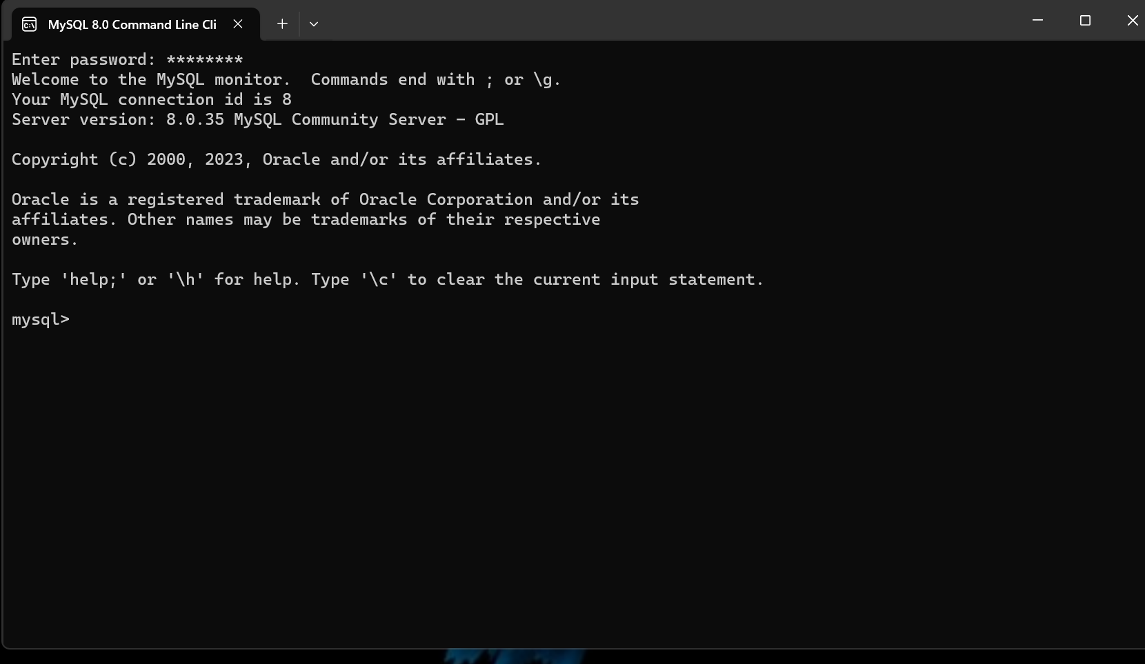

>>>>>DATABASE MOVIE

