Yolanda Brown

Date: 2/4/2024

Module5- Movies

ERD

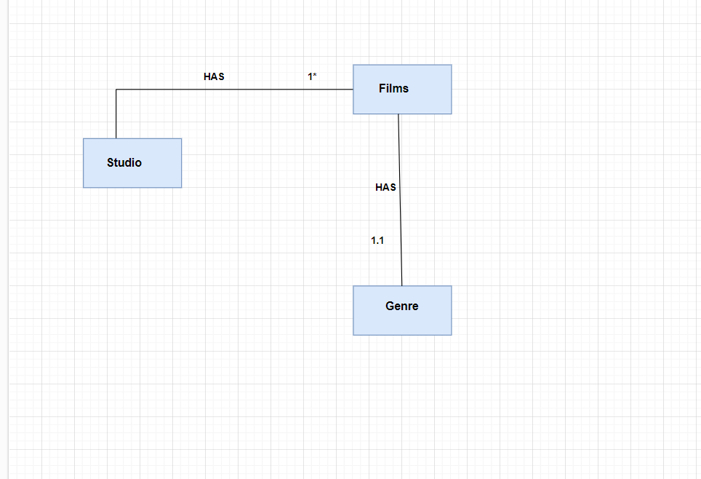

ERD w/Visual Paradigm

