**Yolanda Brown**

**Assignment: Movies: Setup- Module 6 SQL & PYTHON**

**Date: 2/11/2024**

**GIT HUB - https://github.com/ybrown30/csd-310.git**

**SQL Movies Import**

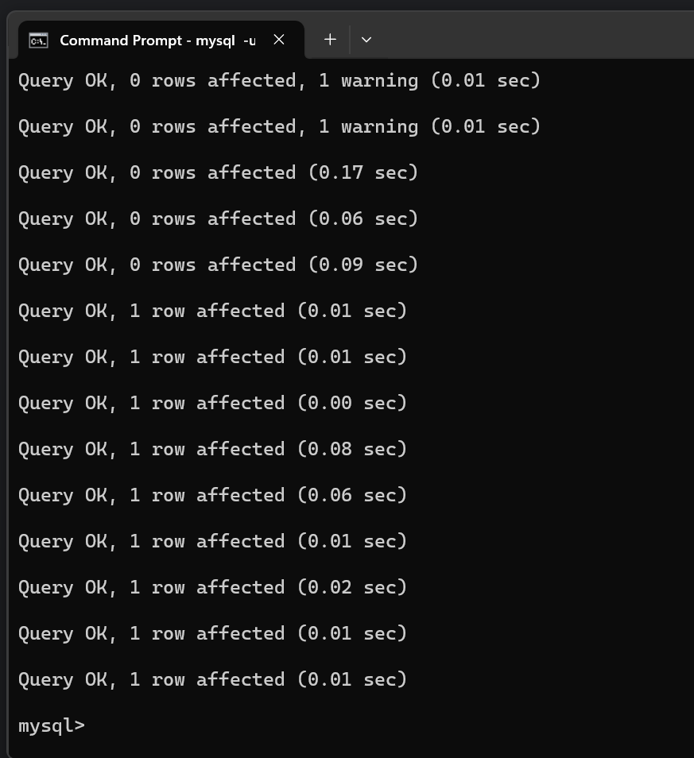**–**

**SHOW TABLES**

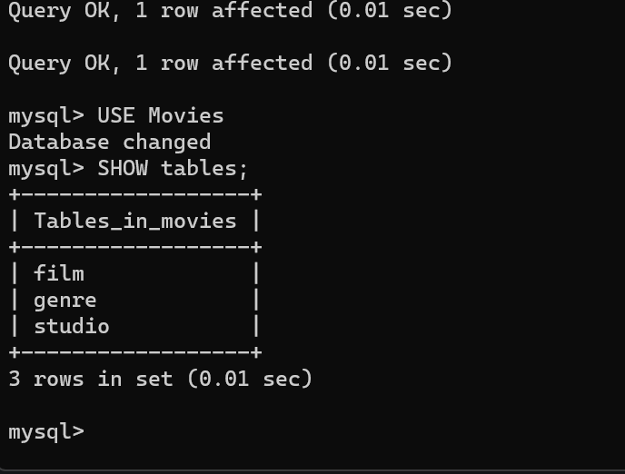

PYTHON CONNECTION

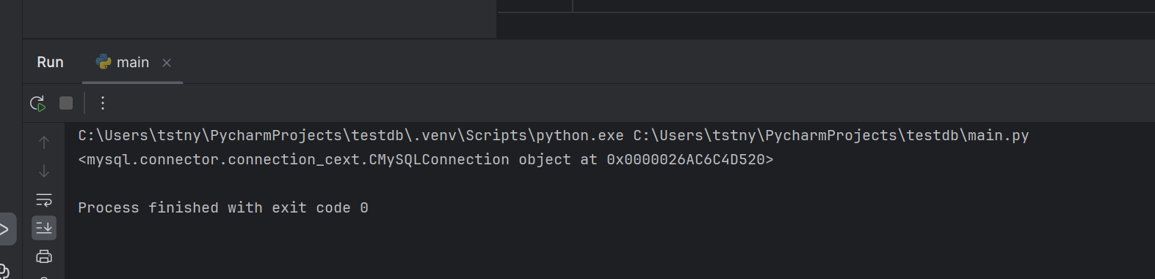

Source help:

https://dev.mysql.com/doc/connector-python/en/connector-python-api-mysqlcursor.html