Yolanda Brown

Assignment-**Building a Web Page Exercise, Part 1**

**Date: 3/24/2024**

**GIT HUB Link**

**https://github.com/ybrown30/csd-340.git**

**Validation Error Message:**

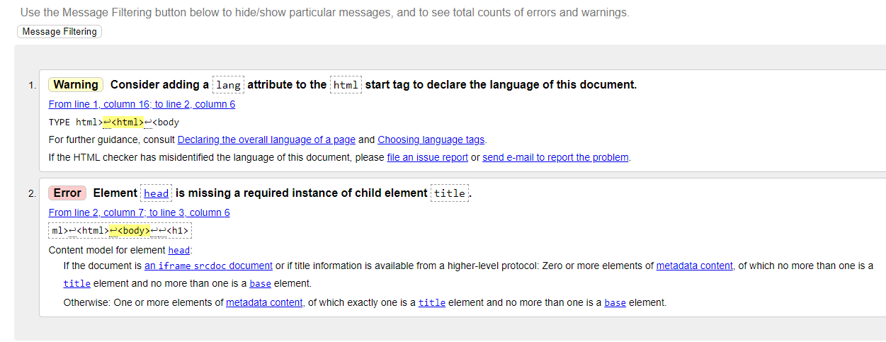

Re-Validation

U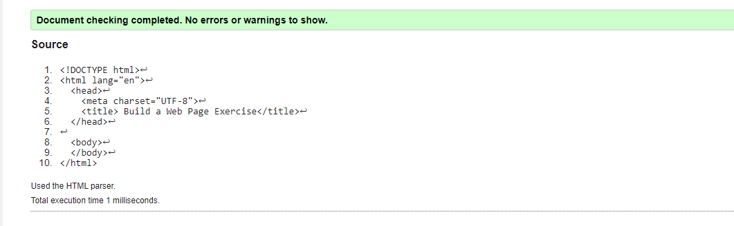

Updated Title, H1

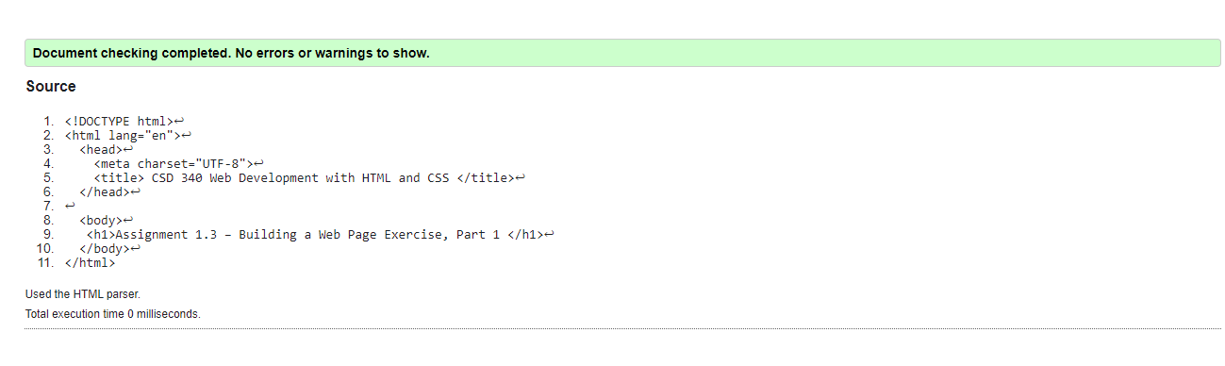

Browser –

