*Appendix*

## Simulink Model

### *Model*



Fig. The Simulink model of 24-TR topology

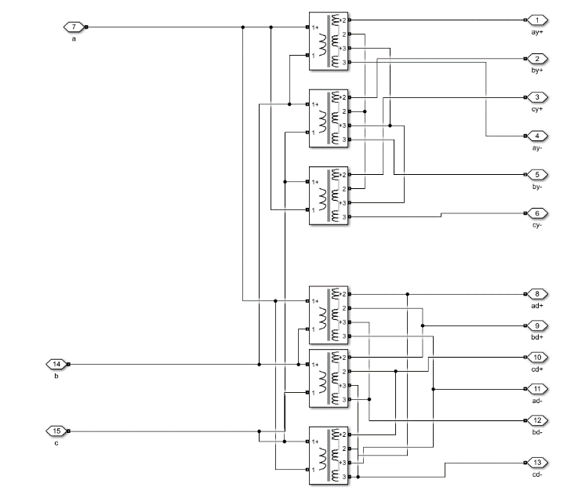

Fig. Detailed Simulink model of 12-pulse phase-shifting rectifier transformers

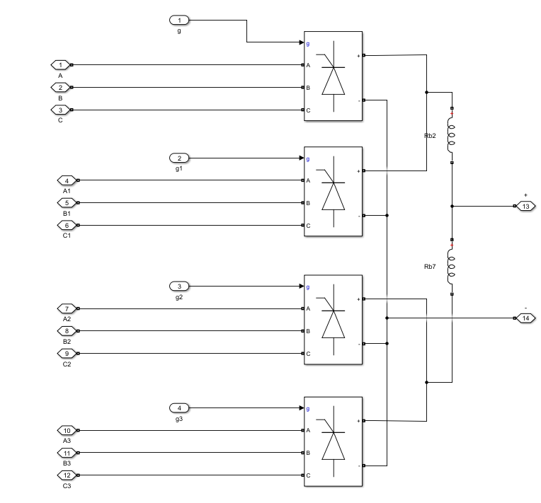

Fig. Detailed Simulink model of a 12-pulse rectifier

Fig. 1 shows the Simulink model of the 24-TR topology, the model parameters like PF in the main body are obtained from this Simulink model. The Simulink model parameters are listed in TABLE I. Fig. 2 is the detailed 12-pulse phase-shifting rectifier transformers and two of them consist of 24-pulse phase-shifting rectifier transformers. Fig. 3 is the detailed Simulink model of a cophase counter parallel connection 12-pulse rectifier. The rectifier and the transformer together constitute the completed cophase counter parallel connection 12-pulse converter system. And two of them consist of a completed cophase counter parallel connection 24-pulse converter system.

### *Parameter*

TABLE I The Simulink Model Parameters

|  |  |
| --- | --- |
| Model Parameter | Data |
| Solver | Discrete 1e-5 |
| *Three-Phase Power:* |  |
| Phase-to-phase voltage (Vrms) | 35000 |
| Source resistance (Ohms) | 0.0210 |
| Source inductance (H) | 0.0034 |
| *35/10.5kV Transformer:* |  |
| Winding 1 parameters [R1(pu), L1(pu) ] | 0.0024033, 0.039949 |
| Winding 2 parameters [R2(pu), L2(pu) ] | 0.0024033, 0.040829 |
| Magnetization resistance Rm (pu) | 207.79 |
| Magnetization inductance Lm (pu) | 89.903 |
| *Rectifier:* |  |
| Equilibrium reactor (mH) | 0.4 |
| Filter capacitor (mF) | 50 |
| *Phasing-Shifting Rectifier Transformer:* |  |
| Winding 1 parameters [R1(pu), L1(pu)] | 0.0065, 0.0215 |
| Winding 2 parameters [R2(pu), L2(pu)] | 0.0065, 0.0215 |
| Winding 3 parameters [R3(pu), L3(pu)] | 0.0065, 0.0215 |
| Magnetization resistance Rm (pu) | 588.23 |
| Magnetization inductance Lm (pu) | 147.23 |
| *LC filter:* |  |
| Capacitor (C) | 1.308e-07 |
| Resistance (R) | 1.10586 |
| Inductance (H) | 0.112 |

## The proof of proposition 1 and proposition2

### *The proof of* proposition *1*

The parameters of equations (3)-(5) in the main body are listed in TABLE II. Substitute equations (3)-(5) of the main body into equation (6) of the main body to get equation (1). The partial derivative of  with respect to *I* and *T* are expressed as equation (2) and equation (3) respectively.

Fig. 4 shows the partial derivative of  with respect to *I* when *T* is 80℃. The partial derivative is greater than zero when , and the partial derivative is less than zero when . Fig. 4 proves that  presents a first-positive-then-negative correlation as .

Fig. 5 shows the partial derivative of  with respect to *T* when *I* is 5kA. The partial derivative is always greater than zero when . Fig. 5 proves that  monotonically positive correlation as .

TABLE II The parameters of equations (3)-(5)

|  |  |  |  |  |
| --- | --- | --- | --- | --- |
|  |  |  |  |  |
| 123V |  |  |  |  |
|  |  |  |  |  |
|  |  |  |  | 33.33kWh/kg |







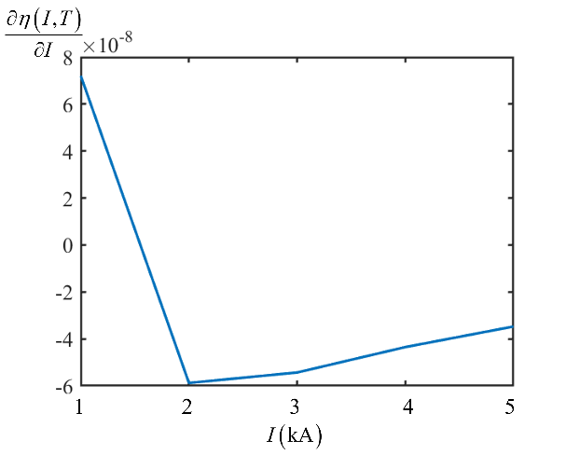

Fig. The partial derivative of  with respect to *I* (T = 80℃)

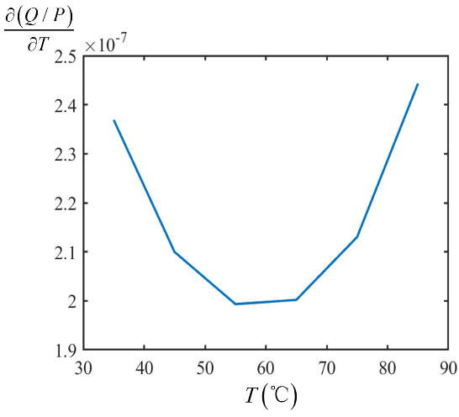

Fig. The partial derivative of  with respect to *T* (*I* = 5kA)

### *The proof of* proposition *2*

The parameters of equations (8)-(13) in the main body are listed in TABLE III.

TABLE III parameters of equations (8)-(13) in the main body

|  |  |  |  |  |  |  |  |  |
| --- | --- | --- | --- | --- | --- | --- | --- | --- |
| *K* |  | *a* | *b* | *c* |  |  |  |  |
| 104 | 10.465kV |  | 1.353 | 91940 | -0.6738 | 0.5065 | 0.6339 | 0.2756 |

Substitute equations (8)-(13) of the main body into equation (14) of the main body to get . As for convenient, we use the monotonicity of  to proves the theorem 1 since The monotonicity of  is opposite to that of .

Fig. 6 shows the partial derivative of  with respect to *I* when *T* is 80℃. The partial derivative is less than zero when , and the partial derivative is greater than zero when . Fig. 5 proves that presents a first-negative-then-positive correlation as .

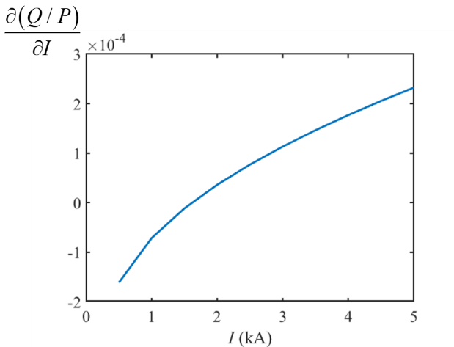

Fig. The partial derivative of  with respect to *I* (T = 80℃)

Fig. 7 shows the partial derivative of  with respect to *T* when *I* is 5kA. The partial derivative is always greater than zero when . Fig. 7 proves that  monotonically negative correlation as .

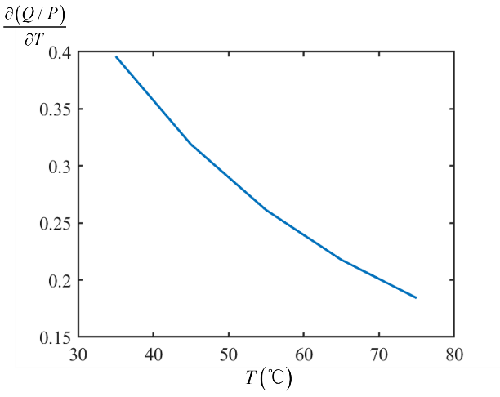

Fig. The partial derivative of  with respect to *T* (*I* = 5kA)

## The parameters of other equations

The parameters of equation (8):

,,

The parameters of equation (23) and (24):









The parameters of equation (25):

,,,,,

## Fitting error

To make sure the compatibility of the PF expression that suitable for the controller, cross-terms related to different stacks are not reserved to improve solvability. The fitting error of PF of a 10-stack P2H load is shown in Fig. 4 in the main body. Therefore, cubic polynomial piecewise formation (25) in the main body with the discretization of  is adopted with the fitting error below 2%.

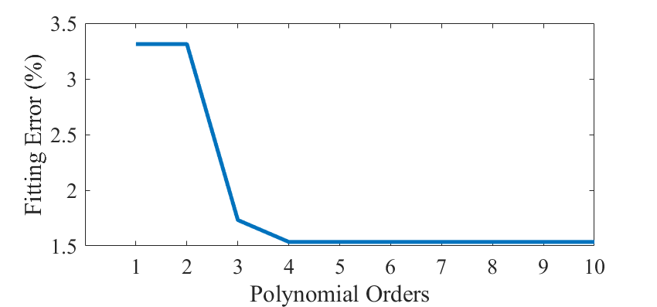

Fig. 8 The relationship of the fitting error with polynomial orders