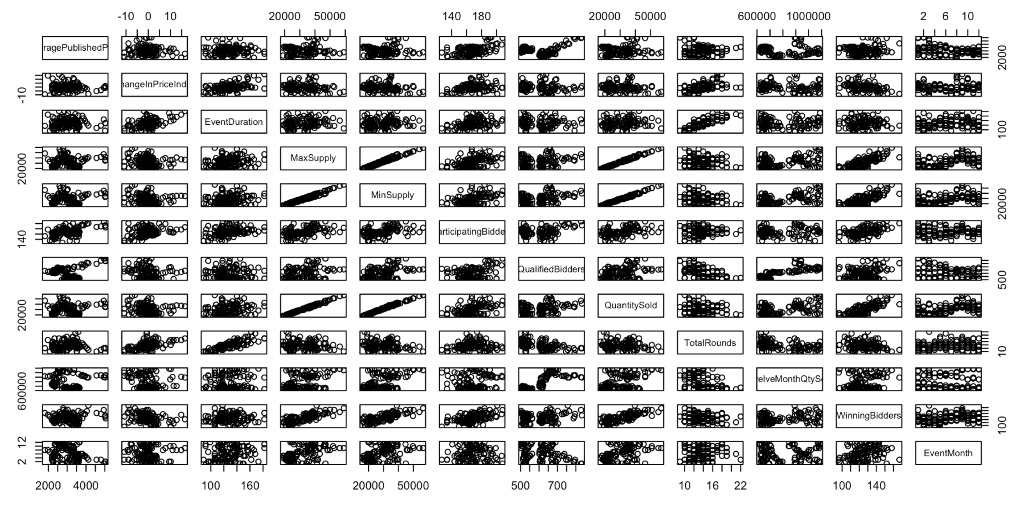

> step(lm0, scope=list(lower=formula(lm0),

+ upper = formula(lmall)),

+ direction="both", trace=1)

Start: AIC=1568.17

Price ~ 1

Df Sum of Sq RSS AIC

+ ParticipatingBidders 1 12668191 37927294 1535.3

+ EventMonth 1 4682484 45913001 1558.4

+ QualifiedBidders 1 2283151 48312334 1564.6

<none> 50595485 1568.2

+ WinningBidders 1 752785 49842700 1568.4

+ TwelveMonthQtySold 1 347994 50247491 1569.3

+ ChangeInPriceIndex 1 117783 50477702 1569.9

+ TotalRounds 1 71456 50524029 1570.0

+ EventDuration 1 34622 50560863 1570.1

+ QuantitySold 1 25050 50570435 1570.1

+ MaxSupply 1 8621 50586864 1570.2

+ MinSupply 1 3316 50592169 1570.2

Step: AIC=1535.3

Price ~ ParticipatingBidders

Df Sum of Sq RSS AIC

+ EventMonth 1 5163866 32763427 1519.6

+ MaxSupply 1 3008299 34918994 1527.3

+ MinSupply 1 2980834 34946459 1527.4

+ QuantitySold 1 2842337 35084957 1527.9

+ ChangeInPriceIndex 1 2209540 35717753 1530.0

+ WinningBidders 1 1534351 36392943 1532.3

+ EventDuration 1 1146147 36781147 1533.6

+ TwelveMonthQtySold 1 877589 37049705 1534.5

<none> 37927294 1535.3

+ TotalRounds 1 309102 37618191 1536.3

+ QualifiedBidders 1 200992 37726302 1536.7

- ParticipatingBidders 1 12668191 50595485 1568.2

Step: AIC=1519.59

Price ~ ParticipatingBidders + EventMonth

Df Sum of Sq RSS AIC

+ ChangeInPriceIndex 1 2058957 30704470 1513.7

+ TwelveMonthQtySold 1 1203999 31559428 1517.1

+ EventDuration 1 654705 32108723 1519.2

+ MinSupply 1 612979 32150448 1519.3

<none> 32763427 1519.6

+ QuantitySold 1 419448 32343979 1520.0

+ MaxSupply 1 408796 32354632 1520.1

+ WinningBidders 1 226229 32537198 1520.8

+ TotalRounds 1 46953 32716474 1521.4

+ QualifiedBidders 1 16158 32747269 1521.5

- EventMonth 1 5163866 37927294 1535.3

- ParticipatingBidders 1 13149574 45913001 1558.4

Step: AIC=1513.74

Price ~ ParticipatingBidders + EventMonth + ChangeInPriceIndex

Df Sum of Sq RSS AIC

+ WinningBidders 1 3466124 27238346 1501.2

+ MinSupply 1 2303227 28401243 1506.3

+ TwelveMonthQtySold 1 1978648 28725822 1507.7

+ MaxSupply 1 1814973 28889497 1508.4

+ QuantitySold 1 1786844 28917626 1508.5

<none> 30704470 1513.7

+ TotalRounds 1 305981 30398489 1514.5

+ QualifiedBidders 1 268411 30436059 1514.7

+ EventDuration 1 34695 30669775 1515.6

- ChangeInPriceIndex 1 2058957 32763427 1519.6

- EventMonth 1 5013283 35717753 1530.0

- ParticipatingBidders 1 15132080 45836550 1560.2

Step: AIC=1501.25

Price ~ ParticipatingBidders + EventMonth + ChangeInPriceIndex +

WinningBidders

Df Sum of Sq RSS AIC

+ TwelveMonthQtySold 1 1549466 25688880 1496.2

<none> 27238346 1501.2

+ MinSupply 1 382984 26855362 1501.5

+ TotalRounds 1 237791 27000555 1502.2

+ QuantitySold 1 146286 27092060 1502.6

+ QualifiedBidders 1 123215 27115131 1502.7

+ MaxSupply 1 114145 27124202 1502.7

+ EventDuration 1 4 27238342 1503.2

- EventMonth 1 1316305 28554651 1505.0

- WinningBidders 1 3466124 30704470 1513.7

- ChangeInPriceIndex 1 5298852 32537198 1520.8

- ParticipatingBidders 1 15956895 43195241 1555.0

Step: AIC=1496.16

Price ~ ParticipatingBidders + EventMonth + ChangeInPriceIndex +

WinningBidders + TwelveMonthQtySold

Df Sum of Sq RSS AIC

+ QualifiedBidders 1 1319415 24369465 1491.8

<none> 25688880 1496.2

+ QuantitySold 1 144794 25544086 1497.5

+ MinSupply 1 63604 25625276 1497.9

+ MaxSupply 1 53052 25635828 1497.9

+ EventDuration 1 30751 25658129 1498.0

+ TotalRounds 1 3283 25685597 1498.1

- TwelveMonthQtySold 1 1549466 27238346 1501.2

- EventMonth 1 1602291 27291171 1501.5

- WinningBidders 1 3036942 28725822 1507.7

- ChangeInPriceIndex 1 5799241 31488121 1518.8

- ParticipatingBidders 1 16324121 42013001 1553.7

Step: AIC=1491.78

Price ~ ParticipatingBidders + EventMonth + ChangeInPriceIndex +

WinningBidders + TwelveMonthQtySold + QualifiedBidders

Df Sum of Sq RSS AIC

<none> 24369465 1491.8

+ EventDuration 1 158467 24210998 1493.0

+ TotalRounds 1 128457 24241008 1493.1

- EventMonth 1 698714 25068179 1493.2

+ QuantitySold 1 76587 24292878 1493.4

+ MaxSupply 1 35663 24333802 1493.6

+ MinSupply 1 15576 24353889 1493.7

- QualifiedBidders 1 1319415 25688880 1496.2

- TwelveMonthQtySold 1 2745666 27115131 1502.7

- WinningBidders 1 3155690 27525155 1504.5

- ChangeInPriceIndex 1 5086970 29456435 1512.7

- ParticipatingBidders 1 12341153 36710618 1539.4

Call:

lm(formula = Price ~ ParticipatingBidders + EventMonth + ChangeInPriceIndex +

WinningBidders + TwelveMonthQtySold + QualifiedBidders, data = cln)

Coefficients:

(Intercept) ParticipatingBidders EventMonth

-31.24652 33.06023 -26.10755

ChangeInPriceIndex WinningBidders TwelveMonthQtySold

-59.25081 -19.61368 -0.00173

QualifiedBidders

2.51362

> summary(modelop)

Call:

lm(formula = Price ~ ParticipatingBidders + EventMonth + ChangeInPriceIndex +

WinningBidders + TwelveMonthQtySold + QualifiedBidders, data = cln)

Residuals:

Min 1Q Median 3Q Max

-1059.75 -262.84 -28.39 304.91 1117.62

Coefficients:

Estimate Std. Error t value Pr(>|t|)

(Intercept) -3.125e+01 5.133e+02 -0.061 0.951564

ParticipatingBidders 3.306e+01 4.351e+00 7.598 9.1e-12 ***

EventMonth -2.611e+01 1.444e+01 -1.808 0.073256 .

ChangeInPriceIndex -5.925e+01 1.215e+01 -4.878 3.5e-06 ***

WinningBidders -1.961e+01 5.105e+00 -3.842 0.000201 ***

TwelveMonthQtySold -1.730e-03 4.826e-04 -3.584 0.000499 ***

QualifiedBidders 2.514e+00 1.012e+00 2.484 0.014430 *

---

Signif. codes: 0 ‘***’ 0.001 ‘**’ 0.01 ‘*’ 0.05 ‘.’ 0.1 ‘ ’ 1

Residual standard error: 462.3 on 114 degrees of freedom

Multiple R-squared: 0.5183, Adjusted R-squared: 0.493

F-statistic: 20.45 on 6 and 114 DF, p-value: 3.911e-16

> summary(modelop2)

Call:

lm(formula = Price ~ ParticipatingBidders + ChangeInPriceIndex +

WinningBidders + TwelveMonthQtySold + QualifiedBidders, data = cln)

Residuals:

Min 1Q Median 3Q Max

-1108.57 -317.86 -44.74 360.03 1122.36

Coefficients:

Estimate Std. Error t value Pr(>|t|)

(Intercept) -1.462e+02 5.143e+02 -0.284 0.776746

ParticipatingBidders 3.458e+01 4.311e+00 8.019 9.87e-13 ***

ChangeInPriceIndex -6.463e+01 1.189e+01 -5.434 3.12e-07 ***

WinningBidders -2.372e+01 4.616e+00 -5.140 1.14e-06 ***

TwelveMonthQtySold -1.908e-03 4.771e-04 -3.999 0.000113 ***

QualifiedBidders 3.094e+00 9.689e-01 3.193 0.001814 **

---

Signif. codes: 0 ‘***’ 0.001 ‘**’ 0.01 ‘*’ 0.05 ‘.’ 0.1 ‘ ’ 1

Residual standard error: 466.9 on 115 degrees of freedom

Multiple R-squared: 0.5045, Adjusted R-squared: 0.483

F-statistic: 23.42 on 5 and 115 DF, p-value: 3.616e-16

### the adjusted R^2 is a bit lower but not by much. Cross validation below compares the two methods more clearly

### CV results:

> MSEAve<- apply(MSE,2,mean); MSEAve #averaged mean square CV error

[1] 226985.2 229959.8

> MSEsd <- apply(MSE,2,sd); MSEsd #SD of mean square CV error

[1] 647.4951 514.4645

> r2<-1-MSEAve/var(y); r2 #CV r^2

[1] 0.4616470 0.4545921

## Shows us that the best model is still the model with EventMonth