역사 전투 기록 정보추출을 위한
근거 보존형 스키마와 자원 구축:
인천상륙작전 코퍼스 기반 연구
Provenance-Preserving Schema and Resource Construction
for Information Extraction from Historical Battle Records:
A Corpus Study of the Inchon Landing
Abstract
This paper presents HBR-IE (Historical Battle Record Information Extraction) v1, a provenance-preserving schema and resource package designed as a reusable ingress layer for literature-driven historical battle simulation rather than as a battle-specific model. The Inchon landing is used only as a case corpus to test portability-oriented design choices. We freeze a six-source bilingual core corpus, construct an evidence-row backbone, materialize conservative canonical resources for Unit and Place, and define rule-driven layers for Time, Event, and Quantity. The v1 package contains 11,166 evidence rows, a 224-row unit lexicon, 11,076 unit mappings, a 582-row place gazetteer, 9,183 place mappings, 14 event families, and a 141-row slot matrix. A 120-row pilot with 48 ambiguity rows shows that recurring instability is better resolved by boundary rules, decision tables, and examples than by schema expansion. The result is a general baseline for historical battle records that preserves evidence traceability while remaining usable for later database construction, event linking, retrieval, and simulation-facing pipelines.

1. Introduction
The Inchon landing core corpus records a dense sequence of operations--amphibious landing on 15 September 1950, capture of Kimpo Airfield on 18 September, urban combat in Seoul on 19-28 September, and link-up north of Osan on 26 September--so it offers a representative case in which Land, Move, OccupyOrCapture, BombardOrFire, Cross, and LinkUp co-occur in the same battle narrative [1-6]. Yet historical battle records rarely align with database-ready units of meaning. They mix long-form Korean/English prose, abbreviated echelons, relative place expressions, phase markers, and heterogeneous quantities, which easily induce over-inference when mapped directly to simulation objects or structured fields.
Information extraction research provides strong precedents: MUC established template-filling practice [7], ACE refined trigger-argument event annotation [8], and TimeML/TimeBank separated event, timex, and temporal-relation layers [9,10]. Annotation methodology has likewise emphasized iterative guideline refinement and tool-friendly span design [11,12]. However, these traditions were developed primarily for news or general prose, not for historical battle writing where echelon hierarchy, weakly anchored geography, and operation-relative time are central.
This study treats the problem as an ingress layer before cross-evidence event merging or BattleIR. We propose HBR-IE v1 as a schema/resource baseline for historical battle records in general, while using the Inchon landing corpus only as the validation case. The contributions are a six-source bilingual corpus freeze, a provenance-preserving evidence-row backbone with canonical and rule-sheet resources, and a pilot-validated v1 freeze.
2. Core Corpus and Task Definition
Figure 1 summarizes the six-source core corpus: one Korean operational backbone, two U.S. Army campaign narratives, and three U.S. Marine operational accounts [1-6]. Only text directly tied to the Inchon/Seoul operation window (1950-09-10 to 1950-09-28) was excerpted, while page markers and section headers were preserved. National Archives viewer, timeline, and monthly-article materials were retained only as weak background sources. This restriction keeps Paper 1 focused on a schema/resource contribution grounded in strong textual evidence rather than on a full system paper.
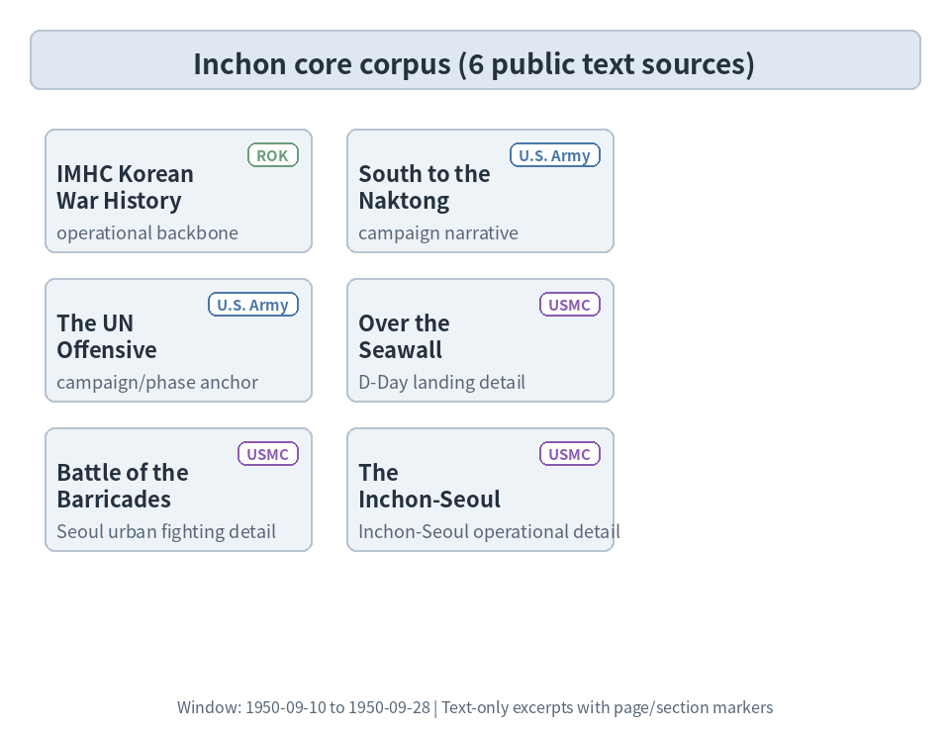
Figure 1. Inchon core corpus and source roles
HBR-IE v1 uses the frozen evidence row as its primary annotation unit. A row may contain 0-n events and 0-n unit/place/time/quantity expressions, but slot filling is restricted to surfaces licensed within the same row. The immediate objective is therefore not global event merging or simulation object construction; it is a locally grounded evidence layer that later modules can trust.
3. Design of HBR-IE v1
Figure 2 shows the v1 package architecture. The schema is an additive interpretation layer above the raw mentions. Unit and Place are modeled as canonical backbones, whereas Time, Event, and Quantity are handled as rule-driven interpretive layers. Every instance preserves source_id, evidence_id, page_ref, and evidence_span. Event typing is trigger-centered, and assertion_status (asserted, planned, failed, hypothetical, negated) is recorded independently from event family. The current freeze adopts 14 event families and a 141-row slot matrix.
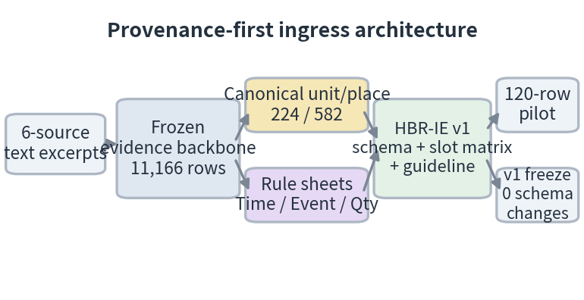
Figure 2. Provenance-first ingress architecture
The design deliberately prioritizes conservative portability over aggressive normalization. Generic force expressions are not promoted into formal units; command/corps/division/regiment/battalion boundaries are not collapsed; and bare low-echelon references without a recoverable same-row parent chain remain unresolved. Weakly anchored relative places are not forced into the gazetteer, and phase-relative/daypart expressions remain partial when their anchors are weak. Quantity rules separate troop strength from unit designator numerals and keep ship, landing-craft, and casualty subtypes distinct.
The frozen resource package materializes 11,166 evidence rows, a 224-row unit lexicon, 11,076 unit mappings (4,641 mapped; 2,349 generic_group; 4,063 unresolved), a 582-row place gazetteer, 9,183 place mappings (8,431 mapped; 713 relative expressions), and a 4,435-row issue registry. These resources make the schema operational rather than merely declarative, because later annotation and retrieval stages can share the same authority layer.
As Figure 3 illustrates, the recurrent failure points were boundary decisions rather than missing top-level classes: landing moment vs inland movement (Land/Move), offensive action vs control acquisition (Attack/OccupyOrCapture), fire delivery vs maneuver (BombardOrFire/Attack), barrier traversal vs general advance (Cross/Move), and planning discourse vs realized action (event family vs assertion_status).
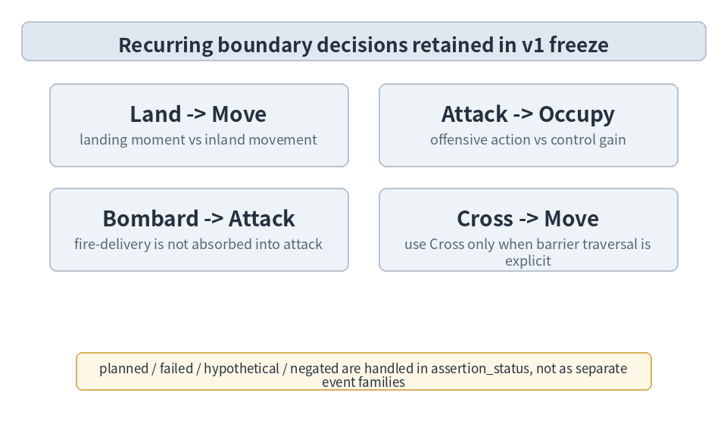
Figure 3. Boundary decisions retained in the v1 freeze
4. Pilot and v1 Freeze
The pilot sampled 120 evidence rows across the six source groups, covering all 14 event families plus review and non-event rows. It intentionally included unresolved low-echelon units, relative/descriptive places, phase-relative times, and quantity/designator boundary cases to stress-test span consistency, conservative reference handling, trigger-centered typing, and same-row slot filling.
Pilot adjudication reviewed 48 ambiguity rows and consolidated them into 10 recurring clusters. As Figure 4 shows, the resulting revisions were absorbed by 23 boundary-rule updates, 13 decision-table changes, 6 example/quick-reference additions, and 3 guideline wording changes, while structural schema changes remained at zero. Event families, slot admissibility, canonical unit/place resources, and the evidence-row annotation unit were all retained.
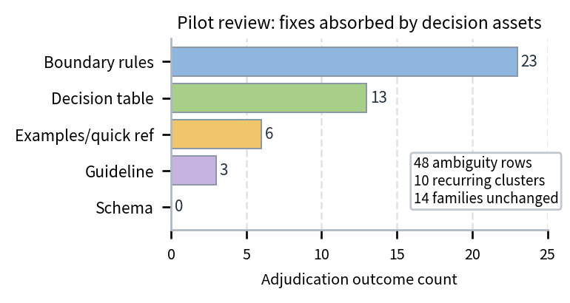
Figure 4. Pilot adjudication outcomes by revision asset
This outcome indicates that early instability in historical battle-record extraction is better handled by disciplined decision assets than by premature schema expansion. In practical terms, the v1 authority is now stable enough to support paper writing, larger-scale pilot annotation, database ingestion, and simulation preprocessing under a shared provenance policy.
5. Conclusion
This study introduces HBR-IE v1 as a provenance-preserving baseline for historical battle records in general, using the Inchon landing only as a validation corpus. Its significance lies in three points: formalizing an evidence-row ingress layer before later merging or simulation; combining conservative Unit/Place canonicalization with rule-driven Time/Event/Quantity handling; and showing through a 120-row pilot that stability depends more on boundary refinement than on schema expansion. HBR-IE v1 should therefore be viewed as a foundation layer for future historical battle databases rather than as a final occurrence-level representation. Future work will test portability on additional battle corpora, add cross-evidence event linking and BattleIR-style merging, and incorporate maps and operational graphics into simulation-facing representations.
References
1. Institute for Military History, Ministry of National Defense, The Korean War, Vol. 6: The Inchon Landing and Counteroffensive [in Korean], 2009.
2. Roy E. Appleman, South to the Naktong, North to the Yalu, Government Printing Office, 1961.
3. Stephen L.Y. Gammons, The UN Offensive: 16 September-2 November 1950, U.S. Army Center of Military History, 2000.
4. Edwin H. Simmons, Over the Seawall: U.S. Marines at Inchon, History and Museums Division, Headquarters, U.S. Marine Corps, 2000.
5. Joseph H. Alexander, Battle of the Barricades: U.S. Marines in the Recapture of Seoul, History and Museums Division, Headquarters, U.S. Marine Corps, 2000.
6. Lynn Montross and Nicholas A. Canzona, The Inchon-Seoul Operation, Historical Branch, G-3, Headquarters, U.S. Marine Corps, 1955.
7. Ralph Grishman and Beth Sundheim, "Message Understanding Conference-6: A Brief History," in COLING 1996 Volume 1, pp. 466-471, 1996.
8. Linguistic Data Consortium, ACE (Automatic Content Extraction) English Annotation Guidelines for Events, Version 5.4.3, 2005.
9. James Pustejovsky et al., "TimeML: Robust Specification of Event and Temporal Expressions in Text," in New Directions in Question Answering, pp. 28-34, 2003.
10. James Pustejovsky et al., "The TIMEBANK Corpus," in Corpus Linguistics 2003, pp. 647-656, 2003.
11. James Pustejovsky and Amber Stubbs, Natural Language Annotation for Machine Learning, O'Reilly Media, 2012.
12. P. Stenetorp et al., "brat: a Web-based Tool for NLP-Assisted Text Annotation," Proc. EACL Demos, pp. 102-107, 2012.

