Computer Vision Project 4 – Part3

Chih-Yuan Sun (cs2368)

Yu-Hsuan Chen (yc2423)

* tentacle dataset with mode set to both

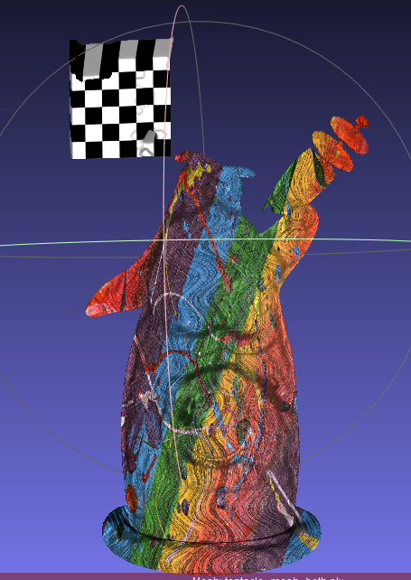

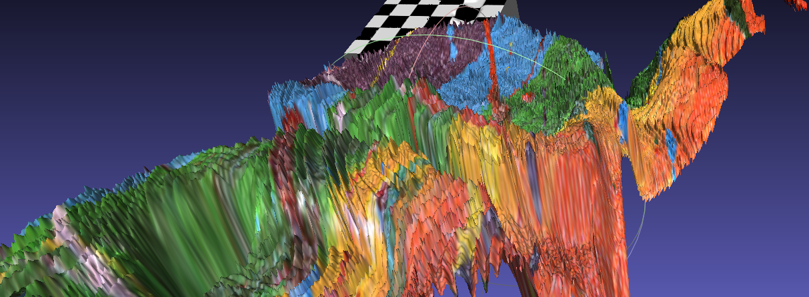

The texture in the above picture is jagged. It is because in Plane-sweep stereo, we discretize disparities. Therefore, compare the result with mode set to depth, the texture of the tentacle generated by Plane-sweep stereo is not smooth.

* tentacle dataset with mode set to depth

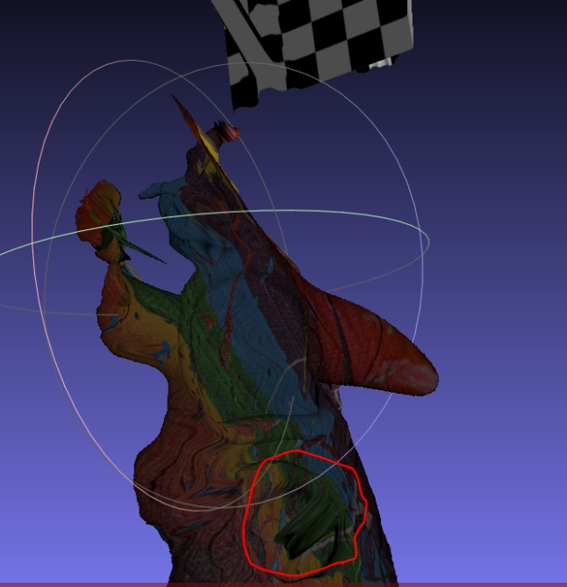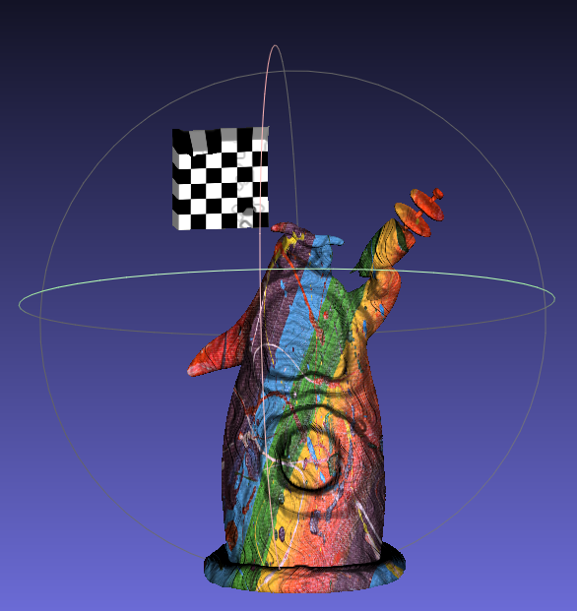

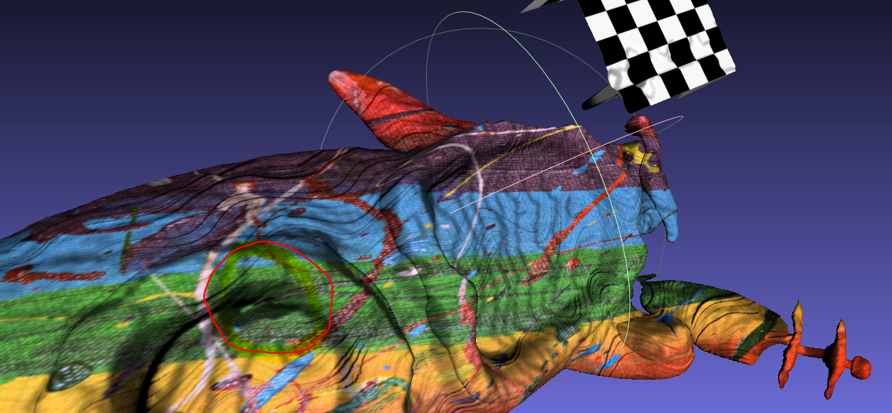

We find out that there is (but it should not happen) a very deep green hole on the tentacle’s belly. It is because Plane-sweep Stereo match that part to a wrong patch. Since the depth of the green hole is the same as the depth of the green part of the tentacle’s gun, maybe Plane-sweep Stereo match the two patches together.

* cat dataset with mode set to normal

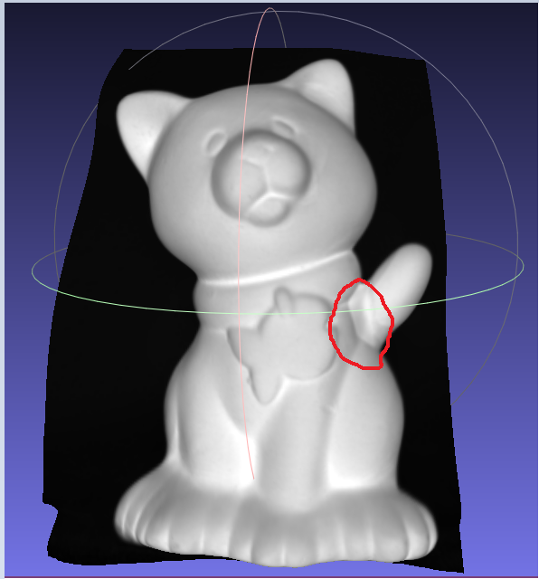

We find out that the tail is not smooth enough. Maybe it is because sometime light cannot reach that part, it put constraint on the derived normal. Therefore, the derived normal is not accurate enough.

* Flowers dataset with mode set to depth

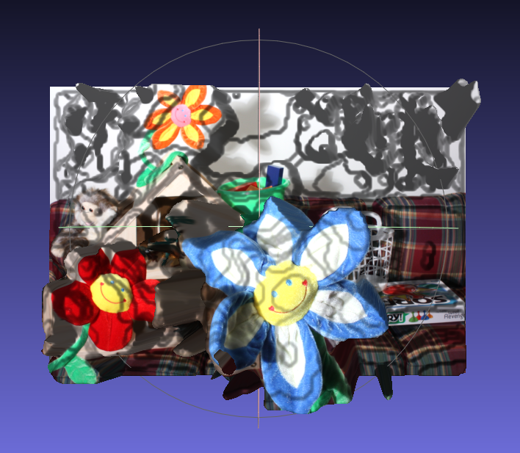

We can find out that the white wall has many different disparities, since it is hard to find correct corresponding patch for each white patch on the wall. Some white patchs may have high NCC volume with lots of patch.