Midterm Exam Comp152 Online Coding Portion

Get the Robot.java and DemoMode.java files.

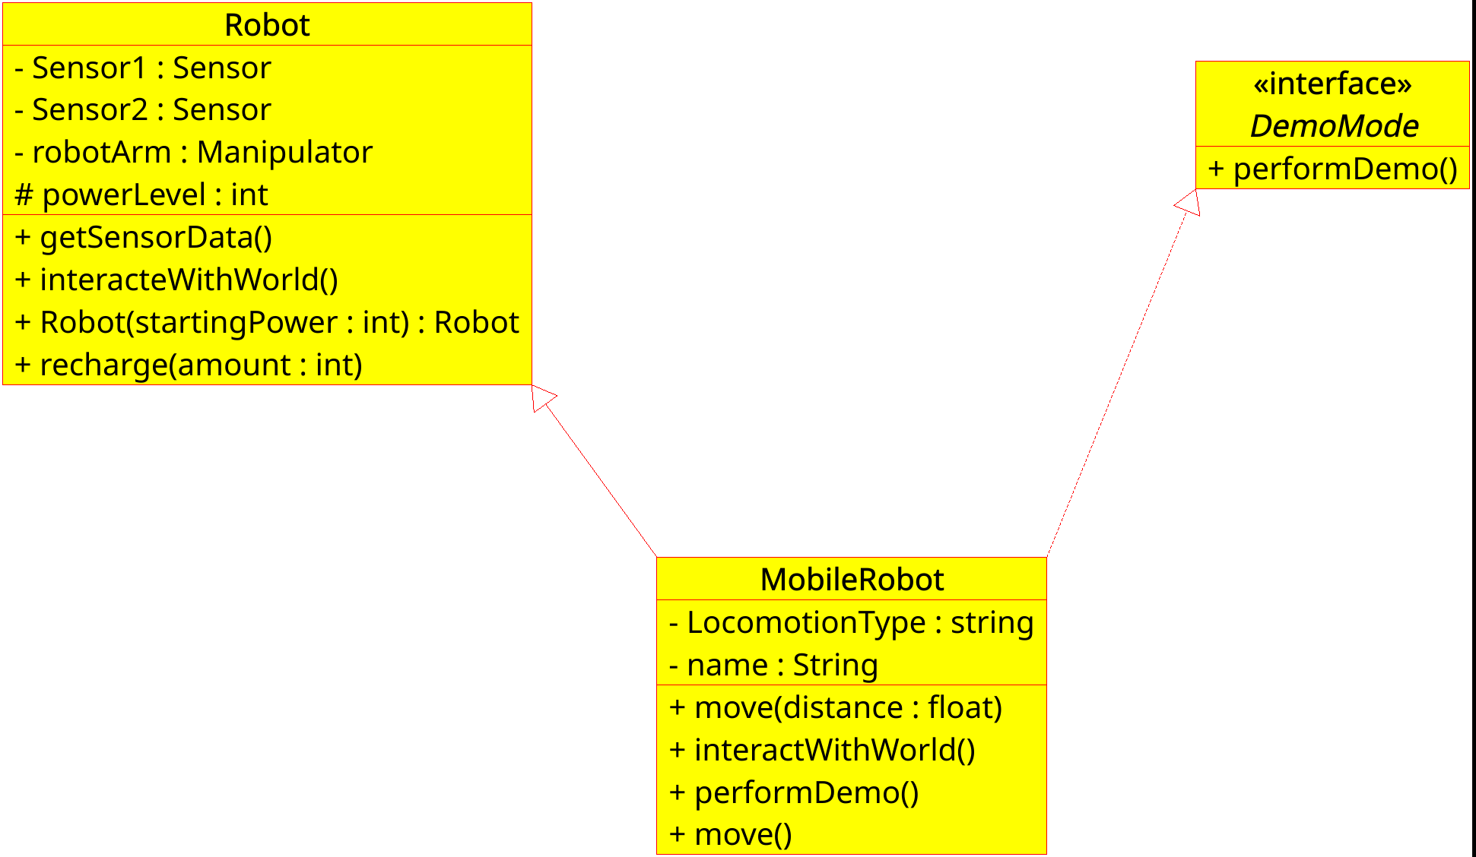
Write the MobileRobot class and fille out the Main class. Both need to be in the bsu.comp152 package.

Write the following Methods in the MobileRobot class
Move(distance) should print a statement telling the user that you are moving that distance using your locomotion type. Reduce the powerLevel by the amount moved divided by 5
Move() should print a statement telling the user that you are moving a default distance using your locomotion type. Reduce the powerLevel by the amount moved divided by 5
interactWithWorld should call the parent class version of the function and then ask the user how far to move and call move to move that far.
performDemo should call recharge on the current object, then call interactWithWorld on itself.
The Constructor needs to be created. It needs to initialize the two instance variables and the Robot part of the parent class. Create the constructor in a way that it does all this.

in the Main class
you should have a main method.
The main method should create a variable of type DemoMode and create a new MobileRobot object to assign to your variable.
Then call performDemo on your DemoMode variable.

