Training and Deployment Resources of Robot Vision–Language–Action Models: A Review of 215 Models with a Validated Feasibility Estimator
[Author names and affiliations]

Abstract
Vision–language–action (VLA) models have become a common way to build general robot policies, but the resources they need—training compute, inference latency and memory—are reported unevenly, which makes it hard to match a model to a robot computer or a training budget. We review 215 robot policy models and related systems released between October 2022 and October 2026 for manipulation, humanoid whole-body control, mobile manipulation and navigation. Each model was coded from primary sources into a 28-field schema with explicit labels for undisclosed and unverified values, and 203 records were re-checked in a second pass. Action heads shifted from discrete tokens to flow matching, and Qwen replaced Llama as the most common language backbone. Only 38 models (18%) report enough to compute training GPU-hours and 28 (13%) report inference memory; industry-only models disclose their training hardware less often than other teams (19% vs. 63%). We propose a roofline-based estimator of inference latency, memory and fine-tuning cost that models token decoding and iterative denoising. Calibrated on 37 published latency measurements from 11 devices, it reaches a median error of 1.37$×$ (1.49$×$ in leave-one-out validation), and its memory estimate is within a median of 1.13$×$ of 23 reported figures. We use it to map which models can run at 10 Hz on eleven devices, from Jetson modules to an H100, and close with a ten-item reporting checklist.
Keywords: vision–language–action models; robot foundation models; embodied AI; training compute; edge deployment; inference latency; roofline model; reporting standards; humanoid robots; mobile manipulation

Featured Application
The open dataset and estimator let robot developers check, before downloading or training anything, whether a published VLA model fits the memory and control-rate budget of their onboard computer and how much GPU memory fine-tuning it will need.

1 Introduction
Robot learning has converged on a recipe borrowed from language and vision: pretrain a large network on heterogeneous data, then adapt it to a robot and a task. Vision–language–action (VLA) models apply this recipe to control. They attach an action-generating head to a vision–language model (VLM), so that one network maps camera images and a language instruction to robot actions [1–3]. Since RT-2 [1] showed in 2023 that web-scale VLM pretraining transfers to robot control, VLAs have spread from tabletop manipulation to humanoid whole-body control [4,5], mobile manipulation [6,7] and navigation [8,9]. Academic laboratories and companies now release several such models per month (Figure 2a).
For anyone who wants to use one of these models, the first questions are practical. Will the model fit in the memory of the robot’s onboard computer? Will it produce actions fast enough for the task? Can it be fine-tuned on the GPUs at hand, and what did it cost to pretrain? The answers depend on a handful of quantities—parameter counts, accelerator-hours, inference latency on a named device, peak memory—that are scattered across papers, model cards, repositories and blog posts, are reported in inconsistent units, or are not reported at all. Existing surveys organise the field by architecture, action representation and training paradigm [10–14], by efficiency technique [15,16], by the barriers to deployment at the edge [17], or by data and benchmarks [18]. They explain how VLAs work and how they might be made cheaper. Judging from their stated scope, they do not tell a reader how much a specific model costs to train or whether it will run on a specific device, and they do not measure how often the required numbers are missing.
This review takes a resource-centred view of the field. We coded 215 robot policy models and related systems released between October 2022 and October 2026 against a fixed schema drawn from primary sources, labelled every missing or uncertain value explicitly, and re-checked 203 of the records in a second verification pass. On this corpus we make four contributions:
- An open, evidence-labelled dataset of 215 models (135 VLAs, 58 policies without a pretrained VLM and 22 related systems) covering manipulation, humanoid whole-body control, mobile manipulation and navigation, with 145 per-stage training-hardware records, 38 published latency measurements and a control-interface taxonomy for the 98 models with a mobile base. The dataset is also published as an interactive gallery.
- A quantitative synthesis of architecture and resource trends: the shift of action heads from discrete tokens to flow matching, the shift of language backbones from Llama to Qwen, model size, training compute and data, control rates, and where reinforcement learning (RL) enters the pipeline.
- A disclosure audit of twelve resource items, which shows which numbers are reported, which are not, and how reporting differs between industry and academic teams.
- A roofline-based estimator of inference latency, memory and fine-tuning cost, calibrated on published latency measurements, validated by leave-one-out prediction and checked against reported memory figures, which we use to map how many models can run at 10 Hz on eleven devices from Jetson modules to an H100.
We end with a ten-item checklist for reporting the resources of robot foundation models.
Section 2 positions this review against prior surveys. Section 3 describes how the corpus was built and coded. Sections 4–6 present the corpus, architecture trends and training resources. Section 7 reports the disclosure audit. Section 8 presents the estimator and the feasibility maps. Sections 9 and 10 cover reinforcement learning and mobile-base control. Section 11 discusses implications and limitations, and Section 12 concludes.

2 Related Surveys
Early surveys of foundation models in robotics [19–21] predate most of the models in our corpus. They name real-time execution and compute as open challenges but do not quantify them. Surveys dedicated to VLAs [10–14,22–25] organise the literature by component (vision encoder, language backbone, action decoder), by action representation [12] or by training paradigm, and several discuss efficiency in qualitative terms. Two recent surveys make efficiency their subject. Guan et al. [15] group techniques for reducing latency, memory and training cost into model architecture, perception features, action generation and training or inference strategies, and Yu et al. [16] organise efficient-VLA methods across the model, training and data pipeline. Grover et al. [17] analyse the constraints of running embodied foundation models on edge hardware and argue that autoregressive VLAs are limited mainly by memory bandwidth and diffusion-based controllers by compute, a view that our estimator makes quantitative and, for diffusion-style heads, revises (Section 8). Other surveys cover datasets and benchmarks [18], world–action models [26,27], foundation models for mobile service robots [28] and VLAs for aerial robots and bimanual manipulation [29].
Table 1 summarises the focus of the most closely related surveys as stated by their authors. Prior surveys describe methods; this review treats resources as data. Judging from their stated scope, none of the surveys above codes per-model training hardware, inference latency and memory under explicit evidence labels, measures how often these values are disclosed, or validates a predictive latency model against published measurements.
Table 1. Recent surveys related to VLA models and the focus stated in their abstracts.
Survey | Year | Stated focus
Firoozi et al. [19] | 2023 | Foundation models across the robot autonomy stack
Hu et al. [20] | 2023 | Foundation models for general-purpose robots; meta-analysis
Ma et al. [10] | 2024 | VLA taxonomy: components, low-level control policies, high-level task planners
Sapkota et al. [11] | 2025 | Concepts, progress, applications and challenges (over 80 VLA models)
Zhong et al. [12] | 2025 | VLAs viewed through action tokenization
Shao et al. [13] | 2025 | Large-VLM-based VLAs for robotic manipulation
Kawaharazuka et al. [14] | 2025 | Full-stack review, including hardware, towards real-world applications
Guan et al. [15] | 2025 | Efficiency techniques for embodied manipulation
Yu et al. [16] | 2025 | Efficient VLAs across the model, training and data pipeline
Grover et al. [17] | 2026 | Deployment constraints of embodied foundation models at the edge
Wang et al. [18] | 2026 | Datasets, benchmarks and data engines
Sa et al. [29] | 2026 | VLAs for aerial robots and bimanual manipulation (183 contributions)
This review | 2026 | Training and deployment resources of 215 models in four domains; disclosure audit; latency, memory and fine-tuning estimator validated on published measurements

3 Materials and Methods

3.1 Scope and Inclusion Criteria
We included models first described between January 2022 and 19 October 2026 that map visual observations, optionally together with language and proprioception, to robot actions or to commands consumed by a robot controller, in one of four domains: manipulation, humanoid whole-body control, mobile manipulation and navigation. We also included whole-body and locomotion controllers that map proprioception and motion targets to joint commands without visual input, because they form the low-level layer of many humanoid and legged VLA systems. Each model was assigned one of three types.
- VLA (135 models): policies built on a pretrained VLM or language model, or presented by their authors as VLAs.
- VA (58 models): policies trained without a pretrained VLM, mostly visuomotor policies such as ACT [30] and Diffusion Policy [31], plus the proprioceptive whole-body controllers mentioned above. Visuomotor policies are included as reference points because many VLAs reuse their action heads and because several remain strong baselines.
- Other (22 models): systems that are not single end-to-end policies but shape VLA practice, such as world–action models that predict future video and actions [32,33], embodied-reasoning VLMs that direct a VLA [34], inference-time techniques such as real-time chunking [35], and fleet data-collection systems [36].
The release date is the month of the first public description (paper, blog post or model card).

3.2 Identification of Models
Candidate models were collected from [TODO(author): e.g., the reference lists of prior surveys, arXiv cs.RO listings, and announcements by robotics companies and laboratories]. The corpus was assembled in three rounds with reference dates of 6 October 2026 (165 models, mostly manipulation and humanoid models), 14 October 2026 (46 mobile-manipulation and navigation models) and 19 October 2026 (four further releases). Values were coded as they stood on the reference date of each round.

3.3 Data Extraction
For each model, the 28 fields in Table 2 were filled from primary sources: the arXiv paper, the README of the official repository, the model card, or the developer’s official blog post. Names of models, datasets and hardware were kept as written in the source. Three fields were also parsed as numbers for analysis: total parameters (billions), pretraining GPU/TPU-hours and data hours.
Table 2. The 28-field extraction schema.
Group | Fields
Identity | Model; group; type (VLA, VA, other); domain; release date; organisations; weights released
Architecture | Architecture; backbone and action representation; key features (two sentences); parameters (as reported); parameters (billions)
Training | Pretraining accelerator; pretraining duration; pretraining steps and batch; pretraining GPU/TPU-hours; basis and unit of the hours; fine-tuning accelerator and duration
Data and evaluation | Tasks and benchmarks; robots and embodiments; data type; data scale; data hours; main datasets
Inference | Inference device, rate, latency and memory as reported
Provenance | Notes; verification status; primary source URL
A second set of fields was coded from the same sources: the vision encoder; the language backbone and its family; the action head and its family (11 classes); action-chunk length; control rate; where inference runs (onboard, local PC, remote server or cloud); inference memory; whether and where RL is used (four statuses and six categories); the type of mobile base and the interface through which the policy commands it (eight classes); and links to official code and weight repositories. Training hardware was further normalised into per-stage records (stage, accelerator model, count, duration and the source’s wording) for 109 models, giving 145 records.

3.4 Evidence Rules
Two labels distinguish missing values. “Not disclosed” means that no primary source reports the value; “unverified” means that the original could not be checked. Missing values were never estimated, with one exception: pretraining GPU-hours were computed as accelerator count times duration when both were reported as numbers. Values available only from secondary sources such as news articles or third-party papers were kept but marked (18 records contain at least one such value), values not checked against the original were marked separately (27 records), and conflicting values from different primary sources were recorded side by side. Every record keeps links to its sources; one record, known only from news reports, has only secondary links.

3.5 Verification
The records were then checked against their primary sources in a second, independent pass. Of the 215 records, 145 were confirmed unchanged and 58 were corrected; 11 were not re-checked, and for one the release date could not be confirmed from a primary source. The verification status is stored with every record.

3.6 Derived Variables and Analysis
Models were grouped into four macro-domains from their coded domain (manipulation, humanoid, mobile manipulation including legged mobile manipulators, and navigation). Developers were grouped by affiliation into industry-only (74 models), academic-only (66) and mixed teams (73); public research institutes and non-profit laboratories (for example, Shanghai AI Laboratory, BAAI and the Allen Institute for AI) count as academic and corporate research laboratories (for example, Google DeepMind, NVIDIA, Microsoft Research and Toyota Research Institute) as industry; two models whose affiliation was not recorded were left unclassified.
For the disclosure audit (Section 7) we scored twelve items per model as disclosed or not: total parameter count; backbone (V)LM, including an explicit statement that there is none; action-head type; training accelerator model for at least one stage; training duration for at least one stage; pretraining GPU/TPU-hours, reported or computable; amount of training data; control rate; inference device; inference memory; released weights (full or partial; 6 records marked as unverified count as released because an official Hugging Face weight repository is listed for them); and an official code repository. Differences between industry-only models and all other models with a recorded affiliation ($n=139$) were tested with Fisher’s exact test and Holm’s correction across the twelve items. We report medians and interquartile ranges, and rank correlations as Spearman’s $ρ$. All numbers, tables and figures in this article are produced by scripts that read the released dataset directly.

3.7 Use of Generative AI
Generative AI was used in this work as follows: [TODO(author): describe any use in locating sources and extracting or verifying values]. A generative AI assistant (Claude, Anthropic) was also used to write the analysis and plotting scripts and to draft the text of this manuscript. All analyses were run on the released dataset, and the author reviewed and edited all text and takes full responsibility for the content.

4 The Corpus
Figure 1 shows the anatomy that the schema follows. A VLA encodes one or more camera views, passes the visual tokens and the instruction through a (V)LM backbone, and decodes actions with a head; the head either emits discrete tokens one at a time, runs several denoising passes of a smaller network, or predicts actions in one forward pass. Many systems, especially humanoids and legged robots, add a low-level controller that turns the policy’s output into joint commands.
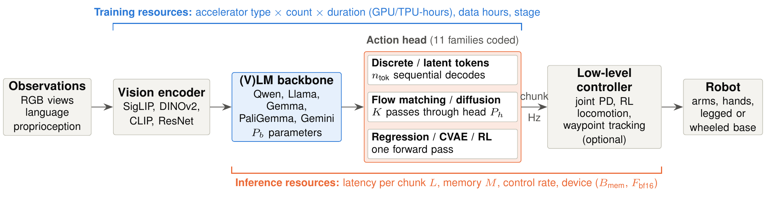
Figure 1. Anatomy of a VLA system and the resources coded in this review. Training resources cover the vision encoder, backbone and action head; inference resources span the backbone, the action head and any low-level controller. The symbols are those of the estimator in Section 8.
The corpus grows from 2 models in 2022 and 14 in 2023 to 60 in 2024 and 91 in 2025; 48 models appeared in 2026 up to the cut-off of 19 October (Figure 2a). Manipulation accounts for 111 models, humanoid whole-body control for 41, mobile manipulation for 34 and navigation for 29. Industry-only teams released 74 models, academic-only teams 66 and mixed teams 73.
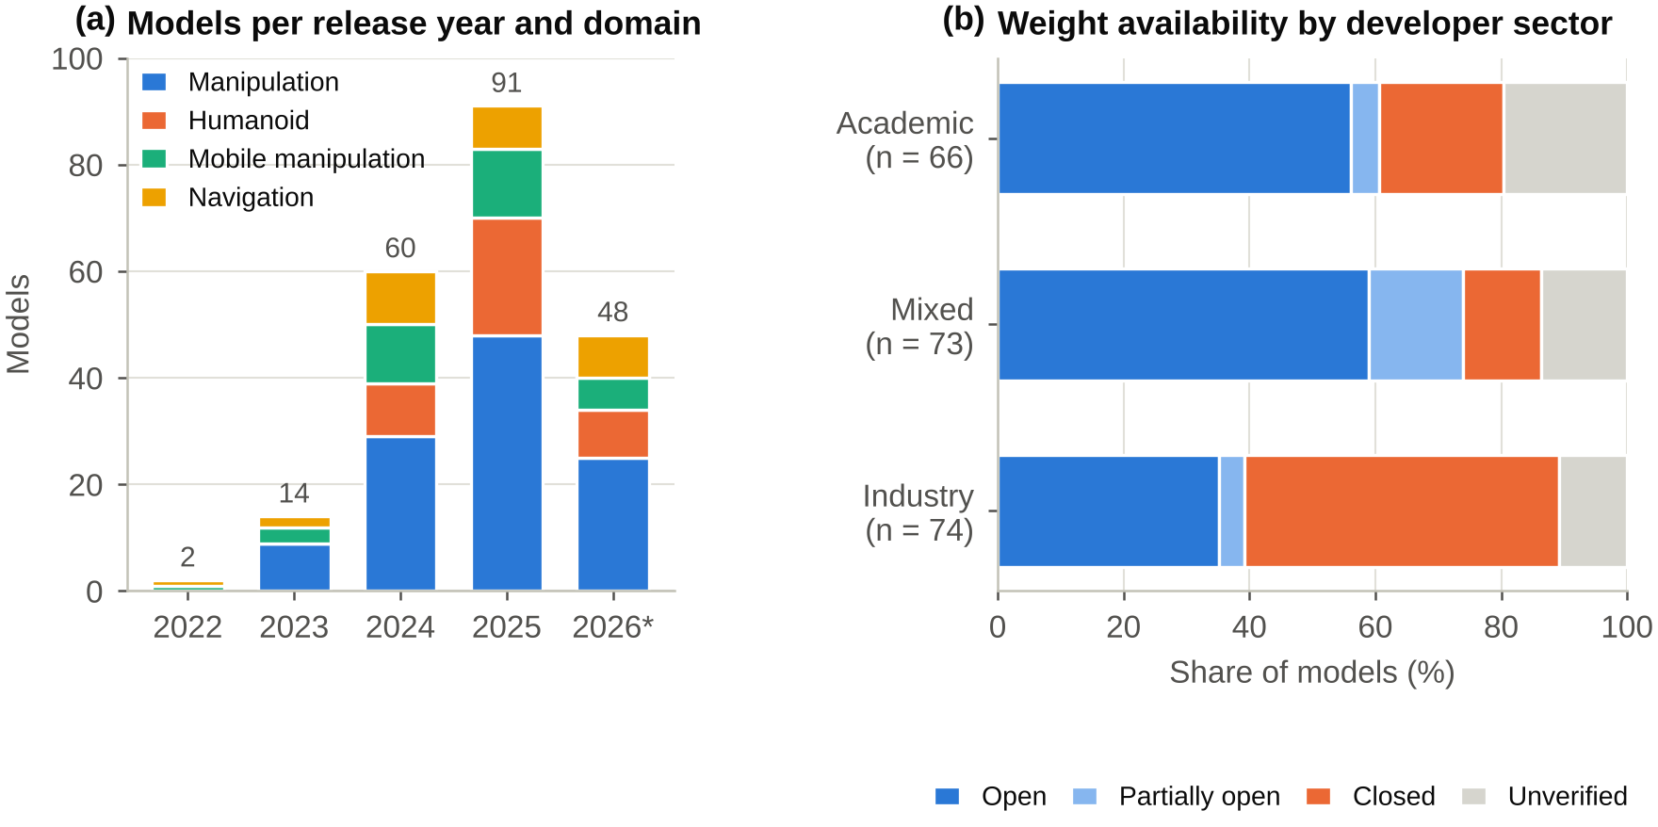
Figure 2. Composition of the corpus. (a) Models per release year and domain (*2026 up to 19 October). (b) Weight availability by developer sector.
Most models are documented by a paper: 182 records cite an arXiv paper (176 distinct preprints, since some papers describe two models), 3 cite a technical report, and 30 are documented only on the web, through blog posts, model cards, repositories or, in one case, news articles. Web-only documentation is concentrated in industry: 29 of the 74 industry-only models (39%) have no paper or report, against one of the 66 academic-only models. Weights are fully released for 100 models and partially for 17 and withheld for 59; availability is marked unverified for 39, although 6 of these have official Hugging Face weights, so 123 models release weights at least partially. 89 models have weights on Hugging Face and 153 have an official code repository. Openness also follows the developer: 61% of academic-only and 74% of mixed-team models release weights at least partially, against 39% of industry-only models; half of the industry-only models (37 of 74) are closed (Figure 2b).

5 Architecture Trends

5.1 Action Heads
The action head is where VLA designs have changed most (Figure 3a). Early policies discretised each action dimension into bins and emitted the bins as tokens, first from a transformer trained from scratch (RT-1 [37]) and then from a VLM that decodes them as language tokens (RT-2 and OpenVLA [1,2]). Discrete or latent-action tokens still made up 30% of the models released in 2024 (18 of 60) but 21% in 2025 (19 of 91) and 8% in 2026 (4 of 48). Flow matching [38], introduced to VLAs by $π_{0}$ [3], went the other way: one model in 2024, 18 in 2025 (20%) and 17 in 2026 (35%), when it became the most common disclosed head. Diffusion heads [39], popularised for visuomotor control by Diffusion Policy [31], were common in 2024 (15 models) and rare in 2026 (one model). Across the whole corpus the head families are discrete tokens (41), flow matching (36), diffusion (33), regression (26), RL policies (18), hybrids of autoregressive and diffusion or flow decoding (9), video world models (7), latent actions (6), CVAE (4) and other (7); 28 models do not disclose the head. The undisclosed share grew from 3% in 2024 to 33% in 2026, a first sign of the reporting gap analysed in Section 7.
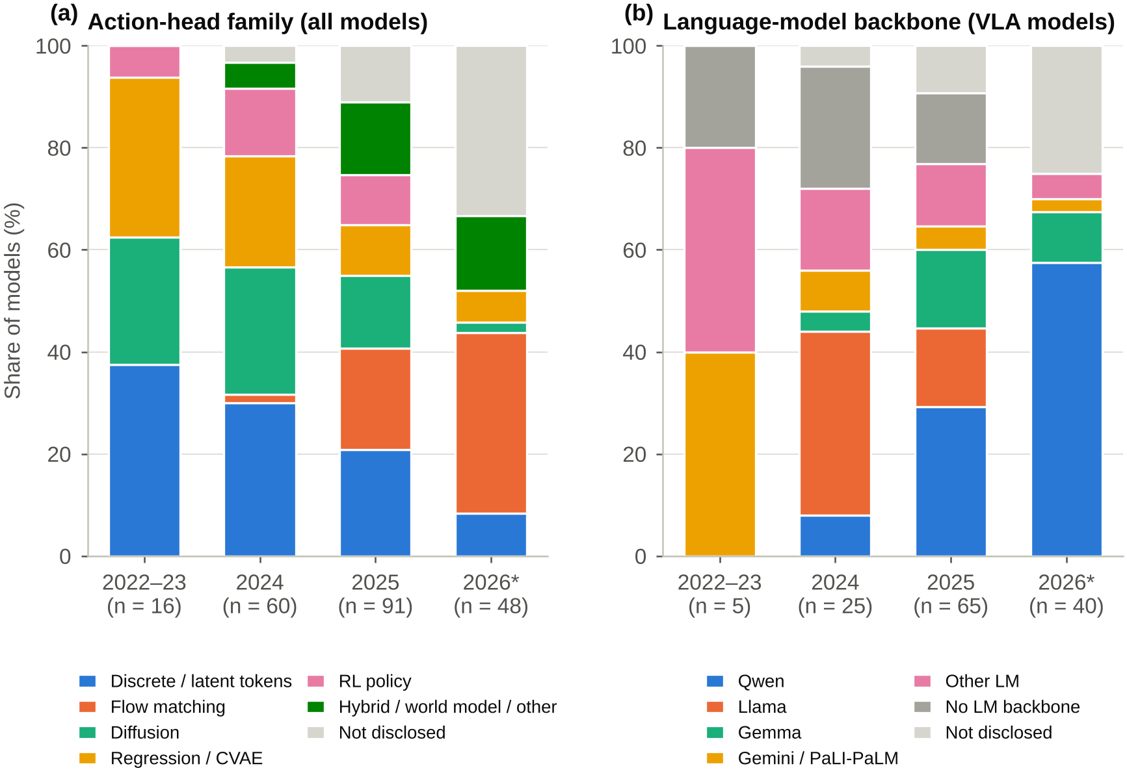
Figure 3. Architecture trends by release year (*2026 up to 19 October). (a) Action-head family across all models. (b) Language-model family of the backbone among VLA models.

5.2 Language Backbones
Among the 135 VLAs, the Qwen family is the most common backbone (44 models), followed by Llama (19), Gemma including PaliGemma [40] (15), Gemini (5) and PaLI/PaLM (3); 16 use other language models (SmolLM, InternLM, Phi, Mamba and others), 16 condition on language through a separate encoder rather than a language-model backbone (for example, the T5 text encoder of RDT-1B [41] or the Florence-2 encoder of FLOWER [42]), and 17 do not disclose the backbone. The mix changed quickly (Figure 3b). In 2024, Llama-based backbones such as the Prismatic VLM [43] behind OpenVLA [2] accounted for 9 of 25 VLAs and Qwen for 2. In 2025 Qwen led with 19 of 65, and in 2026 it accounts for 23 of 40 VLAs while no new VLA in the corpus uses Llama. One likely driver is the availability of strong small Qwen VLMs [44], but the corpus cannot test this.
Where the size of the language model is reported (81 models), the median is 4B. The most common size is 7B (26 models), 42 models use 4B or less and five use 32B or more. Most models with a reported language-model size (68 of 81, nearly all of them VLAs) use 2–8.5B parameters, which matters for the memory analysis in Section 8.

5.3 Model Size
Total parameter counts are disclosed for 113 models (median 3.3B; Figure 4). VLAs are much larger than visuomotor policies without a VLM (median 5B versus 0.093B). The yearly median rose from 0.0975B in 2022–2023 to 1.25B in 2024 and 4.1B in 2025, and stayed at 4.0B in 2026. The largest models are the 55B RT-2 variants [1,45,46] and the 72B DiVLA [47], but no model released since January 2025 discloses a total count above 14B, although some systems pair the policy with a planner of about 70B parameters (DexGraspVLA with Qwen2.5-VL-72B [48], Humanoid-VLA with Llama 3 70B [49]). The plateau around 4B is consistent with designs that must run on a robot or a single GPU at control rates; it may also reflect that the largest proprietary models do not disclose their size.
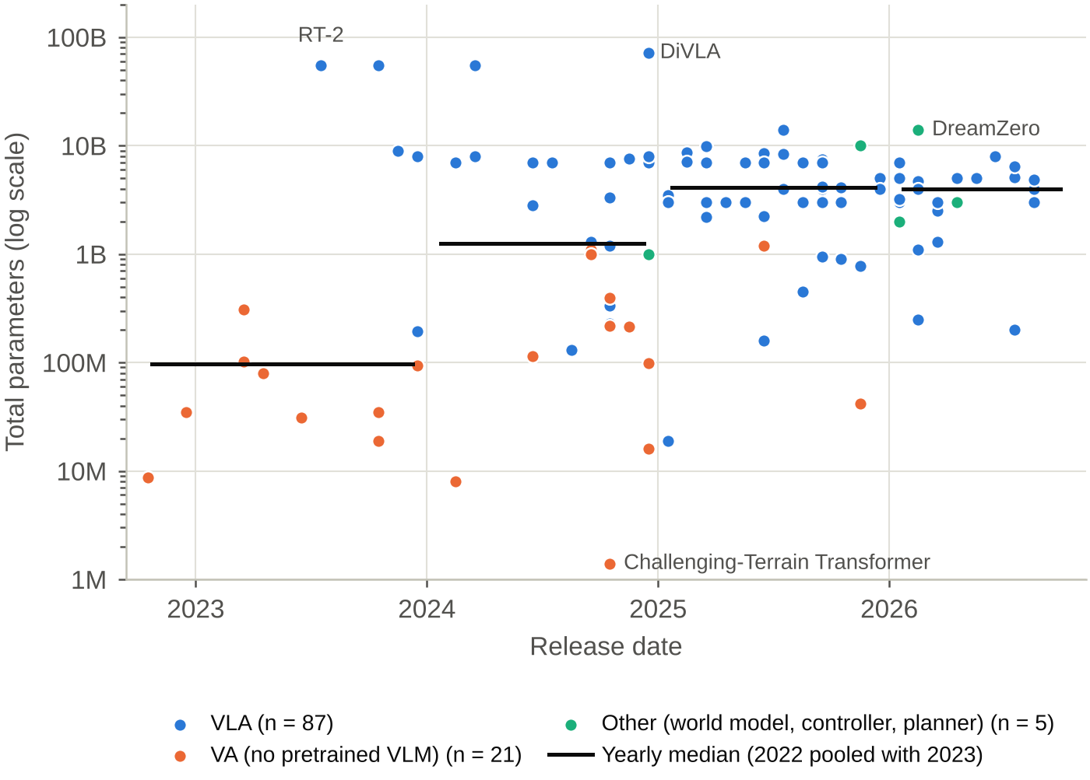
Figure 4. Total parameters against release date for the 113 models that disclose them. Black segments mark the yearly median.

5.4 Chunking, Control Rate and Hierarchy
Of the models that describe their action output, 91 predict chunks of several future actions and 20 predict one step at a time; 104 do not say. Chunking has become the norm: among models that describe their output, the chunked share rose from 54% in 2022–2023 to 72% in 2024, 93% in 2025 and 95% in 2026. Chunking decouples the control rate from inference latency: a policy that needs 70 ms per inference can still command the robot at 50 Hz by executing a 50-step chunk while the next one is computed [3,30,35]. Eighty-eight models report a control or execution rate (median 20 Hz among the 83 with a numeric value; 58 at 10 Hz or more). The rate depends on the head: models with discrete-token heads report a median of 3 Hz (11 models), against 10 Hz for diffusion (20), 30 Hz for flow matching (11) and 50 Hz for RL policies (13).
Hierarchy is the other route to speed. In dual-system designs a slow VLM runs at a few hertz and a small, fast action module runs at tens to hundreds of hertz: GR00T N1 pairs a 10 Hz VLM with a 120 Hz flow-matching transformer [4], and Helix pairs a 7B VLM at 7–9 Hz with an 80M-parameter policy at 200 Hz [5]. Among the 98 models with a mobile base, 39 hand their output to a separately trained or classical controller (Section 10).

6 Training Resources

6.1 Accelerators by Training Stage
The 145 training records from 109 models cover pretraining (76 records), post-training (2), fine-tuning (30), per-task training from scratch (16) and RL in simulation (21) (Figure 5b). Pretraining runs almost entirely on data-centre accelerators: Hopper-class GPUs (H100, H800 and H200; 26 records) and A100/A800 (23) dominate, followed by TPUs (8), V100 (4), workstation or consumer GPUs (3), GB200 (2) and an L40S (1); nine records do not name the accelerator. Where the count is reported (59 records), the median pretraining job used 32 accelerators; 21 used 64 or more, up to 1,024 H100 GPUs for GR00T N1 [4], and 23 used eight or fewer. The median reported pretraining duration is about four days (94 h, 36 records), ranging from 14 h for Octo-Base on a TPU v4 pod [50] to more than eight months for GEN-1.5 [51].
Adaptation is far cheaper. Fine-tuning and per-task training used a median of eight GPUs (45 records with a count; 39 used at most eight and 10 a single GPU) for a median of 24 h (30 records). Simulation RL, used mainly to train locomotion and whole-body controllers, typically runs on a single GPU (median of 20 records): nine of the 21 records use workstation or consumer GPUs and six use L40, L40S or A10 data-centre cards, in line with GPU-parallel simulators such as Isaac Gym [52]. Large motion-tracking controllers are the exception; SONIC reports roughly 21,000 GPU-hours [53].
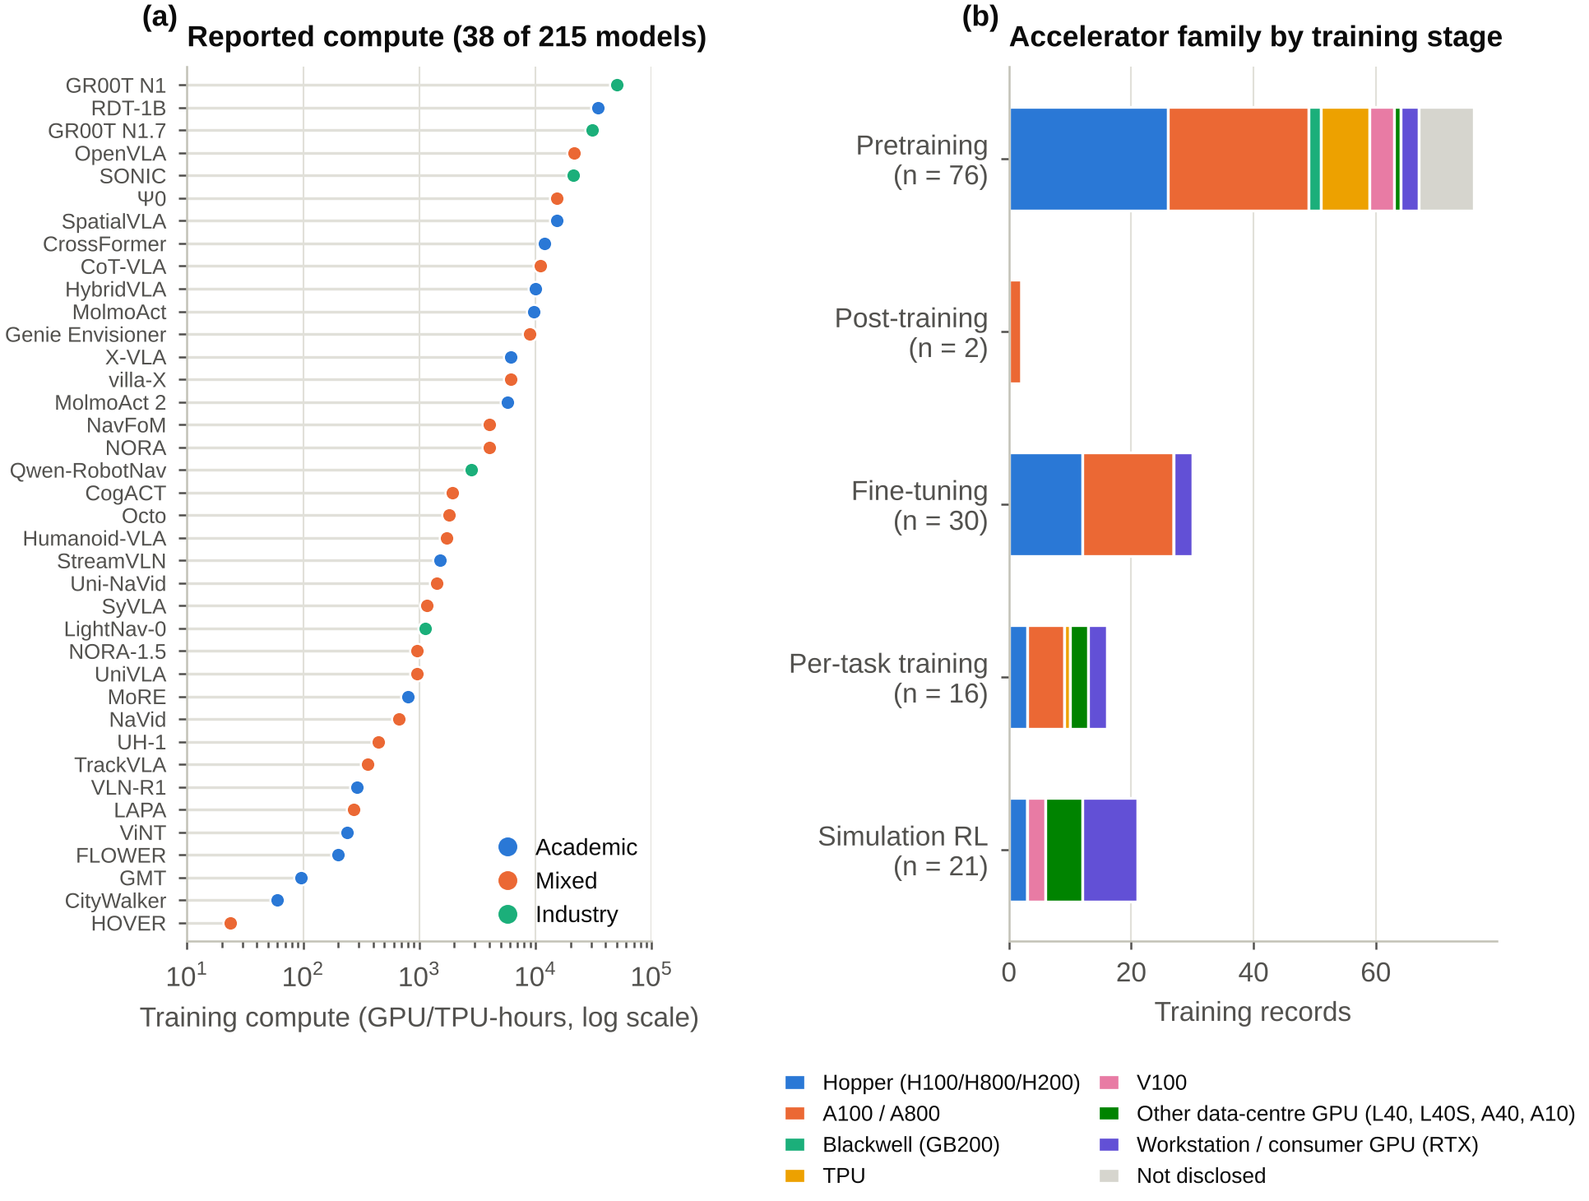
Figure 5. Training resources. (a) Pretraining GPU/TPU-hours for the 38 models where they are reported or computable, coloured by developer sector. (b) Accelerator family of each training record by stage.

6.2 Training Compute
Only 38 models report pretraining compute or both of its factors (Figure 5a). Their median is 1,856 GPU/TPU-hours (interquartile range 704–9,932), from 24 hours for HOVER [54] to roughly 50,000 H100-hours for GR00T N1 [4]. Ten models used 10,000 hours or more: besides GR00T N1, these include RDT-1B (about 34,560 H100-hours [41]), GR00T N1.7 (30,720 GB200-hours [55]) and OpenVLA (21,500 A100-hours [2]). Thirteen used fewer than 1,000 hours. Compute is only weakly related to model size ($ρ=−0.18$, $n=30$) and to release date ($ρ=0.16$, $n=38$), but it rises with the amount of training data among the 12 models that report both ($ρ=0.64$). Data volume, rather than parameter count, appears to set the cost, although these samples are small. These hours mix accelerator generations, from V100 to GB200, and units (TPU figures are core- or chip-hours as reported), and are not normalised to a common unit; they are a lower bound on the true cost because they exclude ablations, failed runs, data processing and simulation.

6.3 Training Data
Real-robot data appear in 145 models (mostly teleoperation), simulated or synthetic data in 94, human video in 54, web vision–language data in 45 and motion capture in 19 (a model can use several). Data scale is reported for 184 models but in incompatible units—episodes, trajectories, frames, hours—so we parsed hours only. Fifty-four models report hours of data (median 1,522 h). Sixteen report 10,000 h or more, and the largest figures come from 2025–2026 models: 270,000 h of real-world manipulation data for GEN-0 [56], over 500,000 h of data from human wearable devices for GEN-1 [57], and over one million hours of video for DYNA-2 (egocentric human video) [58] and V-JEPA 2-AC (internet video) [59]. The median reported data volume rose from 80 h in 2022–2023 (3 models) to 240 h in 2024 (5), 1,522 h in 2025 (24) and 2,774 h in 2026 (22), while the median model size stayed near 4B after 2025. Together with studies of data scaling in imitation learning [60] and large open datasets such as Open X-Embodiment [45] and DROID [61], these figures indicate that the field is now scaling data faster than parameters.

7 Disclosure Audit
Figure 6 shows the share of models that disclose each of the twelve items. What a model is made of is usually reported: the backbone (87%), the head type (87%) and the scale of the training data (86%). What it costs is not. Training accelerators are named for 47% of models, training duration for 27%, pretraining GPU-hours can be computed for 18% and inference memory is reported for 13%. Only 41% report a control rate and 51% name the inference device. Half (53%) report a total parameter count, the single number that the memory estimate in Section 8 needs most.
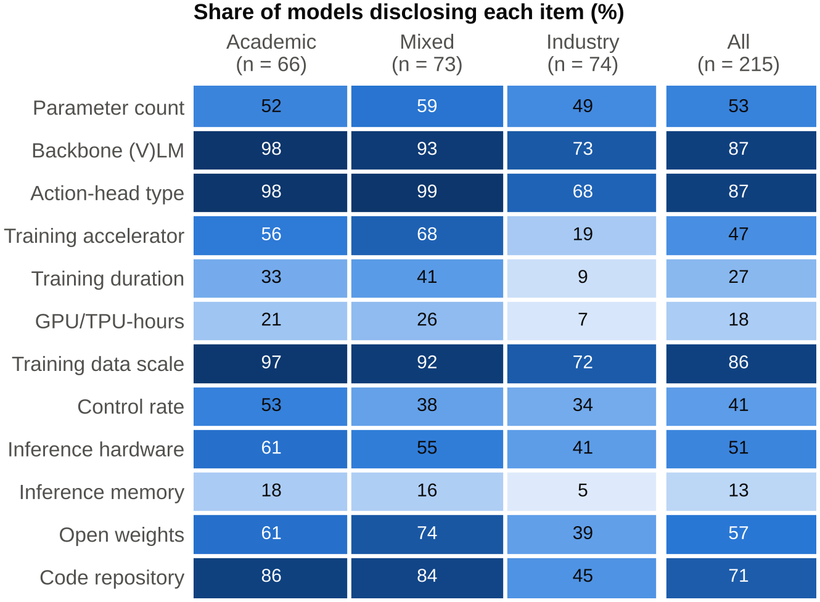
Figure 6. Share of models that disclose each resource item, by developer sector. Two models with unknown affiliation are counted only in “All”.
Disclosure differs by sector (Table 3). Industry-only models disclose eight of the twelve items significantly less often than other models after Holm correction. Relative to other teams, industry-only models are least likely to report training cost: 19% of them name a training accelerator against 63% of the others, 9% against 37% report a training duration, and 7% against 24% allow GPU-hours to be computed, a quarter to a third of the others’ rates. The largest absolute gaps are for the training accelerator (44 percentage points), the official code repository (45% against 85%) and the head type (68% against 99%); industry-only models also release weights less often (39% against 68%). Four items show no significant difference after correction: the parameter count, which about half of the models in every sector report, the control rate, the inference device and inference memory. Counting items, the median model discloses 6 of the 12; the medians are 7 for academic-only and mixed teams and 4.5 for industry-only teams.
Table 3. Disclosure of each item by industry-only models versus all other models (academic-only and mixed teams; two models with unknown affiliation excluded). OR: odds ratio from Fisher’s exact test; $p_{\text{Holm}}$: Holm-adjusted $p$-value over the 12 items.
Item | Industry (n = 74) | Other (n = 139) | OR | $p_{\text{Holm}}$
Parameter count | 36 (49%) | 77 (55%) | 0.76 | 0.39
Backbone (V)LM | 54 (73%) | 133 (96%) | 0.12 | <0.001
Action-head type | 50 (68%) | 137 (99%) | 0.03 | <0.001
Training accelerator | 14 (19%) | 87 (63%) | 0.14 | <0.001
Training duration | 7 (9%) | 52 (37%) | 0.17 | <0.001
GPU/TPU-hours | 5 (7%) | 33 (24%) | 0.23 | 0.01
Training data scale | 53 (72%) | 131 (94%) | 0.15 | <0.001
Control rate | 25 (34%) | 63 (45%) | 0.62 | 0.22
Inference hardware | 30 (41%) | 80 (58%) | 0.50 | 0.07
Inference memory | 4 (5%) | 24 (17%) | 0.27 | 0.07
Open weights | 29 (39%) | 94 (68%) | 0.31 | <0.001
Code repository | 33 (45%) | 118 (85%) | 0.14 | <0.001
Across the corpus, disclosure fell between 2024 and 2026: the share of models that name a training accelerator dropped from 57% to 31%, that report a training duration from 37% to 13% and that disclose the head type from 97% to 67%. Much of this reflects a change in who releases models: industry-only teams released 12% of the 2024 models (7 of 60) but 63% of the 2026 models (30 of 48). Within sectors, naming the training accelerator is flat (industry-only 14% and 13%; other teams 62% and 61%), whereas reporting of training duration and head type fell among academic and mixed teams too (duration from 40% to 22%, head type from 100% to 89%). Part of the 2026 drop may be temporary, because some 2026 releases have so far been described only in blog posts that may be followed by papers. The practical consequence is a selection bias in training cost: 33 of the 38 GPU-hour values come from academic or mixed teams, so cross-model comparisons of training cost mostly describe those teams.

8 Estimating Deployment Feasibility
The disclosure audit shows that latency and memory are rarely reported for the device a reader cares about. We therefore estimate them from the few quantities that are usually available—total parameters, head type, chunk structure—and from device specifications, and we test the estimate against every published latency measurement in the corpus.

8.1 Memory
The inference memory of a model with $P$ billion parameters stored at $b$ bytes per parameter is estimated as
$$M=P b+1 \text{GB}+0.3 \text{GB}×P,$$
where the constant term covers the runtime and the last term activations, key–value caches and the vision encoder’s working memory. A model is taken to fit when $M$ is at most 90% of device memory, or 75% on Jetson modules, whose memory is shared with the CPU. Quantised precisions ($b=1$ for int8 and $b=0.5$ for int4) assume that a working quantised implementation exists, as for NaVILA with AWQ [8,62]. We checked Equation (1) against the 18 models that report an exact inference-memory figure in bf16 or fp16 and five reported quantised figures. The median fold error is 1.13$×$, 21 of the 23 figures are within 1.5$×$ and all are within 2$×$, and the estimate errs on the generous side (geometric-mean ratio 1.09). These figures were available when the constants were chosen, so this is a consistency check rather than an independent validation.

8.2 Latency
Each network pass is modelled with a roofline [63]: it takes as long as the slower of reading the weights from memory and doing the arithmetic, plus a fixed overhead. For a network of $p$ billion parameters processing $n$ tokens on a device with memory bandwidth $B_{\text{mem}}$ (GB/s) and dense BF16 throughput $F_{\text{bf16}}$ (TFLOPS),
$$f\left(p,n\right)=max\left(\frac{1000 p b}{βB_{\text{mem}}},\frac{2 p n}{φF_{\text{bf16}}}\right)+c_{0} \text{(ms)},$$
where $β$ and $φ$ are the achievable fractions of peak bandwidth and compute and $c_{0}$ is a per-pass overhead. The latency of one inference, which produces one action or one action chunk, depends on the head:
$$L_{\text{tokens}}=f\left(P,n_{\text{in}}\right)+n_{\text{tok}}\left(\frac{1000 P b}{βB_{\text{mem}}}+c_{t}\right),$$
$$L_{\text{iterative}}=f\left(P−P_{h},n_{\text{in}}\right)+Kf\left(P_{h},50\right),$$
$$L_{\text{single}}=f\left(P,n_{\text{in}}\right).$$
Token heads (Equation (3)) run one prefill pass over $n_{\text{in}}$ input tokens and then decode $n_{\text{tok}}$ action tokens, each of which re-reads the weights; this is the memory-bound regime of autoregressive decoding [64]. Flow-matching and diffusion heads (Equation (4)) run the backbone once and a head of $P_{h}$ parameters $K$ times over about 50 action tokens. Regression, CVAE and RL heads (Equation (5)) need one pass. On Jetson modules the result is multiplied by $γ$ to account for lower sustained clocks and less mature kernels. The defaults are $n_{\text{in}}=600$ input tokens for models with a VLM (1,500 for navigation models that encode video history) and 64 otherwise, $n_{\text{tok}}=7$ (5 for navigation) unless the source states the number of tokens per action, $K=10$ unless the source states the number of steps. When the head size is not reported, $P_{h}$ is set to 0.3B for VLM-based models of at least 1.5B parameters, to $0.25P$ for smaller VLM-based models and to $0.7P$ for models without a VLM, whose head is most of the network. Token policies without a language model, such as RT-1 [37], emit all action tokens in one pass and are treated as single-pass. Video world-action models are not estimated because their cost depends on the video resolution and horizon.
The estimate needs a total parameter count and a known head type. When only the language-model size $P_{\text{LM}}$ is known, we use $P≈1.15 P_{\text{LM}}$, plus $P_{h}$ for iterative heads. This is possible for 128 of the 215 models (105 from the total count, 23 from the language-model size); 78 models give no size and 9 give a size but no head type. Three of the 128 are video world-action models, which leaves 125 models with a latency estimate. TurboVLA [65], whose head is not described, is treated as single-pass.

8.3 Calibration and Validation
The gallery’s calibration set contains 38 published latency measurements (“anchors”) for 30 models on 11 devices (Table A3 in Appendix B). Each states the device, the precision and the latency of one inference of the network that the record describes; other latency figures in the corpus were left out because they cover only one stage of a multi-stage system, a different model size or an amortised per-action time. Thirty-seven anchors can be estimated, the exception being a video world-action model. Device specifications for 24 devices, from the 8 GB Jetson Orin Nano to data-centre GPUs, are listed in Table A2. The gallery uses $β=φ=0.6$, $c_{0}=c_{t}=4$ ms and $γ=1.5$, chosen to fit these anchors. An exhaustive search over a grid that contains these values finds a different optimum ($β=1$, $φ=0.5$, $c_{0}=3$ ms, $c_{t}=6$ ms, $γ=1.75$) with a slightly lower in-sample error (1.29$×$). That quite different constants fit almost equally well shows that 37 anchors do not pin the constants down individually; they are fitted parameters, not physical efficiencies. Accuracy is measured as the fold error $max\left(\hat{L}/L,L/\hat{L}\right)$.
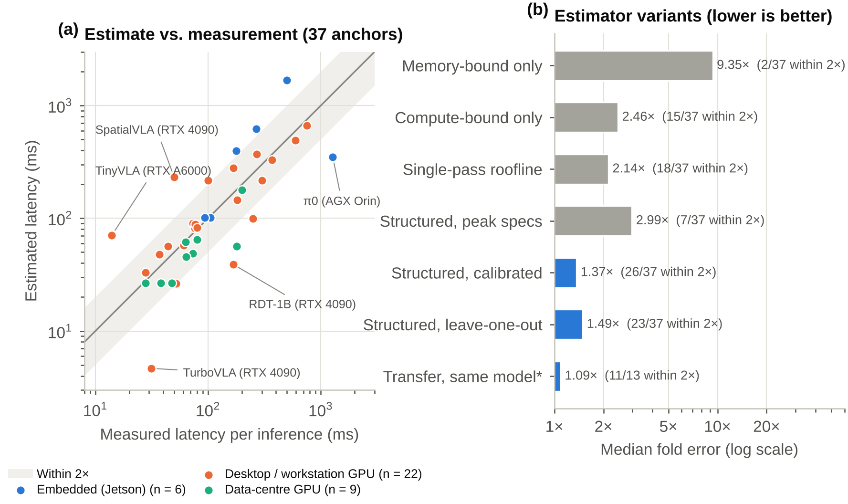
Figure 7. Validation of the latency estimator. (a) Estimated against measured latency for the 37 anchors; the shaded band marks agreement within a factor of two, and the five largest errors are labelled. (b) Median fold error of estimator variants. *Transfer predicts each anchor from another measurement of the same model on another device or at another precision ($n=13$).
With the calibrated constants the median fold error is 1.37$×$, and 26 of the 37 anchors are within a factor of two (23 within 1.5$×$; Figure 7, Table 4). The estimate is nearly unbiased: the geometric mean of the estimated-to-measured ratio is 0.95. Because the constants were fitted to the same anchors, we also ran a leave-one-out test, repeating the grid search on 36 anchors and predicting the held-out one. The out-of-sample median error is 1.49$×$ with 23 of 37 within a factor of two, against 1.29$×$ in sample for the same search, so the fit generalises with a modest loss. One further measurement that meets the anchor criteria but was not used for calibration, ALOHA Unleashed at 43 ms on an RTX 4090 [66], is estimated at 46 ms.
Table 4. Accuracy of estimator variants on the published latency anchors. Fold error is $max\left(\hat{L}/L,L/\hat{L}\right)$; bias is the geometric mean of $\hat{L}/L$ (values below 1 mean underestimation). The first three variants use the calibrated efficiency constants; “peak specifications” uses $β=φ=γ=1$ and no fixed overheads.
Variant | n | Median fold error | $≤$1.5$×$ | $≤$2$×$ | Bias
Memory-bound only (weights read once) | 37 | 9.35$×$ | 0 | 2 | 0.09
Compute-bound only ($2Pn$ FLOPs) | 37 | 2.46$×$ | 8 | 15 | 0.26
Single-pass roofline, no head structure | 37 | 2.14$×$ | 10 | 18 | 0.39
Structured roofline, peak specifications | 37 | 2.99$×$ | 7 | 7 | 0.28
Structured roofline, calibrated (this work) | 37 | 1.37$×$ | 23 | 26 | 0.95
Structured roofline, leave-one-out | 37 | 1.49$×$ | 19 | 23 | 0.87
Transfer from another measurement of the same model | 13 | 1.09$×$ | 10 | 11 | 0.93
Each part of the model earns its place. Using peak specifications without calibration underestimates latency by a factor of about 3.6 (median error 2.99$×$, 7 of 37 within 2$×$). With calibrated constants, a memory-bound-only model (weights read once) errs by a median of 9.35$×$, a compute-bound-only model by 2.46$×$ and a single-pass roofline that ignores the head structure by 2.14$×$. Representing token decoding and iterative denoising explicitly is what brings the error down to 1.37$×$. Within the calibrated estimate, the VLM prefill is compute-bound for 31 of the 33 anchors that have a VLM, but the cost of the action head depends on its type. For token heads, decoding, which re-reads the weights for every token, is the largest term for 6 of the 11 anchors, in line with the view of Grover et al. [17] that autoregressive VLAs are bandwidth-bound. Flow-matching and diffusion heads do not fit the compute-bound description: each of their $K$ passes is small, the head passes are bandwidth-bound rather than compute-bound for all 23 anchors, and the fixed per-pass overhead is the largest single term for 13 of them. In this model, iterative heads are slow because they repeat many small passes, which points to fewer steps and lower per-call overhead, rather than more arithmetic throughput, as the levers.
Errors are similar on desktop, workstation and data-centre GPUs (median 1.30$×$ on 19 desktop, 1.25$×$ on 3 workstation and 1.40$×$ on 9 data-centre anchors) and largest on Jetson modules (2.28$×$ on 6 anchors), where power modes, unified memory and software maturity vary most. The five largest errors fall into three groups. For very small models such as TurboVLA (0.2B) [65], fixed software overheads dominate and the estimate understates latency 6.7-fold. For TinyVLA [67], the assumed head size, and for SpatialVLA [68], sequential decoding of the 12 action tokens per chunk derived from its description, overstate the work, and the estimate overstates latency about fivefold. For RDT-1B [41] and for $π_{0}$ on a Jetson AGX Orin [3], the measurement probably includes work that the estimate does not model, such as separate text or image encoders, preprocessing or a slower power mode, and the estimate understates latency about fourfold.
When a model has been measured on one device, the estimator can transfer that measurement to another device or precision by scaling it with the ratio of the two estimates. On the 13 anchors that have another anchor of the same model (four of these transfers are between precisions on the same device), this transfer has a median error of only 1.09$×$, with 11 of 13 within a factor of two. The gallery therefore uses a measured value when one exists for the same device and precision, a transferred value when the model was measured on another device, and the pure estimate otherwise.

8.4 Which Models Run Where
Figure 8 applies the estimator to the 125 models with a latency estimate on eleven representative devices. A model counts as deployable if it fits in memory and the estimated rate, or the measured or transferred rate when available, is at least 10 Hz. Three regimes appear. On 8–16 GB Jetson modules memory is the binding constraint: in bf16, 88 of the 125 models do not fit in the 8 GB of an Orin Nano and 53 do not fit in the 16 GB of an Orin NX, and only 19 and 20 models reach 10 Hz. On the 64 GB AGX Orin almost everything fits (six models do not) but most models are too slow: 24 reach 10 Hz and 95 run but below 10 Hz. On desktop and data-centre GPUs both constraints relax, and 68 models reach 10 Hz on an RTX 4090, 78 on an RTX 5090 and 105 on an H100.
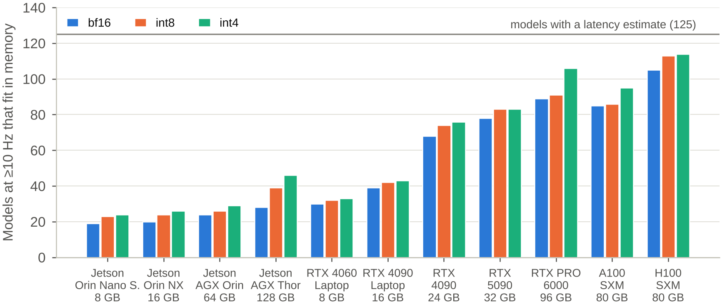
Figure 8. Number of models estimated to fit in memory and run at 10 Hz or faster on eleven devices, by inference precision. The horizontal line marks the 125 models with a latency estimate.
Quantisation helps most where weight reads dominate. The Jetson AGX Thor combines high compute (259 TFLOPS) with modest bandwidth (273 GB/s), so in the estimate most passes on it are bandwidth-bound whatever the head type. Moving from bf16 to int4 there raises the number of models at 10 Hz from 28 to 46, and 16 of the 18 additional models have flow-matching, diffusion or hybrid heads; at 5 Hz the count rises from 66 to 84. On the Orin Nano, int4 lets 45 more models fit in memory, but most of them are too slow, so the number at 10 Hz rises only from 19 to 24. The largest models that reach 10 Hz on an Orin Nano in bf16 are TinyVLA (1.3B) [67] and HPT (1.1B) [69]; on an RTX 4090 they include 7B models such as TrackVLA [70] and 5B models such as $π_{0.7}$ [71]. These are estimates for batch size one without compiler or kernel optimisation; optimised runtimes such as TensorRT, which GR00T N1.7 uses for its reported latencies [55], can change measured rates substantially.

8.5 Fine-Tuning Cost
A similar estimate covers fine-tuning. Per-GPU memory is the sum of model state and activations. Full fine-tuning with mixed-precision Adam needs about 16 bytes per parameter (bf16 weights and gradients, an fp32 master copy and two optimiser moments [72]), divided by the number of GPUs when the state is sharded [72,73]. LoRA [74] keeps frozen bf16 weights (2 bytes per parameter) and trains adapters with 1% of the parameters; QLoRA [75] stores the frozen weights in 4 bits (about 0.55 bytes per parameter); training only the action head keeps the backbone frozen in bf16. Activations are modelled as 2 GB plus 1.5 GB per billion parameters for small batches and 4 GB plus 5 GB per billion for typical batches. These activation constants were set to match four requirements stated in the official repositories of three models—more than 22.5 GB for LoRA and more than 70 GB for full fine-tuning of $π_{0}$ [76], about 27 GB for LoRA on OpenVLA at batch size one [77], and about 70 GB for full fine-tuning of GO-1 [78]—and, unlike the latency model, have not been validated on independent measurements. Training time follows the usual $6PN$ rule [79] ($4PN$ for adapter training, $2PN$ for a frozen backbone) at 35% of peak BF16 throughput and 90% scaling efficiency across GPUs.
Table 5. Estimated fine-tuning feasibility for the 89 models with released weights and enough size information. Each cell gives the number of models whose estimated per-GPU memory fits (90% of device memory; 75% on Jetson) and, in parentheses, the largest such model (total parameters). Memory assumes the “normal” activation budget (4 GB + 5 GB per billion parameters per GPU). Head-only applies to models with a separable flow-matching, diffusion or hybrid head; where the source does not give the head size, the estimator’s default is used.
Configuration | Full | LoRA | QLoRA | Head only
1$×$ RTX 4090 (24 GB) | 20 ($≤$0.77B) | 32 ($≤$2.37B) | 46 ($≤$3B) | 34 ($≤$5.1B)
1$×$ RTX 5090 (32 GB) | 26 ($≤$1.1B) | 48 ($≤$3.3B) | 56 ($≤$4.2B) | 39 ($≤$7.6B)
1$×$ A100 (80 GB) | 47 ($≤$3.2B) | 86 ($≤$9B) | 86 ($≤$9B) | 44 ($≤$8.45B)
8$×$ H100 (80 GB) | 86 ($≤$9B) | 86 ($≤$9B) | 86 ($≤$9B) | 44 ($≤$8.45B)
Jetson AGX Thor (128 GB) | 56 ($≤$4.2B) | 86 ($≤$9B) | 88 ($≤$14B) | 44 ($≤$8.45B)
Table 5 shows what this implies for the 89 models with released weights that can be assessed. A single 24 GB RTX 4090 can fully fine-tune only models below about 0.8B parameters (20 models), but LoRA reaches 2.4B (32 models) and QLoRA 3B (46 models). One 80 GB A100 is enough for LoRA on 86 of the 89 models, up to 9B; the remaining three are the largest in the set (two 14B models and a system whose planner is a 72B VLM). For example, the estimate for LoRA on OpenVLA (7B) is about 54 GB at a typical batch size, so it needs an 80 GB GPU, and 10,000 steps at a global batch of 32 take an estimated 14 h on one A100; on eight H100 GPUs, full fine-tuning of $π_{0}$ takes an estimated 23 min.

9 Reinforcement Learning in VLA Pipelines
Most models in the corpus are trained by imitation alone: 132 do not use RL, 31 use it as a core component, 28 use it partially and 24 do not say. Where RL appears, it enters at one of six points, and the point depends strongly on the domain (Figure 9a). In humanoid models RL trains the controller: 13 humanoid models are RL-trained whole-body controllers, often motion trackers learned in simulation [53,54,80], and 12 place an RL low-level controller under a higher-level policy, usually a VLA, that issues commands or latent goals [81]. Mobile manipulation follows a similar pattern, mostly on legged robots: RL-trained controllers appear in five models and RL low-level controllers in four [82,83].
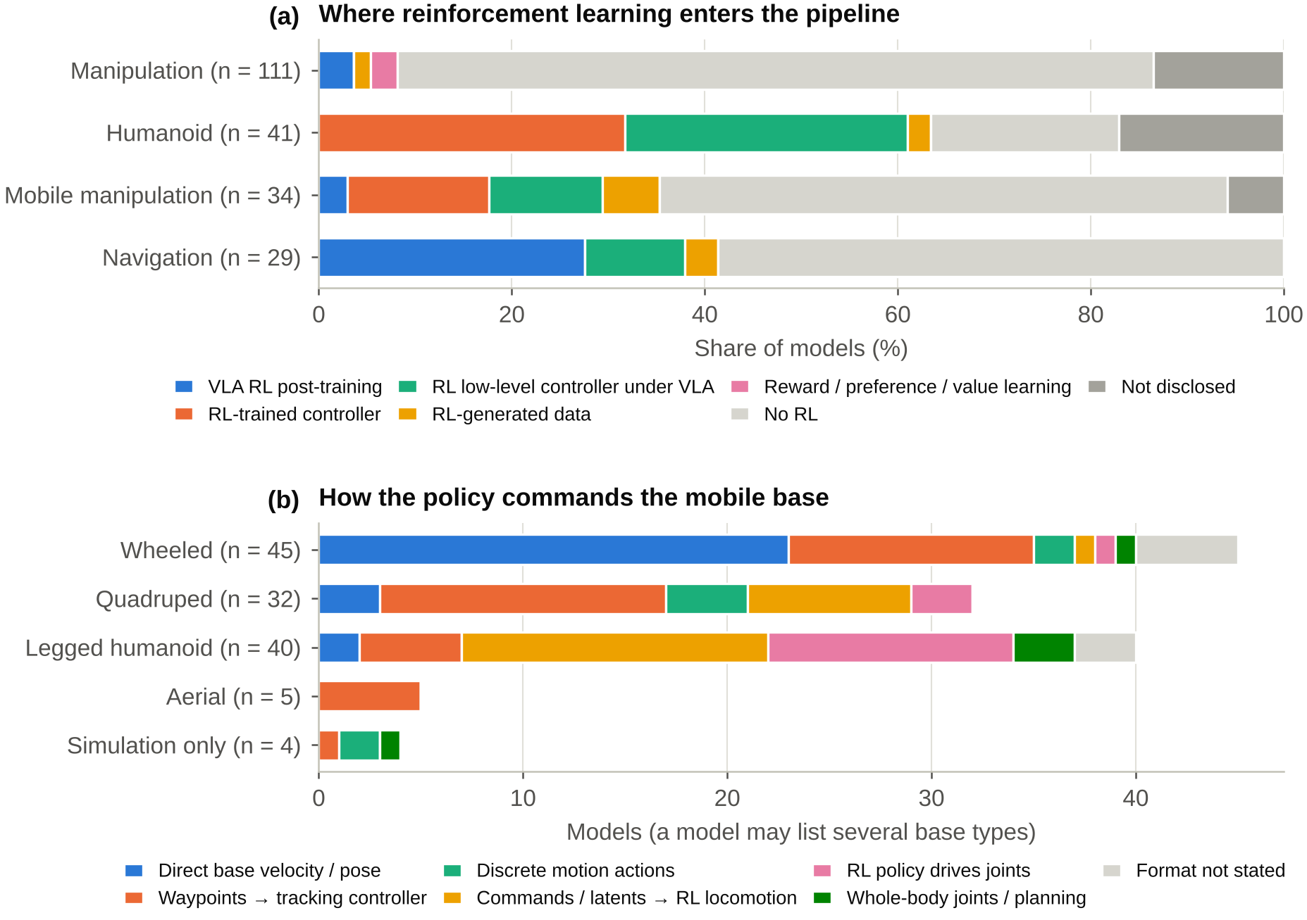
Figure 9. (a) Where reinforcement learning enters the pipeline, by domain. (b) How the policy commands the mobile base, by base type; a model can list more than one base type.
RL post-training of the policy itself is growing (one model in 2024, five in 2025 and seven in 2026) and is concentrated in navigation. Of the 13 models that fine-tune the policy with RL, eight are coded as navigation models [84–91]; one of them (COMPASS) is a VA policy, and one (Qwen-VLA) also covers manipulation and scores its RL stage on a manipulation benchmark. Most train in simulation, where rewards are cheap to compute, using PPO-style objectives [92] or group-relative policy optimisation (GRPO) [93]. In manipulation, RL post-training is rarer (four models): $π_{0.6}^{*}$ learns a value function from demonstrations, autonomous rollouts and human corrections and uses it to improve the policy [94], GR-RL runs online RL on a real robot [95], SyVLA optimises the whole VLA with a PPO variant on a real robot [96], and GEN-1 states that it learns from experience without describing how [57]. One quadruped model applies offline RL to its VLA [97]. Three manipulation models use reward, preference or value learning without full RL post-training, and six models across domains use data generated by RL policies. Simulation RL for controllers usually runs on one or a few GPUs (Section 6), although large motion-tracking controllers can approach VLA pretraining budgets.

10 Commanding the Mobile Base
98 models control a robot with a mobile base: 45 wheeled, 32 quadruped, 40 legged humanoid, five aerial and four simulation-only platforms (a model can list several). How the policy talks to the base is rarely stated in one place, so we coded it into eight classes (Figure 9b). The interface follows the platform. On wheeled robots the policy usually outputs base velocities or poses directly (23 models), as RT-1 does [37], or waypoints for a tracking controller (12), as in the navigation foundation models GNM, ViNT and NoMaD [98–100]. On quadrupeds waypoints dominate (14 models), followed by commands or latents for an RL locomotion controller (8). On humanoids, a VLA rarely commands the legs itself: 15 models send commands or latent goals to an RL locomotion controller and 12 are themselves RL policies that drive the joints, while five output whole-body joint targets or base motions directly (for example, Atlas LBM [101]). All five aerial models output waypoints. Eight models do not state the interface at all.
These choices matter for resources. A policy that outputs waypoints or latent commands can run at a few hertz while a separately trained controller closes the loop at hundreds of hertz, which is how large VLMs are used on legged robots despite the latencies in Section 8. The cost is that the controller, its training and its rate become part of the system that must be reported.

11 Discussion

11.1 Implications for Practitioners
Three practical lessons follow. First, check memory before speed on small embedded computers and speed before memory on large ones. Most of the assessable models do not fit in bf16 on an 8 GB Orin Nano and 42% do not fit on a 16 GB Orin NX, so quantisation is the first lever there; on 64–128 GB modules nearly everything fits, and the head structure and chunking decide whether the policy is fast enough. Second, the head structure matters as much as the parameter count. A 3B model with a flow-matching head and 50-step chunks can control a robot at 50 Hz on a desktop GPU [3], whereas a 7B model that decodes several tokens per action is limited by memory bandwidth to a few hertz [2] unless it uses parallel decoding and chunking [102]. Third, fine-tuning is within reach of a single workstation for most open models below about 3B parameters if LoRA or QLoRA is used, whereas full fine-tuning of 7B-class models still needs several 80 GB GPUs. The gallery that accompanies this review performs these checks for any of the 24 devices in Table A2 or for user-supplied specifications.

11.2 A Reporting Checklist
The disclosure audit points to a small set of numbers that, if reported consistently, would make the estimates above unnecessary. Table 6 lists ten items, in the spirit of model cards [103], datasheets [104], reproducibility checklists [105] and calls to report compute and energy [106–108]. Most cost the authors little: they are already known when the paper is written.
Table 6. A ten-item checklist for reporting the resources of robot foundation policies.
# | Item | Why it matters
1 | Total parameters, split into vision encoder, backbone and action head, with the precision used at inference | Sets memory and the bandwidth-bound part of latency; reported by only 53% of models
2 | Action representation: head type, chunk length, tokens per action or denoising steps | Determines how latency scales with model size (Equations (3)–(5))
3 | For each training stage: accelerator model, count, wall-clock duration, steps and batch size | Allows GPU-hours to be computed; only 18% of models allow this today
4 | Training data by source type (teleoperation, simulation, human video, web), in hours and episodes | Data volume, more than parameter count, tracks training cost (Section 6)
5 | Fine-tuning recipe: method (full, LoRA, head only), GPUs, memory, steps and time | Tells users whether adaptation fits their hardware
6 | Inference latency per action chunk on a named device, with precision, batch size and software stack | Enables like-for-like comparison and calibration of estimators
7 | Peak inference memory on that device | Reported by only 13% of models
8 | Control rate on the robot and where inference runs (onboard, local PC, remote server), including network latency | Separates model speed from system design
9 | Interface to the robot: what the policy outputs, at what rate, and to which low-level controller | Required to reproduce mobile and humanoid systems (Section 10)
10 | Release status of weights, code and training data, with licences, and any RL use with its simulation budget | Determines whether the model can be studied or deployed by others
Standard benchmarks of inference speed for robot policies, analogous to MLPerf for data-centre inference [109], would complement such reporting. The anchors in Table A3 show the problem: they were measured by different authors with different software stacks and sometimes include image preprocessing or network transfer, which limits how precisely any estimator can be calibrated.

11.3 Limitations
The review has several limitations. The corpus is large but not exhaustive; it reflects the search described in Section 3 and the reference dates of 6–19 October 2026, and the field moves fast enough that some 2026 models will have published papers after the cut-off. All values are self-reports by the developers; we did not reproduce training runs or measure latencies ourselves, and 12 records could not be fully verified. Coding the head family, the RL category, the base interface and the developer sector involves judgement, and inter-rater agreement was not measured. GPU-hours mix accelerator generations and exclude experimentation, so they understate true cost and should not be compared across generations without care.
The estimator is deliberately simple. It assumes batch size one, ignores compiler and kernel optimisation, assumes that quantised kernels exist, and treats a dual-system pipeline as a single network, which can make it optimistic for hierarchical models such as Helix whose large VLM runs at a lower rate than the action module. It needs a parameter count and a head type, so 87 models cannot be assessed, and it was validated on only 37 anchors, six of them on embedded devices. The memory check uses figures that were available when the constants were chosen, and the fine-tuning estimates rest on four reported requirements from three models; neither has been validated independently. The estimates should therefore be read as screening tools, accurate to within a factor of two for about two thirds of the anchors, not as substitutes for measurement.

11.4 Future Work
Three extensions would strengthen this line of work: a shared protocol and open harness for measuring VLA latency, memory and energy on common devices, which would multiply the number and quality of anchors; adding energy and power to the coded resources, which matters for battery-powered robots; and keeping the dataset current, which the open gallery and scripts make possible.

12 Conclusions
We reviewed 215 robot policy models and related systems from October 2022 to October 2026 from the perspective of the resources they need to be trained and deployed. The architecture has moved towards flow-matching heads, action chunking and Qwen-family backbones of about 2–8B parameters, and model size has plateaued at a median of about 4B parameters since 2025, while training data have grown to hundreds of thousands of hours. Training cost spans more than three orders of magnitude, from tens to tens of thousands of GPU-hours, but it is reported for fewer than one model in five, and industry-only models disclose training hardware, training duration and compute far less often than academic and mixed teams. A roofline estimator that represents token decoding and iterative denoising predicts published latencies to a median factor of 1.37 (1.49 out of sample) and shows that memory limits deployment on small embedded computers while speed limits it on larger ones. We hope that the dataset, the estimator and the reporting checklist will make resource numbers a routine part of how robot foundation models are described.

Author Contributions
Conceptualization, F.L.; methodology, F.L.; software, F.L.; validation, F.L.; formal analysis, F.L.; investigation, F.L.; data curation, F.L.; writing—original draft preparation, F.L.; writing—review and editing, F.L.; visualization, F.L. The author has read and agreed to the published version of the manuscript.

Funding
This research received no external funding.

Institutional Review Board Statement
Not applicable.

Informed Consent Statement
Not applicable.

Data Availability Statement
The dataset (215 model records, training-hardware records, device specifications and latency anchors), the analysis scripts that produce every number and figure in this article, and an interactive gallery are openly available at https://github.com/yc424k/vla-gallery and https://vla-gallery.is-a.dev/.

Acknowledgments
During the preparation of this manuscript, the author used Claude (Anthropic) [TODO(author): version] for the purposes of writing analysis and plotting code and drafting the manuscript text [TODO(author): and, if applicable, assisting data extraction and verification]. The author has reviewed and edited the output and takes full responsibility for the content of this publication.

Conflicts of Interest
The author declares no conflicts of interest.

Abbreviations
The following abbreviations are used in this manuscript:
BF16 | Brain floating point, 16 bits
CVAE | Conditional variational autoencoder
FSDP | Fully sharded data parallel
GPU | Graphics processing unit
GRPO | Group relative policy optimisation
LLM | Large language model
LM | Language model
LoRA | Low-rank adaptation
QLoRA | Quantised low-rank adaptation
RL | Reinforcement learning
TPU | Tensor processing unit
VA | Vision–action (visuomotor policy without a pretrained VLM)
VLA | Vision–language–action
VLM | Vision–language model

13 Appendix: The Corpus
Table A1 lists every model with its key attributes and primary source. Full records, including the source of every value, are in the released dataset.
Table A1. All 215 models in the corpus, ordered by release month. Domain: Manip. = manipulation, Hum. = humanoid, MoMa = mobile manipulation, Nav. = navigation. Params: total parameters in billions (n/d = not disclosed). LM: language-model family of the backbone. Head: action-head family. W: weights released (Y = yes, P = partially, N = no, ? = unverified; Y* = official Hugging Face weights listed although the record marks availability as unverified). GPU-h: pretraining GPU/TPU-hours as reported, or computed from accelerator count and duration.
# | Model | Date | Domain | Type | Params | LM | Head | W | GPU-h
# | Model | Date | Domain | Type | Params | LM | Head | W | GPU-h
 | GNM [98] | 2022-10 | Nav. | VA | 0.0087 | none | regression | Y
2 | RT-1 [37] | 2022-12 | MoMa | VA | 0.035 | none | tokens | Y
3 | Diffusion Policy (CNN) [31] | 2023-03 | Manip. | VA | 0.309 | none | diffusion | Y
4 | Diffusion Policy (Transformer) [31] | 2023-03 | Manip. | VA | 0.102 | none | diffusion | Y
5 | ACT [30] | 2023-04 | Manip. | VA | 0.08 | none | CVAE | N
6 | ViNT [99] | 2023-06 | Nav. | VA | 0.031 | none | regression | Y | 240
7 | RT-2 [1] | 2023-07 | MoMa | VLA | 55 | PaLI/PaLM | tokens | N
8 | NoMaD [100] | 2023-10 | Nav. | VA | 0.019 | none | diffusion | Y
9 | RT-1-X [45] | 2023-10 | Manip. | VA | 0.035 | none | tokens | Y
10 | RT-2-X [45] | 2023-10 | Manip. | VLA | 55 | PaLI/PaLM | tokens | N
11 | RoboFlamingo [110] | 2023-11 | Manip. | VLA | 9 | other | regression | Y
12 | GR-1 [111] | 2023-12 | Manip. | VLA | 0.195 | none | regression | P
13 | HarmonicMM [112] | 2023-12 | MoMa | VA | n/d | none | RL policy | N
14 | Octo [50] | 2023-12 | Manip. | VA | 0.093 | none | diffusion | Y | 1,792
15 | QUAR-VLA (QUART) [113] | 2023-12 | MoMa | VLA | 8 | other | tokens | N
16 | SARA-RT [114] | 2023-12 | Manip. | Other | n/d | PaLI/PaLM | tokens | N
17 | AutoRT [36] | 2024-01 | MoMa | Other | n/d | n/d | other | N
18 | Mobile ALOHA [115] | 2024-01 | MoMa | VA | n/d | none | CVAE | N
19 | Humanoid Next-Token Locomotion [116] | 2024-02 | Hum. | VA | 0.008 | none | regression | ?
20 | NaVid [117] | 2024-02 | Nav. | VLA | 7 | Llama | tokens | Y | 672
21 | UMI [118] | 2024-02 | Manip. | VA | n/d | none | diffusion | P
22 | 3D-VLA [119] | 2024-03 | Manip. | VLA | n/d | other | tokens | P
23 | DP3 [120] | 2024-03 | Manip. | VA | n/d | none | diffusion | N
24 | Visual Quadrupedal Loco-Manipulation [121] | 2024-03 | MoMa | VA | n/d | none | diffusion | N
25 | RFM-1 [122] | 2024-03 | Manip. | VLA | 8 | n/d | n/d | N
26 | RoboDuet [83] | 2024-03 | MoMa | Other | n/d | none | RL policy | N
27 | RT-H [46] | 2024-03 | MoMa | VLA | 55 | PaLI/PaLM | tokens | N
28 | VBC [82] | 2024-03 | MoMa | VA | n/d | none | RL policy | P
29 | VQ-BeT [123] | 2024-03 | Manip. | VA | n/d | none | tokens | P
30 | RISE [124] | 2024-04 | Manip. | VA | n/d | none | diffusion | N
31 | Tesla Optimus [125] | 2024-05 | Hum. | Other | n/d | n/d | n/d | N
32 | BAKU [126] | 2024-06 | Manip. | VA | 0.114 | none | regression | N
33 | HumanPlus HIT [127] | 2024-06 | Hum. | VA | n/d | none | regression | ?
34 | HumanPlus HST [127] | 2024-06 | Hum. | VA | n/d | none | RL policy | ?
35 | LLaRA [128] | 2024-06 | Manip. | VLA | 7 | Llama | tokens | Y
36 | OmniH2O [129] | 2024-06 | Hum. | VA | n/d | none | RL policy | ?
37 | OpenVLA [2] | 2024-06 | Manip. | VLA | 7 | Llama | tokens | Y | 21,500
38 | RoboMamba [130] | 2024-06 | Manip. | VLA | 2.8 | Mamba | regression | ?
39 | ECoT [131] | 2024-07 | Manip. | VLA | 7 | Llama | tokens | Y
40 | Mobility VLA [132] | 2024-07 | Nav. | VLA | n/d | Gemini | other | N
41 | UMI on Legs [133] | 2024-07 | MoMa | VA | n/d | none | diffusion | P
42 | CrossFormer [134] | 2024-08 | Nav. | VLA | 0.13 | none | regression | Y | 12,032
43 | Helpful DoggyBot [135] | 2024-09 | MoMa | Other | n/d | none | RL policy | N
44 | HPT [69] | 2024-09 | Manip. | VA | 1.1 | none | regression | P
45 | InterACT [136] | 2024-09 | Manip. | VA | n/d | none | regression | ?
46 | Robot Utility Models (RUM) [137] | 2024-09 | MoMa | VA | n/d | none | tokens | Y
47 | ScaleDP [138] | 2024-09 | Manip. | VA | 1 | none | diffusion | Y*
48 | TinyVLA [67] | 2024-09 | Manip. | VLA | 1.3 | other | diffusion | P
49 | ALOHA Unleashed [66] | 2024-10 | Manip. | VA | 0.217 | none | diffusion | ?
50 | Challenging-Terrain Transformer [139] | 2024-10 | Hum. | VA | 0.0014 | none | RL policy | ?
51 | Data Scaling Laws [60] | 2024-10 | Manip. | VA | 0.396 | none | diffusion | Y
52 | Dita [140] | 2024-10 | Manip. | VLA | 0.334 | none | diffusion | Y
53 | EgoMimic [141] | 2024-10 | Manip. | VA | n/d | none | regression | ?
54 | GR-2 [142] | 2024-10 | Manip. | VLA | 0.23 | none | CVAE | ?
55 | HOVER [54] | 2024-10 | Hum. | VA | n/d | none | RL policy | ? | 24
56 | iDP3 [143] | 2024-10 | Hum. | VA | n/d | none | diffusion | Y
57 | LAPA [144] | 2024-10 | Manip. | VLA | 7 | Llama | latent | Y | 272
58 | LeLaN [145] | 2024-10 | Nav. | VLA | n/d | none | regression | Y
59 | RDT-1B [41] | 2024-10 | Manip. | VLA | 1.2 | none | diffusion | Y | 34,560
60 | X-Mobility [146] | 2024-10 | Nav. | VA | n/d | none | regression | Y
61 | $π_{0}$ [3] | 2024-10 | Manip. | VLA | 3.3 | Gemma | flow | Y
62 | CityWalker [147] | 2024-11 | Nav. | VA | 0.214 | none | regression | Y | 60
63 | CogACT [148] | 2024-11 | Manip. | VLA | 7.6 | Llama | diffusion | Y | 1,920
64 | TidyBot++ (diffusion policy) [149] | 2024-11 | MoMa | VA | n/d | none | diffusion | P
65 | CARP [150] | 2024-12 | Manip. | VA | 0.0161 | none | tokens | Y
66 | DiVLA (Diffusion-VLA) [47] | 2024-12 | Manip. | VLA | 72 | Qwen | diffusion | ?
67 | ExBody2 [151] | 2024-12 | Hum. | VA | n/d | none | RL policy | ?
68 | MiniVLA [152] | 2024-12 | Manip. | VLA | 1 | Qwen | tokens | Y
69 | Moto [153] | 2024-12 | Manip. | VA | 0.098 | none | latent | Y
70 | NaVILA [8] | 2024-12 | Nav. | VLA | 8 | Llama | tokens | Y
71 | NWM (Navigation World Models) [154] | 2024-12 | Nav. | Other | 1 | none | video WM | Y
72 | QUART-Online [155] | 2024-12 | MoMa | VLA | 8 | other | tokens | Y
73 | RING (The One RING) [85] | 2024-12 | Nav. | VLA | n/d | none | tokens | Y
74 | TraceVLA [156] | 2024-12 | Manip. | VLA | 7 | Llama | tokens | Y
75 | UH-1 (Humanoid-X) [157] | 2024-12 | Hum. | Other | n/d | none | tokens | Y* | 440
76 | Uni-NaVid [9] | 2024-12 | Nav. | VLA | 7 | Llama | tokens | Y | 1,400
77 | SLIM [158] | 2025-01 | MoMa | VLA | 0.019 | none | RL policy | N
78 | SpatialVLA [68] | 2025-01 | Manip. | VLA | 3.5 | Gemma | tokens | Y | 15,360
79 | $π_{0}$-FAST [159] | 2025-01 | Manip. | VLA | 3 | Gemma | tokens | Y
80 | COMPASS [84] | 2025-02 | Nav. | VA | n/d | none | RL policy | P
81 | DexGraspVLA [48] | 2025-02 | Manip. | VLA | n/d | Qwen | diffusion | Y
82 | DexVLA [160] | 2025-02 | Manip. | VLA | n/d | Qwen | diffusion | P
83 | Figure Helix [5] | 2025-02 | Hum. | VLA | 7.08 | n/d | regression | N
84 | Hi Robot [161] | 2025-02 | Manip. | VLA | n/d | Gemma | flow | N
85 | Humanoid-VLA [49] | 2025-02 | Hum. | VLA | n/d | Llama | tokens | ? | 1,728
86 | Magma [162] | 2025-02 | Manip. | VLA | 8.6 | Llama | tokens | Y
87 | OpenVLA-OFT [102] | 2025-02 | Manip. | VLA | 7 | Llama | regression | Y
88 | BRS (WB-VIMA) [163] | 2025-03 | MoMa | VA | n/d | none | diffusion | ?
89 | CoT-VLA [164] | 2025-03 | Manip. | VLA | 7 | Llama | tokens | ? | 11,000
90 | Dense Policy [165] | 2025-03 | Manip. | VA | n/d | none | regression | N
91 | Figure RL walking controller [166] | 2025-03 | Hum. | VA | n/d | none | RL policy | N
92 | Gemini Robotics [34] | 2025-03 | Manip. | VLA | n/d | Gemini | n/d | N
93 | Gemini Robotics-ER [34] | 2025-03 | Manip. | Other | n/d | Gemini | other | N
94 | GO-1 (Genie Operator-1) [167] | 2025-03 | MoMa | VLA | 3 | InternLM | diffusion | Y
95 | GR00T N1 [4] | 2025-03 | Hum. | VLA | 2.2 | SmolLM | flow | Y | 50,000
96 | HAT [168] | 2025-03 | Hum. | VA | n/d | none | CVAE | ?
97 | HybridVLA [169] | 2025-03 | Manip. | VLA | 7 | Llama | hybrid | Y | 10,000
98 | MoManipVLA [7] | 2025-03 | MoMa | VLA | 7 | Llama | tokens | N
99 | MoRE [97] | 2025-03 | MoMa | VLA | 9.82 | other | tokens | N | 800
100 | NORA [170] | 2025-04 | Manip. | VLA | 3 | Qwen | tokens | Y | 4,000
101 | $π_{0.5}$ [6] | 2025-04 | MoMa | VLA | n/d | Gemma | flow | P
102 | AMO [171] | 2025-05 | Hum. | VA | n/d | none | RL policy | P
103 | GR00T N1.5 [172] | 2025-05 | Hum. | VLA | 3 | n/d | flow | Y
104 | GraspVLA [173] | 2025-05 | Manip. | VLA | n/d | InternLM | flow | Y
105 | NavDP [174] | 2025-05 | Nav. | VA | n/d | none | diffusion | Y
106 | TrackVLA [70] | 2025-05 | Nav. | VLA | 7 | Llama | diffusion | N | 360
107 | TWIST [175] | 2025-05 | Hum. | VA | n/d | none | RL policy | Y
108 | UniVLA (OpenDriveLab) [176] | 2025-05 | Manip. | VLA | 7 | Llama | latent | Y | 960
109 | $π_{0.5}$ + KI [177] | 2025-05 | Manip. | VLA | n/d | Gemma | hybrid | P
110 | 1X Redwood AI [178] | 2025-06 | Hum. | VLA | 0.16 | none | diffusion | N
111 | BumbleBee [179] | 2025-06 | Hum. | VA | n/d | n/d | n/d | ?
112 | Chain-of-Action [180] | 2025-06 | Manip. | VA | n/d | none | regression | Y*
113 | DYNA-1 [181] | 2025-06 | Manip. | Other | n/d | n/d | n/d | N
114 | Gemini Robotics On-Device [182] | 2025-06 | Manip. | VLA | n/d | Gemini | n/d | N
115 | GMT (General Motion Tracking) [183] | 2025-06 | Hum. | VA | n/d | none | RL policy | Y | 96
116 | LeVERB [81] | 2025-06 | Hum. | VLA | n/d | none | latent | ?
117 | LeVERB-A (LeVERB System 1) [81] | 2025-06 | Hum. | VA | n/d | none | RL policy | ?
118 | Real-Time Chunking (inference-time) [35] | 2025-06 | Manip. | Other | n/d | Gemma | flow | N
119 | SmolVLA [184] | 2025-06 | Manip. | VLA | 2.25 | SmolLM | flow | Y
120 | UniVLA (BAAI) [185] | 2025-06 | Manip. | VLA | 8.5 | other | tokens | Y
121 | V-JEPA 2-AC [59] | 2025-06 | Manip. | VA | 1.2 | none | other | Y
122 | VLN-R1 [86] | 2025-06 | Nav. | VLA | 7 | Qwen | tokens | N | 288
123 | WorldVLA [186] | 2025-06 | Manip. | VLA | n/d | other | tokens | Y
124 | AC-DiT [187] | 2025-07 | MoMa | VLA | n/d | none | diffusion | N
125 | Being-H0 [188] | 2025-07 | Hum. | VLA | 14 | n/d | tokens | Y
126 | EgoVLA [189] | 2025-07 | Hum. | VLA | n/d | n/d | regression | Y*
127 | GR-3 [190] | 2025-07 | MoMa | VLA | 4 | Qwen | flow | ?
128 | InternVLA-N1 [191] | 2025-07 | Nav. | VLA | 8.39 | Qwen | diffusion | Y
129 | Skild Brain [192] | 2025-07 | MoMa | Other | n/d | n/d | n/d | N
130 | StreamVLN [193] | 2025-07 | Nav. | VLA | 8.03 | Qwen | tokens | Y | 1,500
131 | TRI LBM 1.0 [194] | 2025-07 | Manip. | VLA | n/d | none | diffusion | ?
132 | villa-X [195] | 2025-07 | Manip. | VLA | n/d | n/d | flow | P | 6,144
133 | Atlas LBM [101] | 2025-08 | Hum. | VLA | 0.45 | none | flow | N
134 | BeyondMimic [80] | 2025-08 | Hum. | VA | n/d | none | diffusion | ?
135 | EO-1 (EmbodiedOneVision) [196] | 2025-08 | Manip. | VLA | 3 | Qwen | hybrid | Y
136 | Galaxea G0 [197] | 2025-08 | MoMa | VLA | n/d | Gemma | n/d | Y
137 | Genie Envisioner (GE-Base/GE-Act/GE-Sim) [198] | 2025-08 | Manip. | VLA | n/d | none | video WM | Y | 8,832
138 | MolmoAct [199] | 2025-08 | Manip. | VLA | 7 | Qwen | tokens | Y | 9,728
139 | RynnVLA-001 [200] | 2025-08 | Manip. | VLA | 7 | other | latent | Y
140 | F1-VLA [201] | 2025-09 | Manip. | VLA | 4.2 | Gemma | flow | Y
141 | FLOWER [42] | 2025-09 | Manip. | VLA | 0.947 | none | flow | Y | 200
142 | Gemini Robotics 1.5 [202] | 2025-09 | Manip. | VLA | n/d | Gemini | n/d | N
143 | Gemini Robotics-ER 1.5 [202] | 2025-09 | Manip. | Other | n/d | Gemini | other | N
144 | GR00T N1.6 [203] | 2025-09 | Hum. | VLA | 3 | n/d | flow | Y
145 | NavFoM [204] | 2025-09 | Nav. | VLA | 7 | Qwen | regression | N | 4,032
146 | OmniVLA [205] | 2025-09 | Nav. | VLA | 7.5 | Llama | regression | Y
147 | RDT2 (RDT2-FM / RDT2-VQ) [206] | 2025-09 | Manip. | VLA | n/d | Qwen | flow | Y
148 | UnifoLM-WMA-0 [207] | 2025-09 | Manip. | Other | n/d | n/d | video WM | Y
149 | VLA-Adapter [208] | 2025-09 | Manip. | VLA | n/d | Qwen | regression | Y
150 | WALL-OSS [209] | 2025-09 | MoMa | VLA | 4 | Qwen | hybrid | Y
151 | GigaBrain-0 [210] | 2025-10 | MoMa | VLA | n/d | Gemma | flow | Y
152 | InternVLA-M1 [211] | 2025-10 | Manip. | VLA | 4.1 | Qwen | diffusion | Y
153 | VLA-0 [212] | 2025-10 | Manip. | VLA | 3 | Qwen | tokens | Y
154 | X-VLA [213] | 2025-10 | Manip. | VLA | 0.9 | none | flow | Y | 6,144
155 | ACT-1 [214] | 2025-11 | MoMa | VA | n/d | n/d | n/d | N
156 | Evo-1 [215] | 2025-11 | Manip. | VLA | 0.77 | Qwen | flow | Y
157 | GEN-0 [56] | 2025-11 | Manip. | Other | 10 | n/d | n/d | N
158 | NORA-1.5 [216] | 2025-11 | Manip. | VLA | n/d | Qwen | hybrid | Y | 960
159 | SONIC [53] | 2025-11 | Hum. | VA | 0.042 | none | RL policy | Y | 21,000
160 | TWIST2 [217] | 2025-11 | Hum. | VA | n/d | none | n/d | ?
161 | VIRAL [218] | 2025-11 | Hum. | VA | n/d | none | RL policy | ?
162 | $π_{0.6}^{*}$ (RECAP) [94] | 2025-11 | Manip. | VLA | n/d | Gemma | hybrid | N
163 | $π_{0.6}$ [219] | 2025-11 | Manip. | VLA | n/d | Gemma | hybrid | N
164 | GR-Dexter [220] | 2025-12 | Manip. | VLA | 4 | Qwen | diffusion | ?
165 | GR-RL [95] | 2025-12 | Manip. | VLA | 5 | Qwen | flow | ?
166 | WholeBodyVLA [221] | 2025-12 | Hum. | VLA | n/d | Llama | latent | ?
167 | Training-time RTC [222] | 2025-12 | Manip. | Other | n/d | Gemma | hybrid | N
168 | 1X World Model policy [223] | 2026-01 | Hum. | Other | n/d | none | video WM | N
169 | Being-H0.5 [224] | 2026-01 | Manip. | VLA | n/d | n/d | flow | Y
170 | Cosmos Policy [32] | 2026-01 | Manip. | Other | 2 | none | video WM | Y
171 | G0Plus [225] | 2026-01 | Manip. | VLA | 3 | n/d | n/d | Y
172 | Helix 02 [226] | 2026-01 | Hum. | VLA | n/d | n/d | n/d | N
173 | InternVLA-A1 [227] | 2026-01 | Manip. | VLA | 3.2 | Qwen | flow | Y
174 | LingBot-VLA [228] | 2026-01 | Manip. | VLA | n/d | Qwen | flow | Y
175 | Rho-alpha ($ρα$) [229] | 2026-01 | Manip. | VLA | n/d | Phi | n/d | N
176 | Spirit v1.5 [230] | 2026-01 | Manip. | VLA | 5 | Qwen | n/d | Y
177 | UnifoLM-VLA-0 [231] | 2026-01 | Hum. | VLA | n/d | Qwen | n/d | Y
178 | VLingNav [88] | 2026-01 | Nav. | VLA | 7 | Qwen | regression | N
179 | ABot-N0 [87] | 2026-02 | Nav. | VLA | 4 | Qwen | flow | N
180 | DreamZero [33] | 2026-02 | Manip. | Other | 14 | none | video WM | Y
181 | EgoScale [232] | 2026-02 | Manip. | VLA | n/d | n/d | flow | ?
182 | G0Tiny [233] | 2026-02 | Manip. | VLA | 0.25 | SmolLM | n/d | Y
183 | HoloBrain-0 [234] | 2026-02 | Manip. | VLA | 1.1 | Qwen | other | Y
184 | TIC-VLA [89] | 2026-02 | Nav. | VLA | n/d | Qwen | regression | Y
185 | Xiaomi-Robotics-0 [235] | 2026-02 | Manip. | VLA | 4.7 | Qwen | flow | Y
186 | GR00T N1.7 [55] | 2026-03 | Hum. | VLA | 3 | Qwen | flow | Y | 30,720
187 | SG-VLA [236] | 2026-03 | MoMa | VLA | 1.3 | Qwen | tokens | ?
188 | $Ψ_{0}$ [237] | 2026-03 | Hum. | VLA | 2.5 | Qwen | hybrid | Y | 15,360
189 | Being-H0.7 [238] | 2026-04 | Manip. | Other | 3 | Qwen | n/d | ?
190 | GEN-1 [57] | 2026-04 | Manip. | VLA | n/d | n/d | n/d | N
191 | GO-2 (Genie Operator-2) [239] | 2026-04 | Manip. | VLA | n/d | n/d | n/d | N
192 | $π_{0.7}$ [71] | 2026-04 | Manip. | VLA | 5 | Gemma | flow | N
193 | MolmoAct 2 [240] | 2026-05 | Manip. | VLA | 5 | n/d | flow | Y | 5,760
194 | Qwen-VLA [91] | 2026-05 | Nav. | VLA | n/d | Qwen | flow | N
195 | Uni-LaViRA [241] | 2026-05 | Nav. | Other | n/d | Gemini | other | P
196 | FutureNav [242] | 2026-06 | Nav. | VLA | 8 | Qwen | tokens | P
197 | G0.5 [243] | 2026-06 | MoMa | VLA | n/d | n/d | tokens | Y
198 | Galbot AstraBrain family [244] | 2026-06 | Hum. | Other | n/d | n/d | n/d | ?
199 | OpenHLM [245] | 2026-06 | Hum. | VLA | n/d | Gemma | flow | Y
200 | Qwen-RobotNav [246] | 2026-06 | Nav. | VLA | 8 | Qwen | regression | N | 2,816
201 | SyVLA [96] | 2026-06 | Manip. | VLA | n/d | Qwen | flow | Y* | 1,152
202 | Gemini Robotics 2 [247] | 2026-07 | Hum. | VLA | n/d | Gemini | n/d | N
203 | Gemini Robotics On-Device 2 [248] | 2026-07 | Manip. | VLA | n/d | Gemma | n/d | N
204 | InternVLA-A1.5 [249] | 2026-07 | Manip. | VLA | n/d | Qwen | n/d | Y
205 | LingBot-VLA 2.0 [250] | 2026-07 | MoMa | VLA | 6.38 | Qwen | flow | Y
206 | TurboVLA [65] | 2026-07 | Manip. | VLA | 0.2 | n/d | n/d | Y*
207 | Xiaomi-Robotics-1 [251] | 2026-07 | MoMa | VLA | 5.1 | Qwen | flow | Y
208 | DYNA-2 [58] | 2026-08 | Manip. | Other | n/d | none | video WM | N
209 | GEN-1.5 [51] | 2026-08 | Manip. | VLA | n/d | n/d | n/d | N
210 | LightNav-0 [90] | 2026-08 | Nav. | VLA | 4.85 | Qwen | tokens | Y | 1,120
211 | PanoVLA [252] | 2026-08 | MoMa | VLA | n/d | Gemma | flow | ?
212 | Skild S1 [253] | 2026-08 | Manip. | VA | n/d | n/d | n/d | N
213 | $τ_{0}$-VLA [254] | 2026-08 | MoMa | VLA | 3 | Qwen | flow | Y
214 | $ω$-0 (OMEGA-0) [255] | 2026-08 | Hum. | VLA | 4 | Qwen | diffusion | Y
215 | Spark-0 [256] | 2026-10 | Manip. | VLA | n/d | Qwen | flow | Y

14 Appendix: Estimator Inputs
Table A2. Device specifications used by the estimator (memory, memory bandwidth and dense BF16 tensor throughput). Values come from vendor specification pages or are derived from published SM counts and clocks; every value and its derivation is documented in the released dataset.
Device | Class | Memory (GB) | Bandwidth (GB/s) | BF16 (TFLOPS)
Jetson Orin Nano Super 8GB | Embedded | 8 | 102 | 17
Jetson Orin NX 16GB | Embedded | 16 | 102 | 19
Jetson AGX Orin 64GB | Embedded | 64 | 205 | 43
Jetson AGX Thor (T5000) | Embedded | 128 | 273 | 258.5
RTX 4060 Laptop | Laptop | 8 | 256 | 29.1
RTX 4090 Laptop | Laptop | 16 | 576 | 79.4
RTX 5080 Laptop | Laptop | 16 | 896 | 70.3
RTX 3060 12GB | Desktop | 12 | 360 | 25.5
RTX 3090 | Desktop | 24 | 936 | 71.2
RTX 4060 Ti 16GB | Desktop | 16 | 288 | 44.1
RTX 4070 Ti SUPER | Desktop | 16 | 672 | 88.2
RTX 4090 | Desktop | 24 | 1,008 | 165.2
RTX 5080 | Desktop | 16 | 960 | 112.6
RTX 5090 | Desktop | 32 | 1,792 | 209.5
RTX A6000 | Workstation | 48 | 768 | 154.8
RTX 6000 Ada | Workstation | 48 | 960 | 364
RTX PRO 6000 Blackwell | Workstation | 96 | 1,792 | 503.8
L40 | Data centre | 48 | 864 | 181.05
L40S | Data centre | 48 | 864 | 362.05
A100 40GB SXM | Data centre | 40 | 1,555 | 312
A100 80GB SXM | Data centre | 80 | 2,039 | 312
H100 SXM | Data centre | 80 | 3,350 | 989.5
H200 SXM | Data centre | 141 | 4,800 | 989.5
B200 | Data centre | 180 | 8,000 | 2250
Table A3. Published latency measurements (anchors) used to calibrate and validate the estimator, with the calibrated estimate. Ratio = estimate/measurement. The video world-model policy (Cosmos Policy) has no estimate because its denoising cost is not modelled.
Model | Device | Prec. | Meas. (ms) | Est. (ms) | Ratio
Model | Device | Prec. | Meas. (ms) | Est. (ms) | Ratio
OpenVLA [2] | RTX 4090 | bf16 | 167 | 279 | 1.67
OpenVLA-OFT [102] | A100 80GB SXM | bf16 | 72.9 | 49 | 0.67
MiniVLA [152] | L40S | bf16 | 80 | 65 | 0.81
TinyVLA [67] | RTX A6000 | bf16 | 14 | 71 | 5.05
SpatialVLA [68] | RTX 4090 | bf16 | 50 | 233 | 4.67
VLA-0 [212] | RTX 5090 | bf16 | 250 | 100 | 0.40
$π_{0}$ [3] | RTX 4090 | bf16 | 73 | 90 | 1.24
$π_{0}$ [3] | Jetson AGX Orin 64GB | bf16 | 1280 | 349 | 0.27
$π_{0}$-FAST [159] | RTX 4090 | bf16 | 750 | 667 | 0.89
$π_{0.5}$ [6] | RTX 4090 | bf16 | 76 | 82 | 1.08
$π_{0.6}$ [219] | H100 SXM | bf16 | 63 | 62 | 0.98
RDT-1B [41] | RTX 4090 | bf16 | 167 | 39 | 0.23
CogACT [148] | RTX A6000 | bf16 | 181 | 145 | 0.80
FLOWER [42] | RTX 4090 | bf16 | 52 | 26 | 0.51
Evo-1 [215] | RTX 4090 | bf16 | 61 | 57 | 0.94
Octo [50] | RTX 4090 | bf16 | 77 | 88 | 1.15
GR00T N1 [4] | L40 | bf16 | 63.9 | 46 | 0.71
GR00T N1.5 [172] | H100 SXM | bf16 | 47.88 | 27 | 0.56
GR00T N1.6 [203] | RTX 5090 | bf16 | 37 | 48 | 1.30
GR00T N1.6 [203] | H100 SXM | bf16 | 38 | 27 | 0.70
GR00T N1.6 [203] | RTX 4090 | bf16 | 44 | 57 | 1.29
GR00T N1.6 [203] | Jetson AGX Thor (T5000) | bf16 | 105 | 101 | 0.97
GR00T N1.7 [55] | H100 SXM | bf16 | 27.9 | 27 | 0.96
GR00T N1.7 [55] | RTX PRO 6000 Blackwell | bf16 | 27.9 | 33 | 1.18
GR00T N1.7 [55] | Jetson AGX Thor (T5000) | bf16 | 93.8 | 101 | 1.08
Cosmos Policy [32] | H100 SXM | bf16 | 610 | – | –
Xiaomi-Robotics-0 [235] | RTX 4090 | bf16 | 80 | 82 | 1.03
MolmoAct 2 [240] | H100 SXM | bf16 | 180 | 56 | 0.31
TurboVLA [65] | RTX 4090 | bf16 | 31.2 | 5 | 0.15
Uni-NaVid [9] | A100 80GB SXM | bf16 | 200 | 178 | 0.89
NaVILA [8] | RTX 4090 | bf16 | 594.6 | 490 | 0.82
NaVILA [8] | RTX 4090 | int4 | 367.8 | 331 | 0.90
StreamVLN [193] | RTX 4090 | bf16 | 270 | 369 | 1.37
TrackVLA [70] | RTX 4090 | bf16 | 100 | 217 | 2.17
ABot-N0 [87] | Jetson Orin NX 16GB | bf16 | 500 | 1673 | 3.35
VLingNav [88] | RTX 4090 | bf16 | 300 | 216 | 0.72
LightNav-0 [90] | Jetson AGX Thor (T5000) | bf16 | 268 | 621 | 2.32
LightNav-0 [90] | Jetson AGX Thor (T5000) | int8/fp8 | 178 | 399 | 2.24

References
1. Brohan, A.; Brown, N.; Carbajal, J.; Chebotar, Y.; Chen, X.; Choromanski, K.; Ding, T.; Driess, D.; Dubey, A.; Finn, C.; et al. RT-2: Vision-Language-Action Models Transfer Web Knowledge to Robotic Control. arXiv 2023, arXiv:2307.15818.
2. Kim, M.J.; Pertsch, K.; Karamcheti, S.; Xiao, T.; Balakrishna, A.; Nair, S.; Rafailov, R.; Foster, E.; Lam, G.; Sanketi, P.; et al. OpenVLA: An Open-Source Vision-Language-Action Model. arXiv 2024, arXiv:2406.09246.
3. Black, K.; Brown, N.; Driess, D.; Esmail, A.; Equi, M.; Finn, C.; Fusai, N.; Groom, L.; Hausman, K.; Ichter, B.; et al. $π_{0}$: A Vision-Language-Action Flow Model for General Robot Control. arXiv 2024, arXiv:2410.24164.
4. NVIDIA; Bjorck, J.; Castañeda, F.; Cherniadev, N.; Da, X.; Ding, R.; Fan, L.; Fang, Y.; Fox, D.; Hu, F.; et al. GR00T N1: An Open Foundation Model for Generalist Humanoid Robots. arXiv 2025, arXiv:2503.14734.
5. Figure AI Helix: A Vision-Language-Action Model for Generalist Humanoid Control Available online: https://www.figure.ai/news/helix (accessed on 6 October 2026).
6. Physical Intelligence; Black, K.; Brown, N.; Darpinian, J.; Dhabalia, K.; Driess, D.; Esmail, A.; Equi, M.; Finn, C.; Fusai, N.; et al. $π_{0.5}$: a Vision-Language-Action Model with Open-World Generalization. arXiv 2025, arXiv:2504.16054.
7. Wu, Z.; Zhou, Y.; Xu, X.; Wang, Z.; Yan, H. MoManipVLA: Transferring Vision-language-action Models for General Mobile Manipulation. arXiv 2025, arXiv:2503.13446.
8. Cheng, A.-C.; Ji, Y.; Yang, Z.; Gongye, Z.; Zou, X.; Kautz, J.; Bıyık, E.; Yin, H.; Liu, S.; Wang, X. NaVILA: Legged Robot Vision-Language-Action Model for Navigation. arXiv 2024, arXiv:2412.04453.
9. Zhang, J.; Wang, K.; Wang, S.; Li, M.; Liu, H.; Wei, S.; Wang, Z.; Zhang, Z.; Wang, H. Uni-NaVid: A Video-based Vision-Language-Action Model for Unifying Embodied Navigation Tasks. arXiv 2024, arXiv:2412.06224.
10. Ma, Y.; Song, Z.; Zhuang, Y.; Hao, J.; King, I. A Survey on Vision-Language-Action Models for Embodied AI. arXiv 2024, arXiv:2405.14093, doi:10.1109/TNNLS.2025.3650584.
11. Sapkota, R.; Cao, Y.; Roumeliotis, K.I.; Karkee, M. Vision-Language-Action (VLA) Models: Concepts, Progress, Applications and Challenges. arXiv 2025, arXiv:2505.04769.
12. Zhong, Y.; Bai, F.; Cai, S.; Huang, X.; Chen, Z.; Zhang, X.; Wang, Y.; Guo, S.; Guan, T.; Lui, K.N.; et al. A Survey on Vision-Language-Action Models: An Action Tokenization Perspective. arXiv 2025, arXiv:2507.01925.
13. Shao, R.; Li, W.; Zhang, L.; Zhang, R.; Liu, Z.; Chen, R.; Nie, L. Large VLM-based Vision-Language-Action Models for Robotic Manipulation: A Survey. arXiv 2025, arXiv:2508.13073.
14. Kawaharazuka, K.; Oh, J.; Yamada, J.; Posner, I.; Zhu, Y. Vision-Language-Action Models for Robotics: A Review Towards Real-World Applications. arXiv 2025, arXiv:2510.07077, doi:10.1109/ACCESS.2025.3609980.
15. Guan, W.; Hu, Q.; Li, A.; Cheng, J. Efficient Vision-Language-Action Models for Embodied Manipulation: A Systematic Survey. arXiv 2025, arXiv:2510.17111.
16. Yu, Z.; Wang, B.; Zeng, P.; Zhang, H.; Zhang, J.; Wang, Z.; Gao, L.; Song, J.; Sebe, N.; Shen, H.T. A Survey on Efficient Vision-Language-Action Models. arXiv 2025, arXiv:2510.24795.
17. Grover, U.; Ranjan, R.; Mao, M.; Dong, T.T.; Praveen, S.; Wu, Z.; Chang, J.M.; Mohsenin, T.; Sheng, Y.; Polyzou, A.; et al. Embodied Foundation Models at the Edge: A Survey of Deployment Constraints and Mitigation Strategies. arXiv 2026, arXiv:2603.16952.
18. Wang, Z.; Wang, B.; Zhang, H.; Du, T.; Chen, T.; Sun, G.; He, Y.; Shen, Z.; Ye, W.; Li, A. Vision-Language-Action in Robotics: A Survey of Datasets, Benchmarks, and Data Engines. arXiv 2026, arXiv:2604.23001.
19. Firoozi, R.; Tucker, J.; Tian, S.; Majumdar, A.; Sun, J.; Liu, W.; Zhu, Y.; Song, S.; Kapoor, A.; Hausman, K.; et al. Foundation Models in Robotics: Applications, Challenges, and the Future. arXiv 2023, arXiv:2312.07843.
20. Hu, Y.; Xie, Q.; Jain, V.; Francis, J.; Patrikar, J.; Keetha, N.; Kim, S.; Xie, Y.; Zhang, T.; Fang, H.-S.; et al. Toward General-Purpose Robots via Foundation Models: A Survey and Meta-Analysis. arXiv 2023, arXiv:2312.08782.
21. Kawaharazuka, K.; Matsushima, T.; Gambardella, A.; Guo, J.; Paxton, C.; Zeng, A. Real-World Robot Applications of Foundation Models: A Review. arXiv 2024, arXiv:2402.05741, doi:10.1080/01691864.2024.2408593.
22. Adilkhanov, A.; Yelenov, A.; Seitzhanov, A.; Mazhitov, A.; Abdikarimov, A.; Sandykbayeva, D.; Kenzhebek, D.; Mukashev, D.; Umurbekov, I.; Chumakov, J.; et al. Survey on Vision-Language-Action Models. arXiv 2025, arXiv:2502.06851.
23. Din, M.U.; Akram, W.; Saoud, L.S.; Rosell, J.; Hussain, I. Vision Language Action Models in Robotic Manipulation: A Systematic Review. arXiv 2025, arXiv:2507.10672.
24. Li, H.; Chen, Y.; Cui, W.; Liu, W.; Liu, K.; Zhou, M.; Zhang, Z.; Zhao, D. Survey of Vision-Language-Action Models for Embodied Manipulation. arXiv 2025, arXiv:2508.15201.
25. Zhang, D.; Sun, J.; Hu, C.; Wu, X.; Yuan, Z.; Zhou, R.; Shen, F.; Zhou, Q. Pure Vision Language Action (VLA) Models: A Comprehensive Survey. arXiv 2025, arXiv:2509.19012.
26. Shen, Q.; Zhang, S.; Liao, Y.; Li, Q.; Tan, Z.; Wang, S.; Yan, S.; Wang, X. World Action Models: A Survey. arXiv 2026, arXiv:2606.20781.
27. Lu, Z.; Zhai, H.; Wang, G.; Zeng, H.; Yang, J.; Liu, J.; Cheng, L.; Zhang, Y.; Qiu, Y.; Cheng, Z.; et al. World-Action Models for Robot Learning and Control: A Survey. arXiv 2026, arXiv:2609.16074.
28. Lisondra, M.; Benhabib, B.; Nejat, G. Embodied AI with Foundation Models for Mobile Service Robots: A Systematic Review. arXiv 2025, arXiv:2505.20503, doi:10.3390/robotics15030055.
29. Sa, I.; Park, C.; Lee, H.-M.; Noh, D.; Ahn, H.S. Vision Language Action (VLA) Models for Unmanned Aerial Robotics and Bimanual Manipulation: A Review. arXiv 2026, arXiv:2607.06706, doi:10.3390/drones10060412.
30. Zhao, T.Z.; Kumar, V.; Levine, S.; Finn, C. Learning Fine-Grained Bimanual Manipulation with Low-Cost Hardware. arXiv 2023, arXiv:2304.13705.
31. Chi, C.; Xu, Z.; Feng, S.; Cousineau, E.; Du, Y.; Burchfiel, B.; Tedrake, R.; Song, S. Diffusion Policy: Visuomotor Policy Learning via Action Diffusion. arXiv 2023, arXiv:2303.04137.
32. Kim, M.J.; Gao, Y.; Lin, T.-Y.; Lin, Y.-C.; Ge, Y.; Lam, G.; Liang, P.; Song, S.; Liu, M.-Y.; Finn, C.; et al. Cosmos Policy: Fine-Tuning Video Models for Visuomotor Control and Planning. arXiv 2026, arXiv:2601.16163.
33. Ye, S.; Ge, Y.; Zheng, K.; Gao, S.; Yu, S.; Kurian, G.; Indupuru, S.; Tan, Y.L.; Zhu, C.; Xiang, J.; et al. World Action Models are Zero-shot Policies. arXiv 2026, arXiv:2602.15922.
34. Gemini Robotics Team; Abeyruwan, S.; Ainslie, J.; Alayrac, J.-B.; Arenas, M.G.; Armstrong, T.; Balakrishna, A.; Baruch, R.; Bauza, M.; Blokzijl, M.; et al. Gemini Robotics: Bringing AI into the Physical World. arXiv 2025, arXiv:2503.20020.
35. Black, K.; Galliker, M.Y.; Levine, S. Real-Time Execution of Action Chunking Flow Policies. arXiv 2025, arXiv:2506.07339.
36. Ahn, M.; Dwibedi, D.; Finn, C.; Arenas, M.G.; Gopalakrishnan, K.; Hausman, K.; Ichter, B.; Irpan, A.; Joshi, N.; Julian, R.; et al. AutoRT: Embodied Foundation Models for Large Scale Orchestration of Robotic Agents. arXiv 2024, arXiv:2401.12963.
37. Brohan, A.; Brown, N.; Carbajal, J.; Chebotar, Y.; Dabis, J.; Finn, C.; Gopalakrishnan, K.; Hausman, K.; Herzog, A.; Hsu, J.; et al. RT-1: Robotics Transformer for Real-World Control at Scale. arXiv 2022, arXiv:2212.06817.
38. Lipman, Y.; Chen, R.T.Q.; Ben-Hamu, H.; Nickel, M.; Le, M. Flow Matching for Generative Modeling. arXiv 2022, arXiv:2210.02747.
39. Ho, J.; Jain, A.; Abbeel, P. Denoising Diffusion Probabilistic Models. arXiv 2020, arXiv:2006.11239.
40. Beyer, L.; Steiner, A.; Pinto, A.S.; Kolesnikov, A.; Wang, X.; Salz, D.; Neumann, M.; Alabdulmohsin, I.; Tschannen, M.; Bugliarello, E.; et al. PaliGemma: A versatile 3B VLM for transfer. arXiv 2024, arXiv:2407.07726.
41. Liu, S.; Wu, L.; Li, B.; Tan, H.; Chen, H.; Wang, Z.; Xu, K.; Su, H.; Zhu, J. RDT-1B: a Diffusion Foundation Model for Bimanual Manipulation. arXiv 2024, arXiv:2410.07864.
42. Reuss, M.; Zhou, H.; Rühle, M.; Yağmurlu, Ö.E.; Otto, F.; Lioutikov, R. FLOWER: Democratizing Generalist Robot Policies with Efficient Vision-Language-Action Flow Policies. arXiv 2025, arXiv:2509.04996.
43. Karamcheti, S.; Nair, S.; Balakrishna, A.; Liang, P.; Kollar, T.; Sadigh, D. Prismatic VLMs: Investigating the Design Space of Visually-Conditioned Language Models. arXiv 2024, arXiv:2402.07865.
44. Bai, S.; Chen, K.; Liu, X.; Wang, J.; Ge, W.; Song, S.; Dang, K.; Wang, P.; Wang, S.; Tang, J.; et al. Qwen2.5-VL Technical Report. arXiv 2025, arXiv:2502.13923.
45. Open X-Embodiment Collaboration; O’Neill, A.; Rehman, A.; Gupta, A.; Maddukuri, A.; Gupta, A.; Padalkar, A.; Lee, A.; Pooley, A.; Gupta, A.; et al. Open X-Embodiment: Robotic Learning Datasets and RT-X Models. arXiv 2023, arXiv:2310.08864.
46. Belkhale, S.; Ding, T.; Xiao, T.; Sermanet, P.; Vuong, Q.; Tompson, J.; Chebotar, Y.; Dwibedi, D.; Sadigh, D. RT-H: Action Hierarchies Using Language. arXiv 2024, arXiv:2403.01823.
47. Wen, J.; Zhu, M.; Zhu, Y.; Tang, Z.; Li, J.; Zhou, Z.; Li, C.; Liu, X.; Peng, Y.; Shen, C.; et al. Diffusion-VLA: Generalizable and Interpretable Robot Foundation Model via Self-Generated Reasoning. arXiv 2024, arXiv:2412.03293.
48. Zhong, Y.; Huang, X.; Li, R.; Zhang, C.; Chen, Z.; Guan, T.; Zeng, F.; Lui, K.N.; Ye, Y.; Liang, Y.; et al. DexGraspVLA: A Vision-Language-Action Framework Towards General Dexterous Grasping. arXiv 2025, arXiv:2502.20900.
49. Ding, P.; Ma, J.; Tong, X.; Zou, B.; Luo, X.; Fan, Y.; Wang, T.; Lu, H.; Mo, P.; Liu, J.; et al. Humanoid-VLA: Towards Universal Humanoid Control with Visual Integration. arXiv 2025, arXiv:2502.14795.
50. Octo Model Team; Ghosh, D.; Walke, H.; Pertsch, K.; Black, K.; Mees, O.; Dasari, S.; Hejna, J.; Kreiman, T.; Xu, C.; et al. Octo: An Open-Source Generalist Robot Policy. arXiv 2024, arXiv:2405.12213.
51. Generalist AI GEN-1.5: Embodied Foundation Models are One-Shot Learners Available online: https://generalistai.com/blog/gen-1.5 (accessed on 6 October 2026).
52. Makoviychuk, V.; Wawrzyniak, L.; Guo, Y.; Lu, M.; Storey, K.; Macklin, M.; Hoeller, D.; Rudin, N.; Allshire, A.; Handa, A.; et al. Isaac Gym: High Performance GPU-Based Physics Simulation For Robot Learning. arXiv 2021, arXiv:2108.10470.
53. Luo, Z.; Yuan, Y.; Wang, T.; Li, C.; Castañeda, F.; Chen, S.; Cao, Z.-A.; Li, J.; Minor, D.; Ben, Q.; et al. SONIC: Supersizing Motion Tracking for Natural Humanoid Whole-Body Control. arXiv 2025, arXiv:2511.07820, doi:10.1126/scirobotics.aed4592.
54. He, T.; Xiao, W.; Lin, T.; Luo, Z.; Xu, Z.; Jiang, Z.; Kautz, J.; Liu, C.; Shi, G.; Wang, X.; et al. HOVER: Versatile Neural Whole-Body Controller for Humanoid Robots. arXiv 2024, arXiv:2410.21229.
55. NVIDIA GR00T-N1.7-3B (Hugging Face model card) Available online: https://huggingface.co/nvidia/GR00T-N1.7-3B (accessed on 6 October 2026).
56. Generalist AI GEN-0 Available online: https://generalistai.com/blog/nov-04-2025-GEN-0 (accessed on 6 October 2026).
57. Generalist AI GEN-1: Scaling Embodied Foundation Models to Mastery Available online: https://generalistai.com/blog/apr-02-2026-GEN-1 (accessed on 6 October 2026).
58. Dyna Robotics Dyna-2: A 1-Million-Hour Scaling Law for World-Action Models Available online: https://www.dyna.co/dyna-2 (accessed on 6 October 2026).
59. Assran, M.; Bardes, A.; Fan, D.; Garrido, Q.; Howes, R.; Komeili, M.; Muckley, M.; Rizvi, A.; Roberts, C.; Sinha, K.; et al. V-JEPA 2: Self-Supervised Video Models Enable Understanding, Prediction and Planning. arXiv 2025, arXiv:2506.09985.
60. Lin, F.; Hu, Y.; Sheng, P.; Wen, C.; You, J.; Gao, Y. Data Scaling Laws in Imitation Learning for Robotic Manipulation. arXiv 2024, arXiv:2410.18647.
61. Khazatsky, A.; Pertsch, K.; Nair, S.; Balakrishna, A.; Dasari, S.; Karamcheti, S.; Nasiriany, S.; Srirama, M.K.; Chen, L.Y.; Ellis, K.; et al. DROID: A Large-Scale In-The-Wild Robot Manipulation Dataset. arXiv 2024, arXiv:2403.12945.
62. Lin, J.; Tang, J.; Tang, H.; Yang, S.; Chen, W.-M.; Wang, W.-C.; Xiao, G.; Dang, X.; Gan, C.; Han, S. AWQ: Activation-aware Weight Quantization for LLM Compression and Acceleration. arXiv 2023, arXiv:2306.00978.
63. Williams, S.; Waterman, A.; Patterson, D. Roofline: An Insightful Visual Performance Model for Multicore Architectures. Commun. ACM 2009, 52, 65–76, doi:10.1145/1498765.1498785.
64. Pope, R.; Douglas, S.; Chowdhery, A.; Devlin, J.; Bradbury, J.; Levskaya, A.; Heek, J.; Xiao, K.; Agrawal, S.; Dean, J. Efficiently Scaling Transformer Inference. arXiv 2022, arXiv:2211.05102.
65. Xie, H.; Yao, C.; Wu, X.; Zhu, Y.; Liang, D.; Bai, X.; Ding, H. TurboVLA: Real-Time Vision-Language-Action Model at 32 Hz on an RTX 4090 with <1 GB VRAM. arXiv 2026, arXiv:2607.27205.
66. Zhao, T.Z.; Tompson, J.; Driess, D.; Florence, P.; Ghasemipour, K.; Finn, C.; Wahid, A. ALOHA Unleashed: A Simple Recipe for Robot Dexterity. arXiv 2024, arXiv:2410.13126.
67. Wen, J.; Zhu, Y.; Li, J.; Zhu, M.; Wu, K.; Xu, Z.; Liu, N.; Cheng, R.; Shen, C.; Peng, Y.; et al. TinyVLA: Towards Fast, Data-Efficient Vision-Language-Action Models for Robotic Manipulation. arXiv 2024, arXiv:2409.12514.
68. Qu, D.; Song, H.; Chen, Q.; Yao, Y.; Ye, X.; Ding, Y.; Wang, Z.; Gu, J.; Zhao, B.; Wang, D.; et al. SpatialVLA: Exploring Spatial Representations for Visual-Language-Action Model. arXiv 2025, arXiv:2501.15830.
69. Wang, L.; Chen, X.; Zhao, J.; He, K. Scaling Proprioceptive-Visual Learning with Heterogeneous Pre-trained Transformers. arXiv 2024, arXiv:2409.20537.
70. Wang, S.; Zhang, J.; Li, M.; Liu, J.; Li, A.; Wu, K.; Zhong, F.; Yu, J.; Zhang, Z.; Wang, H. TrackVLA: Embodied Visual Tracking in the Wild. arXiv 2025, arXiv:2505.23189.
71. Physical Intelligence; Ai, B.; Amin, A.; Aniceto, R.; Balakrishna, A.; Balke, G.; Black, K.; Bokinsky, G.; Cao, S.; Charbonnier, T.; et al. $π_{0.7}$: a Steerable Generalist Robotic Foundation Model with Emergent Capabilities. arXiv 2026, arXiv:2604.15483.
72. Rajbhandari, S.; Rasley, J.; Ruwase, O.; He, Y. ZeRO: Memory Optimizations Toward Training Trillion Parameter Models. arXiv 2019, arXiv:1910.02054.
73. Zhao, Y.; Gu, A.; Varma, R.; Luo, L.; Huang, C.-C.; Xu, M.; Wright, L.; Shojanazeri, H.; Ott, M.; Shleifer, S.; et al. PyTorch FSDP: Experiences on Scaling Fully Sharded Data Parallel. arXiv 2023, arXiv:2304.11277.
74. Hu, E.J.; Shen, Y.; Wallis, P.; Allen-Zhu, Z.; Li, Y.; Wang, S.; Wang, L.; Chen, W. LoRA: Low-Rank Adaptation of Large Language Models. arXiv 2021, arXiv:2106.09685.
75. Dettmers, T.; Pagnoni, A.; Holtzman, A.; Zettlemoyer, L. QLoRA: Efficient Finetuning of Quantized LLMs. arXiv 2023, arXiv:2305.14314.
76. Physical Intelligence openpi (official repository of $π_{0}$ and $π_{0.5}$), README Available online: https://github.com/Physical-Intelligence/openpi (accessed on 19 October 2026).
77. Kim, M.J.; Pertsch, K.; et al. OpenVLA (official repository), README Available online: https://github.com/openvla/openvla (accessed on 19 October 2026).
78. AgiBot World Contributors AgiBot World and GO-1 (official repository), README Available online: https://github.com/OpenDriveLab/AgiBot-World (accessed on 19 October 2026).
79. Kaplan, J.; McCandlish, S.; Henighan, T.; Brown, T.B.; Chess, B.; Child, R.; Gray, S.; Radford, A.; Wu, J.; Amodei, D. Scaling Laws for Neural Language Models. arXiv 2020, arXiv:2001.08361.
80. Liao, Q.; Truong, T.E.; Huang, X.; Gao, Y.; Tevet, G.; Sreenath, K.; Liu, C.K. BeyondMimic: From Motion Tracking to Versatile Humanoid Control via Guided Diffusion. arXiv 2025, arXiv:2508.08241.
81. Xue, H.; Huang, X.; Niu, D.; Liao, Q.; Kragerud, T.; Gravdahl, J.T.; Peng, X.B.; Shi, G.; Darrell, T.; Sreenath, K.; et al. LeVERB: Humanoid Whole-Body Control with Latent Vision-Language Instruction. arXiv 2025, arXiv:2506.13751.
82. Liu, M.; Chen, Z.; Cheng, X.; Ji, Y.; Qiu, R.-Z.; Yang, R.; Wang, X. Visual Whole-Body Control for Legged Loco-Manipulation. arXiv 2024, arXiv:2403.16967.
83. Pan, G.; Ben, Q.; Yuan, Z.; Jiang, G.; Ji, Y.; Li, S.; Pang, J.; Liu, H.; Xu, H. RoboDuet: Learning a Cooperative Policy for Whole-body Legged Loco-Manipulation. arXiv 2024, arXiv:2403.17367.
84. Liu, W.; Zhao, H.; Li, C.; Deng, Y.; Biswas, J.; Pouya, S.; Chang, Y. COMPASS: Cross-embodiment Mobility Policy via Residual RL and Skill Synthesis. arXiv 2025, arXiv:2502.16372.
85. Eftekhar, A.; Hendrix, R.; Weihs, L.; Duan, J.; Caglar, E.; Salvador, J.; Herrasti, A.; Han, W.; VanderBil, E.; Kembhavi, A.; et al. The One RING: a Robotic Indoor Navigation Generalist. arXiv 2024, arXiv:2412.14401.
86. Qi, Z.; Zhang, Z.; Yu, Y.; Wang, J.; Zhao, H. VLN-R1: Vision-Language Navigation via Reinforcement Fine-Tuning. arXiv 2025, arXiv:2506.17221.
87. Chu, Z.; Xie, S.; Wu, X.; Shen, Y.; Luo, M.; Wang, Z.; Liu, F.; Leng, X.; Hu, J.; Yin, M.; et al. ABot-N0: Technical Report on the VLA Foundation Model for Versatile Embodied Navigation. arXiv 2026, arXiv:2602.11598.
88. Wang, S.; Luo, Y.; Chen, X.; Luo, A.; Li, D.; Liu, C.; Chen, S.; Zhang, Y.; Yu, J. VLingNav: Embodied Navigation with Adaptive Reasoning and Visual-Assisted Linguistic Memory. arXiv 2026, arXiv:2601.08665.
89. Huang, Z.; Zhang, Y.; Liu, J.; Song, R.; Tang, C.; Ma, J. TIC-VLA: A Think-in-Control Vision-Language-Action Model for Robot Navigation in Dynamic Environments. arXiv 2026, arXiv:2602.02459.
90. Wang, S.; Luo, A.; Huang, F.; Xu, J.; Wang, X.; Wang, Y.; Ma, Q.; Yang, F.; Mei, R.; Wei, J.; et al. LightNav-0: Eliciting VLM Spatial Intelligence for Generalist Embodied Navigation. arXiv 2026, arXiv:2608.30935.
91. Wang, Q.; Li, M.; Guan, J.; Ye, J.; Xie, S.; Liu, Y.; Chen, J.; Liang, Z.; Zhang, J.; Hu, X.; et al. Qwen-VLA: Unifying Vision-Language-Action Modeling across Tasks, Environments, and Robot Embodiments. arXiv 2026, arXiv:2605.30280.
92. Schulman, J.; Wolski, F.; Dhariwal, P.; Radford, A.; Klimov, O. Proximal Policy Optimization Algorithms. arXiv 2017, arXiv:1707.06347.
93. Shao, Z.; Wang, P.; Zhu, Q.; Xu, R.; Song, J.; Bi, X.; Zhang, H.; Zhang, M.; Li, Y.K.; Wu, Y.; et al. DeepSeekMath: Pushing the Limits of Mathematical Reasoning in Open Language Models. arXiv 2024, arXiv:2402.03300.
94. Physical Intelligence; Amin, A.; Aniceto, R.; Balakrishna, A.; Black, K.; Conley, K.; Connors, G.; Darpinian, J.; Dhabalia, K.; DiCarlo, J.; et al. $π_{0.6}^{*}$: a VLA That Learns From Experience. arXiv 2025, arXiv:2511.14759.
95. Li, Y.; Ma, X.; Xu, J.; Cui, Y.; Cui, Z.; Han, Z.; Huang, L.; Kong, T.; Liu, Y.; Niu, H.; et al. GR-RL: Going Dexterous and Precise for Long-Horizon Robotic Manipulation. arXiv 2025, arXiv:2512.01801.
96. Wang, L.; Wang, Z.; Li, X.; Fan, L.; Lu, C.; Ye, N. Scaling by Diversified Experience for Vision-Language-Action Models. arXiv 2026, arXiv:2606.09009.
97. Zhao, H.; Song, W.; Wang, D.; Tong, X.; Ding, P.; Cheng, X.; Ge, Z. MoRE: Unlocking Scalability in Reinforcement Learning for Quadruped Vision-Language-Action Models. arXiv 2025, arXiv:2503.08007.
98. Shah, D.; Sridhar, A.; Bhorkar, A.; Hirose, N.; Levine, S. GNM: A General Navigation Model to Drive Any Robot. arXiv 2022, arXiv:2210.03370.
99. Shah, D.; Sridhar, A.; Dashora, N.; Stachowicz, K.; Black, K.; Hirose, N.; Levine, S. ViNT: A Foundation Model for Visual Navigation. arXiv 2023, arXiv:2306.14846.
100. Sridhar, A.; Shah, D.; Glossop, C.; Levine, S. NoMaD: Goal Masked Diffusion Policies for Navigation and Exploration. arXiv 2023, arXiv:2310.07896.
101. Boston Dynamics; Toyota Research Institute Large Behavior Models and Atlas Find New Footing Available online: https://bostondynamics.com/blog/large-behavior-models-atlas-find-new-footing/ (accessed on 6 October 2026).
102. Kim, M.J.; Finn, C.; Liang, P. Fine-Tuning Vision-Language-Action Models: Optimizing Speed and Success. arXiv 2025, arXiv:2502.19645.
103. Mitchell, M.; Wu, S.; Zaldivar, A.; Barnes, P.; Vasserman, L.; Hutchinson, B.; Spitzer, E.; Raji, I.D.; Gebru, T. Model Cards for Model Reporting. arXiv 2018, arXiv:1810.03993, doi:10.1145/3287560.3287596.
104. Gebru, T.; Morgenstern, J.; Vecchione, B.; Vaughan, J.W.; Wallach, H.; Daumé, H.; Crawford, K. Datasheets for Datasets. arXiv 2018, arXiv:1803.09010.
105. Pineau, J.; Vincent-Lamarre, P.; Sinha, K.; Larivière, V.; Beygelzimer, A.; d’Alché-Buc, F.; Fox, E.; Larochelle, H. Improving Reproducibility in Machine Learning Research (A Report from the NeurIPS 2019 Reproducibility Program). arXiv 2020, arXiv:2003.12206.
106. Strubell, E.; Ganesh, A.; McCallum, A. Energy and Policy Considerations for Deep Learning in NLP. arXiv 2019, arXiv:1906.02243.
107. Schwartz, R.; Dodge, J.; Smith, N.A.; Etzioni, O. Green AI. arXiv 2019, arXiv:1907.10597.
108. Henderson, P.; Hu, J.; Romoff, J.; Brunskill, E.; Jurafsky, D.; Pineau, J. Towards the Systematic Reporting of the Energy and Carbon Footprints of Machine Learning. arXiv 2020, arXiv:2002.05651.
109. Reddi, V.J.; Cheng, C.; Kanter, D.; Mattson, P.; Schmuelling, G.; Wu, C.-J.; Anderson, B.; Breughe, M.; Charlebois, M.; Chou, W.; et al. MLPerf Inference Benchmark. arXiv 2019, arXiv:1911.02549.
110. Li, X.; Liu, M.; Zhang, H.; Yu, C.; Xu, J.; Wu, H.; Cheang, C.; Jing, Y.; Zhang, W.; Liu, H.; et al. Vision-Language Foundation Models as Effective Robot Imitators. arXiv 2023, arXiv:2311.01378.
111. Wu, H.; Jing, Y.; Cheang, C.; Chen, G.; Xu, J.; Li, X.; Liu, M.; Li, H.; Kong, T. Unleashing Large-Scale Video Generative Pre-training for Visual Robot Manipulation. arXiv 2023, arXiv:2312.13139.
112. Yang, R.; Kim, Y.; Hendrix, R.; Kembhavi, A.; Wang, X.; Ehsani, K. Harmonic Mobile Manipulation. arXiv 2023, arXiv:2312.06639.
113. Ding, P.; Zhao, H.; Zhang, W.; Song, W.; Zhang, M.; Huang, S.; Yang, N.; Wang, D. QUAR-VLA: Vision-Language-Action Model for Quadruped Robots. arXiv 2023, arXiv:2312.14457.
114. Leal, I.; Choromanski, K.; Jain, D.; Dubey, A.; Varley, J.; Ryoo, M.; Lu, Y.; Liu, F.; Sindhwani, V.; Vuong, Q.; et al. SARA-RT: Scaling up Robotics Transformers with Self-Adaptive Robust Attention. arXiv 2023, arXiv:2312.01990.
115. Fu, Z.; Zhao, T.Z.; Finn, C. Mobile ALOHA: Learning Bimanual Mobile Manipulation with Low-Cost Whole-Body Teleoperation. arXiv 2024, arXiv:2401.02117.
116. Radosavovic, I.; Zhang, B.; Shi, B.; Rajasegaran, J.; Kamat, S.; Darrell, T.; Sreenath, K.; Malik, J. Humanoid Locomotion as Next Token Prediction. arXiv 2024, arXiv:2402.19469.
117. Zhang, J.; Wang, K.; Xu, R.; Zhou, G.; Hong, Y.; Fang, X.; Wu, Q.; Zhang, Z.; Wang, H. NaVid: Video-based VLM Plans the Next Step for Vision-and-Language Navigation. arXiv 2024, arXiv:2402.15852.
118. Chi, C.; Xu, Z.; Pan, C.; Cousineau, E.; Burchfiel, B.; Feng, S.; Tedrake, R.; Song, S. Universal Manipulation Interface: In-The-Wild Robot Teaching Without In-The-Wild Robots. arXiv 2024, arXiv:2402.10329.
119. Zhen, H.; Qiu, X.; Chen, P.; Yang, J.; Yan, X.; Du, Y.; Hong, Y.; Gan, C. 3D-VLA: A 3D Vision-Language-Action Generative World Model. arXiv 2024, arXiv:2403.09631.
120. Ze, Y.; Zhang, G.; Zhang, K.; Hu, C.; Wang, M.; Xu, H. 3D Diffusion Policy: Generalizable Visuomotor Policy Learning via Simple 3D Representations. arXiv 2024, arXiv:2403.03954.
121. He, Z.; Lei, K.; Ze, Y.; Sreenath, K.; Li, Z.; Xu, H. Learning Visual Quadrupedal Loco-Manipulation from Demonstrations. arXiv 2024, arXiv:2403.20328.
122. Covariant Introducing RFM-1: Giving Robots Human-like Reasoning Capabilities Available online: https://covariant.ai/insights/introducing-rfm-1-giving-robots-human-like-reasoning-capabilities/ (accessed on 6 October 2026).
123. Lee, S.; Wang, Y.; Etukuru, H.; Kim, H.J.; Shafiullah, N.M.M.; Pinto, L. Behavior Generation with Latent Actions. arXiv 2024, arXiv:2403.03181.
124. Wang, C.; Fang, H.; Fang, H.-S.; Lu, C. RISE: 3D Perception Makes Real-World Robot Imitation Simple and Effective. arXiv 2024, arXiv:2404.12281.
125. Tesla AI & Robotics Available online: https://www.tesla.com/AI (accessed on 6 October 2026).
126. Haldar, S.; Peng, Z.; Pinto, L. BAKU: An Efficient Transformer for Multi-Task Policy Learning. arXiv 2024, arXiv:2406.07539.
127. Fu, Z.; Zhao, Q.; Wu, Q.; Wetzstein, G.; Finn, C. HumanPlus: Humanoid Shadowing and Imitation from Humans. arXiv 2024, arXiv:2406.10454.
128. Li, X.; Mata, C.; Park, J.; Kahatapitiya, K.; Jang, Y.S.; Shang, J.; Ranasinghe, K.; Burgert, R.; Cai, M.; Lee, Y.J.; et al. LLaRA: Supercharging Robot Learning Data for Vision-Language Policy. arXiv 2024, arXiv:2406.20095.
129. He, T.; Luo, Z.; He, X.; Xiao, W.; Zhang, C.; Zhang, W.; Kitani, K.; Liu, C.; Shi, G. OmniH2O: Universal and Dexterous Human-to-Humanoid Whole-Body Teleoperation and Learning. arXiv 2024, arXiv:2406.08858.
130. Liu, J.; Liu, M.; Wang, Z.; An, P.; Li, X.; Zhou, K.; Yang, S.; Zhang, R.; Guo, Y.; Zhang, S. RoboMamba: Efficient Vision-Language-Action Model for Robotic Reasoning and Manipulation. arXiv 2024, arXiv:2406.04339.
131. Zawalski, M.; Chen, W.; Pertsch, K.; Mees, O.; Finn, C.; Levine, S. Robotic Control via Embodied Chain-of-Thought Reasoning. arXiv 2024, arXiv:2407.08693.
132. Chiang, H.-T.L.; Xu, Z.; Fu, Z.; Jacob, M.G.; Zhang, T.; Lee, T.-W.E.; Yu, W.; Schenck, C.; Rendleman, D.; Shah, D.; et al. Mobility VLA: Multimodal Instruction Navigation with Long-Context VLMs and Topological Graphs. arXiv 2024, arXiv:2407.07775.
133. Ha, H.; Gao, Y.; Fu, Z.; Tan, J.; Song, S. UMI on Legs: Making Manipulation Policies Mobile with Manipulation-Centric Whole-body Controllers. arXiv 2024, arXiv:2407.10353.
134. Doshi, R.; Walke, H.; Mees, O.; Dasari, S.; Levine, S. Scaling Cross-Embodied Learning: One Policy for Manipulation, Navigation, Locomotion and Aviation. arXiv 2024, arXiv:2408.11812.
135. Wu, Q.; Fu, Z.; Cheng, X.; Wang, X.; Finn, C. Helpful DoggyBot: Open-World Object Fetching using Legged Robots and Vision-Language Models. arXiv 2024, arXiv:2410.00231.
136. Lee, A.; Chuang, I.; Chen, L.-Y.; Soltani, I. InterACT: Inter-dependency Aware Action Chunking with Hierarchical Attention Transformers for Bimanual Manipulation. arXiv 2024, arXiv:2409.07914.
137. Etukuru, H.; Naka, N.; Hu, Z.; Lee, S.; Mehu, J.; Edsinger, A.; Paxton, C.; Chintala, S.; Pinto, L.; Shafiullah, N.M.M. Robot Utility Models: General Policies for Zero-Shot Deployment in New Environments. arXiv 2024, arXiv:2409.05865.
138. Zhu, M.; Zhu, Y.; Li, J.; Wen, J.; Xu, Z.; Liu, N.; Cheng, R.; Shen, C.; Peng, Y.; Feng, F.; et al. Scaling Diffusion Policy in Transformer to 1 Billion Parameters for Robotic Manipulation. arXiv 2024, arXiv:2409.14411.
139. Radosavovic, I.; Kamat, S.; Darrell, T.; Malik, J. Learning Humanoid Locomotion over Challenging Terrain. arXiv 2024, arXiv:2410.03654.
140. Hou, Z.; Zhang, T.; Xiong, Y.; Duan, H.; Pu, H.; Tong, R.; Zhao, C.; Zhu, X.; Qiao, Y.; Dai, J.; et al. Dita: Scaling Diffusion Transformer for Generalist Vision-Language-Action Policy. arXiv 2025, arXiv:2503.19757.
141. Kareer, S.; Patel, D.; Punamiya, R.; Mathur, P.; Cheng, S.; Wang, C.; Hoffman, J.; Xu, D. EgoMimic: Scaling Imitation Learning via Egocentric Video. arXiv 2024, arXiv:2410.24221.
142. Cheang, C.-L.; Chen, G.; Jing, Y.; Kong, T.; Li, H.; Li, Y.; Liu, Y.; Wu, H.; Xu, J.; Yang, Y.; et al. GR-2: A Generative Video-Language-Action Model with Web-Scale Knowledge for Robot Manipulation. arXiv 2024, arXiv:2410.06158.
143. Ze, Y.; Chen, Z.; Wang, W.; Chen, T.; He, X.; Yuan, Y.; Peng, X.B.; Wu, J. Generalizable Humanoid Manipulation with 3D Diffusion Policies. arXiv 2024, arXiv:2410.10803.
144. Ye, S.; Jang, J.; Jeon, B.; Joo, S.; Yang, J.; Peng, B.; Mandlekar, A.; Tan, R.; Chao, Y.-W.; Lin, B.Y.; et al. Latent Action Pretraining from Videos. arXiv 2024, arXiv:2410.11758.
145. Hirose, N.; Glossop, C.; Sridhar, A.; Shah, D.; Mees, O.; Levine, S. LeLaN: Learning A Language-Conditioned Navigation Policy from In-the-Wild Videos. arXiv 2024, arXiv:2410.03603.
146. Liu, W.; Zhao, H.; Li, C.; Biswas, J.; Okal, B.; Goyal, P.; Chang, Y.; Pouya, S. X-MOBILITY: End-To-End Generalizable Navigation via World Modeling. arXiv 2024, arXiv:2410.17491.
147. Liu, X.; Li, J.; Jiang, Y.; Sujay, N.; Yang, Z.; Zhang, J.; Abanes, J.; Zhang, J.; Feng, C. CityWalker: Learning Embodied Urban Navigation from Web-Scale Videos. arXiv 2024, arXiv:2411.17820.
148. Li, Q.; Liang, Y.; Wang, Z.; Luo, L.; Chen, X.; Liao, M.; Wei, F.; Deng, Y.; Xu, S.; Zhang, Y.; et al. CogACT: A Foundational Vision-Language-Action Model for Synergizing Cognition and Action in Robotic Manipulation. arXiv 2024, arXiv:2411.19650.
149. Wu, J.; Chong, W.; Holmberg, R.; Prasad, A.; Gao, Y.; Khatib, O.; Song, S.; Rusinkiewicz, S.; Bohg, J. TidyBot++: An Open-Source Holonomic Mobile Manipulator for Robot Learning. arXiv 2024, arXiv:2412.10447.
150. Gong, Z.; Ding, P.; Lyu, S.; Huang, S.; Sun, M.; Zhao, W.; Fan, Z.; Wang, D. CARP: Visuomotor Policy Learning via Coarse-to-Fine Autoregressive Prediction. arXiv 2024, arXiv:2412.06782.
151. Ji, M.; Peng, X.; Liu, F.; Li, J.; Yang, G.; Cheng, X.; Wang, X. ExBody2: Advanced Expressive Humanoid Whole-Body Control. arXiv 2024, arXiv:2412.13196.
152. Stanford ILIAD MiniVLA (Stanford AI Lab blog post) Available online: https://ai.stanford.edu/blog/minivla/ (accessed on 6 October 2026).
153. Chen, Y.; Ge, Y.; Tang, W.; Li, Y.; Ge, Y.; Ding, M.; Shan, Y.; Liu, X. Moto: Latent Motion Token as the Bridging Language for Learning Robot Manipulation from Videos. arXiv 2024, arXiv:2412.04445.
154. Bar, A.; Zhou, G.; Tran, D.; Darrell, T.; LeCun, Y. Navigation World Models. arXiv 2024, arXiv:2412.03572.
155. Tong, X.; Ding, P.; Fan, Y.; Wang, D.; Zhang, W.; Cui, C.; Sun, M.; Zhao, H.; Zhang, H.; Dang, Y.; et al. QUART-Online: Latency-Free Large Multimodal Language Model for Quadruped Robot Learning. arXiv 2024, arXiv:2412.15576.
156. Zheng, R.; Liang, Y.; Huang, S.; Gao, J.; Daumé, H.; Kolobov, A.; Huang, F.; Yang, J. TraceVLA: Visual Trace Prompting Enhances Spatial-Temporal Awareness for Generalist Robotic Policies. arXiv 2024, arXiv:2412.10345.
157. Mao, J.; Zhao, S.; Song, S.; Shi, T.; Ye, J.; Zhang, M.; Geng, H.; Malik, J.; Guizilini, V.; Wang, Y. Learning from Massive Human Videos for Universal Humanoid Pose Control. arXiv 2024, arXiv:2412.14172.
158. Zhang, H.; Yu, H.; Zhao, L.; Choi, A.; Bai, Q.; Yang, B.; Xu, W. SLIM: Sim-to-Real Legged Instructive Manipulation via Long-Horizon Visuomotor Learning. arXiv 2025, arXiv:2501.09905.
159. Pertsch, K.; Stachowicz, K.; Ichter, B.; Driess, D.; Nair, S.; Vuong, Q.; Mees, O.; Finn, C.; Levine, S. FAST: Efficient Action Tokenization for Vision-Language-Action Models. arXiv 2025, arXiv:2501.09747.
160. Wen, J.; Zhu, Y.; Li, J.; Tang, Z.; Shen, C.; Feng, F. DexVLA: Vision-Language Model with Plug-In Diffusion Expert for General Robot Control. arXiv 2025, arXiv:2502.05855.
161. Shi, L.X.; Ichter, B.; Equi, M.; Ke, L.; Pertsch, K.; Vuong, Q.; Tanner, J.; Walling, A.; Wang, H.; Fusai, N.; et al. Hi Robot: Open-Ended Instruction Following with Hierarchical Vision-Language-Action Models. arXiv 2025, arXiv:2502.19417.
162. Yang, J.; Tan, R.; Wu, Q.; Zheng, R.; Peng, B.; Liang, Y.; Gu, Y.; Cai, M.; Ye, S.; Jang, J.; et al. Magma: A Foundation Model for Multimodal AI Agents. arXiv 2025, arXiv:2502.13130.
163. Jiang, Y.; Zhang, R.; Wong, J.; Wang, C.; Ze, Y.; Yin, H.; Gokmen, C.; Song, S.; Wu, J.; Fei-Fei, L. BEHAVIOR Robot Suite: Streamlining Real-World Whole-Body Manipulation for Everyday Household Activities. arXiv 2025, arXiv:2503.05652.
164. Zhao, Q.; Lu, Y.; Kim, M.J.; Fu, Z.; Zhang, Z.; Wu, Y.; Li, Z.; Ma, Q.; Han, S.; Finn, C.; et al. CoT-VLA: Visual Chain-of-Thought Reasoning for Vision-Language-Action Models. arXiv 2025, arXiv:2503.22020.
165. Su, Y.; Zhan, X.; Fang, H.; Xue, H.; Fang, H.-S.; Li, Y.-L.; Lu, C.; Yang, L. Dense Policy: Bidirectional Autoregressive Learning of Actions. arXiv 2025, arXiv:2503.13217.
166. Figure AI Natural Humanoid Walk Using Reinforcement Learning Available online: https://www.figure.ai/news/reinforcement-learning-walking (accessed on 6 October 2026).
167. AgiBot World Contributors; Bu, Q.; Cai, J.; Chen, L.; Cui, X.; Ding, Y.; Feng, S.; Gao, S.; He, X.; Hu, X.; et al. AgiBot World Colosseo: A Large-scale Manipulation Platform for Scalable and Intelligent Embodied Systems. arXiv 2025, arXiv:2503.06669.
168. Qiu, R.-Z.; Yang, S.; Cheng, X.; Chawla, C.; Li, J.; He, T.; Yan, G.; Yoon, D.J.; Hoque, R.; Paulsen, L.; et al. Humanoid Policy $∼$ Human Policy. arXiv 2025, arXiv:2503.13441.
169. Liu, J.; Chen, H.; An, P.; Liu, Z.; Zhang, R.; Gu, C.; Li, X.; Guo, Z.; Chen, S.; Liu, M.; et al. HybridVLA: Collaborative Diffusion and Autoregression in a Unified Vision-Language-Action Model. arXiv 2025, arXiv:2503.10631.
170. Hung, C.-Y.; Sun, Q.; Hong, P.; Zadeh, A.; Li, C.; Tan, U.-X.; Majumder, N.; Poria, S. NORA: A Small Open-Sourced Generalist Vision Language Action Model for Embodied Tasks. arXiv 2025, arXiv:2504.19854.
171. Li, J.; Cheng, X.; Huang, T.; Yang, S.; Qiu, R.-Z.; Wang, X. AMO: Adaptive Motion Optimization for Hyper-Dexterous Humanoid Whole-Body Control. arXiv 2025, arXiv:2505.03738.
172. NVIDIA GR00T N1.5 Available online: https://research.nvidia.com/labs/gear/gr00t-n1_5/ (accessed on 6 October 2026).
173. Deng, S.; Yan, M.; Wei, S.; Ma, H.; Yang, Y.; Chen, J.; Zhang, Z.; Yang, T.; Zhang, X.; Zhang, W.; et al. GraspVLA: a Grasping Foundation Model Pre-trained on Billion-scale Synthetic Action Data. arXiv 2025, arXiv:2505.03233.
174. Cai, W.; Peng, J.; Yang, Y.; Zhang, Y.; Wei, M.; Wang, H.; Chen, Y.; Wang, T.; Pang, J. NavDP: Learning Sim-to-Real Navigation Diffusion Policy with Privileged Information Guidance. arXiv 2025, arXiv:2505.08712.
175. Ze, Y.; Chen, Z.; Araújo, J.P.; Cao, Z.; Peng, X.B.; Wu, J.; Liu, C.K. TWIST: Teleoperated Whole-Body Imitation System. arXiv 2025, arXiv:2505.02833.
176. Bu, Q.; Yang, Y.; Cai, J.; Gao, S.; Ren, G.; Yao, M.; Luo, P.; Li, H. UniVLA: Learning to Act Anywhere with Task-centric Latent Actions. arXiv 2025, arXiv:2505.06111.
177. Driess, D.; Springenberg, J.T.; Ichter, B.; Yu, L.; Li-Bell, A.; Pertsch, K.; Ren, A.Z.; Walke, H.; Vuong, Q.; Shi, L.X.; et al. Knowledge Insulating Vision-Language-Action Models: Train Fast, Run Fast, Generalize Better. arXiv 2025, arXiv:2505.23705.
178. 1X Technologies Redwood AI Available online: https://www.1x.tech/discover/redwood-ai (accessed on 6 October 2026).
179. Wang, Y.; Yang, M.; Ding, Z.; Zhang, Y.; Zeng, W.; Xu, X.; Jiang, H.; Lu, Z. From Experts to a Generalist: Toward General Whole-Body Control for Humanoid Robots. arXiv 2025, arXiv:2506.12779.
180. Zhang, W.; Hu, T.; Zhang, H.; Qiao, Y.; Qin, Y.; Li, Y.; Liu, J.; Kong, T.; Liu, L.; Ma, X. Chain-of-Action: Trajectory Autoregressive Modeling for Robotic Manipulation. arXiv 2025, arXiv:2506.09990.
181. Dyna Robotics Dynamism v1 (Dyna-1) Model: A Breakthrough in Performance and Production-Ready Embodied AI Available online: https://www.dyna.co/research/dyna-1 (accessed on 6 October 2026).
182. Google DeepMind Gemini Robotics On-Device brings AI to local robotic devices Available online: https://deepmind.google/discover/blog/gemini-robotics-on-device-brings-ai-to-local-robotic-devices/ (accessed on 6 October 2026).
183. Chen, Z.; Ji, M.; Cheng, X.; Peng, X.; Peng, X.B.; Wang, X. GMT: General Motion Tracking for Humanoid Whole-Body Control. arXiv 2025, arXiv:2506.14770.
184. Shukor, M.; Aubakirova, D.; Capuano, F.; Kooijmans, P.; Palma, S.; Zouitine, A.; Aractingi, M.; Pascal, C.; Russi, M.; Marafioti, A.; et al. SmolVLA: A Vision-Language-Action Model for Affordable and Efficient Robotics. arXiv 2025, arXiv:2506.01844.
185. Wang, Y.; Li, X.; Wang, W.; Zhang, J.; Li, Y.; Chen, Y.; Wang, X.; Zhang, Z. Unified Vision-Language-Action Model. arXiv 2025, arXiv:2506.19850.
186. Cen, J.; Yu, C.; Yuan, H.; Jiang, Y.; Huang, S.; Guo, J.; Li, X.; Song, Y.; Luo, H.; Wang, F.; et al. WorldVLA: Towards Autoregressive Action World Model. arXiv 2025, arXiv:2506.21539.
187. Chen, S.; Liu, J.; Qian, S.; Jiang, H.; Li, L.; Zhang, R.; Liu, Z.; Gu, C.; Hou, C.; Wang, P.; et al. AC-DiT: Adaptive Coordination Diffusion Transformer for Mobile Manipulation. arXiv 2025, arXiv:2507.01961.
188. Luo, H.; Feng, Y.; Zhang, W.; Zheng, S.; Wang, Y.; Yuan, H.; Liu, J.; Xu, C.; Jin, Q.; Lu, Z. Being-H0: Vision-Language-Action Pretraining from Large-Scale Human Videos. arXiv 2025, arXiv:2507.15597.
189. Yang, R.; Yu, Q.; Wu, Y.; Yan, R.; Li, B.; Cheng, A.-C.; Zou, X.; Fang, Y.; Cheng, X.; Qiu, R.-Z.; et al. EgoVLA: Learning Vision-Language-Action Models from Egocentric Human Videos. arXiv 2025, arXiv:2507.12440.
190. Cheang, C.; Chen, S.; Cui, Z.; Hu, Y.; Huang, L.; Kong, T.; Li, H.; Li, Y.; Liu, Y.; Ma, X.; et al. GR-3 Technical Report. arXiv 2025, arXiv:2507.15493.
191. Shanghai AI Laboratory InternVLA-N1: An Open Dual-System Vision-Language Navigation Foundation Model with Learned Latent Plans Available online: https://internrobotics.github.io/internvla-n1.github.io/static/pdfs/InternVLA_N1.pdf (accessed on 14 October 2026).
192. Skild AI Building the general-purpose robotic brain Available online: https://www.skild.ai/blogs/building-the-general-purpose-robotic-brain (accessed on 6 October 2026).
193. Wei, M.; Wan, C.; Yu, X.; Wang, T.; Yang, Y.; Mao, X.; Zhu, C.; Cai, W.; Wang, H.; Chen, Y.; et al. StreamVLN: Streaming Vision-and-Language Navigation via SlowFast Context Modeling. arXiv 2025, arXiv:2507.05240.
194. TRI LBM Team; Barreiros, J.; Beaulieu, A.; Bhat, A.; Cory, R.; Cousineau, E.; Dai, H.; Fang, C.-H.; Hashimoto, K.; Irshad, M.Z.; et al. A Careful Examination of Large Behavior Models for Multitask Dexterous Manipulation. arXiv 2025, arXiv:2507.05331.
195. Chen, X.; Wei, H.; Zhang, P.; Zhang, C.; Wang, K.; Guo, Y.; Yang, R.; Wang, Y.; Xiao, X.; Zhao, L.; et al. villa-X: Enhancing Latent Action Modeling in Vision-Language-Action Models. arXiv 2025, arXiv:2507.23682.
196. Qu, D.; Song, H.; Chen, Q.; Chen, Z.; Gao, X.; Wang, D.; Ye, X.; Lv, Q.; Shi, M.; Ren, G.; et al. EO-1: An Open Unified Embodied Foundation Model for General Robot Control. arXiv 2025, arXiv:2508.21112.
197. Jiang, T.; Yuan, T.; Liu, Y.; Lu, C.; Cui, J.; Liu, X.; Cheng, S.; Gao, J.; Xu, H.; Zhao, H. Galaxea Open-World Dataset and G0 Dual-System VLA Model. arXiv 2025, arXiv:2509.00576.
198. Liao, Y.; Zhou, P.; Huang, S.; Yang, D.; Chen, S.; Jiang, Y.; Hu, Y.; Cai, J.; Liu, S.; Luo, J.; et al. Genie Envisioner: A Unified World Foundation Platform for Robotic Manipulation. arXiv 2025, arXiv:2508.05635.
199. Lee, J.; Duan, J.; Fang, H.; Deng, Y.; Liu, S.; Li, B.; Fang, B.; Zhang, J.; Wang, Y.R.; Lee, S.; et al. MolmoAct: Action Reasoning Models that can Reason in Space. arXiv 2025, arXiv:2508.07917.
200. Jiang, Y.; Huang, S.; Xue, S.; Zhao, Y.; Cen, J.; Leng, S.; Li, K.; Guo, J.; Wang, K.; Chen, M.; et al. RynnVLA-001: Using Human Demonstrations to Improve Robot Manipulation. arXiv 2025, arXiv:2509.15212.
201. Lv, Q.; Kong, W.; Li, H.; Zeng, J.; Qiu, Z.; Qu, D.; Song, H.; Chen, Q.; Deng, X.; Pang, J. F1: A Vision-Language-Action Model Bridging Understanding and Generation to Actions. arXiv 2025, arXiv:2509.06951.
202. Gemini Robotics Team; Abdolmaleki, A.; Abeyruwan, S.; Ainslie, J.; Alayrac, J.-B.; Arenas, M.G.; Balakrishna, A.; Batchelor, N.; Bewley, A.; Bingham, J.; et al. Gemini Robotics 1.5: Pushing the Frontier of Generalist Robots with Advanced Embodied Reasoning, Thinking, and Motion Transfer. arXiv 2025, arXiv:2510.03342.
203. NVIDIA GR00T N1.6 Available online: https://research.nvidia.com/labs/gear/gr00t-n1_6/ (accessed on 6 October 2026).
204. Zhang, J.; Li, A.; Qi, Y.; Li, M.; Liu, J.; Wang, S.; Liu, H.; Zhou, G.; Wu, Y.; Li, X.; et al. Embodied Navigation Foundation Model. arXiv 2025, arXiv:2509.12129.
205. Hirose, N.; Glossop, C.; Shah, D.; Levine, S. OmniVLA: An Omni-Modal Vision-Language-Action Model for Robot Navigation. arXiv 2025, arXiv:2509.19480.
206. Liu, S.; Li, B.; Ma, K.; Wu, L.; Tan, H.; Ouyang, X.; Su, H.; Zhu, J. RDT2: Exploring the Scaling Limit of UMI Data Towards Zero-Shot Cross-Embodiment Generalization. arXiv 2026, arXiv:2602.03310.
207. Unitree UnifoLM-WMA-0 (GitHub repository unitreerobotics/unifolm-world-model-action) Available online: https://github.com/unitreerobotics/unifolm-world-model-action (accessed on 6 October 2026).
208. Wang, Y.; Ding, P.; Li, L.; Cui, C.; Ge, Z.; Tong, X.; Song, W.; Zhao, H.; Zhao, W.; Hou, P.; et al. VLA-Adapter: An Effective Paradigm for Tiny-Scale Vision-Language-Action Model. arXiv 2025, arXiv:2509.09372.
209. Zhai, A.; Liu, B.; Fang, B.; Cai, C.; Ma, E.; Yin, E.; Wang, H.; Zhou, H.; Wang, J.; Shi, L.; et al. Igniting VLMs toward the Embodied Space. arXiv 2025, arXiv:2509.11766.
210. GigaBrain Team; Ye, A.; Wang, B.; Ni, C.; Huang, G.; Zhao, G.; Li, H.; Li, J.; Zhu, J.; Feng, L.; et al. GigaBrain-0: A World Model-Powered Vision-Language-Action Model. arXiv 2025, arXiv:2510.19430.
211. Chen, X.; Chen, Y.; Fu, Y.; Gao, N.; Jia, J.; Jin, W.; Li, H.; Mu, Y.; Pang, J.; Qiao, Y.; et al. InternVLA-M1: A Spatially Guided Vision-Language-Action Framework for Generalist Robot Policy. arXiv 2025, arXiv:2510.13778.
212. Goyal, A.; Hadfield, H.; Yang, X.; Blukis, V.; Ramos, F. VLA-0: Building State-of-the-Art VLAs with Zero Modification. arXiv 2025, arXiv:2510.13054.
213. Zheng, J.; Li, J.; Wang, Z.; Liu, D.; Kang, X.; Feng, Y.; Zheng, Y.; Zou, J.; Chen, Y.; Zeng, J.; et al. X-VLA: Soft-Prompted Transformer as Scalable Cross-Embodiment Vision-Language-Action Model. arXiv 2025, arXiv:2510.10274.
214. Sunday Robotics ACT-1: A Robot Foundation Model Trained on Zero Robot Data Available online: https://www.sunday.ai/blog/no-robot-data (accessed on 14 October 2026).
215. Lin, T.; Zhong, Y.; Du, Y.; Zhang, J.; Liu, J.; Chen, Y.; Gu, E.; Liu, Z.; Cai, H.; Zou, Y.; et al. Evo-1: Lightweight Vision-Language-Action Model with Preserved Semantic Alignment. arXiv 2025, arXiv:2511.04555.
216. Hung, C.-Y.; Majumder, N.; Deng, H.; Renhang, L.; Ang, Y.; Zadeh, A.; Li, C.; Herremans, D.; Wang, Z.; Poria, S. NORA-1.5: A Vision-Language-Action Model Trained using World Model- and Action-based Preference Rewards. arXiv 2025, arXiv:2511.14659.
217. Ze, Y.; Zhao, S.; Wang, W.; Kanazawa, A.; Duan, R.; Abbeel, P.; Shi, G.; Wu, J.; Liu, C.K. TWIST2: Scalable, Portable, and Holistic Humanoid Data Collection System. arXiv 2025, arXiv:2511.02832.
218. He, T.; Wang, Z.; Xue, H.; Ben, Q.; Luo, Z.; Xiao, W.; Yuan, Y.; Da, X.; Castañeda, F.; Sastry, S.; et al. VIRAL: Visual Sim-to-Real at Scale for Humanoid Loco-Manipulation. arXiv 2025, arXiv:2511.15200.
219. Physical Intelligence $π_{0.6}$ Model Card Available online: https://website.pi-asset.com/pi06star/PI06_model_card.pdf (accessed on 6 October 2026).
220. Wen, R.; Chen, G.; Cui, Z.; Du, M.; Gou, Y.; Han, Z.; Huang, L.; Lei, M.; Li, Y.; Li, Z.; et al. GR-Dexter Technical Report. arXiv 2025, arXiv:2512.24210.
221. Jiang, H.; Chen, J.; Bu, Q.; Chen, L.; Shi, M.; Zhang, Y.; Li, D.; Suo, C.; Wang, C.; Peng, Z.; et al. WholeBodyVLA: Towards Unified Latent VLA for Whole-Body Loco-Manipulation Control. arXiv 2025, arXiv:2512.11047.
222. Black, K.; Ren, A.Z.; Equi, M.; Levine, S. Training-Time Action Conditioning for Efficient Real-Time Chunking. arXiv 2025, arXiv:2512.05964.
223. 1X Technologies 1X World Model: From Video to Action: A New Way Robots Learn Available online: https://www.1x.tech/discover/world-model-self-learning (accessed on 6 October 2026).
224. Luo, H.; Wang, Y.; Zhang, W.; Zheng, S.; Xi, Z.; Xu, C.; Xu, H.; Yuan, H.; Zhang, C.; Wang, Y.; et al. Being-H0.5: Scaling Human-Centric Robot Learning for Cross-Embodiment Generalization. arXiv 2026, arXiv:2601.12993.
225. Galaxea AI GalaxeaVLA: G0Plus (GitHub repository OpenGalaxea/GalaxeaVLA) Available online: https://github.com/OpenGalaxea/GalaxeaVLA (accessed on 6 October 2026).
226. Figure AI Introducing Helix 02: Full-Body Autonomy Available online: https://www.figure.ai/news/helix-02 (accessed on 6 October 2026).
227. Cai, J.; Cai, Z.; Cao, J.; Chen, Y.; He, Z.; Jiang, L.; Li, H.; Li, H.; Li, Y.; Liu, Y.; et al. InternVLA-A1: Unifying Understanding, Generation and Action for Robotic Manipulation. arXiv 2026, arXiv:2601.02456.
228. Wu, W.; Lu, F.; Wang, Y.; Yang, S.; Liu, S.; Wang, F.; Zhu, Q.; Sun, H.; Wang, Y.; Ma, S.; et al. A Pragmatic VLA Foundation Model. arXiv 2026, arXiv:2601.18692.
229. Microsoft Research Introducing Rho-alpha, the new robotics model from Microsoft Available online: https://www.microsoft.com/en-us/research/?p=1159224 (accessed on 6 October 2026).
230. Spirit AI Spirit-v1.5 (Hugging Face model card) Available online: https://huggingface.co/Spirit-AI-robotics/Spirit-v1.5 (accessed on 6 October 2026).
231. Unitree UnifoLM-VLA-0 (GitHub repository unitreerobotics/unifolm-vla) Available online: https://raw.githubusercontent.com/unitreerobotics/unifolm-vla/main/README.md (accessed on 6 October 2026).
232. Zheng, R.; Niu, D.; Xie, Y.; Wang, J.; Xu, M.; Jiang, Y.; Castañeda, F.; Hu, F.; Tan, Y.L.; Fu, L.; et al. EgoScale: Scaling Dexterous Manipulation with Diverse Egocentric Human Data. arXiv 2026, arXiv:2602.16710.
233. Galaxea AI GalaxeaVLA: G0Tiny (GitHub repository OpenGalaxea/GalaxeaVLA) Available online: https://github.com/OpenGalaxea/GalaxeaVLA (accessed on 6 October 2026).
234. Lin, X.; Lin, T.; Du, Y.; Xie, H.; Jin, Y.; Li, J.; Wu, S.; Wang, Q.; Li, M.; Zhao, M.; et al. HoloBrain-0 Technical Report. arXiv 2026, arXiv:2602.12062.
235. Cai, R.; Guo, J.; He, X.; Jin, P.; Li, J.; Lin, B.; Liu, F.; Liu, W.; Ma, F.; Ma, K.; et al. Xiaomi-Robotics-0: An Open-Sourced Vision-Language-Action Model with Real-Time Execution. arXiv 2026, arXiv:2602.12684.
236. Tu, R.; Shukla, A.; Yoo, S.; Li, X.; Li, J.; Xie, J.; Su, H.; Tu, Z. SG-VLA: Learning Spatially-Grounded Vision-Language-Action Models for Mobile Manipulation. arXiv 2026, arXiv:2603.22760.
237. Wei, S.; Jing, H.; Li, B.; Zhao, Z.; Mao, J.; Ni, Z.; He, S.; Liu, J.; Liu, X.; Kang, K.; et al. $Ψ_{0}$: An Open Foundation Model Towards Universal Humanoid Loco-Manipulation. arXiv 2026, arXiv:2603.12263.
238. Luo, H.; Zhang, W.; Feng, Y.; Zheng, S.; Xu, H.; Xu, C.; Xi, Z.; Fu, Y.; Lu, Z. Being-H0.7: A Latent World-Action Model from Egocentric Videos. arXiv 2026, arXiv:2605.00078.
239. AgiBot The Unity of Reasoning and Action: AGIBOT Unveils Genie Operator Available online: https://agibot.com/article/231/detail/56.html (accessed on 6 October 2026).
240. Fang, H.; Duan, J.; Clay, D.; Wang, S.; Liu, S.; Huang, W.; Fan, X.; Tsai, W.-C.; Chen, S.; Wang, Y.R.; et al. MolmoAct2: Action Reasoning Models for Real-world Deployment. arXiv 2026, arXiv:2605.02881.
241. Ding, H.; Zhang, S.; Xu, Z.; Guo, J.; Liu, H.; Cheng, X.; Chen, Z.; Qi, H.; Wang, D.; Xu, H.; et al. Uni-LaViRA: Language-Vision-Robot Actions Translation for Unified Embodied Navigation. arXiv 2026, arXiv:2605.27582.
242. Zhang, L.; Gong, Z.; Hao, X.; Fu, H.; Zhang, Q.; Zhou, M.; Ye, H.; Liang, X.; Liang, J.; Ding, W. FutureNav: Unified World-Action Modeling for Vision-and-Language Navigation. arXiv 2026, arXiv:2606.30367.
243. Liu, Y.; Dong, Z.; Ye, B.; Yuan, T.; Jiang, T.; Yang, A.; Cao, S.; Liu, H.; Sun, Y.; Guo, Z.; et al. G0.5: One Autoregressive Stream for Robot Reasoning and Action. arXiv 2026, arXiv:2608.11739.
244. Xinhua News Agency Galbot AstraBrain report (in Chinese) Available online: https://www.xinhuanet.com/digital/20260821/e172222483dc4d75a357145caa74d9d0/c.html (accessed on 6 October 2026).
245. Hu, Y.; Zhu, H.; Zheng, B.; Hu, Y.; Zhang, T.; Chen, Z.; Zhao, J.; Nai, R.; Gao, Y. OpenHLM: An Empirical Recipe for Whole-Body Humanoid Loco-Manipulation. arXiv 2026, arXiv:2606.22174.
246. Zhang, J.; Zhou, G.; Yin, H.; Huang, Y.; Lei, Z.; Peng, Q.; Yuan, H.; Zhang, J.; Guo, X.; Chen, X.; et al. Qwen-RobotNav Technical Report: A Scalable Navigation Model Designed for an Agentic Navigation System. arXiv 2026, arXiv:2606.18112.
247. Google DeepMind Gemini Robotics 2: Safety Evaluations Available online: https://storage.googleapis.com/deepmind-media/gemini-robotics/Gemini-Robotics-2-Safety.pdf (accessed on 6 October 2026).
248. Google DeepMind Gemini Robotics On-Device 2 - Model Card Available online: https://deepmind.google/models/model-cards/gemini-robotics-on-device-2/ (accessed on 6 October 2026).
249. Ma, H.; Cai, J.; Xu, X.; Li, H.; Yang, Y.; Tian, Y.; Cao, J.; Zhu, H.; Qiu, Z.; Zhaxizhuoma; et al. InternVLA-A1.5: Unifying Understanding, Latent Foresight, and Action for Compositional Generalization. arXiv 2026, arXiv:2607.04988.
250. Wu, W.; Wang, F.; Lu, F.; Sun, H.; Liu, S.; Wang, Y.; Yan, Y.; Wang, Y.; Ma, S.; Wang, X.; et al. From Foundation to Application: Improving VLA Models in Practice. arXiv 2026, arXiv:2607.06403.
251. Xiaomi Robotics Team; Guo, J.; Jin, P.; Li, J.; Li, P.; Li, Y.; Liu, F.; Peng, W.; Qin, O.; Su, Y.; et al. Xiaomi-Robotics-1: Scaling Vision-Language-Action Models with over 100K Hours of Real-World Trajectories. arXiv 2026, arXiv:2607.15330.
252. Yang, D.; Chen, H.; Chen, X.; Liu, L.; Li, M.; Tu, C.; Xu, K.; Ma, X.; Liu, S. Learning Panorama-Aware VLA for Mobile Manipulation with Whole-Body Teleoperation. arXiv 2026, arXiv:2608.02257.
253. Skild AI Introducing S1: In-Context Learning for Robotics Available online: https://www.skild.ai/blogs/s1 (accessed on 6 October 2026).
254. Cai, X.; Cai, Y.; Chen, B.; Chen, J.; Chen, Z.; Feng, S.; Hou, T.; Huang, J.; Jiang, H.; Ju, R.; et al. $τ_{0}$-VLA: a Hierarchical Robot Foundation Model with World-Model-Guided Test-Time Computation. arXiv 2026, arXiv:2608.16885.
255. Li, Z.; Zhang, Z.; Wei, Y.; Zhang, W.; Yuan, X.; Zhi, P.; Li, G.; Guo, X.; Gao, F.; Yang, J.; et al. $ω$-0: A Latent Predictive World Action Model for Concurrent Humanoid Loco-Manipulation. arXiv 2026, arXiv:2608.06375.
256. Chen, T.; Lin, W.; Lyu, C.; Xiang, P.; Tang, J.; Nian, T.; Cai, Z.; Ye, K.; Yu, C.; Zhu, W.; et al. Spark-0: Scaling Spatially Aligned Tactile Pretraining for Robot Dexterous Manipulation. arXiv 2026, arXiv:2610.22342.

