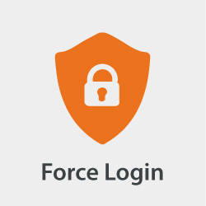

Force Login

for Magento® 2

USER GUIDE

Version 3.0

Table of Contents

Introduction 2

Authors 2

Features 02

Installation 3

Post-Install 3

System Upgrade 3

Clear Cache 3

How to use 4

Whitelisting 4

How to configure 5

Administration 5

Navigation 5

Overview Grid 6

Detail Form 7

Strategies 7

Static 7

RegEx-All 7

Contribution 7

License 7

# Introduction

The Force Login module for Magento® 2 allows you to restrict which pages a not logged in user is able to see. Not logged in visitors get redirected to the login page. This module is especially useful for merchants serving only a specific group of users, e.g. enterprise related business partners and need to ensure that only those users are able to browse the website or the product catalog.

# Authors

The authors of the Force Login module for Magento® 2 is the bitExpert AG[1] and is maintained by Stephan Hochdörfer (S.Hochdoerfer@bitExpert.de) and Florian Horn (F.Horn@bitExpert.de).

# Features

* Force your guest visitors to log in first (or register), before allowing them to visit your pages and catalog
* Administration: Manage the whitelist rules by the GUI in the administration area
* ACL: Restrict the administration of whitelist rules to certain backend user groups
* Whitelisting: Define url rules as pattern to define which pages guest visitors can visit without logging in first
* Multistore-Support: Define if whitelist rules either apply globally or for specific stores

# Installation

The preferred way of installing the Force Login module for Magento® 2 is through Composer[2]. Simply add `bitexpert/magento2-force-customer-login` as a dependency:

composer.phar require bitexpert/magento2-force-customer-login

Optional you can download the latest version [here](https://github.com/bitExpert/magento2-force-login/releases) and install the decompressed code in your projects directory under *app/code/bitExpert/ForceCustomerLogin*.

## Post-Install

After the installment of the module source code, the module has to be enabled by the Magento® 2 CLI.

bin/magento module:enable bitExpert_ForceCustomerLogin

## System Upgrade

After enabling the module, the Magento® *2* system must be upgraded.

If the system mode is set to *production*, run the *compile* command first. This is not necessary for the *developer* mode.

bin/magento setup:di:compile

To upgrade the system, the *upgrade* command must be run.

bin/magento setup:upgrade

## Clear Cache

At last, the Magento® 2 should be cleared by running the *flush* command.

bin/magento cache:flush

Sometimes, other cache systems or services must be restarted first, e.g. Apache Webserver and PHP FPM.

# How to use

The usage of the Force Login module for Magento® 2 is applied implicitly by redirecting visitors if the called URI does not match any configured whitelisted url rules.

## Whitelisting

Whitelisting is based upon the usage of rules. The strategy selection defines how the rules are interpreted, more details are listed in the *Strategies* section.

By default, some static rules are already listed. The following example shows, how to add a whitelist entry for the homepage (startpage).

1. Navigate to the **Overview Grid** and use the *Add Entry* button.
2. Enter **Homepage** into the text field beside from the **Label** label.
3. Enter **/?$** into the text field beside from the **Url Rule** label.
4. Select **All Stores** from the selection field beside from the **Store** label.
5. Use the **Save** button in the upper menu. After being redirected to the **Overview Grid**, the new entry should appear to the list and the systems homepage should be available for guest visitors.

# How to configure

## Administration

The Force Login module for Magento® 2 allows you to enable or disable the module itself on the level of websites, stores and store views.

If the module is *disabled*, the whitelist ruling and the redirection are not applied. If the module is *enabled* based upon the configuration, the whitelist rules are process, which themselves are also configurable for all enabled stores or just specific ones.

After installing and enabling Force Login module for Magento® 2 with the CLI, you must be able to navigate to “*Stores > Configuration > Force Login*”, where you are able to configure the availability of the module for each website, store and store view.

In the administration configuration, you are also able to configure the URL the redirecting is targeting to if not whitelist rule is matching.

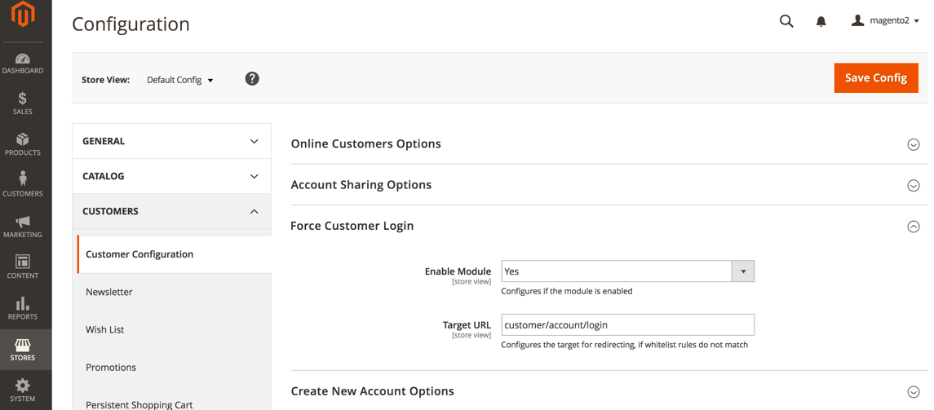

## Navigation

As shown in figure 1, navigate through the Magento® 2 backend menu by clicking onto the item **Customers**. You must see a new menu entry **Forced Login Whitelist**.

Enter this menu entry.

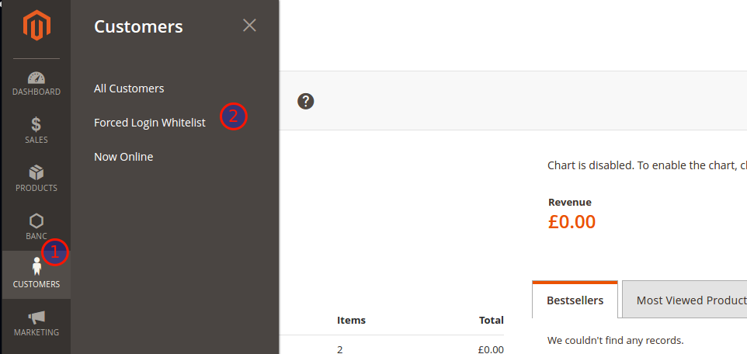  
Figure 1: Force Login Configuration Menu Item

## Overview Grid

A shown in figure 2, you can add new entries by clicking on the *Add Entry* button in the upper right corner (**1**).

The grid (**2**) contains all existing whitelisted *Url Rules*, for which the forced redirect to the *Customer Login Page* is omitted.

The *Url Rules* (**3**) are part of a regular expression checking on the called *Url* and tries to match against the whitelist.

*Url Rules* may be related to all stores or to a specific one (**4**). All rules except some mandatory ones are editable (**5**) and removeable (**6**).

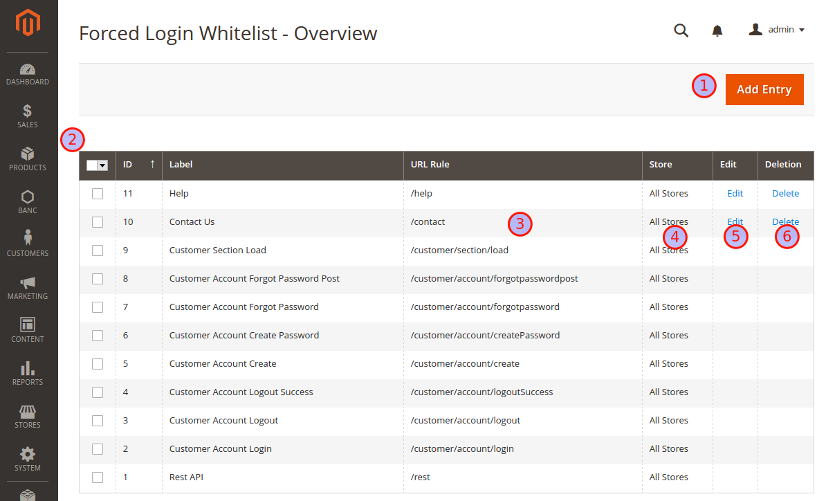  
Figure 2: Force Login Overview of whitelist Url Rules

## Detail Form

As shown in figure 3, you can return to the *Overview Grid* by using the *Back* button (**1**). The *Label* value has only declarative character and is for information purpose only (**2**). The *Url Rule* is part of a regular expression checking on the called

*Url* and tries to match against the whitelist (**3**). *Url Rules* may be related to all stores or to a specific one (**4**).

The strategy selection (**5**) defines how the *Url Rule* is interpreted, more details are listed in the *Strategies* section.

Persist the rule by using the *Save* button (**6**).

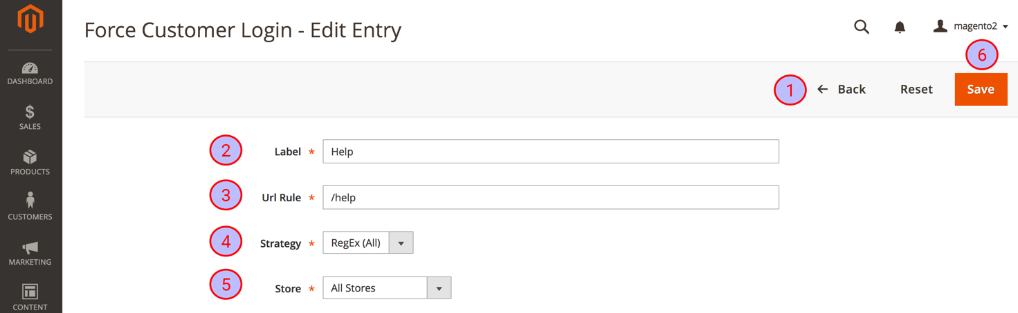

# Strategies

## Static

Rule is used as a literal value and will be added onto the base url for matching. This is default behaviour.

## RegEx-All

1. Rule is based on regular expression[3], and will be used for looking up matching anywhere in the current Url.

# Contribution

Feel free to contribute to this module by reporting issues or create some pull requests for improvements on the Github page of the Force Login module for Magento® 2[4].

# License

The Force Login module for Magento® 2 is released under the Apache 2.0 license[5].

1. http://www.bitExpert.de
2. https://getcomposer.org/
3. https://en.wikipedia.org/wiki/Regular_expression
4. https://github.com/bitExpert/magento2-force-login
5. https://github.com/bitExpert/magento2-force-login/blob/master/LICENSE