**Final Project Report**

**A Comprehensive**

**Exploration of Information**

**And**

**Communication**

**Technologies (ICT) and**

**Associated Technologies**

**Names:**

* **AGUINI Rassim**
* **BALAMANE Mohamed Hani**
* **CHEBAH Youcef**
* **HOUALI Lydia**
* **MANSEUR Zakaria**

**Content Page**

* **Introduction**
* **1. Overview of Information and Communication**

**Technologies**

* 1.1 Evolution and Significance
* 1.2 Key Components of ICT
* 1.3 Impact on Societal and Economic Structures
* **2. Google Services**
* 2.1 Google Search
* 2.2 Google Workspace
* 2.3 Google Cloud Platform
* **3. Microsoft Technologies**
* 3.1 Microsoft 365
* 3.2 Azure Cloud
* 3.3 Windows 11
* **4. Development Tools**
* 4.1 Git
* 4.2 GitHub
* **5. Emerging Trends and Challenges**
* 5.1 Artificial Intelligence
* 5.2 Cybersecurity
* **6. Future Outlook**
* 6.1 Integration of Technologies
* 6.2 Societal Implications
* **7.Case Studies and Industry Examples**
* 7.1 ICT Transformations in Specific Industries
* 7.2 Success Stories and Innovations
* **8. Stakeholder Perspectives**
* 8.1 Industry Experts' Views
* 8.2 End-User Experiences
* **Conclusion**

**Introduction:**

In our modern world, technology plays a crucial role in our daily lives. This report delves into Information and Communication Technologies (ICT) and related tools, including popular services such as Google, Microsoft tools, and essential platforms like Git and GitHub.

**1. Overview of Information and Communication Technologies (ICT):**

**1.1 Evolution and Significance:**

An exploration of the historical evolution of ICT involves not only tracing technological milestones but also understanding the cultural, economic, and geopolitical contexts that have shaped its trajectory. This section will delve into specific epochs, examining the interplay of innovation, societal needs, and global events that propelled ICT forward.

**1.2 Key Components of ICT:**

Moving beyond a categorization of components, a detailed analysis of each element in ICT is warranted. This includes an examination of the evolution of hardware architectures, software paradigms, network infrastructures, and the dynamic landscape of services that collectively form the intricate mosaic of contemporary ICT.

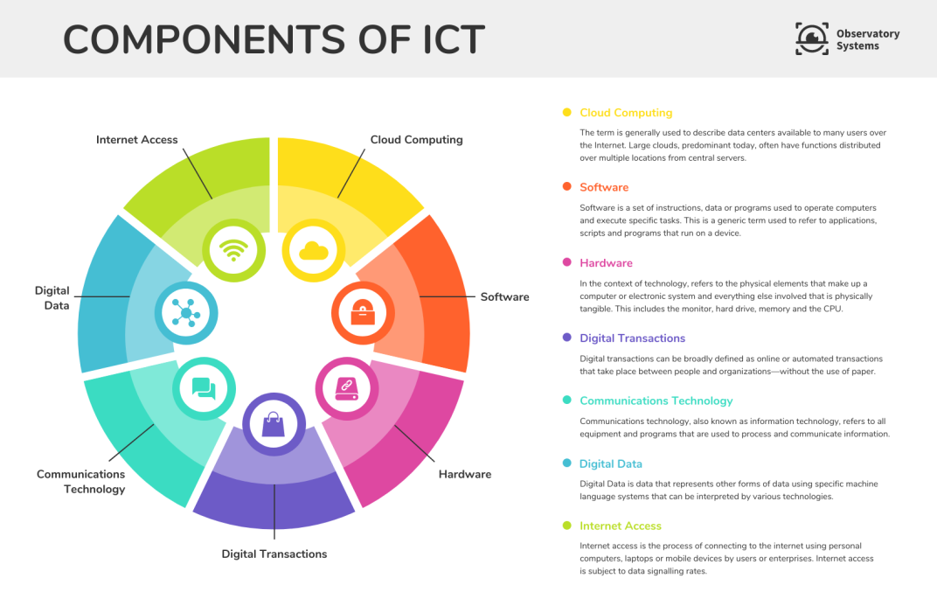

**1.3 Impact on Societal and Economic Structures:**

The transformative influence of ICT extends beyond technological advancements. This subsection will explore how ICT has become a catalyst for societal and economic changes. Real-world case studies will be dissected to reveal the intricate ways in which ICT has shaped cultures, economies, and global interconnectedness.

**2. Google Services:**

**2.1 Google Search:**

Beyond the surface, this section will delve into the inner workings of Google Search. An exploration of search algorithms, personalized search experiences, and the evolving nature of information retrieval will provide a nuanced understanding of how Google Search has become an indispensable knowledge gateway.

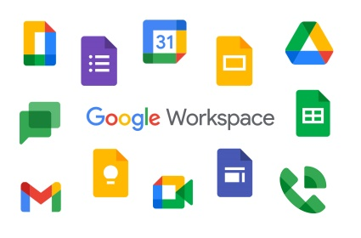**2.2 Google Workspace:**

The collaborative power of Google Workspace goes beyond mere convenience. Real-world examples will be scrutinized to showcase how organizations integrate Gmail, Google Docs, Sheets, and Drive to foster a culture of collaboration, innovation, and adaptability. Insights into collaborative workflows and transformative impacts on productivity will be explored.

**2.3 Google Cloud Platform (GCP):**

Google Cloud Platform is not just a cloud service; it is an ecosystem of innovation. This section will provide an extensive exploration of GCP, delving into industry-specific use cases, success stories, and the transformative potential of cloud-native technologies, artificial intelligence, and data analytics.

**3. Microsoft Technologies:**

**3.1 Microsoft 365:**

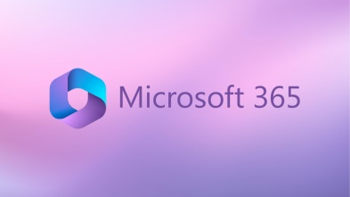Microsoft 365 is not merely an office suite; it is a dynamic platform shaping the future of work. This section will elevate the discourse by exploring industry-specific applications, integration strategies, and success stories that highlight the adaptability and transformative power of Microsoft 365 in diverse professional environments.

|  |  |  |
| --- | --- | --- |
| Function | Google Apps service | Office 365 service |
| Word processing | **Docs** | **Word** |
| Spreadsheets | **Sheets** | **Exel** |
| Presentations | **Slides** | **Powepoint** |
| Email | **Gmail** | **Outlook** |
| Calendar | **Calendar** | **Outlook** |
| Storage | **Drive** | **Onedrive** |
| Group Collaboration Websites | **Sites** | **SharePoint** |
| Contacts | **Contacts** | **Outlook** |
| Instant messaging | **Chat** | **Lync** |
| Conferencing | **Hangouts** | **Skype\Lync** |
| Note taking | **Keep** | **OneNote** |

**3.2 Azure Cloud:**

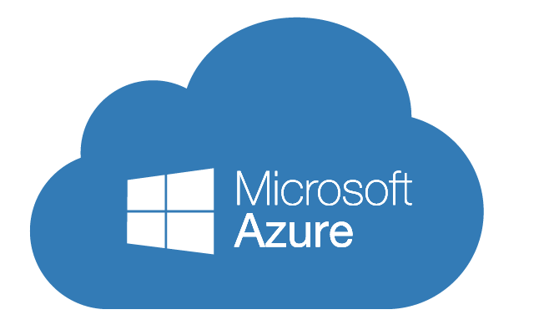Azure Cloud is not just a cloud service; it is an enabler of digital transformation. Detailed analyses will unravel specific industry applications, showcasing how Azure facilitates not just cloud migration but a holistic metamorphosis of business operations, emphasizing scalability, security, and innovation.

**3.3 Windows 11:**

Windows 11 represents more than a mere operating system upgrade. This section will provide a nuanced examination of Windows 11, delving into its impact on user experience, its role in the broader Microsoft ecosystem, and how it aligns with evolving user expectations in an era of heightened digital experiences.

**4. Development Tools: Git and GitHub**

**4.1 Git:**

This section will go beyond the basics, immersing itself in advanced Git features, distributed version control strategies, and real-world scenarios where Git becomes not just a tool but a strategic enabler of collaborative and efficient software development workflows.

**4.2 GitHub:**

GitHub's role extends beyond being a repository; it is a collaborative platform that shapes the landscape of open-source development. This section will explore advanced project management features, security protocols, and collaboration tools, showcasing how GitHub has become a nucleus for global software innovation and collaboration.

|  |  |
| --- | --- |
| GIT VS GITHUB | |
| GIT GITHUB | |
| Installed locally | **Hosted in the cloud** |
| First released in 2005 | **Company launched in 2008** |
| Maintained by the Linux Foundation | **Purchased in 2018 by Microsoft** |
| Focused on version control and code sharing | **Focused on centralized source code hosting** |
| Primarily a command-line tool | **Administered through the web** |
| Provides a desktop interface named Git Gui | **Desktop interface named Github Desktop** |
| No user management features | **Built-in user management** |
| Minimal exteral tool configuration features | **Active marketplace for tool integration** |
| Competes with Mercurial,Subversion,IBM,Rational Team Concert and ClearCase | **Competes with Atlassian Bitbucket and GitLab** |
| Open source licensed | **Includes a free tier and pay-for-use tiers** |

**5. Emerging Trends and Challenges:**

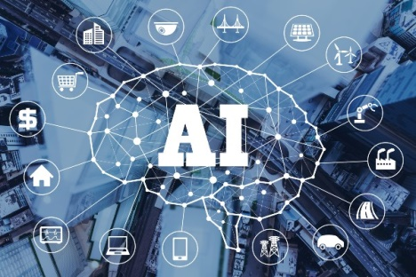**5.1 Artificial Intelligence (AI):**

This segment will offer a granular exploration of AI's role in shaping the future of ICT. In-depth discussions on natural language processing, computer vision, and machine learning applications will be augmented by case studies and real-world examples, illustrating how AI is reshaping industries and societies.

**5.2 Cybersecurity:**

This section will delve deeper into the dynamic landscape of cybersecurity. Beyond just identifying threats, it will explore evolving preventive measures, the role of ICT in fortifying digital ecosystems, and real-world case studies illustrating instances where robust cybersecurity measures thwarted potential threats. 

**6. Future Outlook:**

**6.1 Integration of Technologies:**

Anticipating the future involves more than speculation; it requires an analysis of trends, challenges, and potential breakthroughs. This section will extrapolate potential scenarios of the seamless integration of AI, edge computing, and 5G technologies, considering the societal implications, challenges, and opportunities that arise.

**6.2 Societal Implications:**

As technologies advance, the societal implications become more pronounced. This subsection will delve deeper into the ethical considerations surrounding AI, data privacy, and the responsible deployment of emerging technologies. Perspectives from thought leaders and experts will be incorporated to present a comprehensive view.

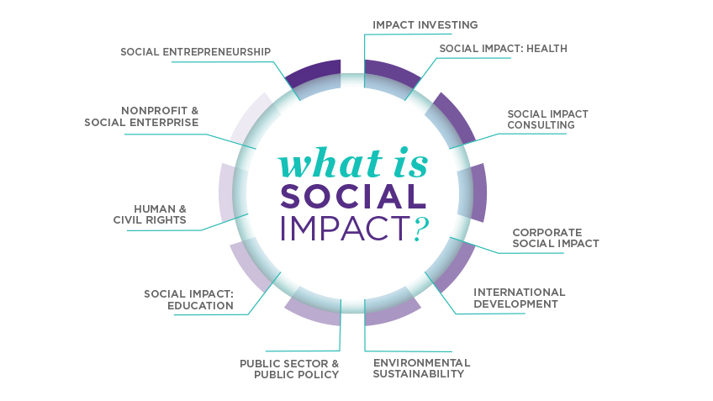

**7.Case Studies and Industry Examples:**

**7.1 ICT Transformations in Specific Industries:**

This section will provide a rich tapestry of case studies, meticulously examining how ICT has catalyzed transformative change in specific industries. The analyses will go beyond surface-level observations, exploring the challenges faced, strategies implemented, and outcomes achieved in diverse sectors, including healthcare, finance, and manufacturing.

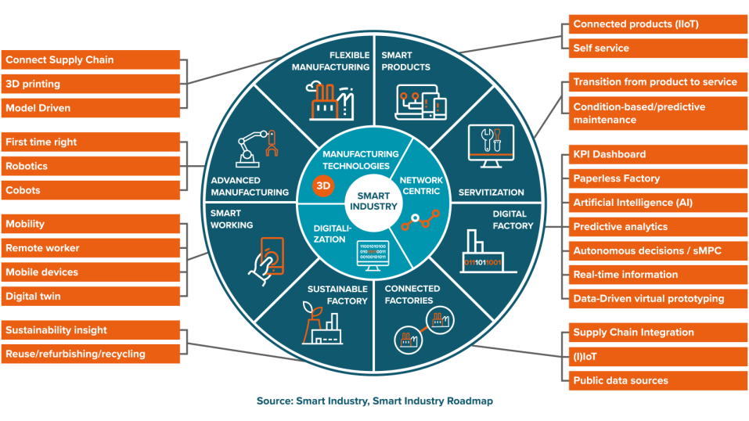

**7.2 Success Stories and Innovations:**

Success stories and innovative use cases will be showcased, offering a mosaic of narratives where organizations leveraged ICT for significant positive impact. Interviews with industry leaders and innovators will provide insights into the strategies that drive successful ICT implementations, fostering inspiration for future endeavors.

**8. Stakeholder Perspectives:**

**8.1 Industry Experts' Views:**

Elevating the discourse, this section will amplify the voices of industry experts through extensive interviews. Their perspectives will provide valuable insights into the current state and future trends of ICT, offering a nuanced understanding of challenges, opportunities, and potential trajectories in the dynamic technological landscape.

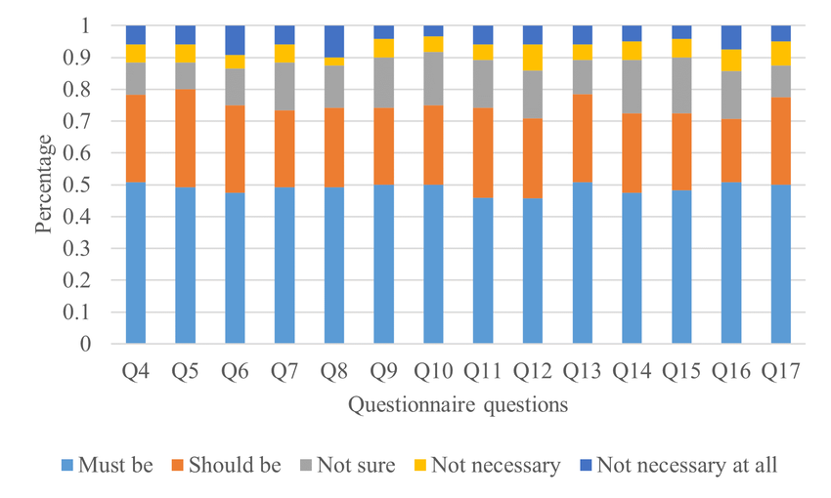

**8.2 End-User Experiences:**

Grounding the report in user-centricity, this section will gather detailed feedback and experiences from end-users. Through user testimonials, surveys, and usability studies, it will delve into the practical implications, challenges faced, and suggestions for improvement in adopting ICT solutions, ensuring a holistic understanding of the user experience.

**Conclusion:**

In conclusion, Information and Communication Technologies, along with associated tools like Google services, Microsoft tools, Git, and GitHub, have become integral aspects of our daily lives. This report aims to shed light on the significance of these technologies, their impact on society, and the challenges they present. As we continue to embrace and rely on these tools, it is crucial to navigate the digital landscape with awareness and consideration for potential challenges.