Dear the Editor and Reviewer,

Today (October 27), when we uploaded the modification reply of“EpiMOGA: an epistasis detection method based on a multi-objective genetic algorithm”, we found that one of the reviewers withdrew from the peer-review of this manuscript and the discussions for this review are closed. Now we cannot submit a reply.

We received an email on October 20 informing us of the modification. According to the time requirement, we think the deadline is October 27. As there are many contents to be supplemented, we completed the revision on October 26. However, due to a network problem on the 26th, several attempts failed to open the web page. On the morning of the 27th, we found that the reviewer had withdrawn from the review when we try to open the website through other channels, and could only complete the modification reply to another reviewer.

We are very sorry for this problem.I hope that you can give us another chance to finish this revision.

The picture below is the screenshot of the time when we received the mail. We have attached the reply to the reviewer's comments below, hoping that it will be helpful.

We sincerely hope you and Review 1 can give us another chance.

Thank you very much!



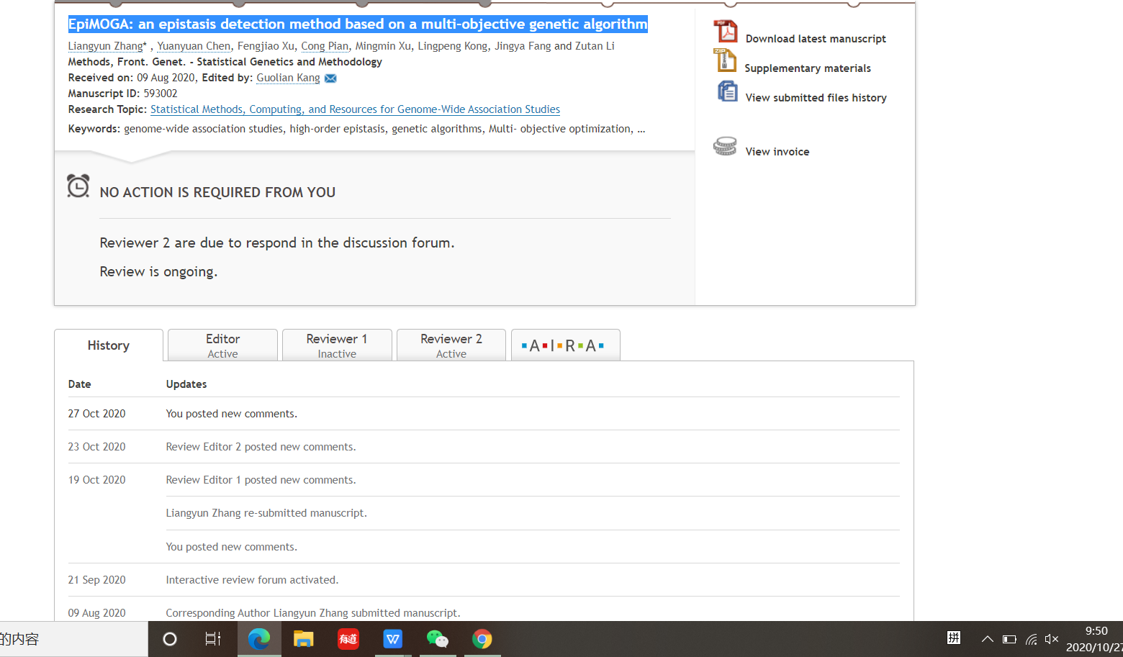

Best regards.

Liangyun Zhang