

XJTLU Entrepreneur College (Taicang)
Module Code and Title | ENT208TC Industry Readiness
School Title | XJTLU Entrepreneur College (Taicang)
Assignment Title | Technical Documentation
Submission Deadline | Friday 15 May, 2026 before 23:59 (Beijing Time, GMT+8)
Session and Group | Session 2 — Group 21
Student IDs | 2362901, 2361528, 2362943, 2360148, 2362636, 2360150, 2361586
Final Word Count | ENT208TC Industry Readiness
If you agree to let the university use your work anonymously for teaching and learning purposes, please type “yes” here. | Yes

I certify that I have read and understood the University’s Policy for dealing with Plagiarism, Collusion, and the Fabrication of Data (available on Learning Mall Online). With reference to this policy, I certify that:
- My work does not contain any instances of plagiarism and/or collusion. My work does not contain any fabricated data.
By uploading my assignment onto Learning Mall Online, I formally declare that all of the above information is true to the best of my knowledge and belief.
Scoring — For Tutor Use
Student ID | D
Stage of Marking | Marker Code | Learning Outcomes Achieved (F/P/M/D) |  |  |  |  | Final Score
 |  | A | B | C | D | E
1st Marker — red pen
Moderation — green pen | IM Initials | The original mark has been accepted by the moderator: Y / N |  |  |  |  | Y / N
2nd Marker if needed



Comprehensive technical reference enabling another developer to understand, maintain, and deploy your product. Includes a strategic IP analysis section. Target length: 6–9 pages (excluding references and cover page). File name: Session[X]Group[Y]_TechnicalDoc.docx
✓ Submission checklist — confirm before uploading
☐ 6–9 pages (excluding references and cover page)
☐ Font: Calibri or Times New Roman, 12pt, 1.5 line spacing, justified
☐ File: Session[X]Group[Y]_TechnicalDoc.docx (.docx or .pdf)
☐ Cover page: group number + all 7 student IDs
☐ Section 1 — system architecture diagram included
☐ Section 2 — technology choices justified with alternatives
☐ Section 3 — deployment guide: someone else can run your project
☐ Section 4 — IP Strategy: novelty, prior art, patent decision
☐ Section 5 — limitations and future work
☐ All references in APA 7th edition (not counted in page limit)

Section 1 — System Architecture

System Architecture Diagram
Reachable is a conversational AI web application built on the Coze platform (by ByteDance), with an external large language model (GLM-5) accessed through the AIPing API gateway. The system follows a four-layer architecture: User Layer, Application Layer, AI Capability Layer, and Data Layer. The architecture diagram below illustrates how all components connect.

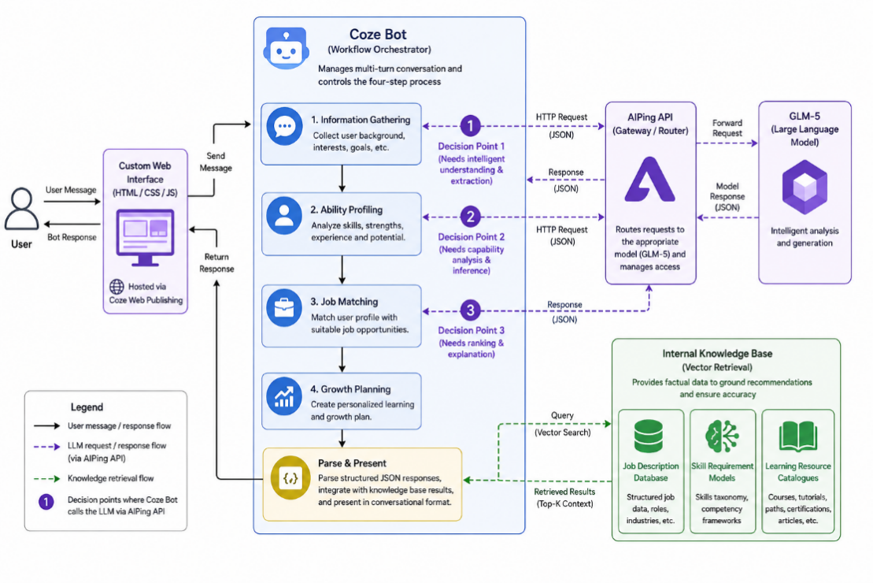
The diagram shows the user interacting with a custom-designed web interface (HTML/CSS/JS) hosted via Coze’s web publishing feature. User messages flow into the Coze Bot, which manages the multi-turn conversation workflow and controls the four-step process: information gathering, ability profiling, job matching, and growth planning. At three critical decision points in the workflow, the Coze Bot sends HTTP requests to the AIPing API, which routes them to the GLM-5 large language model for intelligent analysis. GLM-5 returns structured JSON responses that the Coze Bot parses and presents to the user in a conversational format. The Coze Bot also queries an internal knowledge base (vector retrieval) containing structured job description data, skill requirement models, and learning resource catalogues to ground its recommendations in factual data.

Component Overview
Custom Web Frontend: A purpose-built landing page and chat interface designed with HTML, CSS, and JavaScript, featuring a dark-themed aesthetic with animated elements, quick-action entry cards, and a responsive chat UI. The frontend is served through Coze’s web publishing infrastructure, requiring no separate hosting. It provides the visual identity and user experience layer for the product, including the ability radar chart visualisation and the green-yellow-red job matching tags.
Coze Bot (Conversation Engine): The central orchestrator of the entire application, built using Coze’s bot builder with a carefully engineered system prompt. It manages conversation state across multiple turns, controls the four-step workflow with explicit confirmation checkpoints, and enforces output formatting rules (plain text only, no Markdown). The bot handles routine dialogue autonomously and delegates complex analytical tasks to the external LLM via HTTP plugin calls. It also manages the connection to the knowledge base for data retrieval.
AIPing API Gateway: A third-party API aggregation platform (aiping.cn) that provides unified access to multiple LLM providers. In Reachable, it routes requests to the GLM-5 model by Zhipu AI. AIPing handles authentication, usage monitoring, billing, and provides a dashboard for tracking token consumption and costs. It serves as the bridge between the Coze Bot and the underlying language model.
GLM-5 Language Model: The latest-generation large language model from Zhipu AI, providing the core intelligence for three analytical tasks: generating six-dimension ability profiles from user-provided background information, computing job match rates by comparing user skills against JD requirements, and creating personalised growth plans with specific learning resources and timelines. GLM-5 was selected for its strong Chinese-language comprehension, structured output capabilities, and cost-effectiveness.
Coze Knowledge Base: A vector-retrieval knowledge store within the Coze platform containing structured data files. These include job description collections from major recruitment platforms (covering 8–10 popular career tracks such as product management, data analysis, software development, and marketing), core skill requirement models for each role, and curated free and low-cost learning resource catalogues (from platforms like Coursera, Bilibili, and MOOC.cn). The knowledge base ensures that recommendations are grounded in factual data rather than solely relying on model generation.

Data Flow
A typical user interaction proceeds as follows. The user opens the Reachable web application and is greeted by the landing page. Clicking “Start Ability Assessment” navigates to the chat interface, where the Coze Bot initiates a guided conversation. The bot asks 1–2 questions per turn about the user’s major, skills, project experience, internships, and career interests, collecting information across 3–5 dialogue rounds.
Once sufficient information is gathered, the bot summarises the user’s background in natural language and asks for confirmation. Upon confirmation, it sends the structured user data to GLM-5 via the AIPing API (API Call #1), requesting a six-dimension ability profile. GLM-5 returns a JSON response with scores and commentary for each dimension, which the bot formats and presents conversationally. The user reviews and confirms the profile.
The bot then triggers API Call #2, sending the ability profile along with relevant JD data retrieved from the knowledge base to GLM-5. The model returns nine job recommendations categorised into three tiers: Safe (green, 80%+ match), Stretch (yellow, 50–80%), and Dream (red, <50%), each with matched and missing skills annotated. The user selects a target role, triggering API Call #3, which generates a personalised growth plan including specific skills to learn, projects to build, a phased timeline, and expected improvement in match rate.

Section 2 — Technology Justification
Technology / Tool | What we chose | Alternatives considered | Why we chose this
Application Platform | Coze (ByteDance) | Baidu Qianfan, Dify (open-source), LangChain + custom backend | Coze provides a mature bot builder with built-in conversation state management, HTTP plugin support for external API calls, knowledge base with vector retrieval, and one-click web publishing. Qianfan’s multi-agent architecture added unnecessary complexity for our conversational use case. Dify and LangChain require self-hosted infrastructure exceeding our team capacity.
LLM Model | GLM-5 via AIPing | GPT-4o (OpenAI), ERNIE 4.0 (Baidu), Qwen-Max (Alibaba), DeepSeek-V3 | GLM-5 offers excellent Chinese-language understanding critical for parsing resumes and JDs written in Chinese. AIPing provides a unified API gateway with real-time usage monitoring at very low cost (approximately 0.08–0.12 RMB per complete user session). GPT-4o has higher latency and cost for Chinese text processing. DeepSeek-V3 was considered but AIPing’s monitoring dashboard and token voucher programme made GLM-5 more practical for development.
Frontend | Custom HTML/CSS/JS via Coze web publish | React SPA + Vercel, Vue.js, WeChat Mini Program, native Coze UI | Custom HTML allowed full control over the dark-themed visual identity, animated interactions, and branded chat UI that differentiate Reachable from generic chatbot interfaces. Coze’s native UI is functional but visually generic. A separate React/Vue deployment would require additional hosting infrastructure and CORS configuration for API communication.
Knowledge Base | Coze Knowledge Base (vector retrieval) | Pinecone, ChromaDB, Weaviate, custom PostgreSQL + pgvector | Zero-configuration setup within the Coze ecosystem with automatic vector embedding and semantic search. External vector databases would add infrastructure complexity, API key management, and latency. The built-in solution supports CSV/document upload and can be updated by non-technical team members without code changes.
Prompt Engineering | Structured system prompt with output control rules | Fine-tuned model, RAG pipeline with LangChain, function calling | A carefully designed system prompt with explicit workflow steps, format prohibitions (no Markdown), step-by-step confirmation rules, and response length limits achieved the desired conversational behaviour without model fine-tuning costs or RAG pipeline complexity. This approach allows rapid iteration—prompt changes take effect immediately without redeployment.

Technical Risks and Mitigation
The primary technical risk is model hallucination: GLM-5 may generate plausible but inaccurate job recommendations or salary estimates. We mitigated this by grounding all recommendations in the Coze knowledge base containing curated JD data and skill models. The system prompt explicitly instructs the model to base its analysis on retrieved knowledge base content rather than generating from parametric memory alone.
A second risk is output format instability. Despite explicit prompt instructions prohibiting Markdown formatting, the model occasionally reverts to using headers (#) and bold markers (**). We addressed this through layered prompt engineering: format rules appear in the system prompt’s opening paragraph, are repeated in a dedicated “Format Prohibition” section, and include correct/incorrect output examples. Testing showed this reduced format violations to fewer than 5% of responses.
A third risk is conversation flow collapse, where the model outputs all analytical results in a single response rather than following the designed four-step workflow. We mitigated this with explicit “waiting point” rules in the prompt that require user confirmation before proceeding to the next stage, combined with response length limits that physically prevent the model from generating excessively long single-turn outputs.
Section 3 — Deployment Guide

Environment Requirements
Requirement | Version / Notes
Node.js | v18.x or later (v24.x recommended)
pnpm | v9.x (required; npm and yarn are NOT supported)
Operating System | macOS / Linux / Windows
Zhipu AI API Key | Required — register at https://open.bigmodel.cn/
Internet Access | Required — for AI model calls and RAG search

Setup Steps
Clone the repository:
git clone <repository-url>
cd projects
Install dependencies:
pnpm install
This project enforces pnpm only. Using npm or yarn will cause an error.
Configure environment variables:Copy the example file and fill in your API key:
# macOS / Linux
cp .env.local.example .env.local

# Windows PowerShell
Copy-Item .env.local.example .env.local
Variable | Required | Description
ZHIPU_API_KEY | Yes | Your Zhipu AI API key (get it from https://open.bigmodel.cn/)
ZHIPU_BASE_URL | No | Defaults to https://www.aiping.cn/api/v1
ZHIPU_MODEL | No | Defaults to GLM-5
PORT | No | Defaults to 5000

Run the application:

# macOS / Linux

pnpm dev

# Windows

pnpm dev:win

Verify it is working:

Open your browser and visit http://localhost:5000

You should see the landing page with the "Reachable" branding and gradient glow background

Test the chat API:

curl -s -X POST http://localhost:5000/api/chat \

-H "Content-Type: application/json" \

-d '{"messages":[{"role":"user","content":"hello"}]}'

You should receive a streaming SSE response starting with data: {"content":"..."}

(Optional) Build for production:

# macOS / Linux

pnpm build

pnpm start

# Windows

pnpm build

pnpm start:win

Common Issues and Solutions
Problem | Likely Cause | Solution
MODULE_NOT_FOUND error when running pnpm dev:win | Dependencies not installed | Run pnpm install first, then retry
Chat API returns error or "ZHIPU_API_KEY: Unconfigured" | .env.local file missing or API key not set | 1. Ensure .env.local exists in project root (not .env.local.example). 2. Verify ZHIPU_API_KEY is set with a valid key. 3. Restart the dev server after editing.
pdf-parse throws pdfParser is not a function on Windows | ESM/CommonJS module compatibility issue on some Node.js versions | This is a known limitation. Use the "Describe Resume " shortcut in the chat instead of uploading PDF files.

Section 4 — IP Strategy

Novelty Analysis
Reachable’s core novelty lies in the “Reachability Index” three-colour job matching framework. While existing products such as BOSS Zhipin, Liepin, and LinkedIn offer job recommendation features, they operate on a binary logic of “match or not.” Reachable introduces a graduated assessment that categorises jobs into Safe (80%+), Stretch (50–80%), and Dream (<50%) tiers, explicitly quantifying the gap between a user’s current abilities and each role’s requirements. This reframes the job search decision from “should I apply?” to “how far am I from reaching this?”—a fundamentally different and more actionable paradigm.
A second novelty is the integration of ability profiling, gap analysis, and growth planning into a single conversational interface. No existing consumer product closes the loop from “who am I” to “what can I reach” to “how do I get there” in one continuous dialogue experience.

Prior Art
Existing Product / Patent | What It Does | How Our Solution Differs
BOSS Zhipin AI Matching | Matches job seekers to positions based on resume keywords and employer preferences; provides a binary match recommendation | Reachable provides graduated matching with explicit gap analysis and actionable growth plans, rather than a simple match/no-match output
LinkedIn Career Explorer | Suggests career transitions based on existing skills and industry data; shows transferable skills between roles | Reachable targets the pre-application stage (ability awareness and gap identification) rather than career transitions, and uses a guided conversation rather than a static dashboard
Jobscan (US) | Compares resumes against JDs to provide an ATS compatibility score and keyword optimisation suggestions | Reachable goes beyond resume optimisation to provide holistic ability profiling, job-tier classification, and time-bound growth planning—a full career readiness system rather than a resume-checking tool

Patent Decision
No, we would not seek a patent at this stage. The core innovation is a methodological framework (the three-colour matching model and six-dimension profiling) rather than a technical invention, which is difficult to patent and easy to design around. Patent prosecution in China typically costs 10,000–50,000 RMB and takes 1–3 years, which is disproportionate for a student project at the MVP stage. Additionally, the system is built entirely on third-party platforms (Coze, AIPing) using standard APIs, meaning the technical implementation itself does not contain patentable novelty. The value lies in the product design, user experience, and knowledge base curation, not in a proprietary algorithm.

Alternative Protection
First-mover advantage and brand recognition: By establishing “Reachable” and the “Reachability Index” concept early, we aim to create strong brand association with the graduated job-matching paradigm. Once users build trust and familiarity with the three-colour system, switching costs increase.
Data moat through curated knowledge base: The structured knowledge base (JD skill models, learning resource catalogues, salary data) represents significant manual curation and domain expertise. As we expand this dataset with user feedback and real-world validation, it becomes a competitive moat that new entrants cannot easily replicate without equivalent effort.

Section 5 — Limitations & Future Work

Known Limitations
Limitation | Why It Exists | Impact on Users
Limited job coverage (8–10 career tracks) | Knowledge base was manually curated during a short development cycle; each career track requires structured JD data, skill models, and learning resources | Users in niche fields (e.g., biotech, urban planning) may not find relevant matches. The system currently serves best for tech, business, and design-adjacent roles.
Ability scores are AI-generated estimates, not validated assessments | Scores are produced by GLM-5 based on self-reported information with no external verification or standardised testing | Users may receive inaccurate assessments if they overstate or understate their abilities. The system displays a disclaimer that scores are AI-generated estimates.
Occasional Markdown formatting in responses | Despite extensive prompt engineering, the LLM sometimes reverts to its default Markdown output habits | Users may see #, *, or ** symbols in responses, which disrupts the conversational experience. Current mitigation reduces occurrence to approximately 5% of responses.
Platform dependency on Coze and AIPing | The entire system is hosted on third-party platforms with no self-hosted fallback infrastructure | Service availability depends on Coze and AIPing uptime. Platform policy changes, pricing adjustments, or API deprecation could affect operations.

Future Work
- Expand the knowledge base to cover 20+ career categories including non-tech roles such as finance, law, education, and healthcare, with continuously updated JD and salary data.
- Develop a mock interview simulation feature within the Coze Bot that conducts multi-round behavioural interviews with real-time feedback on answer quality and structure.
- Integrate a validated psychometric assessment (e.g., Holland Code or adapted MBTI) to complement the self-reported ability profile with standardised personality and interest data.
- Address the technical debt of format instability by exploring Coze’s response post-processing capabilities or implementing a client-side Markdown stripper in the custom frontend.
- Investigate the open research question of how to validate AI-generated ability scores against real-world hiring outcomes, potentially through longitudinal tracking of user job search results after using Reachable.

References
ByteDance. (2025). Coze platform documentation. Retrieved from https://www.coze.com/docs

Zhipu AI. (2025). GLM-5 model technical report. Retrieved from https://www.zhipuai.cn/

AIPing. (2026). AIPing API documentation and usage guide. Retrieved from https://aiping.cn/

Holland, J. L. (1997). Making vocational choices: A theory of vocational personalities and work environments (3rd ed.). Psychological Assessment Resources.

Xi, Z., Chen, W., Guo, X., He, W., Ding, Y., Hong, B., ... & Gui, T. (2023). The rise and potential of large language model based agents: A survey. arXiv preprint arXiv:2309.07864.

Wei, J., Wang, X., Schuurmans, D., Bosma, M., Ichter, B., Xia, F., Chi, E., Le, Q., & Zhou, D. (2022). Chain-of-thought prompting elicits reasoning in large language models. Advances in Neural Information Processing Systems, 35, 24824–24837.

