

XJTLU Entrepreneur College (Taicang)
Module Code and Title | ENT208TC Industry Readiness
School Title | XJTLU Entrepreneur College (Taicang)
Assignment Title | Validation Report
Submission Deadline | Friday 15 May, 2026 before 23:59 (Beijing Time, GMT+8)
Session and Group | [Session 2— Group 21]
Student IDs | 2362901, 2361528, 2362943, 2360148, 2362636, 2360150, 2361586
Final Word Count
If you agree to let the university use your work anonymously for teaching and learning purposes, please type “yes” here. | YES

I certify that I have read and understood the University’s Policy for dealing with Plagiarism, Collusion, and the Fabrication of Data (available on Learning Mall Online). With reference to this policy, I certify that:
• My work does not contain any instances of plagiarism and/or collusion. My work does not contain any fabricated data.
By uploading my assignment onto Learning Mall Online, I formally declare that all of the above information is true to the best of my knowledge and belief.
 |  | Scoring — For Tutor Use
Student ID |  | E
Stage of Marking | Marker Code | Learning Outcomes Achieved (F/P/M/D) |  |  |  |  | Final Score
 |  | A | B | C | D | E
1st Marker — red pen
Moderation — green pen | IM Initials | The original mark has been accepted by the moderator: Y / N |  |  |  |  | Y / N
2nd Marker if needed



How to use this template
The sections below are a suggested structure — not a rigid requirement. Your report should tell the story of how you tested your product with real users and what you changed as a result. If your project used a different method or your findings are better organized another way, adapt the structure. What matters is that the marker can clearly see: who you tested with, what you found, and what you changed.
✓ Submission checklist — confirm before uploading
☐ 4–6 pages total (excluding appendix and references)
☐ Font: Calibri or Times New Roman, 12pt, 1.5 line spacing, justified
☐ File: Session[X]Group[Y]_ValidationReport.docx (.docx or .pdf)
☐ Cover page: group number + all 7 student IDs
☐ At least 5 user testing participants documented
☐ Direct quotes or observed behaviours included (not just summaries)
☐ At least one clear iteration shown: finding → change → evidence
☐ Before/after comparison for at least one change
☐ Evidence appendix: links to transcripts, notes, or recordings
☐ All evidence links are functional and accessible
☐ All references in APA 7th edition (not counted in page limit)

Section 1 — Who You Tested With & How
We validated Reachable from Week 3–9 through a 36-response requirement survey, user interviews, prototype testing, and follow-up validation. We tested four assumptions: whether users experienced job-search confusion, whether they understood our concept, whether they could complete the core flow, and whether later iterations improved the experience (Blank & Eckhardt, 2024; Zott & Amit, 2024). The Week 3 survey evidence is listed in Appendix C1. Here is the Validation Timeline:
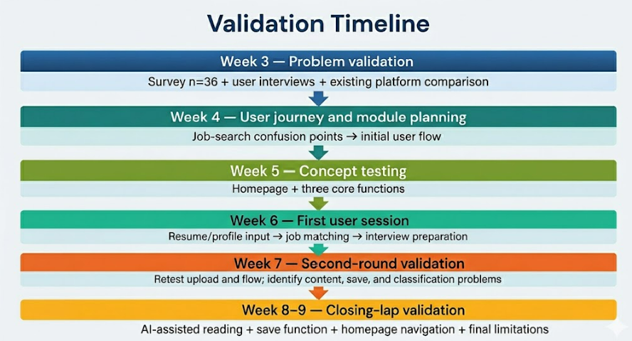

Your participants
Participant | Relevant background | How you recruited them | Session format
Bo.Huang | 2022 CS graduate; applying for internet development roles; submitted 20+ resumes | School employment centre | Online
Jiele.Hu  P2 | 2023 Business graduate; spring recruitment after failed autumn recruitment; strong pain point in low job-search efficiency. | WeChat Moments | Hybrid: Offline in-person & online
Yuxi.Gu  P3 | Operations staff with 2 years’ experience; considering job hopping; needs resume matching, interview sharing, and preparation support. | Workplace communities | Online
Jiahui.Zhang  P4 | 2024 Design graduate; preparing for autumn recruitment; unfamiliar with the job-search process. | School job-search mutual-aid group | Online
Yang.Liu  P5 | Administrative staff with 1 years’ experience; resigned and job searching; needs role-specific interview preparation. | Friend recommendation | Online

What you asked them to do
- Week 3 — Problem validation: Discussed job-search experience, inefficient applications, and problems with BOSS Zhipin, 51Job, and LinkedIn.
- Week 5 — Concept testing: Discussed job-search experience, inefficient applications, and problems with BOSS Zhipin, 51Job, and LinkedIn.
- Week 6 — First user session: Completed the core flow: resume/profile upload → matched jobs → interview preparation.
- Week 7 — Second-round validation: Retested the improved flow and commented on jobs, resources, classification, saving, and matching transparency.
- Week 8–9 — Closing-lap validation: Tested AI-assisted reading, bookmarks, resource classification, and homepage navigation to confirm improvements and limits.

How you captured what happened
We collected transcripts, recordings, observation notes, survey results, and prototype screenshots. During usability tests, we observed first clicks, hesitation, task completion, confusing labels, skipped functions, and direct comments, allowing us to compare what users said with what they did (Köhler et al., 2025).
All records were stored in the team’s shared folder. Interview transcripts are listed in Appendix A1–A5. Session recordings are listed in Appendix B1. Observation notes and task rating sheets are listed in Appendix B2. The Week 3 survey is listed in Appendix C1. Before/after UI screenshots and final prototype screenshots are listed in Appendix C2.

Section 2 — What You Found

We grouped findings by theme, as qualitative usability tests rely on repeated user patterns (Köhler et al., 2025).

Finding 1: Users needed more than job listings.
In Week 3, users wanted help judging job fit and preparing after. P1: “I sent 30 applications, only 3 replies,” unsure if it was his resume or job mismatch. P2: 3–4 hours daily wasted on browsing. Both supported resume matching → interview experience → professional questions. P2: “Job hunting is also knowing if I’m suitable and how to prepare.” Reachable is for job-search preparation, not just job posts.
Evidence: Appendix A1–A2, B2

Finding 2: Homepage confusion.
In Week 5, users thought it was a typical job site. P3: “It looks like a normal recruitment website.” P4: “A new platform for job searching.” P3 and P4 missed the core functions. They needed clearer positioning and a distinct flow.
Evidence: Appendix A3–A4, B2

Finding 3: Unclear steps in the prototype.
In Week 6, users struggled with the upload. P1: “I clicked the upload area several times but nothing happened.” P5: “The button is too small.” Even after matching jobs, they didn’t know what to do next. P1: “I don’t know whether to apply or continue preparing.” The flow needed clearer guidance.
Evidence: Appendix A1, A5, B1, B2

Finding 4: Remaining issues: classification, saving, and content.
In Week 7, users noted improvements. P2: “The upload button is now bigger.” P3: “The upload step is straightforward.” But P2: “All jobs and materials are mixed,” and no save function. P3: “Every time I return, I search from scratch.” By Week 8–9, P2 could bookmark: “I don’t need to search repeatedly.” P3 found AI reading improved efficiency. Still, job quantity, resources, and classification needed expansion.
Evidence: Appendix A2–A3, B1, B2, C2

Section 3 — What You Changed
We iterated based on user findings (Blank & Eckhardt, 2024; Zott & Amit, 2024):
What finding triggered this change | What you changed (before → after) | Evidence that the change helped
Users misunderstood the product as a normal recruitment website. | Before: the homepage and navigation made users focus mainly on job browsing.  After: we made the product direction clearer by strengthening the flow from job matching to learning resources, interview preparation, and forum support. | In Week 5, P3 and P4 both misunderstood the product at first, but agreed that resume matching, interview experience, and professional question preparation matched their needs after explanation.
Users got stuck at resume/profile upload and did not know what to do next. | Before: the upload entry was unclear and there was no obvious drag-and-drop prompt.  After: we improved upload guidance and made the next-step flow clearer from matching to preparation. | In Week 6, P1 said he clicked the upload area several times but did not know how to proceed. In Week 7, P2 said the upload button was “bigger and eye-catching,” and P3 said the upload step was “simple and straightforward.”
Users could not easily find, save, or return to useful jobs and learning resources. | Before: there was no clear bookmark/save function for useful content.  After: we added bookmark functions for job positions and learning resources. | In Week 7, P2 said there was “no favourite or save collection function at all.” In Week 8–9, P2 said she could now bookmark useful jobs and interview resources and did not need to search repeatedly. P3 also said she could smoothly save favourite positions and valuable resources.
Users found long job descriptions and learning materials time-consuming to read. | Before: users had to read and filter long content manually.  After: we added AI-assisted reading and content sorting in the latest version. | In Week 8–9, P2 said the AI reading helper could quickly sort key information and save reading time. P3 said it summarized long job requirements and learning notes, which improved preparation efficiency.

Most significant change — improving content access and return visits
The most significant change was improving how users find, save, and return to useful content. In Week 7, both P2 and P3 said that jobs and learning resources were hard to locate because content was not clearly classified. P2 said that jobs and study materials were “mixed together,” and P3 said she had to start searching from the beginning every time she returned.
In response, we made three connected changes. First, we added category buttons to learning resources, such as books, online courses, and practice materials. Second, we simplified the job positions and learning resources pages so users could locate useful content more quickly. Third, we added bookmark functions and improved the user homepage navigation, so users could directly return to saved jobs, learning resources, liked content, posts, and comments.
This created a clear iteration cycle (according to the picture):
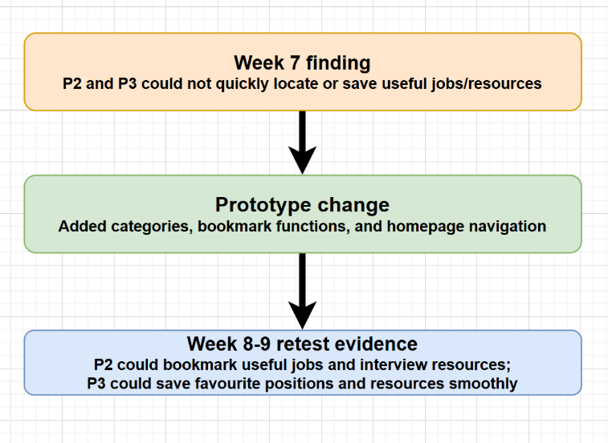
Three connected changes (UI Before & After):
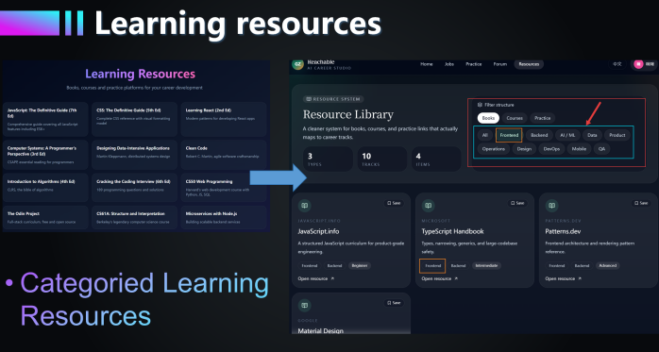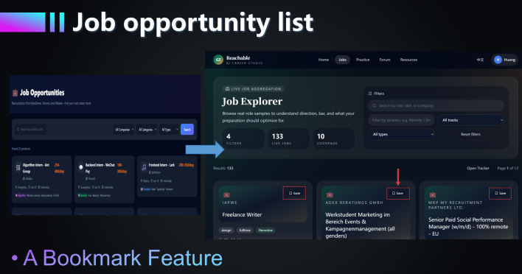
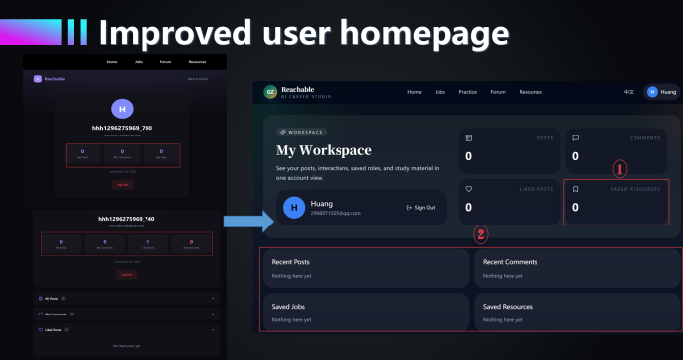
[The more detailed before/after screenshots for improvement are included in Appendix C2.]

What you chose not to change — and why
- Enterprise internal referral docking: P2 and P3 wanted more job opportunities, but we did not build internal referral docking because it depends on external company partnerships beyond our control. Instead, we focused on validated prototype functions: job browsing, categorized resources, bookmarks, homepage navigation, and AI-assisted preparation.
- Full content database：P2 and P3 also wanted more jobs, richer resources, and clearer classification. We improved basic categories, job/resource pages, and bookmark access, but a full database across all majors, industries, and job types requires continuous content collection and maintenance, so we recorded it as future work.

Section 4 — Limitations
  - Limited sample: Our Week 3–9 validation included only five unique participants, mainly students, fresh graduates, and early-career job seekers. Future testing should include more users from different majors, industries, and career stages.
  - Guided testing: Most sessions were guided interviews or prototype tests, which helped us observe clicks, hesitation, and task completion, but may not reflect natural job-search behaviour. Future validation should include independent use without interviewer guidance.
  - Prototype evidence：The evidence shows clear iteration from homepage, upload, classification, saving, and content-access problems to improved bookmarks, resource categorisation, homepage navigation, and AI-assisted reading. However, some features remained prototype-level, and some final pages were supported only by prototype screenshots.
  - AI and content limits：The AI matching and preparation functions were tested as workflow concepts, not as a validated career recommendation system. A larger job database, richer learning resources, and longer-term testing are needed to prove final product performance.

Section 5 — Evidence Appendix
Reference | What it contains | Link
A1 | P1 Bo Huang. [Includes Week 3 problem validation and Week 6 first user session evidence.] | Week 3 transcript: https://xjtlums-my.sharepoint.com/:w:/g/personal/yunchao_he23_student_xjtlu_edu_cn/IQDUxmOz-10ISpLC2UvTeeD_AYyZGNKW-Dog_hInLHBAIQE?e=XaZpaf  Week 6 transcript: https://xjtlums-my.sharepoint.com/:w:/g/personal/yunchao_he23_student_xjtlu_edu_cn/IQAclRdcyetvSLOl1WPPzxPTAWcASTUoq3kUvwbD0YW-6hU?e=HKlAIP
A2 | P2 Jiele Hu. [ Includes Week 3 problem validation, Week 7 second-round validation, and Week 8–9 closing-lap validation.] | Week 3 transcript: https://xjtlums-my.sharepoint.com/:w:/g/personal/yunchao_he23_student_xjtlu_edu_cn/IQDUxmOz-10ISpLC2UvTeeD_AYyZGNKW-Dog_hInLHBAIQE?e=XaZpaf  Week 7 transcript: https://xjtlums-my.sharepoint.com/:w:/g/personal/yunchao_he23_student_xjtlu_edu_cn/IQBRFpX6f-7IR478n44Mu0FnAdFQ7JmPznS_fKOUrCBdEjM?e=u34EFv  Week 8 transcript: https://xjtlums-my.sharepoint.com/:w:/g/personal/yunchao_he23_student_xjtlu_edu_cn/IQCDOVCm1KL_S4QwaKTIsBnRAewbOIQXlF64yduI7Xg7xWY?e=ijZCkc
A3 | P3 Yuxi Gu. [Includes Week 5 concept testing, Week 7 second-round validation, and Week 8–9 closing-lap validation.] | Week 5 transcript: https://xjtlums-my.sharepoint.com/:w:/g/personal/yunchao_he23_student_xjtlu_edu_cn/IQC3sBcj4xGUSYoJnWjm1autAQPsPRADoNGZCa1IlVPzyoI?e=3mQrDb  Week 7 transcript: https://xjtlums-my.sharepoint.com/:w:/g/personal/yunchao_he23_student_xjtlu_edu_cn/IQBRFpX6f-7IR478n44Mu0FnAdFQ7JmPznS_fKOUrCBdEjM?e=u34EFv  Week 8 transcript: https://xjtlums-my.sharepoint.com/:w:/g/personal/yunchao_he23_student_xjtlu_edu_cn/IQCDOVCm1KL_S4QwaKTIsBnRAewbOIQXlF64yduI7Xg7xWY?e=ijZCkc
A4 | P4 Jiahui Zhang. [Includes Week 5 concept testing evidence.] | Week 5 transcript: https://xjtlums-my.sharepoint.com/:w:/g/personal/yunchao_he23_student_xjtlu_edu_cn/IQC3sBcj4xGUSYoJnWjm1autAQPsPRADoNGZCa1IlVPzyoI?e=3mQrDb
A5 | P5 Yang Liu. [Includes Week 6 first user session evidence.] | Week 6 transcript: https://xjtlums-my.sharepoint.com/:w:/g/personal/yunchao_he23_student_xjtlu_edu_cn/IQAclRdcyetvSLOl1WPPzxPTAWcASTUoq3kUvwbD0YW-6hU?e=HKlAIP
B1 | Session recording or screen capture [P1-P5] | P1 Bo Huang recording 1:https://xjtlums-my.sharepoint.com/:v:/g/personal/yunchao_he23_student_xjtlu_edu_cn/IQBjFmx_PDS2Togw9c6CQ98MAWSg_T_Jej654zo7vW42Tas?nav=eyJyZWZlcnJhbEluZm8iOnsicmVmZXJyYWxBcHAiOiJPbmVEcml2ZUZvckJ1c2luZXNzIiwicmVmZXJyYWxBcHBQbGF0Zm9ybSI6IldlYiIsInJlZmVycmFsT  P1 Bo Huang recording 2: https://xjtlums-my.sharepoint.com/:v:/g/personal/yunchao_he23_student_xjtlu_edu_cn/IQAM-VPevsfvRIQ_eLio3H9tAapFWU5KR2U2NvZ3aMuA3Rg?nav=eyJyZWZlcnJhbEluZm8iOnsicmVmZXJyYWxBcHAiOiJPbmVEcml2ZUZvckJ1c2luZXNzIiwicmVmZXJyYWxBcHBQbGF0Zm9ybSI6IldlYiIsInJlZmVycmFsT  P2 Jiele Hu recording 1: https://xjtlums-my.sharepoint.com/personal/yunchao_he23_student_xjtlu_edu_cn/_layouts/15/stream.aspx?id=%2Fpersonal%2Fyunchao%5Fhe23%5Fstudent%5Fxjtlu%5Fedu%5Fcn%2FDocuments%2FENT208%2Fweek3%2FJiele%20Hu%20recording%201%2Emp4&nav=eyJyZWZlcnJhbEluZm8iOnsicm  P2 Jiele Hu recording 2: https://xjtlums-my.sharepoint.com/personal/yunchao_he23_student_xjtlu_edu_cn/_layouts/15/stream.aspx?id=%2Fpersonal%2Fyunchao%5Fhe23%5Fstudent%5Fxjtlu%5Fedu%5Fcn%2FDocuments%2FENT208%2Fweek7%2FJiele%20Hu%20recording%202%2Emp4&nav=eyJyZWZlcnJhbEluZm8iOnsicm  P2 Jiele Hu recording 3: https://xjtlums-my.sharepoint.com/personal/yunchao_he23_student_xjtlu_edu_cn/_layouts/15/stream.aspx?id=%2Fpersonal%2Fyunchao%5Fhe23%5Fstudent%5Fxjtlu%5Fedu%5Fcn%2FDocuments%2FENT208%2Fweek8%2D9%2FJiele%20Hu%20recording%203%2Emp4&nav=eyJyZWZlcnJhbEluZm8iOn  P3 Yuxi Gu audio 1: https://xjtlums-my.sharepoint.com/personal/yunchao_he23_student_xjtlu_edu_cn/_layouts/15/stream.aspx?id=%2Fpersonal%2Fyunchao%5Fhe23%5Fstudent%5Fxjtlu%5Fedu%5Fcn%2FDocuments%2FENT208%2Fweek5%2FYuxi%20Gu%20audio%201%2Em4a&nav=eyJyZWZlcnJhbEluZm8iOnsicmVmZXJ  P3 Yuxi Gu audio 2: https://xjtlums-my.sharepoint.com/personal/yunchao_he23_student_xjtlu_edu_cn/_layouts/15/stream.aspx?id=%2Fpersonal%2Fyunchao%5Fhe23%5Fstudent%5Fxjtlu%5Fedu%5Fcn%2FDocuments%2FENT208%2Fweek7%2FYuxi%20Gu%20audio%202%2Em4a&nav=eyJyZWZlcnJhbEluZm8iOnsicmVmZXJ  P3 Yuxi Gu audio 3: https://xjtlums-my.sharepoint.com/personal/yunchao_he23_student_xjtlu_edu_cn/_layouts/15/stream.aspx?id=%2Fpersonal%2Fyunchao%5Fhe23%5Fstudent%5Fxjtlu%5Fedu%5Fcn%2FDocuments%2FENT208%2Fweek8%2D9%2FYuxi%20Gu%20audio%203%2Em4a&nav=eyJyZWZlcnJhbEluZm8iOnsicmV  P4 Jiahui Zhang recording: https://xjtlums-my.sharepoint.com/personal/yunchao_he23_student_xjtlu_edu_cn/_layouts/15/stream.aspx?id=%2Fpersonal%2Fyunchao%5Fhe23%5Fstudent%5Fxjtlu%5Fedu%5Fcn%2FDocuments%2FENT208%2Fweek5%2FJiahui%20Zhang%20recording%2Emp4&nav=eyJyZWZlcnJhbEluZm8iOnsic  P5 Yang Liu recording: https://xjtlums-my.sharepoint.com/personal/yunchao_he23_student_xjtlu_edu_cn/_layouts/15/stream.aspx?id=%2Fpersonal%2Fyunchao%5Fhe23%5Fstudent%5Fxjtlu%5Fedu%5Fcn%2FDocuments%2FENT208%2Fweek6%2FYang%20Liu%20recording%2Emp4&nav=eyJyZWZlcnJhbEluZm8iOnsicmVmZX
B2 | Observation notes or rating sheets | https://xjtlums-my.sharepoint.com/:w:/g/personal/yunchao_he23_student_xjtlu_edu_cn/IQDGCyvDtwVdSJFyx2T6bhnpAaUnAdSJ6vRggOCg9FW3Fqs?e=o74j5G
C1 | prophase investigation | Survey: https://v.wjx.cn/vm/YDfkEbz.aspx#  Collected Data:  https://pubref.paperol.cn/clientdown/362495817/362495817_1778512735zrdyAH.pdf
C2 | Before/after screenshots | https://xjtlums-my.sharepoint.com/:w:/g/personal/yunchao_he23_student_xjtlu_edu_cn/IQBchAcC1rBXQ6cShWp45Ya0AVCutLtAb0cyHu0NcVe9jeo?e=Q8asWk

References
Blank, S., & Eckhardt, J. T. (2024). The lean startup as an actionable theory of entrepreneurship. Journal of Management, 50(8), 3012–3034. doi: https://journals.sagepub.com/doi/10.1177/01492063231168095
Guesmi, M., Chatti, M. A., Joarder, S., Ain, Q. U., Siepmann, C., Ghanbarzadeh, H., & Alatrash, R. (2023). Justification vs. transparency: Why and how visual explanations in a scientific literature recommender system. Information, 14(7), Article 401. doi: https://doi.org/10.3390/info14070401
Köhler, S. M., Holtz, S., Neff, M. C., Schaaf, J., von Wagner, M., Müller, B. S., & Schütze, D. (2025). Evaluating the prototype of a clinical decision support system in primary care: Qualitative study. JMIR Formative Research, 9, Article e69875. doi: https://pubmed.ncbi.nlm.nih.gov/40835411/
Krajcovic, M., Demcak, P., & Kuric, E. (2025). Is usability testing valid with prototypes where clickable hotspots are highlighted upon misclick? Journal of Systems and Software, 226, Article 112446. doi: https://doi.org/10.1016/j.jss.2025.112446
Liao, M., Sundar, S. S., & Walther, J. B. (2022). User trust in recommendation systems: A comparison of content-based, collaborative and demographic filtering. In CHI Conference on Human Factors in Computing Systems Extended Abstracts. Association for Computing Machinery. doi: https://dl.acm.org/doi/10.1145/3491102.3501936
Zott, C., & Amit, R. (2024). Business models and lean startup. Journal of Management, 50(8), 3183–3201. doi: https://doi.org/10.1177/01492063241228245

