English to Chinese Review Rating Classification
  - FYP Pilot Reproduction Report
Supervisor meeting 23 October 2026 | Experiments completed 21 October 2026
We completed a pilot study using four selected papers to build and assess a common English-to-Chinese review-rating system. With 10,000 labelled English reviews, XLM-R achieved 49.90% Chinese test accuracy and XLM-R with DANN achieved 52.28%. Temperature scaling reduced Chinese calibration error for all three models. These are preliminary results from one random seed.

1 Methods and how we use the papers

Paper 1 MARC and the mBERT baseline
Keung et al. [1] introduced multilingual Amazon review data and mBERT classification benchmarks. We used the English and Chinese MARC splits for five-star prediction and fine-tuned a public mBERT checkpoint on English reviews. English testing measures source-language performance; Chinese testing measures transfer without Chinese task training. This is a reduced-budget benchmark reproduction.

Paper 2 XLMR as a multilingual encoder
Conneau et al. [2] developed XLM-R through large-scale multilingual masked-language pretraining. We replaced mBERT with the public XLM-R Base checkpoint while keeping the English sample, classifier structure and training budget fixed. Both tokenizers retain their own vocabularies. This is a downstream MARC application, rather than a reproduction of XLM-R pretraining or its original benchmark tables.

Paper 3 DANN for adaptation to Chinese
Ganin et al. [3] proposed domain-adversarial learning with labelled source data and unlabelled target data. We added a language-domain classifier and gradient reversal to XLM-R. English labels train the rating branch; English and Chinese texts train the domain branch. The encoder is encouraged to preserve rating information while making language identification harder. This extends DANN to language domains and five-star classification.

Paper 6 Temperature scaling for confidence
Guo et al. [6] studied prediction calibration. For each trained model, we froze the model weights and fitted one positive temperature using 2,500 held-out English reviews. Scaling the logits changes confidence probabilities but preserves the predicted star rating. We then evaluated calibration on both English and Chinese tests without fitting to Chinese labels.

2 Data and experimental protocol
MARC is the only task dataset used in this pilot. Each retained language contains 200,000 training, 5,000 validation and 5,000 test reviews, giving 420,000 original English and Chinese records. We retained the original splits and used the subsets below. Reviews are independent texts, not English-Chinese translation pairs.
Subset | Count | Labels | Use in this pilot
English training | 10,000 | 1 to 5 stars | Same stratified sample for all models
Chinese training | 10,000 | Removed | Uniform random sample for DANN only
English selection | 2,500 | Available | Choose checkpoint with lowest MAE
English calibration | 2,500 | Available | Fit temperature after model selection
English test | 5,000 | Evaluation only | Final source-language evaluation
Chinese test | 5,000 | Evaluation only | Final transfer evaluation

English training contains 2,000 reviews per star rating. The original English validation set was stratified into two disjoint halves for model selection and calibration. Chinese validation was unused. Chinese training stars were removed from the DANN input file; no Chinese rating labels were used for training, model selection or temperature fitting.

Input preparation
Inputs contain the review body paired with its title and product category. Missing titles become empty strings. Each tokenizer truncates the body to 110 tokens, combines the text pair, and applies a total maximum of 128 tokens with padding. Ratings 1 to 5 are encoded as 0 to 4 internally. Review IDs are excluded from model inputs and checked for overlap between subsets.

Training settings
Setting | Value
Common budget | 2 epochs; random seed 42; full encoder fine-tuning
Optimizer | AdamW; learning rate 0.00002; weight decay 0.01; 10% warmup
Batching | 8 English examples per microbatch; accumulate 4; effective source batch 32
Memory and hardware | FP16; gradient checkpointing; RTX 4060 Laptop GPU with 8 GB VRAM
Rating head | Final CLS representation; dropout 0.1; linear five-class classifier
DANN addition | 8 Chinese texts per microbatch; domain head hidden size 256; GRL ramps to 0.1

XLM-R and XLM-R with DANN started independently from the same pretrained checkpoint and task-head initialization. DANN did not continue training the finished source-only model. Its rating loss uses English labels; its domain loss uses language labels for both languages.

3 Pilot results
All results below use the full 5,000-example test set for each language. Each model used the same English training sample and one random seed. Classification values are shown before calibration; temperature scaling leaves them unchanged.
Model | English  accuracy | Chinese  accuracy | Chinese  Macro F1 | Chinese  MAE
mBERT | 59.50% | 35.64% | 0.3299 | 0.9536
XLM-R Base | 61.88% | 49.90% | 0.4951 | 0.6574
XLM-R + DANN | 61.84% | 52.28% | 0.5211 | 0.6128

XLM-R improved Chinese accuracy by 14.26 percentage points over mBERT. Adding DANN improved Chinese accuracy by another 2.38 points, equivalent to 119 additional correct predictions out of 5,000. Chinese MAE decreased from 0.6574 to 0.6128, while English accuracy remained similar at 61.88% and 61.84%.

Confidence calibration
Model | Temperature | English ECE  before to after | Chinese ECE  before to after
mBERT | 1.2687 | 0.0625 to 0.0215 | 0.1008 to 0.0539
XLM-R Base | 1.2313 | 0.0612 to 0.0244 | 0.1338 to 0.0870
XLM-R + DANN | 1.2218 | 0.0520 to 0.0175 | 0.1041 to 0.0592

All temperatures were fitted on English calibration data only. Chinese ECE decreased for all models; for XLM-R with DANN, Chinese NLL also decreased from 1.2022 to 1.1547. Lower ECE reflects closer agreement between confidence and observed accuracy, not a lower classification error rate.
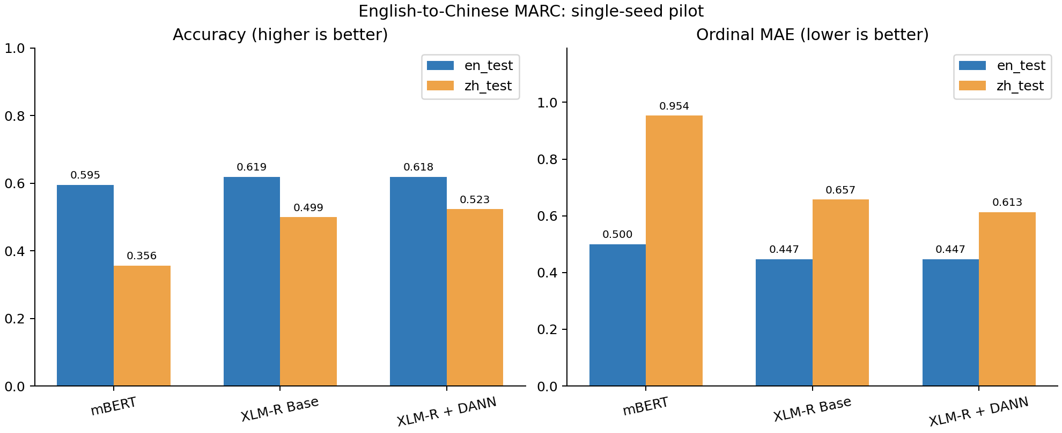
Figure 1 Classification performance across the three pilot models
Metric definitions. Accuracy is exact star agreement. Macro F1 averages F1 equally across the five classes. MAE is the average absolute star-rating error. ECE uses 15 equal-width confidence bins; NLL uses the probability assigned to the true class. Lower MAE, ECE and NLL are better.

4 Interpretation and next steps
The pilot supports using XLM-R as the main baseline and testing DANN as a way to exploit unlabelled Chinese reviews. English-fitted temperature scaling also transferred usefully to Chinese in this run. These observations motivate further experiments, but do not establish a stable or statistically significant improvement.

Scope and limitations
- Only 10,000 English training reviews, two epochs and one seed were used. The original MARC baseline used 200,000 training reviews and 15 epochs with different optimization settings, so these values are not an exact numerical replication.
- XLM-R results are a downstream application, and DANN is a language-domain extension of the original method. DANN accesses Chinese training texts whereas the source-only baselines do not; this difference is part of the adaptation setup.
- Language and product category shifts are confounded. Books represent about 31.5% of the original Chinese training data versus 1.9% of English. Category names are also provided as English input text. Product-category generalization has not yet been tested separately.
- Both public encoders already saw multilingual data during pretraining. Zero-shot here refers to Chinese task supervision. Lower domain-classifier accuracy alone does not prove useful alignment; calibration improvements may also vary with domain and seed.

Proposed next experiments
Repeat the three-model comparison with at least three random seeds and report variation. Then control product categories across languages and test unseen categories separately. Include a target-data adaptation control and a DANN gradient-reversal ablation before attributing gains to adversarial alignment. Expand the training budget after these checks.

Reproducibility materials
The project retains source code, YAML configurations, original data, sampled review IDs, pinned model revisions, SHA256 manifests, best checkpoints, per-review predictions, logits and training logs. Four logic tests and 128 artifact checks passed. The project location is E:\FYP\reproduction_1236. The main evidence files are listed below.
configs/pilot.yaml | docs/PROTOCOL.md
reports/marc_en_zh_pilot/all_results.csv | verification.json in the same folder
results/marc_en_zh_pilot/<model>/metrics.json | data/provenance/downloads.json

References
[1] Keung, P., Lu, Y., Szarvas, G., and Smith, N. A. (2020). The Multilingual Amazon Reviews Corpus. EMNLP. Paper
[2] Conneau, A., et al. (2020). Unsupervised Cross-lingual Representation Learning at Scale. ACL. Paper
[3] Ganin, Y., et al. (2016). Domain-Adversarial Training of Neural Networks. JMLR, 17(59), 1-35. Paper
[6] Guo, C., Pleiss, G., Sun, Y., and Weinberger, K. Q. (2017). On Calibration of Modern Neural Networks. ICML. Paper

