Step 1: Creating a Git repository for the web app
- Log in to your Github account.
- Click on the plus icon next to the profile picture and select New repository from the drop-down menu.
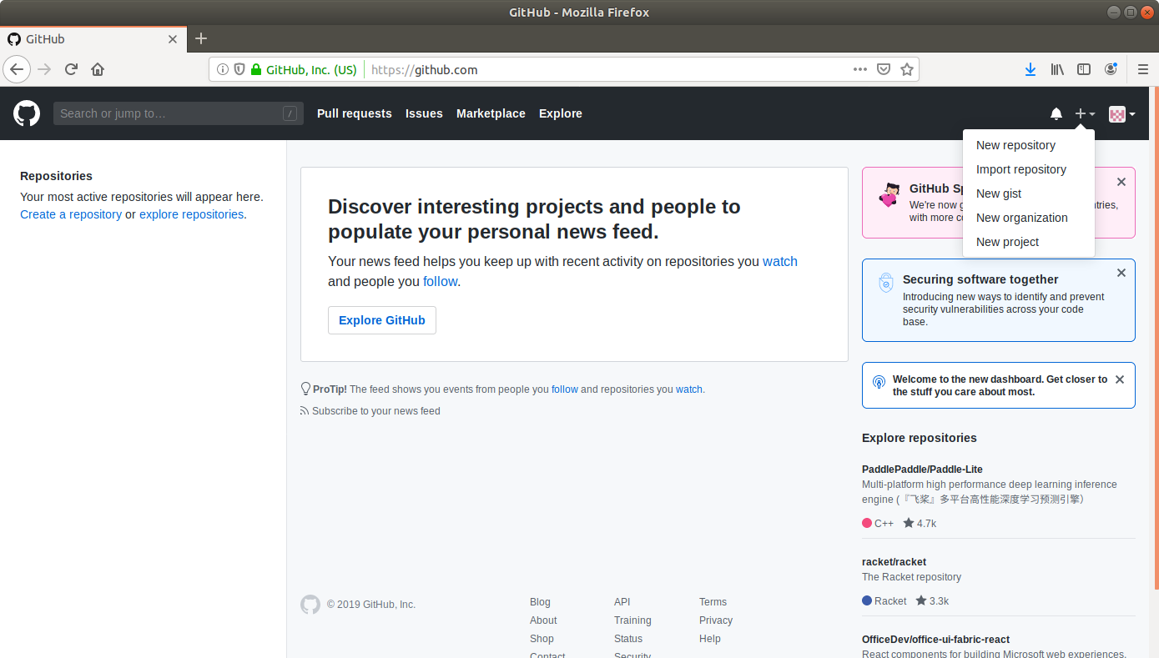

- Fill the required fields in the create repository form.
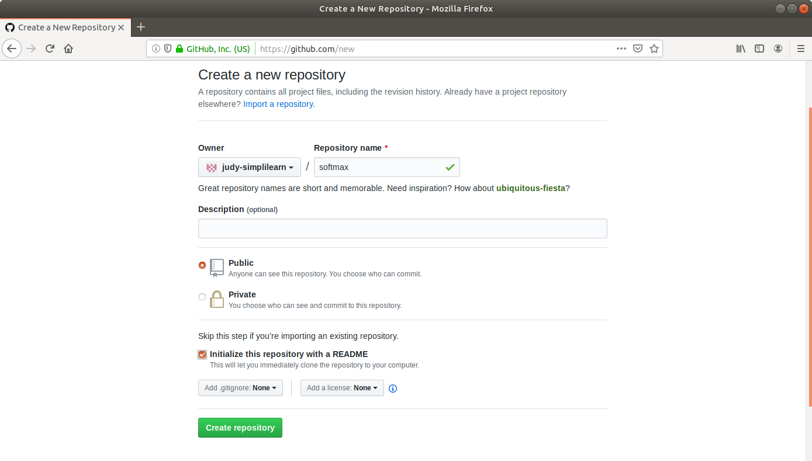
- Click on the Create Repository button.
- Click on the Clone or download button and copy the URL.

Committing the project skeleton to the repository
- Open the terminal and navigate to an appropriate location.
- Run git clone [URL] to clone the repository.
- Unzip the downloaded spring boot project to the cloned repository.
- Commit the changes to the remote SCM.
- Run git add.
- Run git commit -m "Add project skeleton"
- Run git push -u origin master
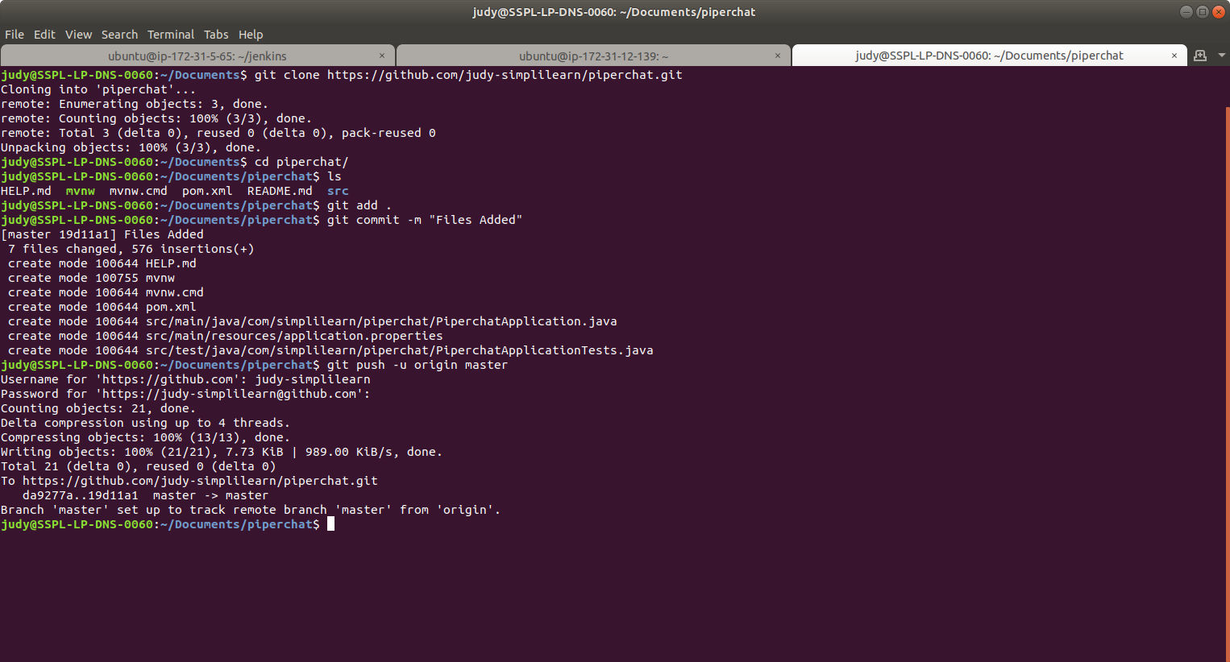
Step 4: Creating an EC2 instance
- Log in to the AWS lab account provided. You will be able to see the following screen:
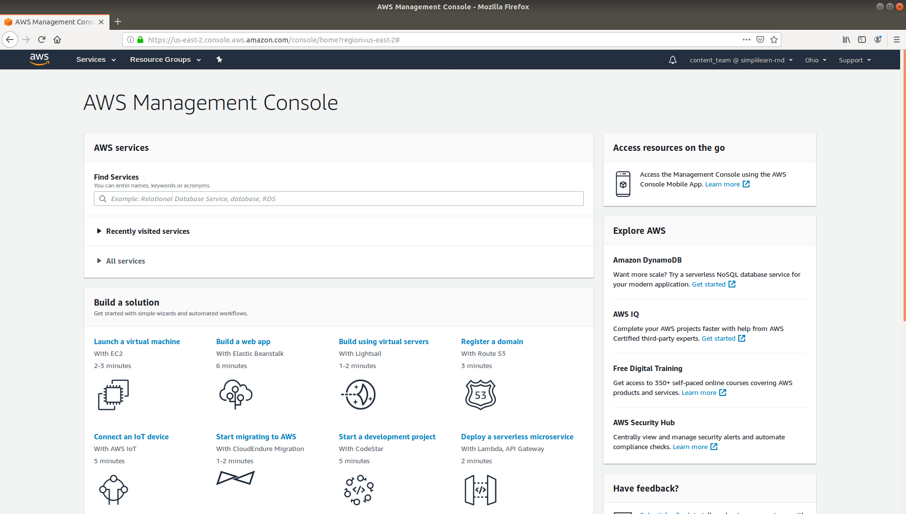
- Click on Services at the top left to view the drop-down list of resources.
- Click on EC2 under the Compute menu from the drop-down list.
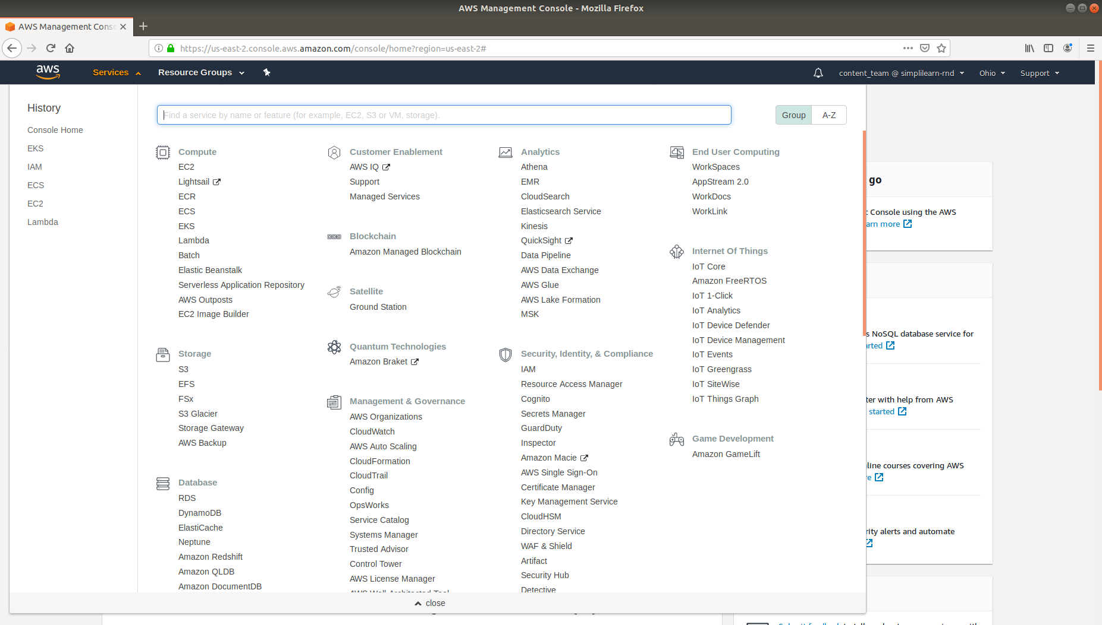
- Click on Launch Instance button and select Launch Instance from the menu.
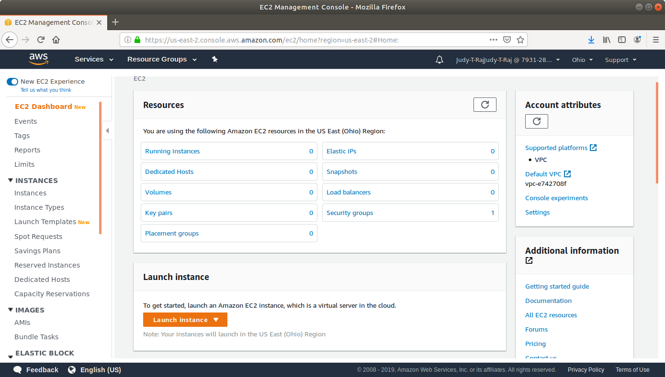
- Choose an Amazon Machine Image (AMI) from the list of AMIs and click on Select.
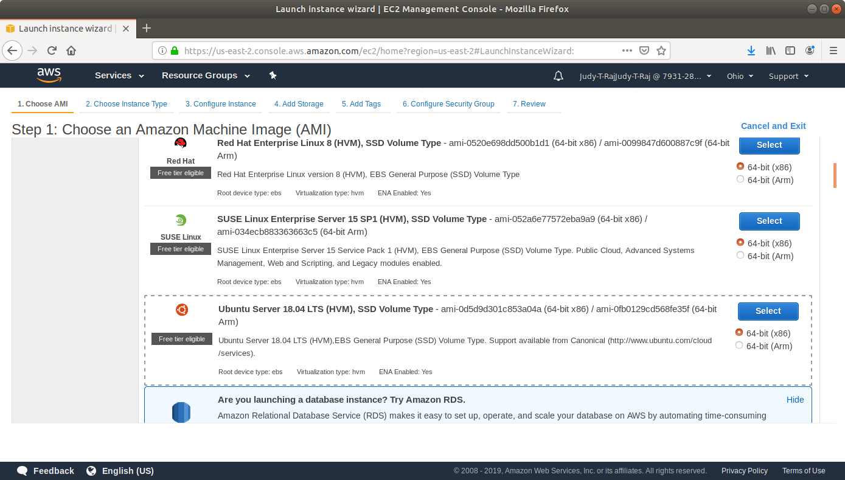
- Choose an Instance Type and click Review and Launch.
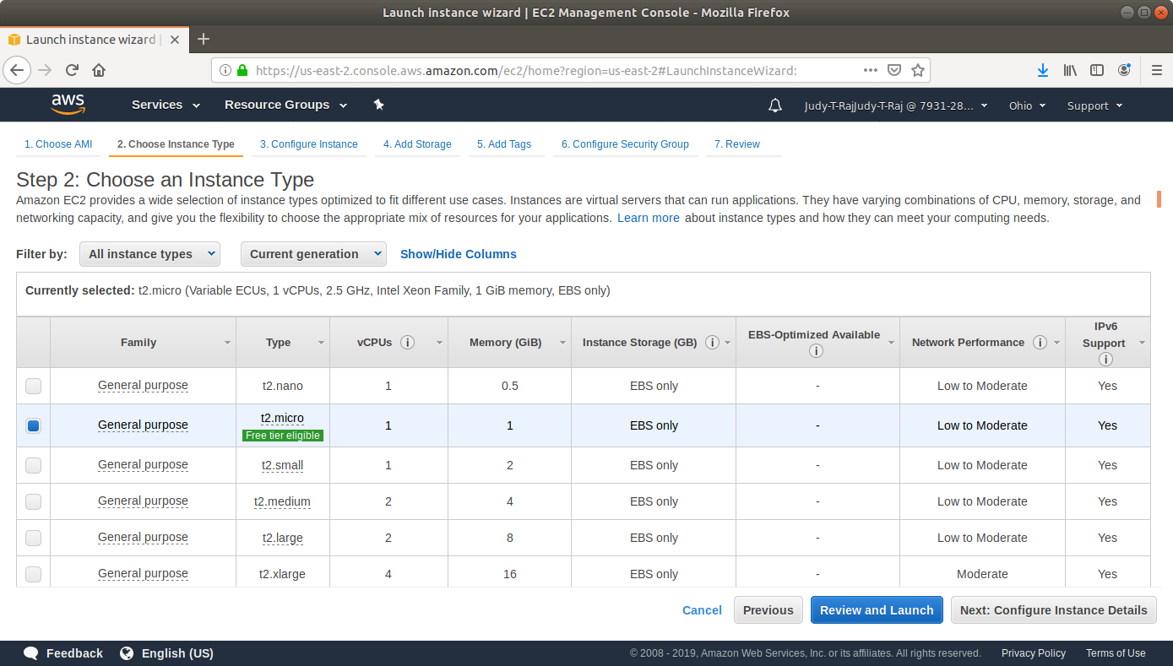
- Click on Launch.
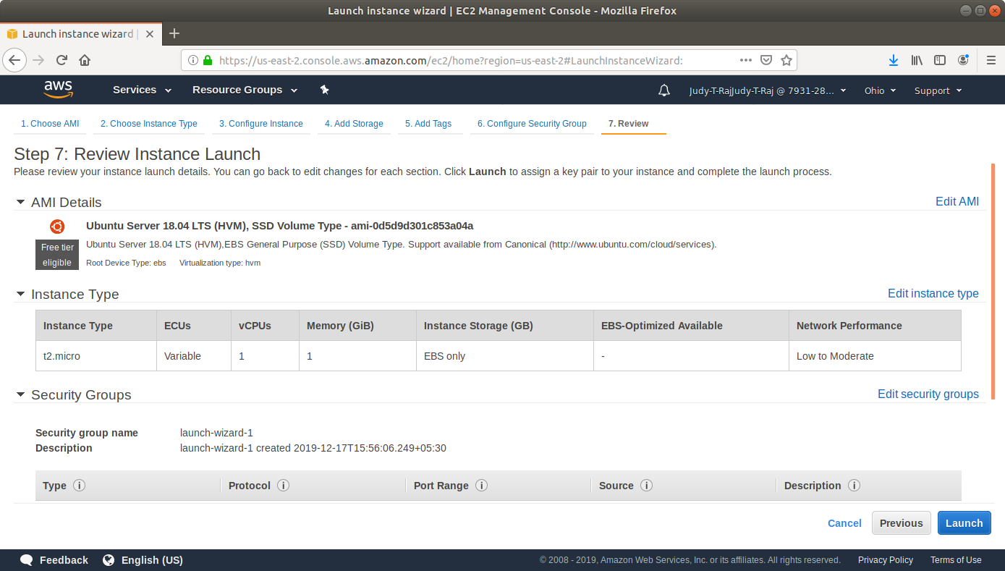
- In the pop-up menu, select Create a new key-value pair.
- Click on Download Key Pair. You’ll need this key to SSH to the VM later.
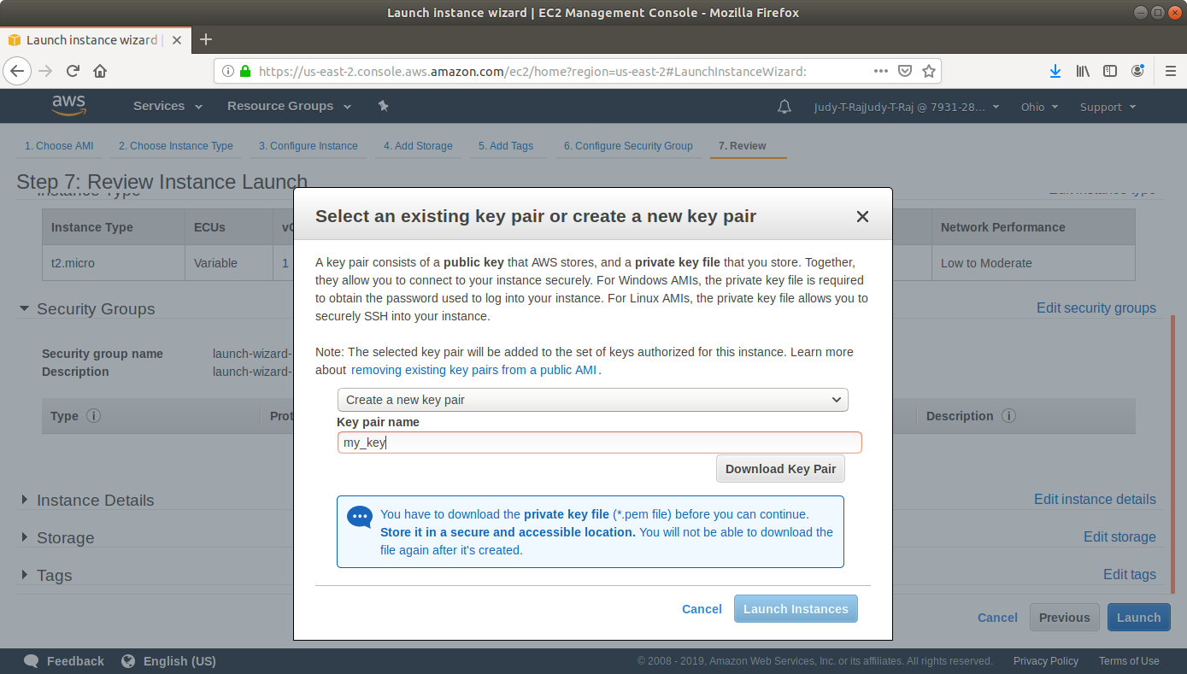
- Click on Launch.
- Repeat the same steps to create two more instances.
- Navigate to the security groups console.
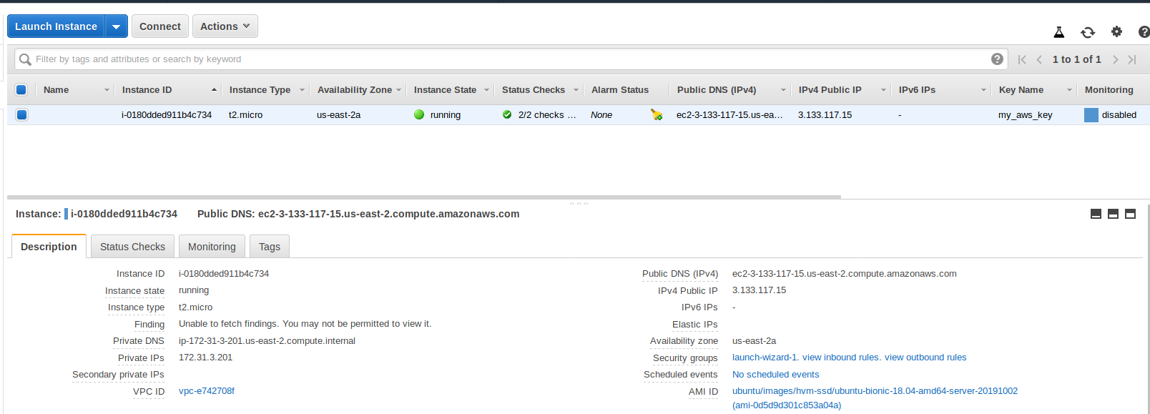

- Add a rule to the security group to which the instance belongs to allow SSH with the following settings:
Type: SSH
Protocol: TCP
Port Range: 22
Source: Anywhere 0.0.0.0/0
- Add a rule to the security group to which the instance belongs to allow HTTP traffic to port 8081 with the following settings:
Type: Custom TCP Rule
Protocol: TCP
Port Range: 8081
Source: Anywhere 0.0.0.0/0
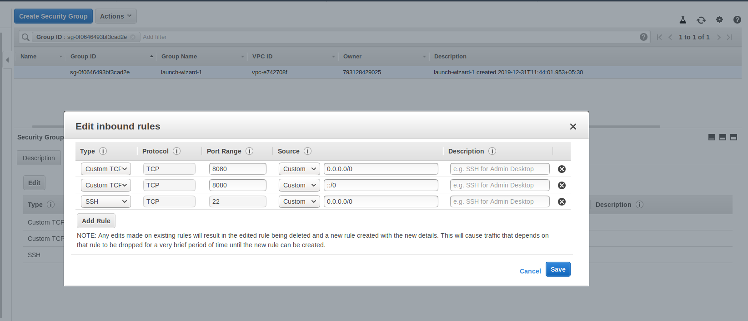
- Add the same rules to the Security Groups to which the other two VMs belong. For the master node, add an inbound rule that allows traffic to port 9007.
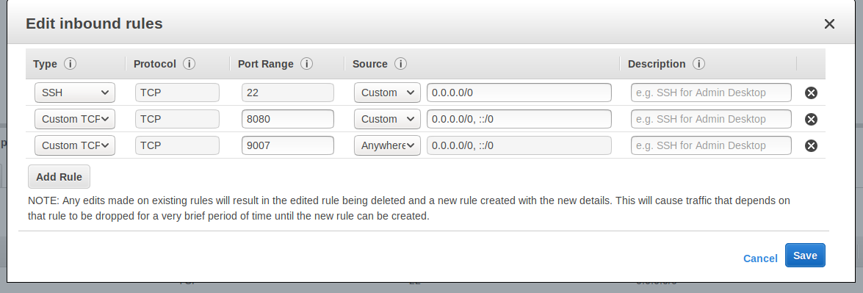
Step 5: Installing Jenkins on EC2
- Open the terminal.
- Navigate to the location where the AWS key is stored.
- Make the key file executable with the command chmod 400 <key-name>.pem
- SSH to the EC2 instance with the command sudo ssh -i <key-name>.pem ubunutu@<public-dns>

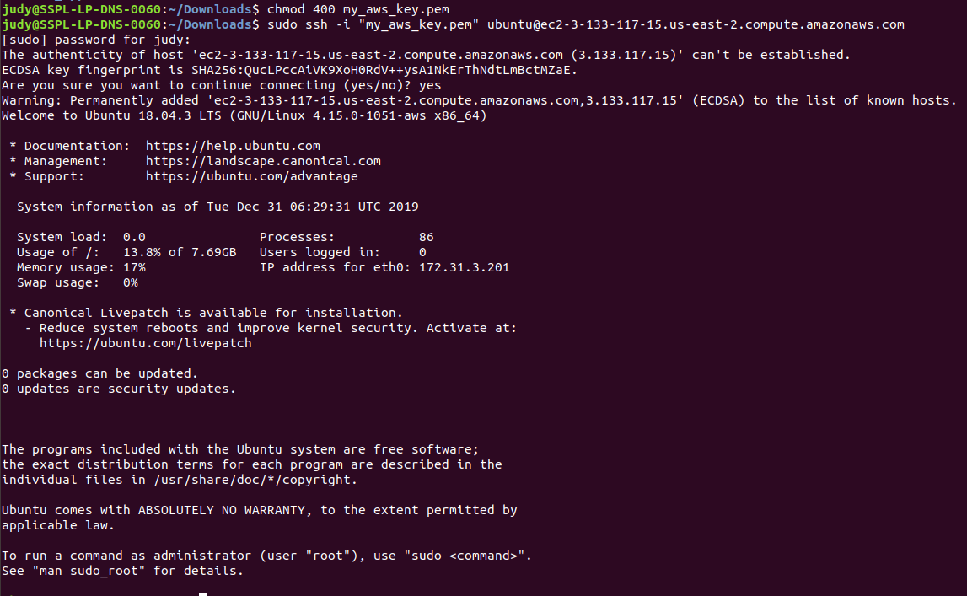
- Run the following commands to install Java and Jenkins:
sudo apt update
sudo apt install openjdk-8-jdk
wget -q -O - https://pkg.jenkins.io/debian/jenkins.io.key | sudo apt-key add -
sudo sh -c 'echo deb http://pkg.jenkins.io/debian-stable binary/ > /etc/apt/sources.list.d/jenkins.list'
sudo apt update
sudo apt install jenkins
sudo ufw allow 8081
- Navigate to http://<Public DNS (IPv4)>:8081 to view the Jenkins server.
- Set up Admin User and install plugins.
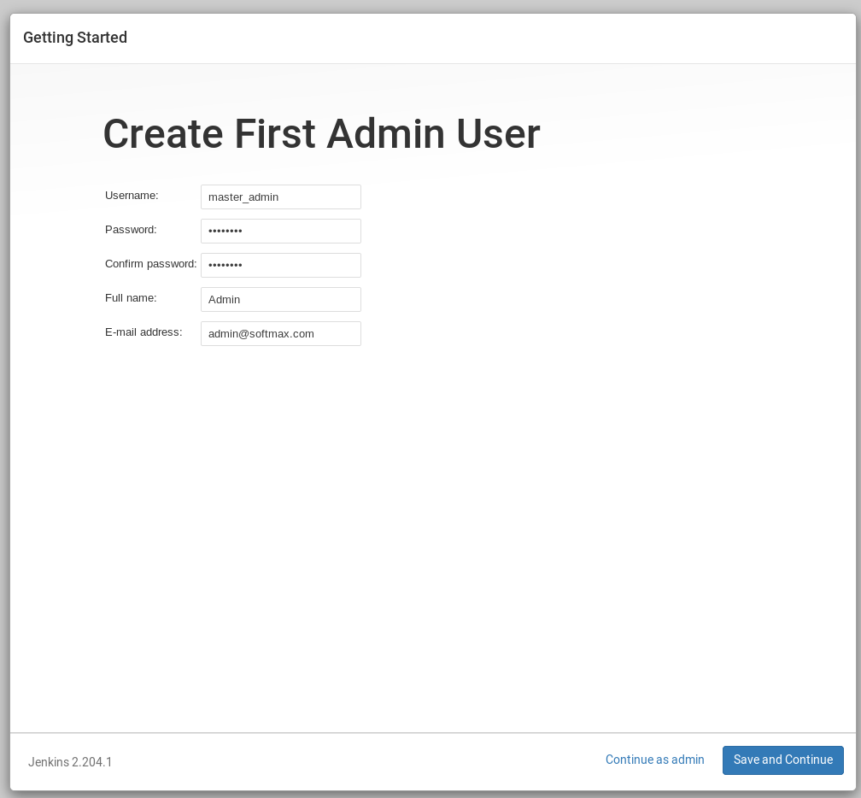
- Follow the instructions on screen to complete installation.

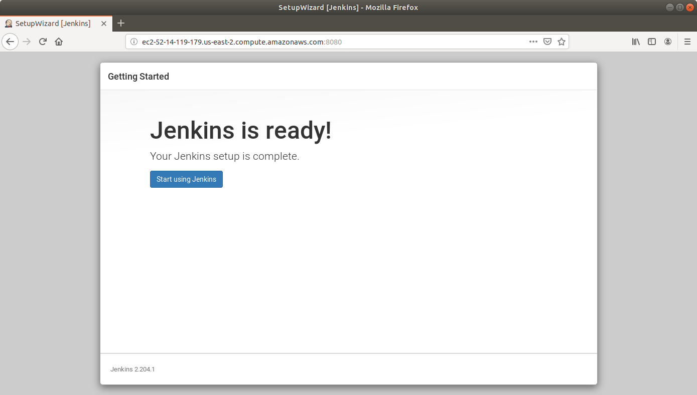
- Repeat the same steps to set up Jenkins on the other two nodes.
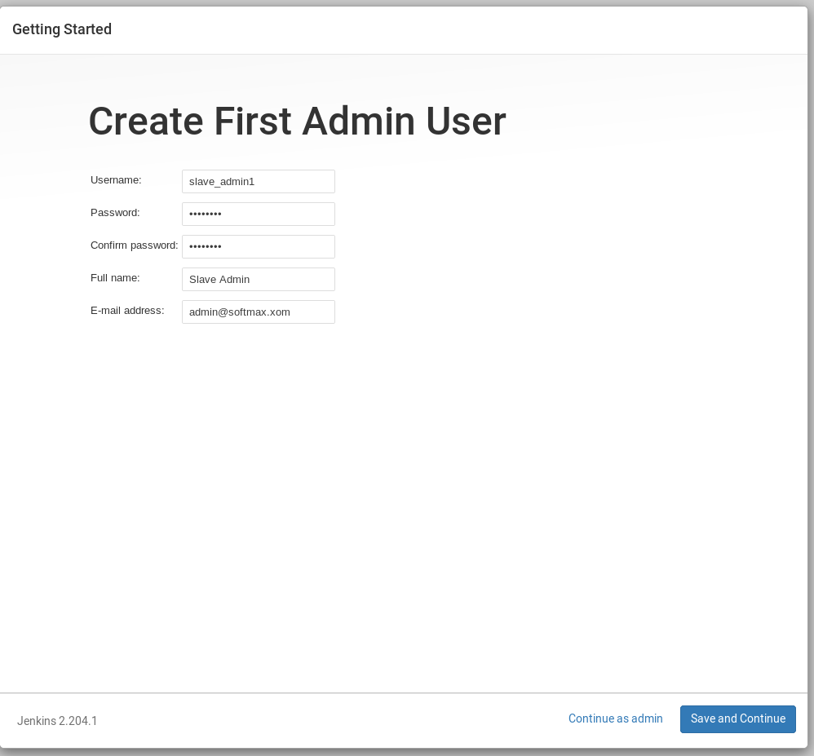
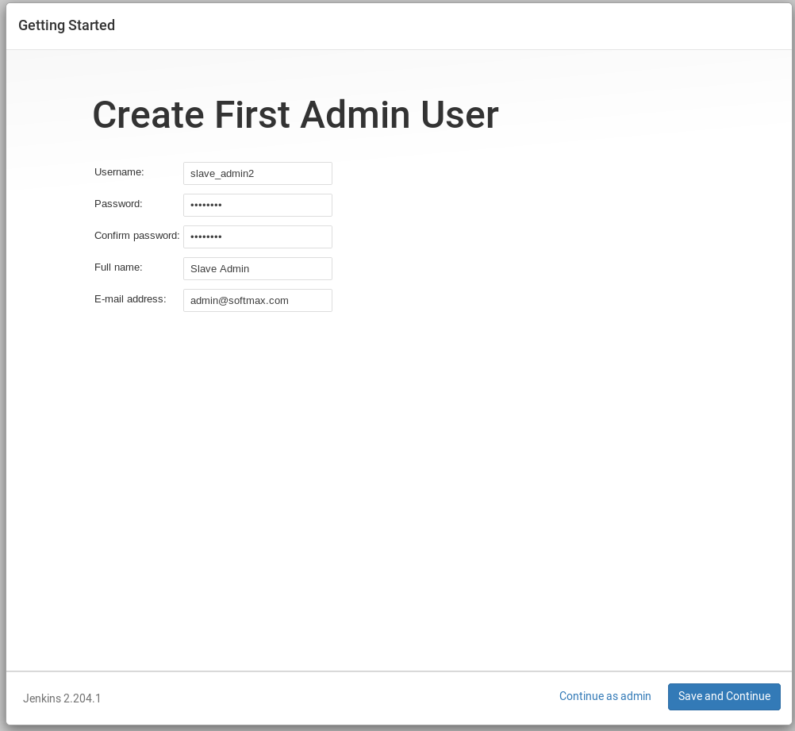

Step 6: Connecting a slave node to Jenkins master
- Go to Jenkins dashboard on the master node.
- Click on Manage Jenkins and select Manage Global Security.
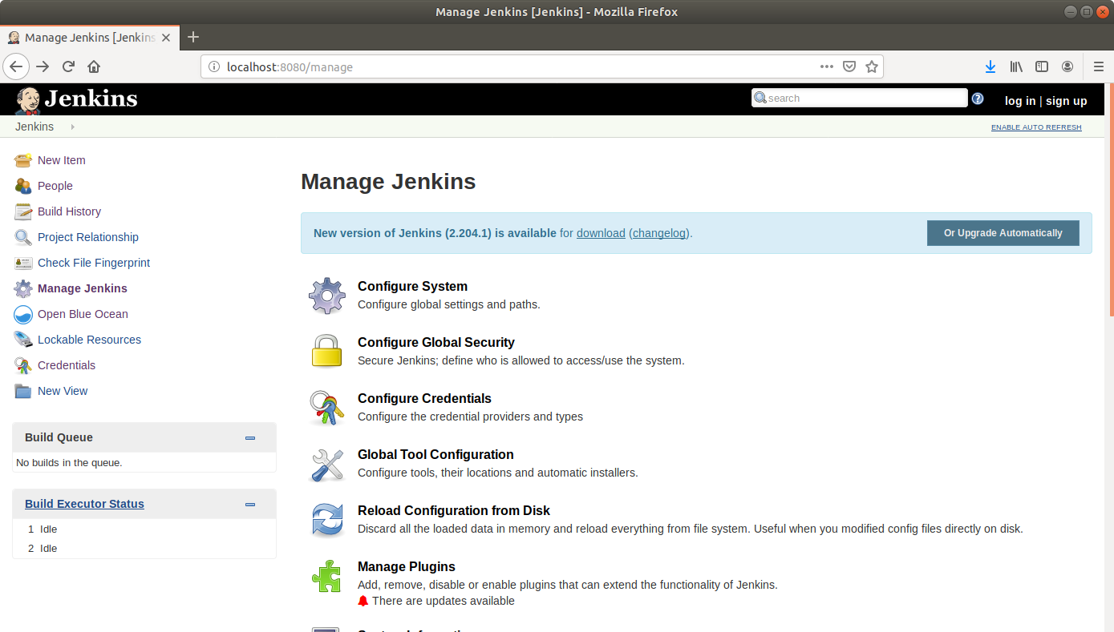
- Scroll down to Agents and enable inbound traffic at port 9007.
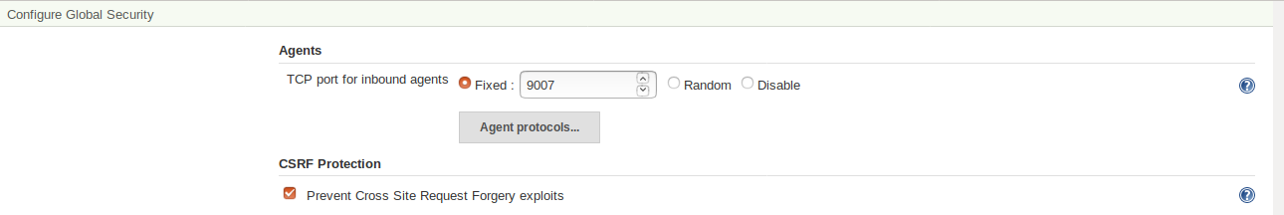
- From the Jenkins dashboard, click on Manage Jenkins and select Manage Nodes.
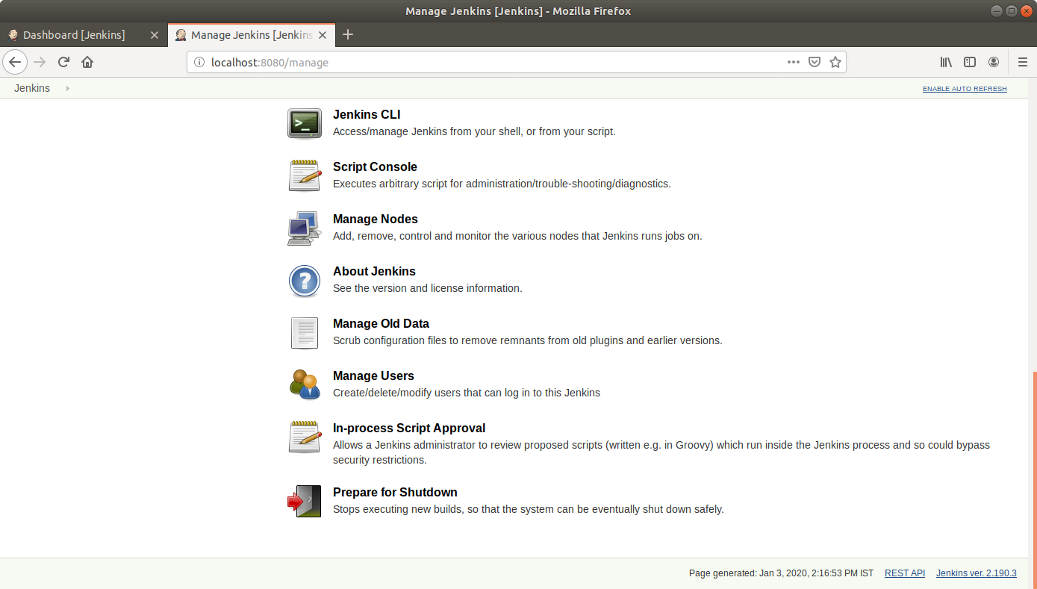

- Give a name to the node and then click OK. Select the Permanent Agent checkbox.
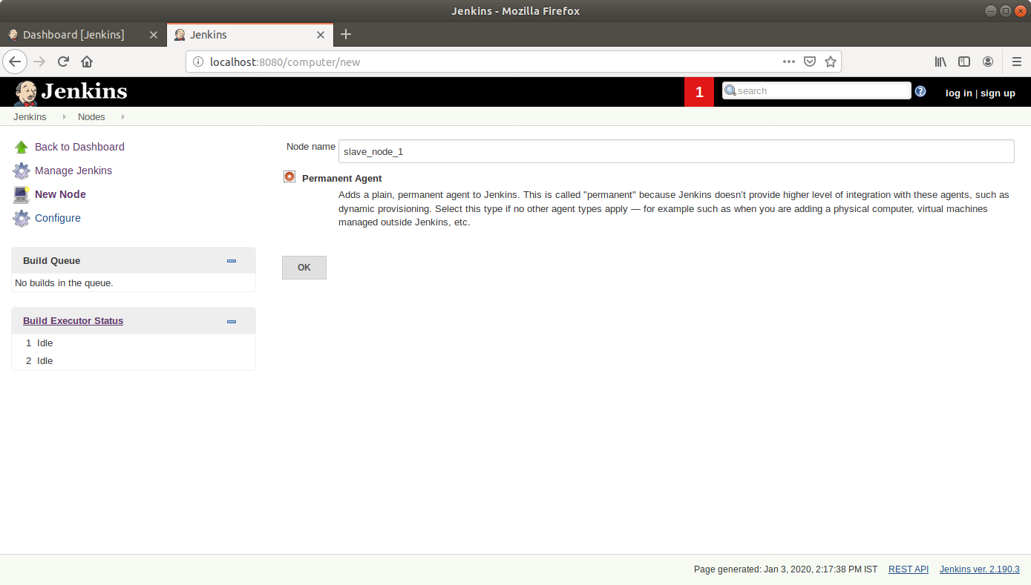
- Enter the required information as shown in the screenshot below:
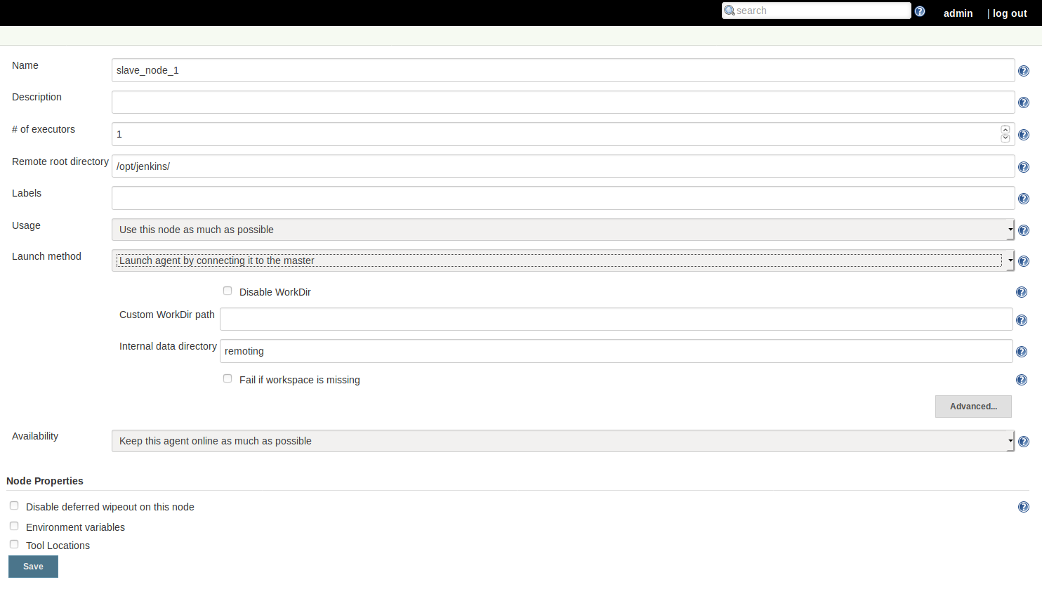

- Click on the agent.jar hyperlink in the new page and copy the link on the new page.
- Copy the command given on the page to be run from the slave agent.
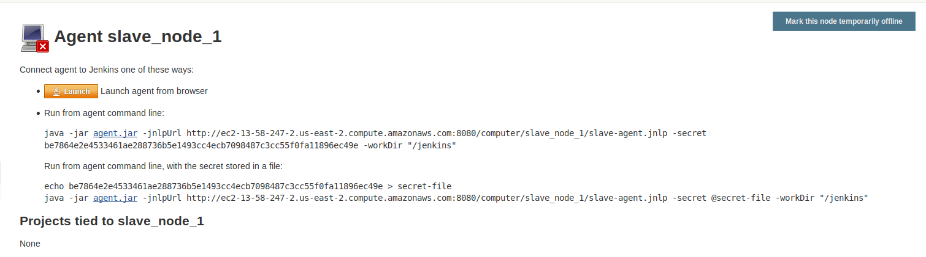
- SSH to the EC2 instance acting as the slave node 1.
- Create a directory at the path specified as Remote root directory.
- Download the agent.jar file to the newly created directory using the wget command.
- Run the command copied from the Jenkins master to connect the instance to master
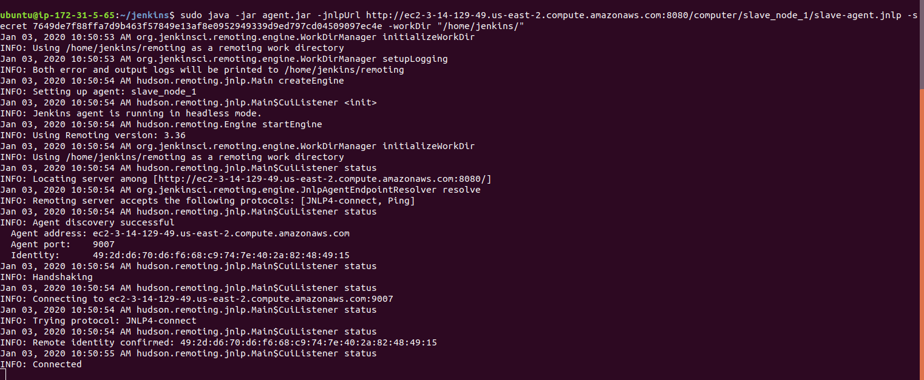
- The slave node will show as connected to the master UI.

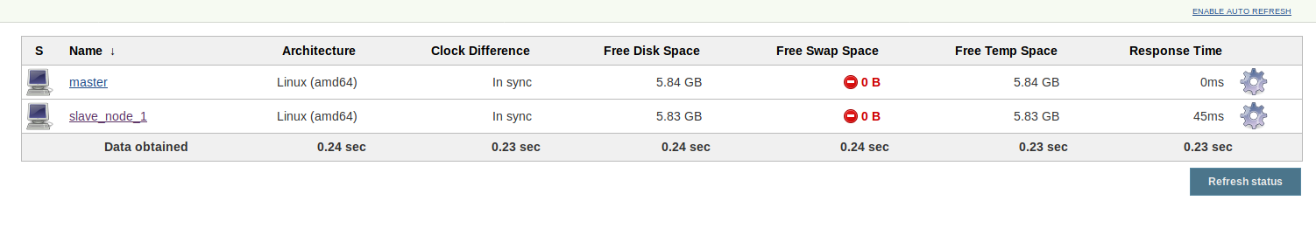
- Repeat the same steps for the second slave node.
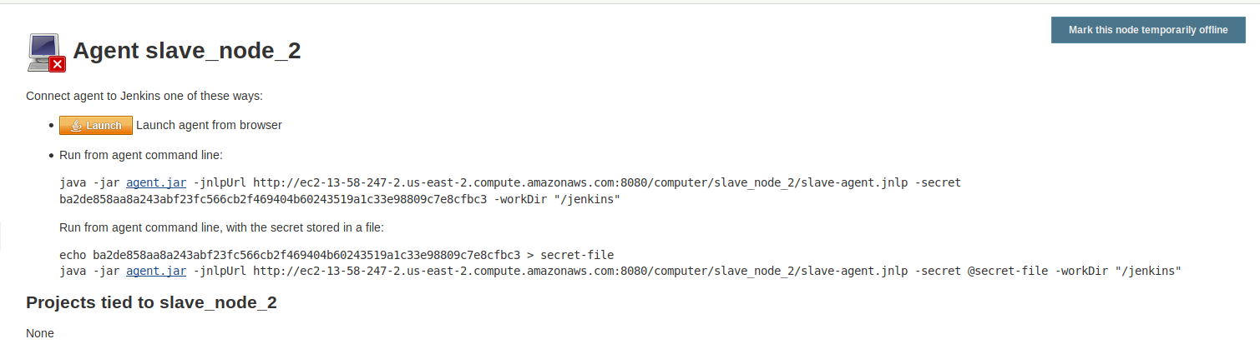
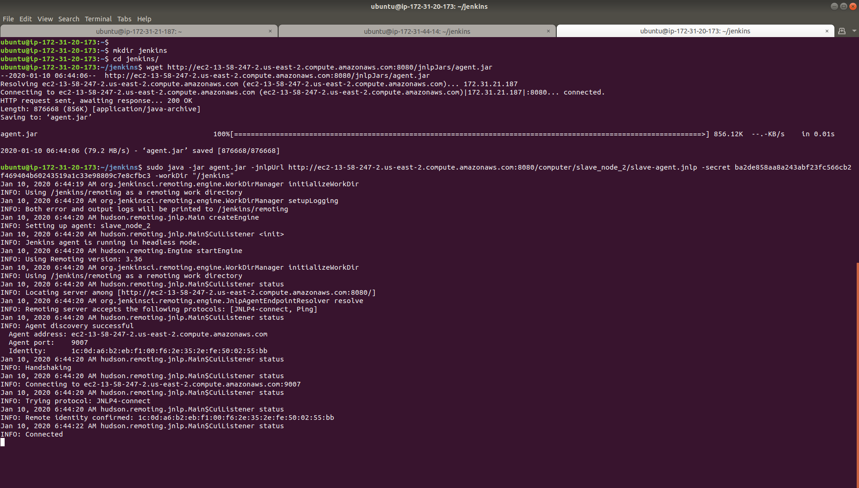
- The master node UI will now reflect two slave nodes.
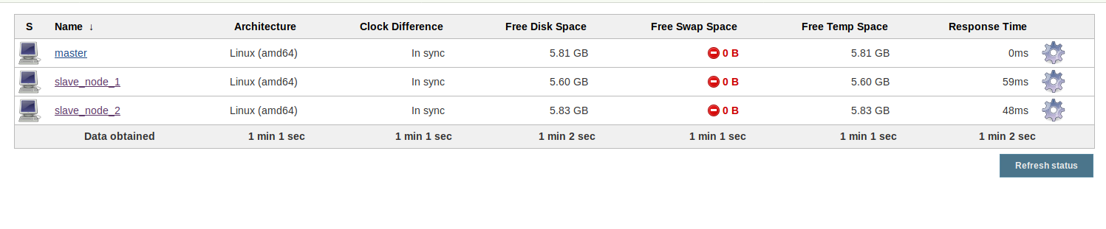

Step 7: Creating a build pipeline in Jenkins
- Navigate to slave_node_1
- Install the Maven Plugin and add a Maven Installer in the Global Tools Configuration page.
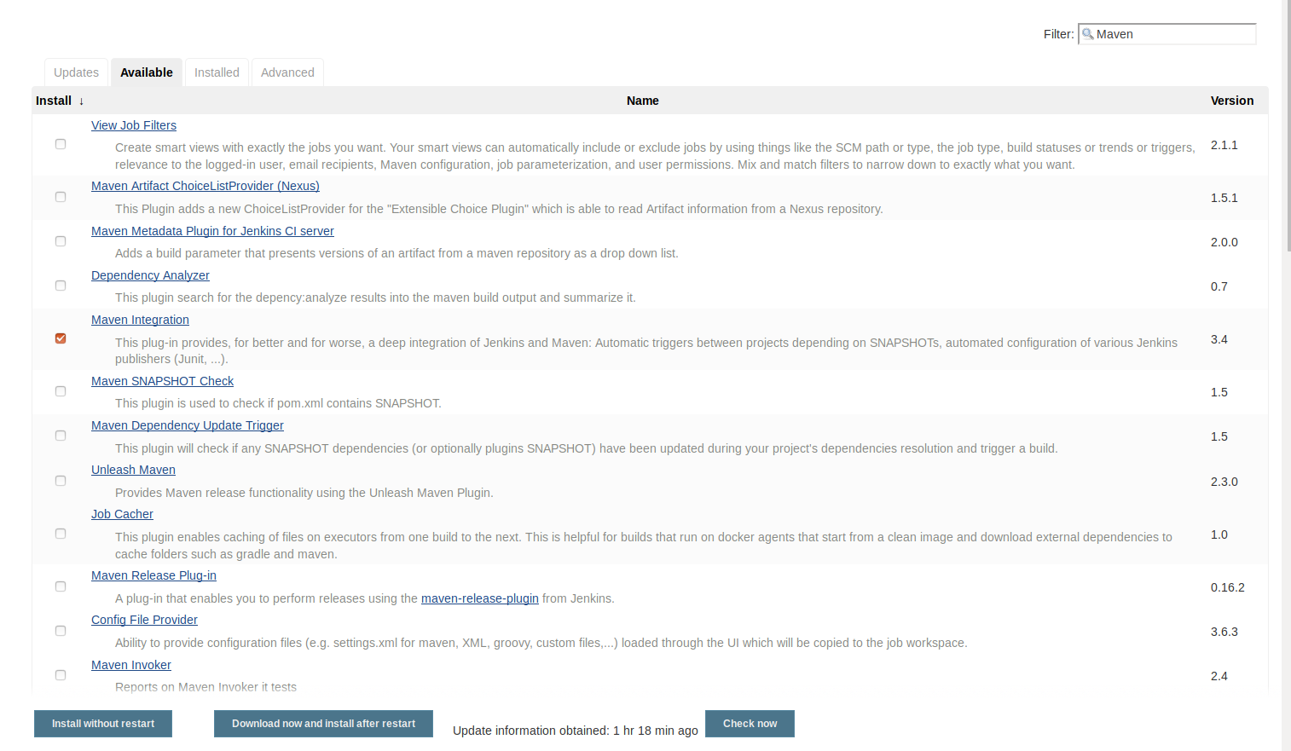

- Repeat the same steps for slave_node_2.
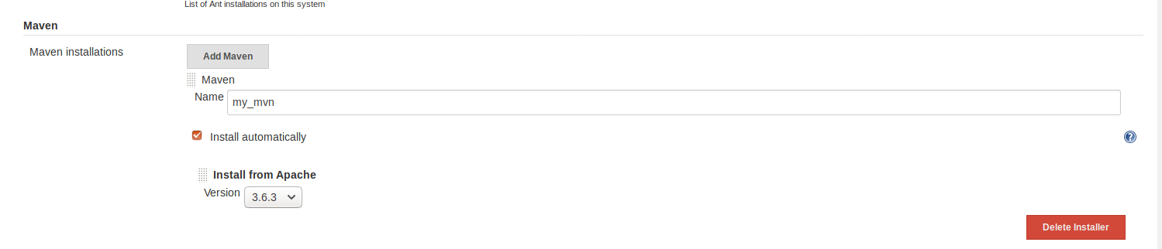
- Go to Jenkins dashboard for the master node.
- Click on New Item.
- Enter a name for your build job.
- Select Pipeline as the build job type.
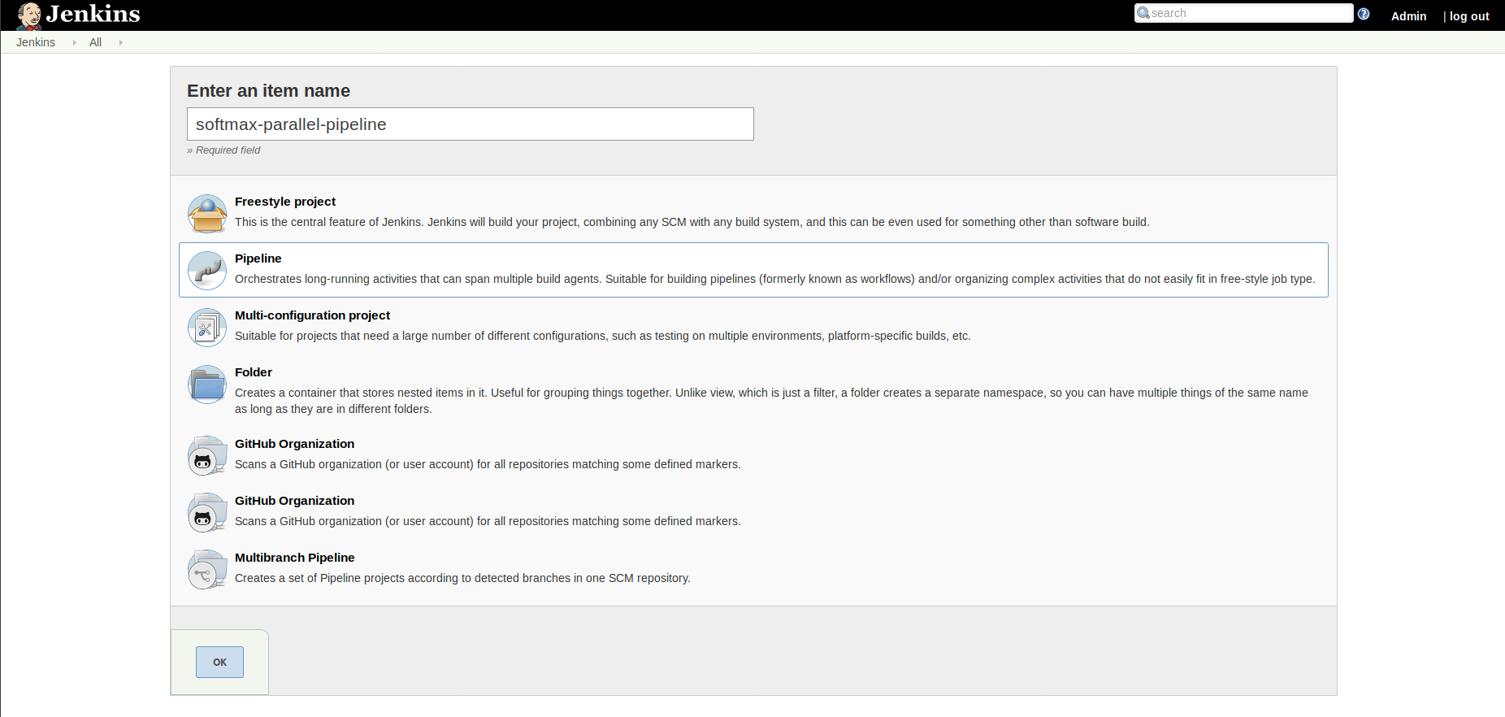
- Click OK.
- On the configuration page, scroll down to the Pipeline section.
- In the script field, paste the script below:
pipeline {
agent none
tools {
maven 'my_mvn'
}
stages {
stage("Checkout") {
agent { label 'slave_node_1' }
steps {
git url: 'https://github.com/judy-simplilearn/Softmax.git'

}
}
stage('Build') {
agent { label 'slave_node_1' }
steps {
sh "mvn compile"
}
}

stage("Unit test") {
agent { label 'slave_node_2' }
steps {
git url: 'https://github.com/judy-simplilearn/Softmax.git'
sh "mvn test"
}
}
}

}

- Click Save.
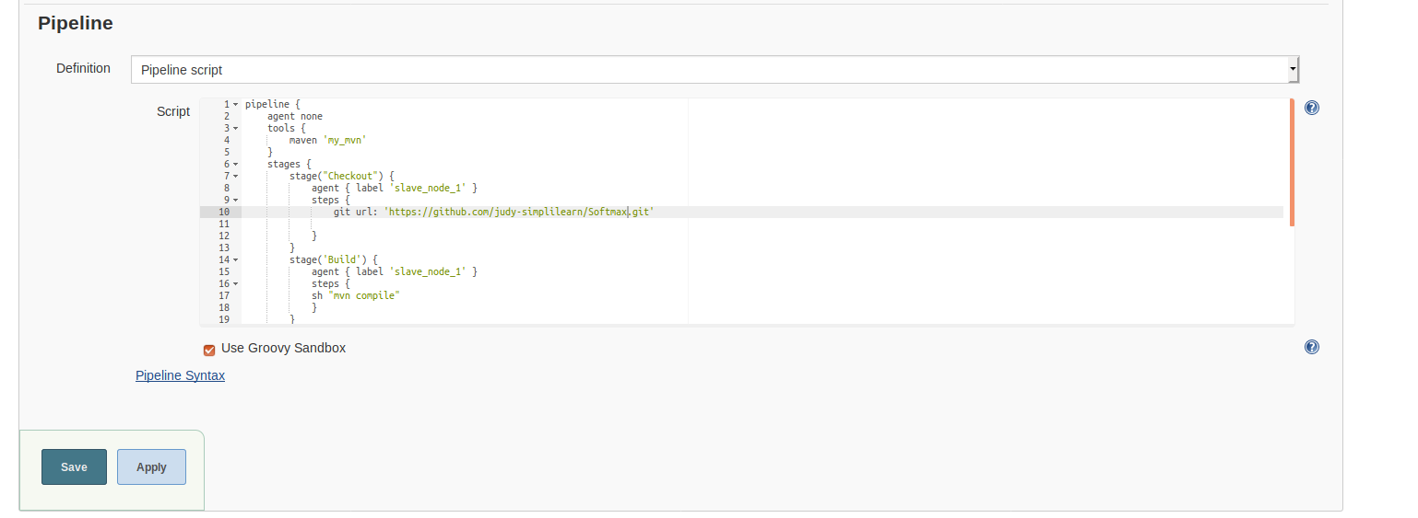
- Click on Build Now in the project window.
- Jenkins will now build your pipeline and output the logs.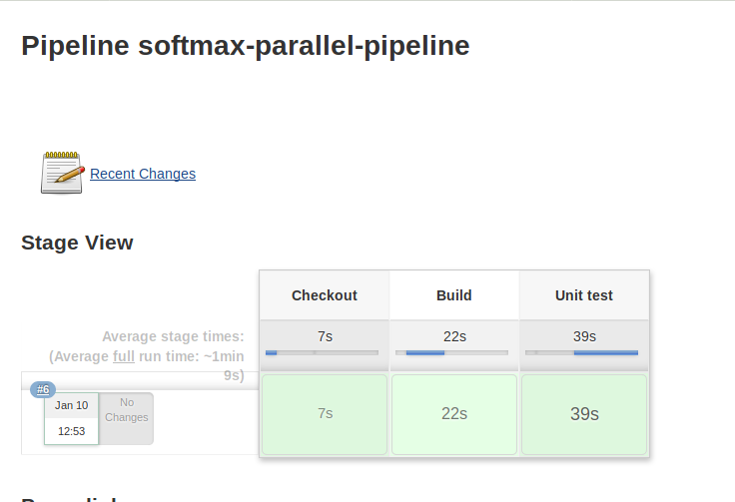
- The logs will show that the job is being run on the slave nodes.

