Table of Contents

Queens medical centre ASMIS report 2

Benefits of the ASMIS 2

User experience 2

Availability Schedule 2

Book or change schedule 3

Email and SMS notification 4

Upscaling for population growth 4

Availability and Workload 4

Receptionist 4

Specialist doctor 4

Potential problems 4

Government’s policy on patient data protection 4

Collect vital information 4

Patients without internet 4

Threat modelling techniques 4

STRIDE method 4

Identify cyber threats 4

UML: Abuse Case Diagram 4

Mitigate cyber threats 5

UML: Social Engineering 5

Security technologies 5

System design 5

Diagram: Network, Database, Micro service 5

Access Control List 5

Address the problem 5

Strengths and weaknesses 5

Employed examples 5

# Queens medical centre ASMIS report

# Benefits of the ASMIS

## User experience

### Availability Schedule

#### UML: Activity Diagram

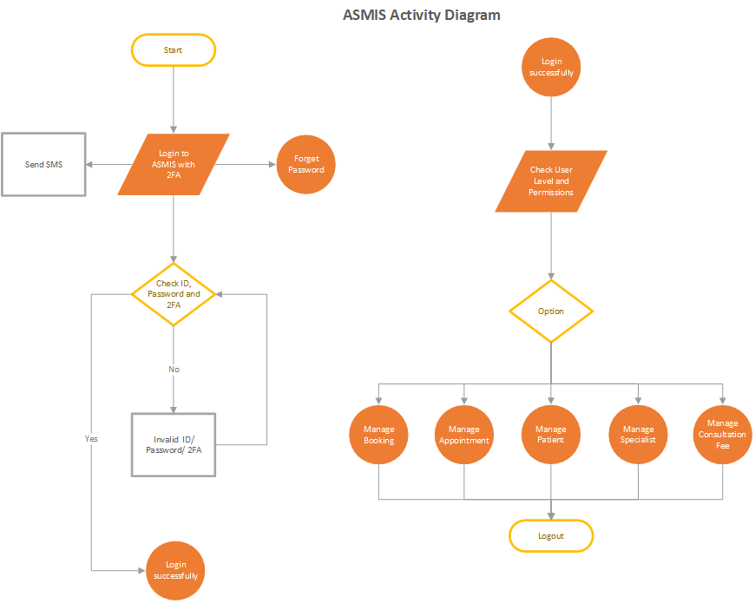

### Book or change schedule

#### UML: Sequence Diagram

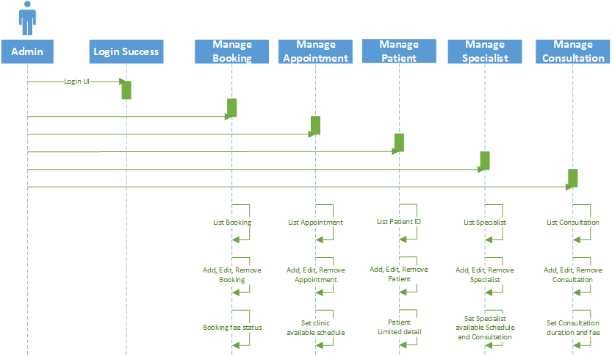

### Email and SMS notification

### Upscaling for population growth

## Availability and Workload

### Receptionist

### Specialist doctor

## Potential problems

### Government’s policy on patient data protection

### Collect vital information

### Patients without internet

# Threat modelling techniques

## STRIDE method

## Identify cyber threats

### UML: Abuse Case Diagram

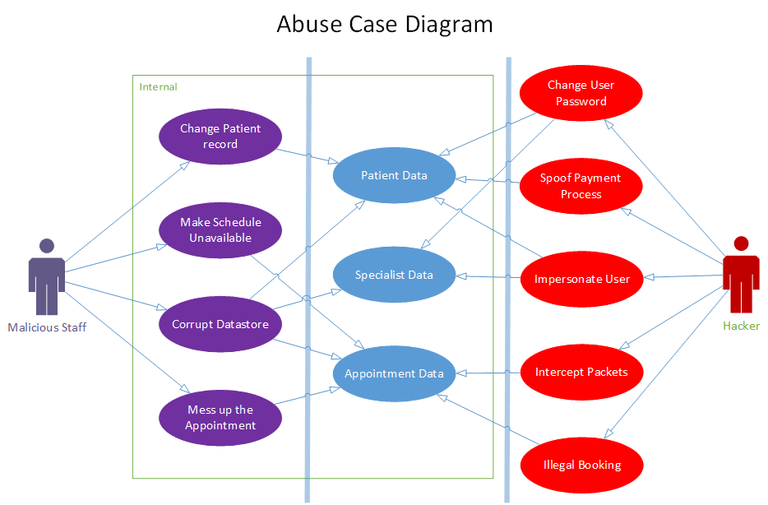

## Mitigate cyber threats

### UML: Social Engineering

# Security technologies

## System design

### Diagram: Network, Database, Micro service

### Access Control List

## Address the problem

## Strengths and weaknesses

## Employed examples