Perform a basic scan using standard tools such as traceroute, dig and nslookup. Use these basic tools to compile a list that details the following information:

## How many hops from your machine to your assigned website?

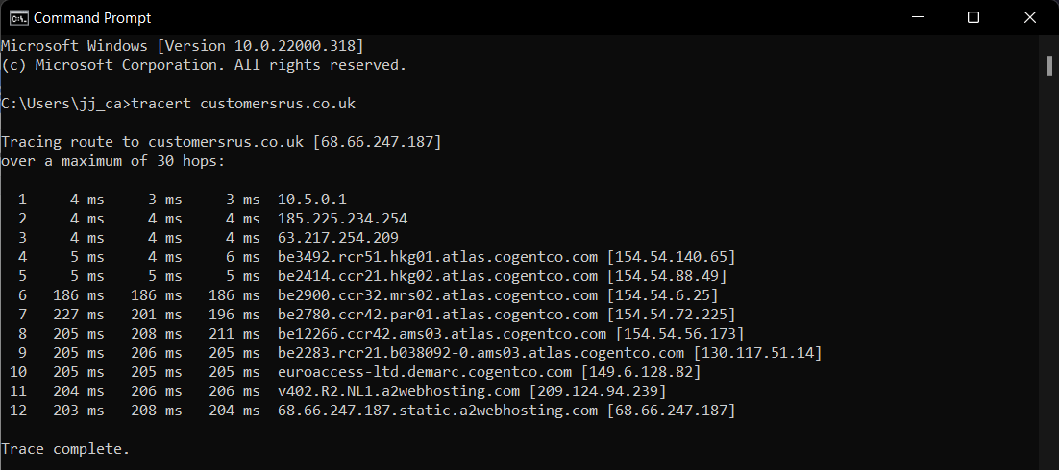

## Which step causes the biggest delay in the route? What is the average duration of that delay?

After the local ISP, other country hop in atlas.cogentco.com domain (ISP: Cogentco) caused the biggest delay, the average duration is 121.41ms.

## What are the main nameservers for the website?

A2 Hosting web hosting nameservers

|  |
| --- |
| Name servers:  ns1.a2hosting.com  ns2.a2hosting.com  ns3.a2hosting.com  ns4.a2hosting.com |

## Who is the registered contact?

|  |
| --- |
| Registrar:  eNom LLC [Tag = ENOM]  URL: <http://www.enom.com> |
| Results returned from whois.arin.net:  OrgName: A2 Hosting, Inc.  OrgId: A2HOS  Address: P.O. Box 2998  City: Ann Arbor  StateProv: MI  PostalCode: 48106  Country: US  RegDate: 2004-03-16  Updated: 2021-10-13  Comment: http://www.a2hosting.com  Ref: <https://rdap.arin.net/registry/entity/A2HOS> |

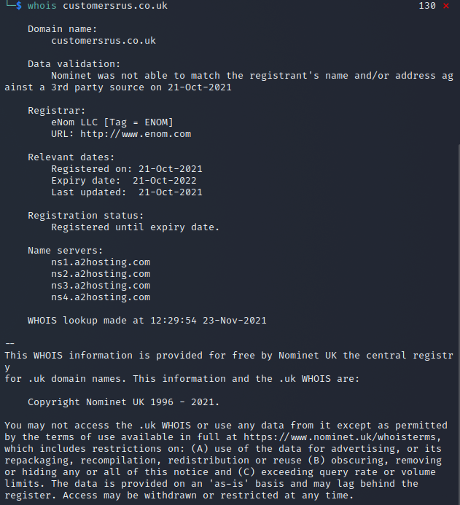

## What is the MX record for the website?

Mail hosting in A2 Hosting based the IP ping result.

|  |
| --- |
| customersrus.co.uk. 5 IN MX 0 mail.customersrus.co.uk. |



## Where is the website hosted?

A2 Hosting, Inc. (United States of America (Ann Arbor) , Netherlands (Amsterdam)

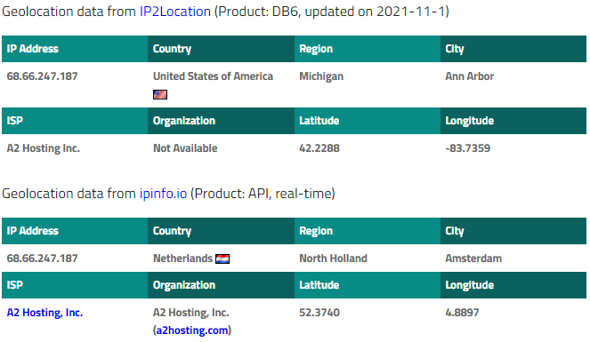

Ref: <https://www.iplocation.net/ip-lookup>

DIG, WHOIS

The robots.txt file (usually kept in the root of a web site) is used to manage the level of access a typical crawler has, although some crawlers used by attackers deliberately ignore the settings specified.

Team activity

Discuss the results of your scans and answer the following questions with your teammates before Seminar 2.

Did you have any issues or challenges with the scans?

How did you overcome them?

How will they affect your final report?

ISP: cogentco

https://www.a2hosting.com/kb/security