Seminar 2 Preparation: TCP/IP v ISO/OSI

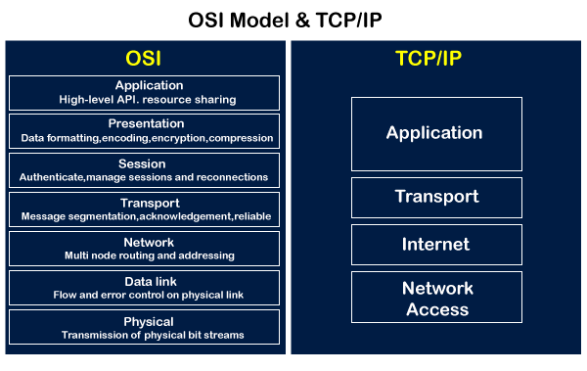

* OSI has 7 layers whereas TCP/IP has 4 layers.
* The OSI Model is a logical and conceptual model that defines network communication used by systems open to interconnection and communication with other systems. On the other hand, TCP/IP helps you to determine how a specific computer should be connected to the internet and how you can be transmitted between them.
* OSI header is 5 bytes whereas TCP/IP header size is 20 bytes.
* OSI refers to Open Systems Interconnection whereas TCP/IP refers to Transmission Control Protocol.
* OSI follows a vertical approach whereas TCP/IP follows a horizontal approach.
* OSI model, the transport layer, is only connection-oriented whereas the TCP/IP model is both connection-oriented and connectionless.
* OSI model is developed by ISO (International Standard Organization), whereas TCP Model is developed by ARPANET (Advanced Research Project Agency Network).
* OSI model helps you to standardize router, switch, motherboard, and other hardware whereas TCP/IP helps you to establish a connection between different types of computers.