# Disaster Recovery Solution

## ****Assumption****

* **ACME has eCommerce website for selling goods similar with the researched companies (**CHX Products**, N.D.).**
* **The COTS solution able to support clusters, containers, and cloud solution like Azure.**

## RPO/ RTO requirements

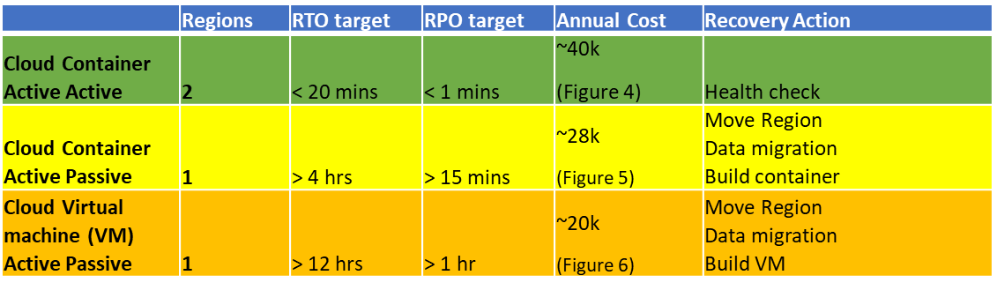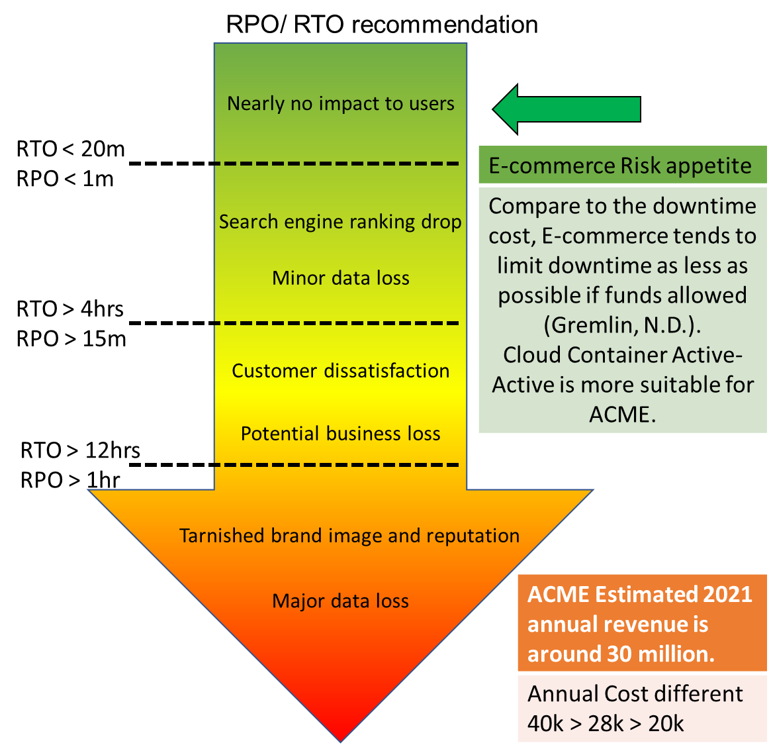

Figure 3: RPO/ RTO recommendation (Gremlin, N.D.)

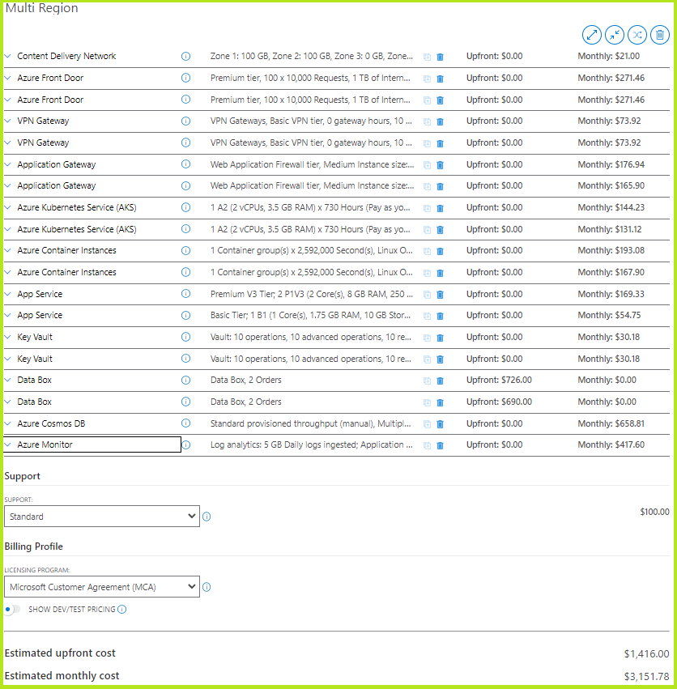

Figure 4: Multi Region, Annual cost: $1,416 + $3,151.78 x 12 = $39,237.36 (Azure, 2022)

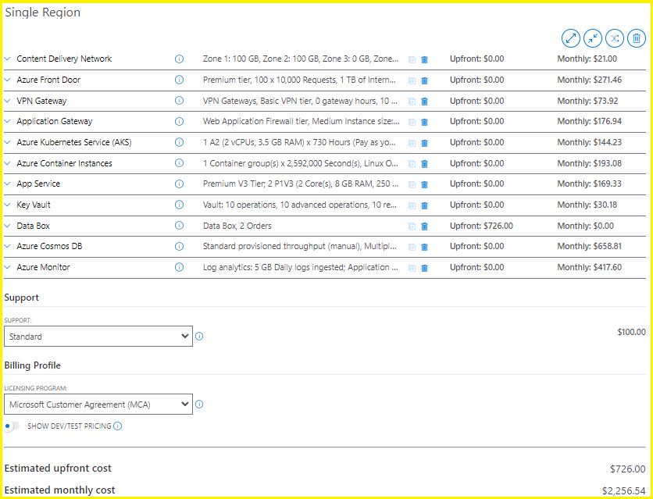

Figure 5: Single Region, Annual cost: $726 + $2,256.54 x 12 = $27,804.48 (Azure, 2022)

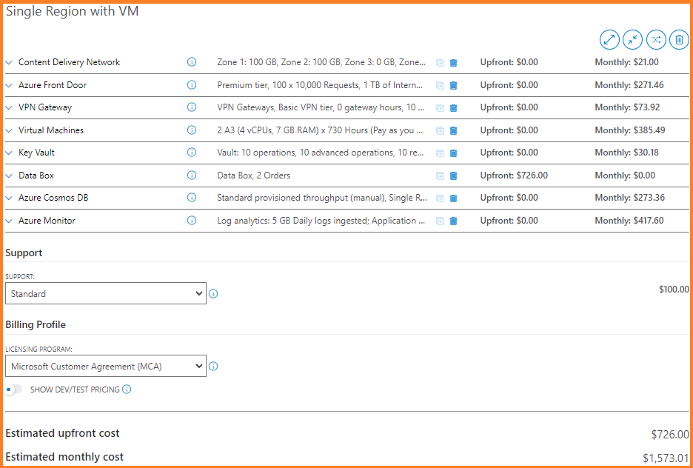

Figure 6: Single Region with VM, Annual cost: $726 + $1,573.01 x 12 = $19,602.12 (Azure, 2022)

## High-level Diagram

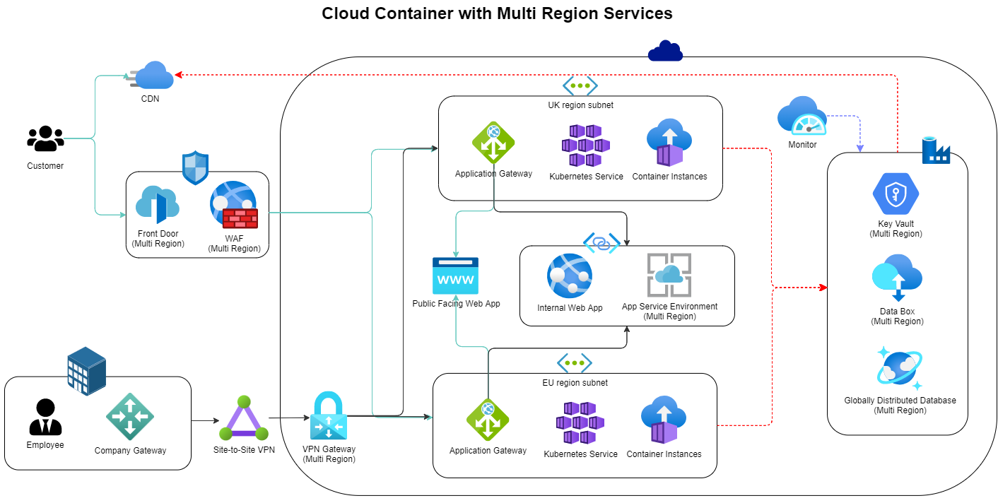

Figure 7: Cloud Container with Multi Region Services (Azure, 2022)

# Challenges

## Resilience

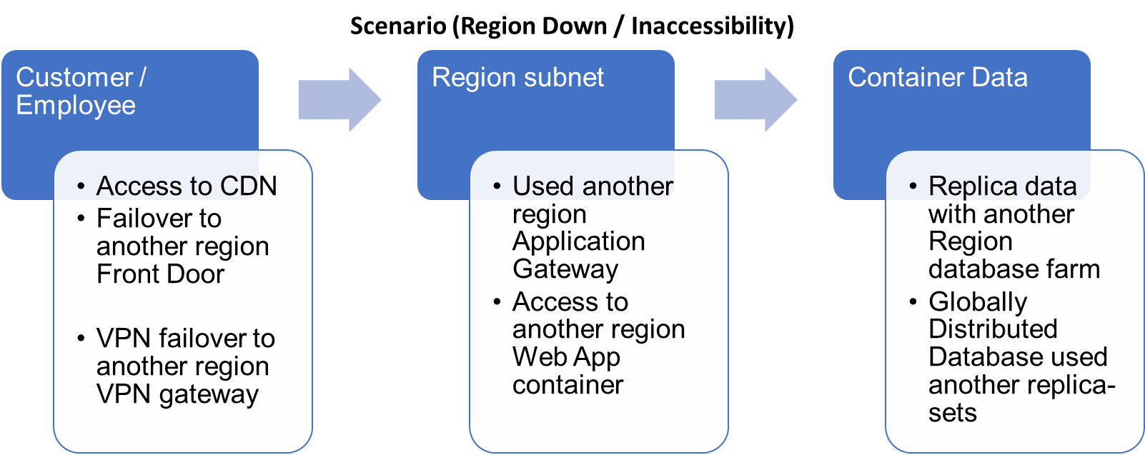

Figure 8: Scenario (Region Down / Inaccessibility), NIST SP 800-160 (NIST, 2021)

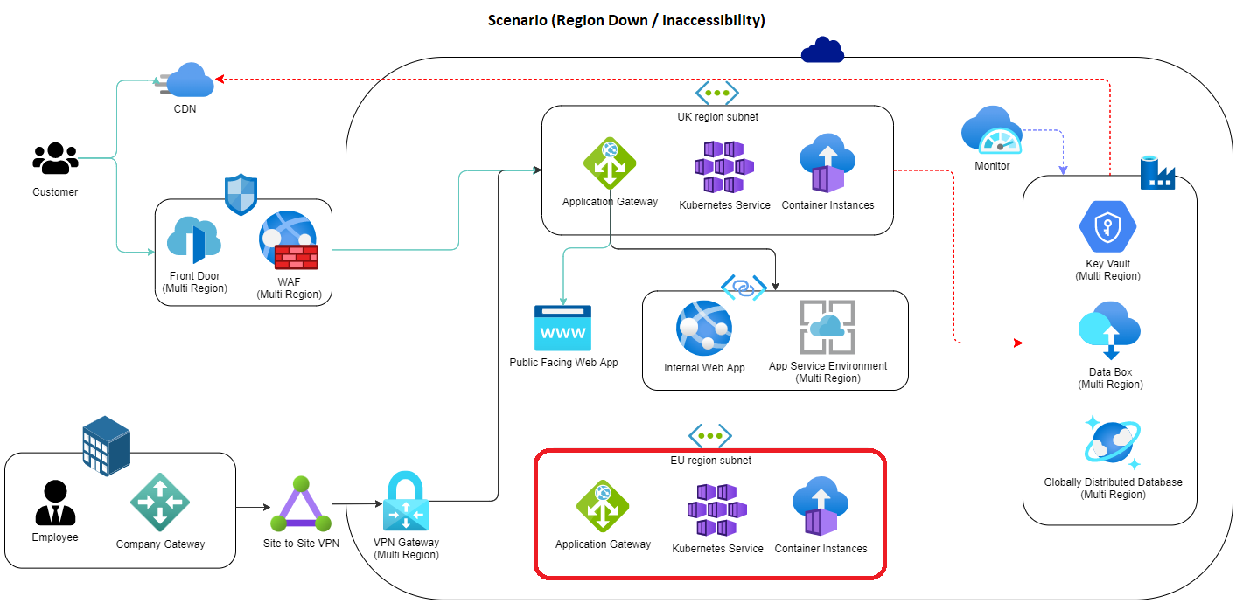

Figure 9: Scenario (Region Down / Inaccessibility) (Azure, 2022)

## Network security

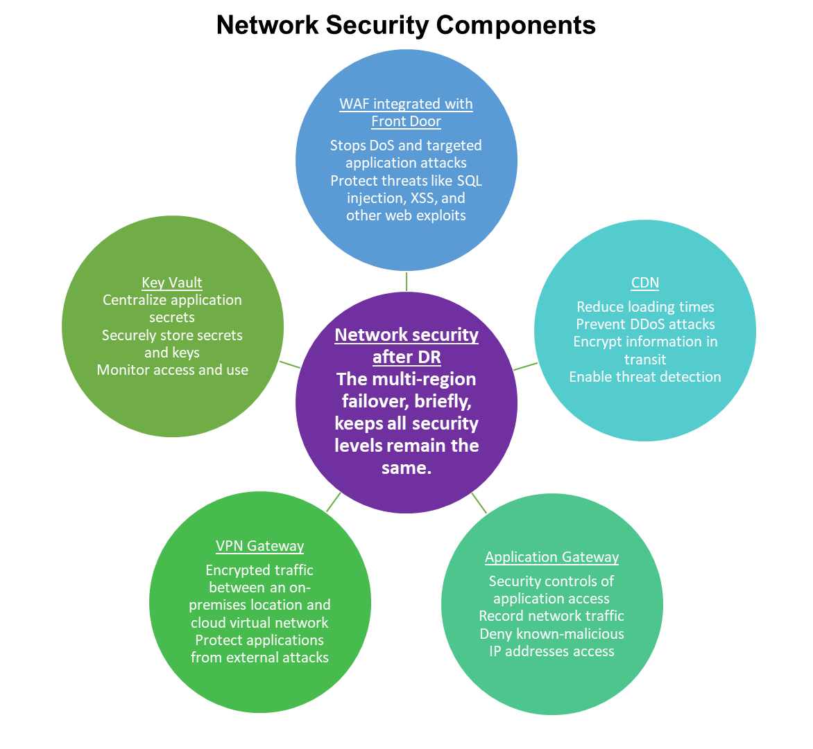

Figure 10: Network Security Components (Azure, 2022), ST18-001 (CISA, 2020)

## Vendor provision/ lock-in

|  |  |
| --- | --- |
| **Secure Software Development Framework (SSDF)** | |
| **Prepare the Organization (PO)** | Container instances and application gateway (Figure 11) Separate the loading and states of the application to different user groups |
| **Protect Software (PS)** | Vendor (Figure 11) Allowed to make changes in the development environment only Use version control features of the repository to track all changes Adopt CI/CD pipeline to automate the software delivery process |
| **Produce Well-Secured Software (PW)** | Quality Assurance (Figure 11) Verify software complies with security requirements and mitigates risks Test executable code to identify vulnerabilities Review the software design to verify compliance |
| **Respond to Vulnerabilities (RV)** | Rollback / Take offline (Figure 12) Identify the vulnerabilities version Limit assess and remediate the vulnerabilities in container Analyse the container and identify the root causes |

Figure 11: SSDF **(NIST, 2022)**

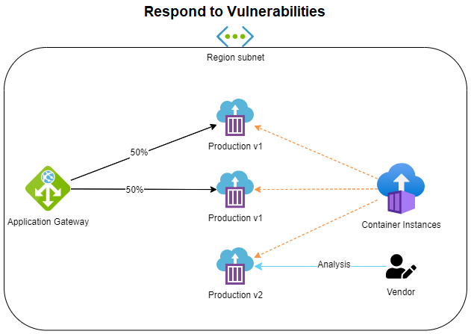

Figure 12: Respond to Vulnerabilities (Azure, 2022)

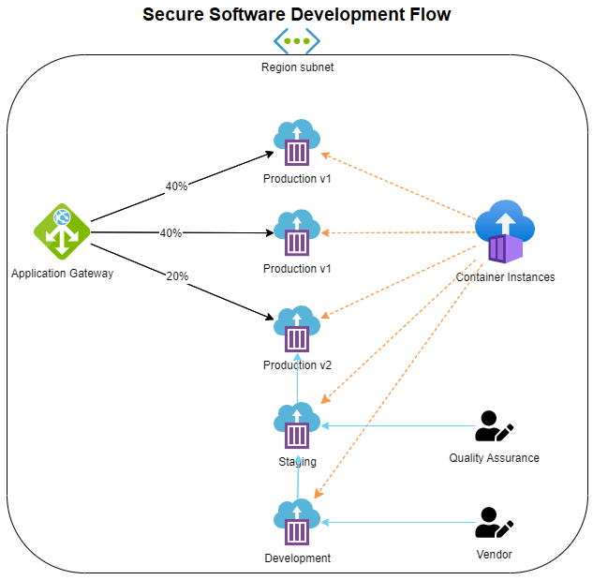

Figure 13: Secure to Vulnerabilities (Azure, 2022)

# ****References****

Azure. **(N.D.)** Pricing calculator. Pricing. **Available from:** https://azure.microsoft.com/en-us/pricing/calculator/[Accessed 15 April 2022]

Azure. **(August 2, 2022)** Global data distribution with Azure Cosmos DB - under the hood. Cosmos DB. **Available from:** https://docs.microsoft.com/en-us/azure/cosmos-db/global-dist-under-the-hood[Accessed 15 April 2022]

Azure. (**February 3, 2022)** Cross-region replication in Azure: Business continuity and disaster recovery. Availability Zones. **Available from:** https://docs.microsoft.com/en-us/azure/availability-zones/cross-region-replication-azure[Accessed 15 April 2022]

Azure. (**N.D.)** Frequently asked questions for Azure Web Application Firewall on Azure Front Door Service. Web Application Firewall. **Available from:** https://docs.microsoft.com/en-us/azure/web-application-firewall/afds/waf-faq[Accessed 15 April 2022]

Azure. (**February 16, 2022)** Azure security baseline for Content Delivery Network. Security baselines for Azure. **Available from:** https://docs.microsoft.com/en-us/security/benchmark/azure/baselines/content-delivery-network-security-baseline[Accessed 15 April 2022]

Azure. (**November 17, 2021)** Azure security baseline for VPN Gateway. Security baselines for Azure. **Available from:** https://docs.microsoft.com/en-us/security/benchmark/azure/baselines/vpn-gateway-security-baseline[Accessed 15 April 2022]

Azure. (**November 10, 2021)** Azure security baseline for Application Gateway. Security baselines for Azure. **Available from:** https://docs.microsoft.com/en-us/security/benchmark/azure/baselines/application-gateway-security-baseline[Accessed 15 April 2022]

Azure. (**October 19, 2021)** About Azure Key Vault. Security. **Available from:** https://docs.microsoft.com/en-us/azure/key-vault/general/overview[Accessed 15 April 2022]

**CHX Products. (N.D.) Spork. Food & Drinkware. Available from: https://www.chxproducts.co.uk/product/spork/** [Accessed 15 April 2022]

CISA. (June 30, 2020) Security Tip (ST18-001). National Cyber Awareness System. **Available from:** https://www.cisa.gov/uscert/ncas/tips/ST18-001[Accessed 15 April 2022]

Gremlin. **(N.D.) Why Do Large Ecommerce Sites Go Down?. The Cost of Downtime for the Top US Ecommerce Sites. Available from:** https://www.gremlin.com/ecommerce-cost-of-downtime/[Accessed 15 April 2022]

NIST. (December 9, 2021) Developing Cyber Resilient Systems: A Systems Security Engineering Approach. NIST Special Publication 800-160 Vol. 2. **Available from:** https://nvlpubs.nist.gov/nistpubs/SpecialPublications/NIST.SP.800-160v2.pdf[Accessed 15 April 2022]

NIST. (APRIL 23, 2020) Secure Software Development Framework (SSDF) Version 1.1: Recommendations for Mitigating the Risk of Software Vulnerabilities. NIST Special Publication 800-218. **Available from:** https://nvlpubs.nist.gov/nistpubs/CSWP/NIST.CSWP.04232020.pdf[Accessed 15 April 2022]