Initial Post

The Grabosky article compares typical criminals with cybercriminals in various contexts. Grabosky stated that there are no differences between traditional criminals and cybercriminals in terms of their motivations for committing crimes. The element of novelty is found in technology's previously unheard-of ability to make it easier to act on these motives (Grabosky, 2001). Regarding the global study of hackers' motivations in figure 1, it was revealed that the six motivations listed by Grabosky are still applicable to all the motivations found in the study (Raconteur, 2017).

Grabosky observed that it appears that online communication offers fresh chances to elicit greater candour than one could anticipate in face-to-face interactions. The smart ones avoid getting caught, or at the very least, getting prosecuted and convicted (Grabosky, 2001). Cyberspace may be used as a technique to facilitate skilled criminals committing cybercrimes without being noticed or being caught.

Grabosky claimed that the state is beginning to face new difficulties because of cybercrime in the digital world. Since governments and legal frameworks have a difficult time adjusting to new media. The regulation of digital technology might halt the economic growth of internet commerce and the current globalization (Grabosky, 2001).

Cybercrimes can simply perform from anywhere in the world. This will not only make it more challenging to identify the culprit as well as seriously obstruct efforts to prosecute the criminal. Such as the cybercrime of forced labour in Cambodia and Myanmar since 2020. The victims of cyber slavery are still obliged to pay the ransom to be freed as of August 2022 (RTHK, 2022). Although the criminal location has been found, the Asian countries' cooperation is only partially forthcoming (Taiwan Posts, 2022). Like phones or other media, the internet is a means for deception, and the nature of crime is the same.

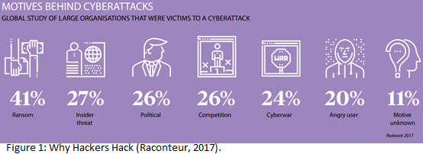

References:

Grabosky, P. (2001) Virtual Criminality: Old Wine in New Bottles?. *Social & Legal Studies*. 10(2): 243-249. DOI: https://doi.org/10.1177/a017405

Raconteur. (2017) Why Hackers Hack. *Cyber Risk Resilience 2017*. Available from: https://www.raconteur.net/infographics/why-hackers-hack/ [Accessed 21 Aug 2022].

RTHK. (August 18, 2022) Govt urged to warn Hongkongers of trafficking risk. *Latest News*. Available from: https://news.rthk.hk/rthk/en/component/k2/1662945-20220818.htm [Accessed 21 Aug 2022].

Taiwan Posts. (August 18, 2022) More terrifying than Cambodia’s organ selling “KK Park”, the main suspect arrested. *Breaking News*. Available from: https://taiwan.postsen.com/news/15967/Got-it-More-terrifying-than-Cambodia%E2%80%99s-organ-selling-KK-Park-the-main-suspect-arrested--International--Sanli-News-Network-SETNCOM.html [Accessed 21 Aug 2022].