Wiki Activity

Find a questionnaire and critique the design, both the format and the questions used.

Consider areas such as ‘why is this question included?’, ‘is the form of the question appropriate?’ etc. How can you improve the questionnaire?

Put your analysis in the module wiki and comment on others’ analyses.

找到一份調查問卷並評論設計，包括格式和使用的問題。

考慮諸如“為什麼包括這個問題？”、“問題的形式合適嗎？”等領域。如何改進問卷？

將您的分析放在模塊 wiki 中並評論其他人的分析。

Growing Science (2022) did a survey about Blockchain technology adoption for sustainable learning that suggest a new model and techniques to collect data in a survey.

The model assesses the influence of five external variables (e.g., Convenience, Facilitating Condition, Effort Expectancy, Cost, and Social Influence) upon the intention to use BT in SLE.

The purpose is to determine if there is a correlation between the belief constructs and external variables.

The research model is based on Technology Acceptance Model (TAM) model and built with nine factors with 36 questions.

This work utilizes theories testing, which shows the idea of relationships. So, one can gauge the qualities of connections among factors. The proposed model is illustrated in Figure 2, which is utilized to check the speculations and distinguish the relations amongst the tested components.

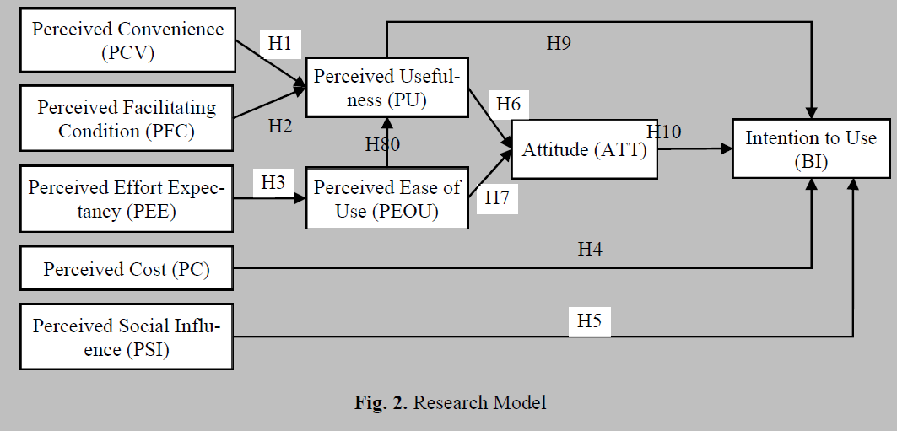

The survey instrument is divided into two sections: The first section contains sociodemographic questions and a screening question about BT awareness. The screening question is used to minimize the biases. Participants who have no idea about BT are excluded from the study. The second section contains open-ended questions that examine the intention to use BT for SLE.

Some questions are too positive that I would like to highlight:

“Blockchain technology usage is a good idea.”

“The use of blockchain technology in completing my tasks is easy.”

The Pushy Question

This is similar to a leading question as you are trying to get them to answer in a certain way. Often this is due to an unconscious selection of options for them to choose from. A good pilot study will highlight these questions. (QuestionPro, 2021)

Acquiescence bias: People have the tendency to say they like things, to say “yes” to things, or to agree with things—even if they don’t actually feel that way. Think about it this way: When your coworker asks if you like her new sweater, you’ll usually agree with her, right? Research has shown that tendency to hold true in answering survey questions, too.

The questionnaire utilizes a five-point scale with anchors ranging from "strongly disagree" to "strongly agree."

the question reformulated in a way that avoids asking for agreement below

Dissatisfied, Satisfied, very satisfied

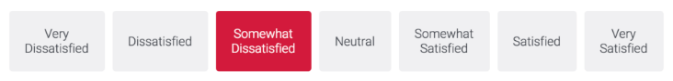

Blockchain technology usage is a good idea

The use of blockchain technology in completing my tasks is easy.

Target Participants

the survey is being distributed over 407 samples of participants,

(QuestionPro (2021) Questionnaire vs Survey: Is there a Difference?)

https://www.qualtrics.com/blog/avoiding-the-yes-bias/