HandsMen Threads: Elevating the Art of Sophistication in Men's Fashion

ABSTRACT
This project showcases the development of a custom Salesforce CRM system for HandsMen Threads, a modern brand specializing in men’s fashion and bespoke tailoring. The aim of the project was to improve how the company manages its data, streamline day-to-day operations, and provide a more engaging experience for customers. The solution centers on a well-structured data model composed of five main custom objects: Customer, Order, Product, Inventory, and Marketing Campaign.
Key business tasks such as confirming orders, updating customer loyalty levels, and alerting teams about low stock were automated using a combination of Apex triggers, scheduled jobs, and flow automation, allowing the system to operate efficiently without manual intervention. Data reliability and security were prioritized through the use of validation rules and a role-based access system tailored for the Sales, Inventory, and Marketing teams.
The implementation also includes an automated batch process that keeps inventory records up-to-date, preventing stock issues and supporting smooth business operations. By integrating automation, structured data management, and personalized customer communication, this Salesforce solution not only enhances operational efficiency but also lays a strong foundation for future growth and scalability within HandsMen Threads.

OBJECTIVE
The main purpose of this project is to design and implement a customized Salesforce CRM solution for HandsMen Threads, a brand focused on sophisticated men’s fashion. The goal is to simplify and organize the company’s core business operations, ensure the accuracy and consistency of data across all departments, and ultimately enhance the overall experience for customers.
By creating a centralized system that integrates customers, orders, products, inventory, and marketing campaigns, this project aims to transform how the company manages its operations. Key objectives include:
- Automating critical business processes such as sending order confirmations, updating customer loyalty statuses, and issuing timely stock alerts, so that routine tasks are handled efficiently without manual intervention.
- Maintaining data integrity through validation rules that help prevent errors and ensure that all information entered into the system is accurate and reliable.
- Providing real-time visibility into inventory levels, customer interactions, and sales activities, giving teams actionable insights to make informed decisions quickly.
- Improving internal coordination and workflow by implementing role-based access controls, which ensure that team members have the right level of access to data and tools based on their responsibilities.
- Enhancing customer engagement by enabling personalized communication and loyalty programs, allowing the brand to deliver targeted offers, updates, and rewards that foster stronger relationships with customers.

Overall, this project aims to not only optimize daily operations but also create a scalable, future-ready CRM platform that supports HandsMen Threads in delivering a seamless, professional, and highly personalized experience for every customer.

TECHNOLOGY DESCRIPTION
Salesforce:
Salesforce is a cloud-based Customer Relationship Management (CRM) platform designed to help organizations efficiently manage their customer data while streamlining business operations. It allows businesses to automate workflows, improve sales processes, and enhance customer service and marketing activities. Salesforce provides both user-friendly, point-and-click tools as well as programmatic features, such as Apex and Flows, enabling the creation of custom solutions tailored to specific organizational needs.
Custom Objects:
In Salesforce, objects function similarly to database tables, storing information about different aspects of the business. Custom Objects are specifically created to capture unique data that standard objects cannot cover. Examples:
- Customer__c – Stores details about each customer.
- Product__c – Holds information about products, including specifications and pricing.
- Order__c – Tracks customer orders and purchase details.

Tabs:
Tabs provide a way to display object data within the Salesforce interface. They allow users to navigate, view, and manage data efficiently. Example: A Product__c tab lets users quickly access and manage product information.
Custom App:
A Salesforce App is a collection of tabs and tools grouped together to support a specific business process. This helps organize related features in one convenient interface.
Profiles, Roles, and Permission Sets:
Profiles define a user’s access levels, determining what users can view, edit, or create. Roles control data visibility within Salesforce's hierarchy and support sharing rules. Permission Sets provide additional access rights without altering existing profiles.
Validation Rules, Email Templates & Alerts, Flows, Apex:
Validation Rules ensure data accuracy. Email Templates and Alerts automate communication. Flows automate complex processes without coding, while Apex allows for custom business logic beyond point-and-click tools.

DETAILED EXECUTION OF PROJECT PHASES
- Salesforce Developer Org Setup
- Created a Salesforce Developer Org via Salesforce Signup.
https://developer.salesforce.com/signup
- Verified the account, set password, and accessed the Salesforce Setup page.
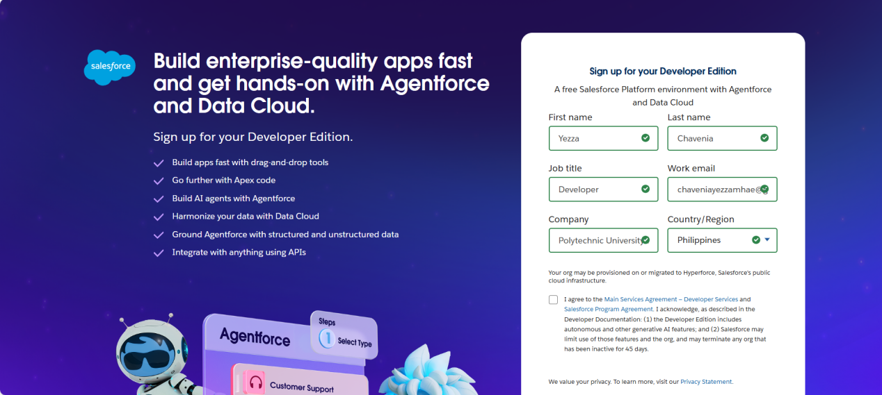
- Custom Object Design
- Created five custom objects: HandsMen Customer, HandsMen Product, HandsMen Order, Inventory, Marketing Campaign.
- Defined object labels, API names, and enabled reporting/search features.
- Created dedicated tabs for each object in the Lightning interface.
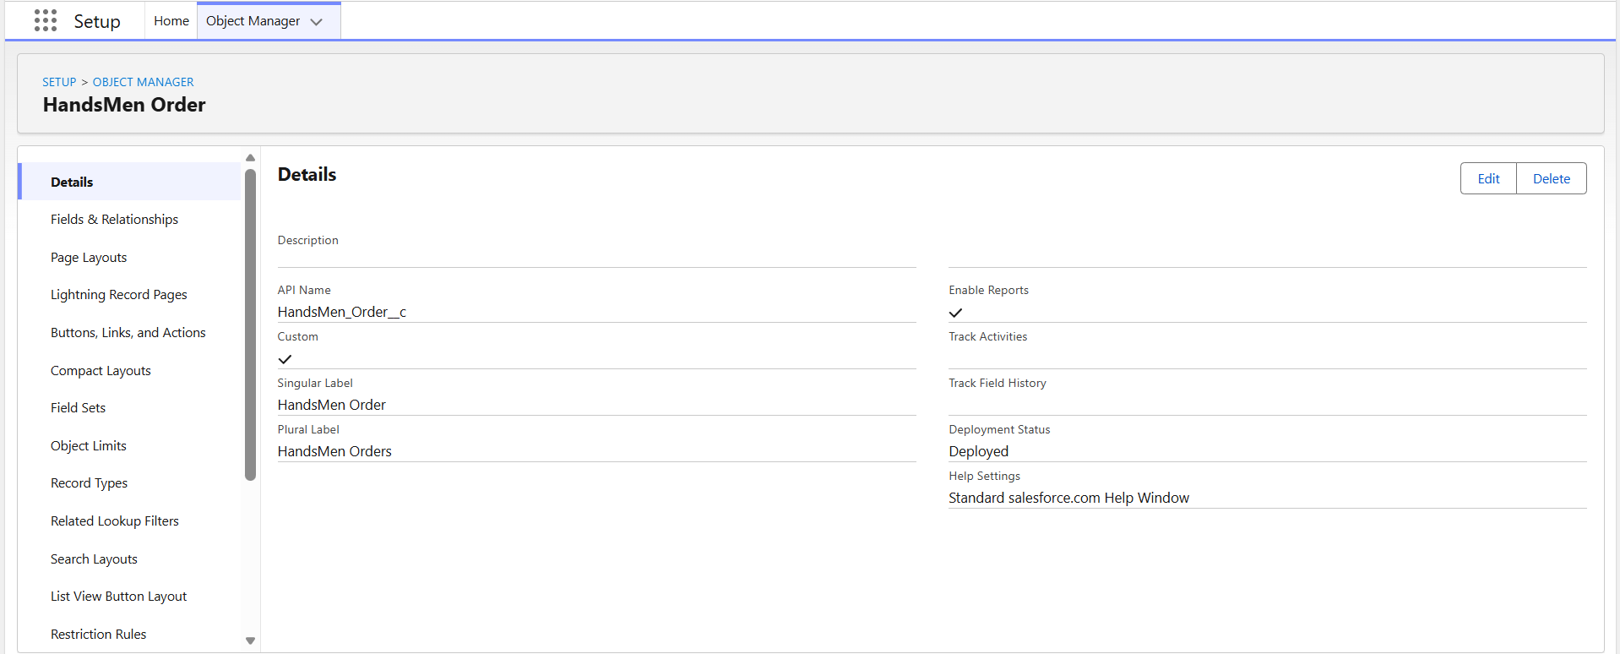
- Lightning App Creation
- Built a custom Lightning App named HandsMen Threads with tabs: Customer, Product, Order, Inventory, Campaign, Reports.
- Assigned full administrative access to the System Administrator profile.
- Validation Rules
- Declarative Rules: Prevent saving invalid orders or emails.
- Programmatic (Apex) Rules: Validates order quantities based on status before insert/update using addError().
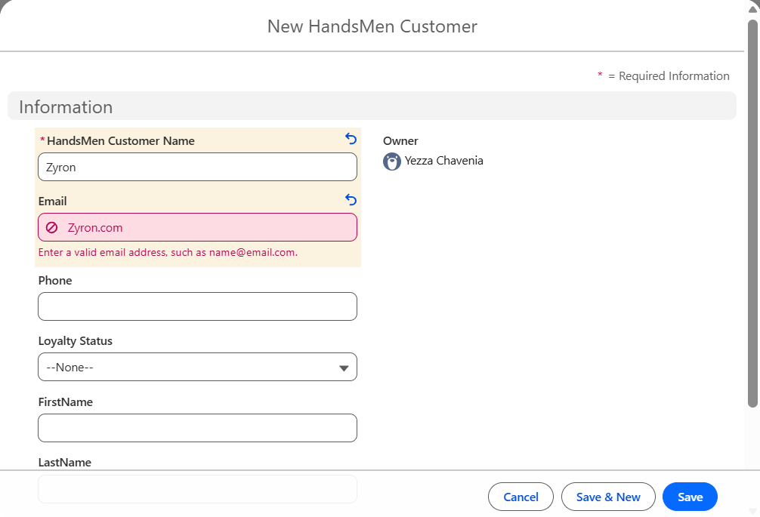
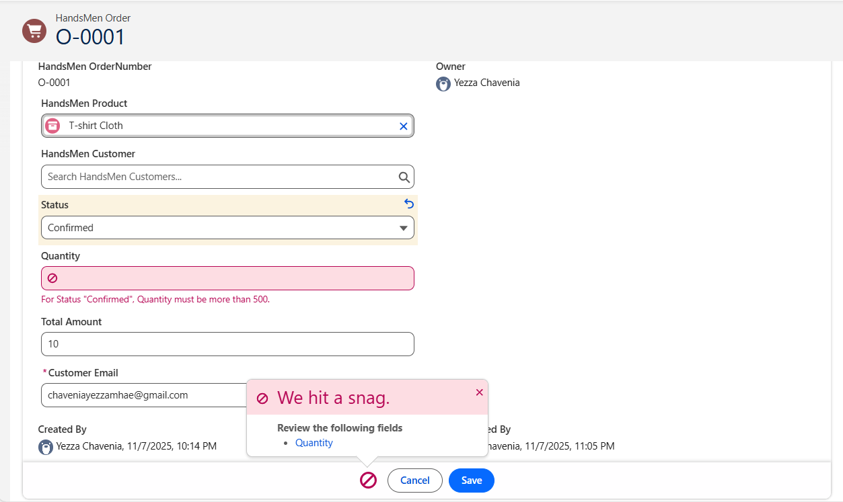

- User Roles and Profile Configuration
- Cloned the Platform 1 profile for permissions.
- Defined roles: Sales Manager, Inventory Manager, Marketing Team.
- User Creation
- Assigned users to roles and profiles:
- Niklaus Mikaelson → Sales
- Kol Mikaelson → Inventory
- Zyron Mikaelson → Marketing
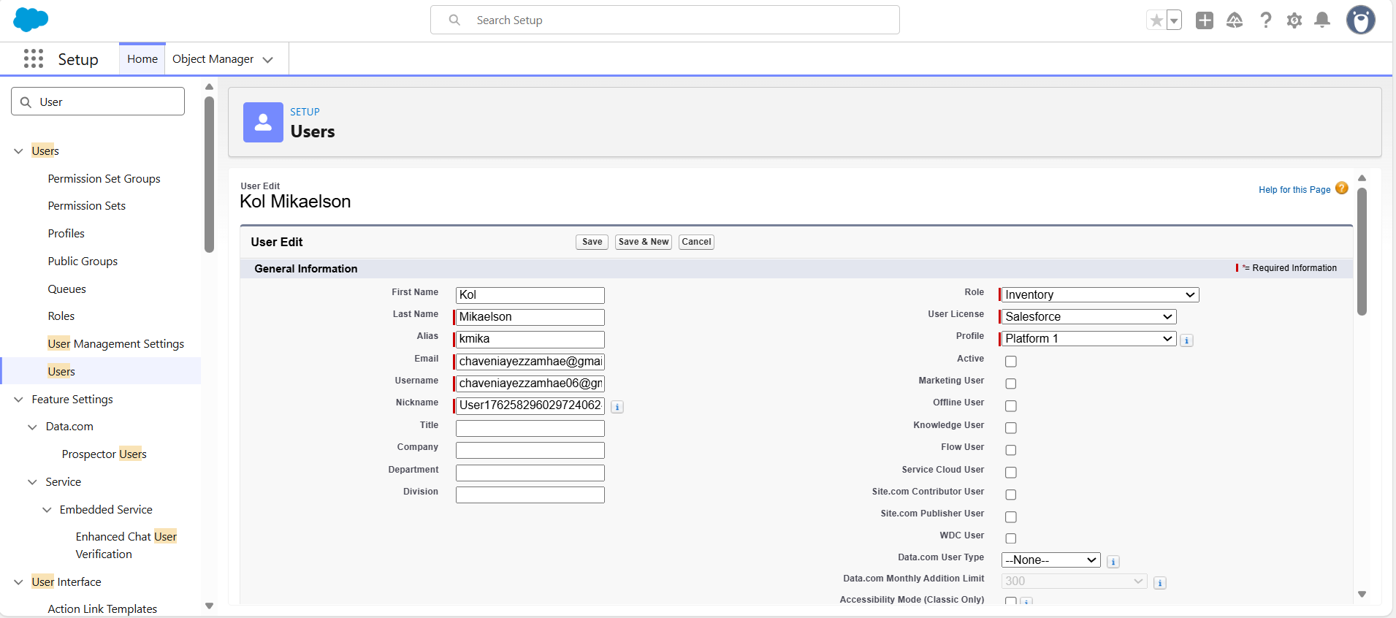
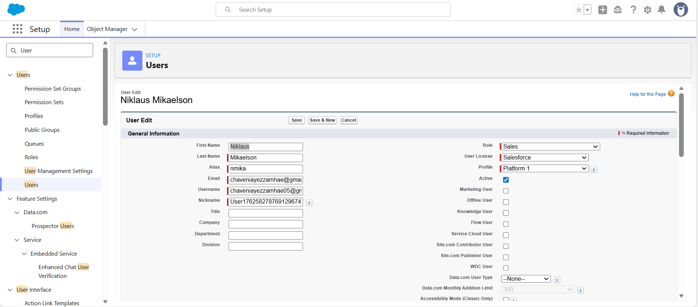
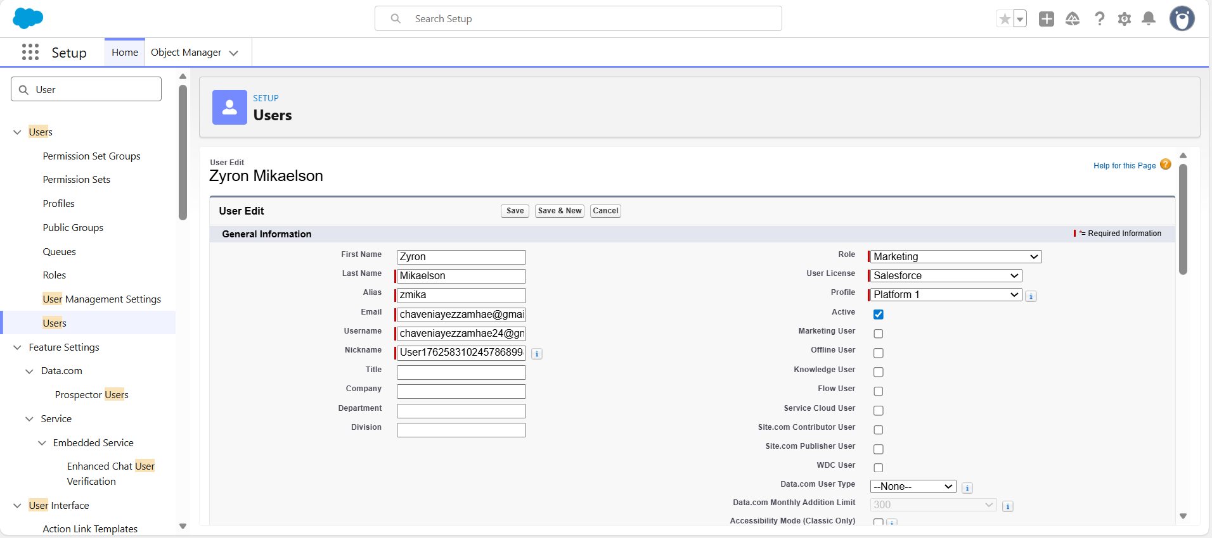

- Email Templates and Alerts
- Created Order Confirmation, Low Stock Alert, Loyalty Program Update templates.
- Integrated with automation flows for reliable messaging.
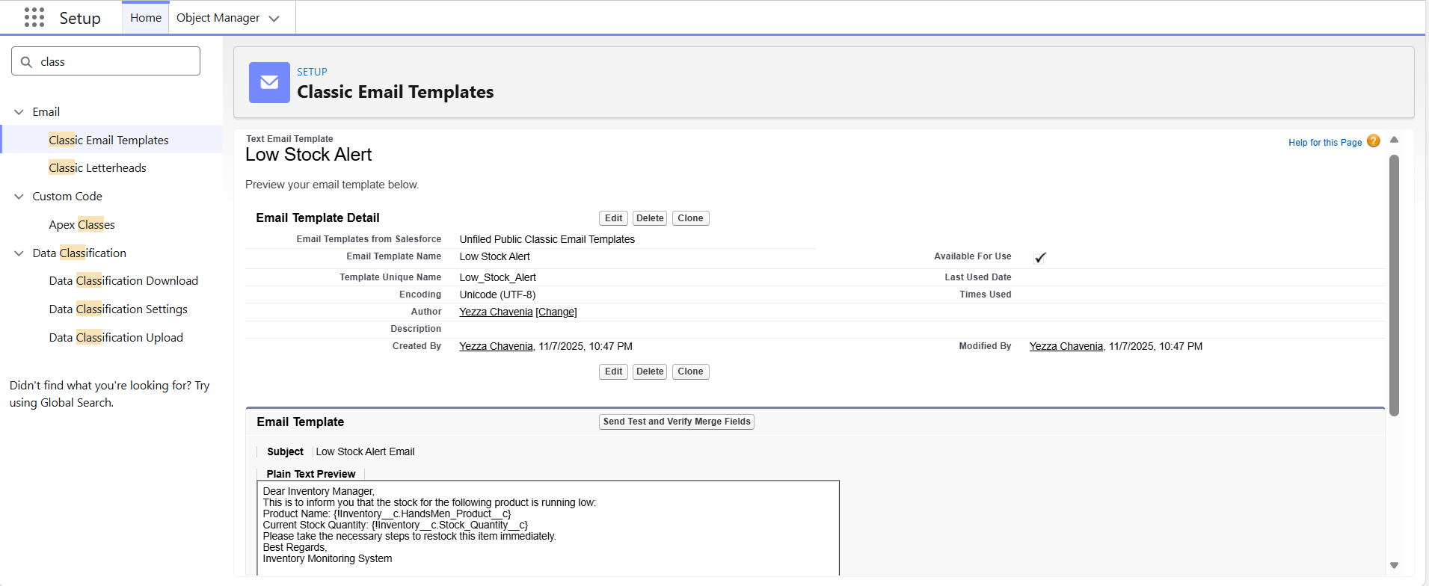
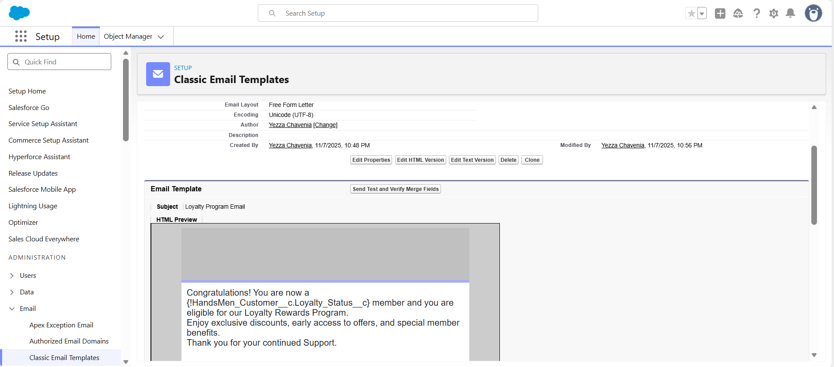
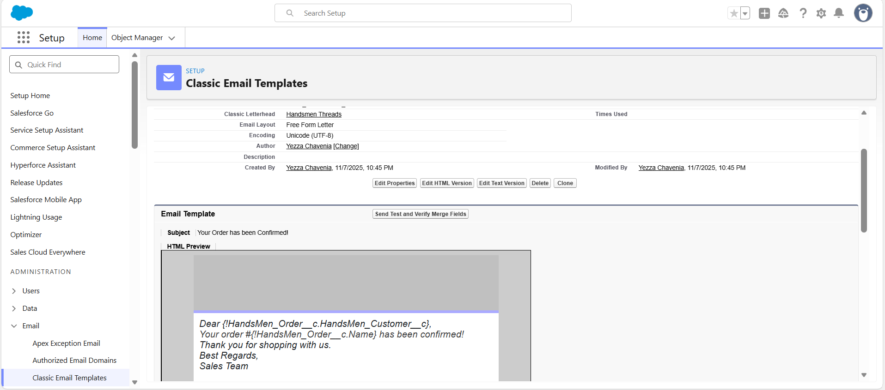

- Flow Implementations
- Order Confirmation Flow, Stock Alert Flow, Scheduled Loyalty Update Flow automated notifications and updates.
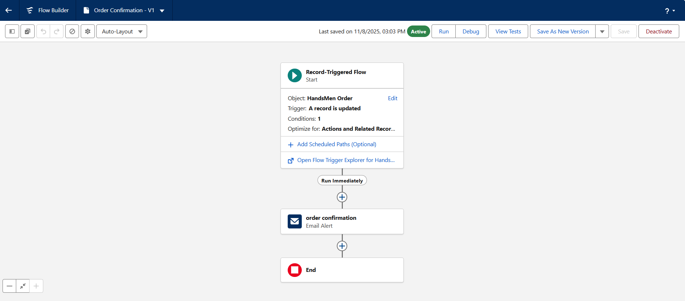
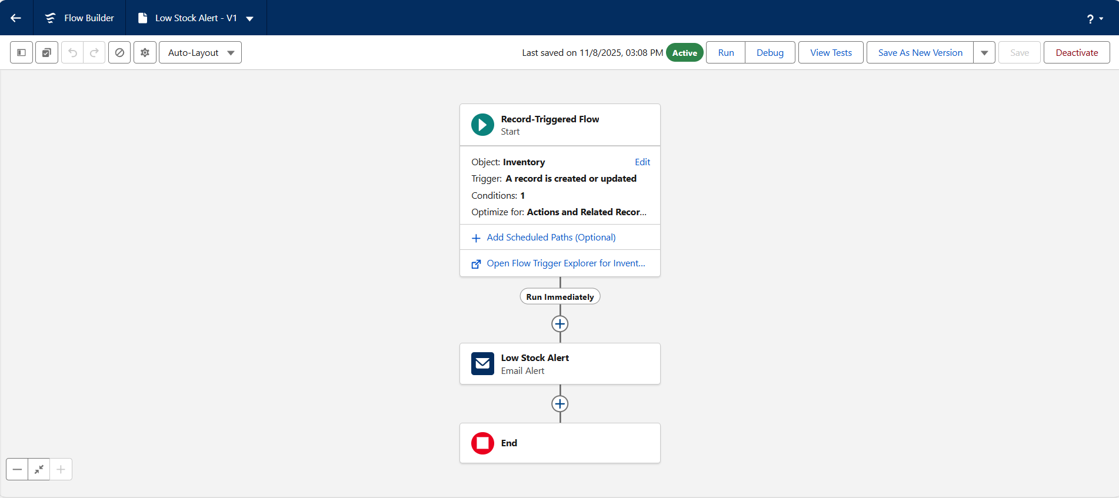
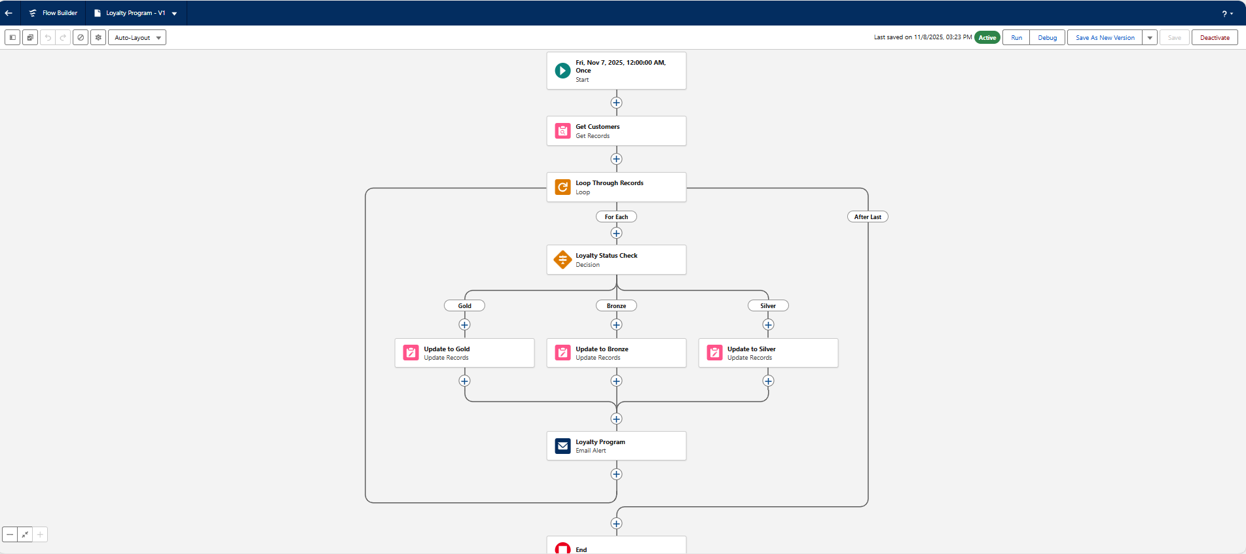

- Apex Triggers & Classes
- Order Total Trigger, Stock Deduction Trigger, Loyalty Status Trigger.
- Apex classes ensure correct order validation and enforce business rules.

PROJECT WALKTHROUGH: REAL-WORLD SCENARIO
- Customer Registration
- Customer Jennie Kim registers in the store or online portal.
- Salesforce creates a Customer record; validation ensures proper email format.
- Product Setup
- Admin sets up products with pricing, descriptions, and inventory levels.

- Placing an Order
- Jennie orders 501 T-shirts at ₱3 each; total calculated automatically.
- Apex triggers ensure quantities meet business rules.
- Updating Inventory
- Inventory automatically decreases; validation ensures stock never drops below zero.
- Loyalty Program
- System evaluates total spending to assign Bronze, Silver, or Gold membership.
- Automated Email Notifications
- Flows send order confirmations and loyalty updates.
- Users and Roles
- Each Salesforce user has role-specific access to ensure security and efficiency.

SCREENSHOTS
- Custom App for HandsMen Threads
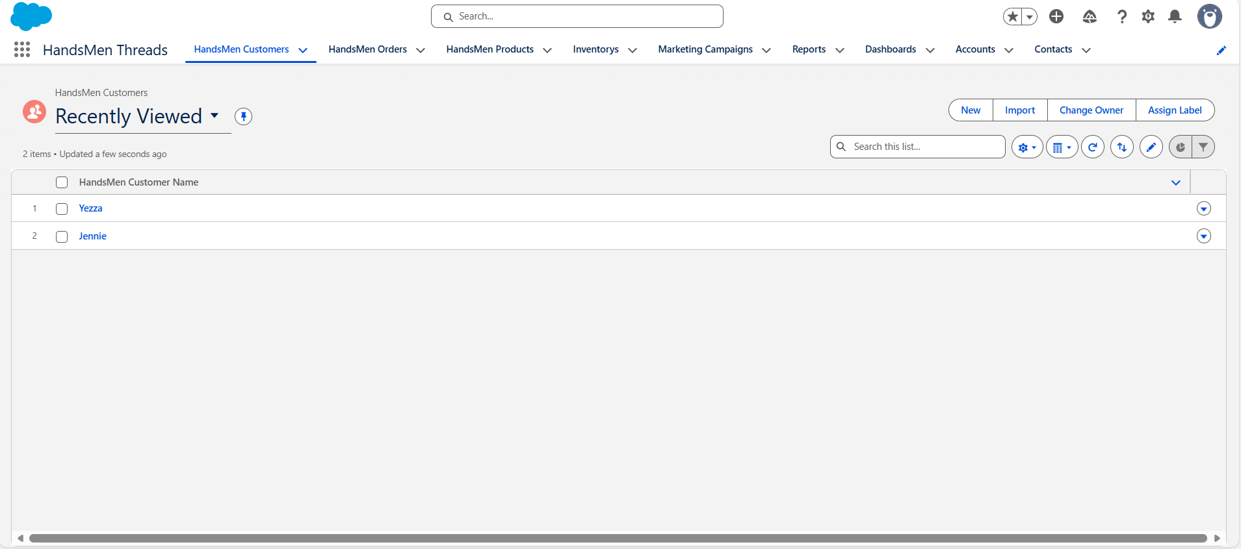

- Customer Creation
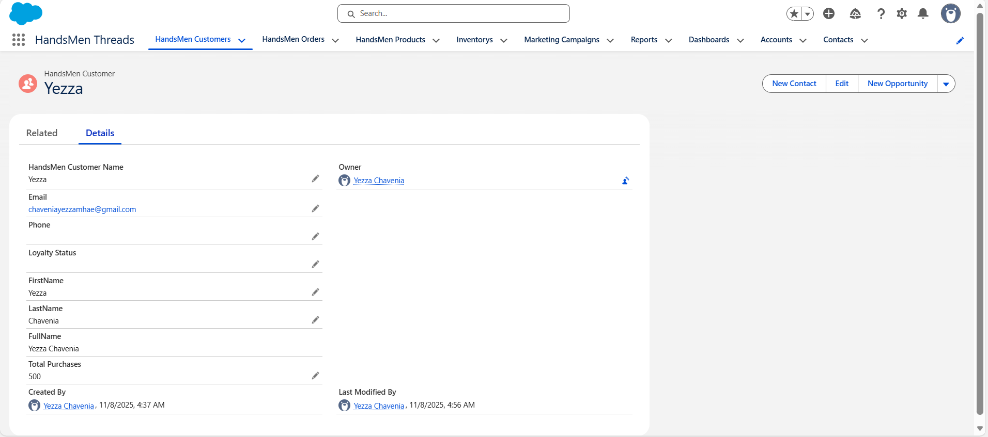

- Products Management
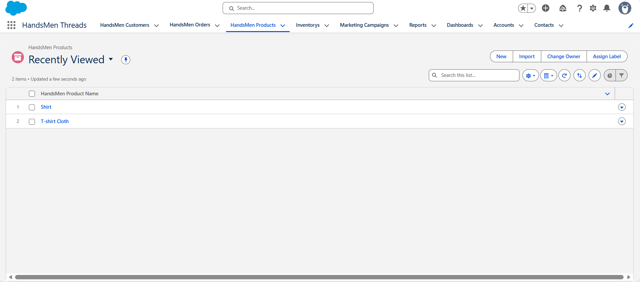
- Order Confirmation
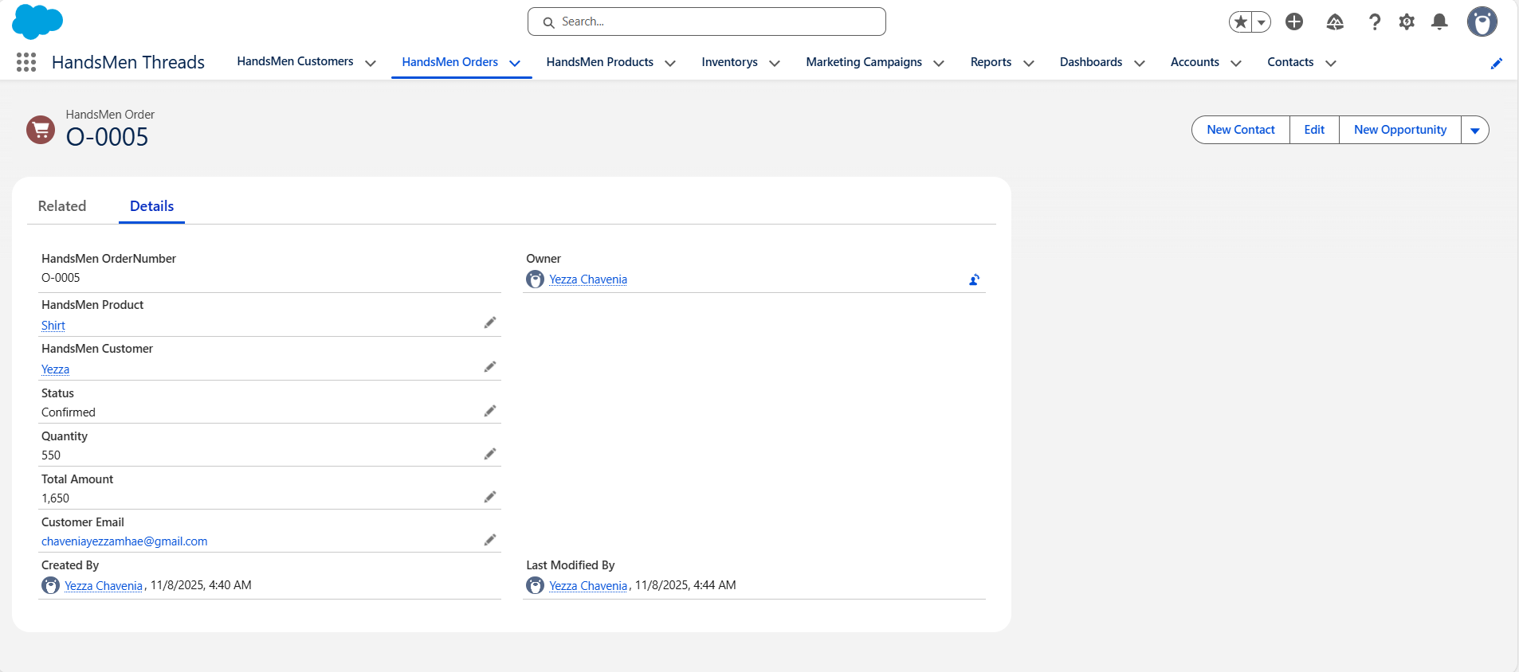

- Inventory Management
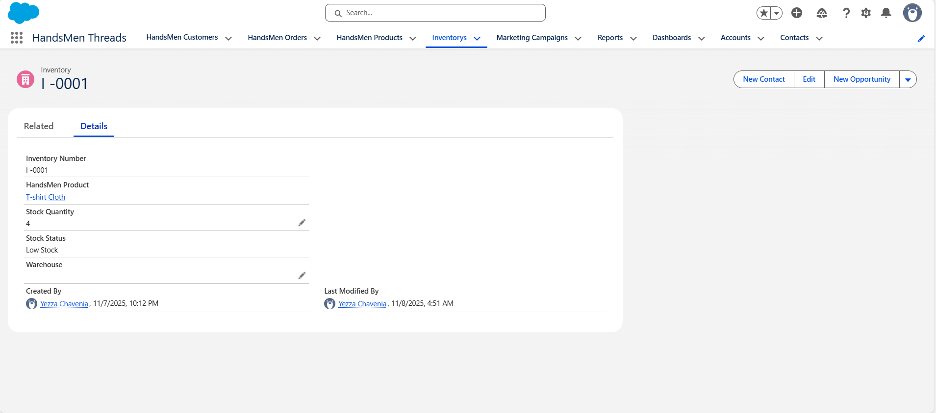

- Validation Rules for Rejection, Pending, Confirmed
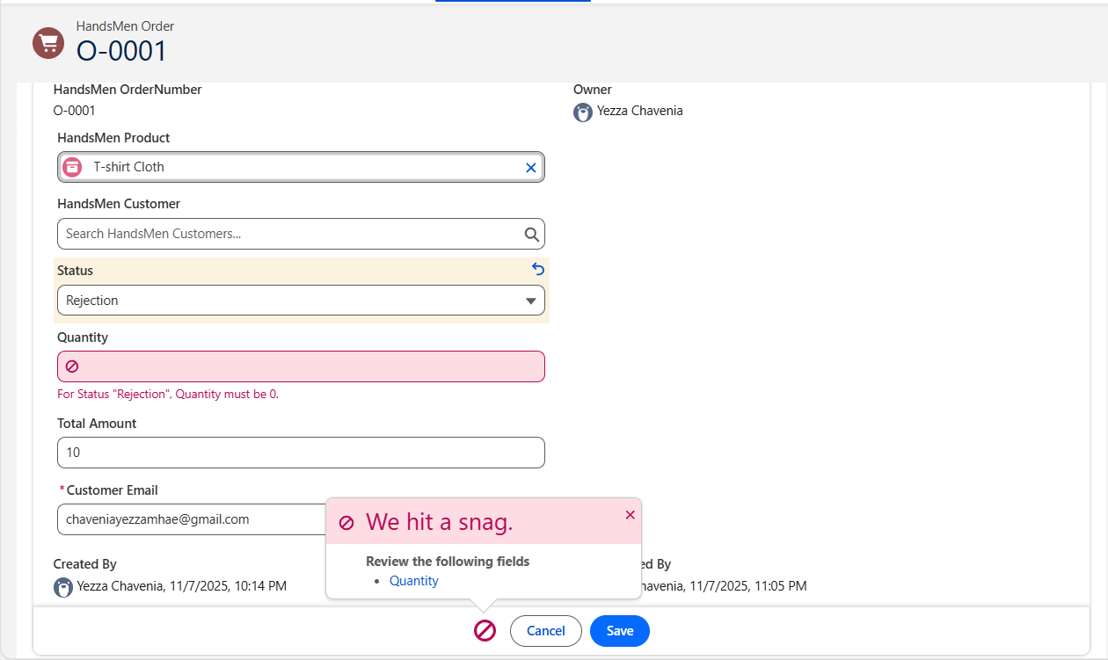
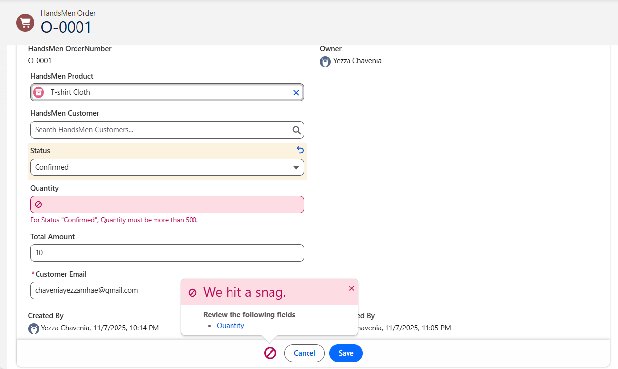
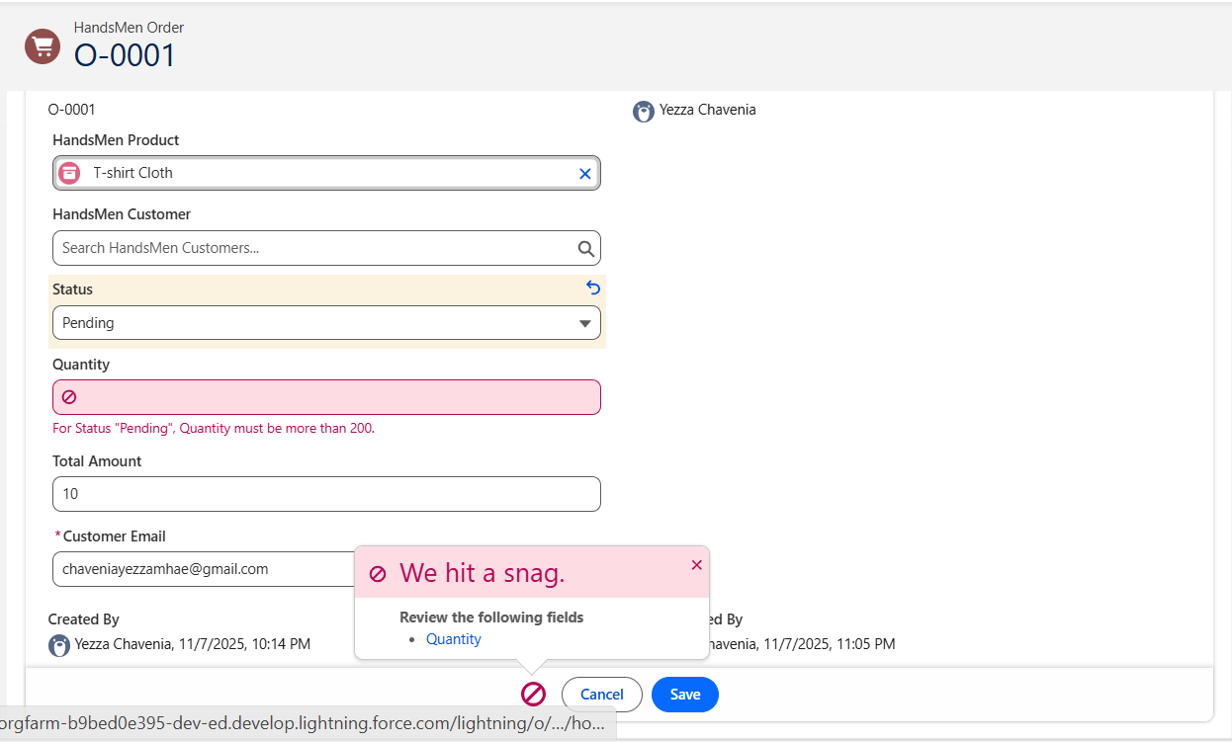

- Email Notifications: Order Confirmation, Low Stock, Loyalty Program
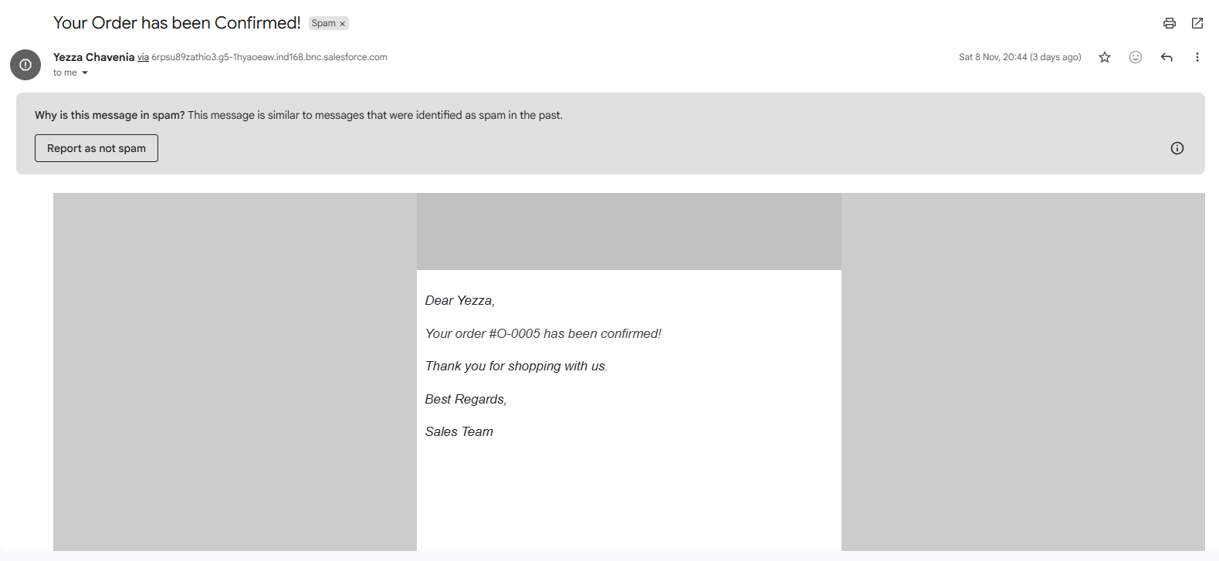
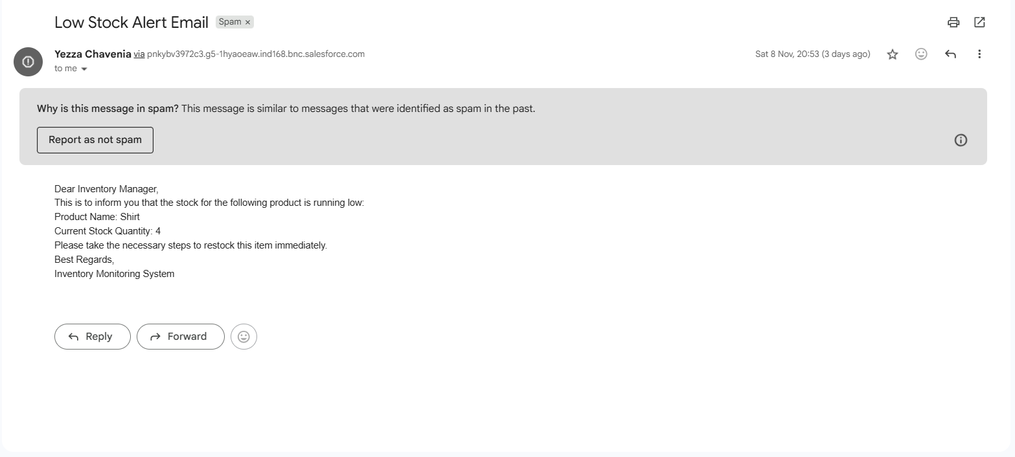
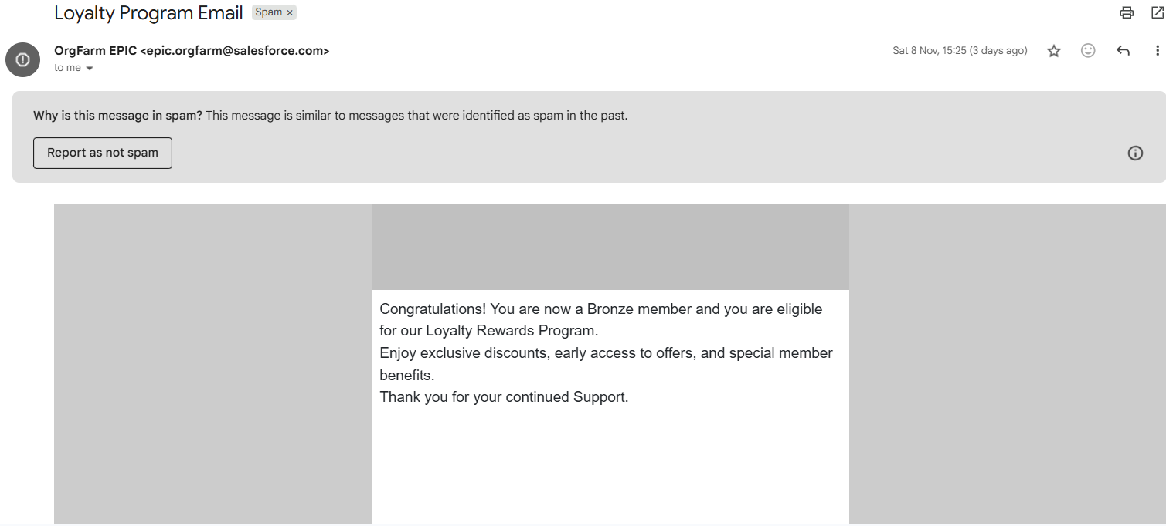

CONCLUSION
The HandsMen Threads CRM simplifies customer management, product catalog maintenance, order handling, inventory monitoring, and loyalty program management. By utilizing Salesforce features like Custom Objects, Flows, Validation Rules, Email Alerts, and Apex, the system delivers:
- Accurate and up-to-date data: Minimizes errors and improves efficiency.
- Better customer experience: Enhances engagement and satisfaction.
- Informed decision-making: Provides actionable insights on sales, inventory, and orders.
- Scalable operations: Supports growth with flexible roles and new products.
- Streamlined workflows: Reduces manual intervention, boosting productivity.
Overall, this CRM demonstrates how Salesforce’s declarative and programmatic tools can support operational efficiency and customer satisfaction.

FUTURE SCOPE
- Customer Portal Integration – Self-service portal for order tracking, loyalty points, and inquiries.
- Mobile Access via Salesforce Mobile SDK – Mobile inventory, order management, and push notifications.
- Enhanced Reporting and Dashboards – Interactive dashboards and predictive analytics.
- AI-Powered Product Recommendations (Einstein) – Personalized suggestions to improve engagement.
- WhatsApp/SMS Communication Integration – Timely updates for orders and promotions.
- Gamification and Engagement Features – Loyalty badges and tiered rewards.
- E-commerce and Payment Gateway Integration – Synchronize orders, payments, and inventory.
- Advanced Automation and Process Improvements – Manage bulk orders, returns, and customer segmentation.

