VAD guided noise updating for Wiener speech enhancement
  - NOIZEUS benchmarks and controlled changes in noise level
Yulong Chen | SID 550889472 | GitHub yche0441
ELEC5305 Acoustics, Speech and Signal Processing | 21 October 2026
Project website and demonstration materials
Repository and downloadable code
Video presentation and code demonstration

Abstract
This project tests when voice activity detection (VAD) helps a Wiener speech enhancer update its noise estimate. A shared two-step noise reduction (TSNR) path compares fixed estimation with an energy gate, then tests a more protective gate selected on development data. All main intelligibility results use one standard STOI implementation. In 32 original evaluation conditions, adaptive updating improves both reference SNR and STOI in only five cases. A nine-setting development study selects a 1 dB threshold and ten-frame hangover. On 48 unused sentence conditions, this setting adds 0.00404 mean STOI over the original gate but remains 0.00064 below fixed estimation. The direction of each average survives removing any one test sentence. A further controlled experiment reuses six sentences and identical underlying noise, applying constant, rising and falling noise envelopes without retuning. It directly examines how gate decisions affect tracking after a level change. Neither gate permits late updates in any rising-noise case, whereas falling noise allows renewed tracking; the selected method then gains 0.143 dB and 0.00201 STOI over fixed estimation. The evidence supports conditional benefits from adaptation, with a trade-off between protecting speech and allowing noise updates. The measurements establish neither perceptual preference nor general superiority.

Contents
1 Research question and contribution 2
2 Literature and design rationale 3
3 Processing method 4
4 Experimental design and verification 5
5 Original benchmark reassessed 6
6 Parameter selection and new sentence test 7
7 Condition effects and sentence sensitivity 8
8 Controlled changes in noise level 9
9 Tracking behaviour and controlled results 10
10 Discussion and conclusions 11
11 References 12

1 Research question and contribution

Problem and motivation
Single-channel speech enhancement must estimate speech and noise from their mixture. Reducing background energy can also remove weak speech. A useful investigation therefore needs a reference signal, complementary metrics and an explanation of the conditions in which the processing helps or fails.
A Wiener enhancer uses a noise power spectral density (PSD) estimate in every frequency bin. An estimate measured near the start of a recording is simple and stable, but cannot track a changing background. Updating it during detected speech pauses can track changes, provided the detector admits suitable frames. Weak speech mistaken for noise can enter the estimate; a loud noise event mistaken for speech can block a needed update.

Research question
When does energy-VAD-guided noise updating improve a TSNR Wiener enhancer compared with a fixed initial estimate, and how do speech protection and noise tracking affect that result? The scope is one established enhancement path and one inspectable update rule. The study examines the rule rather than ranking complete speech enhancement systems.

Contribution
The TSNR core derives from LIU Ming and Pascal Scalart [6] and the method of Plapous et al. [1]. The additional work consists of a controlled update-policy comparison; a common reconstruction that preserves amplitude for reference scoring; a frozen parameter-selection and reassessment procedure; and diagnostics of speech overlap and noise tracking. The controlled noise-envelope experiment then manipulates one property of the same underlying mixture to test an explanation suggested by the benchmark results.
The analysis uses sample-aligned clean and noisy NOIZEUS recordings [2,5]. All methods receive the same noisy signal and use the same window, initialisation, gain calculation and reconstruction. The clean signal is available only to scoring and diagnostic routines. The original data, source licence and numerical outputs remain available in the accompanying code package.

What the experiments establish
The original gate makes small average SNR gains but loses average STOI against fixed estimation. Lowering the decision threshold and lengthening the hangover protects more speech-associated frames and improves mean STOI relative to that gate. The selected rule still updates infrequently and does not exceed fixed estimation on average STOI. Controlled changes in noise level test whether this limited updating also restricts tracking. These are conditional findings about the stated algorithm, recordings and imposed changes.
The report distinguishes the original evaluation, the development-selected new-sentence test, and the later diagnostic experiment. Reused sentences and retrospective analyses are identified explicitly. Each stage answers a different question; additional noise conditions do not create additional independent speakers.

2 Literature and design rationale

The enhancement path
Scalart and Vieira Filho [7] place a priori SNR estimation at the centre of speech enhancement. The Wiener gain depends on estimated speech and noise powers, so errors in either estimate affect suppression. Plapous et al. [1] refine the decision-directed estimate through TSNR to address its delayed response. Harmonic regeneration is a separate extension in that paper and is not implemented here. Keeping TSNR fixed makes the noise update policy an identifiable experimental change.

Choosing a noise estimator
Sohn et al. [8] develop statistical voice activity detection using a likelihood-ratio decision and temporal modelling. This offers a more structured speech-presence model than a broadband energy threshold. The present detector is deliberately simpler: its threshold and hangover make the speech-protection versus update-opportunity trade-off directly inspectable. The experiment does not reproduce the Sohn detector.
Martin [9] uses smoothed spectral minima to estimate noise without depending solely on hard speech-pause decisions. MCRA [4] regulates recursive averaging using estimated speech-presence information; improved MCRA [10] extends this approach under adverse conditions. These methods show why spectral history and uncertainty can be useful when binary decisions are unreliable.
Estimator | Useful property | Principal limitation here
Fixed initial PSD | Stable common baseline | Cannot follow later changes
Energy VAD updating | Simple decisions and explicit update times | Speech contamination or blocked tracking
Minima or probability based tracking [4,9,10] | Uses spectral history or graded speech evidence | Additional state and choices; not implemented

The method choice follows the project question: establish the effect of a transparent hard gate, identify its failure mechanism, then justify a more elaborate tracker if the evidence warrants it. Implementing several unrelated enhancers would confound the noise-estimation question with differences elsewhere in their processing.

What the measurements mean
Hu and Loizou [2] distinguish speech distortion, background-noise distortion and overall quality in subjective evaluation. Taal et al. [3] introduce STOI as an intelligibility predictor for noisy and time-frequency processed speech. These distinctions motivate reference SNR and STOI as complementary measurements. STOI is neither a word-recognition percentage nor a listening-quality score. Waveform plots and audio examples provide context, while the conclusions remain limited to measured behaviour.
The literature therefore motivates three checks: a shared enhancement path to isolate the update policy; paired reference scores to distinguish waveform error from predicted intelligibility; and direct update and tracking diagnostics to investigate why a score changes. References [1-4,7-10] supply the relevant scholarly context; [5,6,11] identify the data and software actually used.

3 Processing method

Common TSNR analysis and synthesis
The input is mono at 8 kHz. A 200-sample window, 80-sample hop and 400-point FFT implement 25 ms analysis and 10 ms updates. The window explicitly reproduces the source Hann convention, w[n] = 0.5 - 0.5 cos(2 pi n / 201), n = 1,...,200. No analysis setting is changed between methods.
Let Yₜ[k] denote a noisy-frame spectrum and Dₜ[k] the current noise PSD. The source branch forms a floored instantaneous estimate qₜ = max(|Yₜ|² / Dₜ − 1, 0.1). The decision-directed estimate combines qₜ with the previous enhanced magnitude using a 0.99 weight on the previous estimate. The following expressions apply separately in each frequency bin:
$$ξ_{t} = 0.99 |Ŝ_{t-1}|² / D_{t} + 0.01 q_{t}$$
$$G_{1,t} = ξ_{t} / (1 + ξ_{t}); ξ_{2,t} = |G_{1,t}Y_{t}|² / D_{t}$$
A second Wiener gain ξ₂,ₜ / (1 + ξ₂,ₜ) has a pre-constraint floor of 0.15. The original impulse-response constraint and energy normalisation are then applied, so 0.15 is not asserted to bound every final constrained gain. The observed phase is retained. Both modes use identical inverse-FFT accumulation, window-sum normalisation, padding and cropping.

Noise initialisation and updating
Every mode starts from the same mean power spectrum of 601 windows advanced one sample at a time within the first 0.10 s. Fixed estimation retains this PSD. The gate computes a broadband energy ratio, with each sum taken over the FFT bins:
$$R_{t} = 10 \log_{10}(Σ |Y_{t}[k]|² / Σ D_{t}[k])$$
A ratio Rₜ greater than threshold θ declares speech and resets the hangover to H frames. The next H frames at or below threshold remain protected; another detection restarts the count. Protected frames retain Dₜ. Eligible unprotected frames update only after current-frame enhancement:
$$D_{t+1} = 0.95 D_{t} + 0.05 |Y_{t}|²$$
The original gate uses 3 dB and five hangover frames. The selected gate uses 1 dB and ten frames. A lower threshold declares speech more readily; a longer hangover retains protection after a detection. Calibration and padded frames never update. Their clean reference is never an algorithm input.

Reconstruction and attribution
Independent peak normalisation from the source demo is removed because it would alter reference-error comparisons. All methods share the replacement reconstruction, which passes a unity-gain identity check. A separate legacy mode reproduces the source for verification. The provided licence and source headers credit the inherited TSNR implementation [6]; the controlled reconstruction and update experiments are documented adaptations.

4 Experimental design and verification

Three complementary stages
Stage | Material and selection | Question
Original benchmark | sp01/sp16 development; sp06/sp11/sp21/sp26 evaluation; car/street at 0/5/10/15 dB | Does the original gate help fixed TSNR?
Parameter study | 9 settings on 16 development cases; selected rule frozen before 48 cases from six unused sentences | Does a more protective gate improve the original rule?
Controlled diagnostic | Same six test sentences reused; same residual noise under 3 prescribed level profiles; 36 mixtures | How do imposed changes interact with the frozen gates?

The original 32 evaluation conditions span four other speakers than the two development sentences. The later test uses sp02, sp07, sp12, sp17, sp22 and sp27: unused sentences at selection time, but speakers already represented in the corpus subsets. The controlled diagnostic deliberately reuses these sentences. Its protocol is saved before running, with no further parameter selection.

One intelligibility implementation throughout
Every main STOI value in this report uses standard pystoi 0.4.1, extended=False [11]. The original v1 outputs have been retrospectively rescored from unchanged, unquantized waveforms. Historical native MATLAB scores remain in the archive. This rescore changes one paired STOI direction and the count improving both metrics from six to five of 32; neither algorithm nor its output is changed.
Across 144 archived scores, mean absolute implementation disagreement is 0.00285; maximum paired-effect disagreement is 0.00542. This motivates consistent scoring, not an error bar on within-pystoi comparisons. The new study and diagnostic already use the common implementation.

Scoring and interpretation
Reference SNR is 10 log10 of clean energy divided by processed-minus-clean error energy. It penalises residual noise and speech distortion together. All whole-recording metrics exclude samples 1:800; there is no delay fitting, gain fitting or per-method amplitude normalisation. Nominal NOIZEUS SNR labels use active speech scaling [5] and need not equal this measured SNR. Means are arithmetic means of case scores, not pooled waveform SNR.
Paired differences always use the same input and reference. New-test sensitivity averages the eight conditions within each sentence, then removes one entire sentence at a time. These six leave-one-out averages are descriptive checks, not confidence intervals or significance tests. The controlled experiment likewise reports all six sentence summaries rather than treating its 36 conditions as independent speakers.

Diagnostic definitions
Valid frames start after sample 800 and contain no analysis padding. Relative to each recording's peak valid clean-frame energy, frames at or above -30 dB form the speech proxy; those at or below -40 dB form the low-energy proxy. Overlap pools updated speech-proxy frames and divides by all speech-proxy frames across cases. Coverage instead averages each case's updated/valid-frame fraction. Thus 16% overlap does not mean 16% of updates contain speech. These labels are diagnostic proxies, never detector inputs.

Verification
Checks cover source reproduction, unity reconstruction, identical initial PSDs, frozen-update equivalence, finite metrics and result-table arithmetic. The original reference SNR was independently reproduced within 6 × 10⁻¹⁴ dB. New diagnostic checks additionally require identical pre-change mixtures, PSDs and traces across paired profiles. Enhancement uses MATLAB R2026a; standard STOI uses Python on unquantized arrays. Saved code, protocols, checks and per-case results support reproduction.

5 Original benchmark reassessed
Table 1 uses the four evaluation sentences, with 16 cases per noise and method. The SNRs are unchanged; all STOI values use the common retrospective rescore. Both enhanced methods raise average SNR over the input, but the incremental gain from updating is small.
Table 1 Original evaluation means with standard STOI
Noise | Method | SNR dB | STOI
Car | Input | 7.103 | 0.7968
Car | Fixed | 10.814 | 0.7966
Car | Original VAD | 10.863 | 0.7894
Street | Input | 7.207 | 0.8236
Street | Fixed | 9.656 | 0.8034
Street | Original VAD | 9.800 | 0.8023

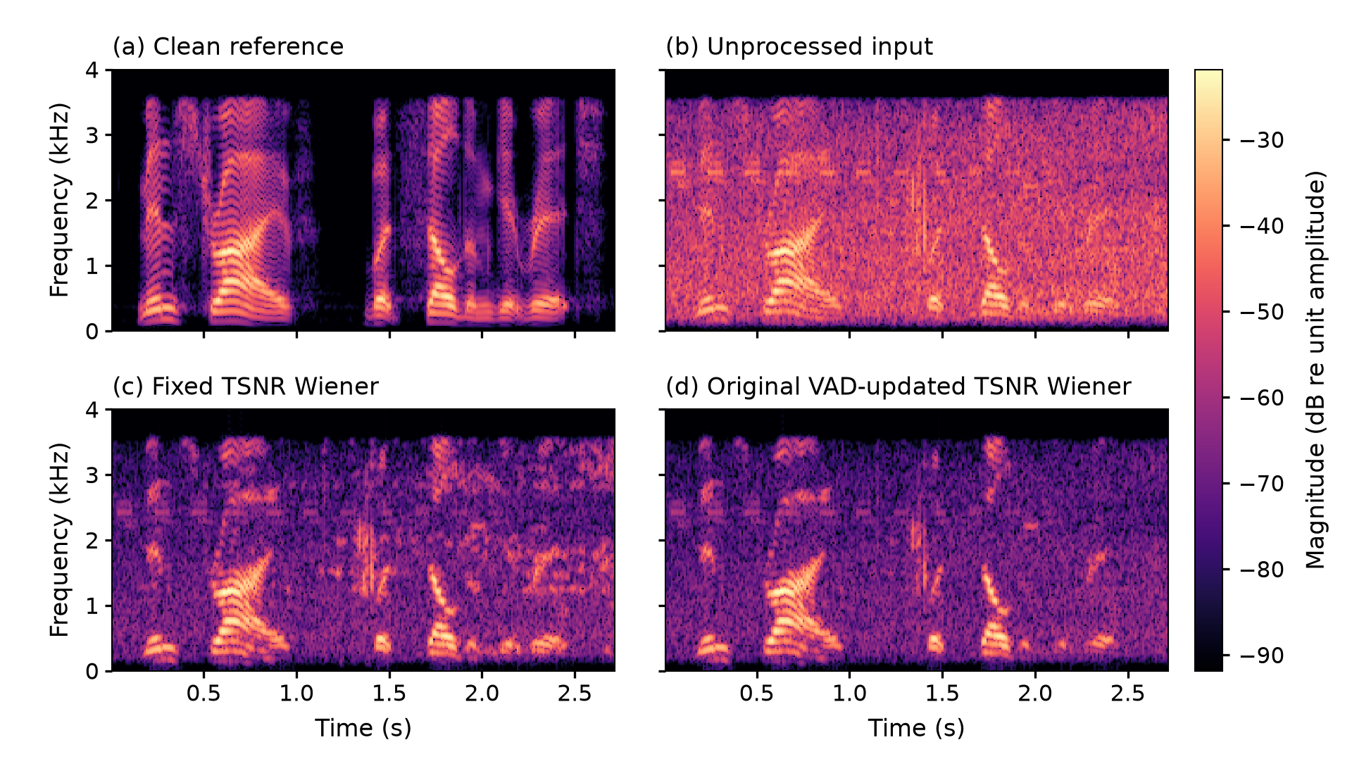
Figure 1 sp06 in street noise at nominal 5 dB. The clean, input, fixed and original VAD panels share the analysis settings and 70 dB colour range. These spectra are unchanged by the metric rescore.
For this example, original VAD raises SNR from 9.793 to 9.897 dB relative to fixed estimation, but STOI falls from 0.7539 to 0.7424. The darker background accompanies lower waveform error without higher predicted intelligibility. In the corresponding trace, updates overlap 42 of 166 clean speech-energy proxy frames; this is a diagnostic clue, not proof of the cause of every score change.
Across the evaluation set, original VAD changes mean SNR by +0.049 dB in car and +0.144 dB in street noise. Mean STOI changes by -0.00717 and -0.00103. It improves SNR in 18/32 cases, STOI in 8/32, and both in 5/32. The small mean SNR advantage therefore cannot establish a generally better enhancer.

6 Parameter selection and new sentence test
The extension tests a more protective gate while retaining the 0.95 PSD smoother. Thresholds 1, 3 and 5 dB cross hangovers of 0, 5 and 10 frames on the 16 sp01/sp16 development cases. The selection rule maximises mean development STOI; ties within 10⁻⁶ use higher SNR, then proximity to the original settings. The rule and test IDs were recorded before scoring.
Table 2 Development results and pooled speech-proxy update overlap
Threshold dB | Hangover frames | SNR dB | STOI | Overlap
1 | 0 | 11.467 | 0.7999 | 14.7%
1 | 5 | 11.375 | 0.8009 | 3.7%
1 | 10 | 11.300 | 0.8012 | 2.6%
3 | 0 | 11.256 | 0.7914 | 35.6%
3 | 5 | 11.265 | 0.7949 | 19.8%
3 | 10 | 11.227 | 0.7967 | 15.5%
5 | 0 | 10.670 | 0.7836 | 52.6%
5 | 5 | 10.748 | 0.7858 | 38.6%
5 | 10 | 10.566 | 0.7888 | 33.4%

At five-frame hangover, lowering the threshold from 3 to 1 dB adds 0.00598 STOI. At 3 dB, increasing hangover from five to ten frames adds 0.00181. At 1 dB, this extension adds only 0.00025 while reducing update coverage from 14.1% to 8.5%. Lowering the threshold provides the larger development gain in these comparisons; extra hangover supplies a smaller gain at the cost of tracking opportunities.
The rule selects 1 dB and ten frames, with development STOI 0.8012. The highest SNR instead occurs at 1 dB and zero hangover. The chosen objective therefore matters. No retuning follows the new-sentence test.
Table 3 Means over 48 new sentence conditions
Method | SNR dB | STOI | Proxy overlap
Input | 7.197 | 0.8102 | -
Fixed | 10.651 | 0.8142 | -
Original VAD | 10.656 | 0.8095 | 16.0%
Selected VAD | 10.715 | 0.8136 | 2.7%

Selected VAD adds 0.059 dB SNR and 0.00404 STOI over the original gate, with 33/48 STOI improvements and 19/48 improvements in both metrics. Proxy overlap falls from 16.0% to 2.7%, while update coverage falls from 27.4% to 4.9%. Against fixed estimation it adds 0.064 dB but loses 0.00064 STOI, and only 14/48 cases improve both. The modification improves the original rule without establishing superiority over fixed estimation.

7 Condition effects and sentence sensitivity
Table 4 separates selected-minus-fixed effects across the eight noise/SNR groups, each containing the same six sentences. A positive group average need not imply consistent improvement for individual sentences.
Table 4 Selected VAD minus fixed estimation
Noise | Nominal SNR dB | SNR change dB | STOI change | Both improve
Car | 0 | +0.0675 | -0.00122 | 1/6
Car | 5 | +0.0181 | -0.00015 | 3/6
Car | 10 | +0.0165 | +0.00029 | 2/6
Car | 15 | +0.0358 | +0.00064 | 4/6
Street | 0 | -0.0849 | -0.00003 | 1/6
Street | 5 | +0.3316 | -0.00596 | 0/6
Street | 10 | +0.1022 | +0.00207 | 3/6
Street | 15 | +0.0219 | -0.00079 | 0/6

The largest mean SNR gain, street at 5 dB, coincides with a STOI loss and no sentence improving both scores. Street at 10 dB improves both averages but only three of six sentences improve both. Different source excerpts can occur at different nominal SNRs, so these rows do not isolate the effect of SNR alone.
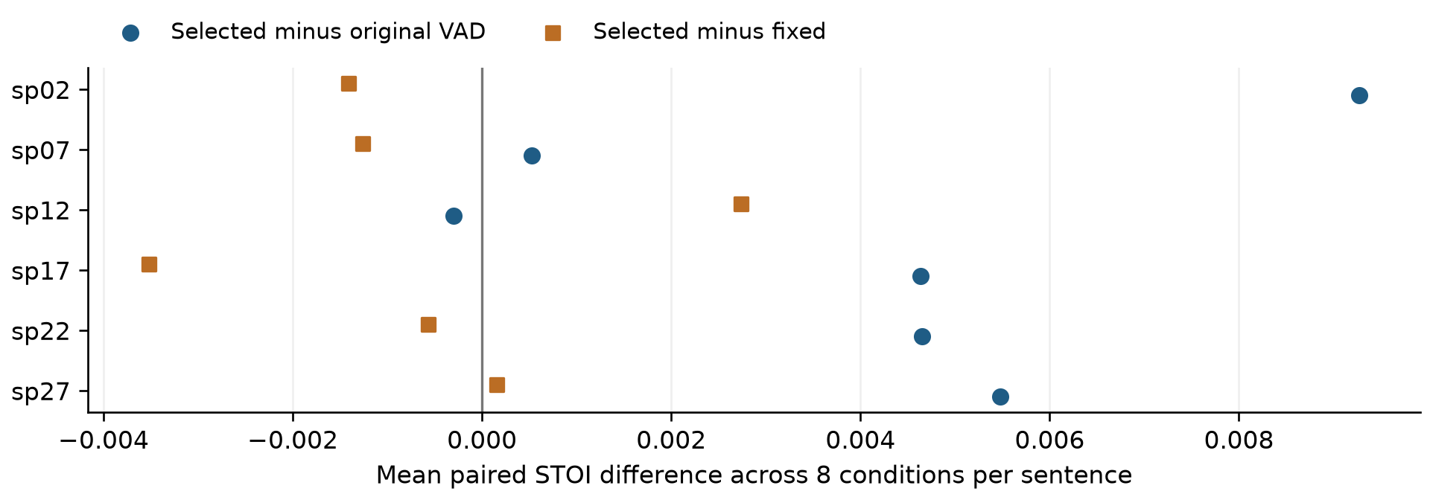
Figure 2 Every sentence-level mean paired STOI effect. Each point averages eight conditions. The six sentences, rather than the 48 repeated conditions, are the units of the sensitivity check.
Five of six sentence means favour selected over original VAD. Removing any one sentence leaves a positive mean STOI effect of +0.00300 to +0.00491. Only two sentence means favour selected over fixed; all leave-one-out averages remain negative (-0.00132 to -0.00007). The direction is not driven by one sentence, although these checks do not quantify population uncertainty.
The predetermined sp02/street/5 dB demonstration remains a counterexample: selected VAD reduces proxy overlap from 25/193 to 10/193 frames versus original VAD, yet STOI falls from 0.7278 to 0.7165. Lower proxy overlap alone therefore does not guarantee a better intelligibility score.

8 Controlled changes in noise level
The earlier noise/SNR groups use different excerpts. This diagnostic instead keeps each underlying speech and noise pair identical, then changes only the noise envelope. It reuses six test sentences and car/street mixtures at nominal 10 dB. Subtracting aligned clean speech s[t] from the noisy source gives residual r[t]. The new input is y[t] = s[t] + a[t]r[t], with no gain fitting. The residual includes any source quantisation discrepancy.
The first 100 ms and the entire pre-change prefix are unchanged. Halfway through the remaining samples, a 50 ms ramp linear in dB reaches 0, +6 or -6 dB noise amplitude level, then holds. The 36 mixtures retain an unprocessed reference and use the frozen fixed, original and selected methods. This tests prescribed trajectories, not variability at equal average SNR. All parameters and the sp02/street/rise example were recorded before this run.
Table 5 Selected minus fixed: six sentence means, each averaging car and street
Noise profile | Whole SNR dB | Whole STOI | Late SNR dB
Constant | +0.0594 | +0.001180 | +0.0552
Rise +6 dB | -0.0359 | +0.000914 | -0.0578
Fall -6 dB | +0.1428 | +0.002011 | +0.3949

Whole scores exclude calibration. Late SNR begins 100 ms after the ramp ends and uses the same clean reference; short late segments are not scored with STOI. Figure 3 shows all six sentence effects and their means, without confidence intervals.
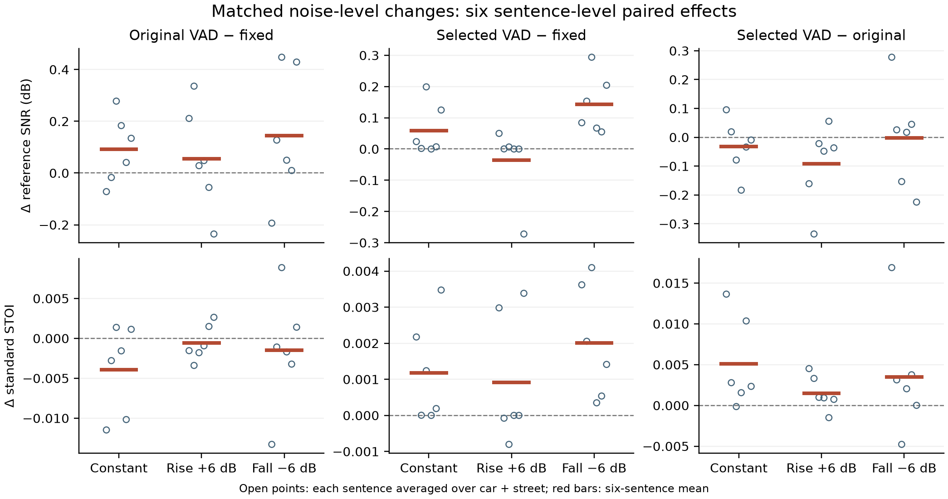
Figure 3 Matched profile comparisons. Open circles are sentence means over two noises; red bars average the six sentences. Axes differ across panels. The complete per-case results retain all outcomes.
For falling noise, selected VAD exceeds fixed SNR and STOI in all six sentence means. However, its mean STOI of 0.9059 remains below the input's 0.9071. With rising noise, selected VAD loses mean SNR against fixed despite a small STOI gain. Improvement over another processed output is therefore not a guarantee of improvement over the input.

9 Tracking behaviour and controlled results
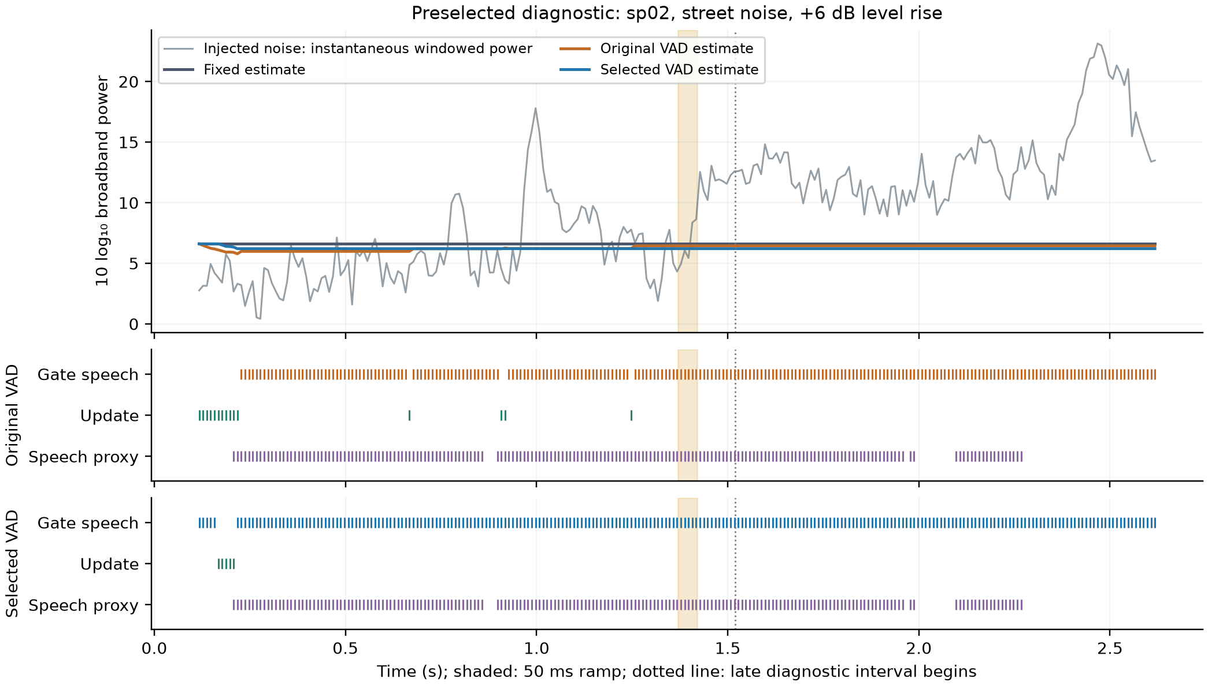
Figure 4 Prespecified sp02/street/+6 dB example. The estimator trace is read before each update. The grey line is the summed power of the known injected noise using the identical analysis window and FFT. It is a broadband realisation diagnostic, not an expected spectral PSD error.
The gate blocks the required update after the rise: both detectors declare speech throughout all 109 late frames in this example, including 27 low-clean-energy proxy frames. Across all 12 rising-noise pairs, neither VAD updates in the late interval. The mean per-case late power ratio of estimated to injected broadband power is -8.58 dB for original and -8.68 dB for selected VAD. The flat estimates in Figure 4 expose the mechanism directly.
Nonzero score differences do not demonstrate successful late tracking: the methods retain estimates and enhancement states established earlier, while whole-recording STOI also includes pre-change speech.
After a fall, mean per-case late update coverage is 34.7% for original and 17.6% for selected VAD. Mean late power ratios are +2.18 and +2.64 dB, versus +3.47 dB for fixed estimation. The lower noise allows more updates, while the protective gate still admits fewer. Each ratio compares summed estimated and injected frame powers in one late interval; these dB ratios are averaged over the 12 matched pairs. They describe the realised signal rather than expected PSD.
Even with every frame admitted, a 0.95 smoother requires approximately ln(0.1)/ln(0.95) = 45 updates, or 0.45 s at a 10 ms hop, to remove 90% of an ideal constant-target initial error. Gating extends elapsed adaptation time; short speech recordings may end before settling. This calculation explains the possible time scale, not a fitted settling-time measurement.
The 12 constant-source inputs pass identity reconstruction; all 36 mixtures pass shared-prefix and initial-PSD checks. Independent Python calculations reproduce every diagnostic noise-power frame and the before/after update recurrence within 8 × 10⁻¹⁵ relative error. In matched late frames, a ±6 dB injection changes the fixed-estimator log ratio by exactly ∓6 dB. The constant-profile scores reproduce the prior 10 dB test, with maximum STOI difference below 5 × 10⁻¹⁶.

10 Discussion and conclusions

What helps and what it costs
The benchmark and parameter study support a consistent interpretation. A lower threshold and longer hangover protect more frames associated with clean speech. The selected gate improves average STOI over original VAD, including after removal of each test sentence, but leaves only 4.9% update coverage. It consequently behaves more like fixed estimation and retains a small mean STOI deficit against that baseline. Speech protection and adaptation are competing objectives within this rule.
The controlled diagnostic supplies a mechanism that the original noise categories could not isolate. A rise increases mixture-to-estimate energy and keeps both gates closed, leaving the noise estimate unable to follow the change. Falling noise instead permits updates, and the selected method improves SNR and STOI over fixed estimation in all six sentence means. Yet it remains below the unprocessed falling-noise mean STOI. Adaptation benefits are therefore conditional on gate access and evaluation criterion, and the effect sizes remain small.
This behaviour is compatible with the motivation for minima-based and probability-weighted tracking [4,9,10]. Their use of history or graded speech evidence addresses limitations of an instantaneous hard gate. The evidence justifies a future controlled comparison with such trackers; it does not establish their performance here. Both present modes share TSNR, so the results also do not test the benefit of its second SNR refinement [1].

Limits of the evidence
The original evaluation has four sentences from four speakers. The later six sentences come from known speakers, and the controlled diagnostic reuses them. The repeated conditions improve coverage of the specified manipulations without enlarging the independent speaker sample. The leave-one-out analysis is a sensitivity check, not a confidence interval. The improvement over original VAD is small and should not be translated into a claim of practically noticeable benefit.
The clean-energy proxy thresholds in Section 4 are not human VAD annotations; intermediate frames remain unlabelled. Weak consonants and recording residuals complicate interpretation. Broadband power tracking describes one part of the estimator and does not establish spectral accuracy. Initial 0.10 s calibration is approximately noise-only; weak clean energy can contaminate both methods.
The imposed envelopes change later SNR and total noise energy as well as temporal variation. They identify responses to these particular trajectories, not the isolated effect of variability at equal average SNR. Short utterances limit settling-time observations. Standard STOI supplies predicted intelligibility; no subjective listening evaluation or manual annotation was performed. Audio examples demonstrate outputs only. The archived native scores remain separate provenance, while every main comparison now uses the same standard implementation.

Conclusion and next investigation
Energy-gated updating provides small average waveform-error improvements but does not reliably improve intelligibility predictions over fixed estimation. A development-selected protective gate improves original VAD by 0.00404 mean STOI on unused sentences while remaining slightly below fixed estimation. The matched noise experiment shows renewed tracking after a fall and blocked updates after a rise, directly connecting an imposed change to the detector's limitation. The project establishes a measured trade-off between speech protection and tracking, with reproducible counterexamples to a general advantage from adaptation.
A useful next experiment would evaluate a probability-weighted tracker on longer, independently selected recordings with prescribed changes, alongside human speech annotations. Any new parameter selection would use a separate development set and an untouched test set. The present findings support that specific extension rather than a claim that a more complex detector must always perform better.

11 References
[1] C. Plapous, C. Marro, and P. Scalart, “Improved signal-to-noise ratio estimation for speech enhancement,” IEEE Transactions on Audio, Speech, and Language Processing, vol. 14, no. 6, pp. 2098-2108, Nov. 2006.
Source: https://doi.org/10.1109/TASL.2006.872621
[2] Y. Hu and P. C. Loizou, “Subjective comparison and evaluation of speech enhancement algorithms,” Speech Communication, vol. 49, nos. 7-8, pp. 588-601, 2007.
Source: https://doi.org/10.1016/j.specom.2006.12.006
[3] C. H. Taal, R. C. Hendriks, R. Heusdens, and J. Jensen, “An algorithm for intelligibility prediction of time-frequency weighted noisy speech,” IEEE Transactions on Audio, Speech, and Language Processing, vol. 19, no. 7, pp. 2125-2136, Sept. 2011.
Source: https://doi.org/10.1109/TASL.2011.2114881
[4] I. Cohen and B. Berdugo, “Noise estimation by minima controlled recursive averaging for robust speech enhancement,” IEEE Signal Processing Letters, vol. 9, no. 1, pp. 12-15, Jan. 2002.
Source: https://doi.org/10.1109/97.988717
[5] University of Texas at Dallas, “NOIZEUS: A noisy speech corpus for evaluation of speech enhancement algorithms.” Dataset description, accessed 5 October 2026.
Source: https://ecs.utdallas.edu/loizou/speech/noizeus/
[6] P. Scalart, “Wiener filter for Noise Reduction and speech enhancement,” MATLAB Central File Exchange, submission 24462. Source header credits LIU Ming (2008), with modifications by Pascal Scalart (2008 and 2020).
Source: https://www.mathworks.com/matlabcentral/fileexchange/24462-wiener-filter-for-noise-reduction-and-speech-enhancement
[7] P. Scalart and J. Vieira Filho, “Speech enhancement based on a priori signal to noise estimation,” Proc. IEEE ICASSP, vol. 2, pp. 629-632, 1996.
Source: https://doi.org/10.1109/ICASSP.1996.543199
[8] J. Sohn, N. S. Kim, and W. Sung, “A statistical model-based voice activity detection,” IEEE Signal Processing Letters, vol. 6, no. 1, pp. 1-3, Jan. 1999.
Source: https://doi.org/10.1109/97.736233
[9] R. Martin, “Noise power spectral density estimation based on optimal smoothing and minimum statistics,” IEEE Transactions on Speech and Audio Processing, vol. 9, no. 5, pp. 504-512, Jul. 2001.
Source: https://doi.org/10.1109/89.928915
[10] I. Cohen, “Noise spectrum estimation in adverse environments: Improved minima controlled recursive averaging,” IEEE Transactions on Speech and Audio Processing, vol. 11, no. 5, pp. 466-475, Sept. 2003.
Source: https://doi.org/10.1109/TSA.2003.811544
[11] M. Pariente et al., pystoi, Python implementation of the Short Term Objective Intelligibility measure. Standard STOI, extended=False; version 0.4.1 used for the local extension.
Source: https://github.com/mpariente/pystoi

