Studio Assessment Submissions

Studio 1A, 1B, 2

Yuhan Chen and 34360905

Self-Evaluation:

|  |  |  |  |  |  |
| --- | --- | --- | --- | --- | --- |
| Need Help | Work in Progress | Pass | Credit | Distinction | High Distinction |

**Task 1A:**

1. **Screenshots of running results**



Figure 1A_1

1. **Note and Discussion**
   1. _Layout.cshtml: A commen layout that provides the user a consistent experience as the user navigate from page to page. For example, the header, navigation bar and the footer.
   2. Breakpoint: for debugging code. F10 to see how the flow works.

**Task 1B:**

1. **Screenshots of running results**

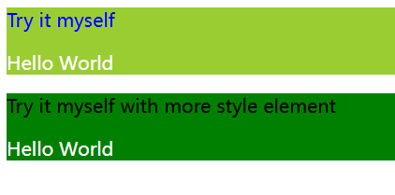

Figure 1B_1

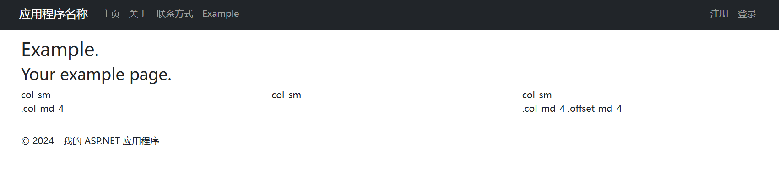

Figure 1B_2

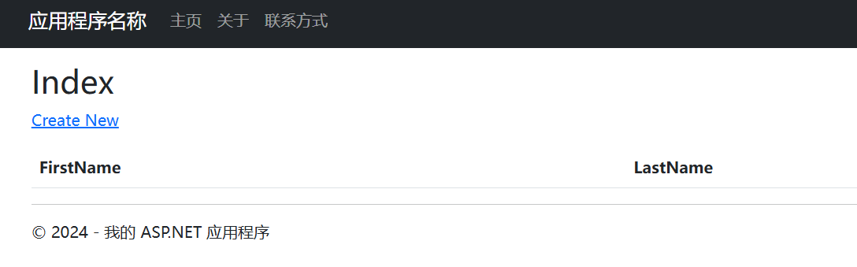

Figure 1B_3

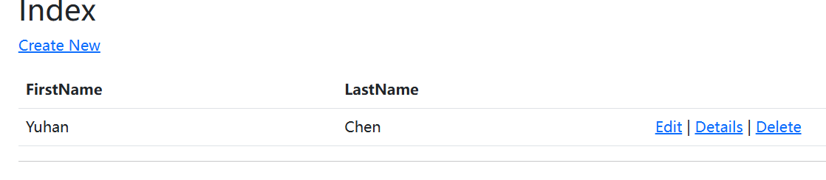

Figure 1B_4

1. **Answers to Questions in the Studio pdf**
   1. How do you think the nvarchar data type differs in comparison to the varchar? Also what do you think is the difference between a Primary Key and an Identity?

The nvarchar and varchar data types are different in how they handle character encoding. For nvarchar, it stores Unicode data and each character can take up to 2 bytes. It is useful for storing text in multiple languages. And for varchar, it stores non-Unicode data and each character takes 1 byte. It is limited to storing characters defined by the code page of the database.

The primary key can identify each data in the table, it is unique for each data and cannot contain NULL values. Each table can only have one primary key. The identity typically used for primary key columns to ensure each row has a unique identifier can helps to maintain unique values.

1. **Note and Discussion**
   1. CSS: Cascading style sheet, is used to tell how HTML or XML elements should be rendered on screen. Two ways to define the style: properties and selector. Use the selector can change the elements easier in the future.
   2. Drag and drop the own css file to the code can apply the css to the page. Drag to the _Layout.cshtml can apply the css to all pages.
   3. Grid System: split the webpage into different columns.
   4. VS can automatically generate certain parts of the code, remember to “rebuild” before this.

**Task 2:**

1. **Screenshots of running results**



Figure 2_1

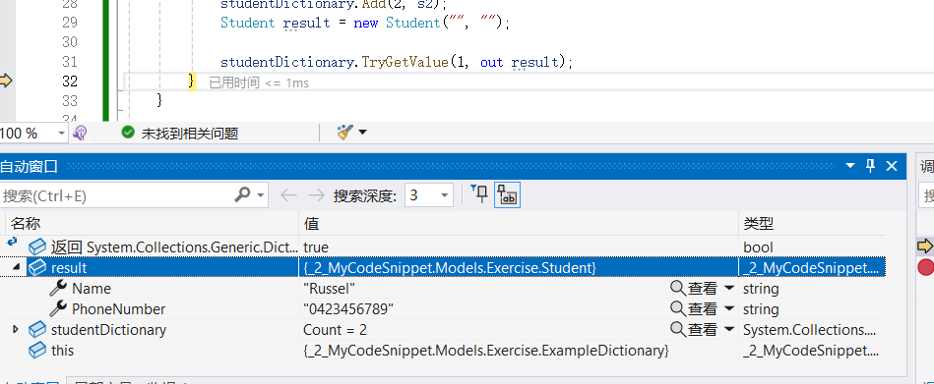

Figure 2_2

1. **Answers to Questions in the Studio pdf**
   1. Is it also possible to have a class with the same name as the name space? So, in this scenario, can I have a class called HelloWorld inside of the HelloWorld namespace? Why is this so? Please explore this.

It can have a class and a namespace with the same name. Because namespace and classes are used for different things: namespace help organize the code and classes define behaviors and data. Even they share a same name, they are recognized differently in the code.

* 1. Using dictionary would often times simplify complex task and often used by developers for various task. If you are planning to be a developer, it is a powerful data structure that you should know. Why do you think this is so?

Dictionaries simplify complex tasks because they allow quick data retrieval using keys. This key-value pairing is efficient for looking up, adding, or removing data. Given their versatility and speed, dictionaries are crucial for developers handling various tasks where rapid access to related data is necessary.

1. **Note and Discussion**
   1. Term “folder” when using the GUI and the term “directory” when using the Command line interface.
   2. Avoid using space when naming folders. The namespace of the created C# file is the project name followed by the folder name.
   3. Be attention to the upper and lower cases. Pascal Case or Title Casing is the standard way for C# developers.
   4. A class normally has “properties” and “behaviors”, everything in C# is an object, so cannot write methods which are not inside a class.