Microsoft Dynamics CRM SDK

Custom Workflow Activities Readme

This folder contains sample codes that demonstrate how to write a custom workflow activity and how to use it within a workflow.

# **Important Notes**

The sample files are not intended to be used in a production environment without prior testing. You should deploy this sample to a test environment and examine it for interaction or interference with other parts of the system.

Before you deploy this sample to a production environment, make sure that you consider the existing customizations you may have implemented in Microsoft Dynamics CRM 2015.

# **Sample Overview**

Custom Workflow Activities included:

* Auto-Route Lead
  + This sample auto-routes a lead based on Customer Service Representative (CSR) load. Before being able to use this workflow activity, you need to confirm the existence of the following in your CRM environment
    - a custom boolean field named new_autoroute exists on the Lead entity
    - the field has been added to a Lead form
    - the native role named Customer Service Representative exists

The managed solution for this sample includes these customizations; if you do not use the managed solution, you will have to create these customizations before running this custom activity workflow.

* Add Activity
  + This sample adds two summands and returns the result.
* Custom Activity
  + This sample creates a task activity.
* Date Checker
  + This sample checks Est. Close date on an opportunity and sends an email to the administrator if the date is greater than 10 days from now.
* Distance Calculator
  + This sample calculates the distance between two zip codes.
* PostUrl
  + This sample posts data to a URL. Before being able to use this workflow activity, you need to deploy an ASPX page in IIS. The steps to do this are:
    1. Create a folder on the CRM server at "c:\posturl".
    2. Add the file 'receiveposturl.aspx' to this folder.
    3. Open IIS on the CRM server.
    4. Under Sites, add a new website with a binding to port 9999 and a physical path of "c:\posturl".
    5. Create a folder on the CRM server at "c:\temp" if it does not exist.
    6. Create a new text file named 'SdkSample.log' in the "c:\temp" folder.
    7. Set security permissions to "c:\temp" and 'SdkSample.log' to grant write permission to the account that is running the Application Pool for the new website.
    8. Test the custom workflow activity and ensure that the log file is updated.

# **Installation Instructions**

To install this sample to Microsoft Dynamics CRM, simply import the managed solution provided. Please note that the example workflow will need to be activated.

Alternatively, it is possible to reproduce the solution manually – details follow.

**How to register your assembly**

1. Open solution CustomWorkflowActivities.sln in Visual Studio.
2. Right click on the project you want to compile, and select Build. You will create a DLL file in \bin\debug.

* To work with the Distance Calculator sample, you need to create your own Bing Developer account from <http://www.bingmapsportal.com/>. Get the Bing Maps Key and set it in DistanceCalculator.cs line 84.

1. Launch the Plugin Registration tool. This tool is included in the Microsoft Dynamics CRM SDK in the sdk\tools\pluginregistration folder.
2. In the Plugin Registration tool’s “Connection” dialog, enter your Microsoft Dynamics CRM server information and click the Connect button. Next select an organization and click the Connect button again or just double click an organization in the list.
3. From the Register menu, select Register New Assembly (Figure 1).

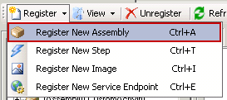

*Figure 1*

1. From the Register New Plugin dialog, select the DLL file you created, and click Register Selected Plugins (Figure 2). If you are deploying to CRM Online, be sure to select “Sandbox” for the isolation mode.

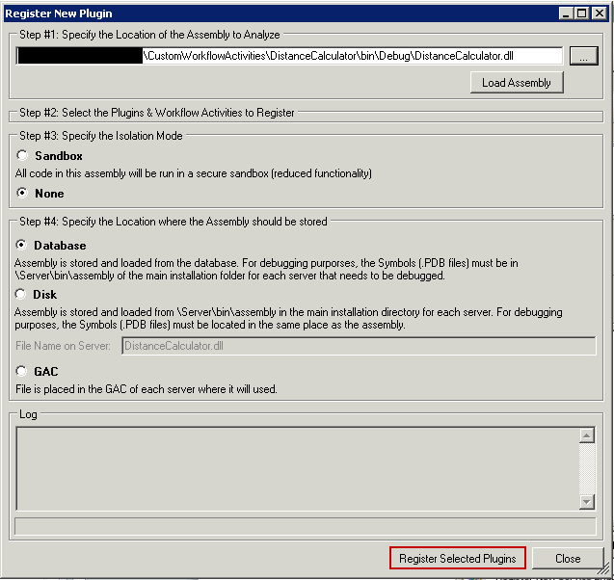

*Figure 2*

1. Once you have your assembly registered, you can set some fields to help you recognize your custom workflow activities in CRM (Figure 3).

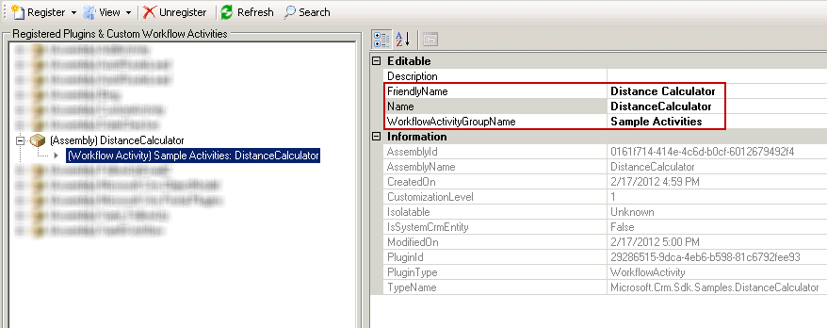

*Figure 3*

**How to use workflow activities within a workflow**

1. Open CRM, go to Settings | Processes and click on the New button.
2. Set the Process Name, the Entity you want to target and Category of Workflow (Figure 4).

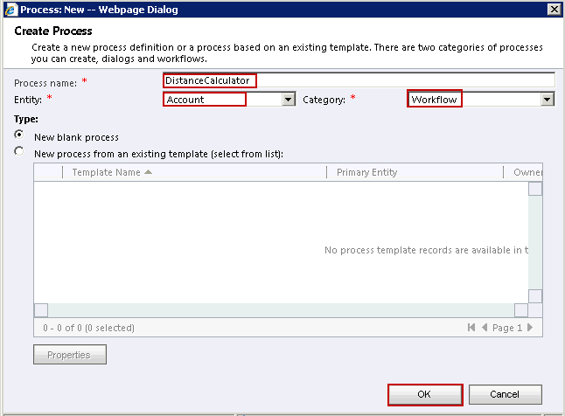

*Figure 4*

1. From Add Step, select your activity workflow. Your custom workflow activity should be inside the Sample Activities group (Figure 5).



*Figure 5*

1. If your activity workflow has input parameters, you can set those by clicking on the Set Properties button (Figure 6).

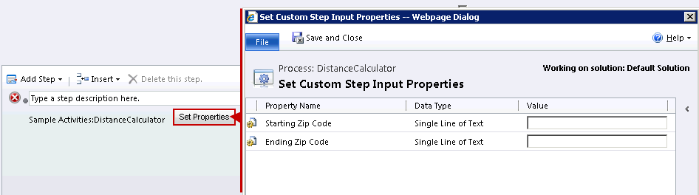

*Figure 6*

1. If your activity workflow has output parameters, you can use those in later steps (Figure 7).

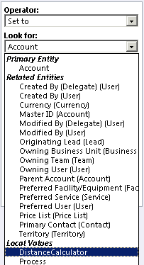

*Figure 7*

# **Copyright**

This document is provided "as-is". Information and views expressed in this document, including URL and other Internet Web site references, may change without notice. You bear the risk of using it.

Some examples depicted herein are provided for illustration only and are fictitious. No real association or connection is intended or should be inferred.

This document does not provide you with any legal rights to any intellectual property in any Microsoft product. You may copy and use this document for your internal, reference purposes.

© 2014 Microsoft Corporation. All rights reserved.

Microsoft, Active Directory, ActiveX, BizTalk, Excel, Great Plains, Internet Explorer, JScript, Microsoft Dynamics, MSN, Outlook, PivotTable, PivotChart, Visual Basic, Visual Studio, Windows, Windows Live, Windows Server, and Windows Vista are trademarks of the Microsoft group of companies.

All other trademarks are property of their respective owners.