Yu-Che Cheng

SID: 861142301

Description:

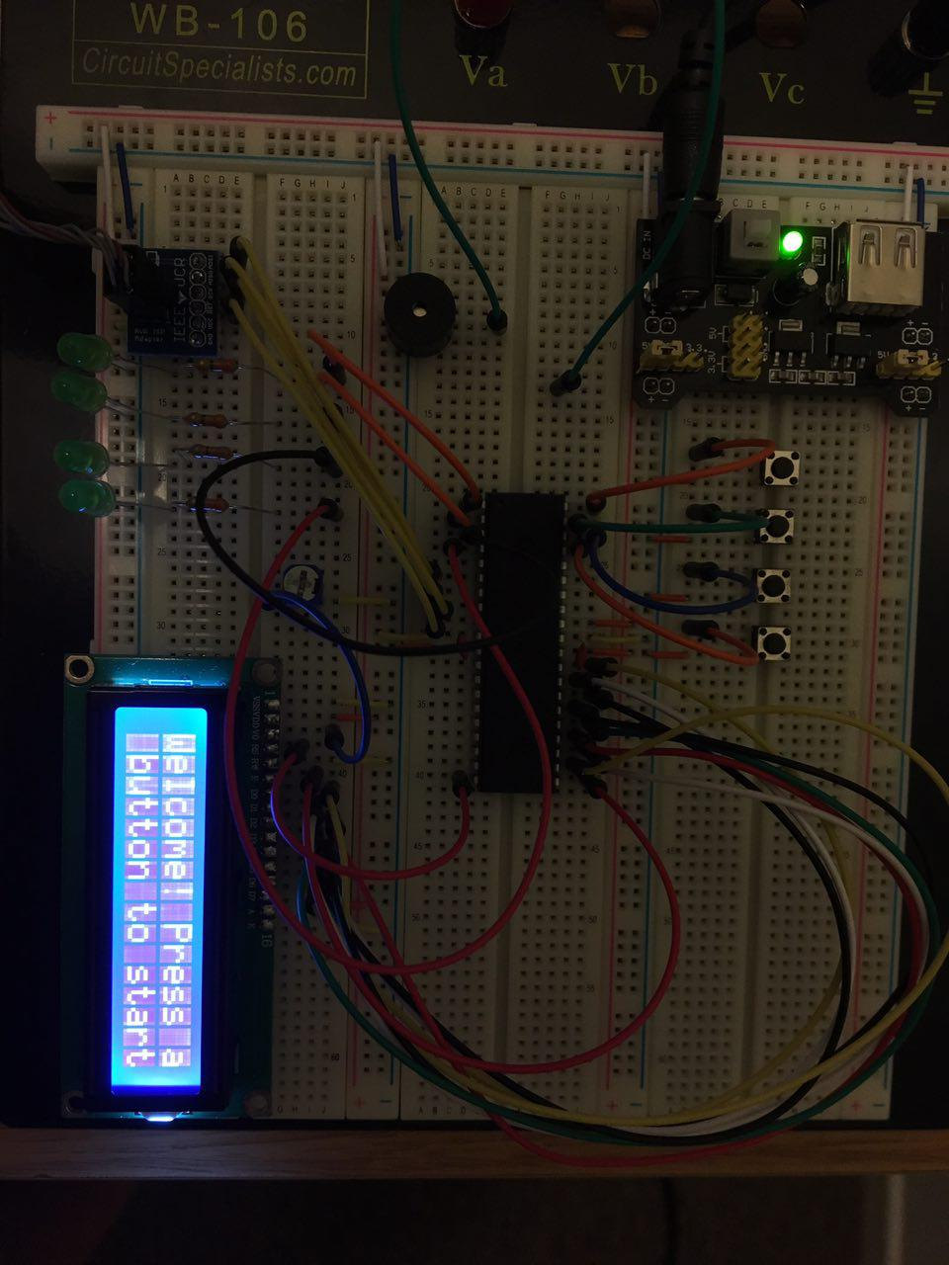This SimonGame project is about recreating the logic of Simon game. The Simon game is played by memorizing the flashing random sequential pattern shown on the device's lights and entering the memorized sequence through buttons. The game will start with a sequence of one and continue for multiple rounds with each consecutive rounds incrementing the pattern length by one, making the pattern longer to remember and the game more difficult as it goes on. The player loses when they enter the sequence incorrectly. The player wins when they enter the sequence correctly 9 times without error. When lose or win is determined, the project's LCD screen will display the number of rounds the player completed correctly and give them an option to play again with another random pattern.

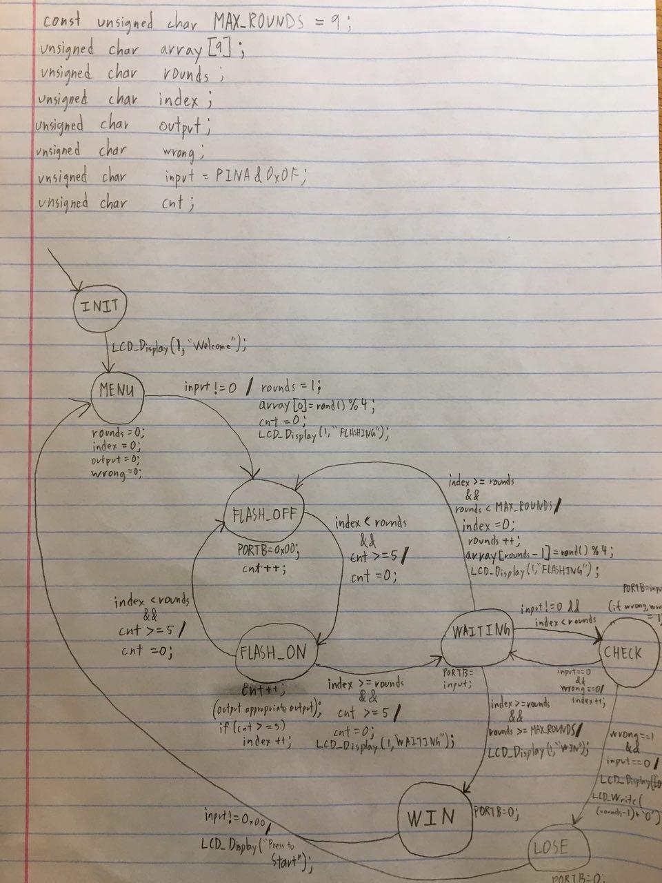

Experience and Challenges;

One of the challenges I faced while working on this project was dealing with the latency between the buttons and their respective LEDs. When I first started off, I had my period set to 500ms. This gave the game a slight pause between pressing the button and the LED flashing on when inputting sequences. To fix this, I lowered the period to 100ms; however, this made my LEDs flash to quickly when flashing the sequence to memorize. To correct this, I added a variable “cnt” to keep track of how long the state machine stays in FLASH_OFF and FLASH_ON and keep it there until 500ms have passed. This reduced the latency without causing my lights to flash too quickly.