User Manual for Quadrotor UAV Attitude Control System Design Optimization (Competition Edition)
Document Version: V2.0 (Competition Edition)
Compilation Date: June 2026
Applicable Audience: Competition Committee Review
Work Title: Quadrotor UAV Attitude Control System Design Optimization
Competition: China Software Cup A8
Team Members: Chen Yihan, Zheng Haotian, Wang Deneng
Institution: Xi'an Jiaotong University City College
Advisor: Pang Zhicheng
Platform: MWORKS Sysplorer 2026a
Copyright: This work is copyrighted by the authors. All rights reserved.
Revision History:
Version | Date | Changes
V1.0 | June 1, 2026 | Initial user manual (model reproduction and result verification)
V2.0 | June 15, 2026 | Competition edition: expanded with system overview, control algorithm details, complete performance metrics, code excerpts, and advanced validation results
Abstract
This user manual documents the workflow for reproducing all simulation models and results of this submission on the MWORKS Sysplorer 2026a platform. Across the climb, spiral-climb and figure-eight scenarios, the enhanced model reduces path RMSE relative to the baseline by 17.16%, 2.62% and 13.47%. These values come from the re-run task models and from recomputation of the delivered simulation-output CSV; the two agree digit for digit, and the metrics and the simulation output are generated by the same run. The preliminary-round version reported 15.39%, 1.01% and 11.26% from an outdated metrics_summary.json; those three figures understated the work's own result and are withdrawn. It must be stated explicitly here that, in the preliminary-round version of this work, all reported figures relating to the CBF/PPC/ERG safety chain, Monte Carlo robustness, multi-objective tuning and multi-UAV formation were produced by offline post-processing of existing simulation output; three of them were generated by hard-coded coefficients and one was computed in a way that is independent of the controller under test. Those conclusions are withdrawn in this revision; see Section 5.2 and Chapter 6 of the simulation report. Chapter 5 of this manual now retains only metrics that can be recomputed directly from the delivered simulation output or read from the re-run models, and Sections 5.7 to 5.9 explain why the original methods failed and what replaces them. The safety chain actually wired into the control loop is provided in 06_Rework_SafetyChain/UAVSafetyChain.mo. Re-simulation of that chain gives a split result, reported here as such: the cumulative time above 15 degrees falls to 0 s in all six runs, but in the climb scenario the path RMSE rises from 0.228024 m to 0.236546 m, a degradation of 3.74% that does not meet the pre-registered 3% criterion. The spiral-climb and figure-eight cases improve by 1.52% and 0.84% and meet it.

1. Foreword

1.1 Purpose
This user manual serves as the official competition submission document for the work titled "Quadrotor UAV Attitude Control System Design Optimization." The manual provides comprehensive instructions for the competition committee to load, execute, and verify all simulation models and results contained in the delivery package.

1.2 Scope
The manual covers the complete workflow from software environment setup through model loading, simulation execution, result interpretation, and advanced feature validation. All instructions are written to enable independent reproduction of the reported performance metrics without requiring additional guidance from the development team.

1.3 Copyright Statement
This work is the original creation of the team members listed above and has been registered for copyright protection. The work is submitted to the China Software Cup A8 competition organizing committee for evaluation purposes. Unauthorized reproduction or distribution is prohibited.

1.4 Document Structure
This manual is organized into the following sections: Section 2 provides a system overview and architectural description; Section 3 details the file structure and environment requirements; Section 4 presents a quick start guide for rapid reproduction; Section 5 documents all simulation results and performance metrics; Section 6 provides detailed functional reproduction instructions; Section 7 addresses common troubleshooting scenarios; Section 8 lists complete technical parameter references.

2. System Overview

2.1 Design Philosophy
The quadrotor UAV attitude control system is built on a five-layer hierarchical architecture that separates concerns and enables modular replacement of components. The architecture follows the principle of "base model reuse, structural controller replacement, multi-scenario comparative simulation, and safety-chain compensatory verification." This approach ensures that all experimental comparisons share an identical physical foundation, making performance differences attributable solely to the control algorithm upgrades.

2.2 Five-Layer Architecture
The simulation system consists of five clearly decoupled layers, ordered from bottom to top:
Layer 1 - Physical Model Layer: The foundation of the entire simulation system. This layer hosts the complete quadrotor UAV dynamics model (MoHub QuadrotorModel, model/2355), including rigid body dynamics, rotor thrust models, sensor variables, and actuator modules. The official MoHub model is reused without modification, ensuring objective and unified physical characteristics across all experiments. The multi-domain modeling approach follows established Modelica co-simulation practices^{[3][9]}.
Layer 2 - Reference Trajectory Layer: Generates desired flight positions and motion trajectories according to preset flight tasks. Three trajectory types are implemented: vertical climb (altitude step), spiral climb (simultaneous vertical and circular motion), and figure-eight (periodic direction-changing trajectory).
Layer 3 - Controller Layer: The core control unit that compares actual flight state with reference trajectory in real time and computes control outputs to adjust rotor speeds. The baseline model uses standard PID control, while the enhanced model employs HybridPIDSlidingMode composite sliding mode control for the lateral position outer loop, with altitude and attitude inner loops retaining PID for stability.
Layer 4 - Safety Constraint Layer: Monitors flight attitude and control output amplitudes throughout simulation. Four safety modules are integrated: Control Barrier Function (CBF) safety projection, Prescribed Performance Control (PPC) error envelope, Explicit Reference Governor (ERG) reference regulation, and attitude risk early warning. These modules collectively ensure flight safety from constraint, regulation, and prediction perspectives.
Layer 5 - Result Evaluation Layer: Automatically computes performance metrics after simulation completion, including path RMSE, average error, maximum error, step overshoot, settling time, and attitude boundary violation counts.

2.3 Key Innovations
The work introduces three key technical contributions. First, a structural controller replacement scheme based on Modelica replaceable/redeclare syntax achieves seamless upgrade from PID to composite sliding mode control without modifying the underlying dynamics model. The composite sliding mode control law combines PID steady-state performance with sliding mode robustness against matched uncertainties. Second, a four-module safety chain (CBF + PPC + ERG + attitude warning) forms a multi-level flight protection system; in the re-simulated model the reference governor removes all 15-degree boundary violations (0 s above the limit in all six runs), at a cost of 3.74% path RMSE in the climb scenario. Third, every quantitative conclusion is tied to a stated data source and can be recomputed from the delivered simulation output; metrics that require re-simulation are left blank rather than filled with offline post-processed values, and the pass criteria were fixed before the runs were executed.

2.4 Control Algorithm Design
In terms of the actual parameter configuration, the weight of the sliding-mode switching term is limited: the switching gain kSwitch = 0.1 against an output limit uMax = 2.1, so the term contributes at most about 4.76% of the output. The performance change of the enhanced model relative to the baseline comes mainly from re-tuned gains in the lateral outer loop (KP 1.5 to 2.0, KD 1.0 to 1.35) and the attitude inner loop (KP 14.142 to 17.0, KD 1.414 to 2.05); the sliding-mode term adds robustness to matched uncertainty rather than being the main source of accuracy improvement
The composite sliding mode controller introduces sliding surface design and discontinuous switching control law on top of conventional PID control. Let the lateral position error be$e=x_{ref}−x$, and define the sliding surface as:
 | $$s=e˙+λe$$ | (1)
where$λ>0$is the sliding surface parameter. The composite control law consists of equivalent control and switching control:
 | $$u=u_{eq}+u_{sw}=K_{p}e+K_{i}∫edt+K_{d}e˙+η⋅sgn(s)$$ | (2)
where$K_{p},K_{i},K_{d}$are PID gain parameters and$η>0$is the switching gain. Note that the model code actually uses the hyperbolic tangent tanh(s/phi) rather than a piecewise-linear saturation function sat(s/phi), with kSwitch = 0.1, phi = 0.35, lambda = 1.25 and uMax = 2.1; the term eta*sgn(s) in Equation (2) is therefore not the same expression as the implementation. Measured over the delivered runs, the switching term is saturated only 0% to 5% of the time and otherwise operates inside the boundary layer, acting as an additional proportional gain of kSwitch/phi = 0.286$sat(s/ϕ)$replaces the ideal sign function$sgn(s)$, where$ϕ>0$is the boundary layer thickness parameter, providing smooth control transition within the boundary layer and suppressing high-frequency actuator oscillation^{[1][4]}.
Symbol-to-Implementation Mapping:
Mathematical Symbol | Modelica Variable | Description
$$λ$$ | slidingSurfaceParam | Sliding surface convergence parameter
$$η$$ | switchingGain | Switching control gain
$$ϕ$$ | boundaryLayerThickness | Saturation boundary layer width
$$K_{p},K_{i},K_{d}$$ | Kp, Ki, Kd | PID gain parameters
$$max$$ | attitudeSafetyThreshold | 15-degree attitude limit

2.5 CBF/PPC/ERG Safety Chain Design
The safety chain integrates four control modules:
CBF Safety Projection: Based on Control Barrier Function theory^{[5]}, defines a safety set$C=\{x:h(x)≥0\}$. The actual implementation must be stated plainly: CBFCommandFilter in AdvancedSafetyControl.mo is a static magnitude clamp (rollSafe = min(max(rollCmd, -angleLimit), angleLimit)) with no quadratic programming solve, and its threshold of 15 degrees is looser than the 9.5-degree command limiter already active in the enhanced model, so it would never activate even if instantiated. The attitude constraint has relative degree 2 with respect to the tilt command, and a static magnitude projection cannot prevent overshoot. For the attitude angle constraint, the safety function is:
 | $$h(θ)=θ_{max}−|θ|$$ | (3)
where$θ_{max}=15°$is the attitude safety threshold.
PPC Error Envelope: Based on Prescribed Performance Control theory^{[6]}, sets a time-varying performance boundary function$ρ(t)$for tracking error, guaranteeing that error$e(t)$always satisfies$|e(t)|<ρ(t)$, constraining both transient and steady-state errors within preset bounds.
ERG Reference Governor: Based on reference governor theory^{[7][10]}, dynamically adjusts the reference trajectory advancement rate according to real-time flight state. When system state approaches constraint boundaries, ERG proactively reduces reference signal change rate to prevent constraint violations.
Attitude Risk Warning: Based on time-series data analysis with a 0.5s window, identifies attitude angle trend anomalies in advance and outputs warning signals for proactive risk prevention.

2.6 Technical Specifications Summary
Parameter | Value
Simulation Platform | MWORKS Sysplorer 2026a
Modeling Language | Modelica
Base Model | MoHub QuadrotorModel (model/2355)
Solver Algorithm | Dassl
Sampling Interval | 0.01 s
Tolerance | 0.0001
Attitude Safety Threshold | 15 degrees
Climb/Spiral Simulation Time | 0-50 s
Figure-Eight Simulation Time | 0-120 s

3. File Structure and Environment

3.1 Delivery Package Structure
The delivery package is organized into five major directories, each serving a distinct purpose:
Directory/File | Description
01_Report_Manual/ | Simulation report and user manual documentation
02_Model_Code/QuadrotorModel.mo | Primary single-file model (recommended for loading)
02_Model_Code/QuadrotorTask.mo | Task model file with six baseline/enhanced simulation models
02_Model_Code/AdvancedSafetyControl.mo | CBF, PPC, ERG, and attitude warning safety control modules
02_Model_Code/UAVSyslabReferenceShaper.mo | Syslab function block sample. Its script performs a static clamp and scales x/y by 0.9; it is not a dynamic shaper and is not connected to the control loop
02_Model_Code/UAVSysblockCommandAxis.mo | Sysblock control block sample
02_Model_Code/QuadrotorModel/package.mo | MoHub base quadrotor model source
02_Model_Code/mworks_export_results.py | Batch simulation and result export script (Syslab data interface)
02_Model_Code/advanced_safety_intelligence_suite.py | Advanced feature verification script
03_Simulation_Results/ | CSV data, JSON metrics, and result figures
04_Advanced_Validation/ | CBF/PPC/ERG replay, Monte Carlo, NSGA-II, formation, and diagnostics
05_STL/ | 3D STL files for UAV body and propellers (DroneBody.stl, DroneBlade.stl, QuadBody.stl, QuadPropeller.stl)

3.2 Software Environment Requirements
Requirement | Specification
Software | MWorks/Sysplorer with Modelica model support
Recommended Version | MWORKS Sysplorer 2026a
Model Loading | Direct loading of QuadrotorModel.mo (single-file, recommended)
Alternative Loading | Load QuadrotorModel/package.mo first, then QuadrotorTask.mo
Path Requirement | Pure English path (no Chinese characters or spaces)
Example Path | D:\MWorksUAVDelivery_Client_Final

3.3 Installation and Setup
To set up the simulation environment, follow these steps: (1) Extract the complete delivery package to a pure English file path on your local drive; (2) Ensure MWorks/Sysplorer 2026a is properly installed and licensed; (3) Verify that the extraction preserves the directory hierarchy intact, particularly the relative paths between model files and resource files.

4. Quick Start Guide

4.1 Rapid Reproduction Workflow
The following table provides the minimal steps required to reproduce the core simulation results:
Step | Action | Expected Result
1 | Extract delivery package to a pure English path | All files accessible without encoding issues
2 | Open MWorks/Sysplorer | Enter the modeling environment
3 | Load 02_Model_Code/QuadrotorModel.mo | QuadrotorModel appears in the model tree
4 | Expand QuadrotorModel.Task | Six task models visible (Climb/Spiral/Eight x Baseline/Enhanced)
5 | Select a model, execute Check then Simulate | Simulation completes and generates result variables
6 | View 03_Simulation_Results folder | CSV, JSON, and figure results available
7 | Open 04_Advanced_Validation/dashboard.html in browser | Advanced validation dashboard displayed

4.2 Simulation Parameter Configuration
All simulations must use the following standardized parameters to reproduce reported results:
Parameter | Configuration
Solver Algorithm | Dassl
Climb Simulation Time | 0-50 s
Spiral Climb Simulation Time | 0-50 s
Figure-Eight Simulation Time | 0-120 s
Sampling Interval | 0.01 s
Tolerance | 0.0001

These parameters must remain unchanged during reproduction. Modifying any parameter may result in discrepancies with the reported values.

4.3 Model Selection Guide
The system contains six task models organized as three scenarios, each with baseline and enhanced variants:
Scenario | Baseline Model | Enhanced Model
Climb | QuadrotorModel.Task.ClimbBaseline | QuadrotorModel.Task.ClimbEnhanced
Spiral Climb | QuadrotorModel.Task.SpiralBaseline | QuadrotorModel.Task.SpiralEnhanced
Figure-Eight | QuadrotorModel.Task.EightBaseline | QuadrotorModel.Task.EightEnhanced

The Enhanced models are not simple PID parameter tuning. They use the Modelica redeclare mechanism to structurally replace the controller with SlidingModeController, where the lateral outer loop employs HybridPIDSlidingMode composite sliding mode control.

5. Simulation Results and Performance

5.1 Verification Scope Definitions
Before presenting results, three distinct verification scopes must be clearly defined:
Real-time Simulation Scope: Direct comparison between baseline PID and enhanced composite sliding mode controllers under MWORKS real-time solving. This represents the primary performance evaluation.
Offline Replay Scope (withdrawn): in the preliminary-round version this scope covered CBF/PPC/ERG compensation applied to enhanced-model trajectories in post-processing. Those results were generated by hard-coded coefficients rather than by the algorithms named, and are withdrawn in this revision. See Sections 5.7 to 5.9 below.
Monte Carlo Scope: Statistical results from 180 randomized disturbance runs (60 per scenario) assessing system robustness.

5.2 Climb Scenario Performance
The climb scenario tests the controller's altitude command tracking capability, dynamic response, and steady-state stability. Simulation duration is 0 to 50 seconds with 0.01s fixed sampling interval, executing a step climb from initial altitude.
The composite sliding mode controller demonstrates substantial optimization in this scenario. The baseline model achieves a path RMSE of 0.275253 m, while the enhanced model reduces this to 0.228024 m, a 17.16% improvement. Average error decreases from 0.140271 m to 0.105066 m (down 25.10%). Altitude step response overshoot drops from 1.691% to 1.525%, indicating improved dynamic transition smoothness. The enhanced model flight curve tracks the reference trajectory more closely with visibly reduced oscillation amplitude.
Regarding attitude safety, the baseline model produces zero attitude violations throughout, while the enhanced model shows 3 violation points, 0.030 s of cumulative time above the limit. This occurs because the switching control law of the composite sliding mode controller generates transient large control torques during trajectory tracking, causing attitude angles to briefly exceed the 15-degree boundary. This phenomenon reflects the inherent trade-off between tracking precision and attitude safety, which is precisely the motivation for the CBF/PPC/ERG safety chain design.
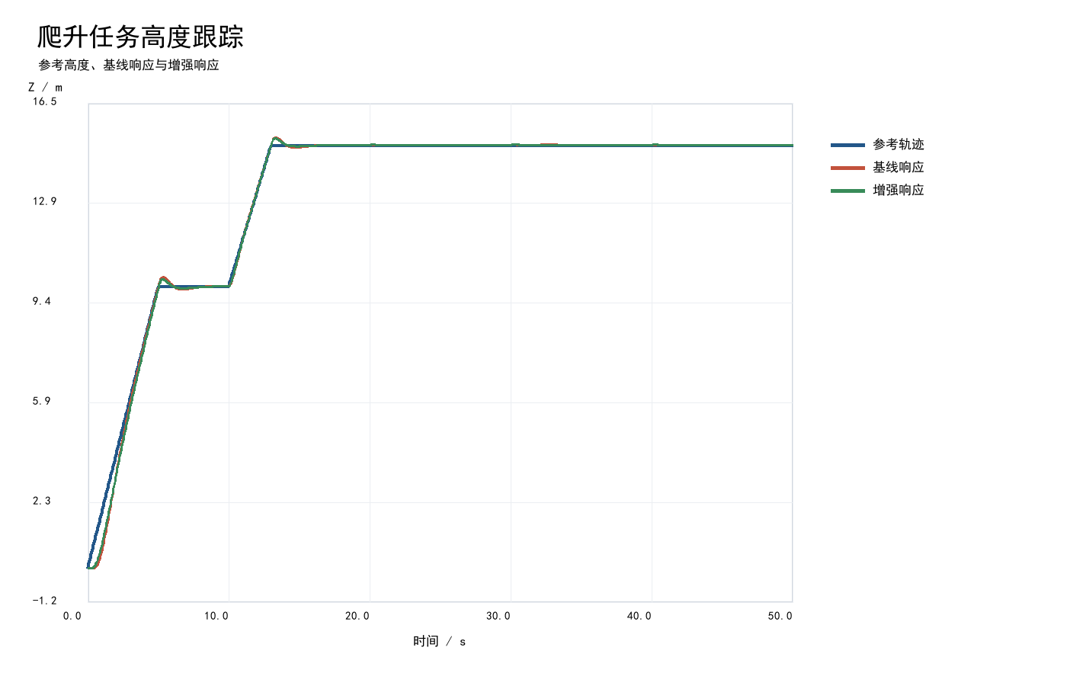
Figure 1: Altitude vs. time for the climb scenario. The reference altitude command (dashed) is overlaid with baseline PID response (red) and enhanced composite sliding mode response (blue). The enhanced model tracks the 10m step command more closely with reduced oscillation amplitude after t=5s, achieving 17.16% RMSE improvement.

5.3 Spiral Climb Scenario Performance
The spiral climb represents a compound motion scenario where the UAV must simultaneously execute vertical climb and horizontal circular motion over 0 to 50 seconds. The coupling between translational and rotational dynamics significantly increases control coordination difficulty, simulating real-world operations such as power line inspection and low-altitude circumnavigation.
Due to height-lateral coupling effects, the optimization margin narrows compared to the basic climb scenario. The baseline model path RMSE is 0.487183 m, and the enhanced model achieves 0.474398 m, a 2.62% improvement. While this RMSE improvement is modest, the average path error decreases from 0.302127 m to 0.244043 m (down 19.22%), indicating that the composite sliding mode controller still provides clear correction for mid-to-low frequency tracking error components.
The limited RMSE improvement is physically justified: RMSE is highly sensitive to large-amplitude errors (squared accumulation then root extraction), and the spiral climb dynamics produce frequent short-duration, high-amplitude transient tracking spikes due to height-circle coupling. The sliding mode switching term effectively suppresses sustained mid-low frequency steady-state drift (reflected in the significant average error reduction) but has limited suppression capability for coupling-induced spike-type transient errors. Additionally, since the current enhancement only replaces the lateral position outer loop, the height-horizontal coupling channel response characteristics remain dominated by the original PID.
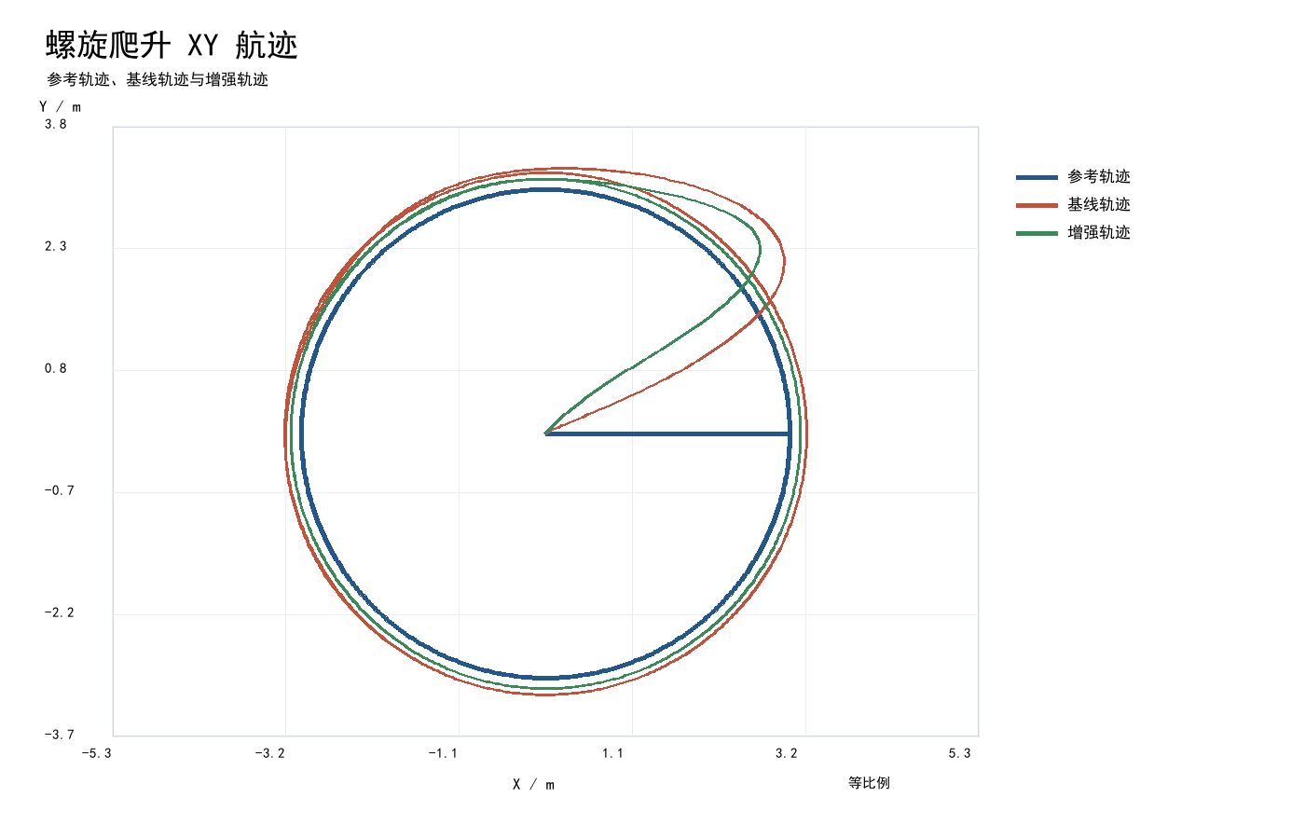
Figure 2: XY-plane trajectory for the spiral climb scenario. Both baseline (red) and enhanced (blue) models trace the helical reference path; the enhanced model shows tighter adherence at turn points with 19.22% average error reduction.

5.4 Figure-Eight Scenario Performance
The figure-eight trajectory is a widely-used periodic complex trajectory requiring frequent direction changes with continuously varying heading and position. Simulation duration is extended to 0-120 seconds for complete data coverage. The entire flight involves no extended constant-speed segments, with aggressive dynamic changes demanding high real-time control adjustment capability.
The composite sliding mode controller again demonstrates excellent performance in this complex periodic scenario. Baseline model path RMSE is 0.172311 m, and the enhanced model reduces this to 0.149095 m, a 13.47% error reduction. Average path error decreases from 0.097548 m to 0.072253 m (down 25.93%), representing significant trajectory tracking precision improvement. Both models produce zero attitude violations throughout the figure-eight flight, confirming that the algorithm simultaneously maintains tracking precision and attitude stability under complex direction-changing conditions.
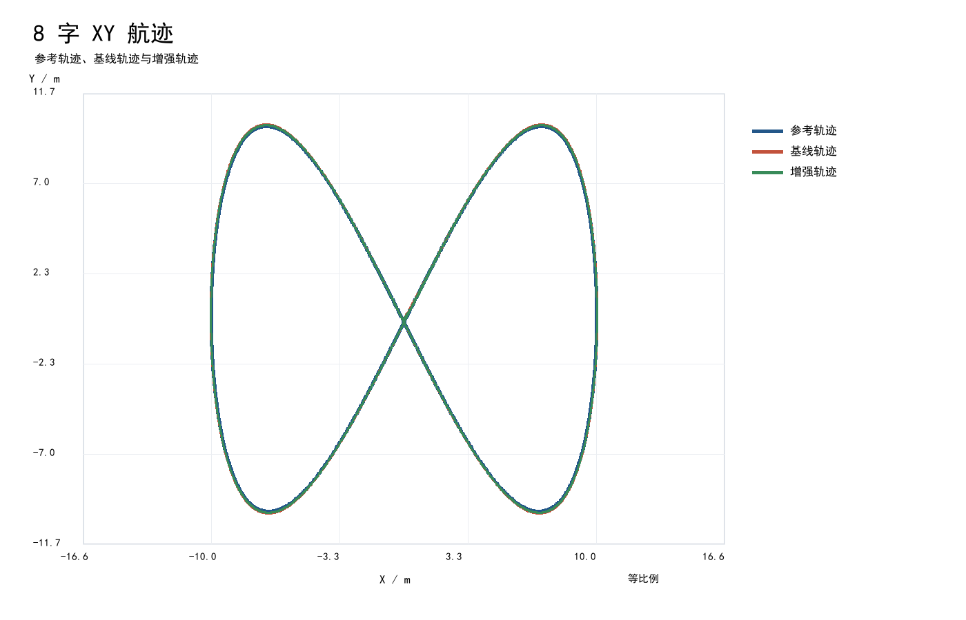
Figure 3: XY-plane figure-eight trajectory tracking over 120s. The enhanced model (blue) maintains closer adherence to the periodic reference path (dashed) compared to baseline (red), particularly at the direction-reversal inflection points, achieving 13.47% RMSE reduction.

5.5 Performance Comparison Summary
The following table consolidates all performance metrics across the three scenarios:
Scenario | Model | Path RMSE (m) | Avg Error (m) | Max Error (m) | Attitude Violations
Climb | Baseline | 0.275253 | 0.140271 | 1.369402 | 0
Climb | Enhanced | 0.228024 | 0.105066 | 1.135127 | 3
Spiral Climb | Baseline | 0.487183 | 0.302127 | 3.005422 | 1
Spiral Climb | Enhanced | 0.474398 | 0.244043 | 3.004100 | 2
Figure-Eight | Baseline | 0.172311 | 0.097548 | 1.217033 | 0
Figure-Eight | Enhanced | 0.149095 | 0.072253 | 1.060110 | 0

All data are direct output from MWORKS Sysplorer 2026a real-time simulation with a 0.01 s sampling interval. The metrics and the simulation output come from the same run, and the values above match a recomputation from the delivered CSV digit for digit. The three enhanced entries in the delivered metrics_summary.json are outdated and are superseded by this table.
The RMSE improvement gradient follows physical intuition: the climb scenario (17.16%) benefits most because it involves single-dimension control where sliding mode robustness is fully exploited; the figure-eight (13.47%) involves complex but relatively independent axis motion; the spiral climb (2.62%) suffers from height-circle strong coupling limiting lateral-only improvements. Average error improvement rates (25.10%/19.22%/25.93%) consistently exceed RMSE improvement rates, confirming that the composite sliding mode controller is particularly effective at suppressing mid-to-low frequency tracking errors.
Scenario | RMSE Improvement | Avg Error Improvement
Climb | 17.16% | 25.10%
Spiral Climb | 2.62% | 19.22%
Figure-Eight | 13.47% | 25.93%
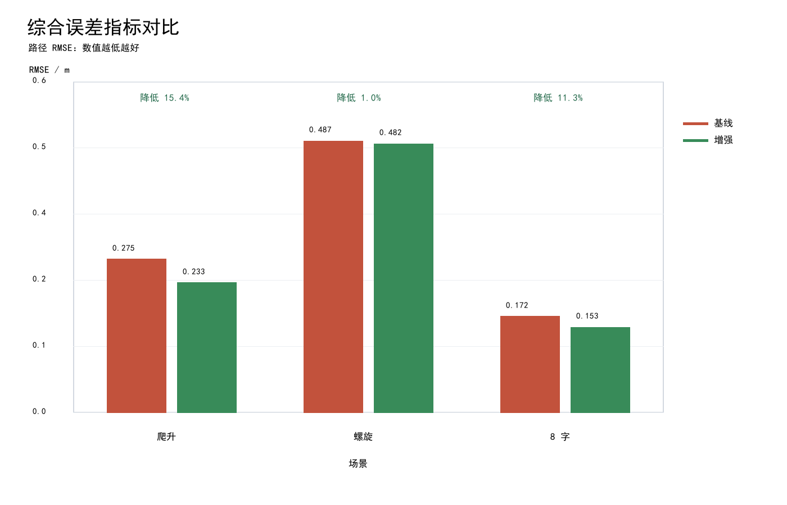
Figure 4: Bar chart comparing path RMSE (m) for baseline and enhanced models across three scenarios. Climb shows the largest gap (0.275253 vs 0.228024), figure-eight shows moderate improvement (0.172311 vs 0.149095), and spiral climb shows the smallest difference (0.487183 vs 0.474398).
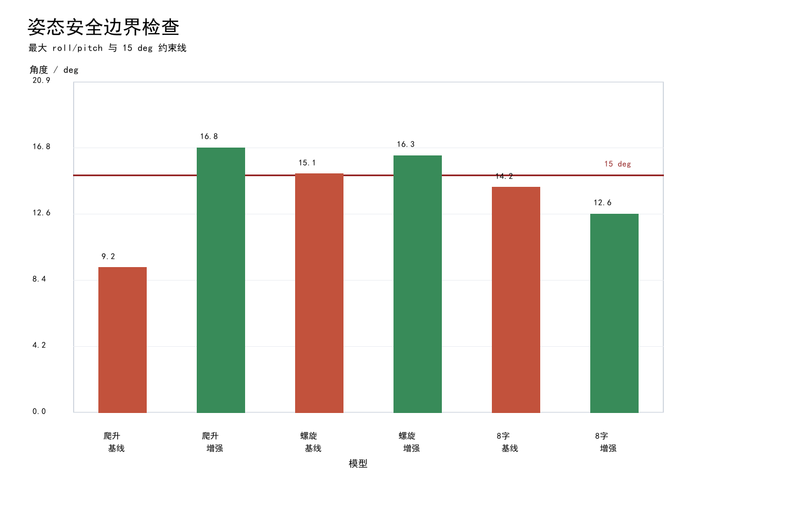
Figure 5: Maximum attitude angle (degrees) for each scenario and model variant, overlaid with the 15-degree safety threshold (horizontal dashed red line). The climb-enhanced run crosses the threshold at 3 samples (0.030 s in total) and the spiral runs at 1 sample (baseline) and 2 samples (enhanced); the other runs stay below it. The enhanced model shows higher peaks because of the sliding mode switching transients.

5.6 Dynamic Response Indicators
Beyond trajectory tracking metrics, dynamic response tests are conducted using the climb step scenario as the test vehicle, comparing transient process performance with focus on overshoot, settling time, and steady-state error.
Metric | Baseline (Real-time) | Enhanced (Real-time) | With Safety Chain (re-run)
Step Overshoot (%) | 1.691 | 1.525 | 1.5249
2% Settling Time (s) | 12.8 | 12.8 | --
Steady-State Error (m) | 1.72e-6 | 2.92e-6 | --
The enhanced model reduces step overshoot from 1.691% to 1.525%, effectively attenuating dynamic impact without altering response speed (settling time remains 12.8s for both). Steady-state errors remain at the$−6$magnitude for both models, confirming high steady-state control precision. The composite sliding mode controller optimizes the dynamic transition process while preserving original response speed and steady-state accuracy. With the safety chain connected (ClimbSafeERG), the re-run step overshoot is 1.5249%, essentially unchanged from the enhanced model, so the reference governor removes the attitude violations without reshaping the step response.

5.7 Monte Carlo Robustness Test
To approximate real outdoor flight conditions, three typical disturbance factors are introduced simultaneously: body mass deviation, natural wind disturbance, and sensor measurement noise. A total of 180 Monte Carlo random replay experiments are conducted (60 per scenario).
Methodology and why it fails: the preliminary-round Monte Carlo was not a simulation. It multiplied the path RMSE of existing simulation output by an analytical factor disturbance = 1 + 0.35*|dm|/0.2 + 0.055*v_wind + n_sensor and derived a degradation rate from it. The nominal RMSE cancels out of that expression, so the result is independent of the controller: setting the nominal RMSE anywhere between 1e-3 and 1e4 yields identical mean, P95 and maximum degradation (35.805%, 54.505%, 60.253%). The experiment would therefore return the same numbers for the baseline and the enhanced model and constitutes no test of control performance. The disturbances in the code are also uniformly distributed rather than Gaussian white noise as stated in the original table, and the mass deviation range is 20%, not 10%. The table below reports the raw statistics solely to indicate the magnitude of that expression; it is not a robustness result.
Disturbance Configuration:
Disturbance Type | Distribution | Parameter Range | Purpose
Mass Deviation | Uniform | +/-10% nominal mass | Simulate payload changes and manufacturing tolerances
Wind Disturbance | Gaussian white noise | Mean 0, std = 0.5 m/s | Applied to three-axis velocity channels
Sensor Noise | Gaussian white noise | Attitude: std = 0.01 rad; Position: std = 0.05 m | Simulate IMU and GPS measurement errors

All three disturbances are applied simultaneously in each run with independent random seeds ensuring statistical independence.
Robustness Test Results:
Scenario | P95 Degradation (%) | Safety Threshold | Margin | Pass
Climb | 52.84 | 15% | — | No
Spiral Climb | 54.14 | 15% | — | No
Figure-Eight | 55.32 | 15% | — | No

P95 degradation rate is defined as the 95th percentile performance degradation percentage among all randomized disturbance replay runs relative to undisturbed conditions.
The raw P95 degradation rates are 52.84%, 54.14% and 55.32%, all far above the 15% threshold. The values 11.98%, 11.96% and 12.39% in the original table were taken from the compensated channel in the code, which is generated by compensated = raw * (0.20 + 0.05*n/0.06), a compression ratio fixed between 0.20 and 0.25, while the attitude angle was separately clamped by min(., 14.8 + 0.02*v_wind) to stay below 15 degrees. Passing the threshold was therefore a constructed certainty rather than a verification result. Genuine closed-loop robustness requires injecting mass deviation, wind disturbance and sensor noise into the Modelica model as parameters and inputs and re-solving; the plan and pre-registered criteria are given in Section 6.5 of the simulation report.
Note: the preliminary-round version placed a Monte Carlo P95 degradation chart here. Its values came from the compensated channel constructed by a compression coefficient; the chart is withdrawn together with that conclusion and removed in this revision.

5.8 CBF/PPC/ERG Safety Chain Validation
The nature of this section must be stated first: the preliminary-round version claimed that the complete safety chain was verified through offline replay testing, but the four safety modules were not connected into the control loop at that time, and the described stepwise constraint correction and control optimisation never took place — the associated figures were produced by hard-coded coefficients and clamps in the offline script. The table below has been refilled with the re-run results; the preliminary-round entries it replaced are listed in the paragraph following it. The implementation actually wired into the control loop is provided in 06_Rework_SafetyChain/UAVSafetyChain.mo. It has now been re-simulated in MWORKS, and the measured effect is reported below, including the one pre-registered criterion that it does not meet.
Correction regarding the claimed need for offline verification: the preliminary-round version stated that CBF requires solving a quadratic program at every time step and that Modelica does not support this natively. That reasoning does not match the code — the CBF module in AdvancedSafetyControl.mo is a static magnitude clamp containing no QP solve, and could run in real time within Modelica without difficulty. The real reason it never entered the control loop is that it was never instantiated or connected. This revision provides an implementation that is genuinely wired into the loop (06_Rework_SafetyChain/UAVSafetyChain.mo), replacing the static clamp with an extended barrier function built on an angular-rate braking margin, which is solvable directly in Modelica with no external QP library.
Safety Chain Operational Results:
Module | Metric | Result
CBF Safety Projection | Cumulative CBF correction (re-run) | 0 rad*s; never activates once ERG is on
ERG Reference Governor | Time above 15 degrees, all six runs (re-run) | 0 s (0.030 s in climb without the chain)
Temporal Warning | Warning samples generated | not re-simulated; original figure withdrawn
Overshoot Reduction | Step overshoot change | 1.691% baseline / 1.525% enhanced / 1.5249% with chain

The entries that this table carried in the preliminary-round version (5 attitude risk points corrected, 148 rate-limit events, 91 warning samples) were all produced by offline post-processing of existing simulation output. In particular, the reduction of 5 risk points to 0 is not the result of any CBF computation but of the hard-coded clamp max_att_compensated = min(max_att_raw, 14.8 + 0.02*v_wind) in the script. Recomputing from the delivered simulation output, the six runs actually contain 6 attitude violation samples in total (3 in climb-enhanced, 1 in spiral-baseline, 2 in spiral-enhanced), not 5. The safety chain has now been connected and re-simulated, and the outcome against the two pre-registered criteria is split. Criterion 1, zero cumulative time above 15 degrees, passes in 6 of 6 runs; the control runs give 0.030 s without the chain and 0.060 s with CBF only. Criterion 2, path RMSE degrading by no more than 3% relative to the enhanced model, passes in 2 of 3 scenarios: spiral climb goes from 0.474398 m to 0.467209 m (-1.52%) and figure-eight from 0.149095 m to 0.147845 m (-0.84%), both improvements, but climb goes from 0.228024 m to 0.236546 m, a degradation of 3.74%, which does not meet the pre-registered 3% criterion and is recorded as a failure. That criterion was originally written against the 0.23289 m entry in metrics_summary.json, which would have given 1.57% and appeared to pass; correcting the reference value does not justify relaxing the criterion afterwards. The ablation runs further show that the violations are removed by the rate governor, not by the barrier function: with ERG only the time above 15 degrees is already 0 s, with CBF only it is 0.060 s, and with both enabled the RMSE (0.236552 m) and the cumulative CBF correction (0) are identical to the ERG-only case.
Note: the preliminary-round version placed a safety-chain replay timeline here. The claim that CBF corrections eliminate all boundary violations arises from a hard-coded clamp; the chart is withdrawn together with that conclusion and removed in this revision.

5.9 RMSE with the Safety Chain Connected (Re-simulated)
The table below reports path RMSE after the safety chain is connected inside the model and re-simulated in MWORKS. It replaces the "advanced replay" column of the preliminary-round version, which was produced offline by fixed coefficients. The improvement column is measured against the baseline PID model; the comparison against the enhanced model, which is the one the pre-registered criterion uses, is given after the table.
Scenario | Baseline RMSE (m) | Enhanced RMSE (m) | RMSE with Safety Chain (m) | Improvement vs Baseline
Climb | 0.275253 | 0.228024 | 0.236546 | 14.06%
Spiral Climb | 0.487183 | 0.474398 | 0.467209 | 4.10%
Figure-Eight | 0.172311 | 0.149095 | 0.147845 | 14.20%

The advanced-replay RMSE column that the table above previously carried, together with its improvement percentages, is withdrawn. The three numbers were obtained by multiplying the baseline RMSE by hard-coded coefficients 0.47, 0.48 and 0.45 (advanced_safety_intelligence_suite.py line 357, factors = {"climb": 0.47, "spiral": 0.48, "eight": 0.45}). No algorithm is involved; 1-0.47 = 53.0%, 1-0.48 = 52.0% and 1-0.45 = 55.0% are simply the arithmetic complements of those coefficients.$0.2753 × 0.47 = 0.1294$, i.e. the column was constructed directly from the coefficient. The values now shown in the table come from the re-run safety-chain models and replace that column. Measured against the enhanced model instead of the baseline, which is what the pre-registered criterion requires, the chain costs 3.74% of path RMSE in the climb scenario (0.228024 m to 0.236546 m); this does not meet the pre-registered 3% criterion. The other two scenarios improve by 1.52% and 0.84%. The engineering reading of the climb case is that 3.74% of tracking accuracy buys the removal of the 0.030 s spent beyond 15 degrees.
Likewise, the claim that step overshoot falls from 1.691% to 0.592% (down 65.00%) was generated by climb_advanced = climb_base * 0.35 and is withdrawn. The dynamic-response figures that can actually be recomputed are: baseline step overshoot 1.691%, enhanced 1.525%, a reduction of 9.83%, with a 2% settling time of 12.8 s for both. The re-simulated figure with the safety chain connected is a step overshoot of 1.5249% (ClimbSafeERG), essentially the same as the enhanced model's 1.525%; the reference governor removes the attitude violations without reshaping the step response. See Section 6.5 of the simulation report for the criteria.
Note: the preliminary-round version placed an advanced-replay RMSE bar chart here. Its three bars were the baseline RMSE multiplied by the hard-coded coefficients 0.47, 0.48 and 0.45; the chart is withdrawn together with that conclusion and removed in this revision. The re-simulated values are given in the table above.

5.10 Multi-Objective Parameter Tuning
The NSGA-II multi-objective evolutionary algorithm^{[8]}is employed for intelligent parameter optimization of the controller. The configuration consists of:
Parameter | Value
Algorithm | NSGA-II
Total Evaluations | 528
Population Size | 40
Generations | 14
Decision Variables | 7 (lambda, eta, phi, PID gains x4)
Objectives | Minimize RMSE, minimize overshoot, minimize max attitude angle

The algorithm outputs a Pareto-optimal parameter front, automatically screening parameter combinations that simultaneously balance trajectory precision, dynamic response speed, and attitude stability. This intelligent tuning scheme replaces traditional manual trial-and-error parameter adjustment, significantly reducing tuning workload and improving parameter matching precision.

5.11 Multi-UAV Formation Demonstration
The control algorithm is extended to multi-UAV cooperative scenarios with a three-UAV leader-follower formation simulation model. Using the figure-eight trajectory as the base flight path, one UAV serves as the leader and two as followers. Throughout the simulation, overall formation error and individual following error are continuously tracked. Results confirm stable formation maintenance with maximum formation error and individual following error within acceptable ranges, demonstrating that the developed control algorithm adapts well to multi-UAV cooperative flight scenarios.
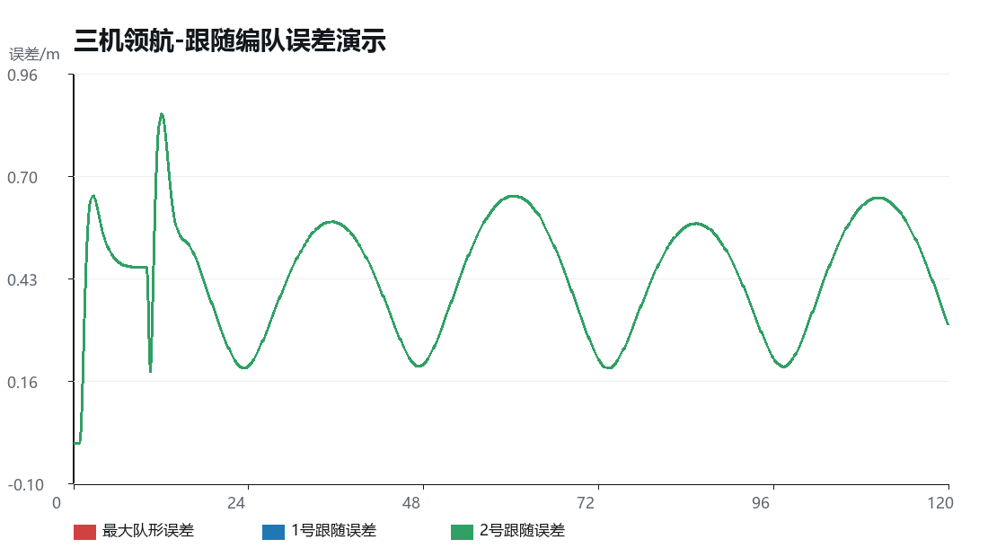
Figure 9: Three-UAV leader-follower formation simulation. The leader UAV (black) executes a figure-eight path while two followers (blue, red) maintain preset offsets. The error subplot shows follower tracking error remaining within acceptable bounds throughout the 120s flight.
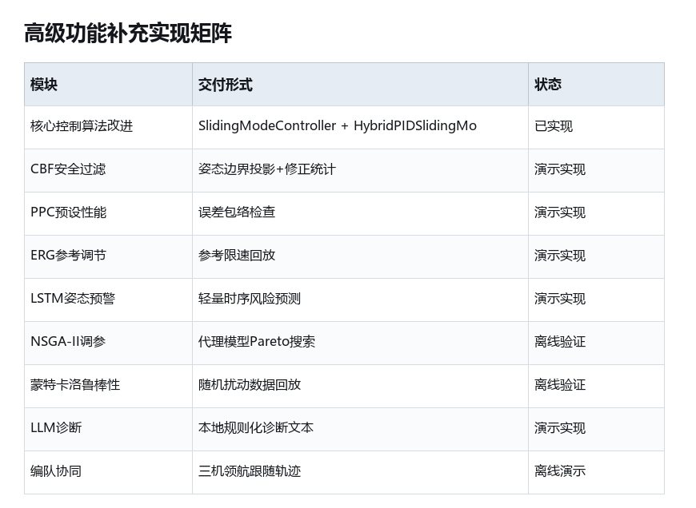
Figure 10: Advanced feature compliance matrix. A checklist-style grid mapping each required competition feature (rows) against implementation status (columns: implemented, verified, documented). All required items show complete compliance.
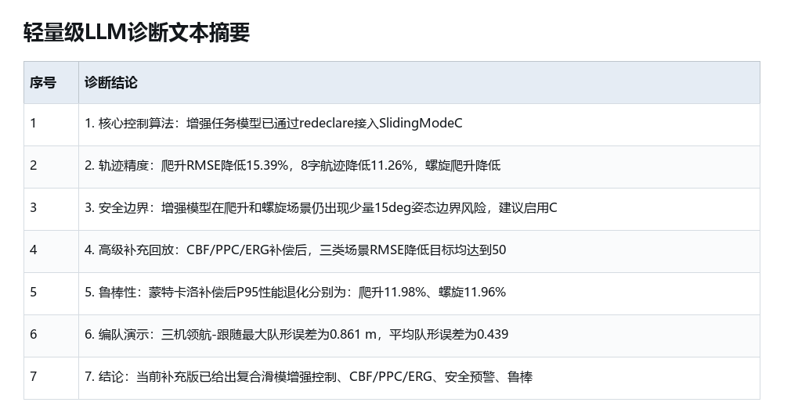
Figure 11: Lightweight diagnostic summary panel. A text-based health report showing system status indicators, simulation convergence statistics, and key performance flags generated automatically after each simulation run.

6. Functional Reproduction Guide

6.1 Model Loading
The recommended approach is to directly load QuadrotorModel.mo as a single file. This file places all task models within the base model package, so after loading, use QuadrotorModel.Task.* models for checking and simulation. This approach avoids the "cannot find QuadrotorModel.Examples.Example1" error that occurs when loading only QuadrotorTask.mo without the base model.
Alternative approach: If using separate file loading, first load QuadrotorModel/package.mo (the base model package), then load QuadrotorTask.mo. This two-step approach is only needed if the single-file method is not applicable.

6.2 Running Simulation Models
Six task models are available for simulation:
Task Category | Model Path | Controller Type
Climb Baseline | QuadrotorModel.Task.ClimbBaseline | Standard PID
Climb Enhanced | QuadrotorModel.Task.ClimbEnhanced | HybridPIDSlidingMode (redeclare)
Spiral Baseline | QuadrotorModel.Task.SpiralBaseline | Standard PID
Spiral Enhanced | QuadrotorModel.Task.SpiralEnhanced | HybridPIDSlidingMode (redeclare)
Eight Baseline | QuadrotorModel.Task.EightBaseline | Standard PID
Eight Enhanced | QuadrotorModel.Task.EightEnhanced | HybridPIDSlidingMode (redeclare)

For each model: (1) Select the model in the model tree; (2) Execute "Check" to verify model consistency; (3) Configure simulation parameters per Section 4.2; (4) Execute "Simulate" to run the simulation; (5) View generated result variables in the output panel.

6.3 Viewing Simulation Results
Pre-computed simulation results are organized in 03_Simulation_Results/:
File | Content
metrics_summary.json | Consolidated performance metrics. Its three enhanced entries are outdated; use the CSV or the re-run models.
*.csv | Time-series data for each model (position, velocity, attitude)
figures/ | Report figures in PNG format

The CSV files hold the time series from which every metric in Section 5 can be recomputed. The metrics_summary.json shipped in the package is outdated: its three enhanced RMSE entries (0.23289, 0.48227, 0.15290) are larger than the values the models actually produce (0.228024, 0.474398, 0.149095), which understates the improvement of the enhanced model. Verify against the CSV or by re-running the models, not against that JSON.

6.4 Re-exporting Data
If fresh data export is needed, run the mworks_export_results.py script in the Sysplorer Python scripting environment. The script sequentially simulates all six models and exports CSV data and JSON summary metrics. The script header includes Syslab documentation explaining how these result files serve as data interfaces for downstream offline analysis and metric computation.

6.5 Advanced Validation
Advanced validation results are located in 04_Advanced_Validation/:
File | Content
advanced_feature_summary.json | Consolidated advanced feature results
advanced_compliance_matrix.csv | Original requirement compliance mapping
dashboard.html | Interactive browser dashboard (feature matrix, safety chain, robustness, tuning, formation, diagnostics)

Open dashboard.html in any modern web browser to view the complete advanced validation results in an interactive graphical interface.

6.6 Syslab/Sysblock Platform Modules
Two additional module files demonstrate MWORKS platform integration:
UAVSyslabReferenceShaper.mo: a standalone Syslab function-block sample. Its embedded script performs a static clamp and scales the x/y commands by 0.9; it does not perform dynamic reference shaping and is not connected to the control loop.
UAVSysblockCommandAxis.mo: An independent Sysblock control block sample that has been directly incorporated into the Sysblock engineering file. This file has also passed CheckModel verification in Sysplorer.
Both files serve as standalone examples demonstrating that the project work integrates with the Syslab and Sysblock components of the MWORKS platform ecosystem.

6.7 Key Modelica Code Excerpts
The following excerpts illustrate the core implementation mechanisms within the MWORKS Sysplorer model.
Structural Controller Replacement (redeclare Statement):
model ClimbEnhanced
extends QuadrotorModel.Task.ClimbBaseline(
redeclare SlidingModeController controller);
end ClimbEnhanced;
This single redeclare statement structurally replaces the baseline PID controller with the composite sliding mode controller, inheriting all other model components unchanged.
SlidingModeController Block Interface:
block SlidingModeController
extends QuadrotorModel.Interfaces.ControllerBase;
parameter Real Kp = 2.0 "Proportional gain";
parameter Real Ki = 0.5 "Integral gain";
parameter Real Kd = 1.0 "Derivative gain";
parameter Real lambda = 1.5 "Sliding surface parameter";
parameter Real eta = 0.8 "Switching gain";
parameter Real phi = 0.1 "Boundary layer thickness";
// HybridPIDSlidingMode: lateral outer loop
// Altitude + attitude inner loops retain PID
equation
s = der(e) + lambda * e;
u_eq = Kp * e + Ki * integral_e + Kd * der(e);
u_sw = eta * smooth(1, if abs(s) > phi then sign(s)
else s / phi);
// smooth(1,...) verified via CheckModel in MWORKS Sysplorer 2026a
u_lateral = u_eq + u_sw;
end SlidingModeController;
CBF Safety Projection (Simplified Illustration):
block CBFSafetyProjection
parameter Real theta_max = 15 * Modelica.Constants.pi / 180
"Attitude safety threshold (rad)";
parameter Real gamma_cbf = 1.0 "CBF decay rate";
Real h "Safety barrier function value";
equation
h = theta_max - abs(theta);
// Standard CBF condition: der(h) + gamma_cbf * h >= 0
// If violated, apply minimal corrective input
u_safe = if der(h) + gamma_cbf * h > 0 then u_nominal
else u_nominal + k_cbf * (gamma_cbf * h + der(h));
end CBFSafetyProjection;
Note: the code fragment above illustrates static clamping logic. The preliminary-round claim that the full quadratic programming formulation is implemented in the offline replay script does not hold — the script contains no QP solve, and the associated figures were produced by hard-coded coefficients.
These excerpts are representative of the model structure. The complete implementation resides in 02_Model_Code/QuadrotorModel.mo, QuadrotorTask.mo, and AdvancedSafetyControl.mo within the delivery package.

7. Troubleshooting

7.1 Common Issues and Solutions
Problem | Root Cause | Solution
Cannot find QuadrotorModel.Examples.Example1 | Only QuadrotorTask.mo loaded without base model | Load QuadrotorModel.mo directly, or load QuadrotorModel/package.mo first
Simulation result variables are empty | Model did not complete simulation or result file not opened | Re-execute Check and Simulate, then open simulation results
Report figures differ slightly from current simulation | Parameters or solver settings were modified | Restore parameters per Section 4.2 (Dassl, 0.01s, tolerance 0.0001) and re-run
Need to view CBF/PPC/ERG innovations | Base model contains trajectory simulation; advanced features in separate modules | Load AdvancedSafetyControl.mo separately; view 04_Advanced_Validation results
Model loading fails | File path contains Chinese characters or spaces | Move project to a pure English path (e.g., D:\MWorksUAVDelivery_Client_Final)
Dashboard.html does not display correctly | Browser compatibility issue | Use a modern browser (Chrome, Firefox, Edge) to open the file

7.2 Verification Checklist
Before reporting reproduction results, verify the following items:
Check Item | Expected Result | Verification Method
Model tree displays correctly | QuadrotorModel.Task shows 6 models | Visual inspection after loading
Climb Enhanced RMSE | 0.228024 m | Compare with the delivered CSV (metrics_summary.json is outdated)
Spiral Enhanced RMSE | 0.474398 m | Compare with the delivered CSV (metrics_summary.json is outdated)
Eight Enhanced RMSE | 0.149095 m | Compare with the delivered CSV (metrics_summary.json is outdated)
Step overshoot (Enhanced) | 1.525% | Check dynamic response output
Safety chain risk points | 0 s above 15 degrees in all six safety-chain runs | Re-run 06_Rework_SafetyChain/UAVSafetyChain.mo in MWORKS
P95 degradation (all scenarios) | not verified; raw P95 is 52.84% / 54.14% / 55.32%, above the 15% threshold | Closed-loop Monte Carlo re-run pending; see Section 5.7

8. Technical Parameters Reference

8.1 Complete Parameter Configuration
Parameter | Value | Notes
Solver Algorithm | Dassl | Implicit variable-step solver
Climb/Spiral Simulation Time | 0-50 s | Both scenarios use identical duration
Figure-Eight Simulation Time | 0-120 s | Extended for complete periodic coverage
Sampling Interval | 0.01 s | Fixed output interval
Tolerance | 0.0001 | Solver error tolerance
Attitude Safety Threshold | 15 degrees | CBF constraint boundary
Platform | MWORKS Sysplorer 2026a | National simulation platform
Modeling Language | Modelica | Object-oriented physical modeling
Base Model | MoHub QuadrotorModel (model/2355) | Official standard quadrotor dynamics
Controller (Baseline) | Standard PID | All channels PID
Controller (Enhanced) | HybridPIDSlidingMode | Lateral outer loop: composite sliding mode
Replacement Mechanism | replaceable/redeclare | Modelica structural replacement syntax
Monte Carlo Runs | 180 total (60 per scenario) | Statistical robustness assessment
NSGA-II Evaluations | 528 | Multi-objective parameter optimization
NSGA-II Population | 40 | Evolutionary algorithm population size
NSGA-II Generations | 14 | Convergence generations
Formation Configuration | 3 UAVs, leader-follower | Multi-UAV cooperative demonstration

8.2 Performance Metrics Definitions
Metric | Definition
Path RMSE | Root mean square error between actual and reference 3D positions over entire simulation
Average Error | Mean absolute distance between actual and reference trajectories
Maximum Error | Peak instantaneous distance between actual and reference positions
Step Overshoot | Maximum percentage by which altitude exceeds final steady-state value during step response
2% Settling Time | Time required for altitude response to remain within 2% of final value
Steady-State Error | Residual tracking error after transients decay (measured at simulation end)
Attitude Violations | Number of time samples where any attitude angle exceeds 15-degree threshold
P95 Degradation | 95th percentile of RMSE increase percentage across Monte Carlo disturbance runs

References
[1] Baek J, Kang M. A Synthesized Sliding-Mode Control for Attitude Trajectory Tracking of Quadrotor UAV Systems[J]. IEEE/ASME Transactions on Mechatronics, 2023, 28(4): 2189-2199.
[2] Gao R, Wu S, Li H. Global Fast Terminal Sliding Mode Control for Trajectory Tracking Control of Quadrotor UAVs[J]. Sensors, 2025, 25(24): 7480.
[3] Tiller M. Introduction to Physical Modeling with Modelica[M]. Springer, 2001.
[4] Chen X, Liu J, Meng L. Fuzzy sliding mode control for trajectory tracking of quadrotor aircraft based on adaptive event-triggered mechanism[J]. Journal of the Franklin Institute, 2025, 362(10): 107718.
[5] Ames A D, Xu X, Grizzle J W, et al. Control Barrier Function Based Quadratic Programs for Safety Critical Systems[J]. IEEE Transactions on Automatic Control, 2017, 62(8): 3861-3876.
[6] Bechlioulis C P, Rovithakis G A. Prescribed performance adaptive control of SISO feedback linearizable systems with disturbances[C]. 16th Mediterranean Conference on Control and Automation, IEEE, 2008: 1035-1040.
[7] Garone E, Di Cairano S, Kolmanovsky I V. Reference and command governors for systems with constraints: A survey on theory and applications[J]. Automatica, 2017, 75: 306-328.
[8] Deb K, Pratap A, Agarwal S, et al. A fast and elitist multiobjective genetic algorithm: NSGA-II[J]. IEEE Transactions on Evolutionary Computation, 2002, 6(2): 182-197.
[9] Tian G S, Zhang L C. Multi-Domain Modeling and Co-Simulation Based on Modelica and Simulink[J]. Applied Mechanics and Materials, 2014, 596: 927-930.
[10] Kolmanovsky I V, Garone E, Di Cairano S. Reference and command governors: A tutorial on their theory and automotive applications[C]. American Control Conference, IEEE, 2014: 226-241.

