My Life in U+2588

A Thesis

Presented to

The Division of The Arts

Reed College

In Partial Fulfillment

of the Requirements for the Degree

Bachelor of Arts

Yik Yin Cheuk

May 2025

Approved for the Division

(Art)

Akihiko Miyoshi

Acknowledgments

To everyone who has ever offered me kindness, encouragement, or light during my time in college: Thank you. Your presence, your words, and your support have shaped me in ways both quiet and profound. Because of you, I've made it through the challenges of college life and discovered not only knowledge, but a sense of belonging, purpose, and growth. You all have given me so much, and I will always carry all of that with deep gratitude.

I want to begin by thanking my professors and advisor. To Aki Miyoshi, thank you for helping me navigate the tangles of what was once a chaotic thesis idea and guiding me towards a much clearer path. Having taken nearly every class you taught, I can say without hesitation that your influence runs through so many of the passions I now hold dear. To Hyong Rhew, your class, *HUM 232: Middle Imperial China*, gave me a window into a part of my heritage I hadn't known how to approach or appreciate. The way you speak about the world has moved me to tears more than once, stirring something nostalgic within me about my family. And to Juniper Harrower, thank you for the incredible opportunity to work alongside you on the Joshua Trees project. That experience helped me grow not only as a website designer and developer, but also as someone who now better understands where curiosity can take me.

I am also deeply grateful to the supervisors I've had the privilege of working with during my time at Reed. To Marwa Al Khamees, thank you for welcoming me into the Center for Life Beyond Reed as a Peer Career Advisor. That role was more than just a job. It was also a space of immense personal growth, where I learned how to support others while also discovering more about myself. I met some of the kindest, most inspiring people through that position, and each interaction helped shape the person I've become. To Jessika Chi and Shishei Tsang, thank you for the opportunity to work with students from so many different cultures. Through you, I gained a deeper understanding and appreciation for cultures and communities, including my own. And to Caleah James, thank you for providing me an opportunity to break out of my shell. Working with you gave me the chance to grow not just professionally, but personally as well, especially in the ways I connect and communicate with others.

To my dear friends: thank you. Thank you for loving me through my messy days, for lifting me up when I couldn't do it alone, and for sharing joy and laughter that made the hard times easier to bear. Your friendship has been one of the greatest gifts of my college life. Each of you has left a mark in my heart, and I will never forget the way you helped me heal, grow, and laugh.

To Daniela Buchillon, thank you for being my first true friend at Reed, the one who befriended me and introduced me to many. Because of you, I found the community I now hold so close to my heart. You've been a role model to me from the very beginning, and I have often looked to your strength, kindness, and confidence as a source of inspiration. I would not be who I am today without your presence, your encouragement, and your unwavering support. I am endlessly grateful for you.

To Niko Adams: meeting you felt like something written in the stars (so corny, I know). I still marvel at how we first met, and I like to believe there was a bit of fate involved (so corny, again, I know). I've never felt more like myself around someone than I do with you. You are one of the rare souls who energizes rather than exhausts my social battery, someone I naturally hope to hang out with, over and over again. I look up to you more than I let on, not just for your effortless charm and personality, but also everything else about you. You make life feel lighter, fuller, and more real.

To Tina Qin, thank you for entering my life in such an unexpected, unconventional, and absolutely unforgettable way. Meeting you and Niko was definitely one of my biggest highlights during my sophomore year, one I'll always treasure. You brought joy, adventure, and a sense of connection when I didn't even know I needed it. I promise I'll visit you someday, and I hope all three of us can reconnect.

To Aakash Mishra, you have been, without question, the person I've looked up to the most at Reed. I know you'll probably ask *why*, but to me, it's obvious. Your work ethic, your strength, your resilience, even in the most difficult moments, leaves a lasting impression on me. I don't think you see just how many people admire you, how many quietly look to you for strength, the way I have. You move through the world with a kind of confidence and openness that I deeply admire. You have pursued things I could only dream of attempting and made them seem possible. You inspire me to be braver and more self-confident. I am forever thankful for having met you, and I’m incredibly lucky to call you my friend.

To Emily Yu, though our time together was brief, your impact on me has been lasting. What began with me feeling like your senior quickly shifted into me looking up to you instead. I'm so incredibly proud of everything you have accomplished in such a short amount of time. You carry yourself with a grace and drive that constantly reminds me how much one person can do, and how quickly someone can become a beacon of inspiration, as long as they have the drive for it.

To Jojo Hartman: we have not spent nearly as much time together as I wish we had, but you have still left such a vivid impression on me. Your ability to know the most random, fascinating topics never fail to amaze me, whether you realize it yourself. Coming to Reed, I felt like I knew so little about the world and being around you reminded me how much there is to still discover and learn. Your natural outgoing spirit and enthusiasm are things I truly admire. You make the world feel a little bigger (in a good way), and a lot more interesting.

To JD, even though we no longer talk, I want to thank you, deeply, for all the joy you brought into my life during middle and high school. You were my constant through all the struggles, through the times when everything felt unbearably low. You made me laugh without trying, gave me comfort without asking, and were always there for me, even at 3am during school nights. You were my longest and closest friend, and I carry our memories close with me, even now (after all, I do have more than 100 gb worth of videos together). I hope that someday, we will cross paths again. But even if we don't, I hope you remember me, along with all the laughter, late-night talks, and wonderful moments we once shared.

To everyone in Mishi, thank you for lighting up my high school years. Each of you brought something special into my life, and the memories we made together still make me smile. Though our lives have moved in different directions, I hope we find ways to reconnect from time to time. You were such an important part of my journey, and I won’t ever forget that.

And of course, Gabe Howland, how could I ever leave you out? Thank you for being by my side through it all. For your unwavering kindness, patience, and care, for loving me more than I ever thought I could be loved. You have helped me grow, helped me heal, and helped me love myself more and more each day. You stood beside me even during the times I couldn't stand beside myself. Thank you for always being patient with my highs and my lows, and for always encouraging me to challenge myself and to be a better person, even when I felt undeserving of it. With you, I never have to pretend. I can be vulnerable, honest, and unmasked. You are a gift I will never take for granted.

And most importantly, to my beloved family. My mother, my father, and my older brother. We may not express love the same way many other families around us do, but I feel it in the quiet moments, in the sacrifices, through the strict lessons, and in the never-ending support you've given me. Mom and dad, thank you for every ounce of effort you have poured into giving me and my brother a better life. I may not always say or seem like it, but I see your love in every little thing you both have done. You are more than just my parents. You are my home and my world. And to Danny, thank you for being such a guiding light during my childhood. Your presence shaped me, taught me, and inspired me in ways I still carry today. Even though we don't see each other anymore, I am endlessly grateful for everything you have given me.

I am forever indebted to you all. Thank you, from the deepest, fullest part of my heart, for everything you all have done for me.

List of Abbreviations

|  |  |
| --- | --- |
| **ANSI**  **ASCII**  **BBS**  **BEL**  **BS**  **CLBR** | American National Standards Institute  American Standard Code for International Interchange  Bulletin Board System  Bell  Backspace  Center for Life Beyond Reed |
| **CSS**  **ESL** | Cascading Style Sheets  English as a Second Language |
| **HTML**  **JS**  **LF**  **NAK**  **PCA** | Hyper Text Markup Language  JavaScript  Line Feed  Negative Acknowledge  Peer Career Advisor |
| **RTTY**  **SARS** | Radioteletype  Severe Acute Respiratory Syndrome |
| **TTY** | Teletype |

Table of Contents

Introduction 1

Chapter 1 5

Stereotypes 5

History of Stereotype 6

Present Day Chinese Stereotypes 8

Chapter 2 13

My Birthplace 13

Poise, Etiquette, and Respect 15

Elementary School 17

Middle and High School 18

My Online Persona 22

The COVID-19 Pandemic 23

College 24

Chapter 3 31

Text-Based Art 31

ASCII 32

History of ASCII 32

Understanding ASCII 33

ASCII Art 35

History of ASCII Art 35

ANSI Art 37

Kaomoji 38

History of Kaomoji 38

Understanding Kaomoji 39

Unicode 40

Understanding Unicode 40

Try It Yourself: Typing Unicode on Mac 41

Chapter 4 43

Inspiration 43

Childhood.html 45

Morning.html and Mirror.html 46

Hallway.html 49

Kitchen.html and Dining.html 51

Street.html 53

Crossing.html 54

Classroom.html 55

Cafeteria.html 56

Conclusion 57

Bibliography 61

List of Figures

Morning.html 46

Mirror.html 48

Hallway.html 49

Kitchen.html 51

Dining.html 52

Street.html 53

Crossing.html 54

Classroom.html 55

Cafeteria.html 56

Abstract

*My Life in U+2588* is a project that explores the long-lasting psychological and emotional impacts of cultural stereotypes and racism. Drawing from personal experiences as a Chinese American in a predominantly white town, this project explores how seemingly small and fleeting moments can have lasting effects on self-perception and mental health. Through an interactive website built using ASCII and Unicode, this project allows users to navigate through a world shaped by racial bias and invisibility. Users are invited to engage with these memories and reflections that illustrate the emotional impact of growing up under the weight of cultural stereotypes. This work aims to create space for empathy and introspection, both for those who have experienced similar struggles and for those who have not.

This thesis is dedicated to my past self, my present self, and the person I am still becoming. To my family, my friends, and to the world, for holding space for stories like mine.

# Introduction

My thesis, *My Life in U+2588*, explores how cultural stereotypes and racism shaped not only my childhood, but the way I understand myself today. This project is a reflection on how moments that may seem fleeting or insignificant to others can become etched into someone's memory for many years. Through this project, I revisit memories I had long forgotten and reflect on how even the smallest incidents and events left a lasting effect on who I have become today. Growing up as a Chinese American in a small, predominantly white town in Pennsylvania, I often found myself defined by stereotypes before I even had the chance to introduce myself. From an early age, it became clear that many people around me had already set an idea of who I was, not because they knew me personally, but because of how I looked and the fact that I was Chinese. Some of these stereotypes were very common: a straight-A student, naturally gifted at math, and eating cats and dogs for dinner. Whether intentional or not, these comments reinforced the idea into my childhood that I was different, that I somehow did not belong to the world. At the time, my younger self didn't fully comprehend what I was feeling, barely having knowledge of culture and race, but in my heart, I always knew something felt off. The embarrassment, the shame, the feeling of being hyper-visible and invisible all at the same time. These assumptions led to a lot of pressure and negative thoughts that loom over me, which eventually led to social anxiety. So much so that I considered the isolations during the COVID-19 pandemic to be one of the best and most peaceful years of my life prior to starting college, solely because of the fact I did not have to see anyone and could remain in the solitude and peace that I have found in my house and space with my beloved parents.

To tell my story, I created an interactive website[1] built using ASCII and Unicode, two text encoding standards that played a part in my childhood happiness. I hadn't realized until working on this thesis just how much these two standards had shaped the way I found comfort and creativity in the digital world. By allowing users to interact with my story, I hope to encourage reflection, allowing individuals to consider how cultural assumptions and stereotypes, how the smallest events can shape the way others think, and how those thoughts can leave a lasting impact on their lives. Through this experience, users are given the chance to navigate moments of isolation, cultural stereotypes, and racism. Sharing these memories, including the ups and downs, is not only a message to my younger self to hold on and stay strong, but to others who may feel alone or unseen in the world. For a long time, I never believed I would ever find a place where I would truly belong. I had come to accept the idea of staying peacefully in my own little world forever, interacting with no one outside of my family. But with the right people, the right place, and the right moment, my life took a turn I would have never expected. One that was filled with much more warmth, connection, and hope for the future.

Stereotypes and racism are deeply embedded in media, history, and storytelling, shaping how entire cultures and communities are perceived. They have the power to influence friendships, individual lives, how people are treated in everyday lives, and how others might perceive individuals and communities. In chapter 1, I will outline the effects of cultural stereotypes, their history, and how they still exist today. I explore how these stereotypes influence not only how others see us, but how we eventually come to see ourselves as well. Because this thesis is centered around my personal experience and self-exploration, I focus specifically on stereotypes related to Chinese identity.

I reflect on key moments from my childhood through my college life in chapter 2, including vivid memories that ultimately make me who I am today, how I understand myself, my culture, my community, and my relationship to the past and present world. Many of these recollections are small, almost trivial that others might not even remember or think twice about. And yet, they continue to live on in my mind, sometimes resurfacing without warning and stirring up feelings of embarrassment, shame, or self-doubt. While some of these stories may have been difficult for me to revisit, they are essential to understanding the emotional foundation of the project, and the personal journey that led me here. Now, as a college student, I have started to make sense of how those early experiences affected me both personally and professionally. Whether it was feeling hesitant to speak in certain spaces, second-guessing my ideas, or struggling to feel like I truly belonged, the experiences of childhood racism and stereotyping lingered. At the same time, coming to college also became a place of healing. Through friendships, cultural affinity groups, classes, and finally this thesis project, I began to understand my story not as a burden, but also as a source of strength. A source I can look back upon to remind myself how much I have grown. Healing didn't happen all at once, and obviously, I am still in the process. But being able to revisit these memories, acknowledge their impacts, and to share them has helped me understand myself. I have learned that healing can come in many forms: community, solitude, creativity, time, and most importantly, learning to forgive my past self for the parts I always felt ashamed of.

In chapter 3, I will explore the world of text-based art, including its many forms, their definitions, history, and evolution throughout the years. Since the core of my website revolves around ASCII and Unicode art, this chapter will also talk about what these forms of digital expression are, their purpose, how they work, and how they are used today. I will trace back to their origins, from early computer systems that relied on ASCII characters, to the more recent years where Unicode's vast range of symbols and scripts exist. This chapter will also touch on how people create and input these symbols themselves, explaining the process behind something that might seem so technical.

Chapter 4 will focus on the heart of the thesis: the interactive website that invites users to experience a digital recreation of my high school life. This website is a narrative experience designed to reflect my emotions, habits, and internal dialogues that defined my daily routine. Built using a combination of ASCII and Unicode art, interactive elements, and narrative storytelling, the website allows users to move through a fictionalized "day in the life." In this chapter, I will walk through the website page by page, explaining the choices behind each scene and interaction, along with the emotions tied to each moment. Each page, no matter how small or insignificant it might seem to others, contain a deep meaning to me. Whether it is the anxious quiet of morning alarms, the isolation of classroom seating, or even simply crossing the road, each page reflected a complex emotion. This chapter not only serves as a guide for the website I have created, but also as a deeper, personal reflection on the memories that I still remember, including the broader cultural and artistic elements that connect them.

# Chapter 1

## Stereotypes

Stereotypes are more than just labels. They are silent expectations, shaping the way we see other individuals and how we are seen in return. They dictate the roles we are supposed to play, the limits of who we are allowed to be, and the paths we are expected to follow. Whether it is based on race, gender, culture, or personality, stereotypes simplify individuals into vague categories, which can lead to misrepresentation, prejudice, and discrimination.[2]

Some stereotypes may look completely harmless at first glance, maybe even considered compliments: "Asians are smart,"[3] "women are nurturing," "men are natural leaders." But beneath these seemingly positive stereotypes can be something far more harmful to individuals, which can also result in pressure to comply with those assumptions. For example, a child who loves art but is constantly told that they must be smart in math or in the sciences may start to question their passions and dreams. A girl who enjoys weightlifting may start to wonder if she is somehow "less feminine." A boy who is sensitive and emotional may feel forced to bury his feelings to maintain his masculinity. The weight of these expectations builds over time. What starts as a passing remark starts to become an unspoken rule. People who don't fit societal expectations may feel ashamed of their interests, identities, or personalities, feeling forced to choose between authenticity and acceptance. Even individuals who might align with some of these stereotypes are not free from the long-lasting effects. They may feel like their worth lies on how well they uphold these assumptions.

More dangerously, stereotypes do not just shape individuals' identities, but they can also influence how society treats people. This was evident during the COVID-19 pandemic, when hatred toward Chinese people, along with those perceived to be of East or Southeast Asian descent, increased worldwide.[4]

## History of Stereotype

“Stereotype” as a word, like many others, originally meant something quite different. From the French language back in 1798, it was a method in which metal plates were used to transfer text and images to a page consistently.[5] But outside of printing, the word “stereotype,” by 1819, had begun to take on a more figurative sense, referring to ideas that are "fixed firmly, continued, or constantly repeated unchangeably,"[6] much like the previous definition of consistent replications of printed stereotypes. By the mid-20th century, "stereotype" had begun to take on the modern definition we associate the word with today: an oversimplified idea or image of a person or group.

Though the term “stereotype” in its current meaning was not defined until the mid-20th century, the idea behind it has been around for thousands of years. Throughout history, human society has used simplified assumptions and generalizations to individuals and groups of individuals based on their race, gender, occupation, or culture. These early stereotypes were often influenced by cultural myths, folklore, religious beliefs, and societal systems that shaped these broad ideas and expectations.

When it comes to Chinese stereotypes, a historical example of racial stereotyping comes from the treatment of Chinese immigrants in the United States during the 19th and 20th centuries. In the 1850s, Chinese workers migrated to the United States during the California Gold Rush in the gold mines and later worked on building railroads in the west.[7] As Chinese workers increased and grew more and more successful in the United States, so did the strength of anti-Chinese sentiment among other workers in the American economy. Chinese workers were often depicted as cheap laborers with no personality, ambition, or family life,[8] shaping this idea that Chinese immigrants were not fully human, while also being a threat to Americans that the Chinese were taking away their jobs and land, deeming them to be unfit into American society. This caused the rise of the "model minority myth" in the 1950s and 1960s, a sociological phenomenon that refers to a stereotype of Asian Americans as inherently successful, often portrayed as math whizzes, musical geniuses, or quiet, hardworking overachievers.[9] This soon resulted in the Chinese Exclusion Act of 1882, which prohibited Chinese workers from entering the United States, and placing heavy restrictions on those already living in the country.[10] This law was a result of racist stereotypes that portrayed Chinese immigrants and workers as overachievers and a threat to American jobs and culture, which also eventually led to growing anti-immigration as well, a justification for discrimination that still persists today. The anti-Chinese labor sentiment became so popular that in 1862, Abraham Lincoln signed an "anti-coolie" bill that banned transportation of 'coolies,' a derogatory code word for low-wage and unskilled laborers, typically those of Chinese or Indian descent.[11]

## Present Day Chinese Stereotypes

Even after many years of progress and civil rights movements, harmful stereotypes and racial biases towards Chinese communities persist today. While many of these prejudices have become more subtle compared to the past, their impact remains. These stereotypes often hide behind jokes, backhanded compliments, or casual assumptions, and they are predominant everywhere, from the media to school classrooms. Some of the same stereotypes that were once used to marginalize Chinese individuals decades ago continue to exist in new forms today.

Media played a vital role in shaping how we perceive groups of people, especially those we have little direct exposure to in our everyday lives. For many Americans, portrayals of Chinese individuals in film and television may have been their first, and sometimes, only point of reference. In the 1970s, the global rise of Hong Kong action cinema, along with figures like Bruce Lee, helped popularize the image of the Chinese "Kung Fu master." Because these martial arts films made up a large portion of Western media representations of Chinese people at the time, this stereotype quickly became widespread until present day. This representation was later reinforced by other famous actors like Jackie Chan, who continued to shape public imagination through martial artis-centered films. Though these movies brought pride and visibility to Chinese culture, they also unintentionally contributed to a narrow and repetitive portrayal of the overall Chinese community in Western media today.[12]

Beyond the martial arts trope, there are several other common stereotypes about Chinese individuals that remain in Western society. Another common stereotype is the belief that all Chinese people, along with the broader Chinese American and Asian community, are exceptionally intelligent, especially in math and science, or naturally gifted in areas like music. These ideas are rooted in the "model minority" myth, and though this stereotype might seem harmless at first glance, some individuals might feel the need to uphold this "model" of being obedient, hardworking, and academically successful. This places an immense pressure on them to meet unrealistic expectations, especially to those that might struggle to conform to these narrow ideals, which can eventually contribute to shame, isolation, and the silencing of real issues such as mental health challenges.

There also exists the exaggerated portrayal of Chinese physical features, especially the slanted or "narrow" eyes and yellow-tinted skin. These have long roots in Western entertainment and propaganda, where actors would wear makeup to represent "yellowface," fake accents, and exaggerated costumes to mimic Chinese or East Asian individuals. These past portrayals also often existed for comic relief rather than portraying them as their real and genuine individuals.[13] Today, a persistent expression of this stereotype is the mocking gesture where someone pulls at the corners of their eyes with their fingers to imitate the so-called "slanted" eye shape. Though many may pass this off as a harmless joke, it is a deeply offensive act rooted in racism and mockery, used to dehumanize, ridicule, insult, stereotype, and “imitate” Chinese and East Asian people.

These seemingly "minor" stereotype, whether through media portrayals or everyday gestures, creates a foundation for broader and ongoing patterns of prejudice against Chinese and East Asian individuals. They can eventually escalate into dangerous, real-world consequences, as seen most clearly during the COVID-19 pandemic. When the COVID-19 pandemic emerged, Chinese individuals and the broader Asian descent found themselves at the center of hostility, discrimination and violence. The virus was frequently referred to in politics and media with terms like the “Chinese virus” or the “Kung flu,”[14] reinforcing the generalization that all Chinese people, were somehow responsible for the pandemic. This narrative led to a surge in xenophobia, hate crimes, and acts of aggression against Asian communities worldwide. In the United States, several instances of verbal harassment, physical assault, and hate-fueled attacks emerged. Chinese individuals, along with anyone that “looked Chinese,” were randomly yelled at on the streets, shoved in subways, punched in broad daylight, and blamed for the virus. One example occurred on March 14, 2020, in Midland, Texas, where a man stabbed a family from Myanmar, injuring three people, including a 2-year-old girl and a 6-year-old boy. When questioned by police, the attacker admitted that he believed the family was Chinese and was trying to spread the coronavirus.[15] On another instance, on March 10th in Manhattan, a Korean American woman was assaulted by a man who grabbed her hair, shoved her, and punched her in the face, ultimately causing her to be hospitalized with a dislocated jaw. He shouted slurs such as, "You've got coronavirus, you Asian (expletive)" and "Where's your (expletive) mask?"[16]

Although, stereotypes are not only set by individuals outside a culture. They can also be created from within. These internal stereotypes stem from long-standing traditions and beliefs, historical biases, and societal expectations that continue to exist today. In China, one example of this is the cultural divide between the norther and southern regions, with the Yangtze River often serving as a rough line separating the two. Northern China is often associated with larger cities, heavier industry, and wheat-based agriculture, such as noodles and dumplings. People from the north are commonly stereotyped by the south as being more direct and physically larger due to the climate and diet. On the other hand, Southern China, with its humid climate and rice-based agriculture, is often perceived by the north as more rural or traditional. Southerners are sometimes stereotyped as being smaller in build, more reserved, and focused on business or trade.[17] This divide between the cultures, though harmless at first, can impact bigger things. For instance, in urban areas like Shanghai or Beijing, there may be a sense of superiority held by locals toward those from southern provinces. On the other hand, southern communities may see the behavior of northern provinces brash, disrespectful, or uncultured, affecting how they are all perceived in general.

One stereotype that exemplifies how internal biases can also influence external ones is the idea that southerners will eat pretty much anything. This belief, often directed at people from Guangdong province, paints southerners as individuals that are willing to consume all kinds of unusual or exotic animals. This stereotype is not only perpetuated within China by northerners who might make fun of Guangdong natives, but it also has contributed to global misconceptions about Chinese dietary practices. The offensive stereotype of Chinese people eating dogs or cats likely originated from these southern regions, even though such practices are far from being widespread.[18]

While many of these stereotypes, both from outside or within a culture, may appear trivial or even humorous on the surface, they often carry deeper implications. Over time, such assumptions can shape the way people are perceived, treated, and understood. From misrepresentation in media to discrimination in everyday interactions, the effect of these stereotypes can influence everything from public policy to personal identity. In this way, they do not simply distort the image of a culture, but they also quietly shape the experiences of individuals tied to it.

# Chapter 2

## My Birthplace

I often wonder how different my life would be if I had been born in Hong Kong instead of the United States. Would I still be here, writing this? Would I have grown up in the same schools, spoken the same way, or even held the same citizenship?

The outbreak of severe acute respiratory syndrome, or SARS, first emerged in November 2002 in Guangdong, China, before it rapidly spread to Hong Kong, turning the place into one of the largest infected areas. Hospitals were overflowed and the crowded streets suddenly empty. It was during this uncertainty that my mother decided to travel to New York City, where some of our relatives lived, to find a safer place to give birth to me. Because of that single decision, I was born in the United States, not Hong Kong. And though it did not seem like a significant event to me at first, I sometimes find myself wondering how much of my life was quietly shaped by that one choice. Would I have grown up with a different sense of identity? Would I have ever come to America, or gone to college here? Would I still eventually hold the same citizenship? Would I still carry the same questions about belonging? Or perhaps I would be living and studying in Hong Kong with other Chinese individual?

A few weeks after I was born, my mother and I returned to Hong Kong, where I met my father and older brother for the very first time. Though my memories of those early years are foggy, certain moments still stand out, fragments of a past that feel distant yet strangely vivid at the same time. I remember the high-rise apartment we stayed in, so high up that the city below felt like an entirely different universe. For some reason, the memory of me choking on a fish bone during a dinner meal stuck with me far longer than any other. And, of course, I remember the mischievous adventures led by my older brother, like how the two of us giggled menacingly as we sent pieces of chewed gum out our high-up apartment window to the city below.

Aside from those mischievous and somewhat strangely detailed memories, I also recount the first of many endless strict lessons by my father. He was always determined to teach me new skills at a very early age, believing that a little challenge would be the quickest and most effective way for me to learn. Around the age of two, he decided it was time for me to learn how to swim. At our apartment complex’s swimming pool, he simply tossed me into the water. There was no gradual introduction, no floaties, and no gentle coaxing. Just the sudden shock of being submerged, limbs flailing as I struggled with the unfamiliar and new environment. Of course, my father was always right there, ready to save me if I was truly drowning, but in that moment, it felt like an actual sink or swim. This was my earliest memory of learning a new skill, but looking back, I do not remember anything of what happened after being thrown into the water, though I strangely have a very detailed visualization of what the pool and its surroundings looked like.

Although, my father's lessons were not always like this. There were times when he made sure I had some foundation before facing the real thing. For example, when he first taught me how to drive a car, he began in a spacious, empty shopping center parking lot, guiding me through the basics: slow turns, repeated loops around the mall, parallel and perpendicular parking, and making sharp 90-degree angle turns. Other than the fact that I was really short and had slight difficulty seeing the road below, I remember thinking it was not as difficult as I had expected. Although beneath that surface, I was definitely tense, terrified of making even the smallest mistakes, too used to my father lecturing or yelling at me for small things. I worried that if I so much even scratched the car, it would mean hours, maybe even days, of lecturing, frustration, and anger from him. Still, I made it through the drills. But just as I was beginning to feel a hint of confidence and relief, he suddenly said, "Alright, let's drive to Philadelphia and back." I remember freezing, turning to him, and wondering if he was being serious or as a joke. What had been a low-pressure, empty-lot lesson suddenly became a two-hour journey, each direction, on busy highways, surrounded by impatient drivers honking their horns and weaving between lanes.

My father was always a strict and relentless teacher, and while I've come to appreciate the value behind many of his lessons, the intensity of his approach left an impact. Beneath the skills I gained was also a growing fear and anxiousness of trying something new. Over time, that fear started to shape how I approached new experience, becoming very hesitant, not because I did not want to grow or learn, but because I was constantly worried that I would fail, make a small and silly mistake, or disappoint someone. It was a constant fear of judgement, of being scolded, or being seen as incapable of what might be seen as easy tasks. That pressure to perform perfectly the first time slowly chipped away at my self-confidence, turning simple curiosity into a constant anxiousness and caution.

## Poise, Etiquette, and Respect

From a young age, my father emphasized importance on teaching me the values of poise, respect, and self-composure, principles that were very common and important to our family and culture. It was not just about being polite, but also about always carrying myself with dignity, regardless of the situation. If someone was standing while speaking to me, I was expected to rise as well, which was a gesture of mutual respect. When seated, I had to cross my legs neatly, remain perfectly still, and stay quiet unless spoken to. Slouching, fidgeting, or making any sorts of noises were signs of poor behavior and simply disrespectful. Even in moments of discomfort or conflict, such as being teased or bullied, I was always advised to never show that I was upset. I was taught to smile, to carry on, and to mask any pain or frustration behind a composed exterior. In my father's eyes, grace under pressure was the ultimate show of strength.

One moment that reflects these lessons took place during a routine visit to a car dealership for a car inspection. As a child of immigrant parents who did not speak fluent English, I had become their translator from a very young age. I was responsible for translating their mail, interpreting conversations, writing emails, letters, and checks, and even helping them understand important documents. It was not unusual for me to speak on their behalf in situations such as a visit to the car dealership. While my dad and I sat in the dealership's waiting area, a worker entered to let us know that our car was ready and that we could proceed to the front desk to make the final payment. I nodded and responded politely with a simple "thank you."

The interaction seemed entirely normal. It was quick, I gave my gratitude, I nodded in acknowledgement, and it felt sufficient. But as soon as we left the dealership, my father began to lecture me that lasted nearly the entire car ride home. He was deeply upset that I had not stood up when the worker had addressed me. To him, remaining seated while someone was speaking directly to me was a clear sign of disrespect. Even though I had responded kindly, and the interaction was only a few seconds, the fact that I had not physically risen showed a lack of manners in his eyes. That minor and fleeting moment, for my father, was a teaching opportunity to remind me that poise and etiquette were not just about what you say, but also how you carry yourself in every interaction, no matter how brief or seemingly insignificant.

While I do not regret the lessons my father taught me about poise, etiquette, and respect, there was an unintended consequence to constantly masking my emotions: I became overly sensitive and emotional to even the smallest incidents. Bottling everything up all the time slowly began to make even minor disruptions feel overwhelming.

One of many instances of this occasion that continue to linger in my memory was back in middle school. I had walked up to the teacher's desk to hand in my homework, and once I returned, my pencil had mysteriously disappeared. I looked around the floor, thinking I might have simply dropped it, but the quiet snickers from a group of boys behind gave me a different answer. It was clear they had taken it, yet when I asked, they just shrugged and feigned ignorance. I spent the next period in chemistry class on the verge of tears, not because of the theft itself, but because of what this simple pencil meant to me. It was a plain, ordinary mechanical pencil, something anyone could pick up at your local supermarket, but it had been given to me by my older brother. That small connection made it precious. The idea of losing it, of having to explain to my brother that I needed another one, caused me sadness and guilt. Even if a dozen more could be bought for less than a dollar, that specific one that I had just lost felt irreplaceable. I remember tilting my head upward and looking up at the ceiling during that chemistry lecture, hoping that as the tears formed, gravity would keep them from falling down.

Eventually, the group of boys returned the pencil. I was quickly relieved, but then quickly embarrassed. My mind raced, wondering if they saw how close I was to crying. Did they now think I was being overly dramatic, a crybaby, too sentimental? That single moment, a simple pencil, spiraled into self-doubt and immense sadness, all because I had never been taught how to properly process my emotions in a healthy way. Only how to hide it.

## Elementary School

Entering elementary school in the United States knowing no English whatsoever was difficult. I had my own ESL (English as a Second Language) teacher to teach me the basics of English, and because she did not know Chinese, it was difficult to sometimes communicate between us. She would use pictures to get the point across and would do mini lessons in the tiny private room that we had.

Even though learning a new language and attending school at the same time was difficult for my younger self, when I think of my elementary school days, all the memories were all very positive. I recall the same classmates I saw all the time, and looking back, I would label them as my first friends ever in life. I recall even having a “best friend.” Though she lived in the next town over, we hung out frequently at my house or at school. I even recall the time when I threw a childish tantrum when my father did not allow her to come over to our house due to snow, ice, and safety reasons. We did many endless things together during school, laughing, and always sitting together during lunch time. I would even accompany her before the school bus arrived to pick her up.

Elementary school felt so at peace, and I always recalled being so welcomed by the staff and teachers as well. I do not recall a single moment where my race and identity affected me during the young days, and I never felt like my race, culture, and what I looked like ever mattered, because no one did care. Whether it was because I was surrounded by children who did not know the concept of race or culture, or simply because they genuinely enjoyed being around me, I never felt unwelcome from that world due to my race.

## Middle and High School

My social life crumbled the moment I transferred to a new school at the start of my sixth grade. Everything I had known—the familiar faces, the unspoken routines, the comfort of belonging—was suddenly gone. Instead, I found myself in an unfamiliar town, surrounded by students who had already formed their own close friend groups with their own inside jokes and shared childhoods and stories. I was an outsider in every sense of the word. Though I had always been one of the few Asian students in my previous school, it never felt as isolating as it did here. For the first time ever, I became painfully aware of how different I looked, how out of place I felt. I had no one I felt confident enough to talk to, and no one seemed particularly interested in the new Asian kid who had just arrived either.

Though, at first, there was one person. One student who, for a moment, made me feel like I was not completely invisible. They were the first friend I made in that strange, unfamiliar school. We spent time together, bonded over shared interests, and for a while, I thought I had found someone who saw me beyond just the "new Asian kid." But then their strange requests began. "Can you help me with my homework?" turned into "Can you do my homework?" At first, I didn't question it. I was eager to keep a friend, eager to feel useful, to feel like I had something to offer. But slowly, the realization crept in that I wasn't truly their friend. I was just a convenience and a tool for them to keep around for their advantage. Whether they assumed I was smart simply because I was Asian, or whether he saw me as the easiest person to manipulate, I'll never truly know. But the moment someone finally pointed it out to me, the hurt was immediate and undeniable. I hadn't even attempted to deny it, because deep inside, I knew it was true.

There were mornings when simply waking up filled me with stress, when the mere thought of stepping out of bed filled me with a quiet, suffocating anxiety. It wasn't just about school itself, but everything leading up to it, the tiniest moments that should have been insignificant but instead became overwhelming obstacles. Even something as simple as crossing the street felt like a challenge. I would stand at the crosswalk, heart pounding, afraid that no car would stop for me, that I would be left standing there, waiting endlessly, invisible to the world.

Simply entering the school was no easier. If someone was in front of me, I made sure to keep my distance, carefully calculating my steps to avoid drawing attention. The idea of even a brief interaction, a passing glance, or an accidental conversation filled me with deep dread. It didn't matter if I knew them or not. The possibility of being noticed, of being made fun of for no reasons I couldn't even predict, was enough to make me try and avoid interaction.

Then there was the cafeteria. The moment I stepped through those doors, I was immediately confronted with a question in my mind: Where do I sit? Who do I sit with? The fear of having no place to go, of wandering aimlessly with a tray in my hands as I searched for a seat that didn't exist, made my stomach twist. At the same time when my usual familiar classmates that I sat around were absent, walking into a classroom only to find that I would be sitting alone in a group of desks, the loneliness felt unbearable, as if there was a spotlight on me. Even assigned seating, something meant to take away the burden of choosing, became another source of stress. What if I ended up next to someone who was rude? But at the same time, what if no one was assigned next to me at all? The sight of empty chairs on either side of me, even if it was completely coincidental, felt like confirmation that nobody wanted to be around me. That I was an afterthought, someone easy to ignore.

All these experiences eventually shaped me into someone who overthinks even the smallest things, someone who feels emotions deeply and is easily affected by the actions and words of others. I became hyper-aware of how I presented myself, always making sure to be poised, respectful, and considerate, sometimes to the point of tears from the feeling of suffocating myself with my own thoughts. For example, every morning before school, I would find myself standing outside my father's room, hesitating and debating whether I should wake him up to drive me to school, just so I could avoid the possibility of running into a classmate in the streets. My mind would race with conflicting thoughts: Was I being selfish? Would he be upset for waking him up? Would he find me uncapable because I could not walk to school alone? But what if I run into people on my way to school? I knew he usually went to bed late, that he was exhausted from work, and the idea of disturbing his rare moments of rest filled me with guilt. I would either imagine his frustration or his forced smile, or even the possibility of a sigh or a groggy complaint, and it would be enough to make me step back and decide to walk to school alone. No matter how much I dreaded it, it always felt like the better option. At least that way, I did not have to carry the weight of feeling like an inconvenience or burden to someone I cared about, and someone who cared for me as well. Even though I knew that he would most likely be more than happy to drive me to school, and that he had driven me before without issue, my mind still latched onto the possibility that this time would be different. That this time, I would be asking for too much. That this time, I would be the reason he didn't get enough rest. It always felt like that. An endless loop of overthinking the smallest things and eventually convincing myself that my needs weren't important enough to be voiced.

Due to the wave of anxiety and stress I usually endured in the mornings, I rarely had an appetite. Sometimes, I would be reminded by something small I said or did the day before, feeling a sense of embarrassment and shame. Each morning, I mentally prepared myself for every possible interaction and try to imagine what I should and shouldn't do. There were days when I told myself I would stay quiet the whole day, not speaking a single world unless the teacher talks to me. All that constant overthinking made breakfast unbearable. I could not stomach anything, and food in the mornings made me incredibly nauseous. On the days I would try and eat something, I would always eat just a few spoonfuls of cereal to satisfy my stomach until lunch hour arrived. Eventually, my body had gotten used to rejecting the idea of eating in the mornings entirely, and breakfast soon disappeared from my routine.

It felt exhausting, feeling this way over such tiny things that are supposed to be insignificant. These small moments, the ones that others did not think twice about, became such heavy weights on my shoulders. I was constantly on edge, overthinking, anticipating the worst, trying to prepare myself for the possibility of rejection at every turn. And the worst part? No one knew. Not even my parents, because I was too afraid that they would see me as someone weak or incapable of being independent. To everyone else around me, I was just another quiet Asian student going about my day, but inside, I was fighting a quiet and internal battle, one where even the simplest parts of my daily life felt like something I had to calculate to survive and move on.

## My Online Persona

Around the age of 11, I had discovered a source of happiness that would carry me through some of my loneliest years. My brother introduced me to Steam, an online platform where users could purchase, download, and play video games, both solo and multiplayer. But it was also more than just an online video game store. It contained a large community where strangers could come together, game, and connect.

The first multiplayer game I ever played was Counter-Strike: Source (CSS), a first-person shooting game that held many servers of all kinds for players to play in. Each server was like little worlds, filled with players, chatting, joking, and hanging out. Over time, I found myself forming friendship with people I have never even met in person. They were never just fleeting connections either. As I eventually became an admin on one of the servers, I soon made a very close group of players who had become some of my closest friends in general. While others would find talking to strangers on the internet risky and dangerous, I found it to be a source of social happiness. While most adults around me warned me of the dangers of talking to strangers online, I found comfort in it.

Over time, I grew close to many of the people I met online. There was something incredibly comforting about being able to hide who I really was. Online, no one saw me as the quiet and smart Asian kid. No one asked where I was from, what language I spoke at home, or made assumptions before properly meeting me. I could just be me without the weight of racism and stereotypes. Though I was always too shy to use voice chat or hop on calls, I always felt at home when it simply came to messaging and texting. Whether it was in-game chat or messages through Steam, typing became my main form of connecting with friends. Eventually, we moved to Discord in January of 2017, a platform designed for more in-depth communication, from messages to voice and video calls. We built a server together, and over time, it became its own little world where we would log on just to chat, laugh, or vent after a long day. I ended up forming strong friendships with people I genuinely enjoyed being around. Of course, I never revealed my real identity such as my real name or face, and instead, went by my online persona name, Anastasiya, a name I had chosen purely because I thought it sounded cool. According to the backstory I made up, Anastasiya was from Brisbane, Australia, because again, I thought it sounded cool. It felt like living in my own little fantasy world where I got to create my character's story from scratch and getting to live as that person. No one questioned it. No one cared. And that was what made it feel so safe to me.

Discovering that space of comfort, meeting all those wonderful people, even if they were online, quickly became one of the few things I truly looked forward to each day. During a time when everything else felt heavy, logging on felt like freedom, joy, and my version of coming home. With my parents constantly working 12-hour shifts, six days a week, from 9am to 9pm, they were rarely home. I never dared talk to them about my problems and internal struggles, having believed that I would be a burden and wasting their rare moments of rest. Most mornings, I would wake up before they did, and most nights, I would go to bed before they returned. When the final bell rang at school, I did not walk home just to relax and reflect on my stressful and isolated day. I rushed back to something that made me feel happy. I would hurry back to my room, hop onto my computer, and reconnect with the people who were waiting for me, who made me laugh, and made me feel seen, even without ever seeing me. They felt like a lifeline during a time when I did not really feel like I had one anywhere else.

## The COVID-19 Pandemic

When the country announced the stay-at-home order for COVID-19 in early 2020, I remember feeling something I had not felt in a long time: relief. While many saw those years as some of the most isolating, stressful, and painful times of their lives, for me, it felt like a very quiet sanctuary. It felt like a break from all the pressure and expectations that had weighed me down for so long. That time was when I felt the most at peace and the most like me. Whenever people ask the highlights of my high school life, I would always say, without hesitation, that my late junior and senior year was the best time, because it was the times I felt like I could breathe.

I did not have to force smiles in the hallways, fill conversations with empty words, endure the harsh expectations and words from my classmates, or push myself to be an overachieving Asian student that I was expected to be. The exhausting interactions, the endless isolations, the endless need to perform, to be someone I was not. It was all gone in an instant. Instead, I spent my days in the comfort in my house, in my room, with my online friends, and with my parents. Even now, the memories of that time are wrapped in a deep sense of nostalgia. The scent of freshly brewed coffee, the quiet rustling of my mother stepping into my room mid-class, placing a plate of breakfast beside me. It was always the same breakfast: a sandwich with eggs and bacon on brioche buns, paired with coffee with minimal sugar and lots of milk, just the way I preferred it to be. That simple gesture, even though it was repeated day after day, became a comfort unlike any other. And now, whenever I even smell the scent of coffee beans or eat any type of breakfast sandwich, I am immediately brought back to those peaceful days. It was also a reminder that, even in the middle of a global chaos, there was warmth and care around. Even now, simply waking up very early in the morning in my own room back home brings me back to those mornings as well: the slight glow of the sun in the morning hours peeking through the curtains, the feeling of being wrapped in the cozy warm blanket that always smelled like the detergent we used, as I listened to my teachers teach, all of it is imprinted into my memory like an old, nostalgic song.

## College

Upon entering college, I carried a lot of anxiety, nervous about stepping into yet another unfamiliar social environment, fear that it would just be a repeat of my four years of high school, and the fear of isolation loomed over me like a grey cloud. But to my relief, I quickly discovered that I was not alone, not just in the general sense of being a new student, but for the first time in years, I was not one of the only Asians in my community. In fact, I was surrounded by a vibrant and diverse community of students who shared similar backgrounds and experiences, and students all over the world. My dorm wing alone, consisting of around 20 students, had American-born Asian students, as well as an international Chinese student, making the space feel so much less foreign and less daunting for me.

During orientation week, with excitement and anxiety intertwined at the same time, I realized that I needed to quickly find my own group of people before friend groups began to form, knowing that I had spent too many years struggling to fit into spaces that had already been established without me. This time, I was determined to find my place before everyone settled, before everyone had formed their own friend circles, and I was left hesitating on the outside. It was not easy, of course. I had always been shy, and social anxiety made every introduction felt like an uphill battle, but I had tried my best to push past my fears and gained just enough confidence to sought out students I felt drawn to, people I instinctively knew I wanted to befriend. I forced myself to start conversations, to step out of my comfort zone, even if my heart pounded in my chest with every word exchanged in interactions. What began as a single interaction and a simple conversation with just one person in my dorm wing, quickly stemmed into something much larger over the years. That one friend introduced me to others, and soon, friendships began to form naturally and effortlessly.

I have made more trusting friends and connections during my time at Reed than I ever thought possible, more than I ever had in all the years leading up to college. These were not just acquaintances or students I occasionally talk to in class. They are friends who bring me comfort, who make me feel seen and understood in ways I would have never expected. I have a friend I would wholeheartedly consider my closest and best friend, someone I can confide in without fear or judgement. I have friends who I would consider family, whose presence makes Reed feel less like a college and more like a home.

There have been many moments during college that steadily built up my self-confidence piece by piece. One of the first moments I was very proud of was when I got hired as a Paideia Czar. It was the first real position I ever held, and it felt huge. As a Paideia Czar, I was responsible for helping organize one of Reed's biggest events of the year: an entire week of workshops and activities taught by students, staff, and alumni to celebrate curiosity, creativity, and learning just for fun. At the time, my resume was practically blank. I had no work experience, and definitely nothing that really stood out. But thanks to the encouragement and slight push I received from friends, I applied anyways, even though I was fully convinced I would be rejected. Even after the interview, I remember closing my Zoom call and thinking, "Well, at least I tried my best." So, when I got the acceptance email, I genuinely could not believe it. For a split second, I wondered if maybe they sent the email to the wrong person. But they didn’t. It was real. That moment became what I now see as my first major achievement at Reed. It was proof that even though I was a student who stuttered on their words constantly, held very little self-confidence, and had no optimism whatsoever, people saw potential in me I did not yet see in myself. And from there, everything began to shift. That one "yes" gave me the courage to try for more. Slowly, I landed job after job across campus, each one incredibly different from the last, and each one helping me develop new skills, meet new people, and step a little further out of my shell.

But college wasn't one of the main things that boosted my self-confidence. The summer of 2024, when I traveled to Hong Kong and Japan, ended up becoming one of the most transformative experiences of my life. As cliche as it may sound, that month abroad changed me in ways I never imagined. For the first time, I felt fully immersed in cultures that were not only vibrant and deeply rooted in tradition, but also intimately connected to parts of my own identity and culture I had never explored. Growing up in the U.S., especially in predominantly white environments, [along with my family not celebrating much], I had always felt somewhat distanced from not only all cultures, but my own culture as well. But being in Hong Kong, surrounded by the Cantonese language I could understand, food that always tasted like home, and people who looked like me, I started to reconnect with an "inner Asian" self that had long been hidden or just simply waiting to become unburied. Japan, too, taught me so much about intentionality in daily life, such as beauty, care, and respect. I was constantly surrounded by people who seemed so confident in themselves. People with incredibly fashion, perfectly done hair, and a graceful way of existing in the world that radiated self-assurance and care. Their presence inspired me to reflect on how I carried myself in public. I didn't just admire then. I wanted to learn from them and to match that confidence with my own. And slowly, I started too. Something about being in that space, witnessing how self-expression and mutual respect could coexist so effortlessly, made me realize I could carry that mindset back with me, not just as a simple fleeting memory, but as a part of who I would become.

That trip was a kind of awakening. I came back to the United States feeling like a completely different person. I felt more sure of myself and more connected to who I wanted to be. My sense of style shifted drastically. I had begun dressing in ways that made me feel confident and expressive, rather than invisible. I started taking better care of my health, my skin, and my habits. I paid more attention to how I moved through the world and how I treated myself, not just how others perceived me. By the time senior year started, I felt like I was stepping into a new version of myself. One that felt more whole, more secure, and more unapologetically me than ever before. For the first time in a very long time, I wasn't just trying to please other people or worrying about how they see me. I had also begun to start trying to see myself. To understand my true self, and to embrace the person I was becoming with kindness and curiosity, rather than constant judgement and insecurity.

Of course, even as I've grown and gained confidence in many areas of my life, anxiety and my habit of overthinking even the smallest, most insignificant things, never truly left me. I still have many issues when it comes to speaking with others and in public spaces, especially in the classroom. The words, "let's go around the room," always makes my heart race immediately. It was the dread of having to speak publicly without a script, without notes, without proper time to prepare and calculate my every word and hand movement. Even when I have something I genuinely want to contribute to a discussion, my brain starts racing: What if what I say is completely wrong? What if it's not just wrong, but somehow offensive or inappropriate? What if people judge me? What if they look at me funny? By the time I start to sort through my thoughts and build up the courage to speak, the moment has usually passed. The class has already moved on to another topic, and my words stay trapped in my throat before the regret of not having spoken hits me. It's frustrating, especially since in my head, I have so much to say, but I so rarely actually say it, unless I'm directly called upon. And even then, even when I am called on and I've rehearsed my thoughts a thousand times in my head, the same thing would happen. I begin to speak, only for anxiety to creep in mid-sentence, scrambling everything I had planned to say. I stutter, lose my train of thought, forget basic vocabulary, and end up blurting out a response that sounds nothing like what I had originally intended. In those moments, I sometimes feel like a broken robot with a few gears loose, or maybe even a third grader trying to string together a sentence in a language I barely know, even though I do know it. This is something I've carried with me through all four years at Reed. No matter how much I've grown, this part of me still exists. But I'm learning to be more patient with myself, to try and see these struggles not as failures, but possible moments of a long journey toward better communicating.

Imposter syndrome is something that seems to linger in every corner of Reed, and even after four years, it continues to loom over me entirely. Despite the growth I've experienced, I still often find myself questioning whether I truly belong in spaces filled with such driven, intelligent, and accomplished people. Around me are students who, in my eyes, have their lives completely figured out. One of my friends landed an internship at Disney. Another has already secured a full-time position at Apple. Being a Peer Career Advisor (PCA), I hear many of my peers speak about their futures with clarity and confidence, following carefully mapped-out paths towards ambitious dreams and goals. Meanwhile, I often feel like I'm still trying to find my footing. My interests shift year to year, and I still fight with uncertainty about what field truly excites me, what future I want to pursue, and whether I'm capable enough to pursue it at all.

Ironically, one of the most impactful roles I've taken on at Reed has been my job as a Peer Career Advisor (PCA) through the Center for Life Beyond Reed (CLBR). In this role, I help other students with resumes, cover letters, job applications, interview prep, LinkedIn profiles, and many more. And yet, time and time again, I find myself sitting across from students who came to me for help yet appear far more confident and certain about their future than I ever was. They speak clearly about their dreams, articulate the kind of careers they're aiming for, and seem to walk into their futures with confidence. In those moments, I always begin to ask myself: Why am I the one advising them? Shouldn’t it be the other way around?

It's hard not to let those thoughts chip away at me, to not internalize these comparisons. But I've been slowly learning to remind myself that what I see on the outside is never the full picture. Everyone struggles in their own way, even those who seem like they have it all together. I may not have a clear, linear path carved out ahead of me, but I've come to understand that growth doesn't always happen in straight lines. My journey may look different, may feel messier, but it is still a path with an ending. And the fact that I continue to show up, support others, and reflect deeply about who I am becoming, that too, is a form of success for me.

If my high school self could see the life I've built here, she wouldn’t believe it. She would probably scoff, roll her eyes, and dismiss it as some cruel joke, a prank meant to give her false hope. Back then, she had already resigned herself to loneliness, convinced that deep connections and friends weren't in the cards for her. The idea that she would one day be surrounded by people who genuinely cared for her, who valued her presence, would feel more like a dream and fantasy than reality. But it isn't. It's real. And I wish I could reach back in time and tell her that. To tell her to hold on, and that one day, she would find the people who would make all the loneliness worth it.

# Chapter 3

## Text-Based Art

Have you ever typed a simple ":)" in a text message? Or perhaps a ":P" or ":D" to express an emotion? If so, you've engaged in text-based art without even realizing it! Text-based art involves creating visual representations using the characters available on a keyboard, transforming ordinary text into images or graphic designs.

One popular form of text-based art is ASCII art, which utilizes the American Standard Code for Information Interchange (ASCII) character set. Dated back to the 1960s, ASCII is comprised of 128 characters, including letters, numbers, punctuation marks, and control codes. Artists creatively arrange these characters to form images, which can range from simple faces to complex designs. For example, a basic smiley face ":)" is a minimalist form of ASCII art.

Beyond ASCII, other forms of text-based art also exist, particularly in regions with different writing systems. In Japan, one of their most popular forms of text-based art is Shift_JIS. These art forms use the Shift_JIS character set, which is an extension of ASCII that includes a wider array of characters from Japanese scripts. Unlike Western ASCII art, which is typically limited to monospaced fonts, Shift_JIS art is designed for flexibility when it comes to proportions and width by using fonts like MS PGothic. This approach allows for more detailed and expression creations. While some emoticons are read sideways ":)", Kaomojis are oriented upright, which makes them more recognizable. For example, “(・。・;)” represents a troubled emotion with a sweat drop, while something simpler, like “(^_^)”, represents a smiley face.[19]

Another foundation of text-based art is Unicode, which as of version 16.0 consists of 154,998 characters[20] and 168 scripts.[21]

## ASCII

ASCII, which stands for American Standard Code for Information Interchange, is one of the earliest computers writing systems developed to help computers understand and represent text. Before computers could easily display words and sentences like they can today, they needed a way to turn letters, numbers, and symbols into something computers could process and store. ASCII does this by assigning a unique number to each character. Currently, the ASCII system has 128 code points, and out of those 128, 95 are printable characters, like letters, numbers, and symbols. The remaining 33 are non-printable control characters, which were meant to manage how text is displayed or transmitted.

### History of ASCII

Before all computers could easily communicate with each other, different manufacturers had their own unique way of representing text and numbers, which made it difficult for other different computers to share the same information smoothly. In response to this problem, ASCII was developed in the early 1960s by the American National Standards Institute (ANSI), whose goal was to create a universal way for computers to represent text and numbers, ensuring that all systems could understand and display the same characters.

At the time, teletype machines, which were essentially typewriters connected to communication networks, were widely used for sending and receiving messages between senders and operators. These machines worked by converting typed characters into electrical signals that could be transmitted over long distances and printed out on another teletype machine at the receiving end. The use of ASCII provided a standardized way for teletype machines and early computers to all encode the same texts and characters, making it easier to share information between devices smoothly.

The first version of ASCII was released in 1963, and by 1967, it became widely used in computers, which ensured smooth communication, before it was officially adopted as a standard across computers in 1986. Since then, ASCII has served as the foundation for many modern systems, with many systems, including UTF-8 and Unicode, expanding the standard to include languages beyond English.

### Understanding ASCII

ASCII is based on the English alphabet, consisting of 128 specified characters. Each ASCII character is assigned a unique numerical code[22], like how elements on the periodic table are identified by their atomic numbers. Just as hydrogen (H) has the atomic number 1, the letter "A" in ASCII is always code 65. Of these 128 ASCII characters, 95 of these characters are printable, which include the digits 0 to 9, lowercase letters from a to z, uppercase letters from A to Z, and punctuation marks like !@#$%^&*(). The remaining 33 characters are non-printing control codes, which were originally designed to communicate with early teletype machines to perform special functions.[23] Most of these control codes today are no longer commonly in use or simplified for easy use. For example, the control code BS (Backspace, code 8) told the teletype machine to delete the last character, which we now know today as our “Backspace” (or “Delete” on Mac) button, while LF (Line Feed, code 10) told the teletype machine to go to a new line, which is more commonly known as our “Enter” or “Return” key today.

While some control codes are still in use today, several others have become obsolete or rare in modern computing. For example, BEL (Bell, Code 7) was originally used to make teletype machines ring a physical bell, mainly used for communicating an error or important alerts before modern computers had screens to visually inform the operator when the computer runs into an error. NAK (Negative Acknowledge, code 21) was used in early networking and data transmission to signal that a message was rejected due to some kind of error. This would inform the sender that it had been received incorrectly so they could adjust or resolve the problem accordingly before resending it to the operator once more.

Each ASCII character is assigned a unique numerical code that allows computers to store and understand text. These codes are typically represented in both decimal (base 10) and hexadecimal (base 16) formats.[24] While we use decimals in the numbering system in our everyday life, hexadecimals are most used in computing because they are easier for programmers to read than long binary numbers. Hexadecimal uses the digits 0 through 9, followed by the letters A through F to represent values. So 0, 1, 2, ..., 9, A (which equals 10), B (11), and so on up until the letter F (which represents 15).

To take an example, the letter "A" in ASCII has a decimal value of 65 and a hexadecimal of 0x41. To break down “0x41”, the “4” represents 4 times 16 (since hexadecimal is base 16), which is 64. The “1” in “0x41” represents 1 times 1, which is 1. Adding them together, 64 + 1 = 65. Hexadecimal format is also written with the prefix "0x", so that’s how the decimal value of 65 also equal the hexadecimal value of 0x41.

|  |  |  |  |  |  |  |  |  |  |  |  |  |  |  |  |  |
| --- | --- | --- | --- | --- | --- | --- | --- | --- | --- | --- | --- | --- | --- | --- | --- | --- |
|  | **0** | **1** | **2** | **3** | **4** | **5** | **6** | **7** | **8** | **9** | **A** | **B** | **C** | **D** | **E** | **F** |
| **0x** | ␀ | ␁ | ␂ | ␃ | ␄ | ␅ | ␆ | ␇ | ␈ | ␉ | ␊ | ␋ | ␌ | ␍ | ␎ | ␏ |
| **1x** | ␐ | ␑ | ␒ | ␓ | ␔ | ␕ | ␖ | ␗ | ␘ | ␙ | ␚ | ␛ | ␜ | ␝ | ␞ | ␟ |
| **2x** |  | ! | “ | # | $ | % | & | ‘ | ( | ) | * | + | , | - | . | / |
| **3x** | 0 | 1 | 2 | 3 | 4 | 5 | 6 | 7 | 8 | 9 | : | ; | < | = | > | ? |
| **4x** | @ | A | B | C | D | E | F | G | H | I | J | K | L | M | N | O |
| **5x** | P | Q | R | S | T | U | V | W | X | Y | Z | [ | \ | ] | ^ | _ |
| **6x** | ` | a | b | c | d | e | f | g | h | i | j | k | l | m | n | o |
| **7x** | p | q | r | s | t | u | v | w | x | y | z | { | | | } | ~ | ␡ |

### ASCII Art

While ASCII consists of the characters, ASCII art is a text-based art form and a graphic design technique that uses these characters to create a visual representation. Although nowadays, people refer to "ASCII art" to text-based visual art in general.

### History of ASCII Art

Before computers had visual graphic representations like the modern-day screens or projectors, text-based art was used instead. This form, which is now known as ASCII art, involves using characters from the ASCII to represent images, much like how each little pixel on modern screens create an image. However, the idea of using texts and symbols to create images existed before ASCII art.

Before ASCII art became the widely recognized form of text-based art, typewriter art was one of the first forms of text-based art that used characters and symbols.[25] Since the invention of the typewriter in 1867, people not only used it for writing and typing, but also used it for creating images using texts and characters by carefully arranging, resizing, and rotating them. One of the earliest examples of typewriter art dates to 1889 when a woman named Flora Stacey created a framed picture of a butterfly.[26] The entire picture was created with just a typewriter, including the butterfly where the lines were composed of brackets, hyphens, periods, and several "o"’s. The paper on the typewriter was turned and twisted in many directions, and each letter struck precisely on calculated spots. Like any other work created on a typewriter, there was no way to undo a mistake or miscalculation. One wrong keystroke meant starting over from the beginning. Unlike ASCII art, where the characters have a fixed width in a grid of pixels, typewriter artists had more flexibility by maneuvering the paper at various angles, overstrike characters for shading, or even using just a part of a character to create finer details.[27] Some typewriter artists used tinted ink ribbons to add color and contrast to their creation as well. This form of text-based art gained popularity since then on but had eventually declined due to the rise of more advanced printing and digital technologies.

H H EEEEEE L L OOOOOO

H H E L L O O

HHHHHH EEEEEE L L O O

H H E L L O O

H H EEEEEE LLLLLL LLLLLL OOOOOO

By the 1980s, the rise of Bulletin Board Systems (BBS), which was essentially an early form of social media where users could post messages and share files, also helped increase ASCII art’s popularity. Users decorated their online messages and forum posts with ASCII designs, often featuring designs such as border frames and simple art pieces.[28] ASCII art became a recognizable part of online identity back then, and this trend soon carried over into email culture as well, where people added ASCII signature blocks to the end of their messages, such as a simple smiley face or a multi-line ASCII drawing.[29]

*******************************

(\_/) * Yik Yin Cheuk *

(='.'=) * ycheuk@reed.edu *

*******************************

Although ASCII art was a popular trend for a few years in early online communities, it began to decrease in popularity in the 1990s as the popularity of graphical web browsers rose, introducing a more visually rich internet experience, where images, icons, and typography became a standard instead. Unlike the limits of text-based environment of BBS and early email platforms, these new web browsers allowed users to easily embed images such as JPEG, GIFs, and PNGs, which made ASCII art less essential as a means of visual expression.

## ANSI Art

While ASCII art uses the 128 standard characters from the ASCII set, ANSI (American National Standards Institute) art extends that further by using color and more characters. ANSI art uses 256 total characters, including line-drawing symbols, boxes, and shapes, such as ╚, ┌, and ╳. While ASCII is limited to just black and white characters, ANSI art also incorporates colors by telling the computer to simply change the color of the text’s foreground and background, even adding effects such as blinking.[30]

## Kaomoji

Kaomoji, a term dervied from the Japanese words for "face" (顔, kao) and "character" (文字, moji), emerged in Japan in the 1980s as a way to express emotions and facial expressions by using text characters. Unlike Western emoticons where they are usually read sideways, like ":)" for a smile or ":(" for a frown, Kaomoji are typically read upright.[31] By combining Japanese katakana, punctuation marks, and other special characters, users could create a variety of expressions, from happiness “(˶ᵔ ᵕ ᵔ˶)”, to surprise “( ˶°ㅁ°) !!”, or playfulness “(๑>؂•̀๑)”.

### History of Kaomoji

On June 20, 1986, at exactly 0:28 am, the oldest recorded instance of the first kaomoji was posted by Yasushi Wakabayashi[32], the administrator of an online bulletin board related to people with disabilities, on ASCII NET, which is one of the earliest forms of Japanese social media. He had posted a (^_^) smiley face.

The rise of kaomoji was during the same decade when emoticons in the United States were developing. While Western emoticons were primarily used by computer scientists and programmers at first, kaomoji served as an online signature of sorts, usually being placed after the sender's name in their online messages.[33]

### Understanding Kaomoji

Unlike ASCII emoticons, kaomoji are not limited to characters found in the basic ASCII set, but instead, also incorporating Japanese kana, kanji, and special symbols from Unicode to create a wider variety of expressions. This can also allow for full-body gestures rather than just focusing on the faces.

The most basic kaomoji styles using characters from the ASCII set, with a focus on the emoticons’ eyes and mouth. For example, the character "T" is often used to represent tears, like (T_T). Similarly, stress or exhaustion can be expression through faces like (x_x). The semicolon ";" can be used as a sweat drop, like "(-_-;)", which is a very popular element in manga and anime to indicate unease. Blushing or embarrassment can be shown using slashes and backslashes "/ \," which mimics shading on an emoticons cheeks "(// V //)". The great than ">" and less than "<" signs can also be used as eyes or facial expressions to convey various emotions. For example, "(>_<)" can express discomfort, frustration, or an exaggerated cringe, which is often used in response to something embarrassing today. A slight alter to the emoticon, "(>_>)" and "(<_<)" can express a suspicious or skeptical look, since the emoticons' eyes look like they are darting away or around. The use of "(>w<)" is very popular today in Japanese cultures, representing excitement or playful energy, with the "w" resembling a scrunched-up, happy mouth, a very popular expression in anime and manga.

A variety of characters and symbols can also be used for the mouth, each conveying their own unique sense of unease, cuteness, or emotion. “^_^” can be read as a simple genuine smiley face, but it can also be seen as an emoticon trying to put up a fake smile. Using “^.^” may be seen as something cuter than “^_^” due to the simple use of the period as the mouth instead. Simply changing the mouths between “T^T” and “T_T” can convey different emotions, with the former emphasizing a more dramatic, wailing expression, while the latter can suggest quiet sadness or disappointment.

## Unicode

Unicode is a universal standard that allows computers from all over the world to display the same text digitally. This is very similar to the purpose of why ASCII was created. While ASCII solved the issue of computers using different and incompatible ways to represent English letters, it was only limited to a small set of characters mainly for English. Unicode was designed to support the writing systems of languages worldwide by assigning a unique code to each character, ensuring that character appears the same across different devices and platforms. As of version 16.0, Unicode includes about 155,063 characters and supports 168 different scripts, covering languages from English and Chinese to ancient scripts no longer in common use. In addition to languages, Unicode also includes 3,790 emojis.[34]

### Understanding Unicode

All Unicode characters have unique code points which are represented as "U+" followed by a sequence of hexadecimal numbers, serving as identifiers that computers used to store, process, and display. For example, "U+1F62D" corresponds to the loudly crying emoji, “😭", while "U+6C34" represents the Chinese character “水”, meaning "water."

Although, one challenge with Unicode is that different operating systems handle its implementation differently, which can lead to inconsistencies in input methods and the output displayed.[35] A very basic different is how users enter Unicode characters. On Windows, Unicode characters can be inputted by holding down the "Alt" key and typing their corresponding hexadecimal numbers on the numeric keypad. Meanwhile, macOS typically uses the "Option" key combined with their hexadecimal numbers. This is also one of the reasons why we say "U+1234" rather than "Alt+1234."

Another complication could arise when it comes to fonts and rendering. Because each operating system and device have their own unique type of fonts that are being displayed on the screen, some Unicode characters might be displayed differently, or simply appear as a blank box, known as a “replacement box” or "tofu."[36] For example, Apple devices primarily use the San Francisco (SF) font as their system font across all platforms, but many Windows devices use the Segoe font, and some characters might simply not exist in the operating system.

### Try It Yourself: Typing Unicode on Mac

To type Unicode characters on Mac, you first need to enable to Unicode Hex Input keyboard through your Mac settings. Here are the steps:

**Adding the Unicode Keyboard**

1. Open your **System** **Settings** / **System** **Preferences**.
2. Navigate to **Keyboard**, then **Input** **Sources**.
3. Click on **Edit** and the “**+**” button to add a new keyboard.
4. In the search bar, search for “**Unicode** **Hex** **Input**”, select it, and then click **Add**.
5. Click **Done**.

**Switching to the Unicode Keyboard**

1. In the top menu bar click the keyboard/input icon and switch to Unicode Hex Input from the list.

Now you can start inputting Unicode characters! To do that, simply hold down the **Option** key, and while holding the key, type the 4-digit hexadecimal code for the character. For example, if you try **Option + 2665**, you get ♥. You can even try and input random letters and numbers and see what surprise character you may get.

# Chapter 4

## Inspiration

Having previously worked on a similar and smaller project for my internet class with Aki, I found myself drawing inspiration from that experience to create something more personal. That earlier project had also been a website built entirely with ASCII art, teleporting users into a world where every detail—homes, streets, cities, even pets and animals—were crafted using characters and symbols. It wasn't just a visual experience, but also an interactive one where users can explore freely and engage with their environment.

The feedback I had received to that project in that class had been positive. My classmates found the ASCII art charming and unexpectedly creative and engaging. It was a reminder that art doesn't always have to be traditional to be impactful. Sometimes, even the simplest keyboard characters on your screen can create an immersive world when combining them together. Seeing how many people enjoyed navigating that world I had built, I had realized how much I valued interactivity between the users and the immersive world.

ASCII art takes me way back to when I was around eleven years old. That was when I first started playing video games, not just for entertainment, but also to cope with the loneliness during my middle and high school years. While many kids seemed to move effortlessly through social circles and making new friends in real life, my social life was on the screen and towards a space that felt ironically and surprisingly safer, more welcoming, and more social in its own way. In the first multiplayer game I ever played, Counter-Strike: Source (CSS), I found myself forming friendship with people I've never even met in person. As I eventually became an admin on one of the servers, I soon made a very close group of players who had become some of my closest friends in general.

One of the earliest memories I have from that time is of a strange little text-based symbol that kept popping up in the chats often: the "lenny face" emoticon, ( ͡° ͜ʖ ͡° ), which symbolized mischievous and suggestive undertone.[37] I didn't really understand the meaning of it at the time, but I had found humor and fascination in seeing it, so I started using it as well. That one emoticon opened the door to a whole new world of other emoticons for me and absolutely loved with how expressive some of them could be. Instead of using simple emoticons like ":(" or ":)", or even emojis in general, I found myself typing out faces like “¯\_(ツ)_/¯” when I wanted to seem indifferent, or “(ノಠ益ಠ)ノ彡┻━┻” when I was frustrated or angry. “(◕‿◕✿)” became my go-to for simply existing in a chat, a kind of presence that didn't demand too much. And I still remember the exact website I used to copy and paste these emoticons from: <https://textfac.es>.

I used them so much that eventually, I started binding these emoticons directly into the CS:S console. Each emoticon had its own hotkey. For example, pressing "2" on the numpad would instant send “¯\_(ツ)_/¯” into the chat, while another might send “(ﾉ◕ヮ◕)ﾉ*:･ﾟ✧”. I eventually had binded it even into my phone keyboard as well to use during texting. It had begun to be a huge part of how I communicated in the online community for many years, up until the start of my college years when my presence in the online community began to decrease.

ASCII art would once again return to be my medium of choice, not just because of its aesthetic appeal, but because it felt like the perfect bridge between simplicity and creativity for me between the digital and the personal. So, for this project, I knew I wanted to take that idea a little further. I wanted users to navigate through pages on their own terms as if they were navigating a living and breathing space. Instead of being a spectator consuming a narrative, they would become active participants in it to encourage engagement. Although this time, the story wouldn't just be about exploring a world, but a way to tell my own personal story and journey.

## [Childhood.html](https://ycheuk.github.io/my_thesis_journey/childhood.html)

Upon entering my website, I wanted users to have a brief introduction and overview of my childhood, my motivations for this research, and my end goal. To access my website, you can use this URL (<https://ycheuk.github.io/my_thesis_journey/>) or by scanning the QR code below:

## [Morning.html](https://ycheuk.github.io/my_thesis_journey/morning.html) and [Mirror.html](https://ycheuk.github.io/my_thesis_journey/mirror.html)

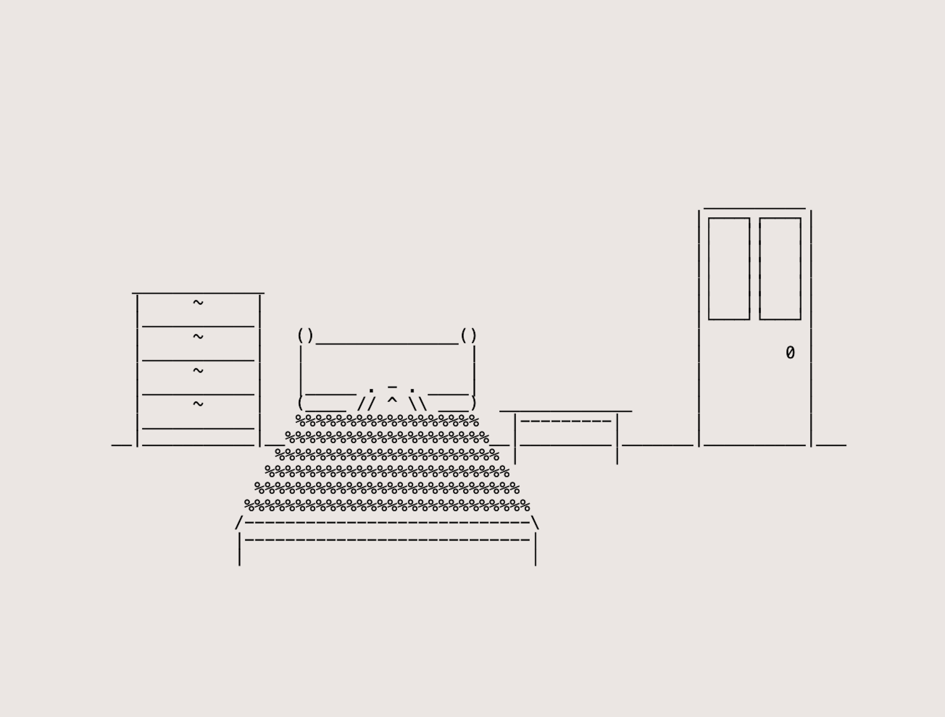

Morning.html

Even to this day, I still set at least five alarms every morning to make sure I wake up on time. For example, if I need to be up by 8 AM, my phone will go off at 7:45, 7:50, 7:55, 8:00, and then at 8:10, just in case I somehow managed to sleep through all the previous alarms. I rarely ever miss my first alarm, but even so, I picked up this habit due to the anxiety of imagining what would happen if I did somehow miss my alarm. During high school mornings, my alarm would usually start ringing at 6:30 AM, but I rarely got out of bed right away. I would lie there, half-awake, either scrolling through my phone or drifting back to sleep, telling myself I had just five more minutes again and again, until I no longer had any more minutes to spare.

I always try to be out of the house by 7:30 AM, which meant I needed to be awake, at the latest, by 7:00 AM. But getting up was always a struggle, not just because of exhaustion, but because of how much effort went into preparing myself for the day. I never wore makeup and never wore anything extreme that would take a long time to prepare. I simply picked out my outfit, made sure my hair was perfect, and ensured I looked presentable enough to avoid judgement. I knew my classmates had a way of noticing the smallest things. They would often whisper about someone's outfit, hushed giggles when someone slips up mid class, and overall judgement all around. I knew how brutal some of these passing comments could be, and even imagining the least hurtful comment always filled me with anxiousness. I had heard them many times before, and I didn’t want to be the subject of their scrutiny.

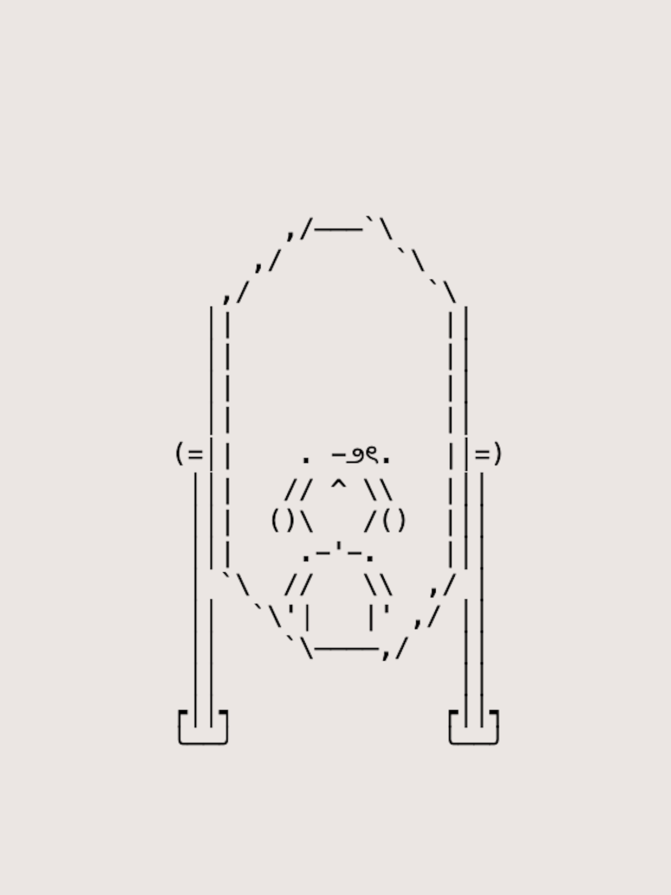

Mirror.html

I always avoided light colors. White, beige, light shades of yellow or peach, I was somehow convinced that they made me look fatter, even though I was very much aware that I was already incredibly thin at the time, even underweight. At the time, I also had very long hair, so long it reached down to my lower back, but I never wore it down, having been once associated and compared to Sadako, the ghost from The Ring, a sinister figure with long black hair covering her face like curtains. I always had thought that was just a metaphor for me appearing scary to others, so I either wore my hair in a high ponytail or a carefully made donut bun. Each morning, I would redo my hair over and over again, making sure it was perfectly symmetrical, making sure there were no loose strands, no misplaced hairs, and most importantly, no imperfections that someone could latch onto. Some days, this process took fifteen minutes, or even half an hour, when it could easily be done within a minute or so since it involved just a simple hair tie.

## [Hallway.html](https://ycheuk.github.io/my_thesis_journey/hallway.html)

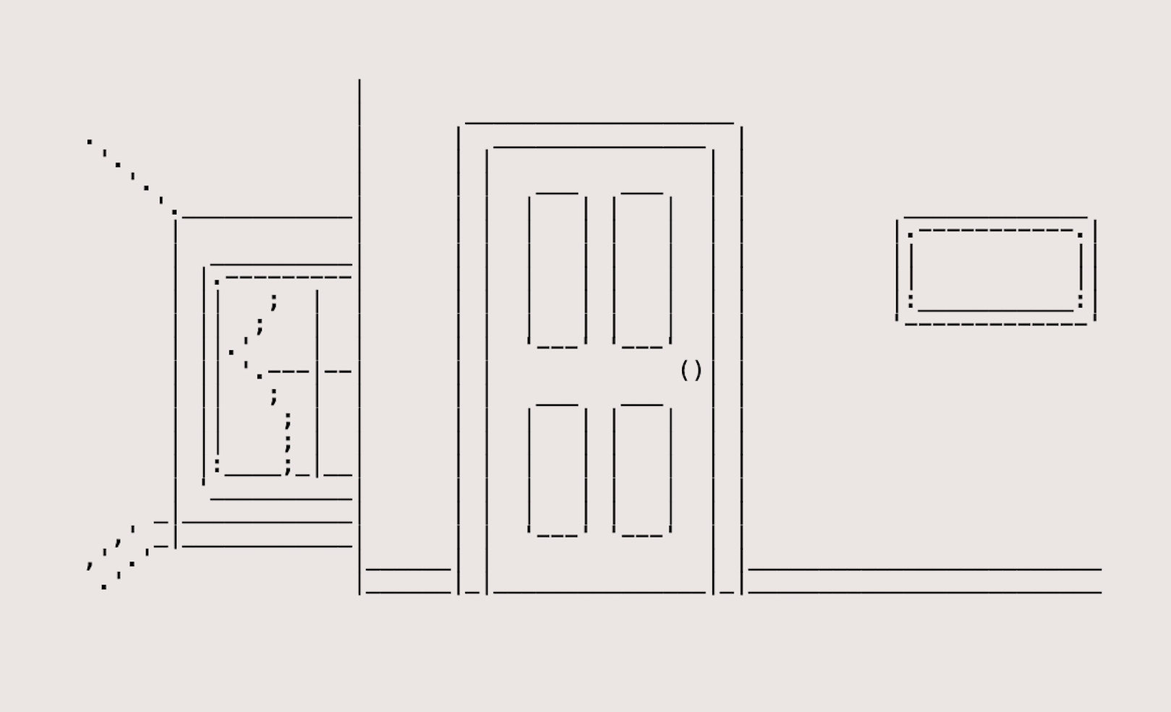

Hallway.html

I have always had, and still have, incredibly loving parents. In our family, openly saying "I love you" is rare, and expressions of affection are often unspoken rather than verbalized, which is very common in Chinese culture. My father had his own methods of raising me, ones that, as a child, I often resented. He wanted me to be "perfect." To be "respectful" and "poised." To be the kind of daughter who always upheld the family's values. Back then, I had always labeled him as "strict," even "cruel." I thought of him as someone with a short temper, someone impossible to please. But with time, I came to really appreciate the lessons he instilled in me, even if others, especially those from cultures where strict parenting isn't the norm, might have seen his ways as harsh, even brutal. Although, his teachings did have one large negative consequence that still burdens me to this day. The constant emphasis on respect, on always being considerate of others, made me overthink everything and become an extremely emotionally sensitive person. I became hyper-aware of how many actions might inconvenience someone, even in the smallest ways.

One of the clearest examples of this happened every morning before school. I would wake up, get ready, and then stand outside my father's bedroom door, listening to his snoring as he slept. I knew that if I woke him up, he would take me to school without hesitation. It would have put my mind at ease and saved me from facing the interactions I so badly wanted to avoid if I walked to school. And yet, I could never bring myself to knock on his door. Every morning, the same debate would happen in my head. Would waking him up be selfish? Would he be annoyed? Would he see me as a burden? Deep down, I knew the answer: of course he wouldn’t. He had never given me a reason to believe he would be angry at such small reasons. But that small, nagging fear never left me. It was the guilt of disturbing him when I knew how hard he worked. My parents both works tirelessly, working 12 hours every day, and the idea of interrupting his rare moments of rest just for my own convenience felt extremely wrong. And so, every morning, I swallowed my fears and hesitation, turned away from his door, and continued my morning to walk to school on my own. It became a routine, even though I always made the same decision.

## [Kitchen.html](https://ycheuk.github.io/my_thesis_journey/kitchen.html) and [Dining.html](https://ycheuk.github.io/my_thesis_journey/dining.html)

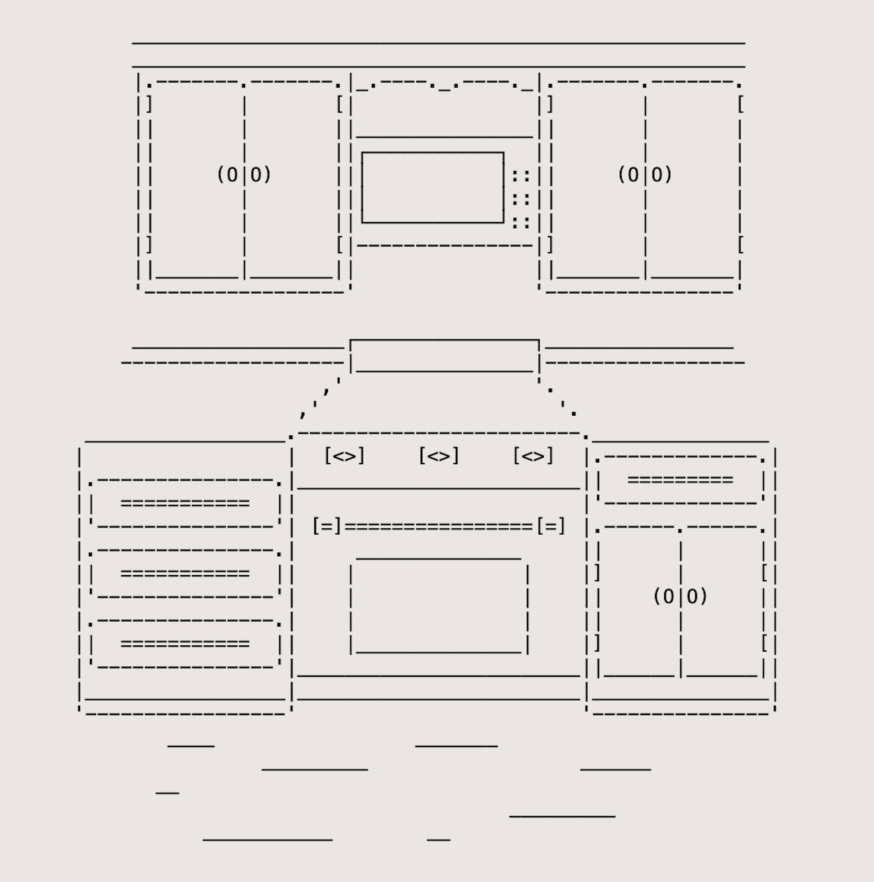

Kitchen.html

Breakfast has always been my least favorite meal of the day, and that still hasn't changed. It wasn't because I was picky, or... maybe I was. I would have happily eaten anything if my stomach had allowed it, but no matter what I ate, I could barely stomach eating food in the mornings. The small act of eating after waking up made me extremely nauseous, and every bite felt like a bottle. This was emphasized when it came to sweet foods, including pancakes, cereal, and pastries. Even savory options like eggs or bacon were slight better, but it still made me feel the need to gag. It never seemed to matter what was on my plate, and breakfast had always been a struggle.

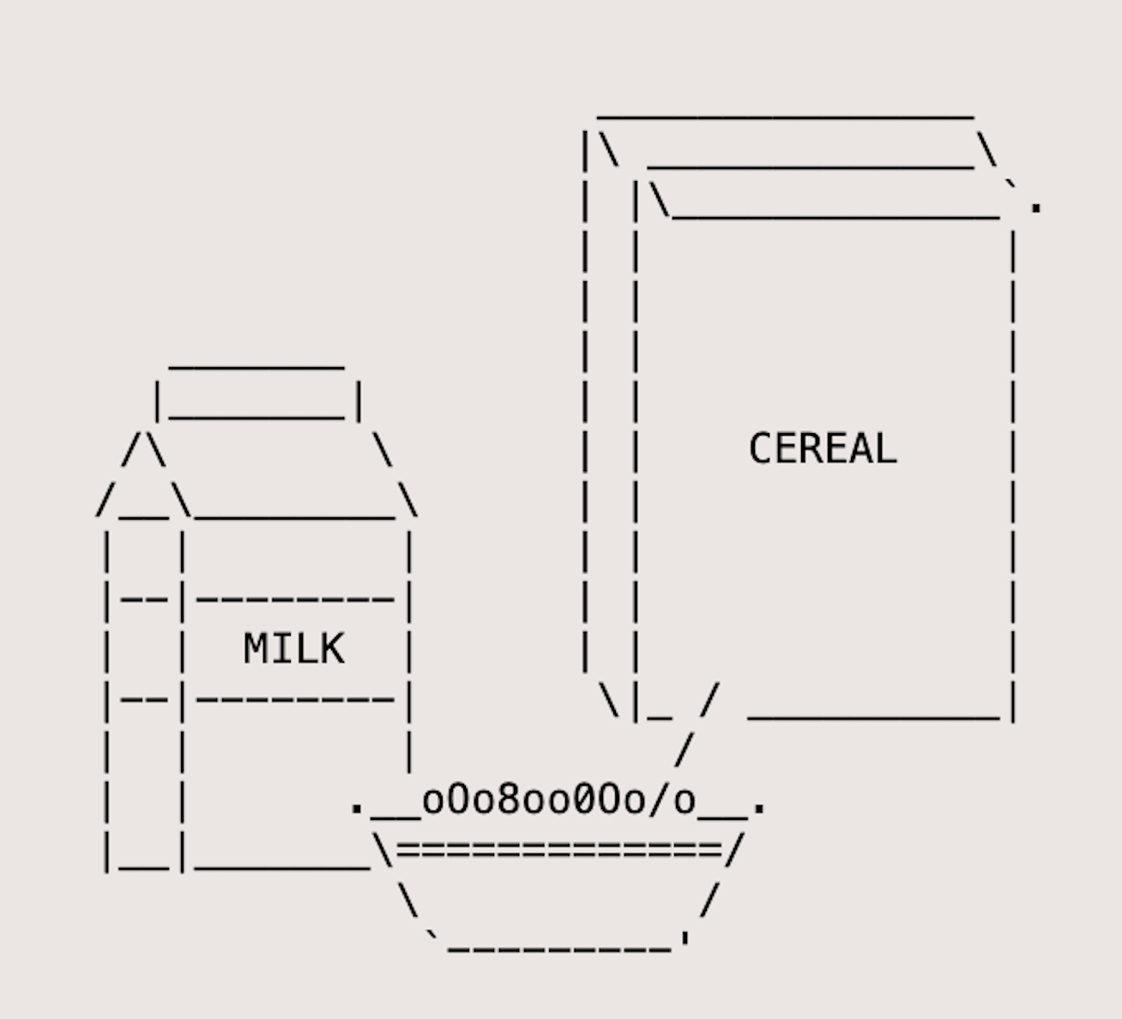

Dining.html

To this day, I still don't know the real reason behind it. Maybe it was something physiological, maybe something to do with my immune system, but I never grew out of it. Although, at the time, I knew I didn't have much of a choice. I know I needed to eat at least something, because if I didn't, my stomach would growl loudly halfway through the morning, an embarrassing prospect that filled me, and surely many others, with anxiety. Eventually, I had given up trying to find a breakfast that wouldn't make me feel sick and settled for the simplest option: a small bowl of cereal. At the time, I was convinced that I was eating enough, but looking back now, I wonder how I ever thought that three spoonfuls of cereal were ever even near sufficient. It was always the same breakfast: a handful of Quaker Oatmeal Squares with just enough milk to barely submerge them. That was all I could really manage. As I sat at the dining table and ate the cereal half-heartedly, my mind was always elsewhere. I wasn't just dreading breakfast, but rather the day ahead. Every possible interaction, every unknown moment that could possibly happen between now and the time I returned home. Breakfast wasn't just a meal I had disliked, but a quiet, uneasy start to another day of trying to navigate everything that came after.

## [Street.html](https://ycheuk.github.io/my_thesis_journey/street.html)

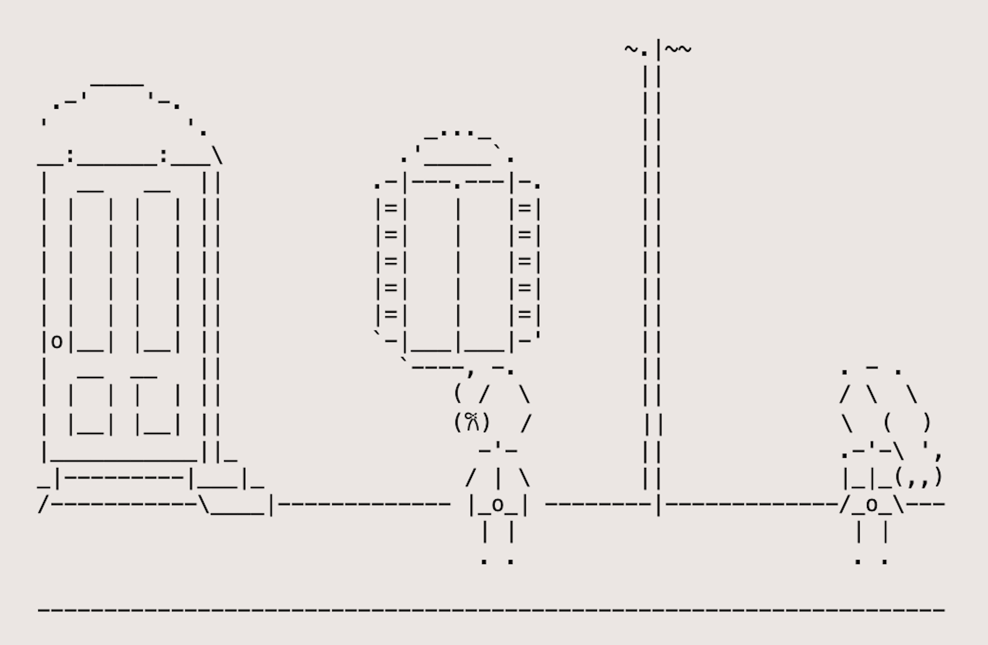

Street.html

It was just another ordinary school day, one of the days I had chosen to walk to school. I took my usual, more secluded route, hoping to avoid unnecessary interactions. But as I made my way down the quiet street, I unexpectedly crossed paths with my neighbor, another student from my high school, though they were a year above me. I rarely saw them in general, aside from the occasional glimpses when they passed by my house with their group of friends.

That morning, from a distance, she suddenly waved in my direction. Caught off guard but feeling a little bit more energetic than usual, I eagerly waved back, my hand lifting high up and waving in an enthusiastic response. But as I met their eyes, I noticed they looked hesitant and almost the awkward smile that suddenly appeared on their face. It was only until I looked over my shoulder when I noticed their group of friends a short distance behind me, who was also waving. They hadn't been waving at me at all.

The slight excitement and the rare positive energy inside drained from my instantly, replaced by embarrassment and shame. Without another word or glance, I lowered my head and walked past my neighbor as if nothing had happened. To this day, I remember that moment very clearly. I remember exactly which street it happened on, even which part of the sidewalk I was standing on. It was one of those fleeting, insignificant moments for everyone else, but one that somehow is etched into an individual's memories almost permanently, as if a constant reminder to that embarrassing and simple moment.

## [Crossing.html](https://ycheuk.github.io/my_thesis_journey/crossing.html)

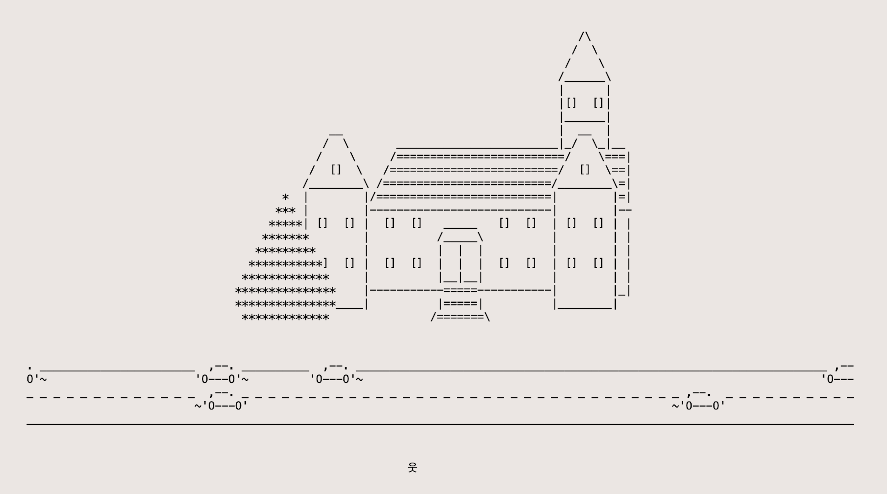

Crossing.html

This page represents the numerous times I felt overwhelmed simply by the act of crossing a busy street to school. Every morning, I would carefully debate between two routes: one that is a faster, quieter path, which would inevitably force me to cross a very busy road, or one that is the longer route with a crossing guard, ensuring a safer and quicker crossing but requiring me to interact with both the guard and possibly other students. Most of the times, I chose the faster route to avoid social interaction, even though it meant facing the intimidating reality of crossing one particularly chaotic street right in front of my school. Despite the existence of the crosswalk, very few drivers would stop, even when it was obvious I was a student with a backpack on my back. Sometimes, I would stand at the edge of the road for what felt like forever, waiting for just one considerate driver to pause, or for the rare moment when the street was clear enough for me to dash across. This small and probably near insignificant event became a daily source of anxiety.

## [Classroom.html](https://ycheuk.github.io/my_thesis_journey/classroom.html)

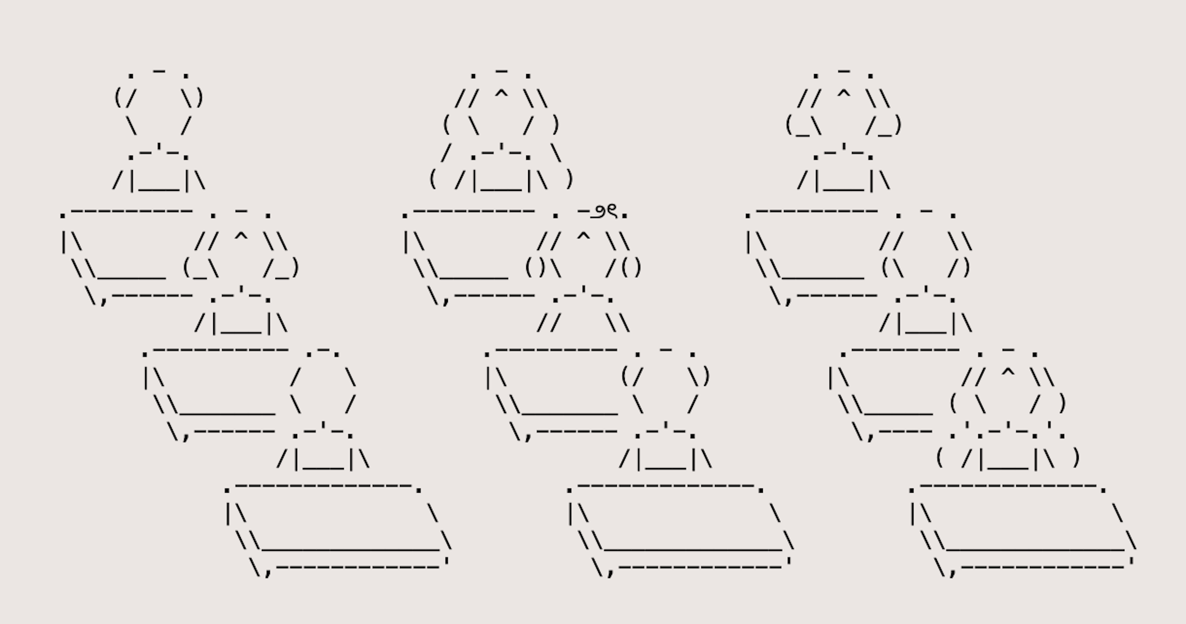

Classroom.html

Nine different classes a day, five days a week. Though the subjects were all different in different classrooms with somewhat different classmates, it all felt the same. Each class seemed to blur into the next almost in a monotonous rhythm, and I felt like I would move mechanically, doing the minimal amount to get through the day. Because seating was assigned alphabetically based off our surnames, I always ended up sitting in the first or second front rows. I hated it. Sitting in the front made me feel exposed and vulnerable, especially knowing there were many others behind me. Even if no one was really paying attention to me, it was impossible to shake the feeling that there was at least a pair of eyes on me, silently judging. I would become hyperaware of everything I was doing—how I sat, how my expression looked, how I held my pencil, and even how I breathed. I would almost always be one of the first students to show up for class, seeing the same familiar groups of friends walk in together, laughing, exchanging welcoming and exciting greetings, and easily talking to each other. The first few minutes that began before the teacher would start the lesson always felt like the longest part of the hour. When class ended, I was always among the first to leave, never lingering or waiting for anyone while others would stick around to walk to their next class with friends. I slipped out as soon as the teacher dismissed us from class out of the desperate need to breathe again in a more open space.

## [Cafeteria.html](https://ycheuk.github.io/my_thesis_journey/cafeteria.html)

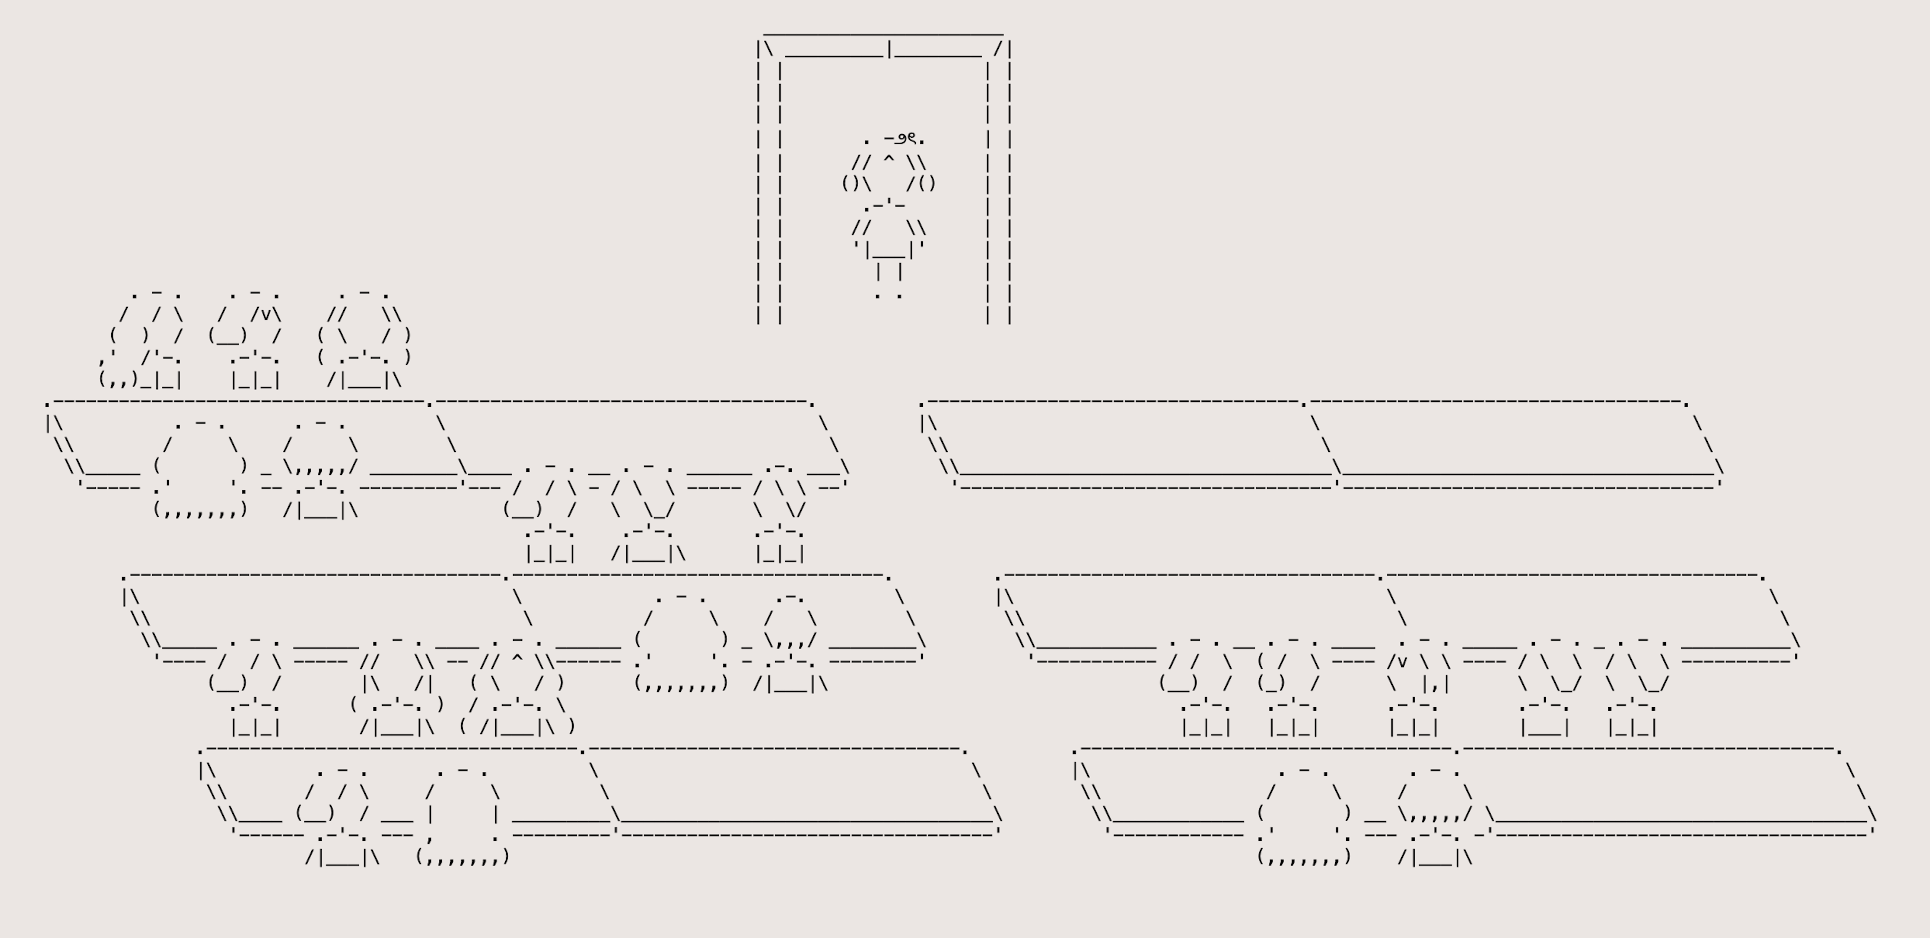

Cafeteria.html

Lunch always happened around noon, and while most students would look forward to it as a break or a chance to eat and chat with their friends, for me, it was the most anxious part of the school day for me. I rarely thought about what food they were serving or how hungry I was. I always felt like I was stuck in a loop, worrying about who I would sit with, or if I'd be sitting with anyone at all. Every day, as the lunch bell got closer, I would always wonder if I should sit near someone and pretend, we're close enough to make conversation, or should I take my lunch tray and disappear to a far corner of the cafeteria, hoping to blend into the background where no one can see me. Or maybe I just avoid it altogether. Some days, I would even linger in the hallways, stalling until lunch time was over. Other times, I would seriously consider hiding away in an empty classroom, or if none were available, locking myself in a bathroom stall, because it felt safer than being seen sitting alone.

## Conclusion

Throughout the making of this project, I uncovered memories I didn't know were still within me, both the joyful and the painful. Revisiting my high school years was especially difficult, remembering all the time I truly felt I would never belong to the world. I found myself scrolling through my high school's Facebook page, trying to piece together fragments that I had forgotten class schedules, familiar hallways, the faces of classmates and teachers I had forgotten, everything. Many of the memories that resurfaced were ones I had tried hard to forget, ones I never thought I would revisit again. And yet, through this process, I've come to learn so much more about myself, not just who I was, but how far I've come since coming to Reed.

There were moments while writing and creating this project where I found myself in tears. But what came as a surprise was that the tears didn't come from my high school memories, but moments when I reflected on my family. Due to the deep language barrier between me and my parents, there's so much about me they'll never fully know, especially when it comes to the struggles I faced during high school. But even if I knew their language well, I'm not sure I would've had the courage to tell them at the time. For most of my teenage years, I believed that the anxiety and loneliness I experienced were personal failures, signs that I was weak. And weakness was something I avoided showing at all costs, especially in front of my family.

Not long ago, I had a rare and unexpected conversation with my father about high school. As we drove past the school, he had pointed out how much the school seemed to have changed, pointing to the brand-new building that had been constructed next to the football field since I graduated from there. Then he asked if I ever thought about going back someday to visit my old teachers. Without hesitation or needing a moment to consider his question, I had immediately said no. He didn't ask why, but I saw the surprise on his face, and a little bit of confusion. So, I gave him a short explanation: that I simply did not have a good time there. That the students weren't kind to me. That I was on the receiving end of racism and Chinese stereotypes very often. I simply did not ever want to see those people again.

I didn't expect much of a response, maybe possibly a lecture on how I should just ignore those people and move on with my life. My parents and I have never really talked much about my emotional life, partly because of the language barrier, but also because I've always believed that sharing my weaknesses and problems with someone meant that it was my fault, that I should have just been stronger. But he had said something I didn't expect.

"If you had told me, if I had known, I would've transferred you to another school, even if it meant moving to the next town over."

I was stunned, and I couldn't respond right away. Those words hit me harder than I could have imagined. It was just one sentence, a simple one too. I realized then how wrong I was about keeping quiet, how wrong I was in believing that my weakness was my fault. After that, I continued to wonder what could've changed if I had simply said something to my parents back then. Would I have had a better high school experience? A safer and more welcoming place to learn? A friend to sit with at lunch?

As I look back now, I don't really see weakness anymore, but survival. I see someone who was trying their best in an environment that didn't always welcome them. I was able to survive high school and continue to college. And as a student who once had such intense social anxiety, I can say with confidence today that I've grown an immense amount. I've learned to trust my voice, to ask for support, and to find community. This thesis project isn't just a reflection and message to my past self, but also a message to anyone who feels alone, unseen, or overwhelmed: Keep going. You are not weak for feeling lost and not broken for struggling. Healing and growth take time, and sometimes, all it takes is finding the right people, the right place, and the right moment. I used to think that saying "it gets better" was a lie, a cliché statement to make you feel better. But now, I truly believe in it.

# Bibliography

All Tech Asia. “The Story behind Asian Emoticons, or These Things: (“◉◞౪◟◉”).” *Medium*, *All* *Tech* *Asia*, 27 Nov. 2015, medium.com/act-news/the-story-behind-asian-emoticons-or-these-things-%E0%B1%AA-31666846a246.

Al's Retro Geek Lab. “Back to the BBS - Part 8: The Art Scene #ANSI #Asciiart.” *YouTube*, 23 Dec. 2022, www.youtube.com/watch?v=gOghuaxh88U.

Asia Society. “Episode 5: Stereotype Bingo | Asia Society.” Asiasociety.org, asiasociety.org/education/episode-5-stereotype-bingo.

Aziz, Sahar. “Anti-Asian Racism Must Be Stopped before It Is Normalised.” Aljazeera, 16 Apr. 2020, [www.aljazeera.com/opinions/2020/4/16/anti-asian-racism-must-be-stopped-before-it-is-normalised/](http://www.aljazeera.com/opinions/2020/4/16/anti-asian-racism-must-be-stopped-before-it-is-normalised/).

bjiru. “The History of Emoticons.” *YouTube*, 15 Nov. 2023, [www.youtube.com/watch?v=tf-YVA_Ta68](http://www.youtube.com/watch?v=tf-YVA_Ta68).

Blackburn, Sarah-SoonLing. “What Is the Model Minority Myth?” *Learning for Justice*, Southern Poverty Law Center, 21 Mar. 2019, [www.learningforjustice.org/magazine/what-is-the-model-minority-myth](http://www.learningforjustice.org/magazine/what-is-the-model-minority-myth).

Cassel, David. “The Surprisingly Rich History of ASCII Art.” *The New Stack*, 11 Mar. 2018, thenewstack.io/surprisingly-rich-history-ascii-art/.

Diamond, Sarah. “The History of “Stereotype,” Written on Metal Plates.” *The* *New York Times*, 21 Apr. 2024, [www.nytimes.com/2024/04/21/insider/the-history-of-stereotype-written-on-metal-plates.html](http://www.nytimes.com/2024/04/21/insider/the-history-of-stereotype-written-on-metal-plates.html).

Etymonline. “Stereotype | Origin and Meaning of Stereotype by Online Etymology Dictionary.” *Etymonline*, 2019, www.etymonline.com/word/stereotype.

Gover, Angela R., et al. “Anti-Asian Hate Crime during the COVID-19 Pandemic: Exploring the Reproduction of Inequality.” *American Journal of Criminal Justice*, vol. 45, no. 4, 7 July 2020, pp. 647–667, pmc.ncbi.nlm.nih.gov/articles/PMC7364747/, <https://doi.org/10.1007/s12103-020-09545-1>.

Hurwitz, Michael. “Stereotypes Chinese People Have about Themselves.” Yoyochinese.com, 26 Feb. 2014, yoyochinese.com/blog/learn-chinese-china-regional-stereotypes.

Jobs in Japan. “(@_@) the Origin of Kaomoji.” *Jobs* *in* *Japan*, 30 Aug. 2022, jobsinjapan.com/living-in-japan-guide/the-origin-of-kaomoji/.

Kanazawa, Mark. “Immigration, Exclusion, and Taxation: Anti-Chinese Legislation in Gold Rush California.” *The Journal of Economic History*, vol. 65, no. 03, 26 Aug. 2005, <https://doi.org/10.1017/s0022050705000288>.

Kelechava, Brad. “ANSI Art and ASCII Art - Origins in Standards.” *The ANSI Blog*, 31 Oct. 2019, blog.ansi.org/2019/10/ansi-art-ascii-art-iso-standards-x3-64/.

Korpela, J K. *Unicode Explained*. New York, N.Y., O’reilly, 2006.

Kurtzman, Laura. “Trump’s “Chinese Virus” Tweet Linked to Rise of Anti-Asian Hashtags on Twitter.” University of California San Francisco, 18 Mar. 2021, [www.ucsf.edu/news/2021/03/420081/trumps-chinese-virus-tweet-linked-rise-anti-asian-hashtags-twitter](http://www.ucsf.edu/news/2021/03/420081/trumps-chinese-virus-tweet-linked-rise-anti-asian-hashtags-twitter).

Lee, Josephine. “Yellowface Performance: Historical and Contemporary Contexts.” *Oxford Research Encyclopedia of Literature*, 25 Feb. 2019, oxfordre.com/literature/display/10.1093/acrefore/9780190201098.001.0001/acrefore-9780190201098-e-834.

Lim, Min. “Kaomoji as Expression.” *Unravel*, 15 Jan. 2017, unravellingmag.com/articles/kaomoji-as-expression/.

Messenger, Robert. “Flora Fanny Stacey (1845-1909): The World’s First Typewriter Artist.” Blogspot.com, 15 Apr. 2025, oztypewriter.blogspot.com/2020/02/flora-fanny-stacey-1845-1909-worlds.html.

Messenger, Robert. “One Man’s (Typewriter) Art ....” *Blogspot*, 28 Apr. 2018, oztypewriter.blogspot.com/2013/04/one-mans-typewriter-art.html.

Ngai, M. M. “Chinese Gold Miners and the “Chinese Question” in Nineteenth-Century California and Victoria.” *Journal of American History*, vol. 101, no. 4, 1 Mar. 2015, pp. 1082–1105, https://doi.org/10.1093/jahist/jav112.

Office of the Historian. “Chinese Immigration and the Chinese Exclusion Acts.” *Office of the Historian*, 2016, <https://history.state.gov/milestones/1866-1898/chinese-immigration>.

Pardee, Grant. “The Weird History of Le Lenny Face ( ͡° ͜ʖ ͡°), the Spammy Meme That Refuses to Die.” *The Daily Dot*, 26 Jan. 2017, www.dailydot.com/unclick/le-lenny-face/.

Robles, Jorge. “Stereotypes: A Big Problem in Our Modern Society.” *Medium*, 15 May 2013, medium.com/collection-of-essays/stereotypes-a-big-problem-in-our-modern-society-4137a916b2c6.

Ruiz, Neil G., et al. “Asian Americans and the “Model Minority” Stereotype.” *Pew Research Center*, 30 Nov. 2023, [www.pewresearch.org/race-and-ethnicity/2023/11/30/asian-americans-and-the-model-minority-stereotype/](http://www.pewresearch.org/race-and-ethnicity/2023/11/30/asian-americans-and-the-model-minority-stereotype/).

Samarrai, Fariss. ““Rice Theory” Explains North-South China Cultural Differences, Study Shows.” UVA Today, 8 May 2014, news.virginia.edu/content/rice-theory-explains-north-south-china-cultural-differences-study-shows.

Schneider, Kate. "From “Coolies” to the “Model Minority”." *The Undergraduate Journal of American Studies*: 15.

Stark, Joan. “History of ASCII Art.” *Archive*.*org*, 2025, web.archive.org/web/20091026141759/http:/geocities.com/SoHo/7373/history.htm.

Unicode. “Supported Scripts.” *Unicode.org*, [www.unicode.org/standard/supported.html](http://www.unicode.org/standard/supported.html).

Unicode. “Unicode Character Count V16.0.” *Unicode.org*, 2024, [www.unicode.org/versions/stats/charcountv16_0.html](http://www.unicode.org/versions/stats/charcountv16_0.html).

W3 Schools. “HTML ASCII Reference.” *W3 Schools*, www.w3schools.com/charsets/ref_html_ascii.asp.

WABC. ““Where’s Your (Expletive) Mask?”: Asian Woman Attacked in Manhattan Hate Crime.” ABC7 New York, 11 Mar. 2020, abc7ny.com/assault-hate-crime-bias-attack-coronavirus/6003396/.

1. The website can be accessed at: https://ycheuk.github.io/my_thesis_journey/
2. Robles, Jorge. “Stereotypes: A Big Problem in Our Modern Society.” *Medium*, 15 May 2013, medium.com/collection-of-essays/stereotypes-a-big-problem-in-our-modern-society-4137a916b2c6.
3. Ruiz, Neil G., et al. “Asian Americans and the “Model Minority” Stereotype.” *Pew Research Center*, 30 Nov. 2023, [www.pewresearch.org/race-and-ethnicity/2023/11/30/asian-americans-and-the-model-minority-stereotype/](http://www.pewresearch.org/race-and-ethnicity/2023/11/30/asian-americans-and-the-model-minority-stereotype/).
4. Gover, Angela R., et al. “Anti-Asian Hate Crime during the COVID-19 Pandemic: Exploring the Reproduction of Inequality.” *American* *Journal* *of* *Criminal* *Justice*, vol. 45, no. 4, 7 July 2020, pp. 647–667, pmc.ncbi.nlm.nih.gov/articles/PMC7364747/, https://doi.org/10.1007/s12103-020-09545-1.
5. Diamond, Sarah. “The History of “Stereotype,” Written on Metal Plates.” *The New York Times*, 21 Apr. 2024, www.nytimes.com/2024/04/21/insider/the-history-of-stereotype-written-on-metal-plates.html.
6. Etymonline. “Stereotype | Origin and Meaning of Stereotype by Online Etymology Dictionary.” *Etymonline*, 2019, www.etymonline.com/word/stereotype.
7. Ngai, M. M. “Chinese Gold Miners and the “Chinese Question” in Nineteenth-Century California and Victoria.” *Journal of American History*, vol. 101, no. 4, 1 Mar. 2015, pp. 1082–1105, https://doi.org/10.1093/jahist/jav112.
8. Kanazawa, Mark. “Immigration, Exclusion, and Taxation: Anti-Chinese Legislation in Gold Rush California.” *The Journal of Economic History*, vol. 65, no. 03, 26 Aug. 2005, https://doi.org/10.1017/s0022050705000288.
9. Blackburn, Sarah-SoonLing. “What Is the Model Minority Myth?” *Learning for Justice*, Southern Poverty Law Center, 21 Mar. 2019, www.learningforjustice.org/magazine/what-is-the-model-minority-myth.
10. Office of the Historian. “Chinese Immigration and the Chinese Exclusion Acts.” *Office of the Historian*, 2016, history.state.gov/milestones/1866-1898/chinese-immigration.
11. Schneider, Kate. "From “Coolies” to the “Model Minority”." *The Undergraduate Journal of American Studies*: 15.
12. Asia Society. “Episode 5: Stereotype Bingo | Asia Society.” Asiasociety.org, asiasociety.org/education/episode-5-stereotype-bingo.
13. Lee, Josephine. “Yellowface Performance: Historical and Contemporary Contexts.” *Oxford Research Encyclopedia of Literature*, 25 Feb. 2019, oxfordre.com/literature/display/10.1093/acrefore/9780190201098.001.0001/acrefore-9780190201098-e-834.
14. Kurtzman, Laura. “Trump’s “Chinese Virus” Tweet Linked to Rise of Anti-Asian Hashtags on Twitter.” *University of California San Francisco*, 18 Mar. 2021, www.ucsf.edu/news/2021/03/420081/trumps-chinese-virus-tweet-linked-rise-anti-asian-hashtags-twitter.
15. Aziz, Sahar. “Anti-Asian Racism Must Be Stopped before It Is Normalised.” *Aljazeera*, 16 Apr. 2020, [www.aljazeera.com/opinions/2020/4/16/anti-asian-racism-must-be-stopped-before-it-is-normalised/](http://www.aljazeera.com/opinions/2020/4/16/anti-asian-racism-must-be-stopped-before-it-is-normalised/).
16. WABC. ““Where’s Your (Expletive) Mask?”: Asian Woman Attacked in Manhattan Hate Crime.” *ABC7 New York*, 11 Mar. 2020, abc7ny.com/assault-hate-crime-bias-attack-coronavirus/6003396/.
17. Samarrai, Fariss. ““Rice Theory” Explains North-South China Cultural Differences, Study Shows.” *UVA Today*, 8 May 2014, news.virginia.edu/content/rice-theory-explains-north-south-china-cultural-differences-study-shows.
18. Hurwitz, Michael. “Stereotypes Chinese People Have about Themselves.” *Yoyochinese*, 26 Feb. 2014, yoyochinese.com/blog/learn-chinese-china-regional-stereotypes.
19. bjiru. “The History of Emoticons.” *YouTube*, 15 Nov. 2023, [www.youtube.com/watch?v=tf-YVA_Ta68](http://www.youtube.com/watch?v=tf-YVA_Ta68).
20. Unicode. “Unicode Character Count V16.0.” *Unicode.org*, 2024, www.unicode.org/versions/stats/charcountv16_0.html.
21. Unicode. “Supported Scripts.” *Unicode.org*, www.unicode.org/standard/supported.html.
22. W3 Schools. “HTML ASCII Reference.” *W3 Schools*, www.w3schools.com/charsets/ref_html_ascii.asp.
23. W3 Schools. “HTML ASCII Reference.” *W3 Schools*, www.w3schools.com/charsets/ref_html_ascii.asp.
24. Van Hoey, Jo. “Binary Numbers, Hexadecimal Numbers, and Registers.” *Beginning X64 Assembly Programming*, 2019, pp. 13–19, https://doi.org/10.1007/978-1-4842-5076-1_2.
25. Stark, Joan. “History of ASCII Art.” *Archive.org*, 2025, web.archive.org/web/20091026141759/http:/geocities.com/SoHo/7373/history.htm.
26. Messenger, Robert. “Flora Fanny Stacey (1845-1909): The World’s First Typewriter Artist.” *Blogspot*, 15 Apr. 2025, oztypewriter.blogspot.com/2020/02/flora-fanny-stacey-1845-1909-worlds.html.
27. Messenger, Robert. “One Man’s (Typewriter) Art ....” *Blogspot*, 28 Apr. 2018, oztypewriter.blogspot.com/2013/04/one-mans-typewriter-art.html.
28. Al's Retro Geek Lab. “Back to the BBS - Part 8: The Art Scene #ANSI #Asciiart.” *YouTube*, 23 Dec. 2022, www.youtube.com/watch?v=gOghuaxh88U.
29. Cassel, David. “The Surprisingly Rich History of ASCII Art.” *The New Stack*, 11 Mar. 2018, thenewstack.io/surprisingly-rich-history-ascii-art/.
30. Kelechava, Brad. “ANSI Art and ASCII Art - Origins in Standards.” *The ANSI Blog*, 31 Oct. 2019, blog.ansi.org/2019/10/ansi-art-ascii-art-iso-standards-x3-64/.
31. All Tech Asia. “The Story behind Asian Emoticons, or These Things: (“◉◞౪◟◉”).” *Medium*, *All Tech Asia*, 27 Nov. 2015, medium.com/act-news/the-story-behind-asian-emoticons-or-these-things-%E0%B1%AA-31666846a246.
32. Jobs in Japan. “(@_@) the Origin of Kaomoji.” Jobs in Japan, 30 Aug. 2022, jobsinjapan.com/living-in-japan-guide/the-origin-of-kaomoji/.
33. Lim, Min. “Kaomoji as Expression.” *Unravel*, 15 Jan. 2017, unravellingmag.com/articles/kaomoji-as-expression/.
34. Korpela, J K. *Unicode Explained*. New York, N.Y., O’reilly, 2006.
35. Korpela, J K. *Unicode Explained*. New York, N.Y., O’reilly, 2006.
36. Korpela, J K. *Unicode Explained*. New York, N.Y., O’reilly, 2006.
37. Pardee, Grant. “The Weird History of Le Lenny Face ( ͡° ͜ʖ ͡°), the Spammy Meme That Refuses to Die.” *The Daily Dot*, 26 Jan. 2017, www.dailydot.com/unclick/le-lenny-face/.